## 4.1 Hydrological Analysis:

**Hydrological Design**

In hydrological analysis catchment area was calculated from topo map.

To calculate design discharge, we apply various methods, and among them, suitable discharge was chosen. In all methods, we choose Return Period: 100 Years

*Outlet point @ 28 19 N 18 54 E*

The design discharge can be calculated by using various methods as given below:

**Design Parameters:**

Catchment Area = A = 105.7 km2

Area under 3000m = 78,981,907m2

Perimeter under 3000 = 41970m

**Rational Formula**

Q = CIA/360

Figure 1 Catchment Area

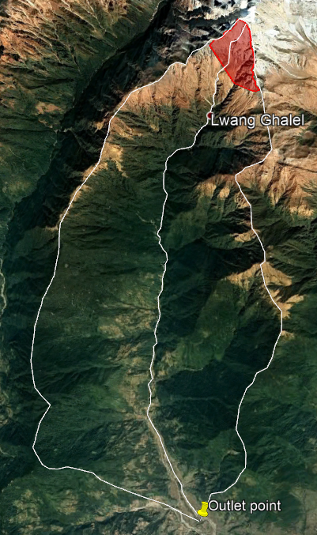

Where,

L = 21.6 km

S = 4398/21600

= 0.2042

Tc= 78.08 minutes

C = 0.2

Where, K=5.914,

T= 100 years

x= 0.1623

a= 0.50

n= 1.0127

i= 68.8 mm/hr

Q = CiA/360

= 404.01 m3/sec (Taking C = 0.2 for hilly forest)

Figure 2 Snow covered Catchment area

Figure 2 Catchment area under 3000m

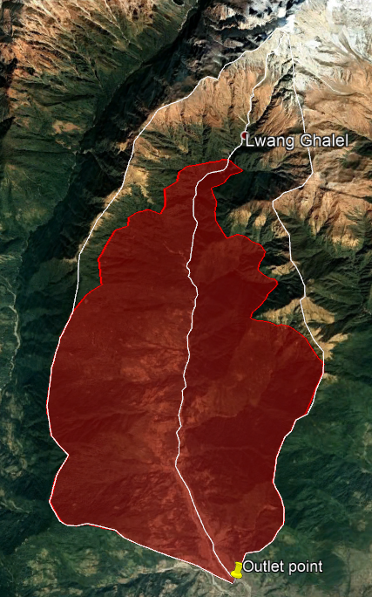**Dickens Formula (1865):**

*QP = CDA3/4*

Where Cd = 14

A = 105.7km2

Q = 461.51 m3/s

**Modified Dickens:**

*Q= CTA3/4*

Where

T = 100

As = Snow covered catchment area = 1.90km2

= 1.854

Ct = 15.68

Q = 516.89m3/s

**Ryve’s formula:**

*Q= CRA2/3*

Where CR = 10.2

Figure Catchment area under 3000

Q = 228.0255m3/s

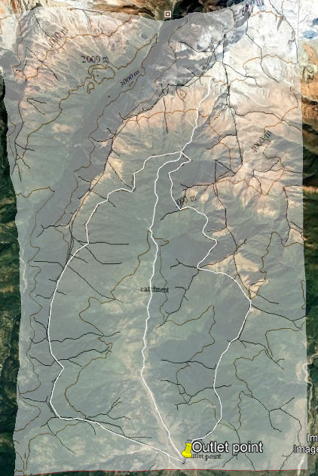

**WECS Method:**

The formula for 100-year return period is given by  
 Q100=14.63(A3000+1)0.7342

Where, A3000 = 78.98 km2

Q100 = 365.1m3/s

Figure 4 Contour map overlay and tracing of catchment area under 3000

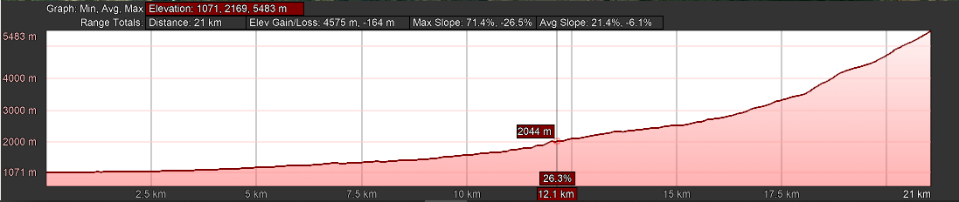

Figure River elevation profile

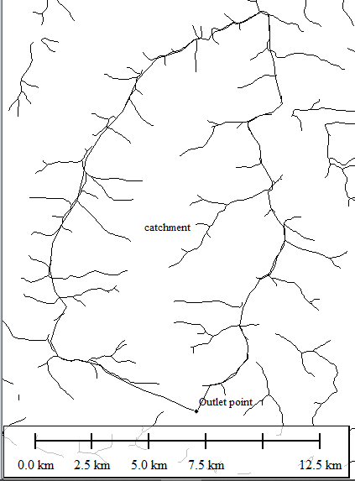

Figure Ridge lines

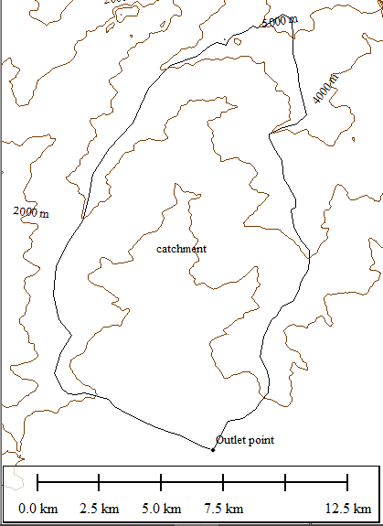

Figure Contour map (Interval 1000m)

|  |  |  |
| --- | --- | --- |
| **S.No** | **Method** | **Discharge** |
| 1 | Dicken’s Formula | 461.51 m3/s |
| 2 | Ryves Formula | 228.025 m3/sec |
| 3 | WECS | 365.1 m3/sec |
| 4 | Rational method | 404.01 m3/sec |
| 5 | Modified Dicken’s Formula | 516.89 m3/s |

Table: Discharge Table