MeetBrief AI
Presentation Guide
Slide content, speaker notes and viva answers, divided for 4 presenters
One-line pitch: MeetBrief AI is a Chrome extension and local backend that captures online meetings, then gives late joiners a catch-up, explains and translates what was said, and answers questions with evidence, using only free open models that run on a laptop.

Who presents what
Table 1: Division of work (about 5 minutes each; change the timing to match your slot)
Presenter | Part | Slides | Main topics
Member 1 name | 1. Problem and background | 1–5 | Problem statement, existing work and gap, objectives, scope, requirements
Member 2 name | 2. System design and workflow | 6–10 | Architecture, tech stack, end-to-end workflow, hybrid capture, shared rooms
Member 3 name | 3. NLP models and methodology | 11–14 | Models used, meeting memory, summaries and grounded Q&A, multilingual pipeline
Member 4 name | 4. Results, demo and conclusion | 15–20 | Evaluation, model comparison, testing and security, live demo, limitations, future work

Text in red is for you to fill in. Everyone should read the Key facts page, because a viva question can go to any member.

Read this before making slides
• The speech accuracy figure (WER 0.0) was measured with Whisper base. The system now uses Whisper small, and that figure has not been re-measured. Say which model it came from.
• Evaluation numbers come from small synthetic datasets. Call them a sanity check, not general accuracy.
• The multilingual results use Mac text-to-speech voices, not real speakers. In a real Meet call, one Telugu-labelled line has been captured so far; a full live test across all five languages has not been completed.
• Never say "all languages" or "100% accurate". The accurate claim is in the Key facts below.

Key facts everyone must know
Table 2: Key facts
Item | Value
Project type | Chrome Manifest V3 extension + Python FastAPI backend + SQLite
AI models | 9 open models from Hugging Face, all run locally; no paid or external AI API
Meeting platforms | Google Meet tested live; Zoom web and Teams web are experimental
Capture | Meet captions + tab audio together (hybrid), also transcript and recording upload
Languages | Speech labelled as English, Telugu, Kannada, Hindi or Tamil by default (configurable; Whisper knows about 99). Translation to the 21 languages in the code table; 14 are offered in the panel
Code size | About 8,200 lines of Python (including tests) and 2,500 lines of extension JavaScript
API | 52 HTTP routes (40 meeting routes, 12 room routes)
Automated checks | 88 backend tests, 42 meeting-simulator checks, 12 rooms checks, 17 Meet-page checks, all passing at the last run
Machine used | Apple M2, 16 GB RAM, models on CPU

Part 1: Problem and Background
Presenter: Member 1 name

Slide 1: Title
On the slide
• MeetBrief AI: a multilingual, context-aware meeting assistant
• Team names, guide name, RV University, School of CSE

What to say
Good morning. We are presenting MeetBrief AI, a meeting assistant that helps people understand online meetings even if they join late, speak a different language, or miss a technical point. Everything runs locally on a laptop.

Slide 2: Problem statement
On the slide
• Late joiners lose context and interrupt the meeting to ask what happened
• Decisions, owners and deadlines get lost in conversation
• Multilingual teams switch languages mid-meeting
• Cloud AI note-takers send private meetings to third parties, and may invent details

What to say
Our problem statement: design a privacy-preserving, multilingual meeting assistant that captures online meetings without sending data to external AI services, extracts decisions and tasks with evidence, gives faithful summaries, refuses to guess when information is missing, and gives late joiners a personal catch-up, using only open models that run on a student laptop.

Slide 3: Existing work and the gap
On the slide
• Early: HMM dialogue acts (Stolcke 2000), AMI and ICSI corpora, TextRank (2004)
• Structured outcomes: action items and decisions (Purver 2007), CALO assistant (Tur 2010)
• Transformers: BERT, SQuAD 2.0 (unanswerable questions), BART, Whisper, NLLB-200
• Known risk: abstractive models hallucinate (Maynez 2020)
• Gap: no surveyed system combines local models, evidence, abstention, Indian languages and late-joiner catch-up

What to say
Research moved from hand-built features to pre-trained Transformers. Two findings shaped our design: meeting outcomes work better as structured records than as plain summaries, and abstractive models can invent facts. So we use models for fluency but link every claim back to the transcript. No system we surveyed brought all of these together.

Slide 4: Objectives
On the slide
• Capture meetings from captions, tab audio, transcripts and recordings
• Build a structured meeting memory: decisions, tasks, owners, deadlines, questions
• Generate evidence-linked summaries; answer questions and abstain when unsure
• Explain and translate content for each person
• Support late joiners with shared rooms and "What I missed"
• Keep data private and measure every component

What to say
We set eight objectives in the report, grouped here into six. Each maps to a working feature, and each was measured or tested, which my teammates will show.

Slide 5: Scope and requirements
On the slide
• In scope: extension, local backend, shared rooms, 9 local models, evaluation
• Out of scope: recovering speech nobody captured, meeting bots, native mobile apps
• See the requirement tables below (pick the main rows for the slide)

What to say
Here is what we built and what we deliberately left out. MeetBrief cannot recover speech from before anyone's browser joined. For that, a user can upload the host's recording or official transcript.
Table 3: Functional requirements
ID | Requirement
FR1 | Detect a meeting and capture captions and tab audio with user consent
FR2 | Import transcripts (.txt, .vtt, .srt, .json, .docx) and recordings (.mp4, .m4a, .mp3, .wav, .webm)
FR3 | Identify speakers from captions, or separate voices from audio
FR4 | Extract decisions, tasks, owners, deadlines and unresolved questions with evidence
FR5 | Generate catch-up, quick, detailed, chronological, topic and personalised summaries
FR6 | Answer questions from the transcript and abstain when the answer is absent
FR7 | Explain any statement by style and difficulty; translate per viewer
FR8 | Share a room per meeting link: one capturer, automatic handover, per-member catch-up
FR9 | Export results; allow task edits and speaker naming

Table 4: Non-functional requirements
Type | Requirement
Privacy | Local models only; private in-memory mode; audio deleted right after transcription; 30-day default retention
Faithfulness | Outputs link to transcript segments; uncertain items are flagged
Performance | A 15 s audio chunk must finish in under 15 s to keep up live (measured about 9 s on average, 13.6 s at worst)
Reliability | Each model falls back to classical NLP if missing; capturer handover after 25 s without a heartbeat
Security | Token auth, restricted CORS, allow-listed member routes, upload size limits, escaped UI text

Table 5: Hardware and software used
Category | Details
Hardware | Apple M2 laptop, 16 GB RAM, about 8–9 GB of disk for model files; a second laptop on the same Wi-Fi for rooms
Browser | Google Chrome 116 or later (Manifest V3, side panel, tabCapture, offscreen documents)
Language/runtime | Python 3.13, JavaScript
Backend | FastAPI, Uvicorn, Pydantic, SQLite
ML libraries | PyTorch, Transformers, sentence-transformers, faster-whisper, PyAV, scikit-learn, langdetect
Export | ReportLab, uharfbuzz (Telugu/Hindi text shaping in PDFs)
Testing | pytest, browser harnesses with the real background.js, StackHawk HawkScan (DAST)

Questions you may be asked
Q: How is this different from Otter or Google's own notes?
A: Those run in the cloud. MeetBrief runs open models on your own laptop, links outputs to evidence, abstains when unsure, supports code-mixed Indian-language input, and gives each late joiner their own catch-up.
Q: Why not use GPT or Claude?
A: Meetings are private, and a paid API adds cost and sends data outside. Our aim was to show this works with free local models.
Q: Can it capture what was said before anyone joined?
A: No. No extension can. Users can upload the host's recording or official transcript instead.

Part 2: System Design and Workflow
Presenter: Member 2 name

Slide 6: System architecture
On the slide
• Use the architecture figure below
• Three layers: browser extension, local API, NLP engine and storage

What to say
There are three layers. In the browser, content scripts read the meeting page, a service worker manages capture state, and an offscreen document records tab audio. The FastAPI backend receives everything and runs the NLP. SQLite stores meetings on disk, and private meetings stay in memory only. The side panel shows results and can also run as a web app.
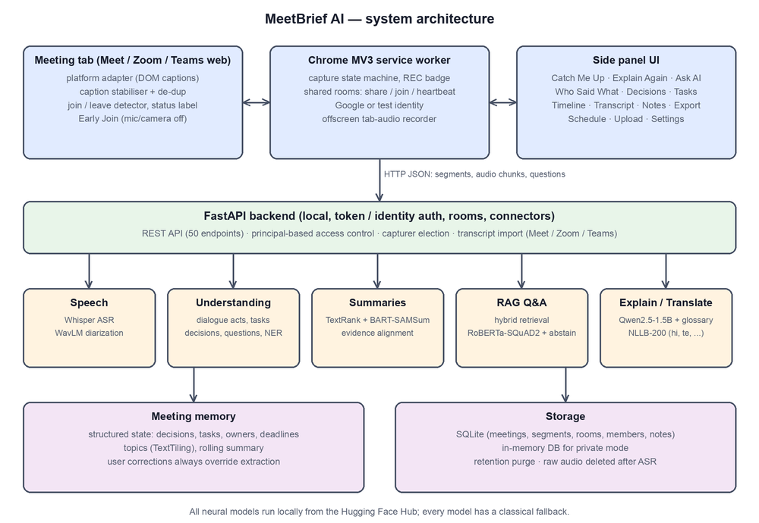
Figure 1: System architecture

Slide 7: Technology stack
On the slide
• Extension: Manifest V3 service worker, content scripts, offscreen document, side panel
• Backend: Python, FastAPI, Uvicorn, SQLite
• AI: PyTorch, Transformers, sentence-transformers, faster-whisper
• Platform adapters: Google Meet, Zoom web, Teams web

What to say
Each meeting platform has a small adapter that outputs speaker and text. Everything after that uses one common Segment format, so the NLP does not depend on the platform.

Slide 8: End-to-end workflow
On the slide
1. Detect: the meeting code is found from the link and the user joins
2. Room: the first person auto-shares; later people join automatically
3. Capture: captions and tab audio are read by the elected capturer
4. Normalise: text is cleaned, de-duplicated and stored as Segments
5. Understand: speakers, language, decisions, tasks, questions, topics
6. Serve: summary, Ask AI, Explain Again, Read in, export
7. End: when the last member leaves, the final summary is built

What to say
This is the full journey of a sentence. It is captured, cleaned, understood, and then available to every member in their own language. Results update live while the meeting continues.
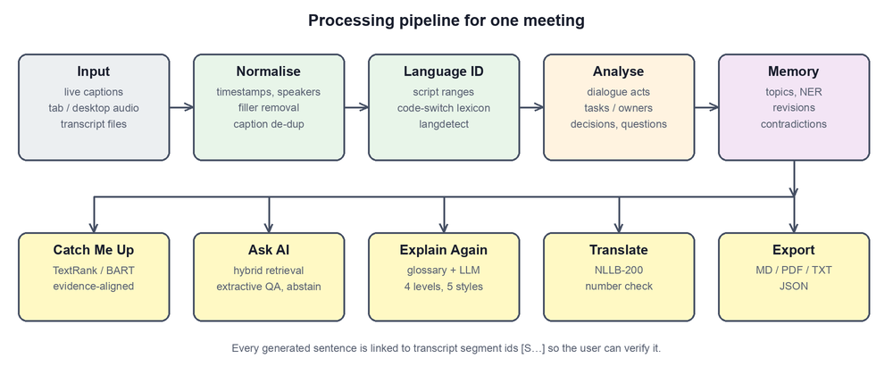
Figure 2: Processing pipeline

Slide 9: Hybrid capture: captions and tab audio
On the slide
• Captions: real names, and they include the recording person's own voice
• Tab audio: 15-second WebM/Opus chunks, transcribed by Whisper, then deleted
• Merge: an audio sentence with 60% or more content-word overlap with one caption line is dropped
• If captions stop, tab audio carries the meeting
• Voice naming: after 2 agreeing matches, "Speaker 2" gets the caption's real name

What to say
Neither source is enough alone. Captions have names but can miss speech. Tab audio works without captions but never contains your own voice, because Meet does not play you back to yourself. So we use both, and keep only what the captions missed.

Slide 10: Shared rooms for late joiners
On the slide
• A room is keyed by the meeting link; no invitations needed
• One capturer is elected through 10 s heartbeats; others stand by, so no duplicates
• If the capturer leaves or crashes, a member takes over after about 25 s
• Each member's join time defines their "What I missed"
• Idle rooms expire after 15 minutes; the last person leaving triggers the final summary

What to say
Rooms are what make this useful for late joiners. If I join 20 minutes late, the room already holds everything said, and I get a catch-up of exactly what I missed. Only one laptop records, so nothing is duplicated.
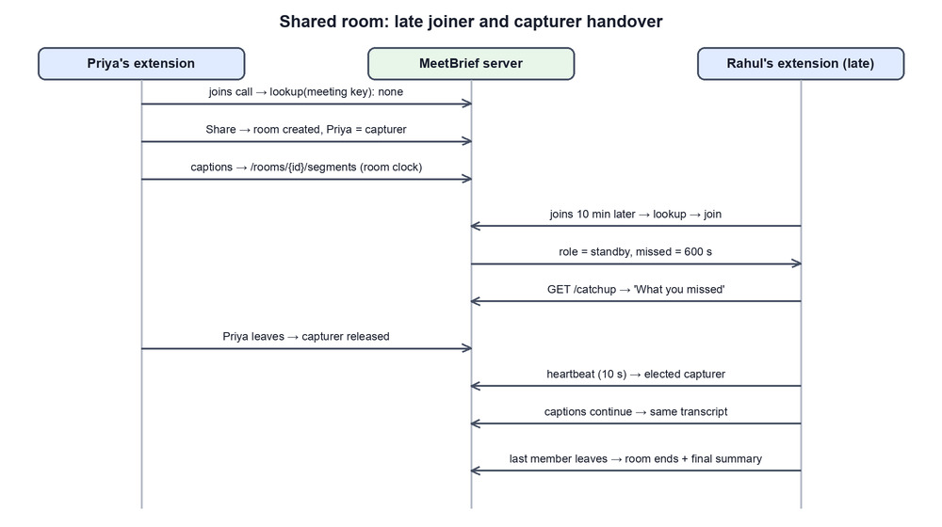
Figure 3: Shared room behaviour

Questions you may be asked
Q: Why does the user have to click the toolbar icon for tab audio?
A: Chrome only allows tab capture after the user invokes the extension on that tab: the toolbar icon, a keyboard shortcut or a context menu. A click inside the side panel does not count. We found this during live testing.
Q: Why an offscreen document?
A: A Manifest V3 service worker has no access to media streams, so recording runs in an offscreen document.
Q: How do you avoid duplicates?
A: Three ways: only one capturer per room, redrawn captions are merged, and audio lines that match a caption are dropped.
Q: What happens if the backend laptop goes off?
A: That is the single point of failure in our setup. Members cannot reach the room until it returns. Stored meetings are safe in SQLite.

Part 3: NLP Models and Methodology
Presenter: Member 3 name

Slide 11: Models used
On the slide
• Show the model table below
• All open models, downloaded once, run locally

What to say
We use nine open models, each for one job. Each can be replaced with a setting, and if one is missing that feature falls back to classical NLP such as TextRank and TF-IDF, and the interface says so.
Table 6: Models and what each does (sizes are approximate)
Task | Model | Size | Used for
Speech recognition | Whisper small (faster-whisper, int8) | 244 M | Speech to text and direct speech-to-English translation
Speaker separation | microsoft/wavlm-base-plus-sv | 95 M | Voice embeddings, online clustering (cosine threshold 0.86)
Summarization | philschmid/bart-large-cnn-samsum | 400 M | Abstractive dialogue overview
Translation | facebook/nllb-200-distilled-600M | 600 M | Summaries and transcript lines in the viewer's language
Explanation | Qwen/Qwen2.5-1.5B-Instruct | 1.5 B | Explain Again: simplify, example, steps, analogy
Question answering | deepset/roberta-base-squad2 | 125 M | Extractive answers with a "no answer" option
Embeddings | paraphrase-multilingual-MiniLM-L12-v2 | 118 M | Semantic search, topics, evidence alignment
Zero-shot NLI | MoritzLaurer/mDeBERTa-v3-base-mnli-xnli | 280 M | Optional second opinion on dialogue acts
Named entities | dslim/bert-base-NER | 110 M | People, organisations, places in memory

Slide 12: Methodology: structured meeting memory
On the slide
• Normalise: one Segment schema (text, time, speaker, language, source, flags)
• Dialogue acts: decision, proposal, task, question, other
• Extract: tasks with owner and deadline; decisions with revision history
• Link: "actually" or "instead" marks the earlier decision as superseded
• User corrections are stored separately and always win

What to say
Instead of only summarising, we build a structured memory of the meeting. Every item keeps the IDs of the transcript segments it came from. Decisions and tasks use transparent rules, because we measured rules at 93.8% accuracy against 59.4% for zero-shot NLI on dialogue acts. The neural model could not tell deciding from suggesting.

Slide 13: Summaries and grounded Q&A
On the slide
• Summary: BART writes the overview; each sentence is aligned to transcript evidence
• Unsupported sentences or unseen entities are flagged
• Q&A: hybrid sparse + dense retrieval, then a relevance gate, then SQuAD 2.0 reader
• Abstain when passages cover under half the question's content words
• "Why" questions need an explicit reason in the transcript

What to say
This is where we control hallucination. A generated sentence must be supported by the transcript or it is flagged. For questions, if the transcript does not contain the answer, MeetBrief says so instead of guessing. In our evaluation it abstained correctly on all unanswerable questions.

Slide 14: Multilingual pipeline
On the slide
• Split audio on pauses; detect language per utterance
• Guess limited to the meeting languages (default: en, te, kn, hi, ta)
• Non-English: Whisper translates speech straight to English
• Models read the English, so tasks spoken in any language reach the summary
• Each viewer picks "Read in"; lines show "Translated from Telugu" with the original below

What to say
Our key finding: Whisper small writes Telugu and Kannada text badly, but understands the speech well enough to translate it. So we ask Whisper for English directly. Telugu then came out very well, for example: Ravi will be working on the database. Hindi and Tamil keep the original text beside the English. Telugu and Kannada show only the English, because their script output is unreliable. Each viewer can read in their own language through NLLB-200.
Table 7: Five-language test (Mac text-to-speech voices, live-style 15 s chunks)
Spoken | Language label | English output example | Quality
English | Correct | Ravi will handle the database work. | Exact
Telugu | Correct | We will meet again at 10 am tomorrow. | Very good
Hindi | Correct | We will talk about budget tomorrow. If you have any questions, ask. | Good
Tamil | Correct | We will meet tomorrow morning at 4 o'clock. (should be evening) | Good, some errors
Kannada | Sometimes wrong | If you have any doubts, ask me. (often loose) | Weakest

Questions you may be asked
Q: Why rules for decisions when you have neural models?
A: We measured both. Rules scored 0.938 and zero-shot NLI 0.594 on 32 labelled sentences. NLI recalled 0 of 8 decisions. So NLI is optional and only raises confidence.
Q: Why Qwen2.5-1.5B?
A: In our 9-item benchmark it gave 8 correct explanations against 2 for Qwen 0.5B and 0 for Flan-T5-large. This is a small human-rated sample.
Q: What is abstention?
A: Refusing to answer when evidence is missing. The reader scores a no-answer option, and a relevance gate rejects weak passages.
Q: Why does Kannada perform worst?
A: Whisper small has little Kannada ability, and Kannada sounds close to Telugu to the model. A larger model would help but is too slow live on our laptop.
Q: What is diarization?
A: Working out who spoke when. We embed each segment with WavLM and cluster online. It gives labels like Speaker 1, not names.

Part 4: Results, Demo and Conclusion
Presenter: Member 4 name

Slide 15: Evaluation results
On the slide
• Show the results table below
• State clearly: small synthetic datasets

What to say
We evaluated each component. The held-out set was annotated before the first run, though two fixes were made after seeing failures, so we treat it as only partly unbiased. Action items scored F1 1.0, decisions 0.8, and Q&A was correct on all answerable questions and abstained on all unanswerable ones.
Table 8: Measured results (held-out set unless stated; with models)
Metric | Result
Decisions precision / recall / F1 | 0.667 / 1.0 / 0.8
Action items P / R / F1 | 1.0 / 1.0 / 1.0
Proposals P / R / F1 | 1.0 / 0.333 / 0.5 (weakest extraction result)
Task owner and deadline accuracy | 1.0 and 1.0
Q&A answerable / unanswerable abstained | 4/4 and 2/2 (development set: 12/12 and 5/5)
Overview ROUGE-1 / 2 / L | 0.55 / 0.367 / 0.43 (TextRank: 0.357 / 0.116 / 0.242)
Abstractive sentences supported by evidence | 4/4
Dialogue-act accuracy, 32 sentences | Rules 0.938; zero-shot NLI 0.594
ASR word error rate, 29.3 s synthetic audio | 0.0 with Whisper base (clean TTS; real speech will be worse; not re-measured on small)
Diarization, same audio | Speaker accuracy 1.0, 3 of 3 speakers found
Translation round-trip chrF | Hindi 0.835, Telugu 0.827; numbers preserved 6/6 each

Slide 16: Rules versus models
On the slide
• Overview ROUGE-1 rose from 0.357 (TextRank) to 0.55 (BART) on held-out
• Dialogue acts: rules 0.938 beat NLI 0.594
• Explanation: Qwen 1.5B 8/9 correct, Flan-T5-large 0/9
• Latency cost: summary about 0.9 ms with rules, about 5.8 s with models

What to say
Models did not win everywhere. They improved summary quality and explanations, but rules were better for dialogue acts. So we chose per task from evidence, rather than using a neural model everywhere.
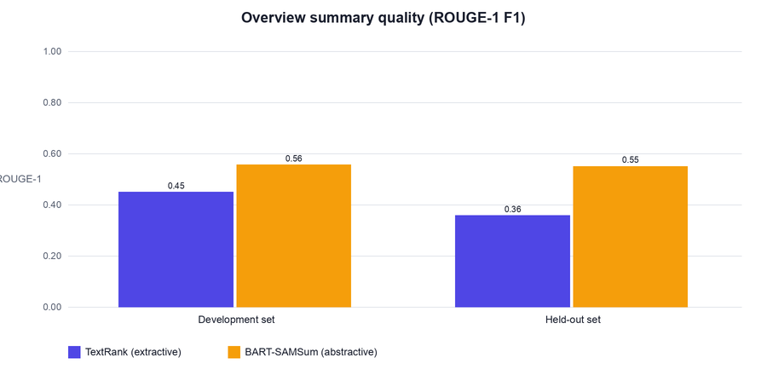
Figure 4: ROUGE scores, rules versus models

Slide 17: Testing and security
On the slide
• 88 backend tests; 42 simulator, 12 rooms and 17 Meet-page checks
• Simulations use the real background.js, including crash handover
• HawkScan: first scan 1 High, 2 Medium, 3 Low; final scans 0 open findings
• Root cause of the High: a threading race, fixed with a database lock
• Live two-laptop testing found bugs that simulation could not

What to say
Beyond unit tests, we simulated rooms with the real extension code. The security scan found a High issue, which turned out to be a database race rather than injection, and we fixed it. After later changes the scan subscription expired, so the latest changes are covered by tests, not a new scan. Live testing mattered most: it exposed Chrome's tab-capture permission rule.

Slide 18: Live demo
On the slide
• Run the steps in the demo checklist below
• Keep a recorded backup

What to say
Now we will show it working in a real Google Meet call between two laptops.

Demo checklist (practise this at least twice)
1. Before: start the backend, reload the extension, connect both laptops to the same Wi-Fi.
2. Second laptop settings: backend URL http://<first laptop IP>:8000, API token empty, name and email saved under Settings → Account.
3. Sit in separate rooms or use earphones. Unmute in Meet.
4. On the recording laptop: join first, click the MeetBrief toolbar icon once, and turn on CC.
5. Speak a decision and a task in English, for example: Ravi will finish the database by Friday.
6. The other person speaks in Telugu or Hindi. Open Transcript and show the Translated from tag.
7. Show Decisions, Action Items, then Ask AI: one answerable question, and one unanswerable one to show abstention.
8. Show What I missed on the second laptop.
9. Backup: a screen recording, and datasets/sample_transcripts/sprint_planning.txt through Upload if Wi-Fi or Meet fails.

Slide 19: Limitations and future work
On the slide
• Datasets are small and synthetic; no AMI/ICSI-scale evaluation yet
• Kannada is weak; Telugu and Kannada show English only
• With captions off, the recording person's own voice is not captured
• Meet captions follow one language at a time
• Real-speech accuracy not yet measured; Zoom and Teams experimental
• Future: microphone capture, larger or fine-tuned Indic ASR, real-meeting evaluation, hosted server

What to say
We want to be honest about limits. The biggest are small evaluation data and weak Kannada. The next step is microphone capture for the recording person, and an Indic-focused speech model.

Slide 20: Conclusion
On the slide
• A working local, multilingual meeting assistant using 9 open models
• Evidence-linked outputs and abstention reduce the risk of invented facts
• Shared rooms give each late joiner a personal catch-up
• Measured design choices: models where they help, rules where they win

What to say
To conclude: MeetBrief shows a useful and private meeting assistant is possible on a laptop with free models. Thank you. We are happy to take questions.

Questions you may be asked
Q: Your F1 of 1.0 looks too good.
A: Agreed, the dataset is small and synthetic. We say so in the report. It is a sanity check, not a general accuracy claim.
Q: Why is ROUGE not enough?
A: ROUGE measures word overlap, not truth. So we also check evidence support for generated sentences.
Q: Is it secure to run with 0.0.0.0?
A: Only on a trusted network for testing. Dev identities are for testing and must not be used on a public server. Real deployment needs Google sign-in and HTTPS.
Q: Is it legal to record a meeting?
A: MeetBrief asks for consent and shows a capture status, but participants should still be told. Audio is deleted after transcription.

Common Slide Tips and Sources

Slide tips
• Keep to 4–5 short points per slide. The What to say text is for speaking, not for the slide.
• Figures are in report/source/fig/. Screenshots of the panel make good backup slides.
• Hand over by name: "Now next member will explain..."
• Rehearse together with a timer, including the demo.

Where these facts come from
Table 9: Sources in the project
Topic | File
Measured results | research/evaluation_results.md
Explanation benchmark | research/explanation_benchmark.md
Architecture | docs/ARCHITECTURE.md
Rooms | docs/ROOMS.md
Security scan | docs/SECURITY_SCAN.md
Literature and full references | report/MeetBrief_AI_Project_Report.pdf, Chapter 2 and References

