MeetBrief AI: A Privacy-Preserving, Evidence-Grounded Multilingual Meeting Assistant with Shared Rooms for Late Joiners
G.V. Sashank  SoCSE  RV University, Bengaluru, India  USN | G.V. Aasrith  SoCSE  RV University, Bengaluru, India  USN | K. Sai Bhavesh  SoCSE  RV University, Bengaluru, India  USN | K. Vignesh  SoCSE  RV University, Bengaluru, India  USN

Abstract—Participants who join an online meeting late, lose their connection, or struggle with its language have no reliable way to recover what was said, and existing assistants are cloud services that serve only the user who started them. We present MeetBrief AI, a Chrome extension with a local backend that builds a structured, evidence-linked meeting memory from live captions, tab or desktop audio, or imported transcripts, using only open models that run on a laptop. A hybrid pipeline combines cue-phrase rules for dialogue acts, tasks, owners, deadlines and decision revisions with BART-SAMSum summarization, hybrid sparse–dense retrieval, extractive question answering that abstains on unanswerable questions, Qwen2.5-1.5B explanations and NLLB-200 translation into each viewer's language; every generated sentence is aligned to supporting transcript segments. A shared-room protocol keyed by the meeting link elects one capturer and gives every other participant a personalised catch-up of what they missed. On annotated meetings, action items reach F1 = 1.0 and held-out decisions F1 = 0.80; question answering is correct on 16/16 answerable questions with 7/7 correct abstentions; and the abstractive overview raises ROUGE-1 from 0.36 to 0.55 with all sentences evidence-supported. Rules outperform zero-shot NLI for dialogue acts (accuracy 0.94 vs 0.59). A live two-device Google Meet trial validated the protocol and exposed seven integration faults, which we report with their fixes.
Index Terms—meeting summarization, retrieval-augmented question answering, dialogue acts, speaker diarization, multilingual NLP, privacy-preserving AI, browser extensions
I. Introduction
Online meetings on Google Meet, Zoom and Microsoft Teams are where teams decide and assign work, yet the spoken content is rarely recorded in a usable form. The people who most need a recap — late joiners, participants with a poor connection, or those less fluent in the meeting language — are least able to ask for one. Commercial meeting assistants address part of this problem, but they process audio and text in the vendor's cloud, are largely English-first, and summarise only for the account that started them, so a late joiner receives nothing for the minutes they missed.
This paper describes MeetBrief AI, an open, fully local meeting assistant built as a Chrome extension and a Python backend. Its contributions are: (1) a hybrid NLP pipeline in which precise structured facts come from transparent rules with evidence and fluent text comes from small open models whose output is aligned to the transcript; (2) grounded question answering that abstains when the meeting does not contain the answer; (3) a shared-room protocol that gives each late joiner a personalised catch-up with a single elected capturer and automatic handover; (4) support for Telugu, Kannada, Hindi, Tamil and code-switched speech; and (5) a component-wise evaluation that compares rules with models and reports failures found in a live trial.
II. Related Work
A. Prior Work
Early meeting research produced the ICSI [1] and AMI [2] corpora and modelled dialogue acts with HMMs [3]. Extractive summarization of meetings [4] commonly used graph ranking such as TextRank [5], and TextTiling [6] segmented topics by lexical cohesion. Purver et al. [7] and Hsueh and Moore [8] detected action items and decisions, and the CALO assistant [9] integrated these components on a server. Pre-trained Transformers [10], [11] enabled abstractive summarizers such as BART [12], trained on dialogue data like SAMSum [13], and meeting-specific models such as HMNet [14]; QMSum [15] introduced query-based meeting summarization. Abstractive models hallucinate [16], which motivated retrieval-augmented generation [17]. SQuAD 2.0 [18] added unanswerable questions, sentence encoders [19], [20] enabled multilingual semantic search, and NLI-based zero-shot classification [21] promised label-free dialogue-act tagging. For speech, x-vectors [22] and WavLM [23] support diarization, Whisper [24] offers robust multilingual ASR, NLLB-200 [25] covers Indian languages, and small instruction-tuned models such as Qwen2.5 [26] run on laptops. No prior system we are aware of combines live multi-participant catch-up, local processing, evidence alignment with abstention, and Indian-language support.
B. Comparative Discussion
Table I summarises the surveyed work. Three patterns shape this project. Structured meeting outcomes were studied early, but with corpus-specific classifiers and server-side processing. Later work improved fluency through pre-trained models, at the cost of possible hallucination. Speech and translation models now cover Indian languages, yet they are usually evaluated alone rather than inside a meeting assistant.
TABLE I
Summary of related work
Work | Method | Gap for this project
ICSI, AMI [1], [2] | Meeting corpora | English; no live use
Stolcke et al. [3] | HMM dialogue acts | Needs labelled data
TextRank [5] | Graph ranking | Extractive only
Purver; Hsueh [7], [8] | Action items, decisions | Corpus-specific
CALO [9] | Integrated assistant | Server-side; no late joiners
BART, HMNet [12], [14] | Abstractive summaries | May hallucinate [16]
QMSum [15] | Query-based summaries | Benchmark, not a live system
RAG, SQuAD 2.0 [17], [18] | Grounding, no-answer | Not meeting-specific
Whisper, NLLB [24], [25] | Speech, translation | Not tied to meeting memory

C. Positioning
Meeting summarization, action-item detection, grounded question answering and multilingual speech recognition all exist. What we did not find is a system that combines them locally, keeps evidence for its outputs, abstains when the meeting lacks the answer, and serves each late joiner separately. That combination is the contribution.
III. Research Gaps
Gap 1—Late-joiner support. Prior assistants [9] serve a meeting as a whole, and commercial tools summarise for the account that started them. Multi-participant coordination, in which each member receives what they personally missed, is not addressed.
Gap 2—Faithfulness of meeting outputs. Abstractive models can invent content [16], and retrieval [17] reduces but does not remove this risk. Outputs need sentence-level evidence and a way to refuse.
Gap 3—Local processing. Meeting content is private, yet most assistants depend on a vendor's cloud. Whether small open models on a laptop are adequate needs measurement per task.
Gap 4—Indian-language meetings. Corpora such as AMI [2] are English. Speech and translation models [24], [25] cover Indian languages, but their behaviour inside a live meeting pipeline, including code-switching, is rarely reported.
Gap 5—Rules versus models. Zero-shot classification [21] promises label-free dialogue-act tagging, but its value against simple rules for meeting decisions is not established.
IV. Problem Statement
Meeting participants who join late, lose their connection, or are less fluent in the meeting language have no reliable way to recover what was said. Cloud assistants raise privacy concerns, serve only the person who started them, and may produce unsupported content [16]. This work therefore designs and evaluates a privacy-preserving, multilingual meeting assistant that captures meetings from captions or audio without external AI services, extracts decisions and tasks with traceable evidence, produces faithful summaries, abstains when information is absent, and gives each late joiner a personal catch-up, using only open models that run on a laptop.
V. Research Questions
Table II states the research questions and the prior work behind each.
TABLE II
Research questions and their grounding
RQ | Question | Prior work
RQ1 | Can transparent rules reliably extract decisions, tasks, owners and deadlines, compared with a neural classifier? | [3], [7], [8], [21]
RQ2 | Do abstractive summaries improve on extractive ones while staying supported by evidence? | [5], [12], [13], [16]
RQ3 | Can question answering abstain on absent answers without losing answerable ones? | [17], [18]
RQ4 | Which small open models are adequate for each task on a laptop? | [12], [21], [26]
RQ5 | Can a shared-room protocol give late joiners a catch-up with one capturer in a real call? | [9]
RQ6 | Can local models handle English, Telugu, Kannada, Hindi and Tamil meeting speech? | [24], [25]

VI. Methodology and System Design
A. Architecture
MeetBrief has four layers (Fig. 1): platform adapters in the meeting tab read captions and detect joining and leaving; a Manifest V3 service worker coordinates capture, rooms and notifications; a FastAPI backend runs the NLP pipeline and stores the meeting memory in SQLite (or in memory for private meetings); and a side panel presents catch-up, Explain Again, Ask AI, decisions, tasks, timeline, transcript and export. Captions update progressively, so a block is emitted only after 1.8 s of stability and only words beyond the longest common prefix are sent; button and icon text inside the caption region is removed. Without captions, 15 s tab-audio chunks or a desktop loopback recorder feed Whisper, and official transcripts can be imported from Meet, Zoom and Teams.
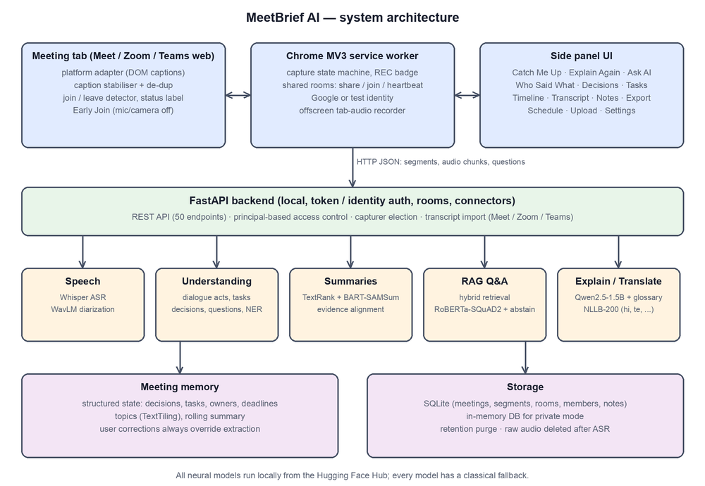
Fig. 1. MeetBrief architecture. All models run locally; each has a classical fallback.
B. Shared Rooms for Late Joiners
A meeting is identified by a key derived from its link (e.g. google_meet:abc-defg-hij, accepting both the /code and /meet/code URL forms). When a signed-in participant joins, the extension looks up the key; if no room exists it offers to share, and the sharer becomes the capturer. Others are admitted automatically (optionally by e-mail domain or approval), stand by, and receive a catch-up computed up to their own join time. Members send heartbeats every 10 s; the server keeps one live capturer, prefers a member whose captions are visible, hands over after 25 s without heartbeats, closes rooms idle for 15 min so reused links start fresh, and ends the room with a final summary when the last member leaves (Fig. 2). Only the current capturer may append transcript segments, which are placed on the room clock, avoiding both duplicates and gaps.
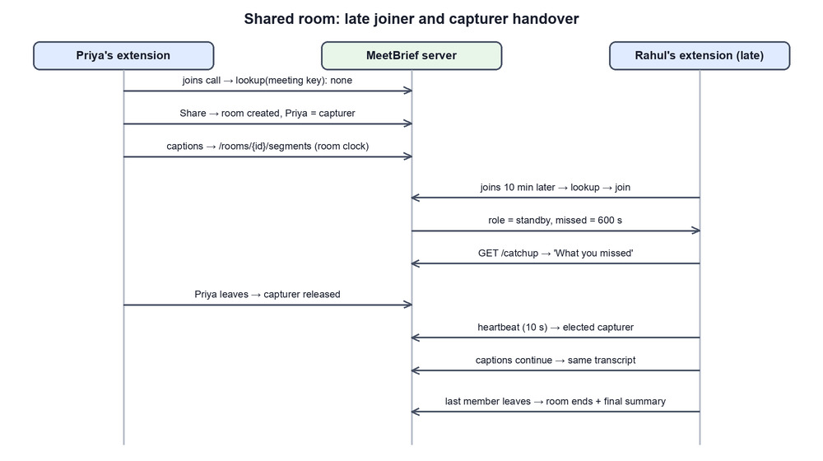
Fig. 2. Shared-room protocol: late-joiner catch-up and capturer handover.
C. Security and Privacy
Requests carry a principal: the owner's token, a server-verified Google identity, or a test identity. Access control is fail-closed; members can read only meetings of rooms they belong to (others return 404), cannot modify or delete them, and see other members' e-mail addresses only if they are the sharer. Raw audio is deleted after transcription, retention is configurable, and the web UI uses a nonce-based CSP. A DAST scan found and we fixed a database race condition, a permissive CSP and member e-mail exposure.
D. Design Decisions and Justification
• Rules for structured facts, models for fluent text. Owners and deadlines must be exact and traceable, and rules outperformed zero-shot NLI on dialogue acts (Section X-C).
• Evidence alignment for every generated sentence. This responds directly to hallucination in abstractive models [16].
• Abstention as a feature. A relevance gate and a no-answer score [18] let the system refuse instead of guessing.
• One elected capturer per room. A single writer avoids duplicate transcripts, and heartbeats allow automatic handover.
• Hybrid capture. Captions give real names and the capturing user's own voice, which tab audio never contains. Audio fills gaps: a sentence with at least 60% content-word overlap with a caption line is dropped as a duplicate.
• Direct speech-to-English translation. Whisper small writes Telugu and Kannada text unreliably but translates the speech far better, so the analysis models read that English, and each viewer reads lines tagged with their source language.
• Everything local. Each model has a classical fallback, so a missing model reduces quality but does not stop the system.

VII. NLP Pipeline
A. Normalisation and Language Identification
All inputs become segments with time, speaker, language and source. Language is identified per segment from Unicode script ranges, a lexicon of romanised Hindi and Telugu words for code-switching, and a character n-gram naive-Bayes detector.
B. Dialogue Acts and Information Extraction
Sentences are tagged as decision, proposal, task, question or other with cue-phrase rules. An optional zero-shot NLI model [21] may raise the confidence of a rule item but never adds items. Tasks receive an owner (addressee or self-commitment) and a deadline, owners are verified with BERT NER, and confirmations such as "I can do that by Friday" are merged into the request they answer. A later confirmed decision with a revision cue ("actually", "postpone") on the same subject supersedes the earlier one, preserving history. Topics are segmented with TextTiling and labelled with embedding-based MMR keywords.
C. Evidence-Aligned Summarization
TextRank selects quoted key moments; BART fine-tuned on SAMSum writes an overview, chunked hierarchically under 1,024 tokens. Each generated sentence is aligned to its most similar segment with multilingual MiniLM embeddings; sentences with low support or with entities absent from the transcript are flagged. The catch-up adds options, confirmed and superseded decisions, tasks and the current topic.
D. Question Answering with Abstention
Queries are rewritten from chat history, then scored by word TF-IDF, character 3–5-gram TF-IDF and dense embeddings. A relevance gate requires the retrieved passages to cover at least half of the question's content words, and "why" questions need an explicit reason cue. Owner, deadline and decision questions use the memory; others use RoBERTa-SQuAD2 [11], [18], accepting a span only if it beats the no-answer score. If the span comes from a superseded decision, the reader is re-run on the revision so the current state leads.
E. Explanation, Translation and Speech
Explain Again retrieves what the meeting said about a term, then explains it in five styles and four levels using a glossary or Qwen2.5-1.5B, labelled as general knowledge. NLLB-200 translates outputs while preserving citations and numbers. Whisper small transcribes audio, detects language per utterance among the configured meeting languages, and translates non-English speech directly into English for the analysis models; WavLM x-vectors are clustered online with a cosine threshold of 0.86 and persistent centroids, and generic speaker labels are never replaced by guessed names.
F. Models
Table III lists the open models used. All run locally and can be replaced through configuration.
TABLE III
Models used
Task | Model
Speech recognition | Whisper small (faster-whisper) [24]
Speaker embeddings | WavLM-Base-Plus [23]
Summarization | BART-large-CNN-SAMSum [12], [13]
Translation | NLLB-200-distilled-600M [25]
Explanation | Qwen2.5-1.5B-Instruct [26]
Question answering | RoBERTa-base-SQuAD2 [11], [18]
Embeddings | Multilingual MiniLM-L12 [19], [20]
Zero-shot NLI (optional) | mDeBERTa-v3-base-XNLI [21]
Named entities | BERT-base-NER [10]

VIII. Datasets and Benchmark
A. Datasets
We annotated a development set of synthetic meetings (product planning, database performance, Hinglish and Telugu–English discussions) and a held-out design-review meeting annotated before the first evaluation. A further 32 sentences were labelled with dialogue acts, and a 29.3 s three-voice text-to-speech meeting was used for speech.
B. Benchmark Design and What Was Realised
The rules were written against the development set, so its rule scores are optimistic. The held-out set contains 4 answerable and 2 unanswerable questions; the development set contains 12 and 5. We did not evaluate on AMI or QMSum. Two changes were made after seeing held-out failures, so that set is only partly unbiased.
IX. Experimental Design
A. Metrics
Metrics are ROUGE-1/2/L F1 [27], precision, recall and F1 with fuzzy matching, QA accuracy and abstention, WER, speaker accuracy and round-trip chrF [28].
B. Statistics
Samples are small, so we report raw counts and do not claim statistical significance.
C. Protocol
Every text component was run with rules only and with the Hugging Face models on an Apple M2 laptop (generation on the MPS GPU, other models on CPU). Speech results use Whisper base, the model in use when they were measured; the system now defaults to Whisper small, and those figures have not been re-measured.
X. Results
A. RQ1 and RQ3: Extraction and Question Answering
TABLE IV
Extraction and QA (rules vs. with models)
Metric | Dev | Held-out
Decisions P/R/F1 | 1.0/1.0/1.0 | 0.67/1.0/0.80
Proposals P/R/F1 | 1.0/1.0/1.0 | 1.0/0.33/0.50
Action items P/R/F1 | 1.0/1.0/1.0 | 1.0/1.0/1.0
Owner / deadline acc. | 1.0 / 1.0 | 1.0 / 1.0
QA answerable correct | 12/12 | 4/4
QA unanswerable abstained | 5/5 | 2/2

Table IV shows that rule-based task extraction generalises (F1 = 1.0 held-out) because task language is formulaic, while proposals are the weakest category (recall 0.33) since suggestions are phrased indirectly. Scores were identical with and without models because models only confirm rule items. QA answered every answerable question and refused every unanswerable one.
B. RQ2: Summary Quality
TABLE V
Summary quality (ROUGE F1) and faithfulness
Metric | TextRank | BART-SAMSum
Dev overview R-1/R-2/R-L | 0.449/0.327/0.425 | 0.555/0.336/0.405
Held-out overview R-1/R-2/R-L | 0.357/0.116/0.242 | 0.550/0.367/0.430
Sentences evidence-supported | – | 16/16

The abstractive overview improves ROUGE-1 by 0.10–0.19 (Table V) with every sentence supported; BART-SAMSum also beat a meeting-specific summarizer (0.554 vs 0.514 ROUGE-1). The full catch-up scores slightly lower with the abstractive overview because quoted moments dominate it.
C. RQ4: Model Selection
TABLE VI
Model selection benchmarks
Comparison | Result
Dialogue acts: rules vs zero-shot NLI | acc. 0.938 vs 0.594 (decision recall 8/8 vs 0/8)
Explanations: Flan-T5-L / Qwen 0.5B / Qwen 1.5B | 0 / 2 / 8 of 9 correct
ASR WER (Whisper base); diarization acc. | 0.0; 1.0 (3 of 3 speakers)
Round-trip chrF hi / te (numbers kept) | 0.835 / 0.827 (6/6)
Latency analyse / summary / QA (ms) | 27 / 0.9 / 4 rules; 1,071 / 5,798 / 54 models

Zero-shot NLI never recognised a decision and, when allowed to add items, lowered held-out decision precision from 0.67 to 0.50, so it is optional. Model size mattered for explanations: Flan-T5-large invented domain meanings, whereas Qwen2.5-1.5B was correct on 8 of 9 items (Table VI). Speech results on clean TTS audio and round-trip chrF are proxies; real noisy meetings and human review remain necessary.
D. RQ5: Shared Rooms in a Live Trial
Two laptops joined one Google Meet call with the backend on one of them. Both joined the same room, one captured while the other read the shared catch-up. The trials exposed seven faults missed by simulated tests: Meet served the call at a /meet/code path, so the call was never detected; caption regions contained button text; room lookup ran only at join time; Meet's idle toolbar hiding looked like leaving; a failed server check was cached and hid the user's identity; a status message was re-sent every 0.7 s; and Chrome refused tab capture requested by the service worker, so capture now follows the user's click on the extension's toolbar icon. All were fixed and covered by new browser-harness checks, and the system passes 88 automated tests. A later call on the multilingual pipeline carried Telugu-labelled speech end to end into the room's transcript as English; a full five-language live test is still pending.
E. RQ6: Multilingual Speech
We ran an informal check with text-to-speech voices, using four sentences per language in live-style 15 s chunks. English output was nearly exact. Telugu translations kept the meaning well, for example "Ravi will be working on the database." Hindi and Tamil kept their original script beside the English, with some word errors; one Tamil sentence rendered evening as morning. Kannada was weakest, with loose translations and some utterances labelled as English. Chunks took about 9 s on average and 13.6 s at worst, which keeps up with live audio. No accuracy is claimed from this check.
XI. Discussion
Models did not win everywhere. They improved summaries and explanations, but rules were better for dialogue acts, because zero-shot NLI could not separate deciding from suggesting. Choosing per task from measurement was more useful than applying a neural model throughout. Abstention held on every unanswerable question in these sets, which supports treating refusal as a core feature. Most serious faults appeared only in live calls, not in simulation, so live testing was essential for a browser-based system.
TABLE VII
Research questions: findings and status
RQ | Finding | Status
RQ1 | Rules 0.938 vs NLI 0.594; held-out action-item F1 1.0, decisions 0.80, proposal recall 0.33 | Supported on small sets
RQ2 | ROUGE-1 0.36 to 0.55 held-out; sentences evidence-supported | Supported on small sets
RQ3 | 16/16 answerable; 7/7 abstained | Supported on small sets
RQ4 | Qwen 1.5B 8 of 9 correct; laptop latency acceptable | Partly; human-rated, small sample
RQ5 | Two-laptop trial worked after seven fixes | Shown in live trials
RQ6 | Four languages usable; Kannada weak | Informal; live test pending

XII. Threats to Validity and Ethics
• Synthetic data. The evaluation sets are small and synthetic, so the numbers are a sanity check rather than evidence of performance on long, noisy, real meetings.
• Rule development. Rules were developed on the development set, and the held-out set was consulted for two fixes.
• Speech tests. Text-to-speech audio is cleaner than real meetings, and the WER was measured on Whisper base.
• Languages. Kannada speech is the weakest, Telugu and Kannada are shown in English only, and the multilingual check is informal.
• Capture limits. Without captions, the capturing user's own voice is not recorded. Caption reading depends on each platform's page structure, and the Zoom and Teams web adapters were not tested live. Speech that no participant captured cannot be recovered.
• Ethics. Recording requires the consent of all participants. MeetBrief shows a capture indicator, never names generic speakers, keeps data local, and supports deletion and private mode.

XIII. Contributions
1. A hybrid pipeline that takes structured facts from transparent rules and fluent text from evidence-aligned open models [5], [12], [16].
2. Grounded question answering that abstains when the meeting lacks the answer [17], [18].
3. A shared-room protocol with one elected capturer, automatic handover and per-member catch-up.
4. A hybrid capture and speech-translation path for English, Telugu, Kannada, Hindi and Tamil meetings [24], [25].
5. A component-wise comparison of rules and models, with faults found in live trials reported.

XIV. Scope and Conclusion
The work covers online meetings captured through a browser, with Google Meet tested live, and runs on a single laptop with members on the same network.
MeetBrief AI shows that a useful, privacy-preserving meeting assistant can be built from open models on a laptop by combining transparent rules for structured facts with evidence-constrained generation, and that late-joiner support is best solved by coordination — shared rooms with one elected capturer — rather than by more modelling. Future work includes evaluation on AMI and QMSum and on real Indian code-switched meetings, a supervised dialogue-act model to raise proposal recall, a server-side meeting bot, and quantised models for low-end devices.
References
[1] A. Janin et al., "The ICSI meeting corpus," in Proc. IEEE ICASSP, 2003, pp. I-364–I-367.
[2] J. Carletta et al., "The AMI meeting corpus: A pre-announcement," in Proc. MLMI, LNCS 3869, 2005, pp. 28–39.
[3] A. Stolcke et al., "Dialogue act modeling for automatic tagging and recognition of conversational speech," Comput. Linguist., vol. 26, no. 3, pp. 339–373, 2000.
[4] G. Murray, S. Renals, and J. Carletta, "Extractive summarization of meeting recordings," in Proc. Interspeech, 2005, pp. 593–596.
[5] R. Mihalcea and P. Tarau, "TextRank: Bringing order into texts," in Proc. EMNLP, 2004, pp. 404–411.
[6] M. A. Hearst, "TextTiling: Segmenting text into multi-paragraph subtopic passages," Comput. Linguist., vol. 23, no. 1, pp. 33–64, 1997.
[7] M. Purver et al., "Detecting and summarizing action items in multi-party dialogue," in Proc. SIGdial, 2007, pp. 18–25.
[8] P.-Y. Hsueh and J. D. Moore, "Automatic decision detection in meeting speech," in Proc. MLMI, LNCS 4892, 2007, pp. 168–179.
[9] G. Tur et al., "The CALO meeting assistant system," IEEE Trans. Audio, Speech, Lang. Process., vol. 18, no. 6, pp. 1601–1611, 2010.
[10] J. Devlin, M.-W. Chang, K. Lee, and K. Toutanova, "BERT: Pre-training of deep bidirectional transformers for language understanding," in Proc. NAACL-HLT, 2019, pp. 4171–4186.
[11] Y. Liu et al., "RoBERTa: A robustly optimized BERT pretraining approach," arXiv:1907.11692, 2019.
[12] M. Lewis et al., "BART: Denoising sequence-to-sequence pre-training for natural language generation, translation, and comprehension," in Proc. ACL, 2020, pp. 7871–7880.
[13] B. Gliwa, I. Mochol, M. Biesek, and A. Wawer, "SAMSum corpus: A human-annotated dialogue dataset for abstractive summarization," in Proc. Workshop New Frontiers in Summarization, 2019, pp. 70–79.
[14] C. Zhu, R. Xu, M. Zeng, and X. Huang, "A hierarchical network for abstractive meeting summarization with cross-domain pretraining," in Findings of EMNLP, 2020, pp. 194–203.
[15] M. Zhong et al., "QMSum: A new benchmark for query-based multi-domain meeting summarization," in Proc. NAACL-HLT, 2021, pp. 5905–5921.
[16] J. Maynez, S. Narayan, B. Bohnet, and R. McDonald, "On faithfulness and factuality in abstractive summarization," in Proc. ACL, 2020, pp. 1906–1919.
[17] P. Lewis et al., "Retrieval-augmented generation for knowledge-intensive NLP tasks," in Proc. NeurIPS, 2020, pp. 9459–9474.
[18] P. Rajpurkar, R. Jia, and P. Liang, "Know what you don't know: Unanswerable questions for SQuAD," in Proc. ACL, 2018, pp. 784–789.
[19] N. Reimers and I. Gurevych, "Sentence-BERT: Sentence embeddings using Siamese BERT-networks," in Proc. EMNLP-IJCNLP, 2019, pp. 3982–3992.
[20] N. Reimers and I. Gurevych, "Making monolingual sentence embeddings multilingual using knowledge distillation," in Proc. EMNLP, 2020, pp. 4512–4525.
[21] W. Yin, J. Hay, and D. Roth, "Benchmarking zero-shot text classification: Datasets, evaluation and entailment approach," in Proc. EMNLP-IJCNLP, 2019, pp. 3914–3923.
[22] D. Snyder, D. Garcia-Romero, G. Sell, D. Povey, and S. Khudanpur, "X-vectors: Robust DNN embeddings for speaker recognition," in Proc. IEEE ICASSP, 2018, pp. 5329–5333.
[23] S. Chen et al., "WavLM: Large-scale self-supervised pre-training for full stack speech processing," IEEE J. Sel. Topics Signal Process., vol. 16, no. 6, pp. 1505–1518, 2022.
[24] A. Radford, J. W. Kim, T. Xu, G. Brockman, C. McLeavey, and I. Sutskever, "Robust speech recognition via large-scale weak supervision," in Proc. ICML, 2023, pp. 28492–28518.
[25] NLLB Team et al., "No language left behind: Scaling human-centered machine translation," arXiv:2207.04672, 2022.
[26] Qwen Team, "Qwen2.5 technical report," arXiv:2412.15115, 2024.
[27] C.-Y. Lin, "ROUGE: A package for automatic evaluation of summaries," in Text Summarization Branches Out, 2004, pp. 74–81.
[28] M. Popović, "chrF: Character n-gram F-score for automatic MT evaluation," in Proc. WMT, 2015, pp. 392–395.

