AI PIONEERS INTERNSHIP · YUVAINTERN
Week 3 Report
Unsupervised Learning & Model Evaluation
Intern | Submitted | Code repository
Gurram Venkata Sai Aasrith | October 2026 | https://github.com/Aasrith1319/ai-pioneers-internship

1. Objective
This week covered two topics: unsupervised learning (finding structure in data without labels using K-Means, hierarchical clustering and PCA) and rigorous model evaluation (cross-validation, confusion matrix, precision, recall, F1, ROC-AUC and hyperparameter tuning). The deliverable is a clustering analysis and a model evaluation report.

Part A – Clustering

2. Dataset
I used the Wine dataset from scikit-learn: 178 wines described by 13 chemical measurements (alcohol, malic acid, flavanoids, colour intensity, proline, etc.). The wines come from three cultivars, but the labels were hidden during clustering and used only afterwards to check whether the discovered clusters are meaningful. All features were standardized first because K-Means and hierarchical clustering are based on distances.

3. Choosing the number of clusters
I ran K-Means for k = 2 to 10. The elbow plot shows the within-cluster sum of squares flattening after k = 3, and the silhouette score is highest at k = 3 (0.285). Both methods agree on three clusters.
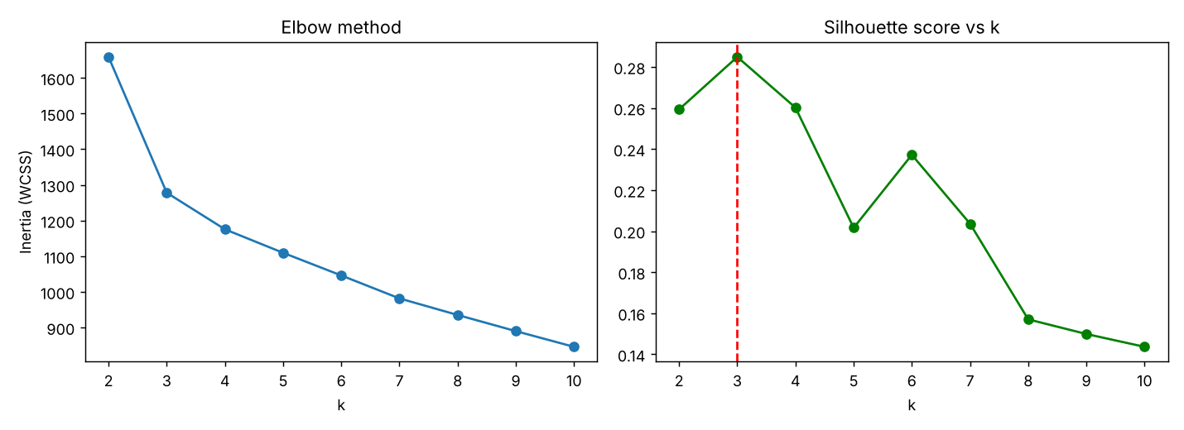
Figure 1. Elbow method and silhouette scores for k = 2…10

4. K-Means vs Hierarchical Clustering
Algorithm | Silhouette ↑ | Davies-Bouldin ↓ | Adjusted Rand vs true cultivar ↑
K-Means | 0.285 | 1.389 | 0.897
Agglomerative (Ward) | 0.277 | 1.419 | 0.79
K-Means performed better on all three measures. Its Adjusted Rand Index of 0.897 means the clusters it found without any labels almost exactly match the three real grape cultivars.
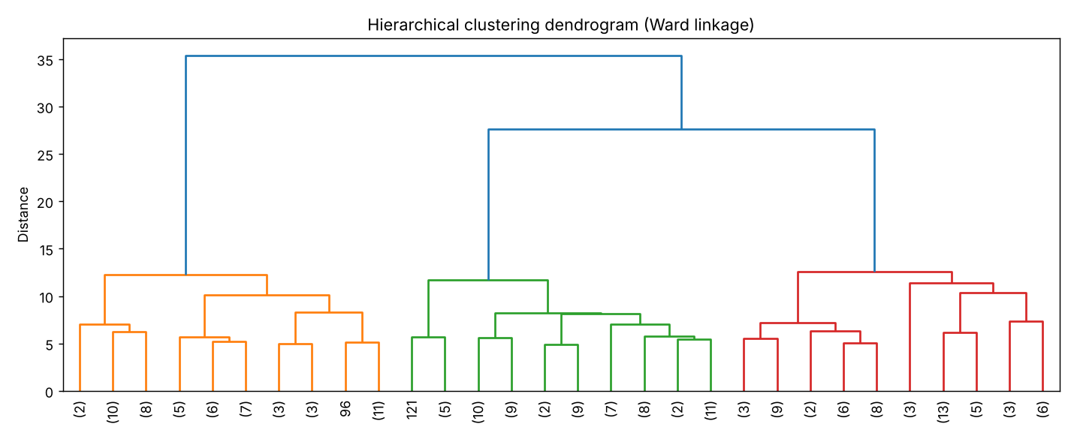
Figure 2. Dendrogram of agglomerative clustering (Ward linkage)

5. Dimensionality Reduction with PCA
PCA compresses the 13 correlated features into uncorrelated principal components. The first two components retain 55.4% of the variance, and 8 components are needed to keep 90%. Plotting the data on PC1 and PC2 shows three clearly separated groups, and the K-Means clusters line up closely with the true cultivars.
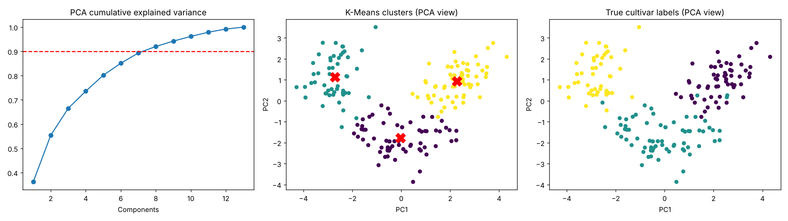
Figure 3. Cumulative explained variance; K-Means clusters vs true labels in PCA space

6. Cluster interpretation
Cluster | Alcohol | Flavanoids | Colour intensity | Proline
0 | 12.25 | 2.05 | 2.97 | 510.17
1 | 13.13 | 0.82 | 7.23 | 619.06
2 | 13.68 | 3 | 5.45 | 1100.23
Cluster 2 contains high-alcohol, high-proline, flavanoid-rich wines; cluster 1 has the most intense colour but low flavanoids; cluster 0 has lower alcohol and the lightest colour. These are distinct, interpretable wine profiles.

Part B – Model Evaluation

7. Method
Using the Titanic classification task from Week 2, I evaluated models with stratified 5-fold cross-validation on the training set (each model is trained 5 times on 4/5 of the data and tested on the remaining 1/5), reporting mean ± standard deviation. This gives a far more reliable estimate than a single train/test split. The 20% test set was kept untouched until the very end.

8. Hyperparameter tuning
GridSearchCV tested 48 Random Forest configurations (n_estimators, max_depth, min_samples_leaf, max_features) and selected the one with the best cross-validated ROC-AUC. Best parameters: n_estimators = 300, max_depth = 6, min_samples_leaf = 1, max_features = 0.5.
Model (5-fold CV) | Accuracy | Precision | Recall | F1 | ROC-AUC
Logistic Regression | 0.799 ± 0.021 | 0.757 ± 0.050 | 0.711 ± 0.039 | 0.731 ± 0.022 | 0.860 ± 0.026
Random Forest (default) | 0.808 ± 0.011 | 0.749 ± 0.021 | 0.751 ± 0.023 | 0.749 ± 0.014 | 0.877 ± 0.020
Random Forest (tuned) | 0.837 ± 0.019 | 0.811 ± 0.046 | 0.754 ± 0.032 | 0.780 ± 0.023 | 0.891 ± 0.021
Tuning improved every metric: cross-validated accuracy rose from 0.808 to 0.837 and ROC-AUC from 0.877 to 0.891 compared with the default Random Forest. Limiting tree depth reduced the overfitting seen in Week 2.

9. Results on the held-out test set
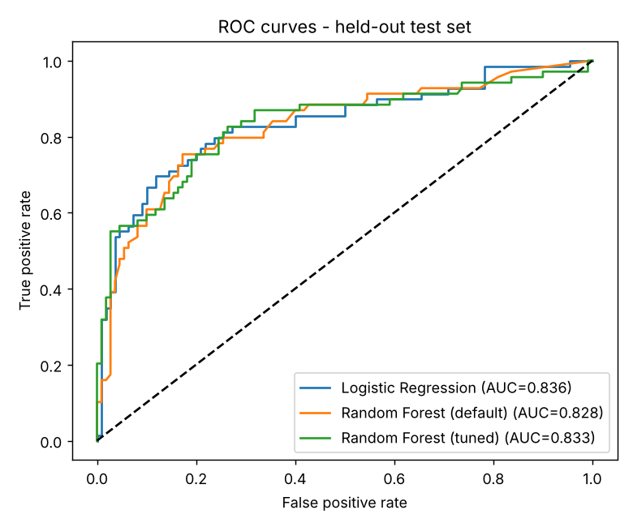
Figure 4. ROC curves on the test set
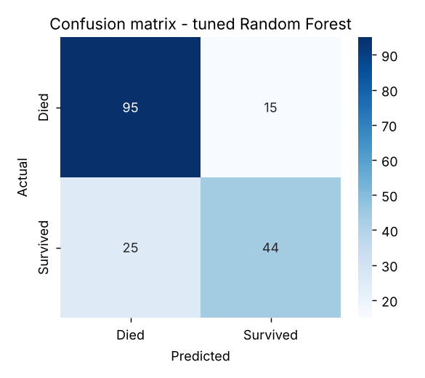
Figure 5. Confusion matrix of the tuned Random Forest
Class | Precision | Recall | F1-score | Support
Died | 0.792 | 0.864 | 0.826 | 110
Survived | 0.746 | 0.638 | 0.688 | 69
Overall accuracy |  |  | 0.777 | 179
On the 179 unseen passengers, the tuned model correctly identified 95 of 110 non-survivors and 44 of 69 survivors. Its main weakness is recall on the survived class (0.638): 25 survivors were predicted as not surviving. Test ROC-AUC values (0.83–0.84) are slightly below the cross-validation scores, which is normal variation for a single 179-row test set; this is why cross-validation is the more reliable guide for model selection.

10. Conclusions
- Elbow and silhouette methods together give a defensible choice of k; here both pointed to 3.
- Clustering found the real wine cultivars without labels (ARI 0.897), and PCA made this visible in two dimensions.
- Cross-validation with mean ± std is more trustworthy than one train/test split.
- A confusion matrix shows which errors a model makes, which accuracy alone hides.
- Hyperparameter tuning with GridSearchCV gave a measurable improvement and reduced overfitting.

11. Code
Script: week3_unsupervised/clustering_evaluation.py in https://github.com/Aasrith1319/ai-pioneers-internship.

