AI PIONEERS INTERNSHIP · YUVAINTERN
Week 1 Report
Python for Machine Learning & Data Preprocessing
Intern | Submitted | Code repository
Gurram Venkata Sai Aasrith | October 2026 | https://github.com/Aasrith1319/ai-pioneers-internship

1. Objective
The goal of this week was to learn the Python data stack used in machine learning (NumPy, Pandas, Matplotlib, Seaborn and scikit-learn) and apply it to a complete preprocessing workflow: loading data, exploring it, cleaning missing values, encoding categorical variables, normalizing numeric features and selecting useful features. The deliverable is a cleaned, model-ready version of a real dataset with every step documented and reproducible.

2. Dataset
I used the Titanic passenger dataset (891 passengers, 15 columns). The target variable is survived (1 = survived, 0 = died); the overall survival rate is 38.4%. It is a good preprocessing exercise because it mixes numeric and text columns, has substantial missing data, contains redundant and leaky columns, and has heavy outliers in the fare column.

3. Exploratory Data Analysis
Before changing anything I inspected data types, summary statistics and the share of missing values per column, then plotted survival against the most important variables.
Column | Missing values | % of rows | Decision
deck | 688 | 77.2% | Too sparse to impute – converted to a has_deck flag
age | 177 | 19.9% | Imputed with the median age of the same class and sex
embarked | 2 | 0.2% | Imputed with the most frequent port (S)
embark_town | 2 | 0.2% | Dropped – duplicate of embarked
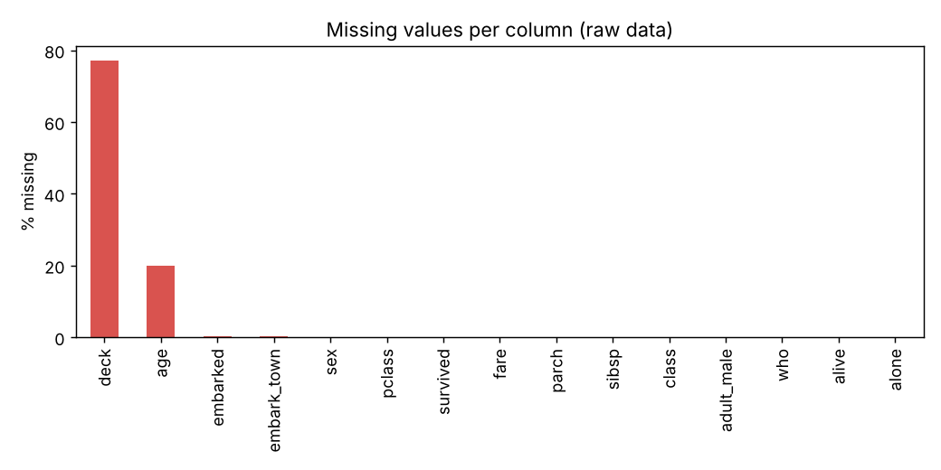
Figure 1. Percentage of missing values per column in the raw data
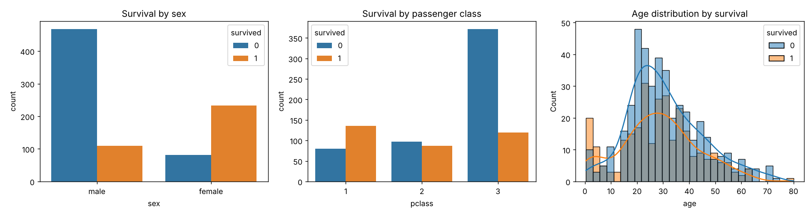
Figure 2. Survival by sex, passenger class and age
Key observations: women survived far more often than men, first-class passengers survived more often than third-class passengers, and young children had a higher survival rate than adults. These patterns guided the feature-engineering choices below.

4. Preprocessing Steps

4.1 Removing redundant and leaky columns
alive is the target written as text, so keeping it would leak the answer into the model. class, embark_town, who and adult_male only repeat information already in pclass, embarked, sex and age. All five were removed.
I also checked for duplicates: 107 rows are identical, but the dataset has no passenger name or ticket ID, so these are different people with the same attributes. They were kept, because deleting them would distort the class and sex distributions.

4.2 Handling missing values
- Age: filled with the median age of the passenger's class-and-sex group (e.g. third-class men). This is more accurate than one global median because age differs strongly between groups.
- Embarked: only two missing values, filled with the mode.
- Deck: 77% missing, so instead of guessing values I created a binary has_deck feature (cabin known or not), which itself carries survival signal. After this step the dataset had 0 missing values.

4.3 Feature engineering
- family_size = sibsp + parch + 1
- fare_per_person = fare / family_size (a family ticket's fare was shared)
- age_group (child, teen, young adult, adult, senior) – used for exploration

4.4 Outlier handling
Fare is extremely right-skewed (a few tickets above £500). Using the IQR rule, values above Q3 + 1.5×IQR were capped rather than removed, so no passengers were lost: 116 fare values and 69 fare-per-person values were capped.

4.5 Encoding categorical variables
- sex – label encoding (male = 0, female = 1), since it is binary.
- embarked – one-hot encoding with drop_first=True (embarked_Q, embarked_S), because ports have no natural order and dropping one column avoids multicollinearity.

4.6 Normalization
Age, fare, fare_per_person, sibsp, parch and family_size were standardized with StandardScaler (mean 0, standard deviation 1). This puts all features on the same scale, which is essential for distance-based models such as KNN and helps gradient-based models such as logistic regression converge.

4.7 Feature selection
I measured how much information each feature shares with survival using mutual information and also checked the correlation matrix. sibsp and alone were removed because family_size already contains them, and the age_group dummies were removed because they duplicate the continuous age column.
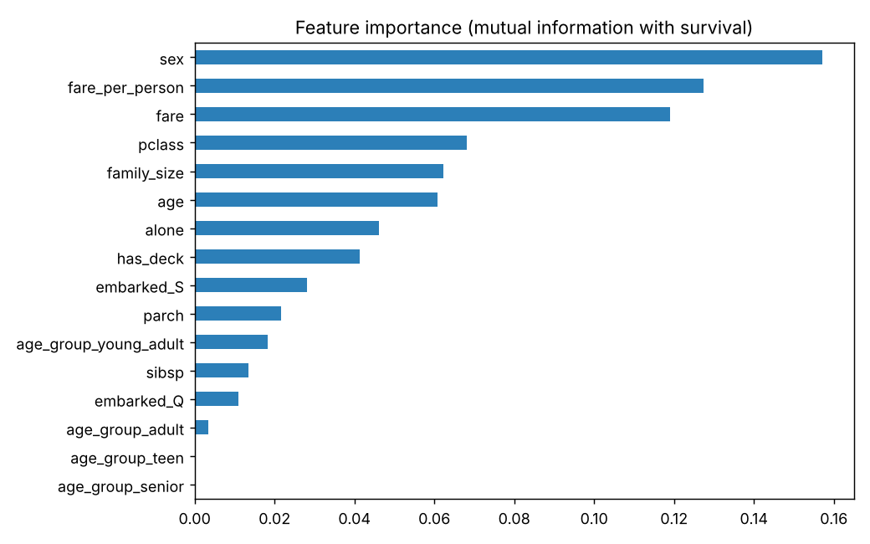
Figure 3. Mutual information between each feature and survival
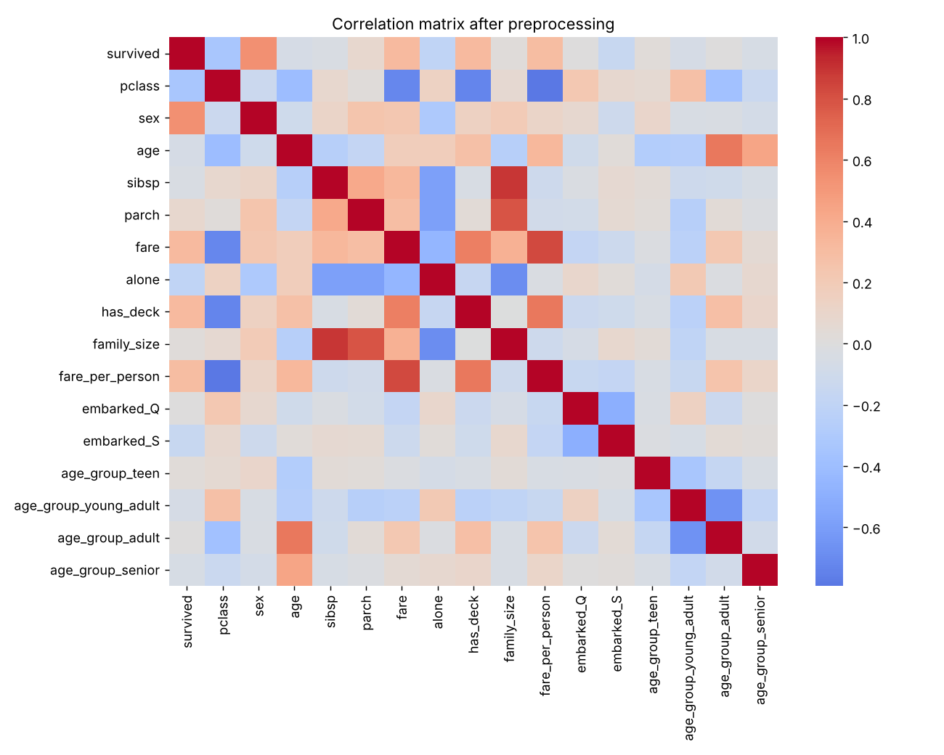
Figure 4. Correlation matrix after preprocessing

5. Result
 | Raw data | Cleaned data
Rows × columns | 891 × 15 | 891 × 11
Missing values | 869 | 0
Text columns | 7 | 0 (all numeric)
Scaled features | No | Yes (StandardScaler)
Final columns: survived, pclass, sex, age, parch, fare, has_deck, family_size, fare_per_person, embarked_Q, embarked_S. The cleaned file is saved as data/titanic_clean.csv and is used directly in Weeks 2 and 3. The strongest predictors are fare_per_person, sex, fare, pclass and has_deck.

6. Learnings
- Missing values should be handled according to why they are missing – group-wise imputation, a flag column, or dropping are each right in different situations.
- Leaky columns (like alive) can make a model look perfect while being useless, so every column must be checked for what it really represents.
- Capping outliers keeps information that deleting rows would lose.

7. Code
Script: week1_preprocessing/preprocess.py in https://github.com/Aasrith1319/ai-pioneers-internship. Run with python week1_preprocessing/preprocess.py.

