AI PIONEERS INTERNSHIP · YUVAINTERN
Week 4 Report
AI Project Deployment & Capstone
Intern | Submitted | Code repository
Gurram Venkata Sai Aasrith | October 2026 | https://github.com/Aasrith1319/ai-pioneers-internship

Key Results at a Glance
Table 1. Headline numbers
Measure | Value
Hold-out test accuracy / F1 / ROC-AUC | 0.782 / 0.693 / 0.832
5-fold CV accuracy, final pipeline | 0.83
Improvement over a naive numeric-only model | +13.2 accuracy points
Serialized model size / load time | 1.95 MB / 57 ms
API latency: 1 passenger / batch of 100 | 26.2 ms / 39.2 ms
Automated tests | 7 / 7 passing

1. Objective and Project
Build an end-to-end ML application covering preprocessing, training, testing, serialization and deployment with Flask. The project is a Titanic Survival Predictor. Given a passenger's class, sex, age, family aboard, fare, port and whether their cabin is known, it returns the probability that they survived. It reuses the preprocessing from Week 1 and the tuned model from Week 3.

2. System Architecture
- Raw input (e.g. sex = "female", embarked = "C")
- FeatureEngineer: encodes sex, creates family_size and fare_per_person, caps fare at the IQR limit learned in training (£65.63)
- ColumnTransformer: median imputation + StandardScaler (numeric), mode imputation + one-hot (embarked)
- RandomForestClassifier (n_estimators 300, max_depth 6, max_features 0.5)
- Flask API returns the class and the probability

def build_pipeline():
pre = ColumnTransformer([
('num', Pipeline([('impute', SimpleImputer(strategy='median')),
('scale', StandardScaler())]), numeric),
('cat', Pipeline([('impute', SimpleImputer(strategy='most_frequent')),
('onehot', OneHotEncoder(drop='first'))]),
['embarked']),
('pass', 'passthrough', ['pclass', 'sex', 'has_deck'])])
return Pipeline([('features', FeatureEngineer()), ('preprocess', pre),
('model', RandomForestClassifier(
n_estimators=300, max_depth=6,
max_features=0.5, random_state=42))])

Impact: Because every step lives inside one Pipeline, the imputers, scaler and fare cap are fitted only on training folds, so there is no data leakage. The API applies exactly the same transformations as training, and a passenger with a missing age is still handled (median = 28 years).

3. Impact of Each Pipeline Step (Ablation Study)
To measure what each step contributes, I added the steps one at a time and scored each version with the same stratified 5-fold cross-validation on all 891 passengers.
Table 2. Ablation study, 5-fold cross-validation
Pipeline version | CV accuracy | CV ROC-AUC
A. Numeric columns only (pclass, age, sibsp, parch, fare) | 0.698 | 0.744
B. + encode sex (label) and embarked (one-hot) | 0.817 | 0.872
C. + has_deck flag (from 77%-missing deck) | 0.814 | 0.868
D. + family_size, fare_per_person, fare capping | 0.81 | 0.865
E. + tuned hyperparameters (final pipeline) | 0.83 | 0.873
Impact: Encoding sex and embarked is by far the biggest gain: accuracy 0.698 → 0.817 (+11.9 points), because sex is the strongest predictor and a model cannot use it as text. With the untuned default forest, the extra features (has_deck, family_size, fare_per_person) slightly lowered accuracy (0.817 → 0.810): unlimited-depth trees overfit the additional columns. Tuning the hyperparameters (max_depth = 6) lets the model use those features without overfitting and gives the best result (0.830 accuracy, 0.873 ROC-AUC). Feature engineering only pays off once the model is regularized.

4. Training, Testing and Serialization

X_tr, X_te, y_tr, y_te = train_test_split(
X, y, test_size=0.2, stratify=y, random_state=42)
pipe = build_pipeline().fit(X_tr, y_tr) # evaluate on unseen 20%
pipe = build_pipeline().fit(X, y) # refit on all 891 rows
joblib.dump(pipe, 'model/titanic_pipeline.joblib')

Table 3. Hold-out test results (179 unseen passengers)
Accuracy | F1-score | ROC-AUC
0.782 | 0.693 | 0.832
The saved file is 1.95 MB and loads in 57 ms. It is loaded once when the server starts, not on every request. metadata.json records the feature list, metrics and scikit-learn version (1.9.1) so the model can be reproduced. The custom FeatureEngineer class lives in features.py so that joblib can unpickle it inside the API.

5. Prediction API
Table 4. Endpoints
Endpoint | Method | Description
/ | GET / POST | HTML form for interactive predictions
/predict | POST | JSON prediction for 1 passenger or a list of up to 1000
/health | GET | Status check and model metrics
Core of the prediction endpoint (app.py):

@app.post('/predict')
def predict():
payload = request.get_json(silent=True)
records = payload if isinstance(payload, list) else [payload]
clean, errors = validate(...) # type, category and range checks
if errors:
return jsonify(error='Validation failed', details=errors), 422
proba = MODEL.predict_proba(pd.DataFrame(clean))[:, 1]
return jsonify([{'survived': int(p >= 0.5),
'survival_probability': round(p, 4)} for p in proba])

Example request and response:

POST /predict
{"pclass": 3, "sex": "male", "age": 22, "sibsp": 1, "parch": 0,
"fare": 7.25, "embarked": "S", "has_deck": 0}

→ 200 OK {"survival_probability": 0.1196, "survived": 0}

Example of invalid input being rejected:

POST /predict {..., "pclass": 5, "sex": "robot"}

→ 422 {"error": "Validation failed", "details": {"0": [
"'pclass' must be one of [1, 2, 3]",
"'sex' must be one of ['female', 'male']"]}}

Impact: Without validation, a value such as sex = "robot" is mapped to NaN and the model silently returns a meaningless probability. Validation turns this into a clear 422 error listing every problem at once.

6. Example Predictions
Table 5. Predictions from the deployed model for five representative passengers
Passenger | Class | Fare (£) | Survival probability | Prediction
1st-class woman, 38, cabin known | 1 | 71.28 | 99.5% | Survived
1st-class man, 54, cabin known | 1 | 51.86 | 17.5% | Did not survive
2nd-class girl, 4, with parents | 2 | 26 | 86.7% | Survived
3rd-class woman, 27, with 2 kids | 3 | 11.13 | 57.3% | Survived
3rd-class man, 22, travelling alone | 3 | 7.25 | 8.3% | Did not survive
The predictions follow the historical "women and children first" pattern and the class gap. A first-class man (17.5%) is far less likely to survive than a third-class woman (57.3%). A young third-class man travelling alone has the lowest probability (8.3%). The 4-year-old girl gets 86.7% despite travelling second class, which shows the model has learned the effect of age.

7. Web Interface
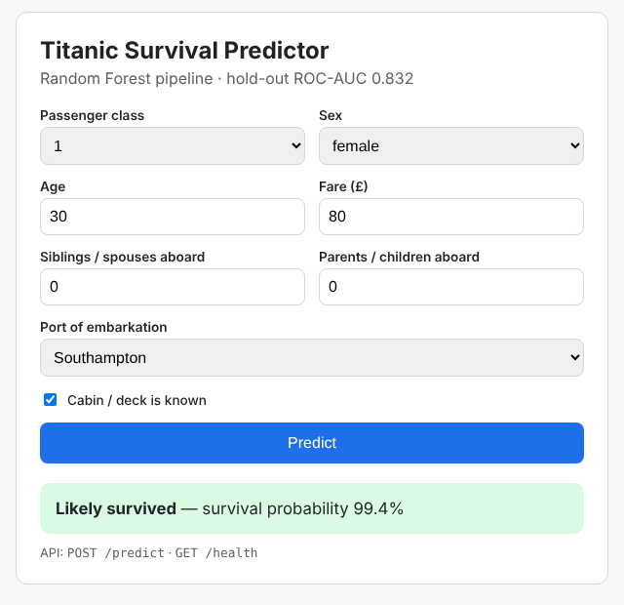
Figure 1. The deployed web app predicting for a first-class female passenger (99.4%)

8. Testing and Performance
Table 6. Automated tests (pytest), 7 / 7 passing
Test | What it checks | Result
test_health | GET /health returns 200 and status ok | Pass
test_single_prediction | Class is 0/1 and probability is in [0, 1] | Pass
test_batch_prediction_orders_risk_sensibly | 1st-class woman ranked above 3rd-class man | Pass
test_validation_errors | Two bad fields → 422 with two messages | Pass
test_missing_field | Missing age → 422 | Pass
test_non_json | Plain-text body → 400 | Pass
test_html_form | Form returns a probability | Pass
Table 7. Measured API performance (Flask test client, 50 requests)
Operation | Time
Model load at start-up | 57 ms
Single prediction (median) | 26.2 ms
Batch of 100 passengers | 39.2 ms (0.39 ms per passenger)
Impact: Batching is about 67× more efficient than sending 100 single requests, because the Random Forest scores all rows in one vectorized call.

9. How to Run

pip install -r requirements.txt
cd week4_deployment
python train.py # trains and saves the pipeline
python -m pytest -q # 7 passed
python impact_analysis.py # ablation + performance numbers in this report
python app.py # open http://127.0.0.1:5000

10. Internship Summary
Table 8. Four-week summary
Week | Work done | Key number
1 | EDA, imputation, encoding, scaling, feature selection | 869 missing values → 0; 891 × 11 clean dataset
2 | 4 classifiers + 4 regressors | Best F1 0.739 (KNN); best R² 0.453
3 | K-Means, hierarchical, PCA, CV, GridSearchCV | ARI 0.897; CV ROC-AUC 0.891
4 | Pipeline, joblib, Flask API, UI, tests | Test ROC-AUC 0.832; 26.2 ms per prediction

11. Limitations and Future Improvements
- Recall for survivors is 0.638 at the 0.5 threshold. Exposing a configurable threshold (0.3 gives recall 0.812, see Week 3) would suit use-cases where missing a survivor is costly.
- Deploy publicly (Render or Hugging Face Spaces) behind gunicorn, with a Dockerfile and CI that runs the 7 tests on every push.
- Add per-prediction explanations (SHAP) and try gradient boosting with probability calibration.

12. Code
week4_deployment/ in https://github.com/Aasrith1319/ai-pioneers-internship: train.py, features.py, app.py, templates/index.html, test_app.py, impact_analysis.py.

