AI PIONEERS INTERNSHIP · YUVAINTERN
Week 2 Report
Supervised Machine Learning Models
Intern | Submitted | Code repository
Gurram Venkata Sai Aasrith | October 2026 | https://github.com/Aasrith1319/ai-pioneers-internship

1. Objective
This week's aim was to implement the main supervised learning algorithms with scikit-learn – Linear Regression, Logistic Regression, Decision Trees, Random Forest and K-Nearest Neighbors – and to learn the full cycle of training, prediction and evaluation with appropriate metrics. The deliverable is a comparison of several trained models on held-out test data.

2. Problems and Data
Task | Dataset | Target | Models
Classification | Titanic (cleaned in Week 1), 891 rows, 10 features | survived (0/1) | Logistic Regression, Decision Tree, Random Forest, KNN
Regression | scikit-learn Diabetes, 442 patients, 10 features | Disease progression after one year | Linear Regression, Decision Tree, Random Forest, KNN
Both datasets were split 80/20 into training and test sets with a fixed random seed (42). The classification split was stratified so both sets keep the same survival rate.

3. Algorithms Used
- Linear Regression – fits a straight-line relationship between features and a continuous target by minimizing squared error.
- Logistic Regression – a linear model passed through a sigmoid function to output a probability for a binary class.
- Decision Tree – learns if/else splits on features; depth was limited (5 for classification, 4 for regression) to prevent overfitting.
- Random Forest – an ensemble of many decision trees trained on random subsets of rows and features, whose votes are averaged; more robust than a single tree.
- K-Nearest Neighbors – predicts from the k most similar training examples (k = 7 for classification, 9 for regression). Inputs were standardized because KNN depends on distances.

4. Classification Results
Metrics used: accuracy (overall correctness), precision (of passengers predicted to survive, how many did), recall (of passengers who survived, how many were found) and F1 (balance of precision and recall). F1 is the main metric because the classes are imbalanced (38% survived).
Model | Train acc. | Test acc. | Precision | Recall | F1
K-Nearest Neighbors | 0.854 | 0.799 | 0.739 | 0.739 | 0.739
Logistic Regression | 0.809 | 0.799 | 0.762 | 0.696 | 0.727
Decision Tree | 0.876 | 0.777 | 0.73 | 0.667 | 0.697
Random Forest | 0.919 | 0.777 | 0.738 | 0.652 | 0.692
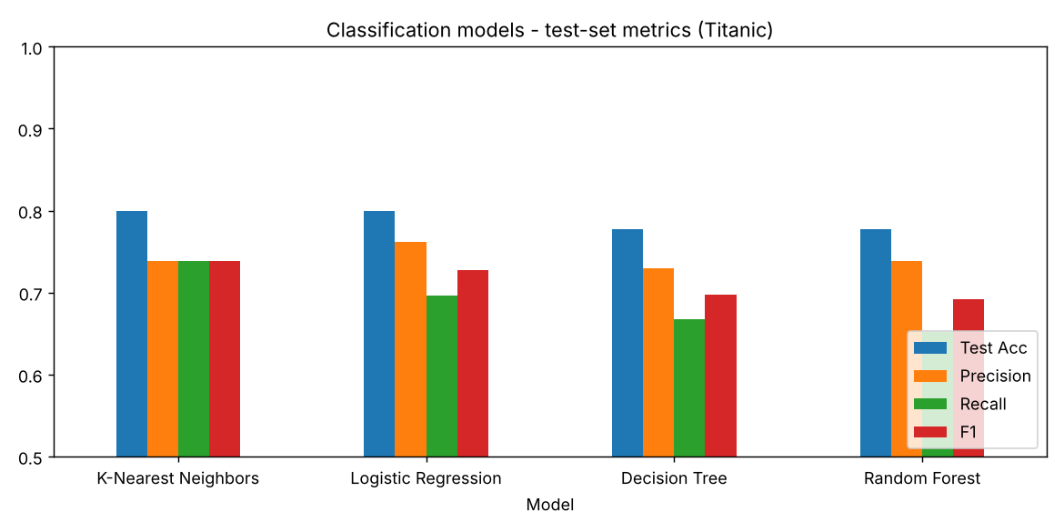
Figure 1. Test-set metrics of the four classifiers
K-Nearest Neighbors and Logistic Regression achieved the best test accuracy (0.799), with KNN slightly ahead on F1 (0.739). The tree-based models scored higher on the training data (Random Forest 0.919) than on the test data, which shows mild overfitting – they memorize some training patterns that do not generalize. This is addressed with hyperparameter tuning in Week 3.
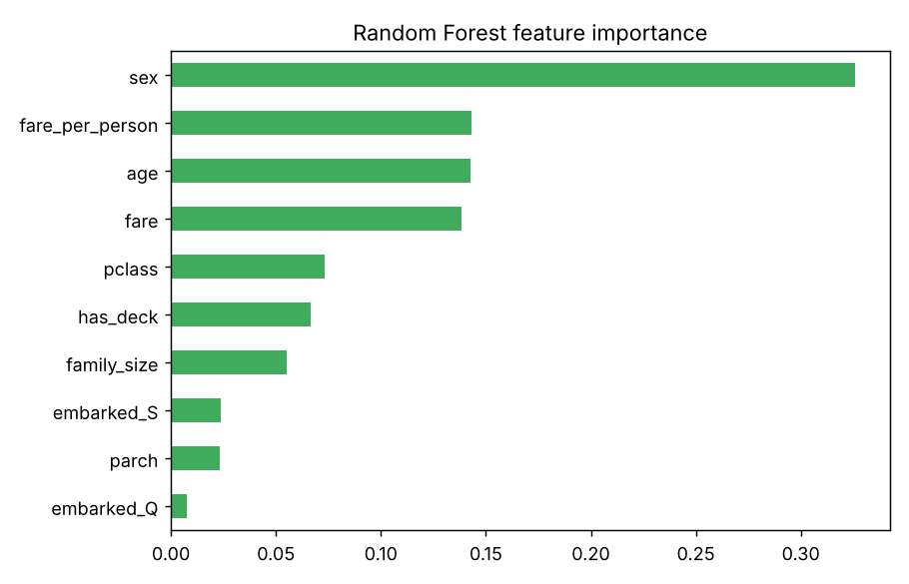
Figure 2. Random Forest feature importance
Random Forest's feature importances confirm the Week 1 analysis: sex, fare and age are the most influential features, followed by passenger class and family size.

5. Regression Results
Metrics used: MAE (average absolute error), RMSE (penalizes large errors more) and R² (share of variance in the target that the model explains; 1.0 is perfect).
Model | MAE | RMSE | R²
Linear Regression | 42.79 | 53.85 | 0.453
Random Forest | 44.06 | 54.12 | 0.447
K-Nearest Neighbors | 44.19 | 55.42 | 0.42
Decision Tree | 47.05 | 59.74 | 0.326
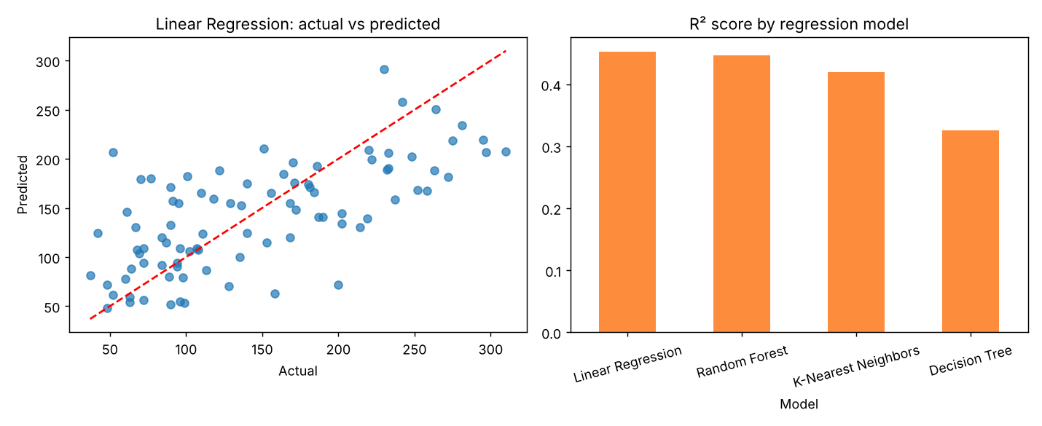
Figure 3. Actual vs predicted values for the best model, and R² by model
The simple Linear Regression model performed best (R² = 0.453, RMSE = 53.85), narrowly ahead of Random Forest. With only 442 samples and largely linear relationships, a simpler model generalizes as well as or better than complex ones. The single Decision Tree was weakest (R² = 0.326) because it predicts only a few fixed values per leaf.

6. Conclusions
- More complex models are not automatically better – on small or mostly linear datasets, simple models compete strongly.
- Comparing training and test scores is the quickest way to detect overfitting.
- Choosing the right metric matters: F1 for imbalanced classification, RMSE/R² for regression.
- Scaling is required for distance-based models like KNN.

7. Code
Script: week2_supervised/supervised_models.py in https://github.com/Aasrith1319/ai-pioneers-internship.

