AI PIONEERS INTERNSHIP · YUVAINTERN
Week 3 Report
Unsupervised Learning & Model Evaluation
Intern | Submitted | Code repository
Gurram Venkata Sai Aasrith | October 2026 | https://github.com/Aasrith1319/ai-pioneers-internship

Key Results at a Glance
Table 1. Headline numbers from this week
Measure | Value | What it means
Best number of clusters (k) | 3 | Elbow and silhouette both agree
K-Means agreement with true cultivars (ARI) | 0.897 | 172 of 178 wines grouped correctly
ARI without feature scaling | 0.371 | Scaling improved clustering by 142%
Variance kept by 2 PCA components | 55.4% | Enough to cluster with ARI 0.895
Tuned Random Forest, 5-fold CV ROC-AUC | 0.891 ± 0.021 | Up from 0.877 for the default model
Survivors found at threshold 0.3 vs 0.5 | 56 vs 44 of 69 | Recall rises from 0.638 to 0.812
Each section below follows the same structure: what I did, the code, the result, and the measured impact of that step.

Part A – Clustering

1. Dataset
Wine dataset (scikit-learn): 178 wines, 13 chemical measurements, 3 grape cultivars (59 / 71 / 48 wines). The cultivar labels were hidden during clustering and used only afterwards to check whether the clusters are meaningful.

2. Feature Scaling
The features have very different ranges. For example, proline ranges from 278 to 1680, while hue ranges from 0.48 to 1.71. Without scaling, K-Means distances are dominated almost entirely by proline.

from sklearn.preprocessing import StandardScaler
X_scaled = StandardScaler().fit_transform(wine.data) # mean 0, std 1 per feature

Table 2. Effect of scaling on K-Means (k = 3)
Input | Adjusted Rand Index vs true cultivar
Raw features | 0.371
Standardized features | 0.897
Impact: Scaling raised ARI from 0.371 to 0.897, a 142% improvement. It was the most important single step in the clustering pipeline.

3. Choosing the Number of Clusters

for k in range(2, 11):
km = KMeans(n_clusters=k, n_init=10, random_state=42).fit(X_scaled)
inertia.append(km.inertia_)
sil.append(silhouette_score(X_scaled, km.labels_))

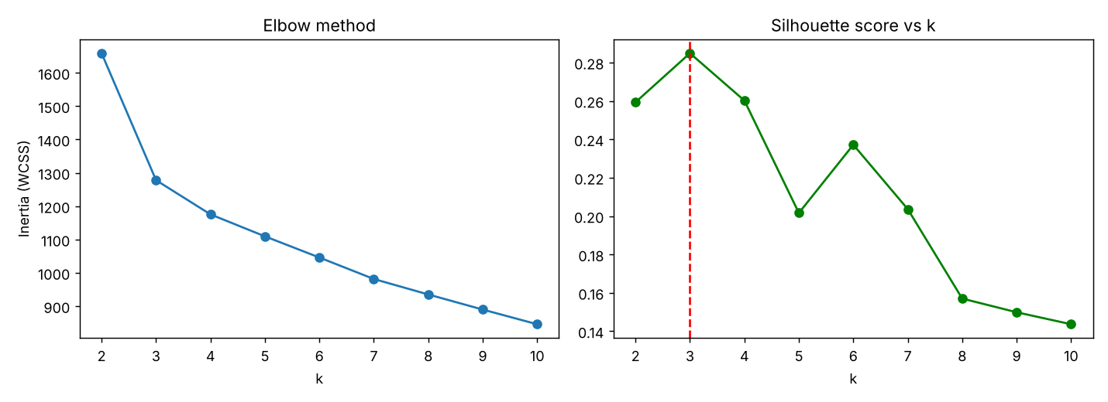
Figure 1. Elbow method (left) and silhouette score (right) for k = 2…10
Table 3. Silhouette score for each k
k | 2 | 3 | 4 | 5 | 6 | 7
Silhouette | 0.259 | 0.285 | 0.26 | 0.202 | 0.237 | 0.204
Inertia | 1658.8 | 1277.9 | 1175.4 | 1109.5 | 1046 | 981.6
Impact: Inertia falls by 381 from k = 2 to k = 3 but only by 103 from k = 3 to k = 4 (the "elbow"), and the silhouette peaks at k = 3 (0.285). Picking k = 4 instead would lower the silhouette to 0.260 and split a real cultivar in two.

4. K-Means vs Hierarchical Clustering

km = KMeans(n_clusters=3, n_init=10, random_state=42).fit(X_scaled)
agg = AgglomerativeClustering(n_clusters=3, linkage='ward').fit(X_scaled)

Table 4. Clustering quality (↑ higher is better, ↓ lower is better)
Algorithm | Silhouette ↑ | Davies-Bouldin ↓ | ARI vs cultivar ↑
K-Means | 0.285 | 1.389 | 0.897
Agglomerative (Ward) | 0.277 | 1.419 | 0.79
Table 5. Effect of the linkage method in hierarchical clustering
Linkage | ARI | Cluster sizes
ward | 0.79 | 64 / 58 / 56
complete | 0.577 | 69 / 58 / 51
average | -0.005 | 174 / 3 / 1
single | -0.007 | 174 / 3 / 1
Impact: The linkage choice decides whether hierarchical clustering works at all. Ward gives balanced clusters (64/58/56, ARI 0.79). Average and single linkage put 174 of 178 wines in one cluster (ARI ≈ 0), because they chain nearby points together.
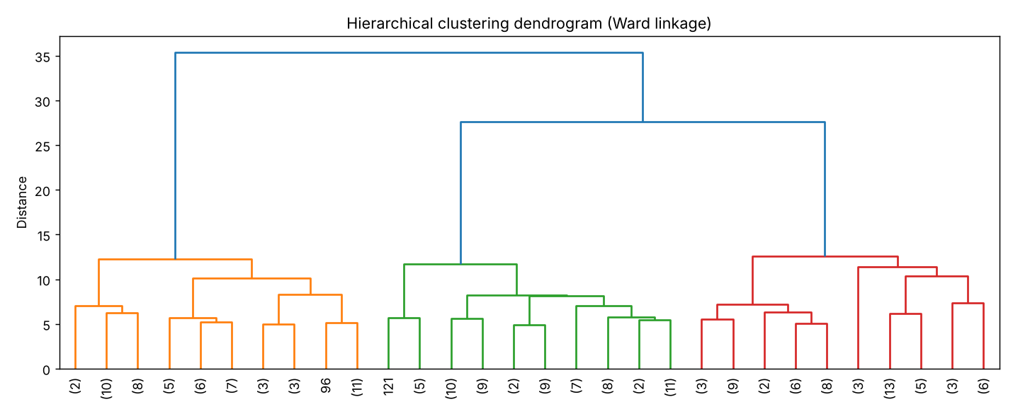
Figure 2. Dendrogram of agglomerative clustering (Ward linkage)

5. Dimensionality Reduction with PCA

pca = PCA().fit(X_scaled)
cumulative = np.cumsum(pca.explained_variance_ratio_) # 0.362, 0.554, 0.665, ...
Z = PCA(n_components=2).fit_transform(X_scaled)

Table 6. K-Means on PCA-reduced data
PCA components kept | ARI vs cultivar | Silhouette
2 | 0.895 | 0.561
5 | 0.897 | 0.369
8 | 0.897 | 0.315
13 (no reduction) | 0.897 | 0.285
Impact: Reducing 13 features to 2 components (85% fewer dimensions) kept clustering accuracy almost unchanged (ARI 0.895 vs 0.897) and doubled the silhouette (0.285 → 0.561), because PCA removes noisy directions. 8 components are needed to keep 90% of the variance.
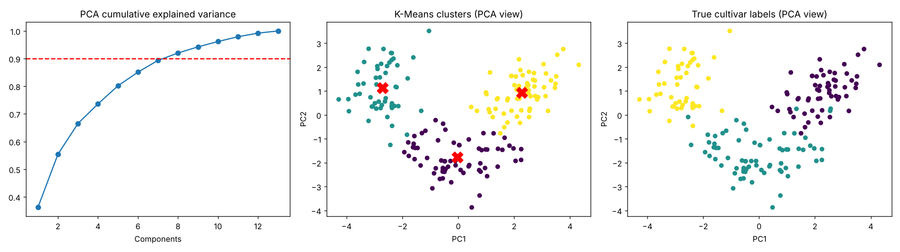
Figure 3. Cumulative explained variance; K-Means clusters vs true cultivars in PCA space

6. Interpreting the Clusters
Table 7. Cluster vs true cultivar (counts of wines)
 | Cultivar 0 | Cultivar 1 | Cultivar 2
Cluster 0 | 0 | 65 | 0
Cluster 1 | 0 | 3 | 48
Cluster 2 | 59 | 3 | 0
Table 8. A representative wine from each cluster (the wine closest to the centroid)
Cluster | Wine # | Alcohol % | Flavanoids | Colour intensity | Proline
0 | 106 | 12.25 | 2.03 | 3.4 | 510
1 | 148 | 13.32 | 0.76 | 8.42 | 650
2 | 48 | 14.1 | 2.92 | 6.2 | 1060
Concrete example: wine #48 (cluster 2) has 14.1% alcohol and proline 1060, which is typical of the premium, full-bodied cultivar. Wine #148 (cluster 1) has very low flavanoids (0.76) but intense colour (8.42). Wine #106 (cluster 0) is the light, low-alcohol style (12.25%, colour 3.4).
Impact: Only 6 of 178 wines (3.4%) were placed in a cluster that does not match their cultivar, all of them cultivar-1 wines whose chemistry overlaps the other two groups.

Part B – Model Evaluation

7. Why Cross-Validation
Titanic survival task from Week 2 (891 passengers). The 20% test set (179 passengers) was held out and touched only once at the end.

cv = StratifiedKFold(n_splits=5, shuffle=True, random_state=42)
scores = cross_validate(model, X_train, y_train, cv=cv,
scoring=['accuracy','precision','recall','f1','roc_auc'])

Table 9. Same model, five different random train/test splits
Split seed | 0 | 1 | 2 | 3 | 4
Test accuracy | 0.81 | 0.838 | 0.821 | 0.872 | 0.832
Impact: A single split could report anything from 0.81 to 0.872 for the same model, a 6.2-point swing caused only by luck. 5-fold CV gives 0.832 ± 0.023, a stable estimate that is safe to compare models with.

8. Hyperparameter Tuning

grid = GridSearchCV(RandomForestClassifier(random_state=42),
{'n_estimators': [100, 300], 'max_depth': [4, 6, 8, None],
'min_samples_leaf': [1, 3, 5], 'max_features': ['sqrt', 0.5]},
cv=cv, scoring='roc_auc', n_jobs=-1).fit(X_train, y_train)
grid.best_params_
# {'max_depth': 6, 'max_features': 0.5, 'min_samples_leaf': 1, 'n_estimators': 300}

Table 10. Effect of max_depth (the most influential hyperparameter)
max_depth | Train accuracy | CV accuracy | Overfitting gap
2 | 0.807 | 0.787 | 0.02
4 | 0.873 | 0.817 | 0.055
6 | 0.908 | 0.837 | 0.071
8 | 0.945 | 0.83 | 0.115
12 | 0.98 | 0.816 | 0.164
None | 0.987 | 0.813 | 0.174
Table 11. 5-fold cross-validation, mean ± standard deviation
Model | Accuracy | Precision | Recall | F1 | ROC-AUC
Logistic Regression | 0.799 ± 0.021 | 0.757 ± 0.050 | 0.711 ± 0.039 | 0.731 ± 0.022 | 0.860 ± 0.026
Random Forest (default) | 0.808 ± 0.011 | 0.749 ± 0.021 | 0.751 ± 0.023 | 0.749 ± 0.014 | 0.877 ± 0.020
Random Forest (tuned) | 0.837 ± 0.019 | 0.811 ± 0.046 | 0.754 ± 0.032 | 0.780 ± 0.023 | 0.891 ± 0.021
Impact: Unlimited trees memorize the training data (train 0.987, CV 0.813, gap 0.174). Limiting depth to 6 cut the gap to 0.071 and raised CV accuracy to 0.837. Overall, tuning improved CV accuracy from 0.808 to 0.837 (+2.9 points) and F1 from 0.749 to 0.780 across 48 configurations tested.

9. Confusion Matrix, Precision, Recall and ROC-AUC
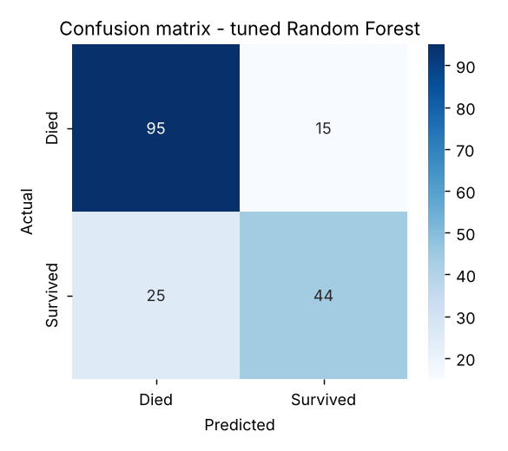
Figure 4. Confusion matrix of the tuned Random Forest on the 179-passenger test set
Table 12. Per-class report on the test set
Class | Precision | Recall | F1-score | Support
Died | 0.792 | 0.864 | 0.826 | 110
Survived | 0.746 | 0.638 | 0.688 | 69
Accuracy |  |  | 0.777 | 179
Reading the matrix: of 110 passengers who died, 95 were predicted correctly and 15 were wrongly predicted to survive (false positives). Of 69 survivors, 44 were found and 25 were missed (false negatives). Precision for "Survived" = 44 / (44 + 15) = 0.746; recall = 44 / (44 + 25) = 0.638.
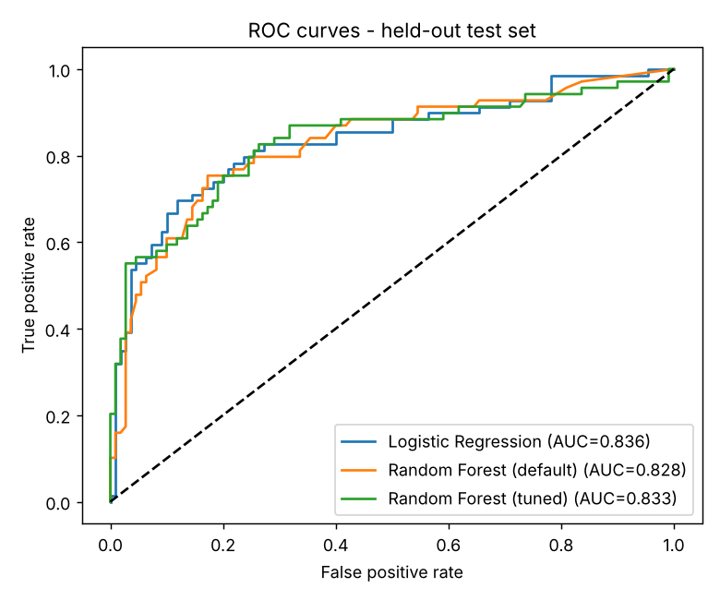
Figure 5. ROC curves on the held-out test set
Table 13. Effect of the decision threshold on the tuned model
Threshold | Precision | Recall | F1 | Survivors found
0.3 | 0.667 | 0.812 | 0.732 | 56 / 69
0.4 | 0.708 | 0.739 | 0.723 | 51 / 69
0.5 | 0.746 | 0.638 | 0.688 | 44 / 69
0.6 | 0.784 | 0.58 | 0.667 | 40 / 69
Impact: The default 0.5 threshold misses 25 survivors. Lowering it to 0.3 finds 12 more (recall 0.638 → 0.812) and raises F1 from 0.688 to 0.732, at the cost of precision (0.746 → 0.667). ROC-AUC (0.833) measures ranking quality across all thresholds, which is why it was used as the tuning metric.

10. Conclusions
Table 14. What each step contributed
Step | Measured impact
Feature scaling | ARI 0.371 → 0.897
Elbow + silhouette for k | Correct k = 3 (silhouette 0.285)
Ward linkage | ARI 0.79 vs ≈ 0 for single/average
PCA to 2 components | Silhouette 0.285 → 0.561, ARI unchanged
5-fold cross-validation | Removed a 6.2-point split-to-split swing
GridSearchCV tuning | CV accuracy 0.808 → 0.837, overfit gap 0.174 → 0.071
Threshold 0.5 → 0.3 | Recall 0.638 → 0.812

11. Code
week3_unsupervised/clustering_evaluation.py (main analysis) and week3_unsupervised/impact_analysis.py (impact experiments) in https://github.com/Aasrith1319/ai-pioneers-internship.

