HR Portal Pro

User interface: screens and flows
Every screen of the portal, in the order a real day would use them. 52 screenshots across 9 flows.
The screenshots were taken from the running application with its demo data. They follow one story from start to finish: the Super Admin onboards a new hire, an employee applies for leave and uploads a document, another employee resigns, the manager and HR approve, HR runs payroll, and the employee sees the results.
Demo sign-ins used
Sign-in | Role | What they do in this document
admin@hrportal.local | Super Admin | Departments, holidays, onboarding, user accounts
ananya.iyer@hrportal.local | HR Admin | Final leave approval, attendance, payroll, documents, resignations, reports, audit
priya.sharma@hrportal.local | Manager | Team view and approving Rahul's leave
rahul.verma@hrportal.local | Employee | Attendance, leave, documents, payslips, notifications
sneha.patel@hrportal.local | Employee | Resignation
meera.nair@hrportal.local | Employee (new hire) | First sign-in, password change, profile
Contents
Flow | Signed in as | Screens | No.
1. Signing in | Everyone | Sign-in page · Wrong password | 1–2
2. Super Admin | admin@hrportal.local | Super Admin dashboard · Departments · Department added · Holidays · Employee directory · Onboard new hire: the form · Onboarded: temporary password · Users (sign-ins) | 3–10
3. New hire: first sign-in | meera.nair@hrportal.local (temporary password) | Must change the password · Complete your profile · First dashboard | 11–13
4. Employee | rahul.verma@hrportal.local | Employee dashboard · My profile · Attendance before check-in · Checked in · Checked out · Apply for leave · My leave: waiting for manager · My documents · Document uploaded | 14–22
5. Employee: resignation | sneha.patel@hrportal.local | Resignation form · Resignation submitted | 23–24
6. Manager | priya.sharma@hrportal.local | Manager dashboard · My team · Team approvals · Approved: sent on to HR · Team attendance | 25–29
7. HR Admin | ananya.iyer@hrportal.local | HR Admin dashboard · HR approvals · Leave approved by HR · All leave · Attendance for a day · Attendance corrected · Payroll runs · Draft payroll · Payroll finalized · Documents to verify · Document verified · Employee profile (HR view) · Letter shared · Resignations · Resignation accepted · Reports · Offboard form · Audit log | 30–47
8. Employee: results | rahul.verma@hrportal.local | Leave approved · My payslips · Documents after HR · Notifications | 48–51
9. Super Admin: password reset | admin@hrportal.local | Password reset | 52–52

1. Signing in
Signed in as: Everyone
Every user, whatever their role, starts on the same sign-in page.
The flow, screen by screen
- Sign-in page: Everyone signs in here with their work email and password.
- Wrong password: A wrong password shows an error. After five wrong tries the account is locked.

1. Sign-in page Signing in
Everyone signs in here with their work email and password.
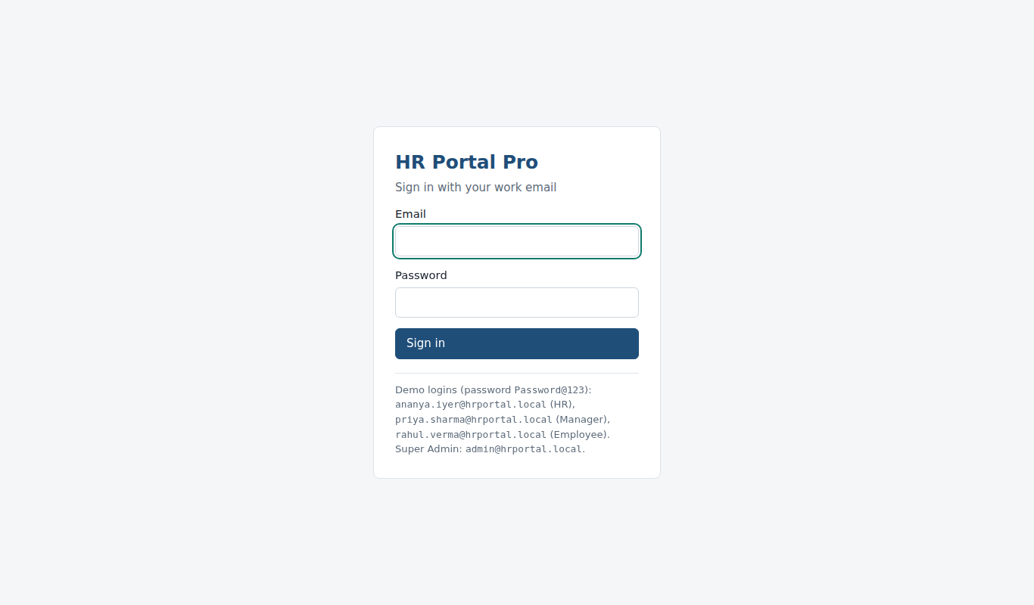

2. Wrong password Signing in
A wrong password shows an error. After five wrong tries the account is locked.
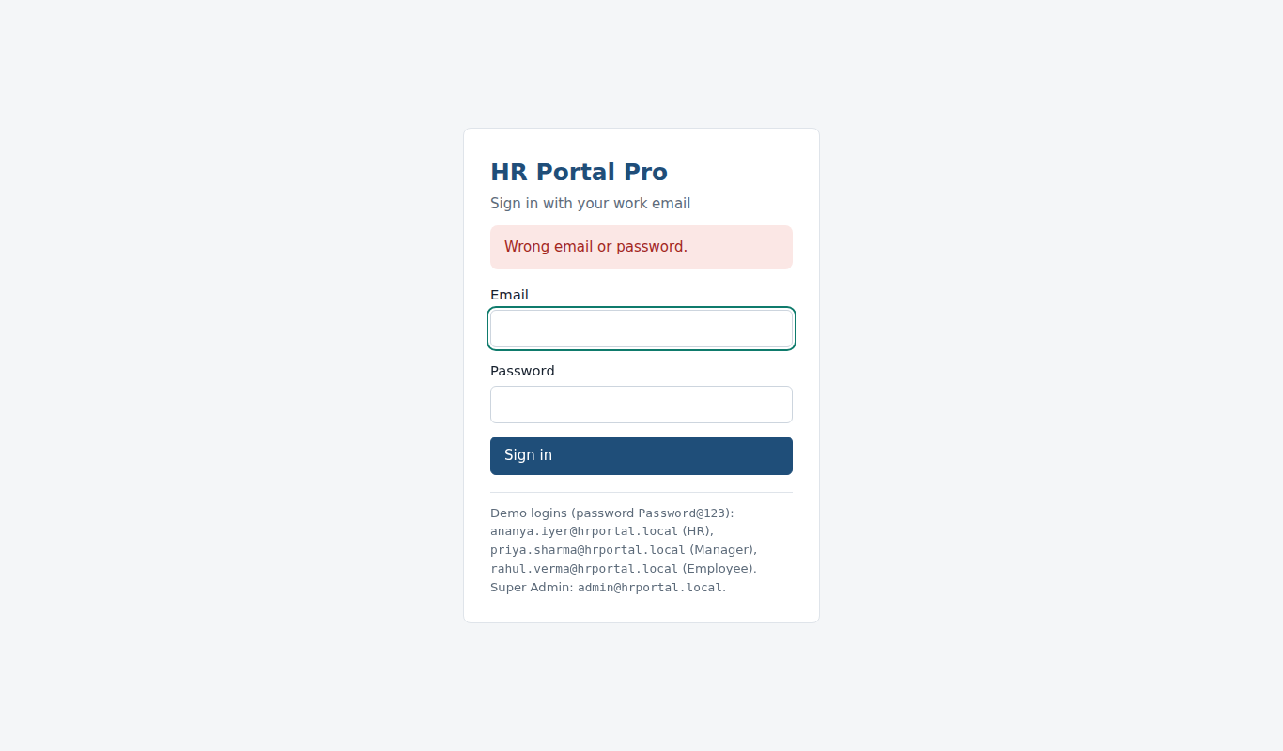

2. Super Admin
Signed in as: admin@hrportal.local
The Super Admin sets up the company (departments and holidays), onboards a new hire, Meera Nair, and looks after user accounts.
The flow, screen by screen
- Super Admin dashboard: Company totals: HR approvals waiting, active employees and who is out of office today.
- Departments: The list of departments with their locations.
- Department added: Typed a name and location, clicked Add department: "Quality Assurance" now appears in the list.
- Holidays: Public holidays for the year. Picked a date, typed the name and clicked Add holiday.
- Employee directory: All employees with search and filters. Onboard new hire starts the joining flow.
- Onboard new hire: the form: Name, work email, code, job title, department, manager, salary, joining date and access level.
- Onboarded: temporary password: The login is created. The temporary password is shown once, to share with the new hire.
- Users (sign-ins): Every login with its role, status and last sign-in. Change role, unlock, disable or reset a password here.

3. Super Admin dashboard Super Admin
Company totals: HR approvals waiting, active employees and who is out of office today.
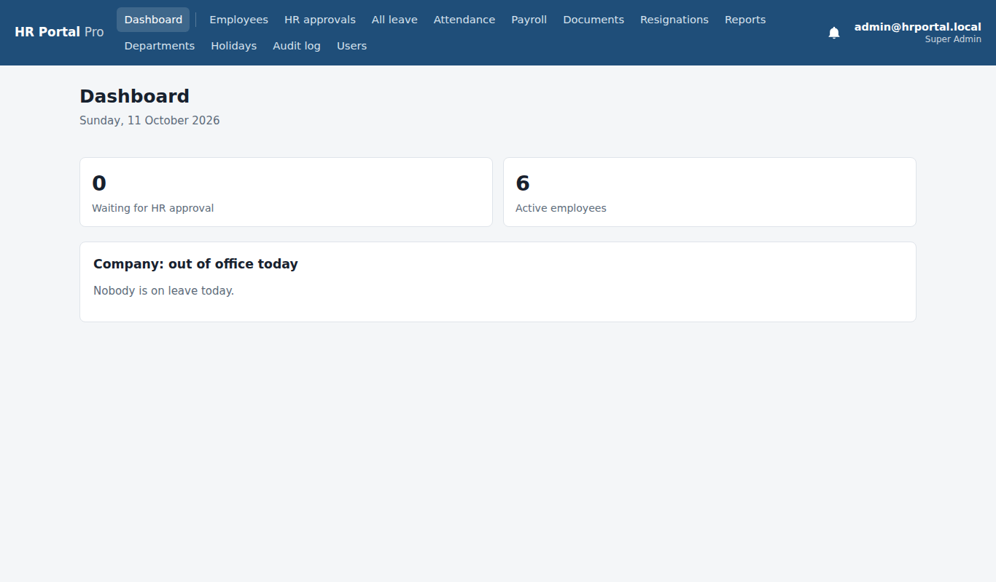

4. Departments Super Admin
The list of departments with their locations.
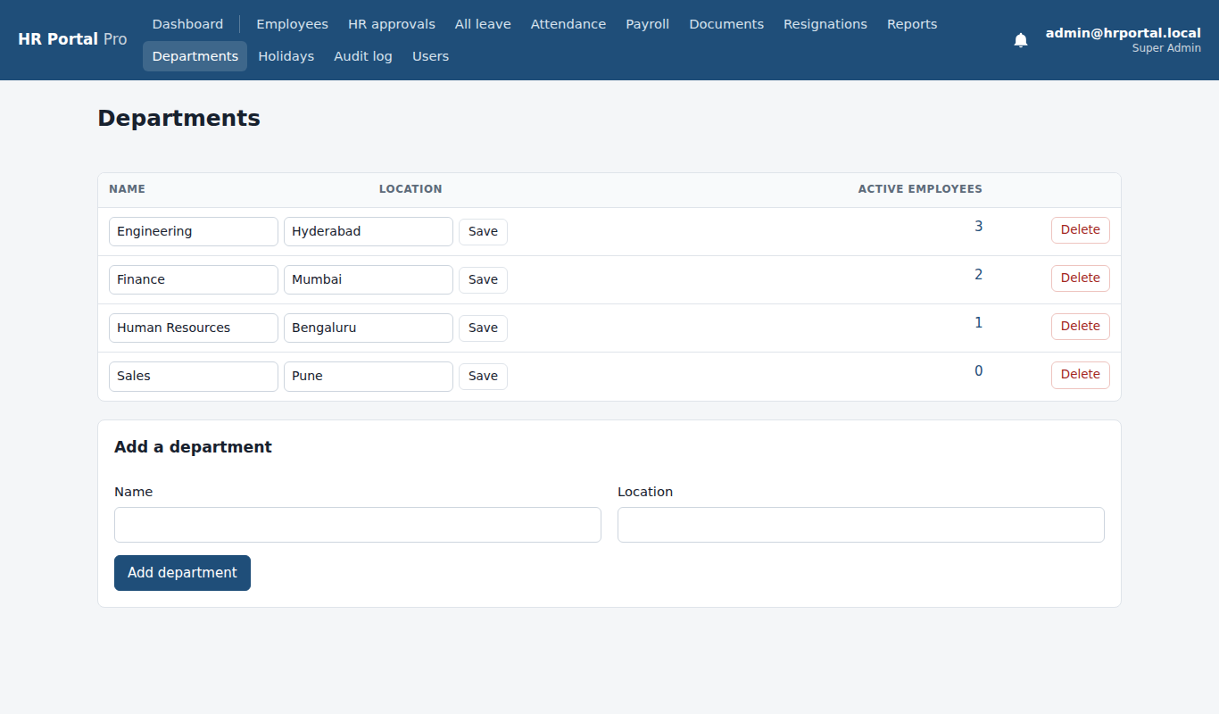

5. Department added Super Admin
Typed a name and location, clicked Add department: "Quality Assurance" now appears in the list.
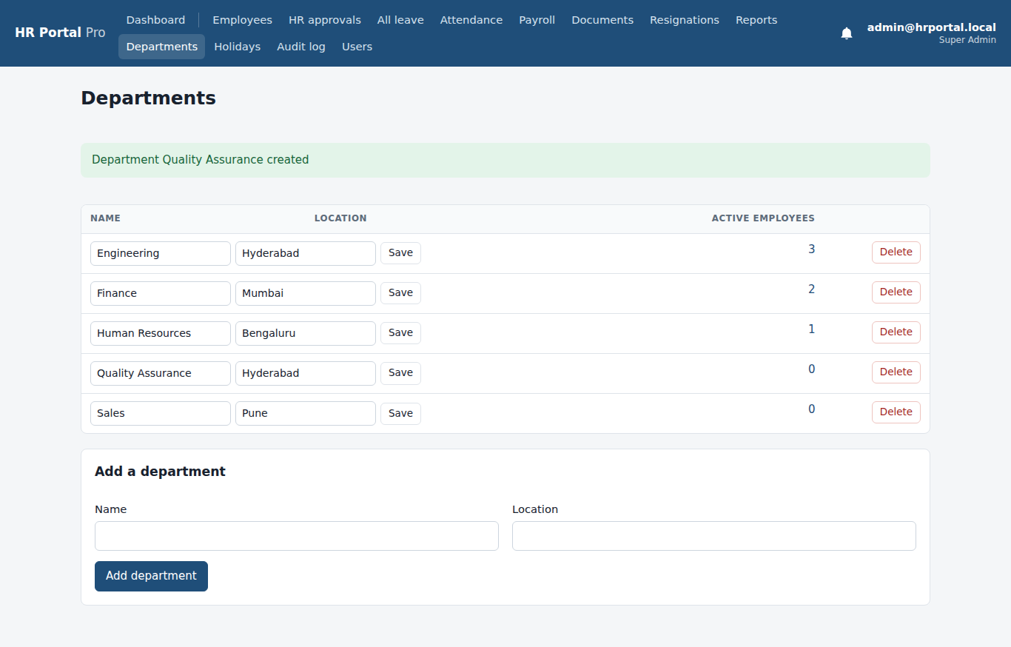

6. Holidays Super Admin
Public holidays for the year. Picked a date, typed the name and clicked Add holiday.
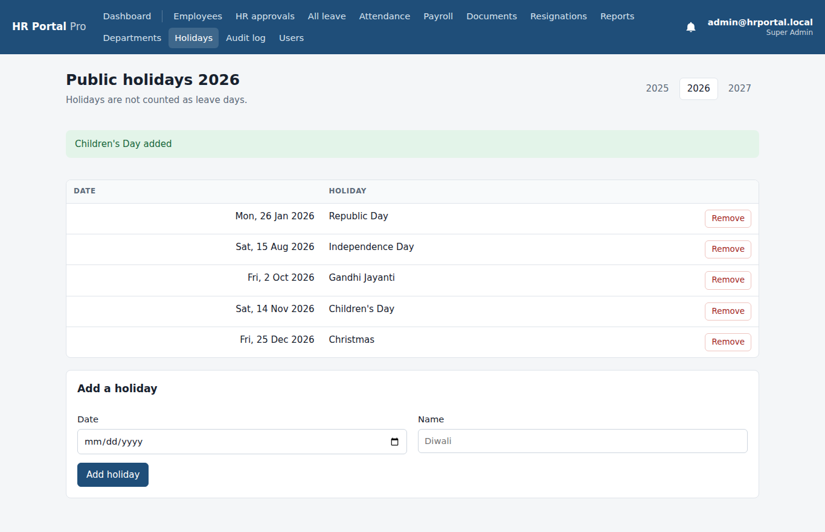

7. Employee directory Super Admin
All employees with search and filters. Onboard new hire starts the joining flow.
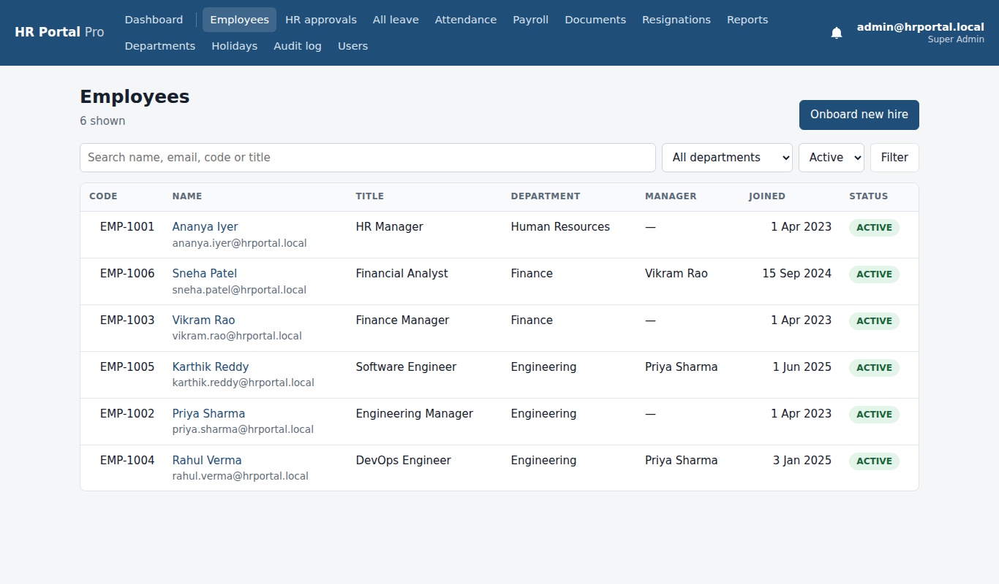

8. Onboard new hire: the form Super Admin
Name, work email, code, job title, department, manager, salary, joining date and access level.
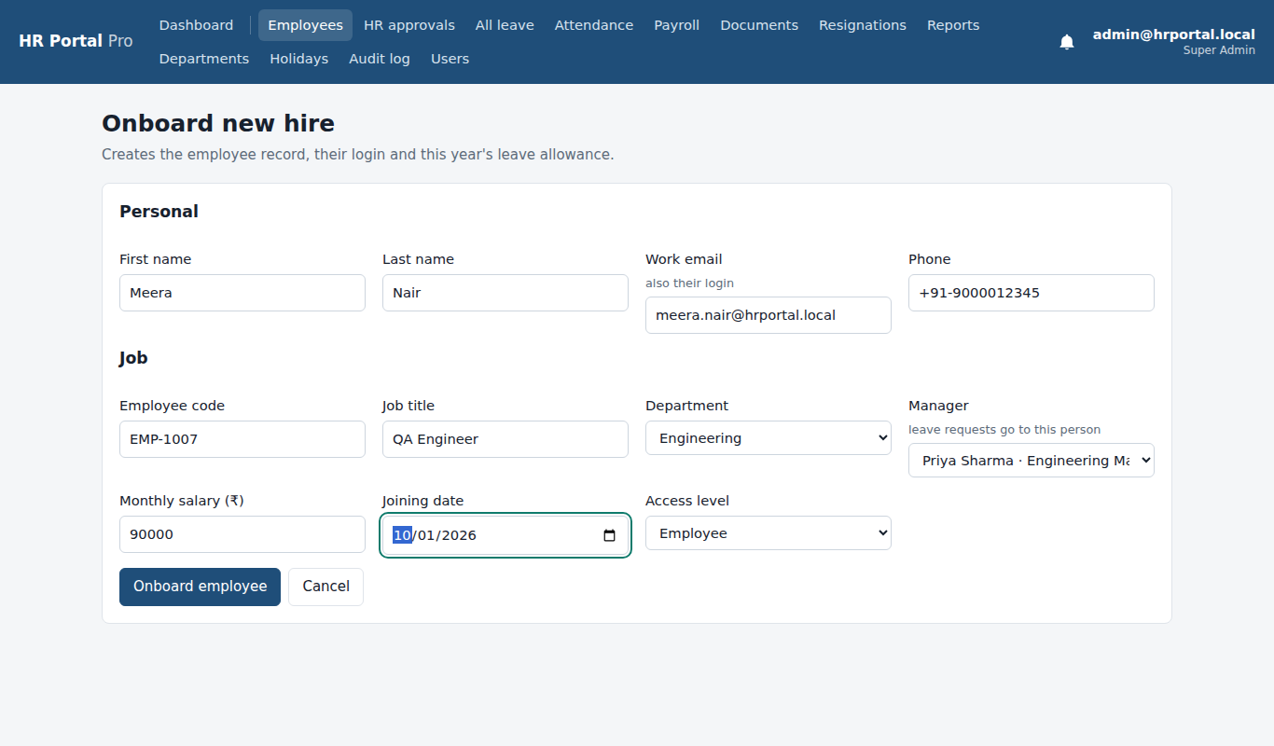

9. Onboarded: temporary password Super Admin
The login is created. The temporary password is shown once, to share with the new hire.
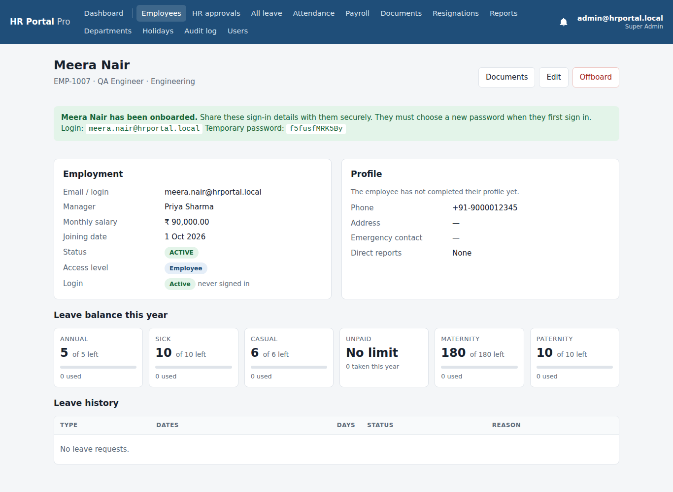

10. Users (sign-ins) Super Admin
Every login with its role, status and last sign-in. Change role, unlock, disable or reset a password here.
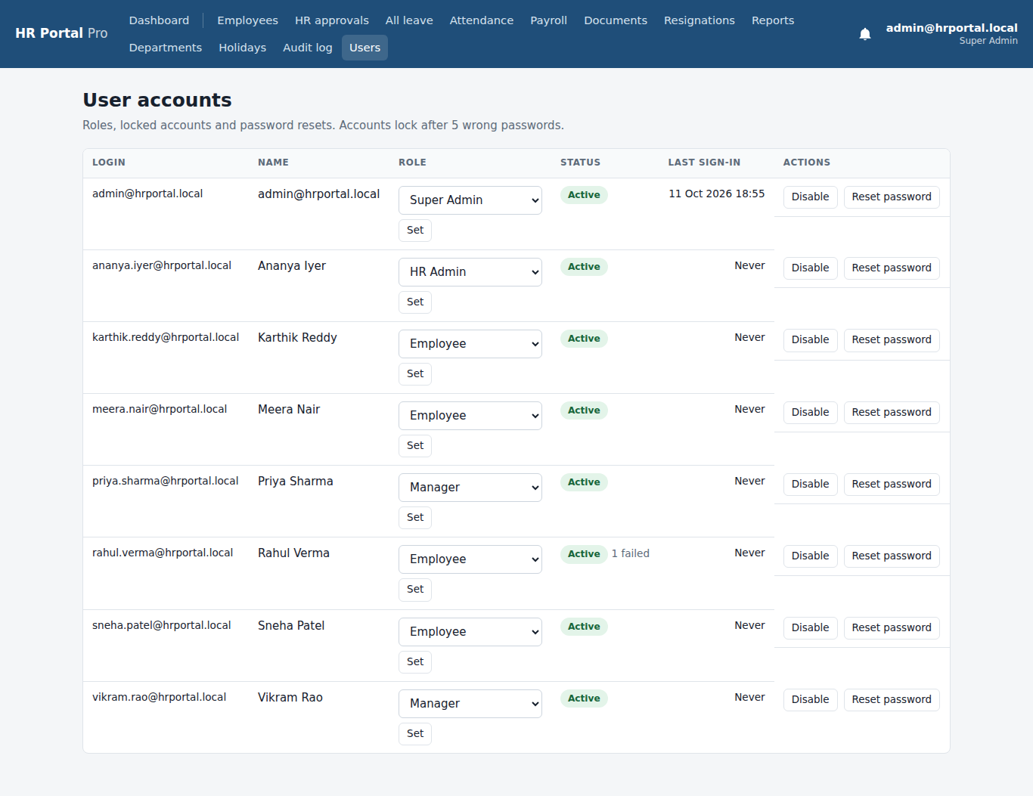

3. New hire: first sign-in
Signed in as: meera.nair@hrportal.local (temporary password)
Meera signs in for the first time. The portal makes her choose her own password and complete her profile before anything else.
The flow, screen by screen
- Must change the password: On the first sign-in the new hire is sent straight to Change password.
- Complete your profile: Next, the profile must be completed before anything else opens.
- First dashboard: Profile saved. The new hire now sees their own dashboard.

11. Must change the password New hire: first sign-in
On the first sign-in the new hire is sent straight to Change password.
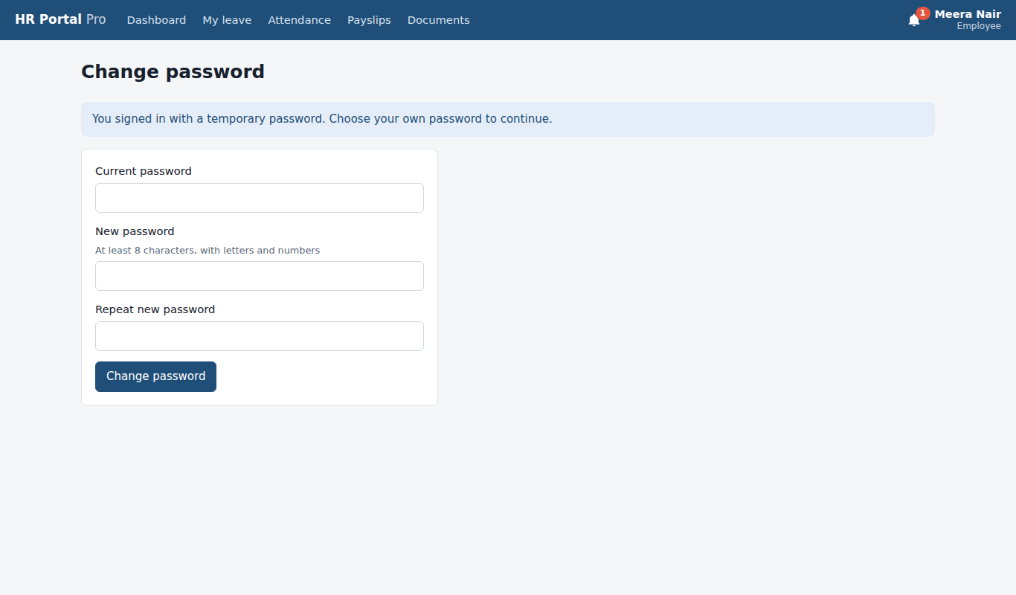

12. Complete your profile New hire: first sign-in
Next, the profile must be completed before anything else opens.
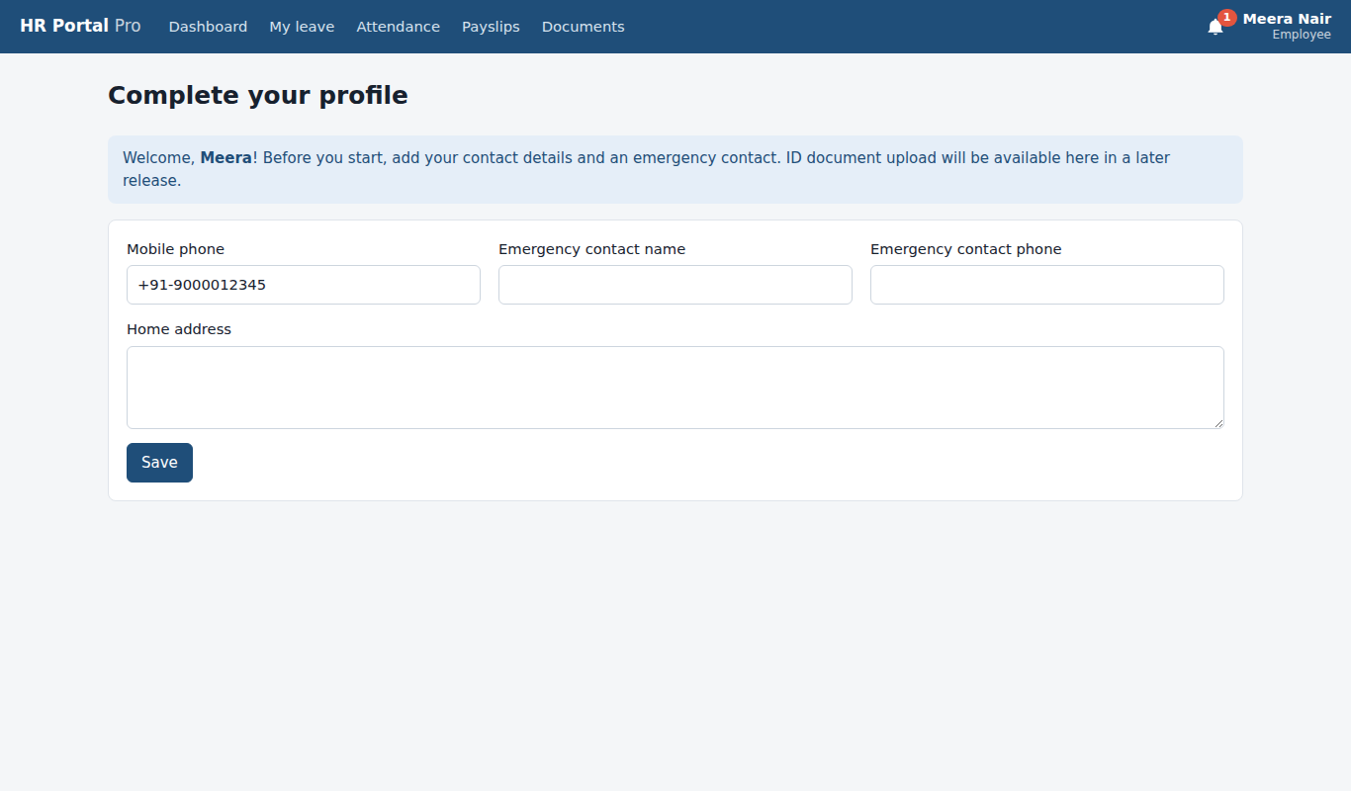

13. First dashboard New hire: first sign-in
Profile saved. The new hire now sees their own dashboard.
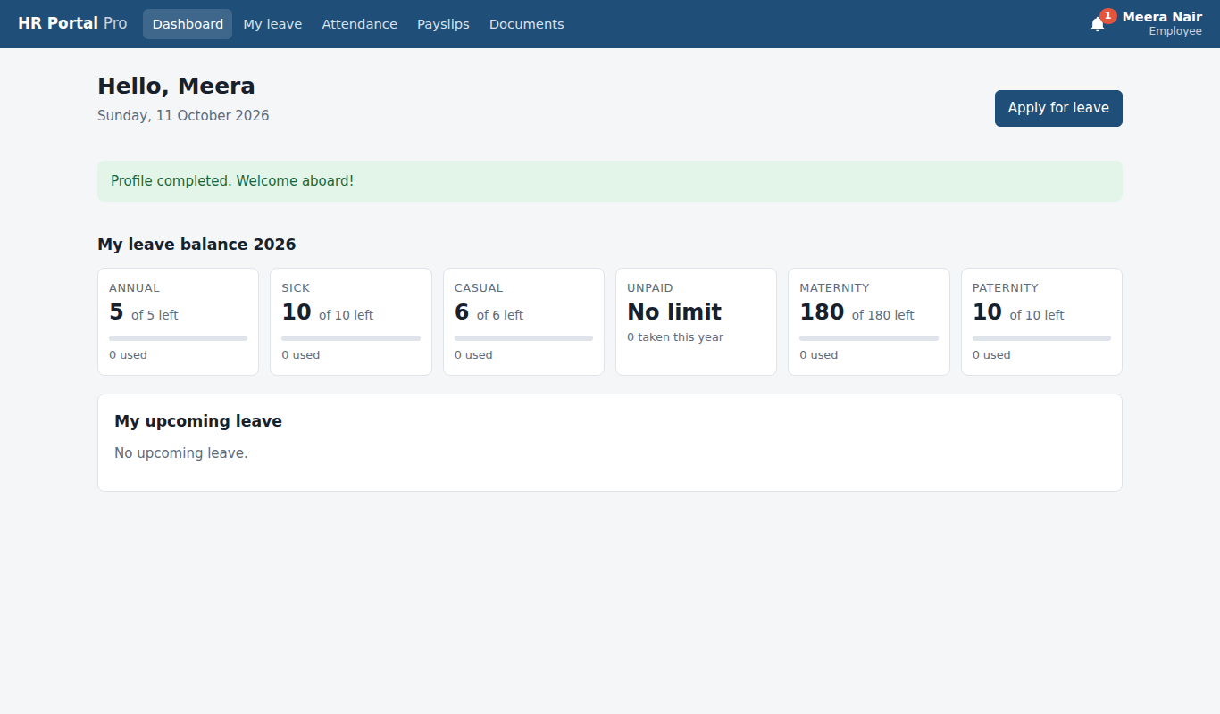

4. Employee
Signed in as: rahul.verma@hrportal.local
Rahul uses the employee self-service: dashboard, profile, attendance check-in and check-out, a 6-day leave request (19 to 26 Oct) and uploading his PAN card.
The flow, screen by screen
- Employee dashboard: Leave balances for the year, upcoming leave, and an Apply for leave button.
- My profile: Job details (managed by HR) and contact details. Edit contact details changes phone, address and emergency contact.
- Attendance before check-in: Today's box with the Check in button, and this month's day-by-day list with totals.
- Checked in: After Check in, today shows the check-in time and a Check out button.
- Checked out: After Check out, today shows the check-in and check-out times and the hours worked.
- Apply for leave: Leave type, dates and reason, with the balances and how leave is counted.
- My leave: waiting for manager: The request shows Waiting for manager. The manager is notified and emailed.
- My documents: The onboarding checklist and the upload form.
- Document uploaded: The PAN card now shows Waiting for HR. HR is notified.

14. Employee dashboard Employee
Leave balances for the year, upcoming leave, and an Apply for leave button.
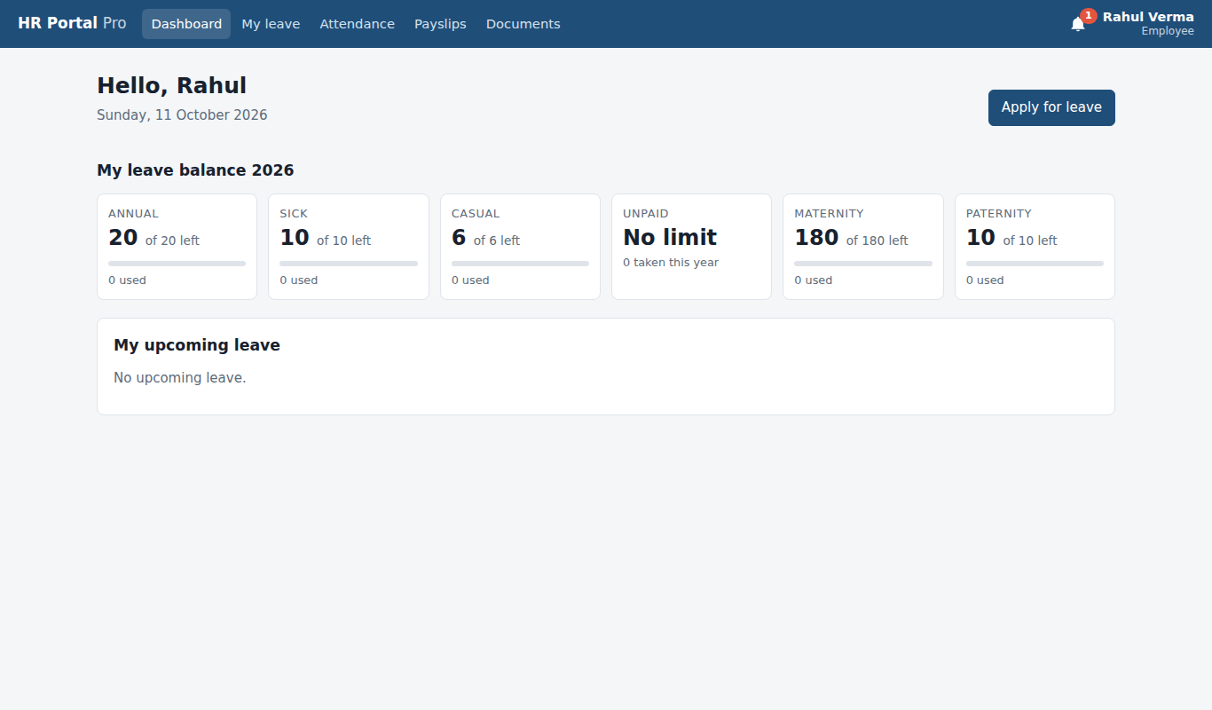

15. My profile Employee
Job details (managed by HR) and contact details. Edit contact details changes phone, address and emergency contact.
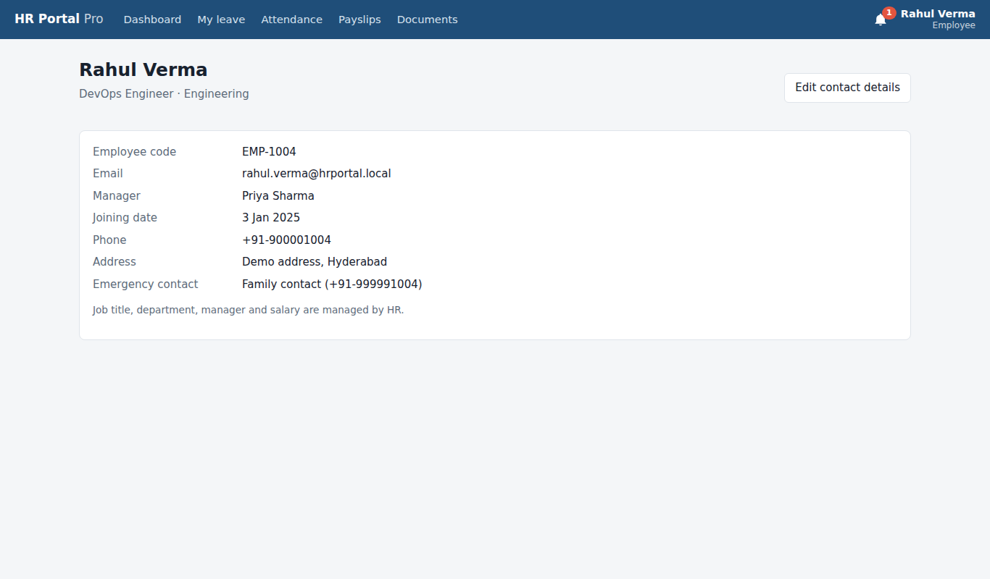

16. Attendance before check-in Employee
Today's box with the Check in button, and this month's day-by-day list with totals.
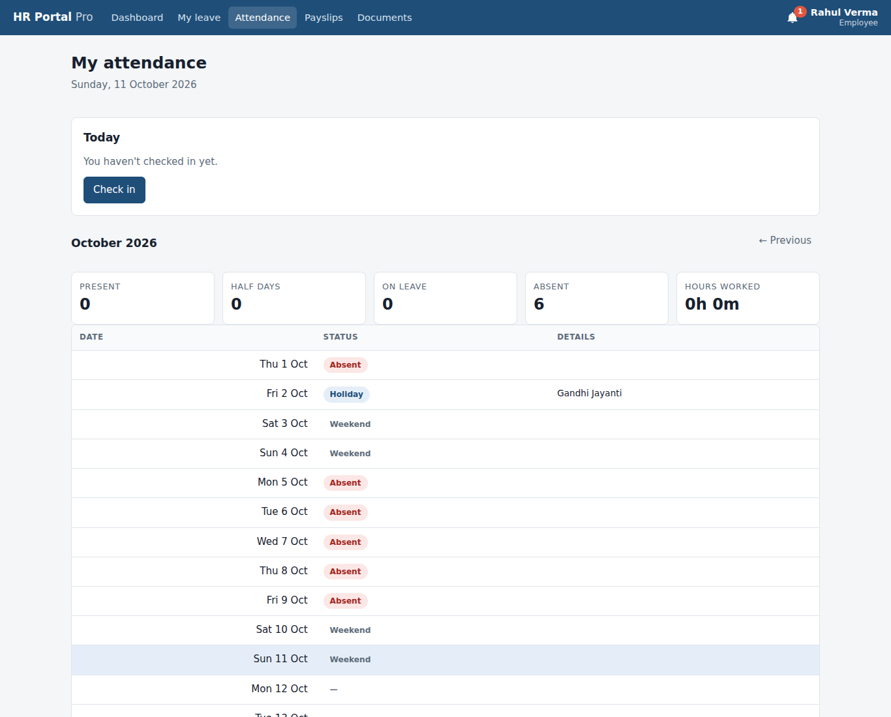

17. Checked in Employee
After Check in, today shows the check-in time and a Check out button.
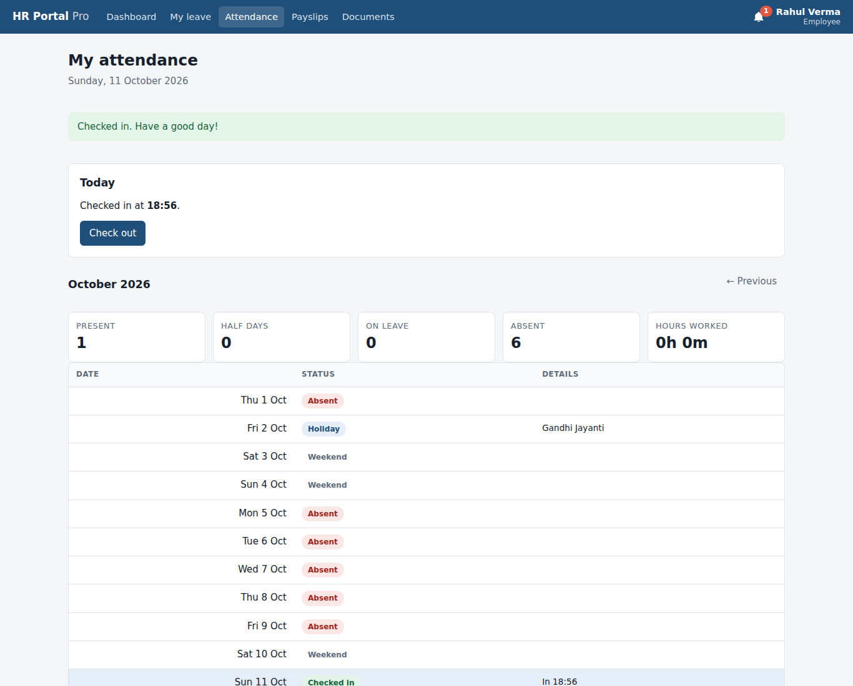

18. Checked out Employee
After Check out, today shows the check-in and check-out times and the hours worked.
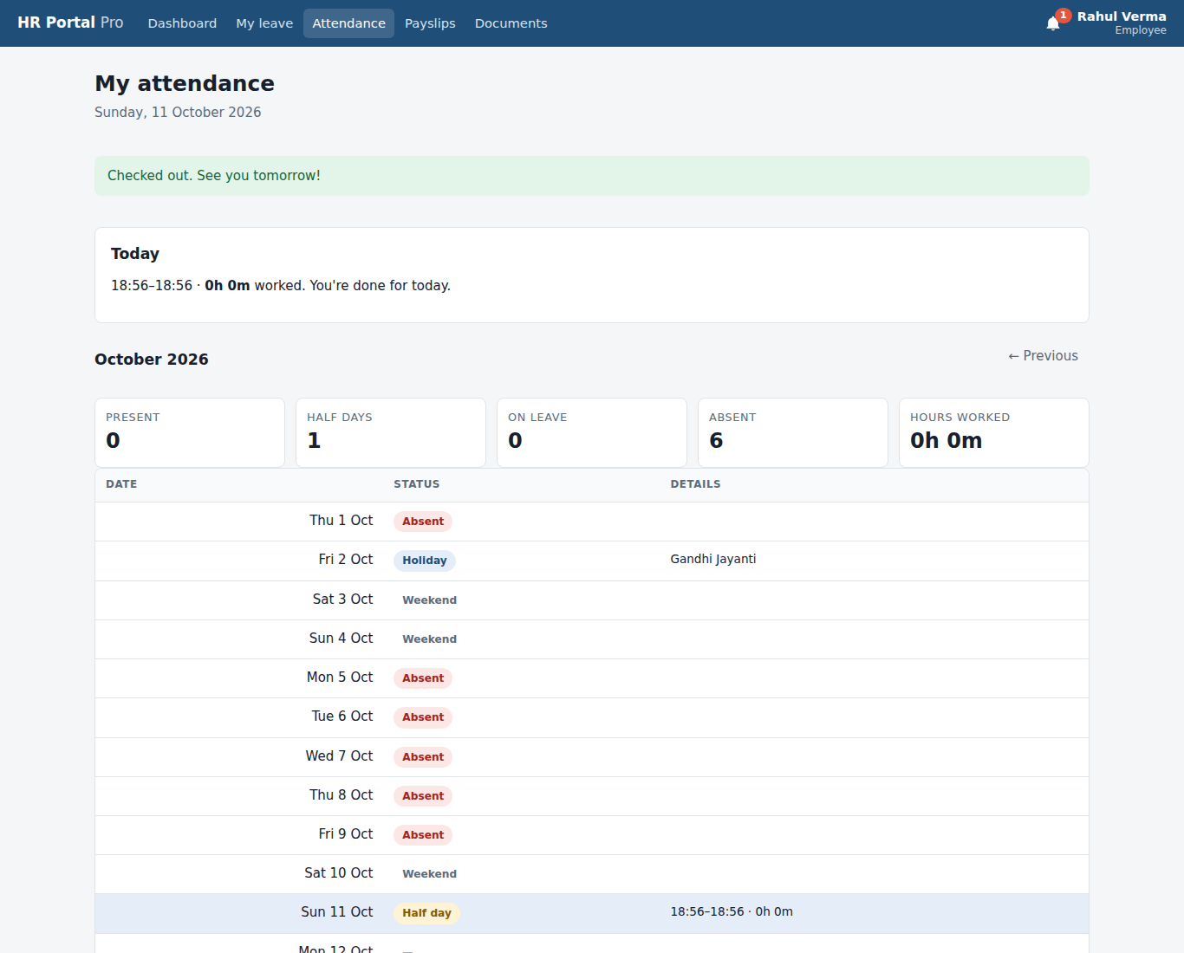

19. Apply for leave Employee
Leave type, dates and reason, with the balances and how leave is counted.
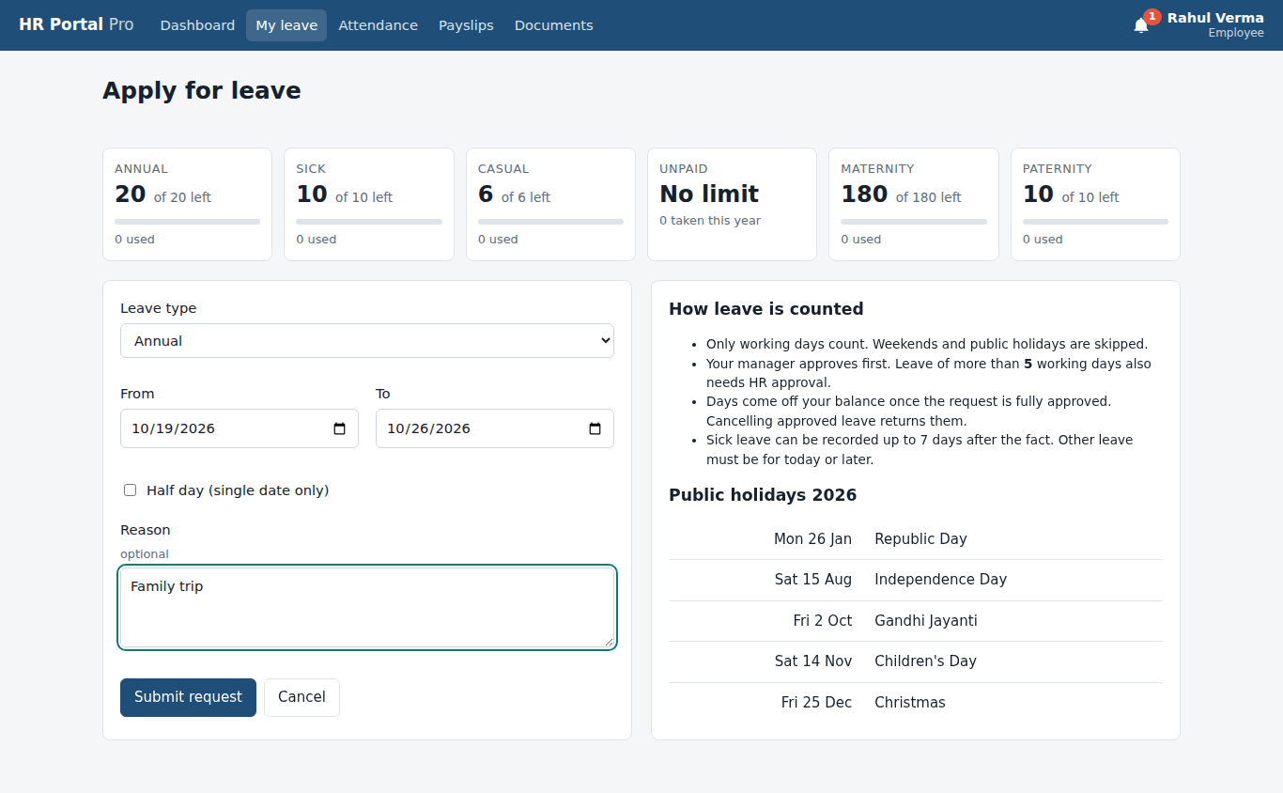

20. My leave: waiting for manager Employee
The request shows Waiting for manager. The manager is notified and emailed.
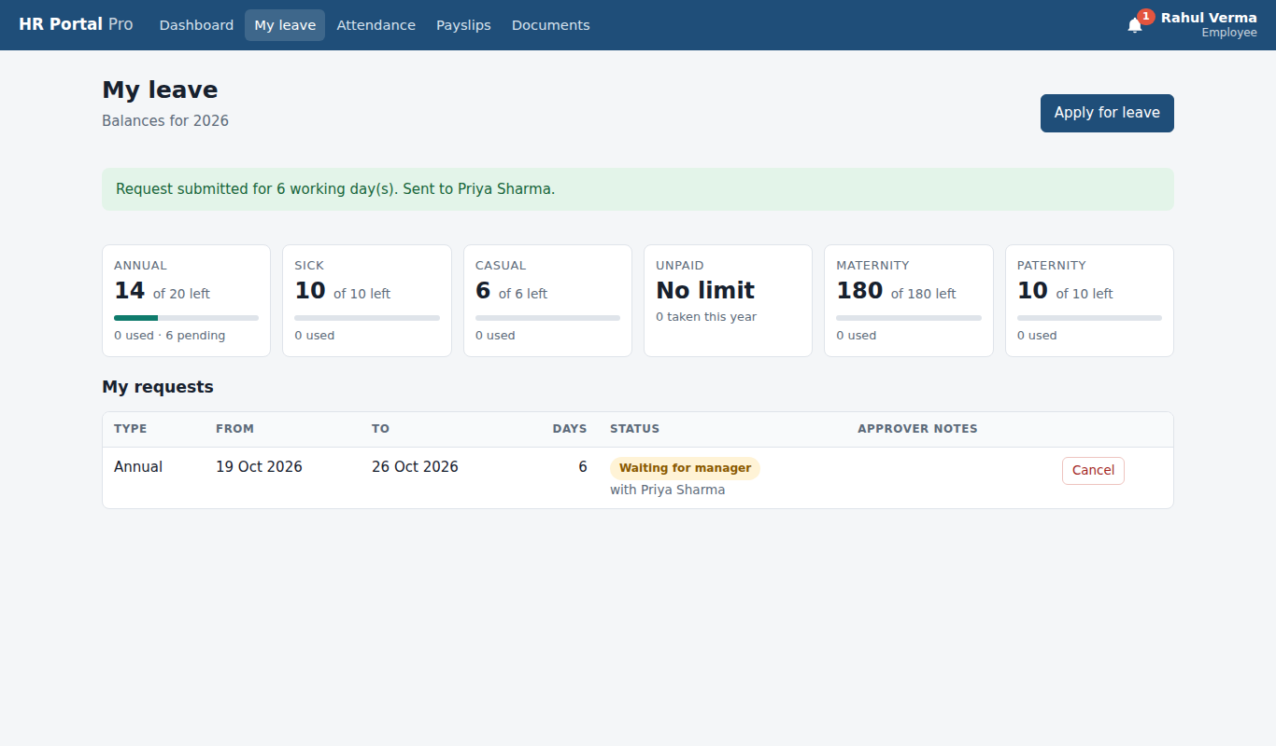

21. My documents Employee
The onboarding checklist and the upload form.
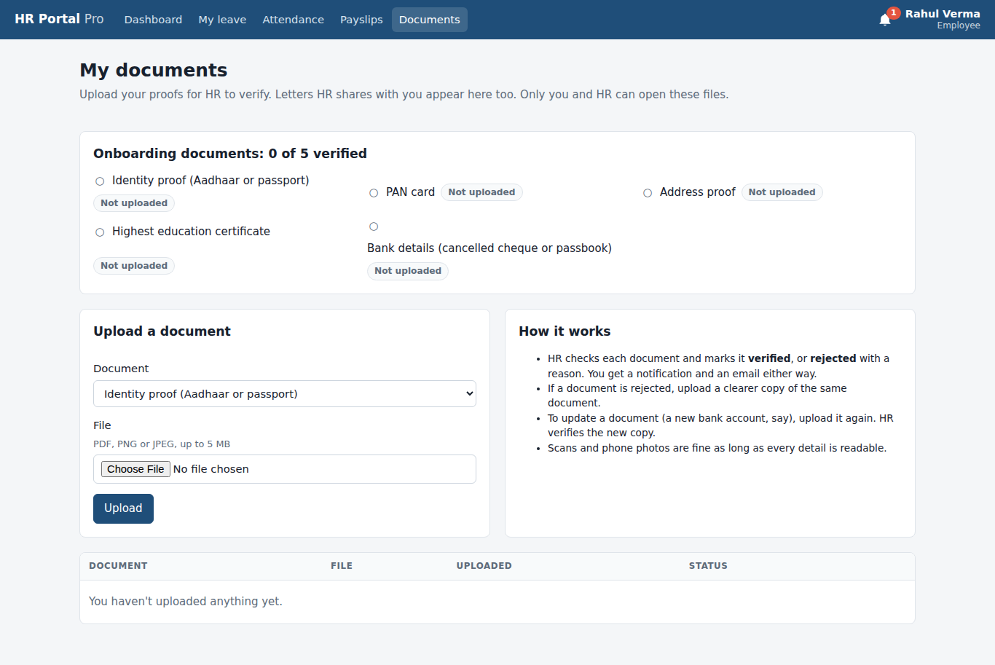

22. Document uploaded Employee
The PAN card now shows Waiting for HR. HR is notified.
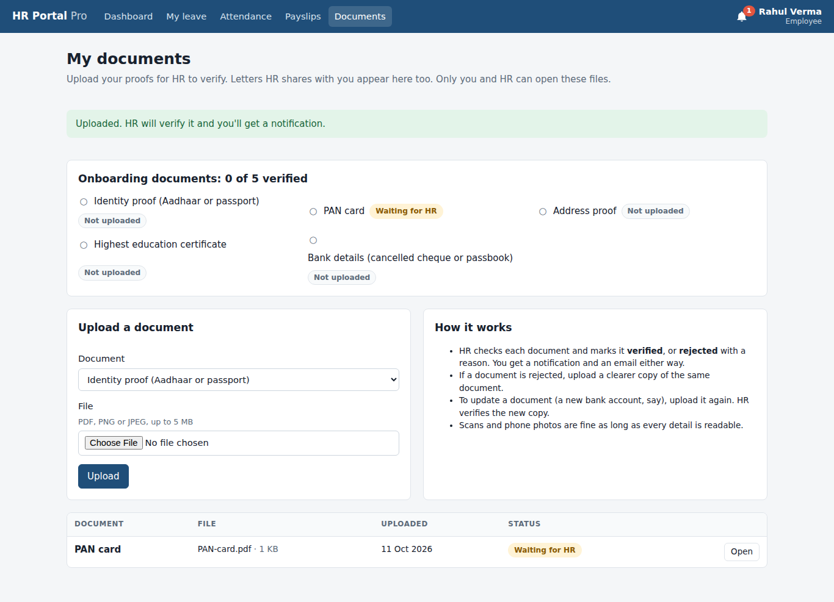

5. Employee: resignation
Signed in as: sneha.patel@hrportal.local
Sneha resigns from the portal. Her manager and HR are told straight away.
The flow, screen by screen
- Resignation form: Requested last working day (today + 30 days suggested) and the reason.
- Resignation submitted: Status Waiting for HR. The manager and HR are told. It can be withdrawn until HR decides.

23. Resignation form Employee: resignation
Requested last working day (today + 30 days suggested) and the reason.
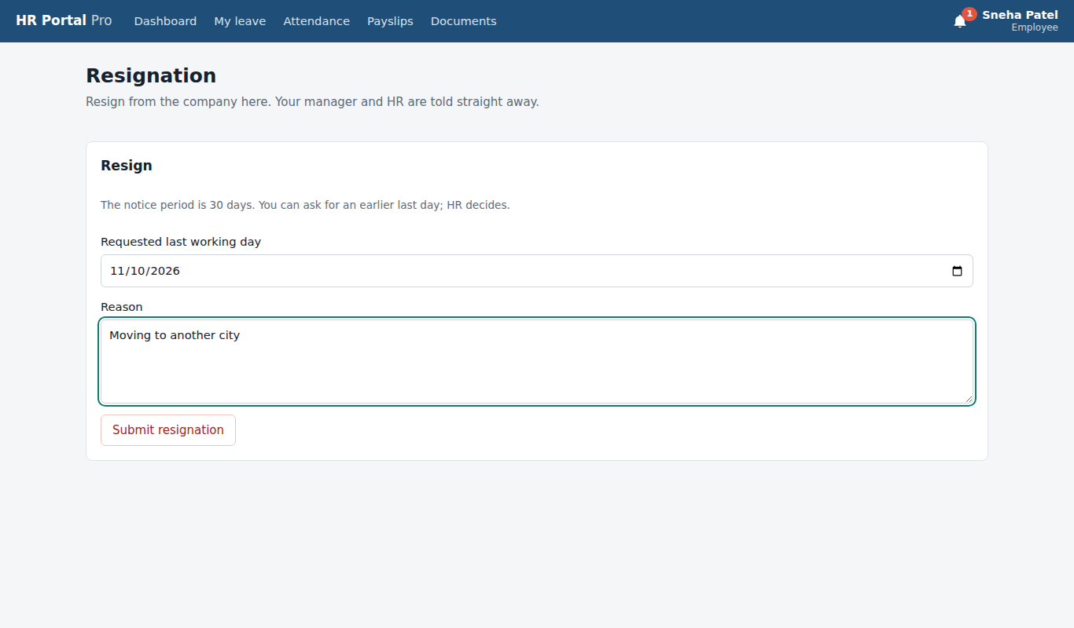

24. Resignation submitted Employee: resignation
Status Waiting for HR. The manager and HR are told. It can be withdrawn until HR decides.
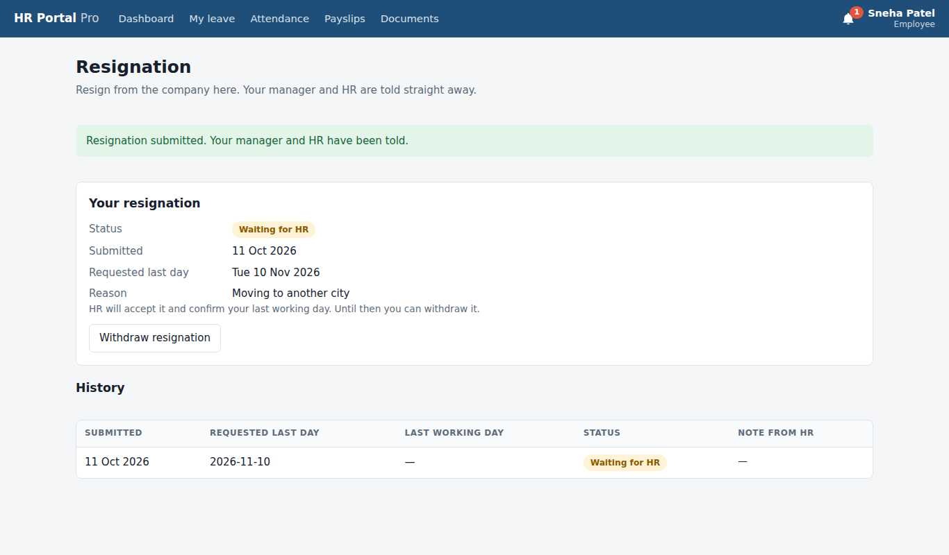

6. Manager
Signed in as: priya.sharma@hrportal.local
Priya, Rahul's manager, looks after her team and approves Rahul's leave. Because it is longer than 5 working days it goes on to HR.
The flow, screen by screen
- Manager dashboard: Team requests waiting, team size and who in the team is out today.
- My team: Direct reports with their remaining leave, and who is out today.
- Team approvals: Leave requests from direct reports, with Approve and Reject and an optional comment.
- Approved: sent on to HR: Rahul's 6-day leave is approved by the manager. Over 5 days, so it goes to HR for final approval.
- Team attendance: Each person's status today and their figures for the month.

25. Manager dashboard Manager
Team requests waiting, team size and who in the team is out today.
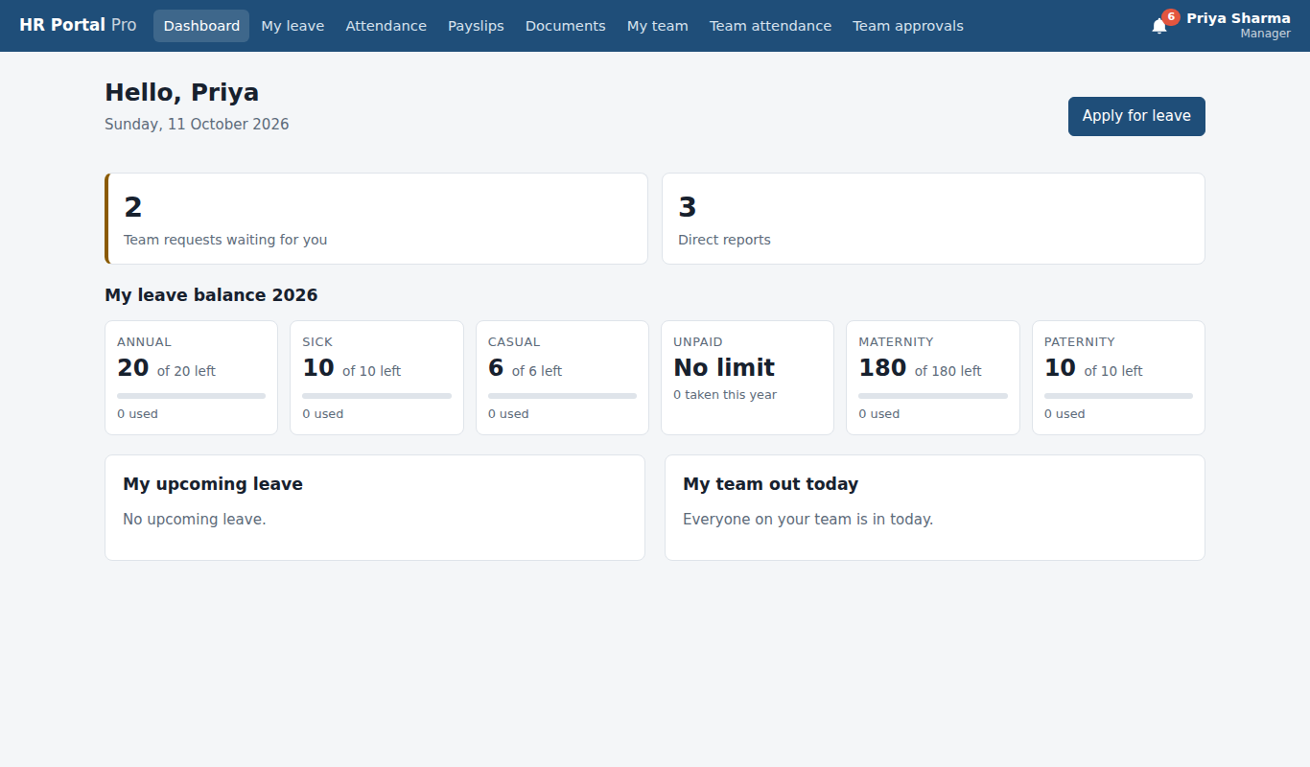

26. My team Manager
Direct reports with their remaining leave, and who is out today.
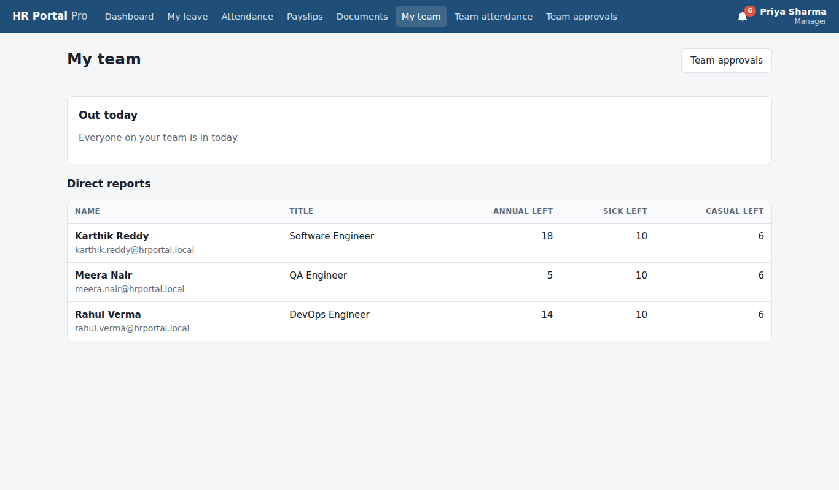

27. Team approvals Manager
Leave requests from direct reports, with Approve and Reject and an optional comment.
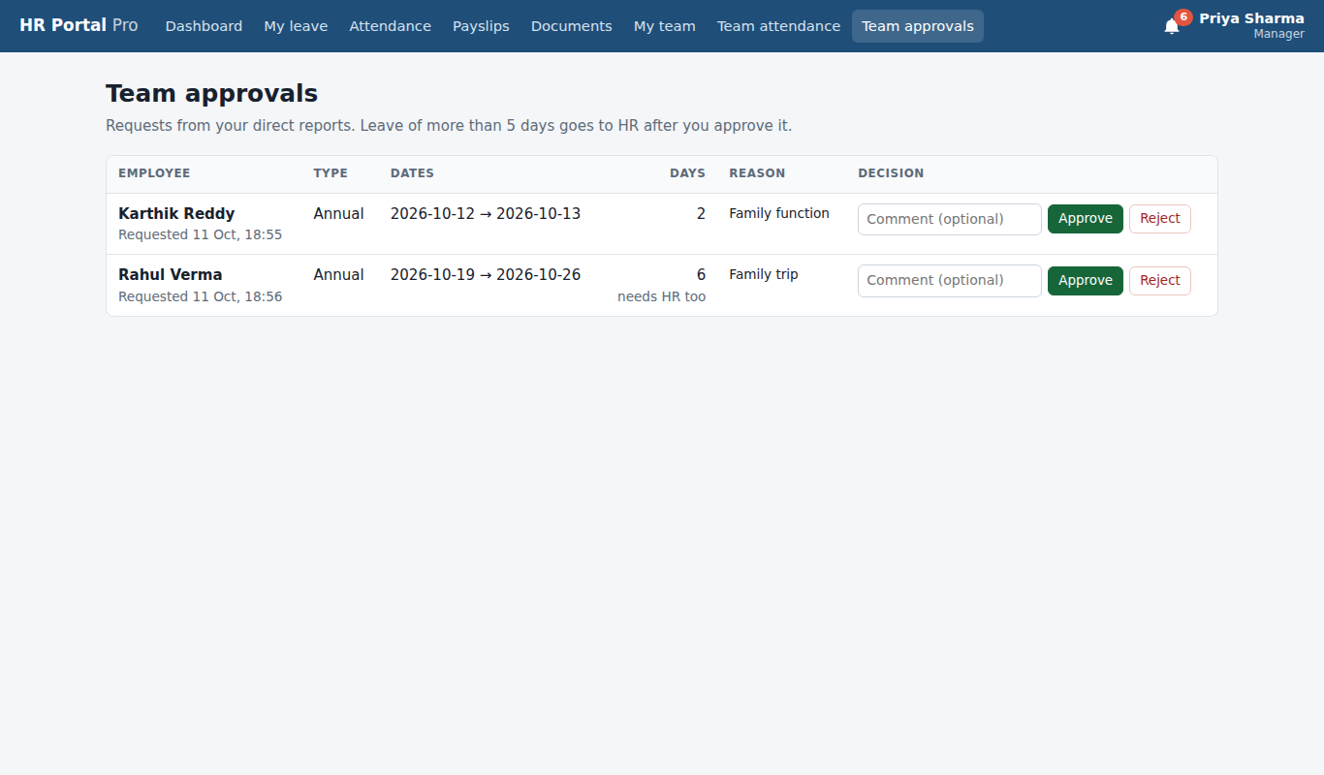

28. Approved: sent on to HR Manager
Rahul's 6-day leave is approved by the manager. Over 5 days, so it goes to HR for final approval.
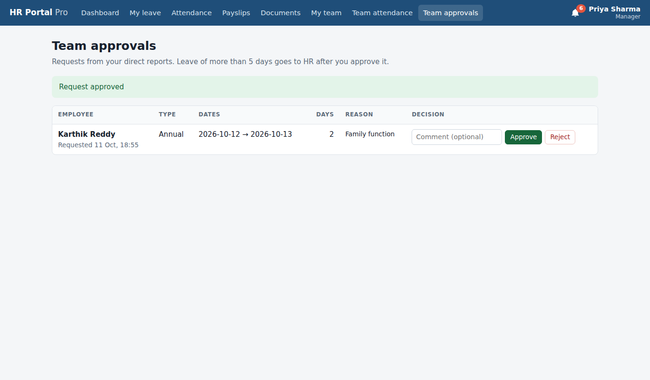

29. Team attendance Manager
Each person's status today and their figures for the month.
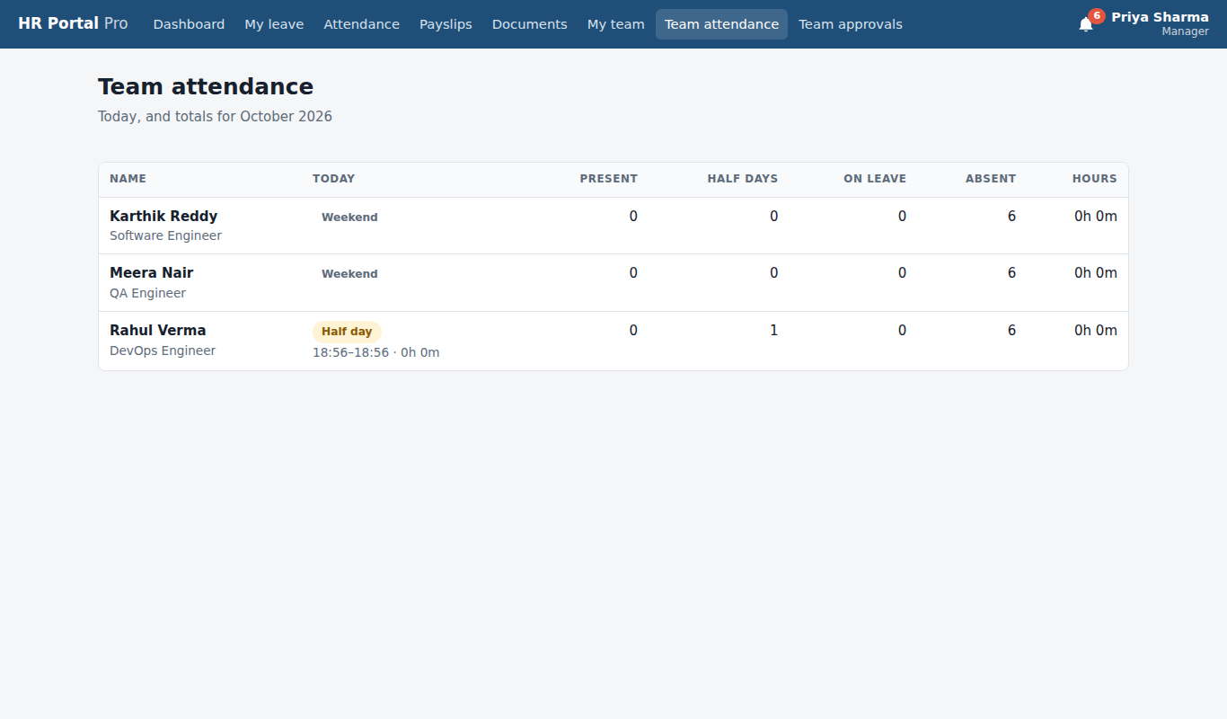

7. HR Admin
Signed in as: ananya.iyer@hrportal.local
Ananya gives the final leave approval, corrects attendance, runs September payroll, verifies Rahul's PAN card, shares an offer letter, accepts Sneha's resignation, and uses reports, offboarding and the audit log.
The flow, screen by screen
- HR Admin dashboard: HR approvals waiting, active employees and the company's out-of-office list.
- HR approvals: Long leave already approved by the manager, waiting for HR.
- Leave approved by HR: Final approval: the days come off the balance and Rahul is emailed.
- All leave: Every leave request in the company, with filters and Cancel.
- Attendance for a day: Everyone's status on a chosen day, with a correction form for past days.
- Attendance corrected: Karthik's day corrected with times and a reason. The change is in the audit log.
- Payroll runs: Past payroll runs. Pick a month and click Run payroll.
- Draft payroll: A draft with a payslip for every employee: paid days, loss of pay, gross, deductions and net pay.
- Payroll finalized: Locked and published: each payslip PDF is stored and every employee is emailed.
- Documents to verify: Uploads waiting for HR, plus the onboarding checklist for every employee.
- Document verified: Rahul's PAN card is verified; his checklist goes up by one.
- Employee profile (HR view): Employment, profile, leave balance and history, with Documents, Edit and Offboard.
- Letter shared: HR shared an offer letter. It appears in the employee's documents as Issued by HR.
- Resignations: Waiting for HR, serving notice and recently closed.
- Resignation accepted: Sneha now shows under Serving notice with 30 days left. She leaves automatically the night after her last working day (10 Nov 2026).
- Reports: Attendance, leave balances and the payroll register as CSV files for Excel.
- Offboard form: Last working day and reason. Offboarding switches off the login and cancels future leave.
- Audit log: Every action in the portal: who did it, when, and what changed.

30. HR Admin dashboard HR Admin
HR approvals waiting, active employees and the company's out-of-office list.
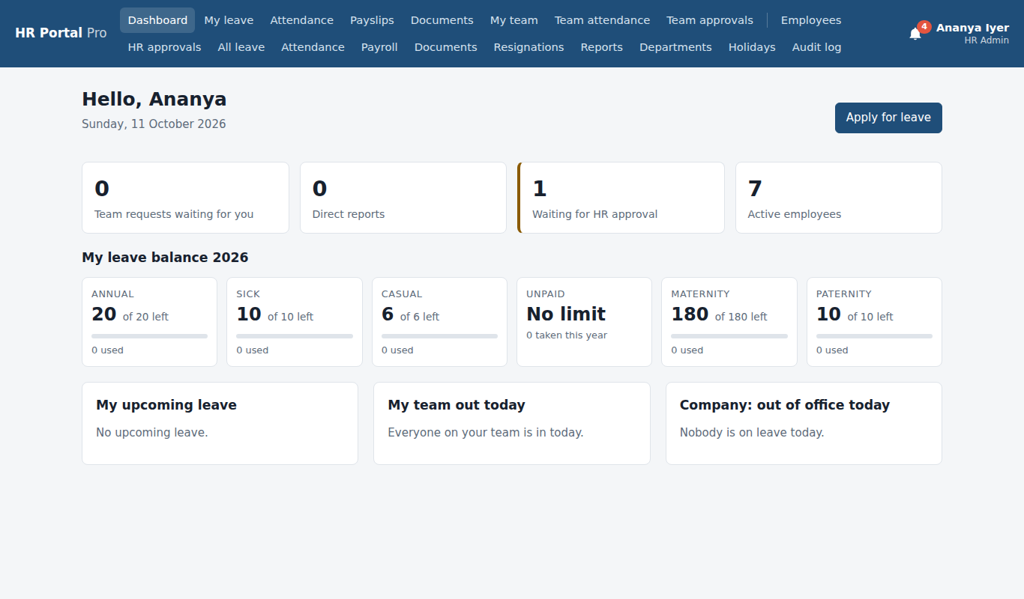

31. HR approvals HR Admin
Long leave already approved by the manager, waiting for HR.
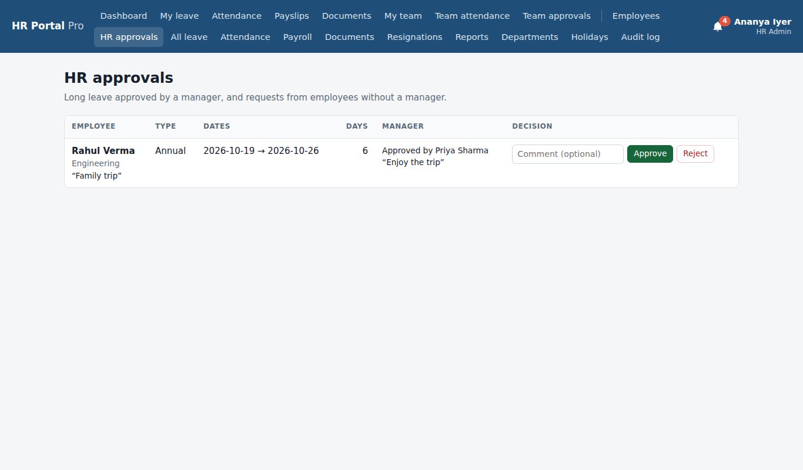

32. Leave approved by HR HR Admin
Final approval: the days come off the balance and Rahul is emailed.
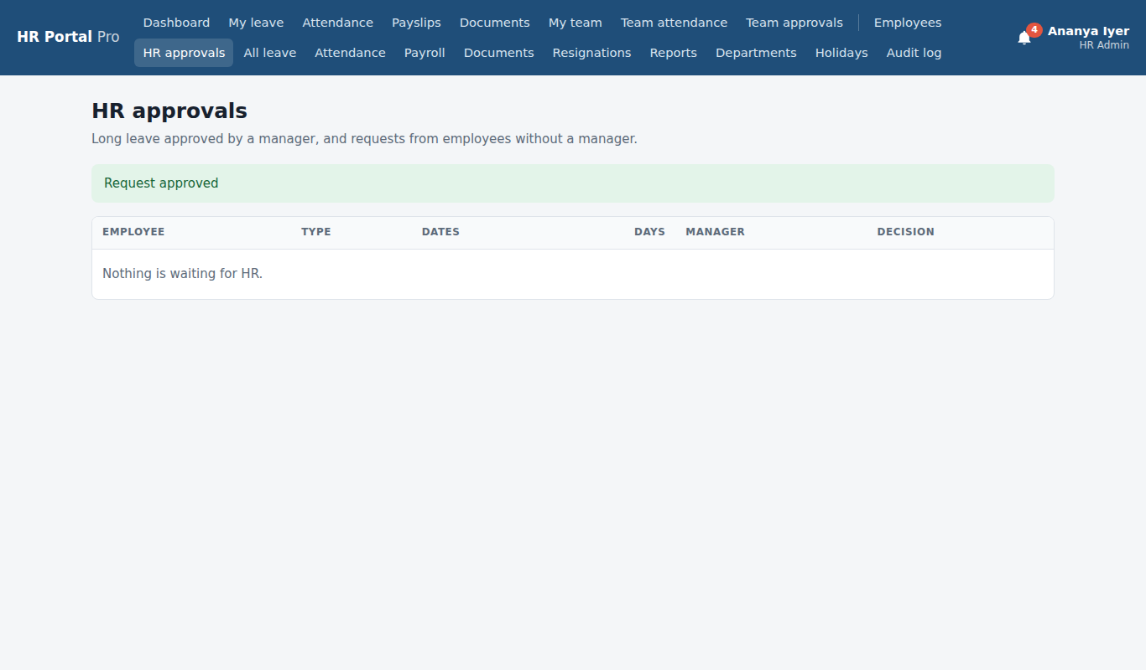

33. All leave HR Admin
Every leave request in the company, with filters and Cancel.
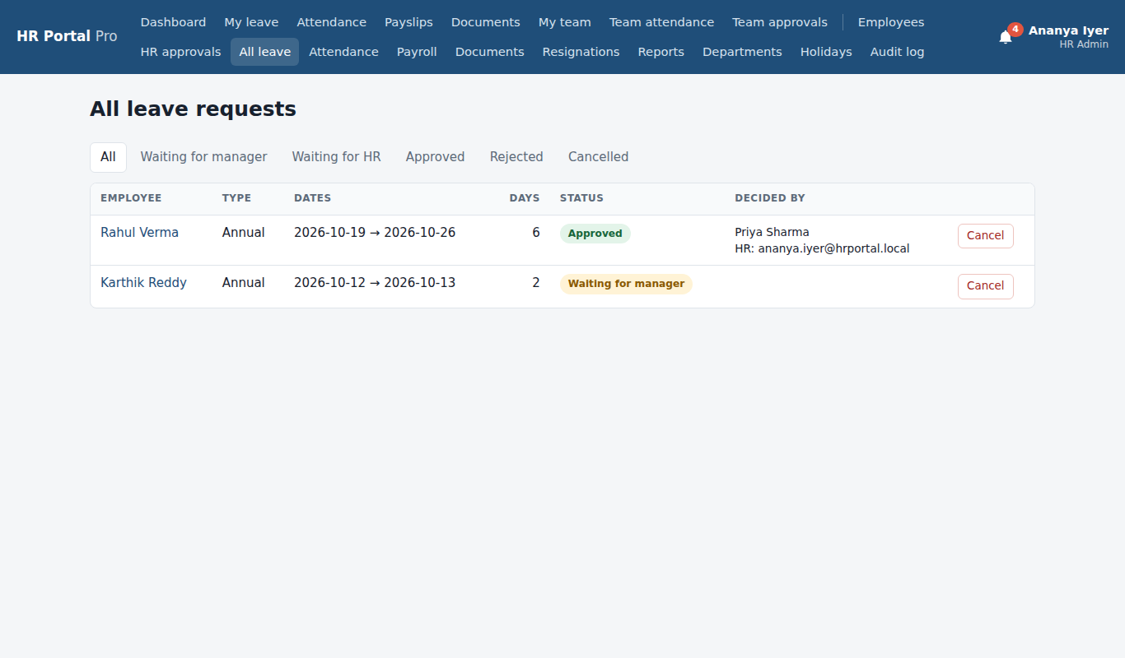

34. Attendance for a day HR Admin
Everyone's status on a chosen day, with a correction form for past days.
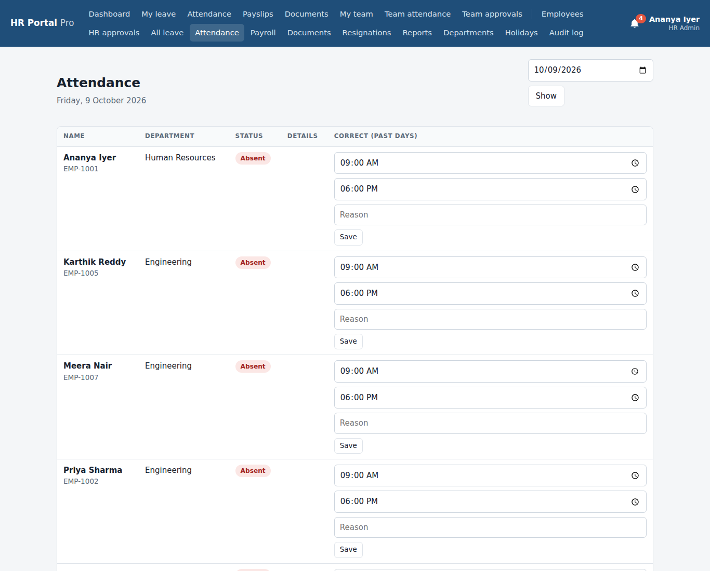

35. Attendance corrected HR Admin
Karthik's day corrected with times and a reason. The change is in the audit log.
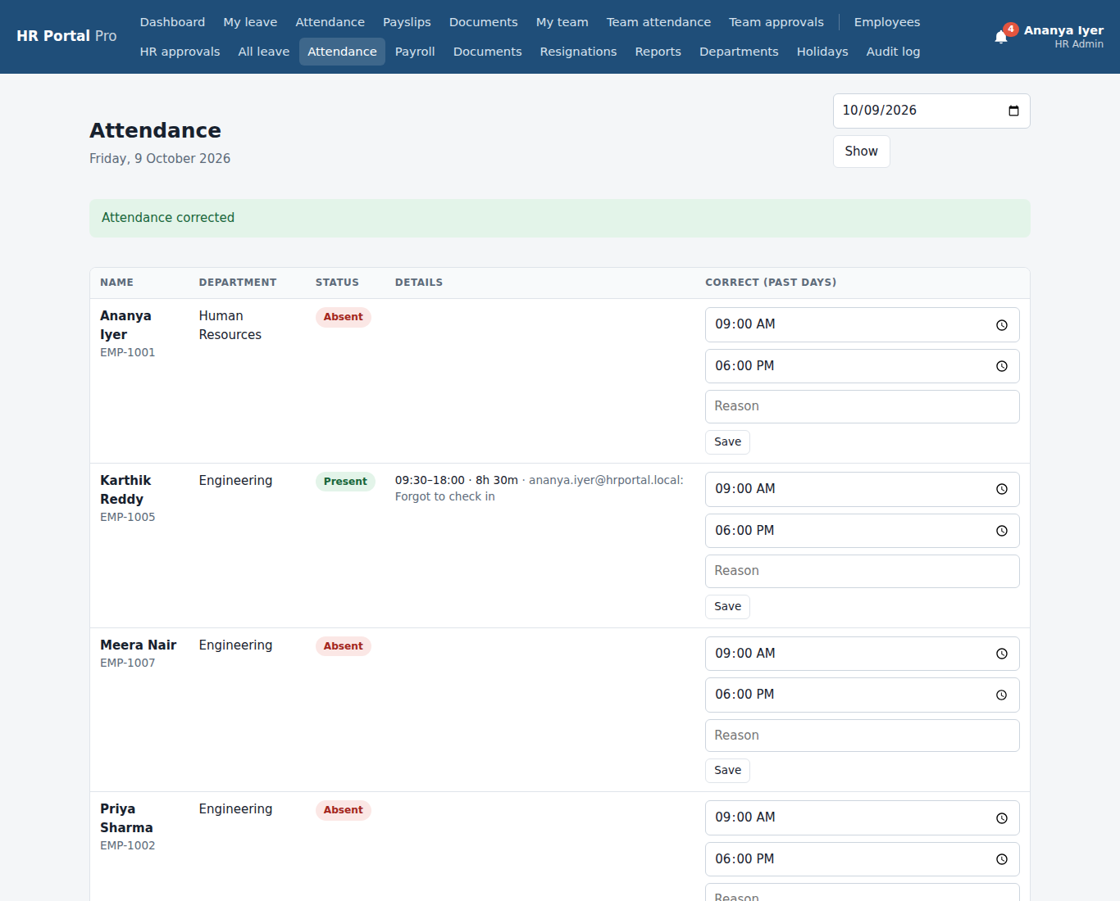

36. Payroll runs HR Admin
Past payroll runs. Pick a month and click Run payroll.
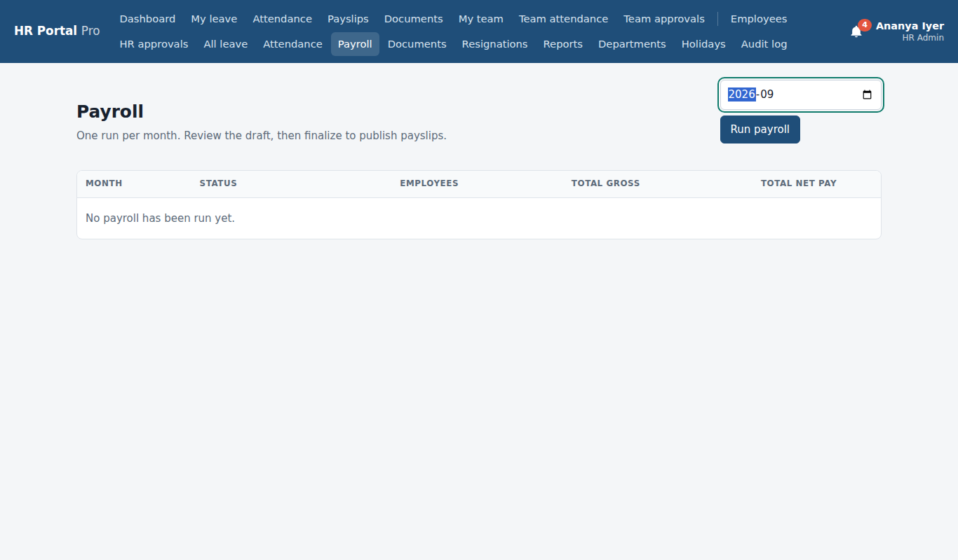

37. Draft payroll HR Admin
A draft with a payslip for every employee: paid days, loss of pay, gross, deductions and net pay.
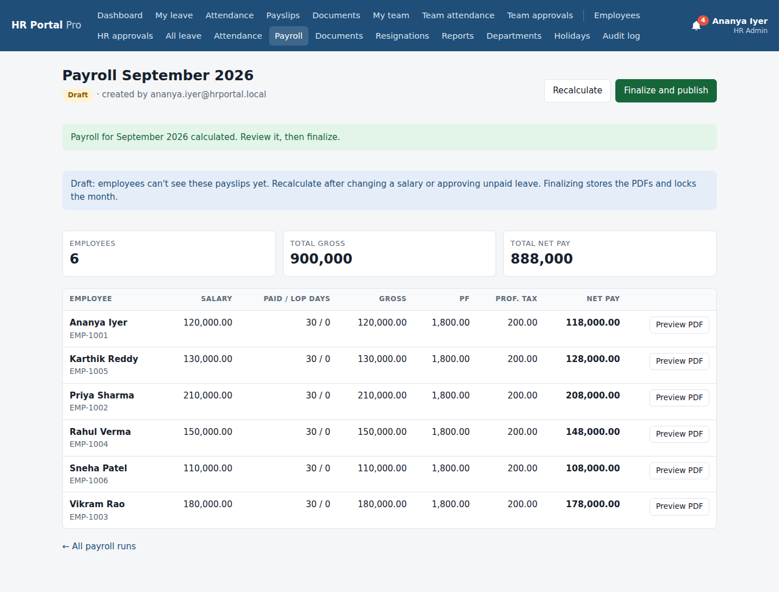

38. Payroll finalized HR Admin
Locked and published: each payslip PDF is stored and every employee is emailed.
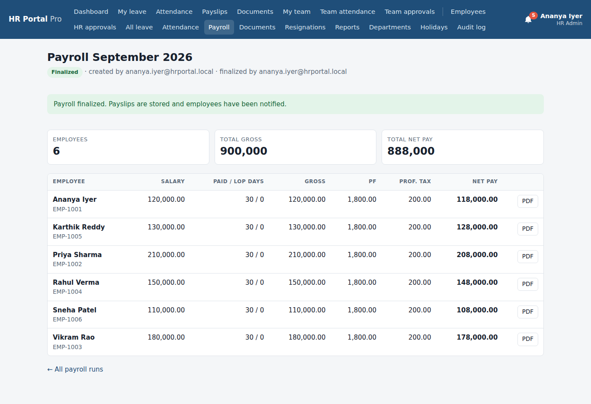

39. Documents to verify HR Admin
Uploads waiting for HR, plus the onboarding checklist for every employee.
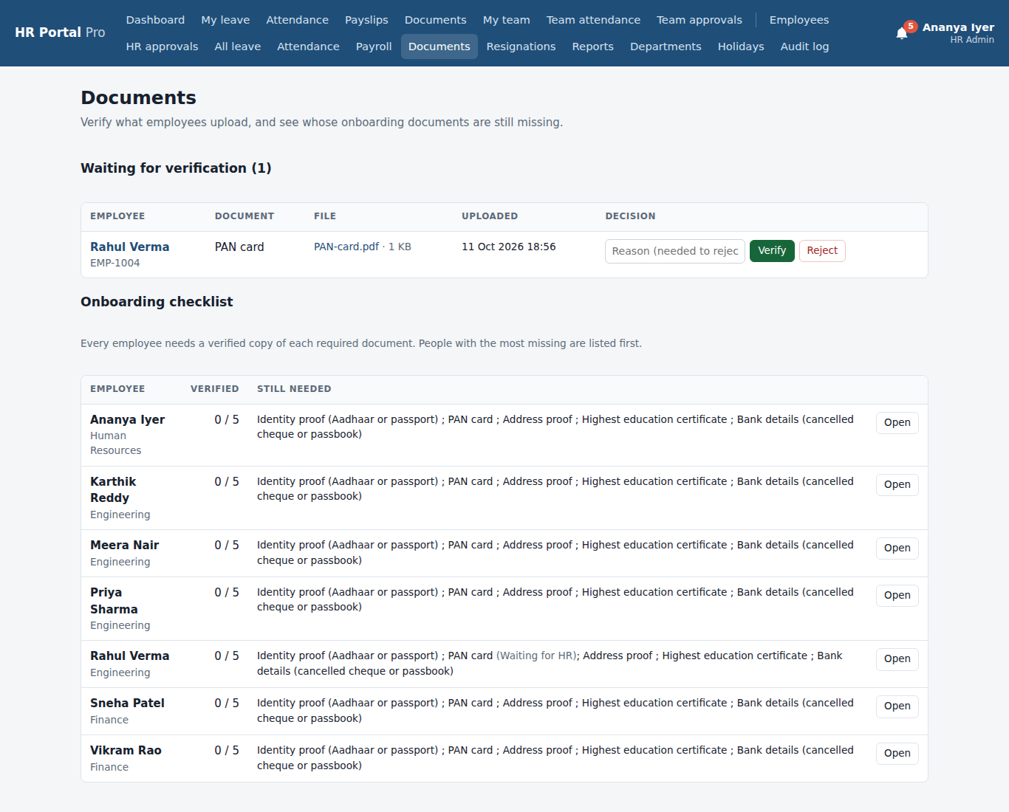

40. Document verified HR Admin
Rahul's PAN card is verified; his checklist goes up by one.
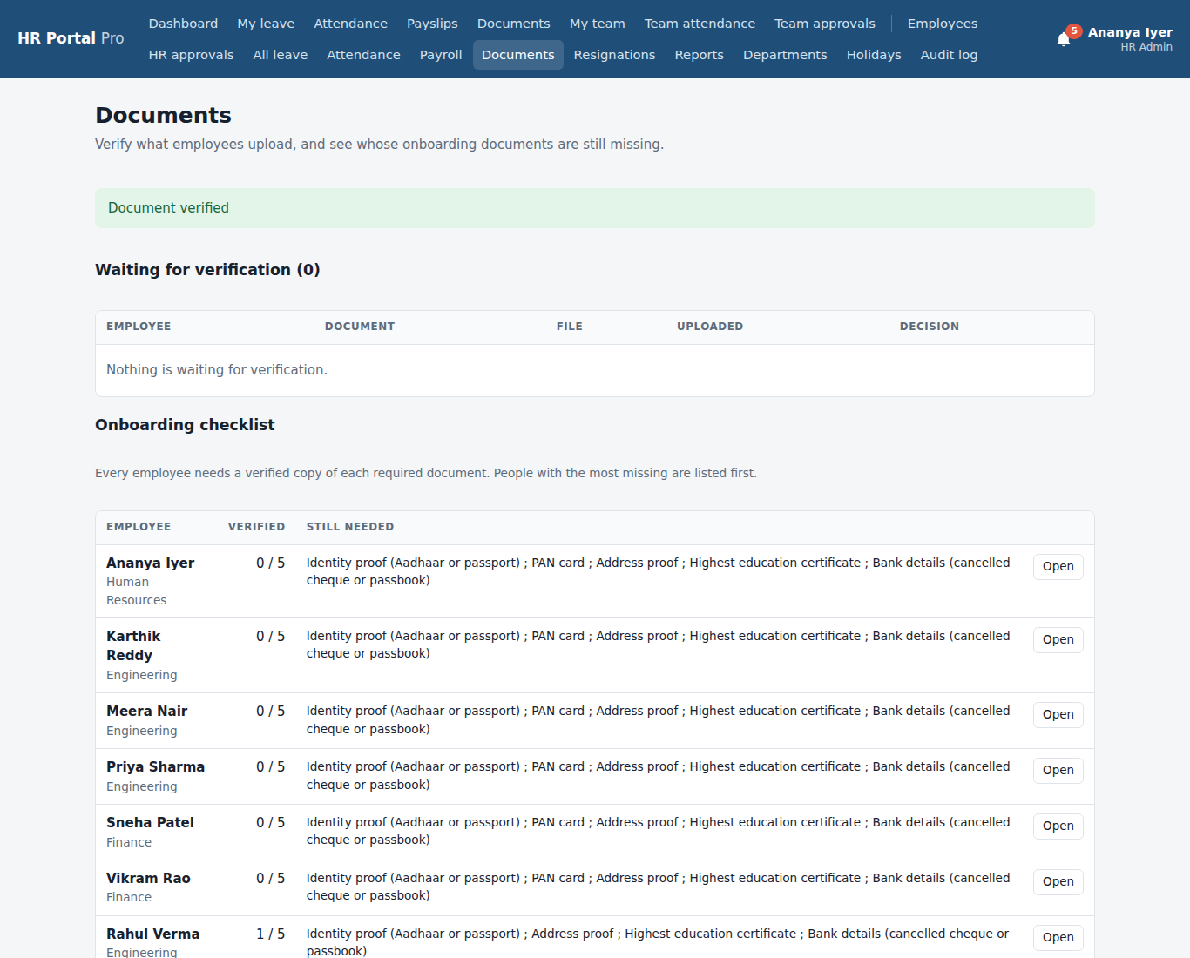

41. Employee profile (HR view) HR Admin
Employment, profile, leave balance and history, with Documents, Edit and Offboard.
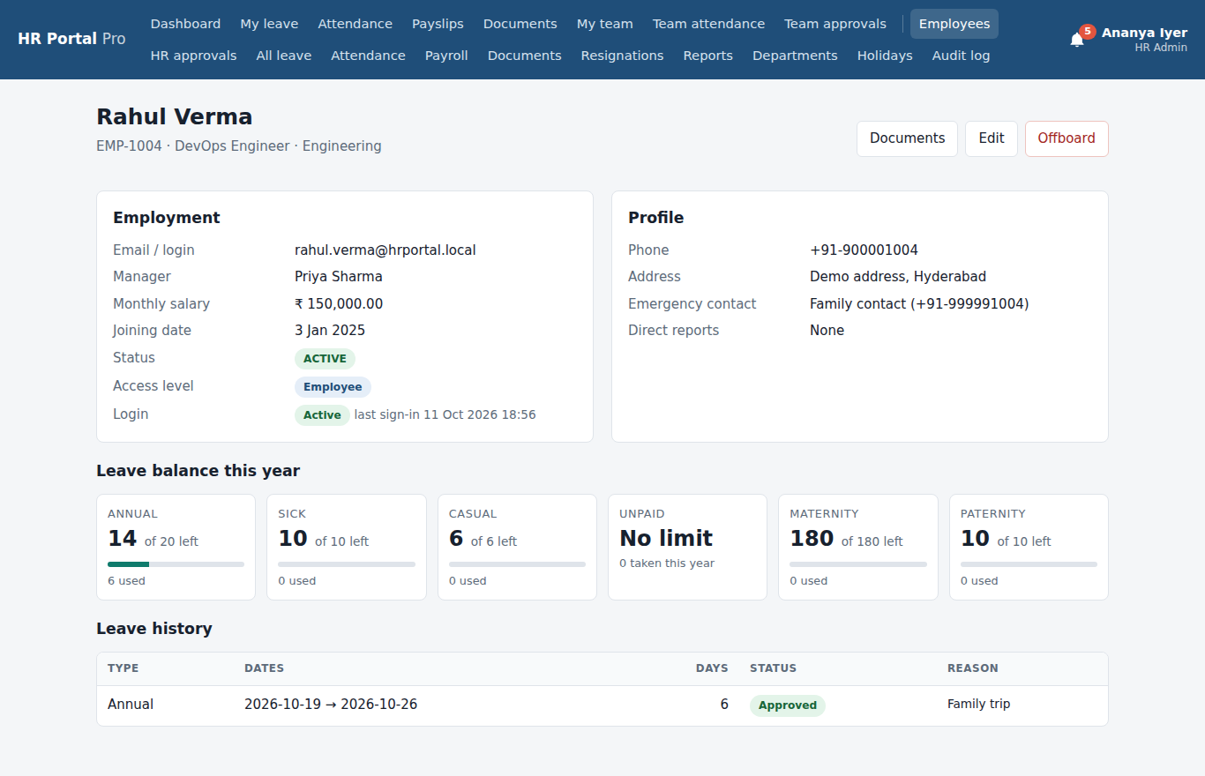

42. Letter shared HR Admin
HR shared an offer letter. It appears in the employee's documents as Issued by HR.
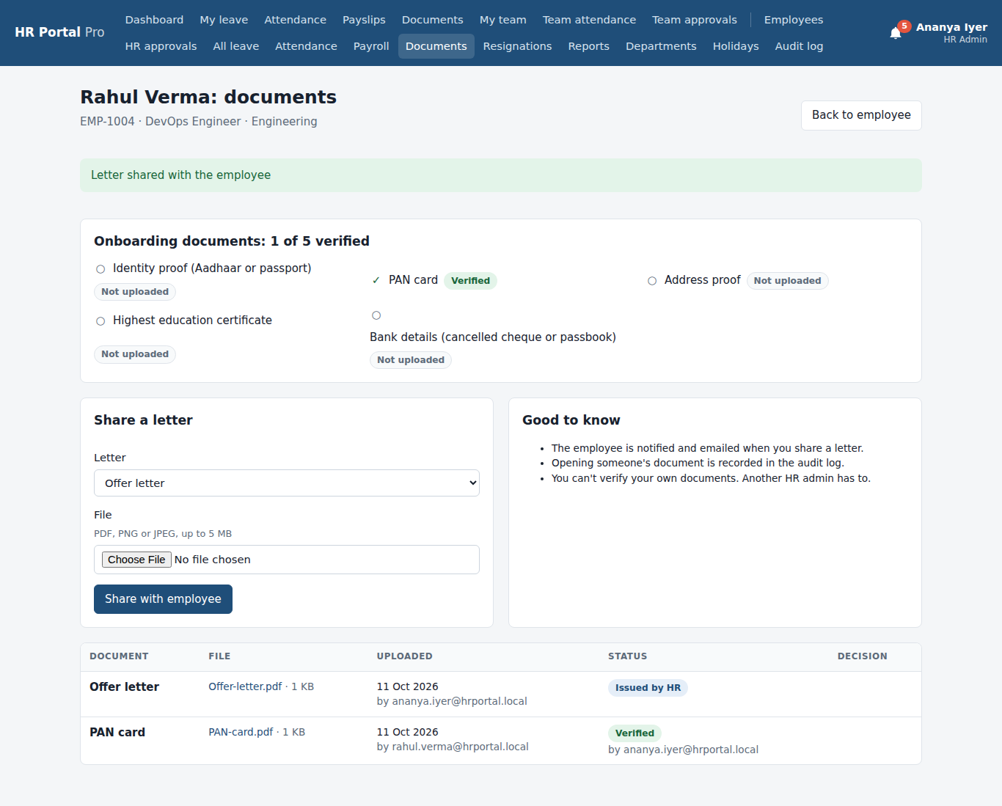

43. Resignations HR Admin
Waiting for HR, serving notice and recently closed.
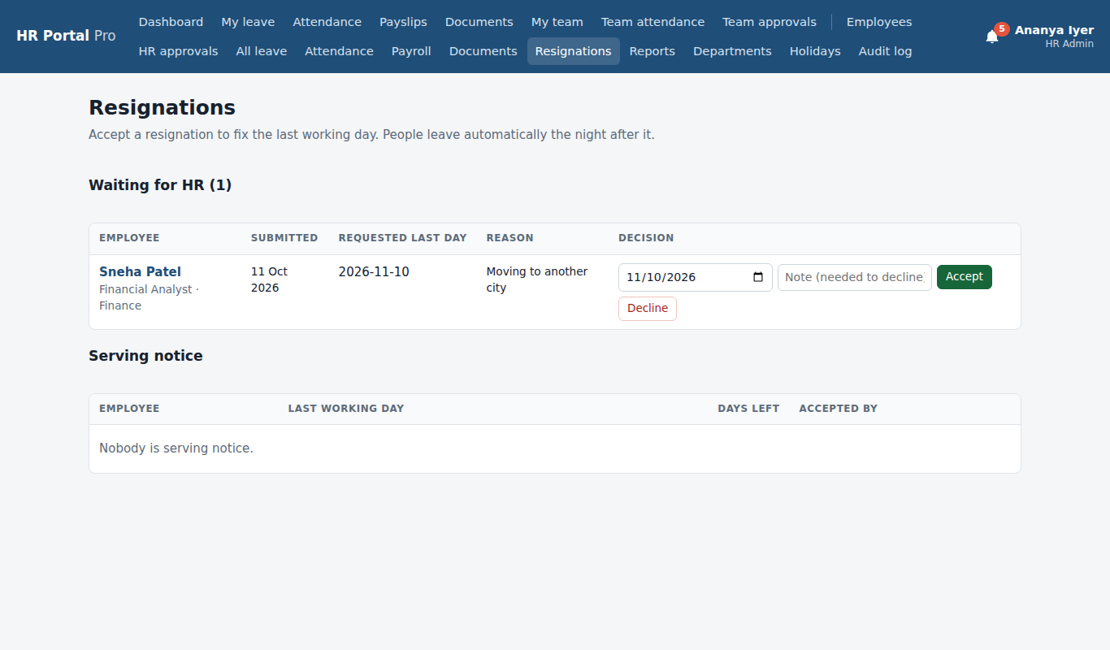

44. Resignation accepted HR Admin
Sneha now shows under Serving notice with 30 days left. She leaves automatically the night after her last working day (10 Nov 2026).
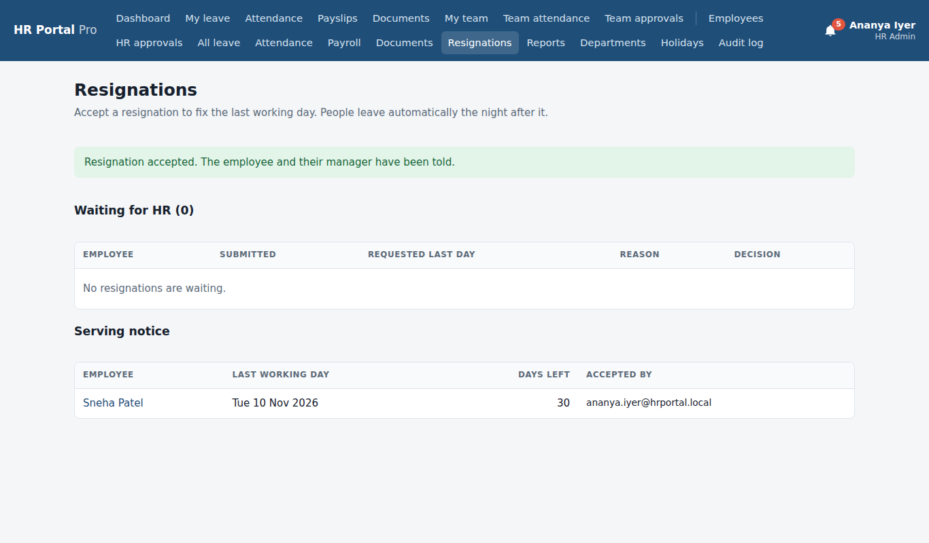

45. Reports HR Admin
Attendance, leave balances and the payroll register as CSV files for Excel.
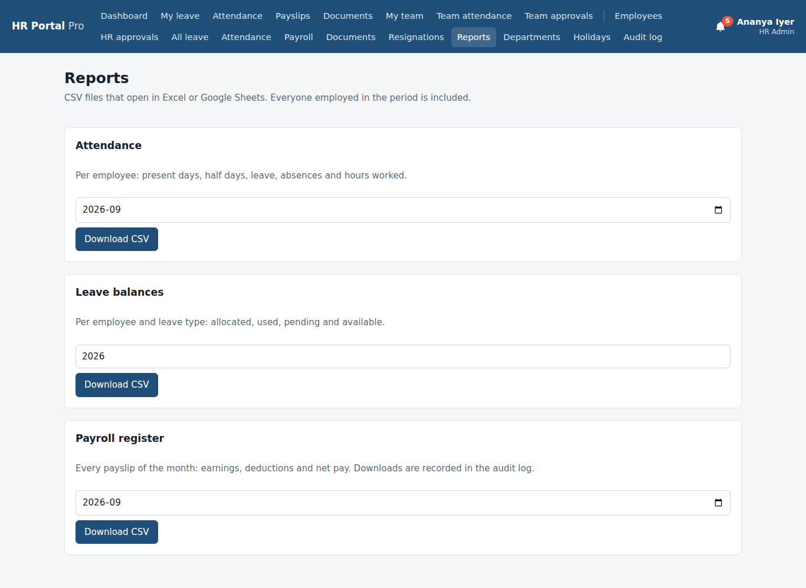

46. Offboard form HR Admin
Last working day and reason. Offboarding switches off the login and cancels future leave.
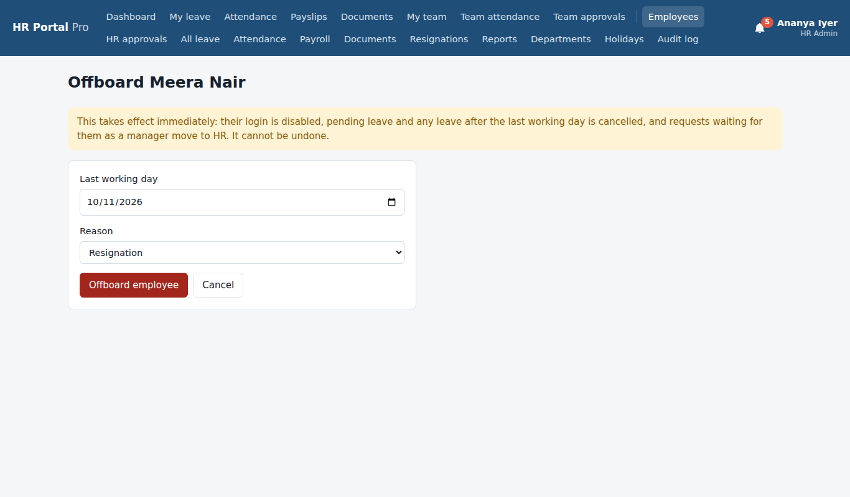

47. Audit log HR Admin
Every action in the portal: who did it, when, and what changed.
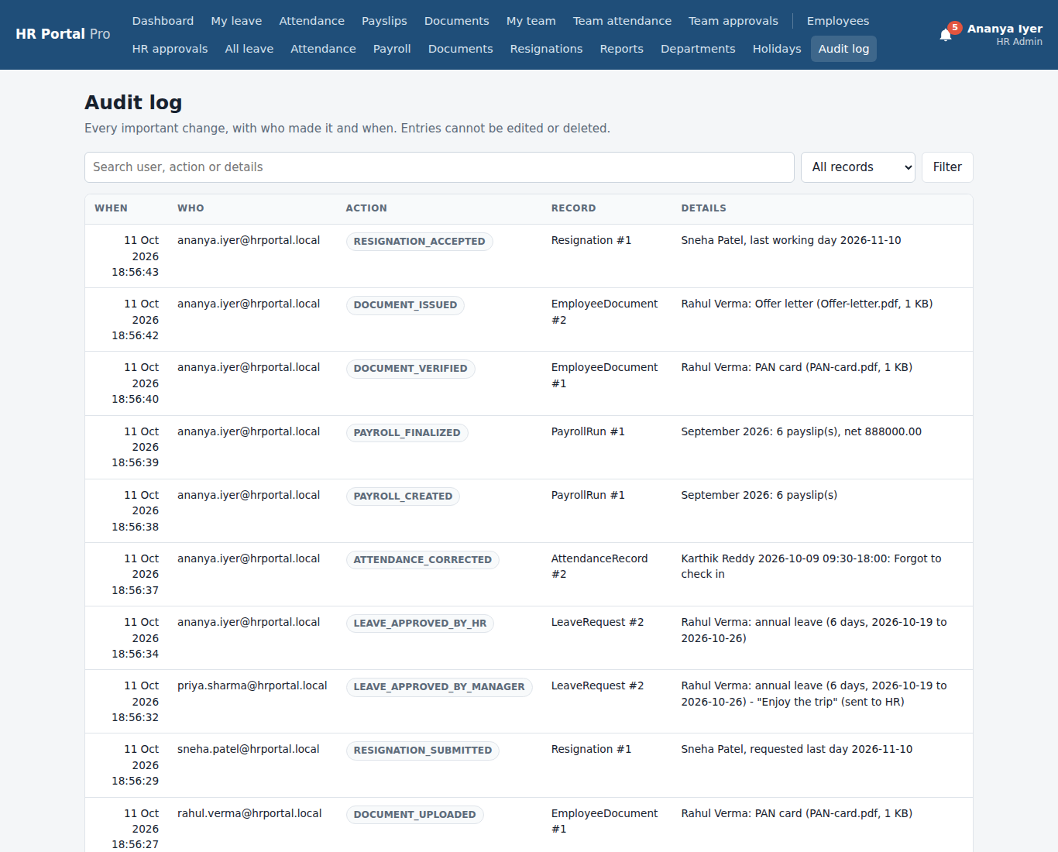

8. Employee: results
Signed in as: rahul.verma@hrportal.local
Rahul signs in again and sees the results of what his manager and HR did.
The flow, screen by screen
- Leave approved: The request now shows Approved, with the manager's comment.
- My payslips: The finalized September payslip, with Download PDF.
- Documents after HR: PAN card Verified, checklist 1 of 5, and the offer letter from HR.
- Notifications: Everything that happened, newest first. Each one was also sent by email.

48. Leave approved Employee: results
The request now shows Approved, with the manager's comment.
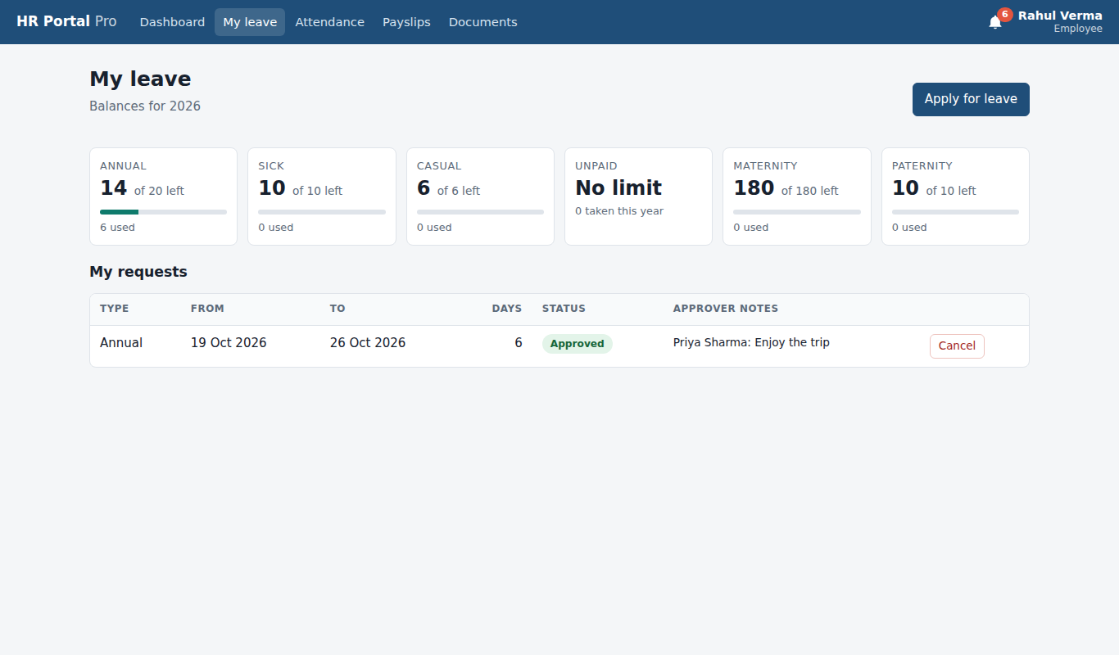

49. My payslips Employee: results
The finalized September payslip, with Download PDF.
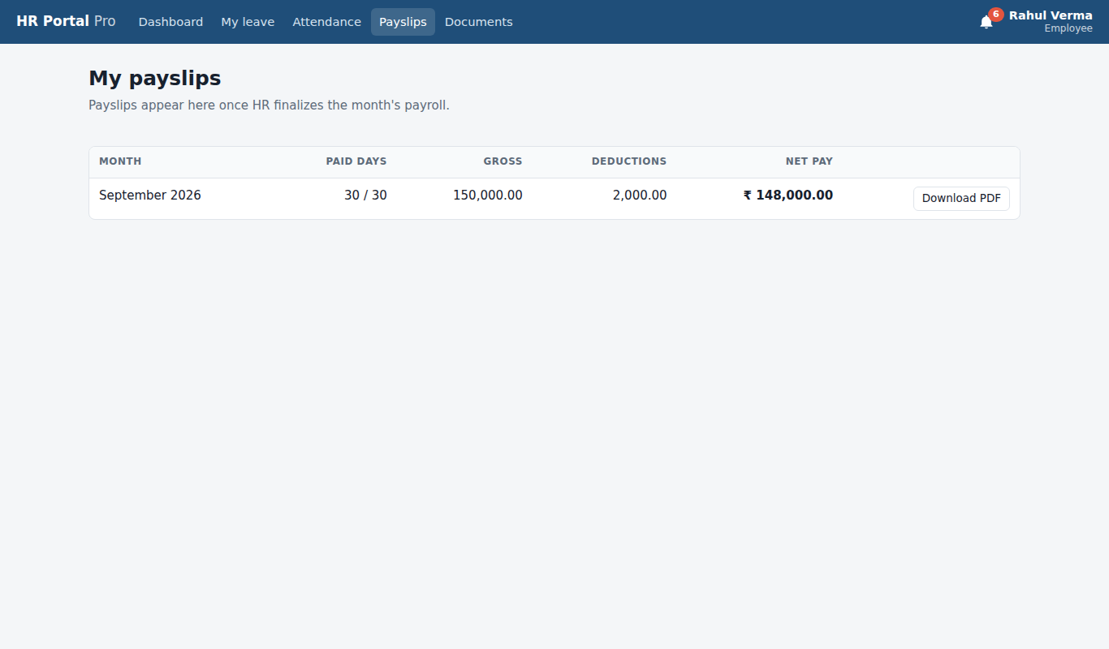

50. Documents after HR Employee: results
PAN card Verified, checklist 1 of 5, and the offer letter from HR.
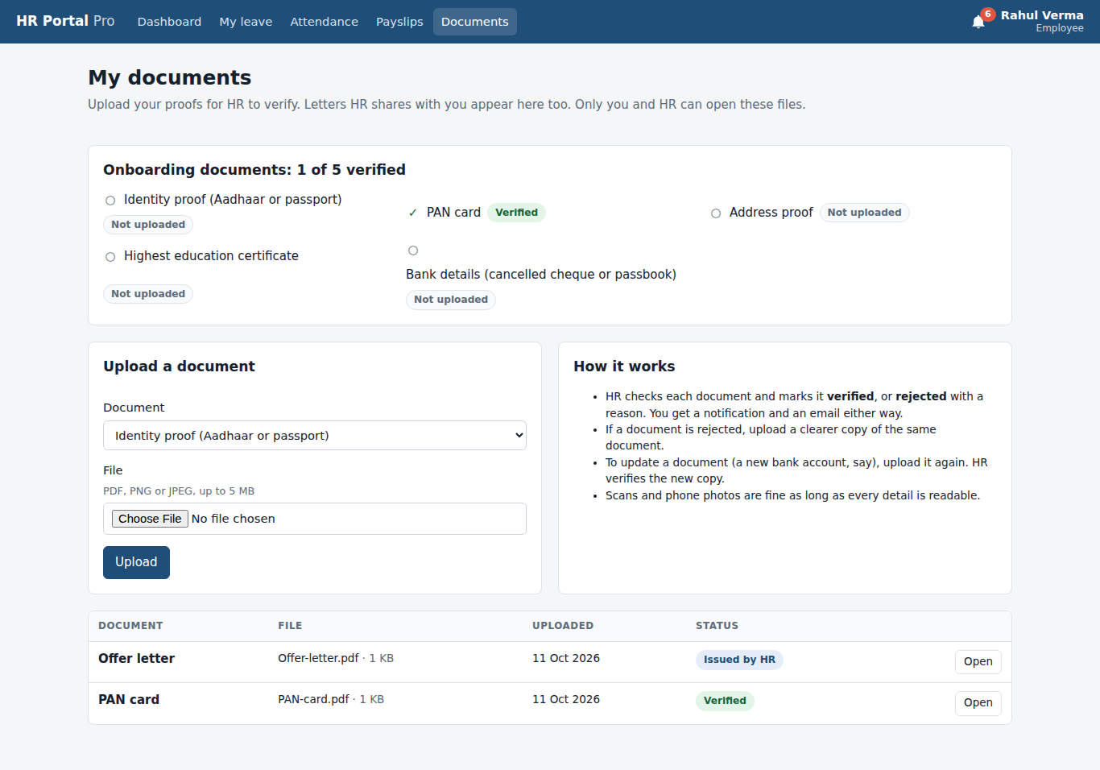

51. Notifications Employee: results
Everything that happened, newest first. Each one was also sent by email.
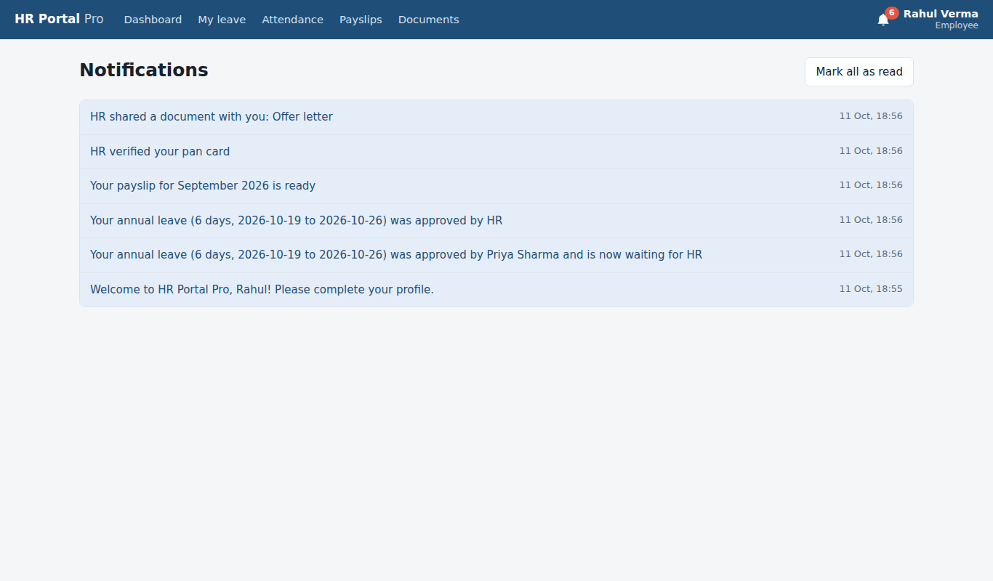

9. Super Admin: password reset
Signed in as: admin@hrportal.local
The Super Admin resets a password from the Users page.
The flow, screen by screen
- Password reset: A new temporary password for Meera; she must change it at her next sign-in.

52. Password reset Super Admin: password reset
A new temporary password for Meera; she must change it at her next sign-in.
