HR Portal Pro

Employee workflow
Step-by-step guide to every module, written for the person using the portal.
Everything an employee does in the portal: signing in for the first time, leave, attendance, payslips, documents and resignation. Each section below shows the module as a small flow diagram, then the exact steps: what to click and what you should see.
How to read the diagrams
- Purple: the item to click in the top menu
- Blue: a button to click or a field to fill in
- Green: the result you should see
- Red: something rejected
- Pink: an email is sent
- Amber diamond: a decision you make
Contents
1. Your first sign-in
2. Dashboard and your profile
3. Apply for leave
4. Track or cancel your leave
5. Attendance
6. Payslips
7. Documents
8. Resignation
9. Notifications, password and signing out

1. Your first sign-in
Before you start: Your work email and the temporary password HR gave you.
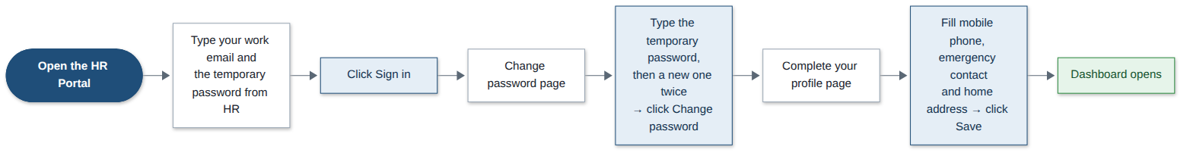
Step | What you do | What you see
1 | Open the HR Portal web address in your browser. | The sign-in page.
2 | Type your work email and the temporary password, then click Sign in. | The Change password page opens. You must set your own password first.
3 | Type the temporary password as the current password, then your new password twice. Click Change password. | The Complete your profile page opens.
4 | Fill in your mobile phone, emergency contact name and phone, and home address. Click Save. | Your Dashboard opens. From now on you go straight to it.
Good to know: Your new password needs at least 8 characters with letters and numbers. Five wrong passwords lock your account; ask the Super Admin to unlock it.

2. Dashboard and your profile
Before you start: Nothing.
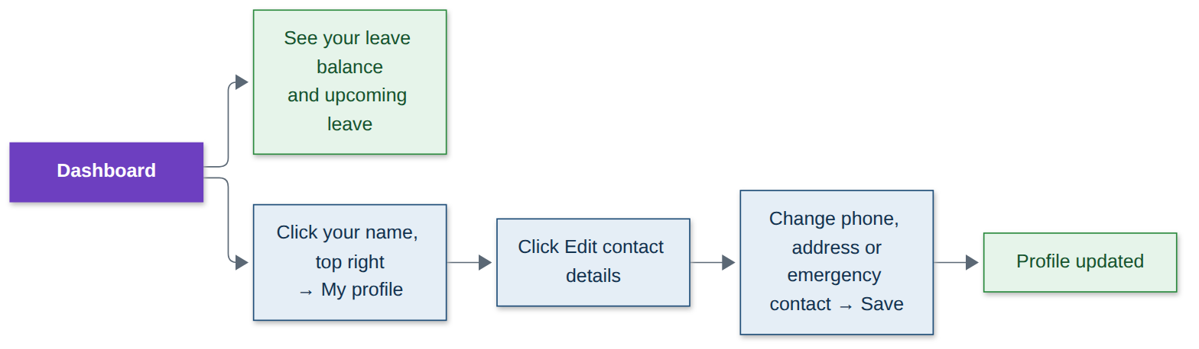
Step | What you do | What you see
1 | Look at your Dashboard after signing in. | Your leave balance for the year and your upcoming leave.
2 | Click your name at the top right, then My profile. | Your job details and contact details.
3 | Click Edit contact details. | The contact form.
4 | Change your phone, address or emergency contact, then click Save. | Your profile is updated.
Good to know: Your job title, manager and salary can only be changed by HR.

3. Apply for leave
Before you start: The dates you want off and the type of leave.
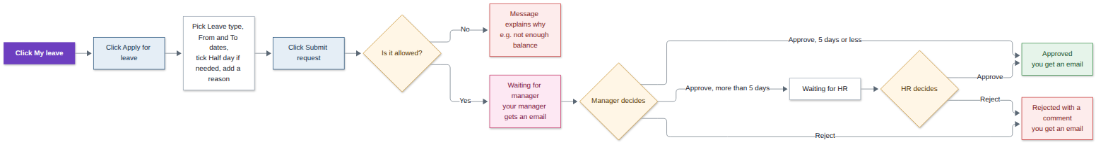
Step | What you do | What you see
1 | Click My leave in the top menu (or Apply for leave on the Dashboard). | Your leave requests.
2 | Click Apply for leave. | The leave form, with your balances and the year’s holidays.
3 | Pick the Leave type, the From and To dates, tick Half day if needed, and add a reason. | The form filled in.
4 | Click Submit request. | The request shows Waiting for manager, and your manager gets an email.
5 | Wait for your manager. | Up to 5 working days: approved or rejected by your manager. More than 5: it then goes to HR for final approval.
6 | Check your email or the bell icon. | You are told when it is approved or rejected, with any comment.
Good to know: Only working days count, so weekends and holidays are skipped. You cannot overlap another request, take more than your balance, or cross into next year in one request. Sick leave can be entered up to 7 days after; other leave must be for today or later.

4. Track or cancel your leave
Before you start: Nothing.
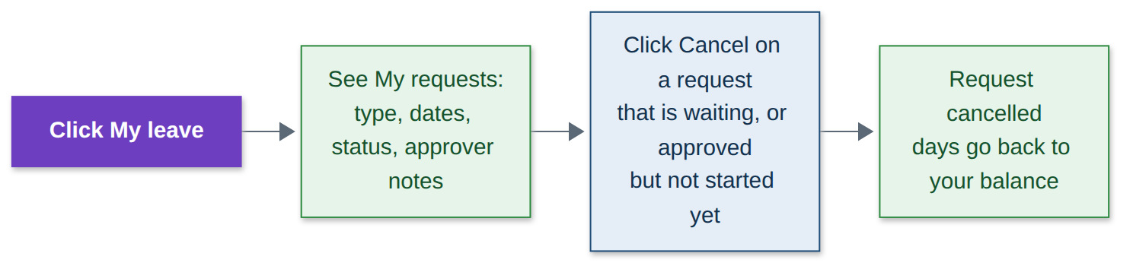
Step | What you do | What you see
1 | Click My leave in the top menu. | My requests: type, dates, status and approver notes.
2 | To cancel, click Cancel next to the request. | The request is cancelled and the days go back to your balance.
Good to know: You can cancel a request while it is waiting, or after approval as long as the leave has not started.

5. Attendance
Before you start: Nothing.
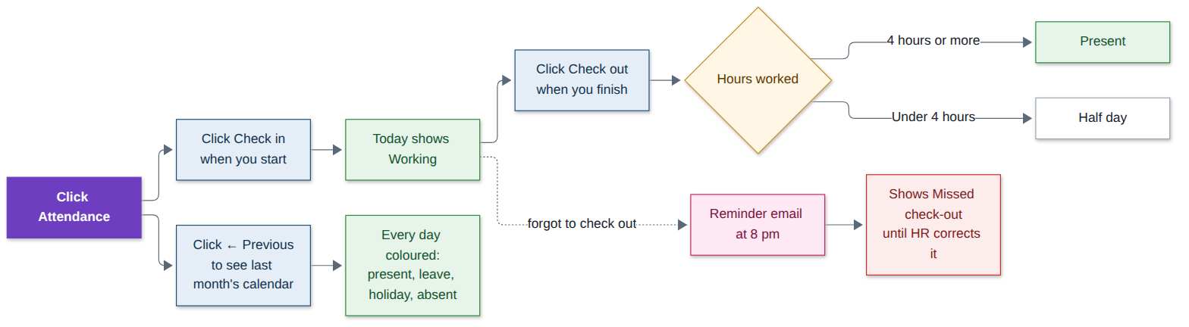
Step | What you do | What you see
1 | Click Attendance in the top menu. | Today’s box and this month’s calendar.
2 | When you start work, click Check in. | Today shows Working with your start time.
3 | When you finish, click Check out. | Today shows Present, or Half day if you worked under 4 hours.
4 | If you forget to check out. | You get a reminder email at 8 pm. If the day ends open it shows Missed check-out until HR corrects it.
5 | Click ← Previous to see an earlier month. | Every day coloured: present, half day, on leave, holiday, weekend or absent, with totals.
Good to know: You can check in and check out once a day.

6. Payslips
Before you start: HR must have finished the month’s payroll.
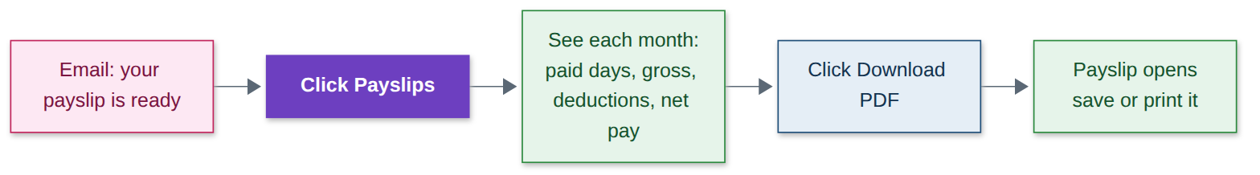
Step | What you do | What you see
1 | Watch for the email “Your payslip is ready”. | An email and a bell notification.
2 | Click Payslips in the top menu. | Each month with paid days, gross pay, deductions and net pay.
3 | Click Download PDF. | Your payslip opens. Save or print it.
Good to know: Only you and HR can see your payslips.

7. Documents
Before you start: Scans or phone photos of your documents (PDF, PNG or JPEG, up to 5 MB each).
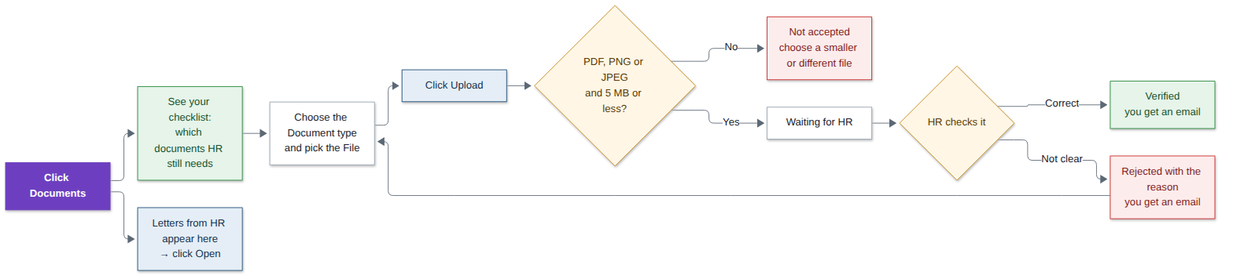
Step | What you do | What you see
1 | Click Documents in the top menu. | Your checklist: identity proof, PAN card, address proof, education certificate and bank details.
2 | Choose the Document type and pick the File. | The file is selected. Very large files are flagged before uploading.
3 | Click Upload. | It shows Waiting for HR, and HR gets an email.
4 | Wait for HR to check it. | Verified: ticked on your checklist. Rejected: the reason is shown.
5 | If it was rejected, upload a clearer copy the same way. | It goes back to Waiting for HR.
6 | Letters HR shares with you (offer, appraisal, experience) appear in the list. Click Open. | The letter opens.
Good to know: Only PDF, PNG and JPEG files are accepted. Only you and HR can open your documents; your manager cannot.

8. Resignation
Before you start: The last working day you would like and your reason for leaving.
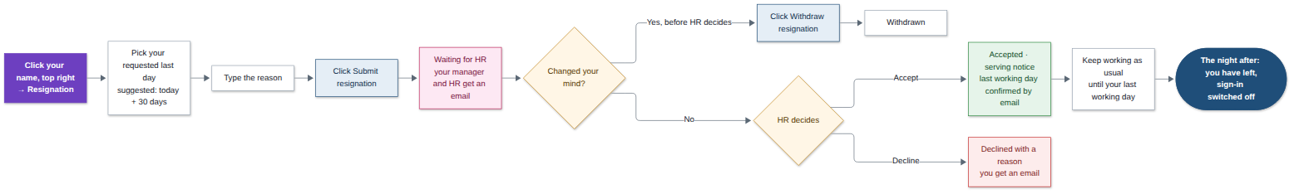
Step | What you do | What you see
1 | Click your name at the top right, then Resignation. | The Resign form. The notice period is 30 days.
2 | Pick your requested last working day. The form suggests today plus 30 days; you can ask for an earlier day. | The date is filled in.
3 | Type your reason, then click Submit resignation. | It shows Waiting for HR. Your manager and HR get an email.
4 | Changed your mind? Click Withdraw resignation. | It shows Withdrawn. You can only do this before HR decides.
5 | Wait for HR. | Accepted: HR confirms your last working day by email. Declined: you see HR’s reason.
6 | After acceptance, keep working as usual. | Attendance, leave and payslips carry on up to your last working day.
7 | The night after your last working day. | You have left the company and your sign-in is switched off.
Good to know: You can have only one resignation in progress. After acceptance, leave after your last working day is cancelled and can’t be requested, and your last payslip covers the days up to that day. To change an accepted date, talk to HR.

9. Notifications, password and signing out
Before you start: Nothing.
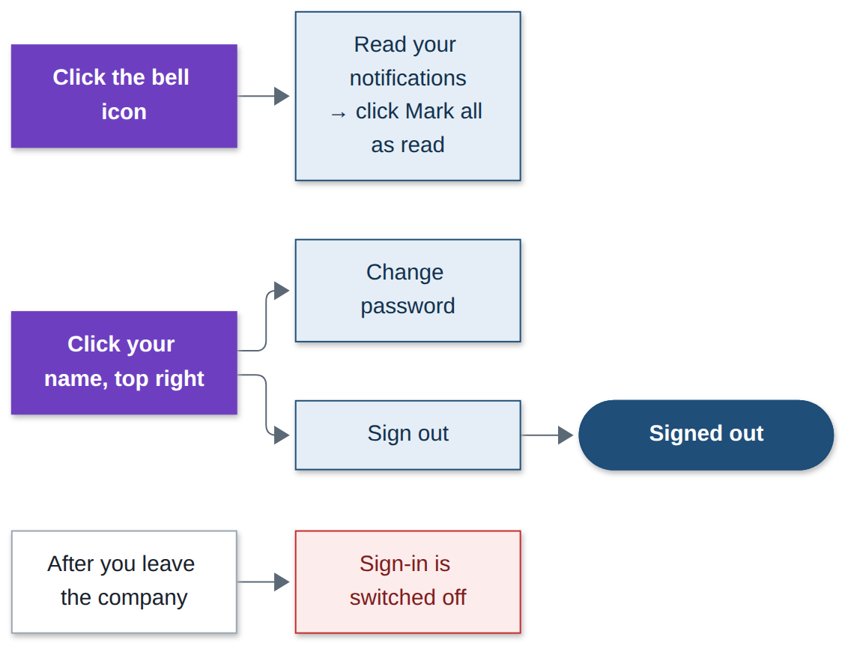
Step | What you do | What you see
1 | Click the bell icon at the top. | Everything that happened to your requests and documents.
2 | Click Mark all as read. | The counter clears.
3 | Click your name at the top right, then Change password. | Change it any time.
4 | Click your name at the top right, then Sign out. | You are signed out.
Good to know: Every notification is also sent to your email. When you leave the company, your sign-in is switched off.

