HR Portal Pro

Manager workflow
Step-by-step guide to every module, written for the person using the portal.
Everything a manager does in the portal: seeing the team, approving leave, following attendance and resignations, and their own self-service. Each section below shows the module as a small flow diagram, then the exact steps: what to click and what you should see.
How to read the diagrams
- Purple: the item to click in the top menu
- Blue: a button to click or a field to fill in
- Green: the result you should see
- Red: something rejected
- Pink: an email is sent
- Amber diamond: a decision you make
Contents
1. Your first sign-in
2. Dashboard
3. My team
4. Team approvals (leave)
5. Team attendance
6. When someone in your team resigns
7. Your own leave and self-service
8. Privacy, notifications and signing out

1. Your first sign-in
Before you start: Your work email and the temporary password HR gave you.
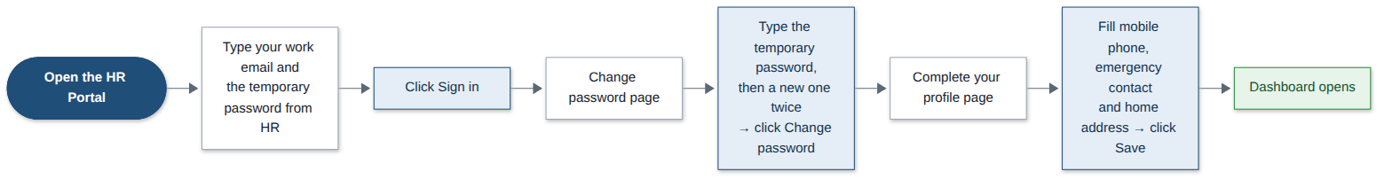
Step | What you do | What you see
1 | Open the HR Portal web address in your browser. | The sign-in page.
2 | Type your work email and the temporary password, then click Sign in. | The Change password page opens. You must set your own password first.
3 | Type the temporary password as the current password, then your new password twice. Click Change password. | The Complete your profile page opens.
4 | Fill in your mobile phone, emergency contact and home address. Click Save. | Your Dashboard opens, with the team menu items: My team, Team attendance and Team approvals.
Good to know: Your new password needs at least 8 characters with letters and numbers. Five wrong passwords lock your account; ask the Super Admin to unlock it.

2. Dashboard
Before you start: Nothing.
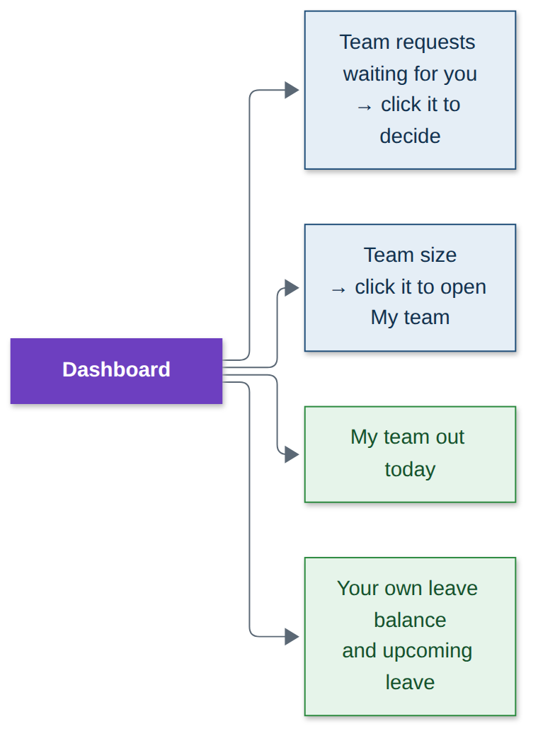
Step | What you do | What you see
1 | Look at your Dashboard after signing in. | Team requests waiting for you, your team size, and who in your team is out today.
2 | Click Team requests waiting for you. | Team approvals opens, ready to decide.
3 | Click the team size card. | My team opens.
4 | Look further down. | Your own leave balance and upcoming leave.

3. My team
Before you start: Nothing. Your direct reports are set by HR.
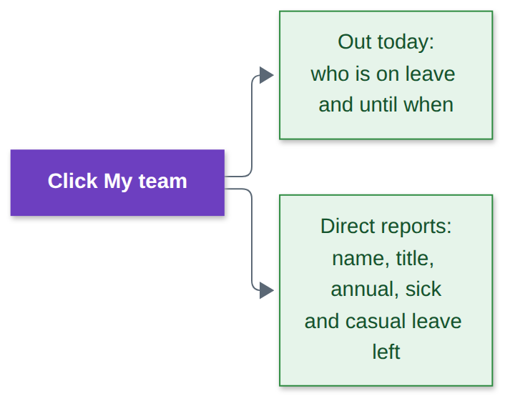
Step | What you do | What you see
1 | Click My team in the top menu. | Out today: who is on leave and until when.
2 | Look at Direct reports. | Each person’s name, title, and annual, sick and casual leave left.
Good to know: You only see the people who report directly to you. To change who reports to you, ask HR.

4. Team approvals (leave)
Before you start: Nothing. You get an email whenever someone in your team applies.
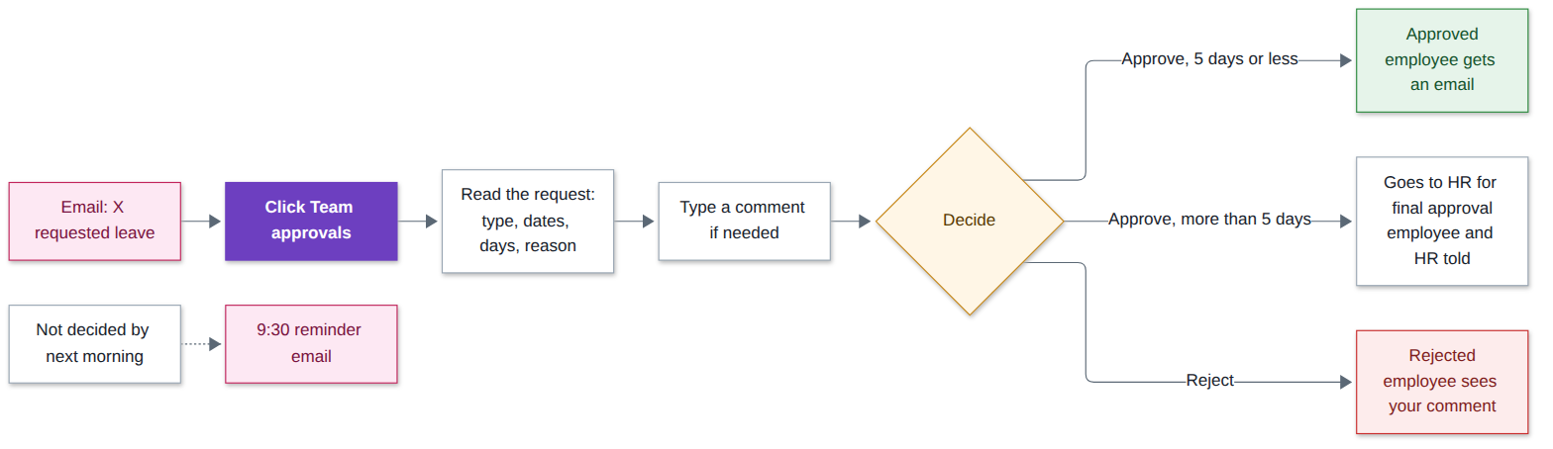
Step | What you do | What you see
1 | Open the email “… requested leave”, or click Team approvals in the top menu. | Requests from your direct reports: type, dates, days and reason.
2 | Read the request. Type a comment if you want. | —
3 | Click Approve. | Up to 5 working days: approved and the employee is emailed. More than 5: it goes to HR for final approval, and the employee and HR are told.
4 | Or click Reject. | Rejected; the employee sees your comment by email.
5 | If you leave a request undecided. | You get a reminder email on weekday mornings at 9:30.
Good to know: You can only decide requests from your own direct reports, and never your own leave.

5. Team attendance
Before you start: Nothing.
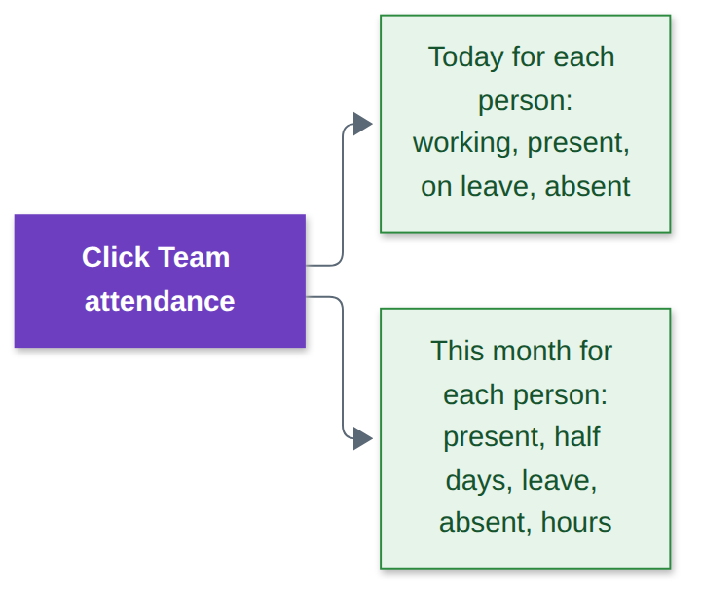
Step | What you do | What you see
1 | Click Team attendance in the top menu. | Today’s status for each person: working, present, on leave, absent and so on.
2 | Look at the month figures. | Present days, half days, leave, absent days and hours worked this month for each person.
Good to know: If someone forgot to check out or the time is wrong, ask HR: only HR can correct attendance.

6. When someone in your team resigns
Before you start: Nothing. HR makes the decision.
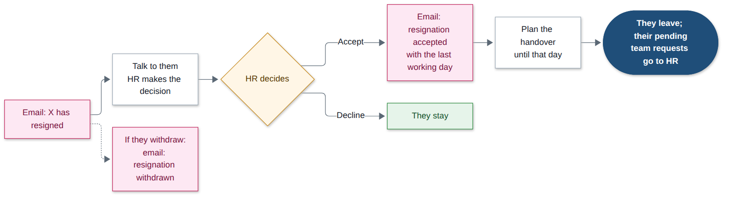
Step | What you do | What you see
1 | You get an email “… has resigned”, with the requested last working day. | Short notice is mentioned if the date is earlier than the 30-day notice period.
2 | Talk to the person and to HR. | HR accepts or declines the resignation.
3 | If HR accepts, you get an email with the last working day. | Plan the handover. They keep working normally until that day.
4 | If they withdraw it, you get an email. | Nothing changes.
5 | The night after their last working day. | They have left. Any of their pending team requests go to HR.
Good to know: Managers are told about resignations but cannot accept or decline them.

7. Your own leave and self-service
Before you start: Nothing.
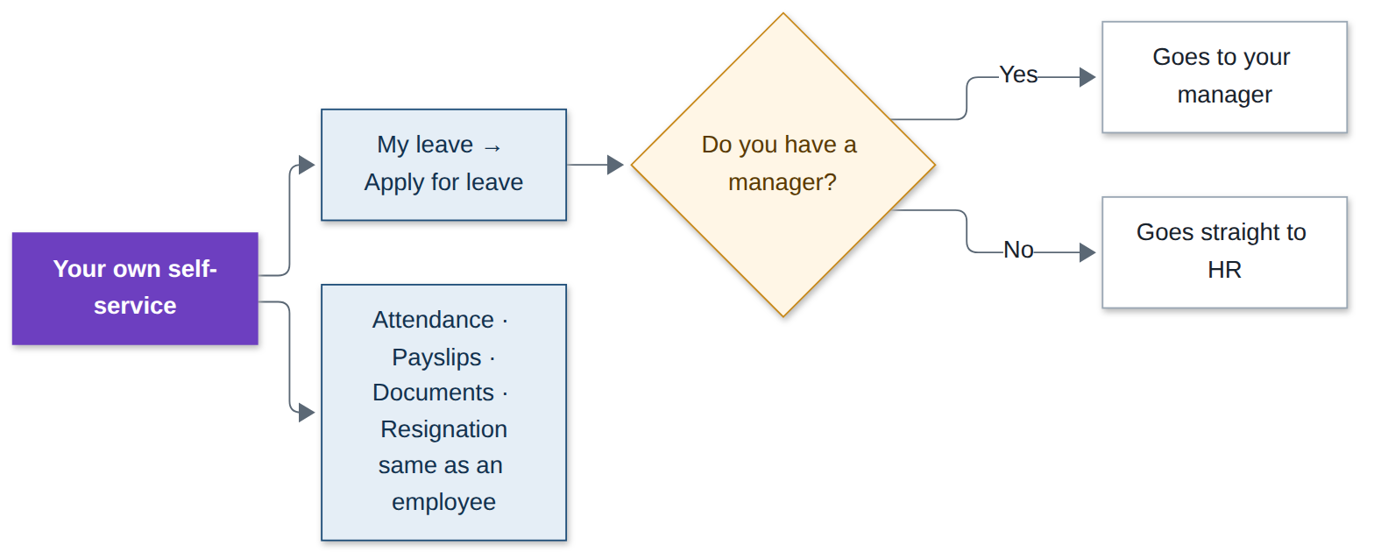
Step | What you do | What you see
1 | Click My leave, then Apply for leave, fill it in and click Submit request. | If you have a manager it goes to them; if not, it goes straight to HR.
2 | Use Attendance, Payslips, Documents and Resignation exactly like an employee. | See the Employee workflow document for the steps.

8. Privacy, notifications and signing out
Before you start: Nothing.
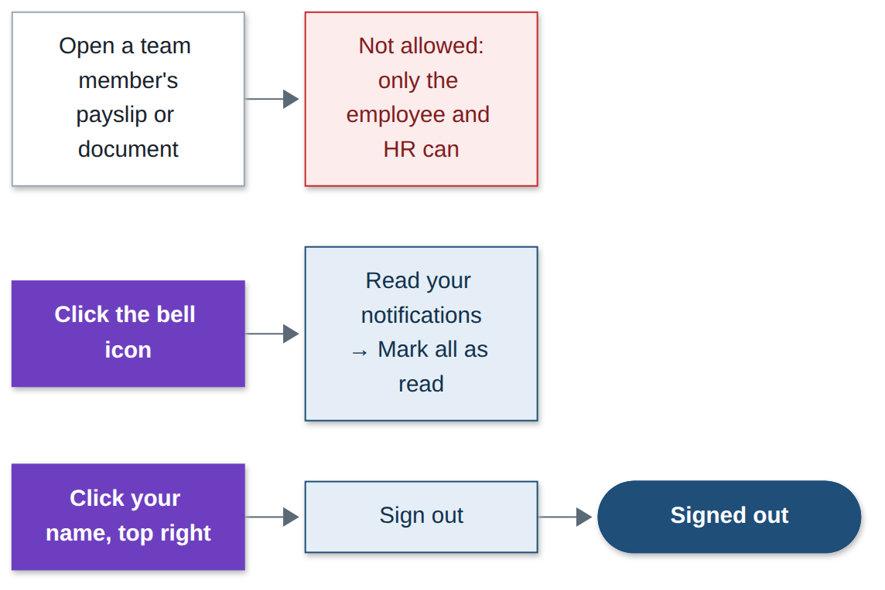
Step | What you do | What you see
1 | Try to open a team member’s payslip or document. | Not allowed: only the employee and HR can see them.
2 | Click the bell icon at the top, then Mark all as read. | Your notifications; the counter clears.
3 | Click your name at the top right, then Change password or Sign out. | Password changed, or you are signed out.
Good to know: Every notification is also sent to your email.

