HR Portal Pro

Super Admin workflow
Step-by-step guide to every module, written for the person using the portal.
The Super Admin sets up the company, gives people their sign-ins and access levels, and can use every HR screen. Each section below shows the module as a small flow diagram, then the exact steps: what to click and what you should see.
How to read the diagrams
- Purple: the item to click in the top menu
- Blue: a button to click or a field to fill in
- Green: the result you should see
- Red: something rejected
- Pink: an email is sent
- Amber diamond: a decision you make
Contents
1. Sign in and your password
2. Departments
3. Holidays
4. Employees: onboard, edit, documents, offboard
5. HR approvals (leave)
6. All leave
7. Attendance
8. Payroll
9. Documents
10. Reports
11. Users (sign-ins)
12. Audit log, notifications and signing out

1. Sign in and your password
Before you start: The portal web address and your Super Admin email and password.
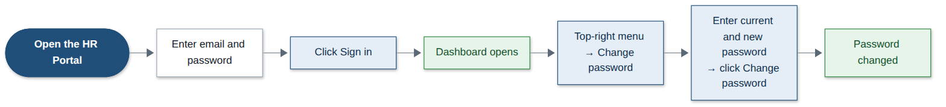
Step | What you do | What you see
1 | Open the HR Portal web address in your browser. | The sign-in page.
2 | Type your email and password, then click Sign in. | The Dashboard opens with company totals.
3 | Click your name at the top right, then Change password. | The Change password page.
4 | Type your current password, then the new one twice. Click Change password. | “Your password has been changed”.
Good to know: A new password needs at least 8 characters with letters and numbers. Five wrong passwords lock the account.

2. Departments
Before you start: Nothing. Set these up before adding people.
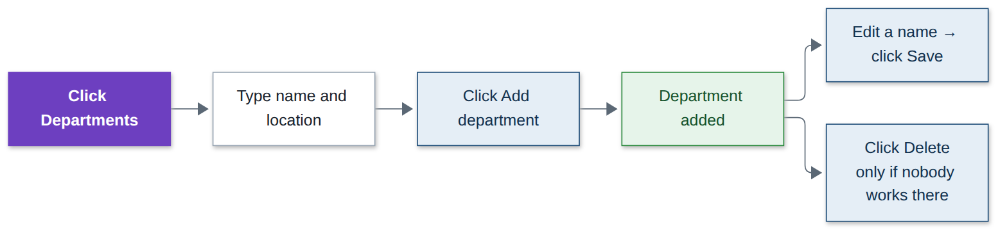
Step | What you do | What you see
1 | Click Departments in the top menu. | The list of departments.
2 | Type a name and location, then click Add department. | The department is added.
3 | To rename one, change the name in its row and click Save. | The new name is shown.
4 | To remove one, click Delete. | It is removed.
Good to know: A department that has (or had) employees cannot be deleted. Two departments cannot share a name.

3. Holidays
Before you start: The list of public holidays for the year.
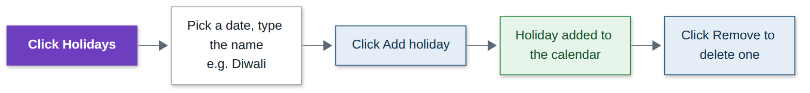
Step | What you do | What you see
1 | Click Holidays in the top menu. | This year’s holidays.
2 | Pick a date, type the name (for example Diwali), then click Add holiday. | The holiday is added. Leave on that day counts as zero days.
3 | To delete one, click Remove. | It is removed.
Good to know: The same date cannot be added twice.

4. Employees: onboard, edit, documents, offboard
Before you start: The new person’s details: name, work email, job title, department, manager, salary and joining date.
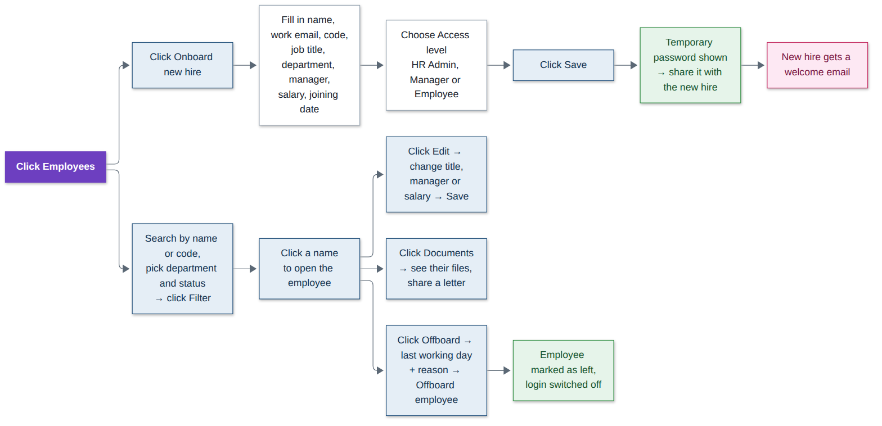
Step | What you do | What you see
1 | Click Employees in the top menu. | The employee directory.
2 | Click Onboard new hire. | The new employee form.
3 | Fill in the details. Choose the Access level: HR Admin, Manager or Employee. | All fields filled.
4 | Click Save. | A temporary password is shown once. Share it with the new hire.
5 | The new hire signs in. | They get a welcome email, must set their own password and complete their profile.
6 | To find someone: type a name or code, pick department and status, click Filter. | Matching employees.
7 | Click a name to open the employee. | Their employment details, profile and leave.
8 | Click Edit, change title, manager or salary, click Save. | Changes saved and recorded in the audit log.
9 | Click Documents to see their files or share a letter. | Their document list and checklist.
10 | Click Offboard, choose the last working day and reason, click Offboard employee. | They are marked as left, their sign-in is switched off and future leave is cancelled.
Good to know: Only the Super Admin can give someone the HR Admin or Super Admin access level.

5. HR approvals (leave)
Before you start: Nothing. Requests arrive here automatically.
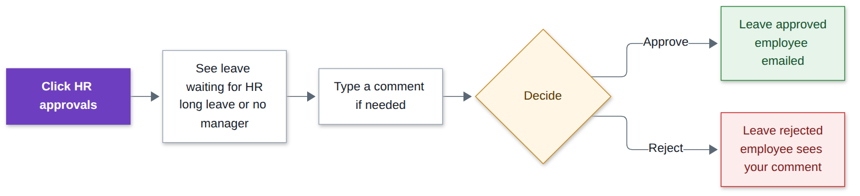
Step | What you do | What you see
1 | Click HR approvals in the top menu. | Leave waiting for HR: long leave already approved by the manager, or requests from people without a manager.
2 | Read the request. Type a comment if you want. | —
3 | Click Approve. | Leave approved; the employee gets an email.
4 | Or click Reject. | Leave rejected; the employee sees your comment.
Good to know: Leave of more than 5 working days always needs HR after the manager.

6. All leave
Before you start: Nothing.
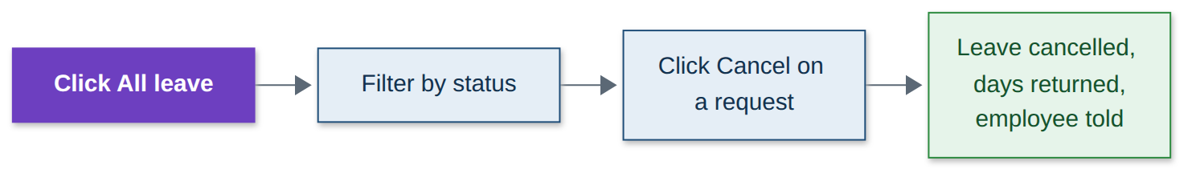
Step | What you do | What you see
1 | Click All leave in the top menu. | Every leave request in the company.
2 | Pick a status to filter. | Only those requests.
3 | Click Cancel on a request. | It is cancelled, the days go back to the employee and they are told.

7. Attendance
Before you start: Nothing.
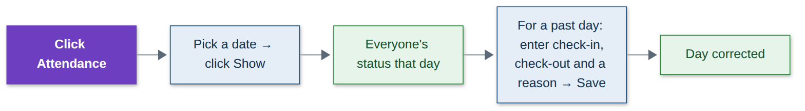
Step | What you do | What you see
1 | Click Attendance in the top menu. | Today’s status for every employee.
2 | Pick another date and click Show. | Everyone’s status for that day.
3 | For a past day, type check-in, check-out and a reason, then click Save. | The day is corrected.
Good to know: Only past days can be corrected, and a reason is always needed.

8. Payroll
Before you start: Salaries and leave should be up to date for the month.
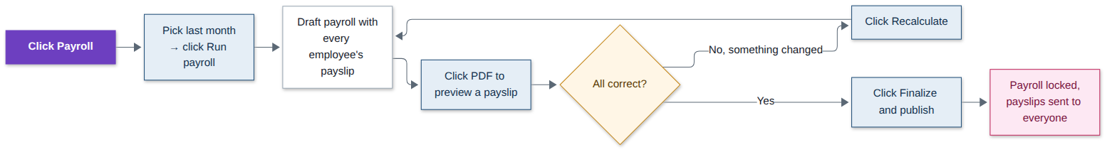
Step | What you do | What you see
1 | Click Payroll in the top menu. | Past payroll runs.
2 | Pick last month and click Run payroll. | A draft with a payslip for every employee.
3 | Click PDF next to any employee to preview a payslip. | The payslip opens.
4 | If a salary or leave changed, click Recalculate. | The draft is worked out again.
5 | When everything is correct, click Finalize and publish. | Payroll is locked and every employee gets their payslip by email.
Good to know: A month can only be run once, and future months cannot be run. Once finalized it cannot be changed.

9. Documents
Before you start: Nothing. Employees upload their own documents.
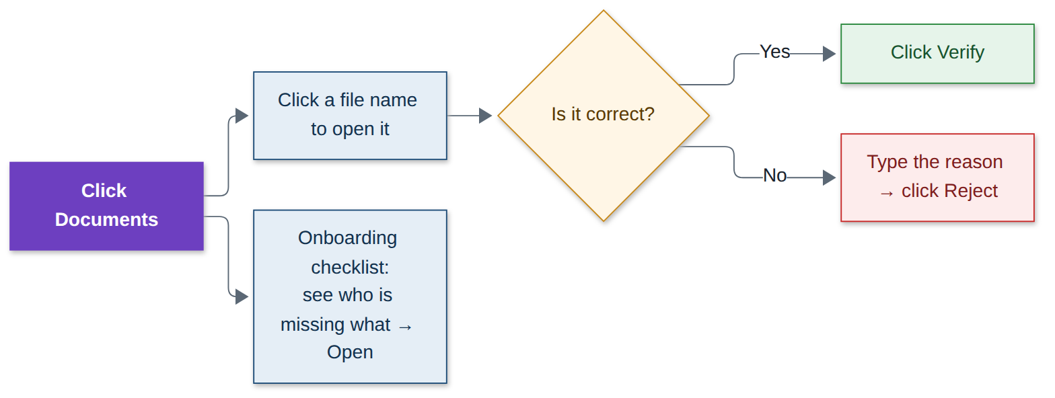
Step | What you do | What you see
1 | Click Documents in the top menu. | Documents waiting for checking, and the onboarding checklist.
2 | Click a file name to open it. | The document opens.
3 | If it is correct, click Verify. | Marked verified; the employee is emailed.
4 | If not, type the reason and click Reject. | The employee is asked to upload it again.
5 | In the onboarding checklist, click Open next to a person. | What they are still missing.
Good to know: Nobody can verify their own documents.

10. Reports
Before you start: The month or year you want.
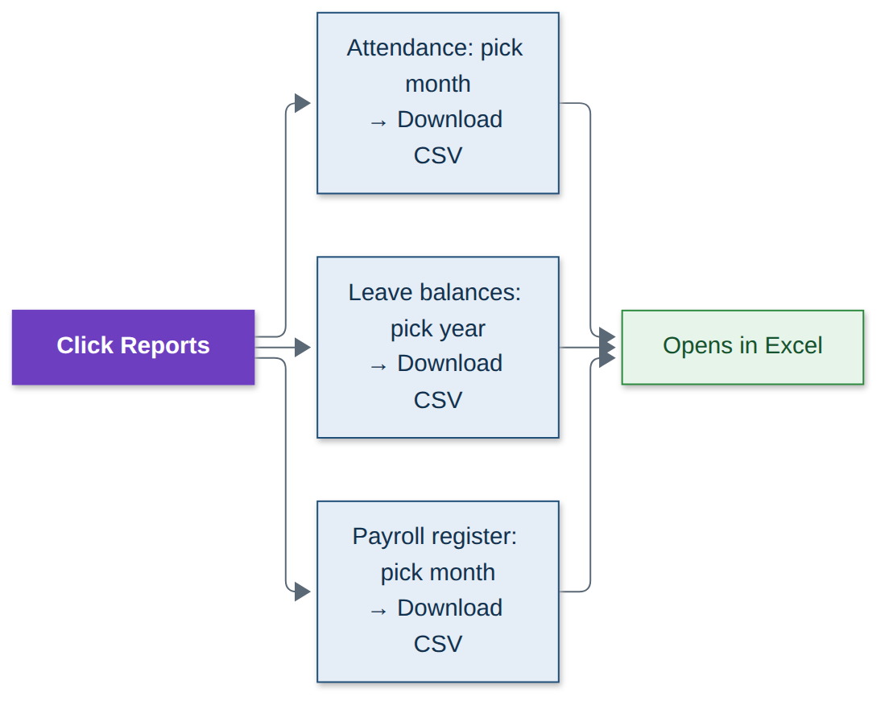
Step | What you do | What you see
1 | Click Reports in the top menu. | Three reports.
2 | Attendance: pick a month, click Download CSV. | A file that opens in Excel.
3 | Leave balances: pick a year, click Download CSV. | A file that opens in Excel.
4 | Payroll register: pick a month, click Download CSV. | A file that opens in Excel.

11. Users (sign-ins)
Before you start: Nothing.
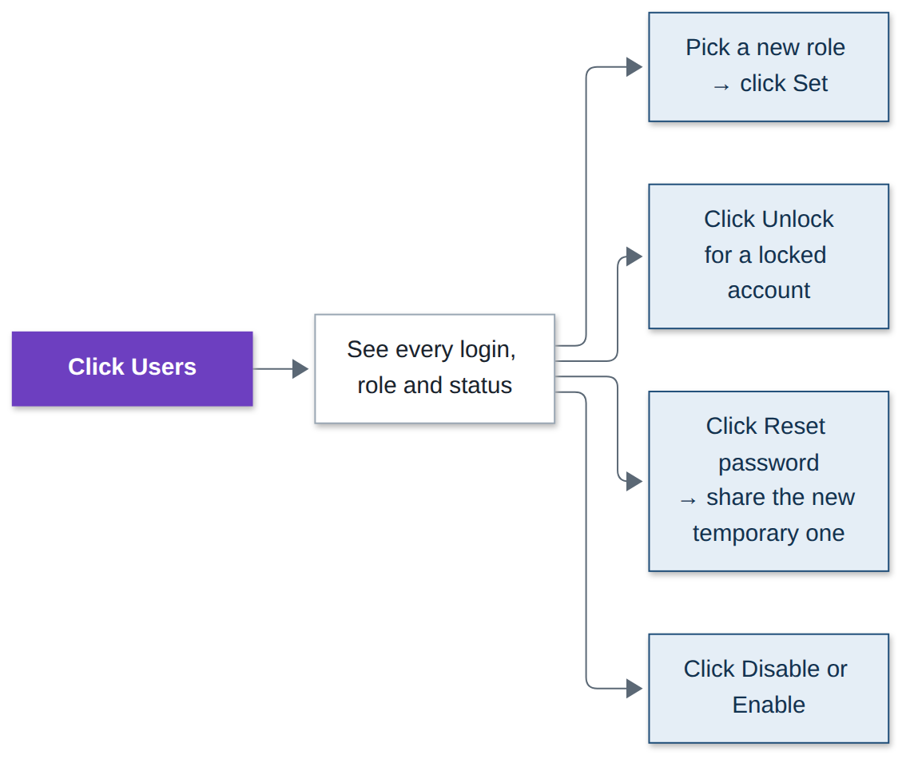
Step | What you do | What you see
1 | Click Users in the top menu. | Every sign-in with its role, status and last sign-in.
2 | To change a role, pick the new role and click Set. | Role changed.
3 | If someone is locked out, click Unlock. | They can sign in again.
4 | If someone forgot their password, click Reset password. | A new temporary password is shown. Share it with them.
5 | Click Disable to stop someone signing in, or Enable to allow it again. | Sign-in switched off or on.
Good to know: You cannot change your own role or disable yourself. People who have left cannot be enabled again.

12. Audit log, notifications and signing out
Before you start: Nothing.
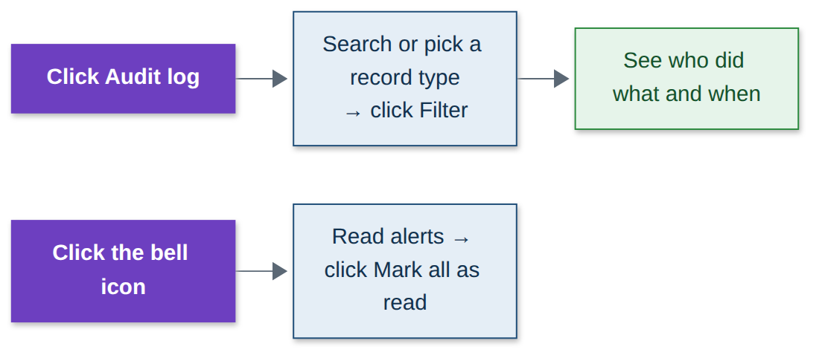
Step | What you do | What you see
1 | Click Audit log in the top menu. | Every action taken in the portal.
2 | Type a search or pick a record type, click Filter. | Who did what and when.
3 | Click the bell icon at the top. | Your notifications.
4 | Click Mark all as read. | The counter clears.
5 | Click your name at the top right, then Sign out. | You are signed out.

