HR Portal Pro

HR Admin workflow
Step-by-step guide to every module, written for the person using the portal.
The HR Admin runs the people processes: onboarding, leave approvals, attendance, payroll, documents, resignations and reports. Each section below shows the module as a small flow diagram, then the exact steps: what to click and what you should see.
How to read the diagrams
- Purple: the item to click in the top menu
- Blue: a button to click or a field to fill in
- Green: the result you should see
- Red: something rejected
- Pink: an email is sent
- Amber diamond: a decision you make
Contents
1. Your first sign-in
2. Dashboard
3. Departments
4. Holidays
5. Employees: onboard, edit, documents, offboard
6. HR approvals (leave)
7. All leave
8. Attendance
9. Payroll
10. Documents
11. Resignations
12. Reports
13. Audit log, notifications and signing out
14. Your own leave and self-service

1. Your first sign-in
Before you start: Your work email and the temporary password the Super Admin gave you.
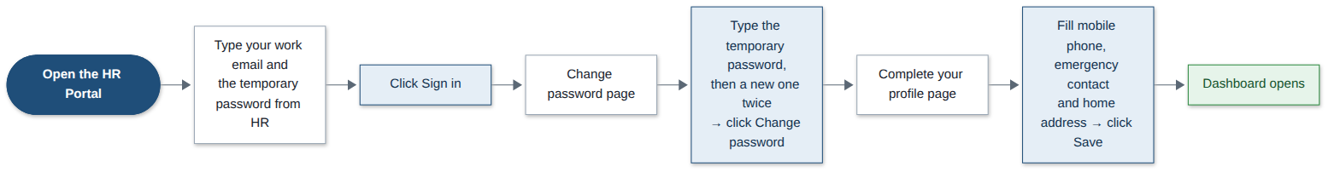
Step | What you do | What you see
1 | Open the HR Portal web address in your browser. | The sign-in page.
2 | Type your work email and the temporary password, then click Sign in. | The Change password page opens. You must set your own password first.
3 | Type the temporary password as the current password, then your new password twice. Click Change password. | The Complete your profile page opens.
4 | Fill in your mobile phone, emergency contact and home address. Click Save. | Your Dashboard opens with the HR menu: Employees, HR approvals, All leave, Attendance, Payroll, Documents, Resignations, Reports, Departments, Holidays and Audit log.
Good to know: Your new password needs at least 8 characters with letters and numbers. Five wrong passwords lock your account; ask the Super Admin to unlock it.

2. Dashboard
Before you start: Nothing.
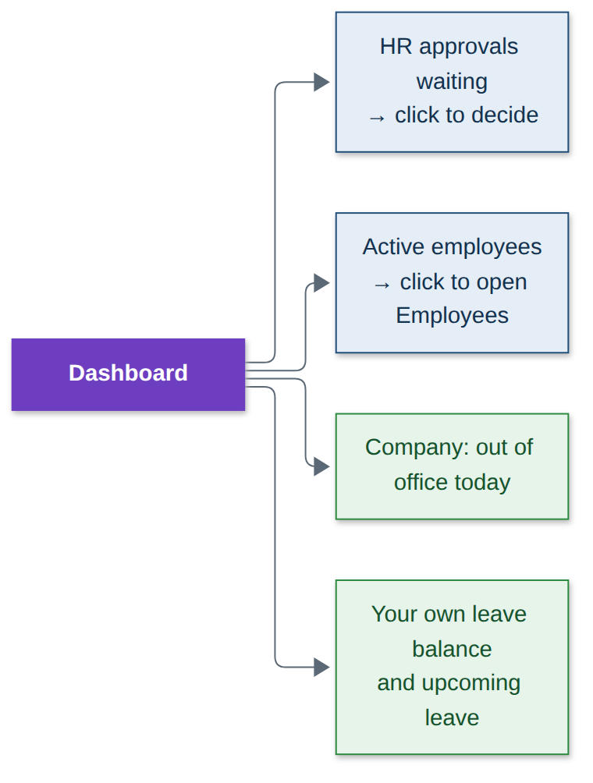
Step | What you do | What you see
1 | Look at your Dashboard after signing in. | HR approvals waiting, the number of active employees, and who in the company is out today.
2 | Click HR approvals waiting. | HR approvals opens, ready to decide.
3 | Click Active employees. | The employee directory opens.
4 | Look further down. | Your own leave balance and upcoming leave.

3. Departments
Before you start: Nothing. Set these up before adding people.
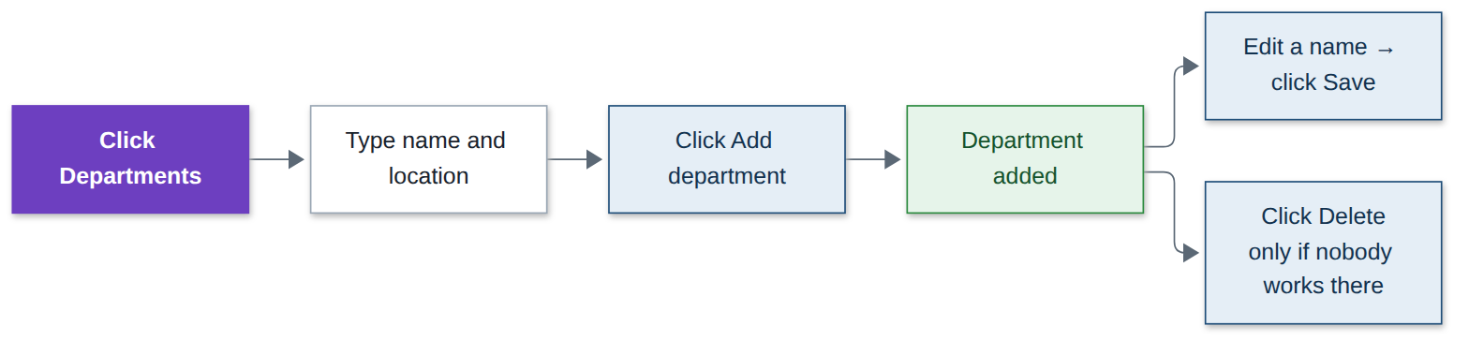
Step | What you do | What you see
1 | Click Departments in the top menu. | The list of departments.
2 | Type a name and location, then click Add department. | The department is added.
3 | To rename one, change the name in its row and click Save. | The new name is shown.
4 | To remove one, click Delete. | It is removed.
Good to know: A department that has (or had) employees cannot be deleted. Two departments cannot share a name.

4. Holidays
Before you start: The list of public holidays for the year.
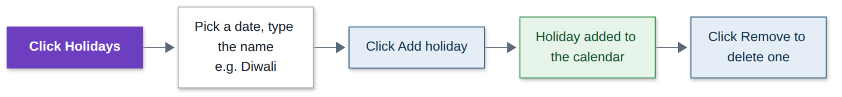
Step | What you do | What you see
1 | Click Holidays in the top menu. | This year’s holidays.
2 | Pick a date, type the name (for example Diwali), then click Add holiday. | The holiday is added. Leave on that day counts as zero days.
3 | To delete one, click Remove. | It is removed.
Good to know: The same date cannot be added twice.

5. Employees: onboard, edit, documents, offboard
Before you start: The new person’s details: name, work email, employee code, job title, department, manager, salary and joining date.
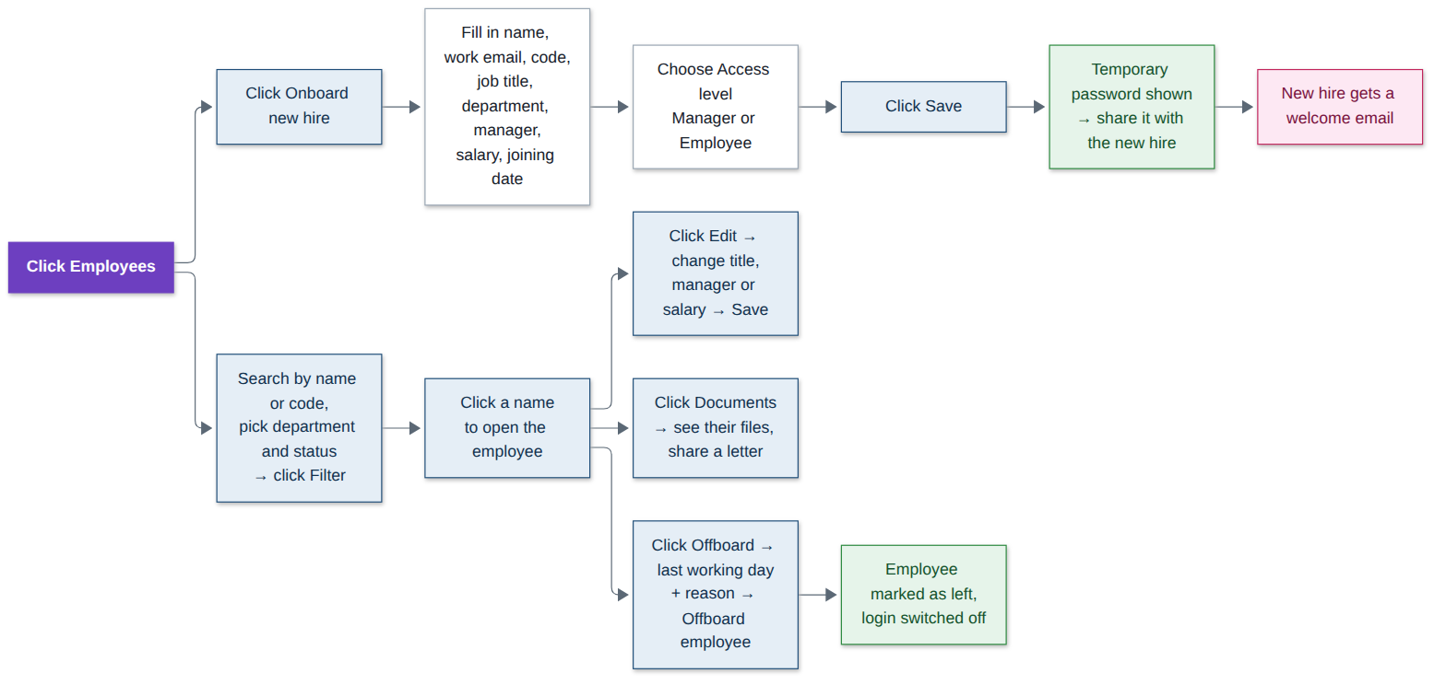
Step | What you do | What you see
1 | Click Employees in the top menu. | The employee directory.
2 | Click Onboard new hire. | The new employee form.
3 | Fill in the details. Choose the Access level: Manager or Employee. | All fields filled.
4 | Click Save. | A temporary password is shown once. Share it with the new hire. They get a welcome email and their manager is told they are joining.
5 | To find someone: type a name or code, pick department and status, click Filter. | Matching employees.
6 | Click a name to open the employee. | Their employment details, profile, leave balance and leave history.
7 | Click Edit, change title, manager or salary, click Save. | Changes saved and recorded in the audit log.
8 | Click Documents to see their files or share a letter. | Their document list and checklist.
9 | Click Offboard, choose the last working day and reason, click Offboard employee. | They are marked as left, their sign-in is switched off and future leave is cancelled.
Good to know: HR can give the Manager or Employee access level. Only the Super Admin can make someone an HR Admin. Use Offboard for exits that are not resignations; resignations go through the Resignations page.

6. HR approvals (leave)
Before you start: Nothing. Requests arrive here automatically and you get an email.
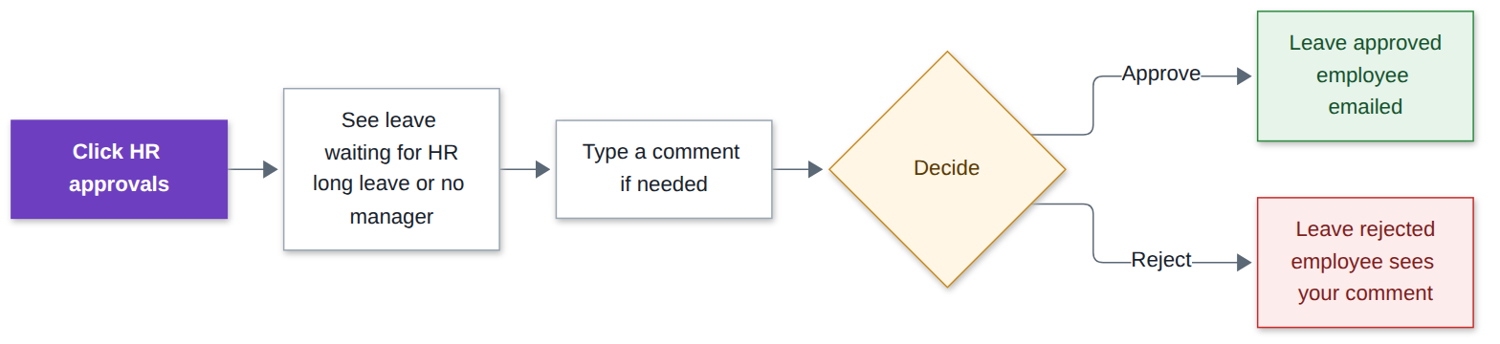
Step | What you do | What you see
1 | Click HR approvals in the top menu. | Leave waiting for HR: requests over 5 working days already approved by the manager, and requests from people without a manager.
2 | Read the request. Type a comment if you want. | —
3 | Click Approve. | Leave approved, days taken off the balance, and the employee gets an email.
4 | Or click Reject. | Leave rejected; the employee sees your comment.
Good to know: You cannot decide your own leave. Weekday mornings at 9:30 you get a reminder if requests are waiting.

7. All leave
Before you start: Nothing.
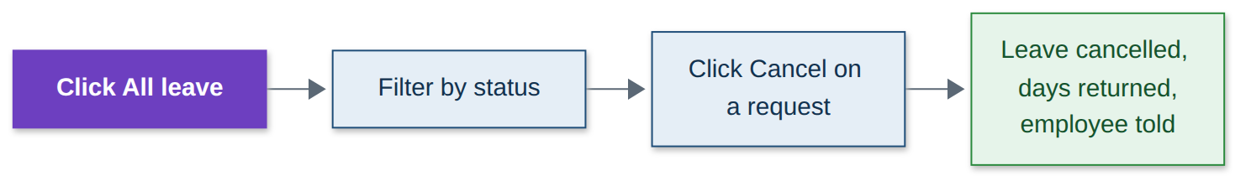
Step | What you do | What you see
1 | Click All leave in the top menu. | Every leave request in the company.
2 | Pick a status to filter. | Only those requests.
3 | Click Cancel on a request. | It is cancelled, the days go back to the employee and they are told.

8. Attendance
Before you start: Nothing.
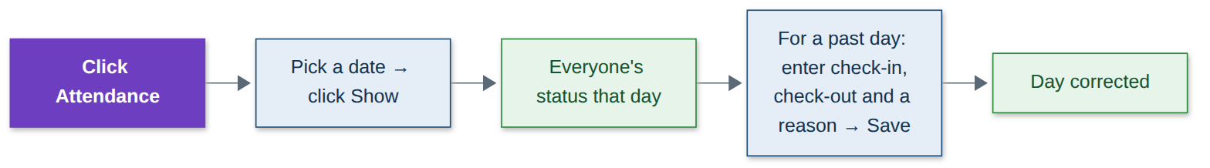
Step | What you do | What you see
1 | Click Attendance in the top menu. | Today’s status for every employee.
2 | Pick another date and click Show. | Everyone’s status for that day.
3 | For a past day, type check-in, check-out and a reason, then click Save. | The day is corrected, for example a forgotten check-out.
Good to know: Only past days can be corrected, check-out must be after check-in, and a reason is always needed.

9. Payroll
Before you start: Salaries and leave should be up to date for the month.
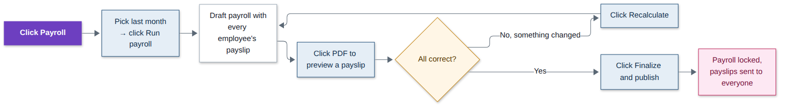
Step | What you do | What you see
1 | Click Payroll in the top menu. | Past payroll runs.
2 | Pick last month and click Run payroll. | A draft with a payslip for every employee: paid days, loss of pay, gross, deductions and net pay.
3 | Click PDF next to any employee to preview a payslip. | The payslip opens. Employees cannot see drafts.
4 | If a salary or leave changed, click Recalculate. | The draft is worked out again.
5 | When everything is correct, click Finalize and publish. | Payroll is locked and every employee gets their payslip by email.
Good to know: A month can only be run once, and future months cannot be run. Once finalized it cannot be changed. On the 5th of each month you get a reminder if last month is not finished.

10. Documents
Before you start: Nothing. Employees upload their own documents and you get an email.
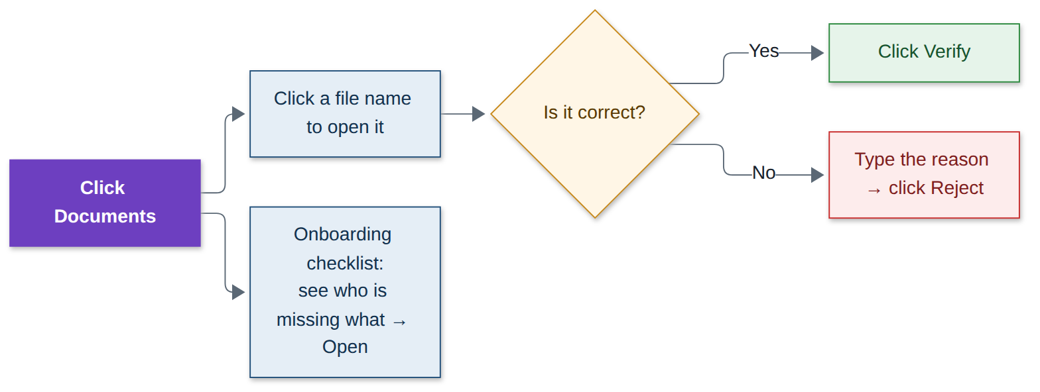
Step | What you do | What you see
1 | Click Documents in the top menu. | Documents waiting for checking, and the onboarding checklist.
2 | Click a file name to open it. | The document opens.
3 | If it is correct, click Verify. | Marked verified; the employee is emailed.
4 | If not, type the reason and click Reject. | The employee is asked to upload it again.
5 | In the onboarding checklist, click Open next to a person. | What they are still missing. From there you can share a letter.
Good to know: You cannot verify your own documents; another HR admin has to. Opening someone’s document is recorded in the audit log.

11. Resignations
Before you start: Nothing. You get an email when someone resigns.
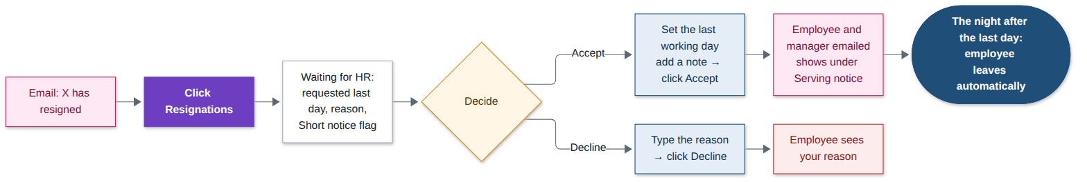
Step | What you do | What you see
1 | Click Resignations in the top menu. | Waiting for HR, Serving notice and Recently closed.
2 | Read the request: requested last day, reason and a Short notice flag if it is under 30 days. | —
3 | To accept: set the last working day, add a note if you want, click Accept. | The employee and their manager are emailed. They move to Serving notice with the days left.
4 | To decline: type the reason, click Decline. | The employee sees your reason.
5 | The night after their last working day. | They leave automatically: sign-in off, remaining leave cancelled, and you are told.
Good to know: You cannot decide your own resignation. After acceptance, leave after the last working day is cancelled and their last payslip covers the days up to that day.

12. Reports
Before you start: The month or year you want.
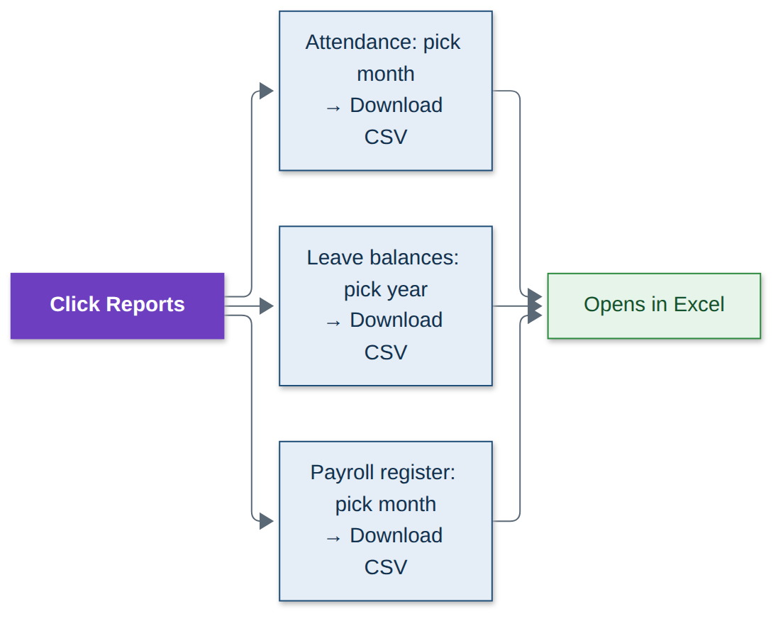
Step | What you do | What you see
1 | Click Reports in the top menu. | Three reports.
2 | Attendance: pick a month, click Download CSV. | A file that opens in Excel.
3 | Leave balances: pick a year, click Download CSV. | A file that opens in Excel.
4 | Payroll register: pick a month, click Download CSV. | A file that opens in Excel.

13. Audit log, notifications and signing out
Before you start: Nothing.
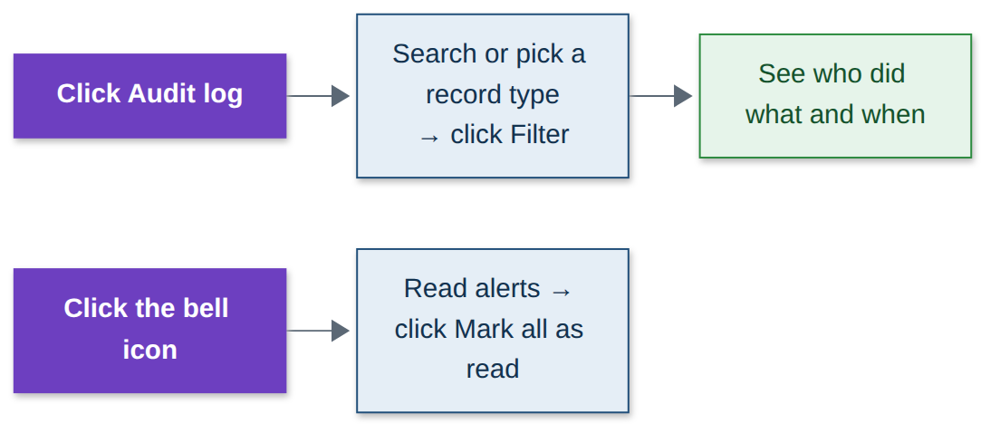
Step | What you do | What you see
1 | Click Audit log in the top menu. | Every action taken in the portal.
2 | Type a search or pick a record type, click Filter. | Who did what and when.
3 | Click the bell icon at the top, then Mark all as read. | Your notifications; the counter clears.
4 | Click your name at the top right, then Sign out. | You are signed out.

14. Your own leave and self-service
Before you start: Nothing.
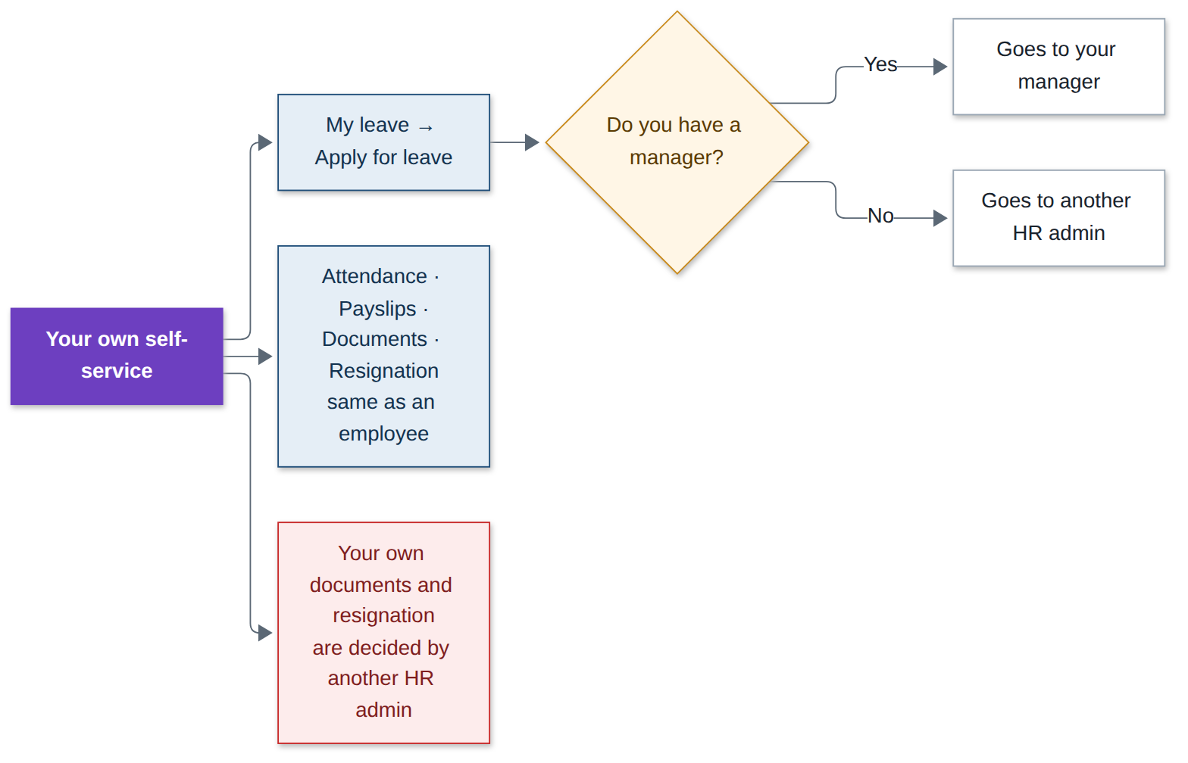
Step | What you do | What you see
1 | Click My leave, then Apply for leave, fill it in and click Submit request. | If you have a manager it goes to them; if not, another HR admin decides it.
2 | Use Attendance, Payslips, Documents and Resignation exactly like an employee. | See the Employee workflow document for the steps.
Good to know: Your own leave, documents and resignation are always decided by someone else.

