INTERNET PROGRAMMING LAB

EXPERIMENT 10
StyleHub Online Fashion Shopping Platform
Student Name: Thalamati Aasritha
Register Number: 192311008
Batch: CSE
Date: 26/10/2026
Submitted as part of the Internet Programming Laboratory

1. Aim
To design and implement the stylehub online fashion shopping platform using HTML5, CSS3 and JavaScript, with product browsing, category filtering, cart management and a sample checkout flow.

2. Problem Description
The StyleHub platform provides a fashion catalogue for clothing, footwear and accessories. Products are organized by category, with search and filtering, product descriptions and prices, and a shopping bag. The source brief also calls for user accounts, size guides, reviews, order tracking, returns/exchanges, wish lists, recommendations and administrator product maintenance.

3. Software and Technologies
• HTML5 — page structure
• CSS3 — responsive layout and styling
• JavaScript — search, category filtering, cart operations and checkout feedback
• Google Chrome, Safari, Firefox or another modern browser

4. Algorithm / Procedure
- Load the homepage and display the product categories.
- Show the available products with names, descriptions and prices.
- Allow the user to search by keyword or filter by category.
- Add selected products to the cart and update the item count and total.
- Allow removal of cart items and recalculate the total.
- Validate checkout state and display a demo checkout message.

5. Program Code (HTML, CSS and JavaScript)
Save the complete code as Experiment_10_Source.html and open it in a browser. The standalone source is also included separately in the ZIP package.
<!DOCTYPE html><html lang="en"><head><meta charset="UTF-8"><meta name="viewport" content="width=device-width,initial-scale=1"><title>StyleHub | Fashion Store</title>
<style>
*{box-sizing:border-box}body{margin:0;font-family:Arial,sans-serif;background:#faf8f6;color:#292521}header{padding:20px 6%;background:#282321;color:white;display:flex;justify-content:space-between;align-items:center}header strong{font-family:Georgia,serif;font-size:28px;letter-spacing:2px}nav a{color:white;text-decoration:none;margin-left:20px}.hero{padding:48px 6%;background:linear-gradient(110deg,#f0e5dc,#faf8f6)}.hero h1{font:42px Georgia,serif;margin:0 0 12px}.hero p{color:#6f625b}.search{display:flex;gap:10px;max-width:700px;margin-top:22px}input,select{padding:12px;border:1px solid #d8cec6;border-radius:5px;min-width:0}input{flex:1}button{background:#8b5e4a;color:white;border:0;border-radius:5px;padding:12px 16px;cursor:pointer;font-weight:bold}.layout{display:grid;grid-template-columns:205px 1fr;gap:22px;padding:30px 6%}.side,.card,.cart{background:white;border:1px solid #eee6e0;border-radius:10px;padding:18px}.side button{display:block;width:100%;margin:8px 0;text-align:left;background:#f5eee9;color:#5a4034}.grid{display:grid;grid-template-columns:repeat(auto-fit,minmax(210px,1fr));gap:18px}.product .image{height:145px;border-radius:7px;display:grid;place-items:center;background:#f4ebe4;font-size:58px}.product h3{margin-bottom:5px}.muted{font-size:14px;color:#81756e}.price{font-size:21px;font-weight:bold}.tag{font-size:11px;text-transform:uppercase;letter-spacing:1px;color:#8b5e4a}.cart{margin:0 6% 30px}.hidden{display:none}footer{text-align:center;padding:22px;color:#81756e}@media(max-width:700px){.layout{grid-template-columns:1fr}.hero h1{font-size:32px}.search{flex-direction:column}header{flex-direction:column;gap:12px;align-items:flex-start}}
</style></head><body>
<header><strong>STYLEHUB</strong><nav><a href="#products">New arrivals</a><a href="#products">Collections</a><a href="#cart">Bag (<span id="count">0</span>)</a></nav></header>
<section class="hero"><p class="tag">The new season edit</p><h1>Style that feels like you.</h1><p>Thoughtfully selected fashion for everyday moments and special occasions.</p><form class="search" id="searchForm"><input id="query" placeholder="Search clothing, footwear and accessories"><button>Find your style</button></form></section>
<main class="layout"><aside class="side"><h3>Shop by category</h3><button onclick="filter('All')">All collections</button><button onclick="filter('Women')">Women</button><button onclick="filter('Men')">Men</button><button onclick="filter('Footwear')">Footwear</button><button onclick="filter('Accessories')">Accessories</button><p class="muted">Sample catalogue · demo prices</p></aside><section id="products"><h2>Curated for you</h2><p class="muted">Explore collections and add your favourites to the shopping bag.</p><div class="grid" id="grid"></div></section></main>
<section class="cart" id="cart"><h2>Your shopping bag</h2><div id="items" class="muted">Your bag is empty.</div><p id="total" class="price"></p><button onclick="checkout()">Continue to checkout</button><p id="message" class="muted"></p></section><footer>STYLEHUB · Internet Programming Lab demo</footer>
<script>
const products=[{id:1,name:'Linen Everyday Shirt',cat:'Men',price:1799,icon:'👔',desc:'Relaxed fit · breathable linen'},{id:2,name:'Classic Midi Dress',cat:'Women',price:2899,icon:'👗',desc:'Soft fabric · versatile style'},{id:3,name:'Minimal Sneakers',cat:'Footwear',price:2499,icon:'👟',desc:'Comfort sole · everyday wear'},{id:4,name:'Structured Tote Bag',cat:'Accessories',price:1999,icon:'👜',desc:'Roomy interior · clean finish'},{id:5,name:'Cotton Co-ord Set',cat:'Women',price:3299,icon:'🧥',desc:'Two-piece set · relaxed fit'},{id:6,name:'Casual Knit Polo',cat:'Men',price:1599,icon:'👕',desc:'Soft knit · smart casual'}];
let active='All',bag=[];
function render(){const q=document.getElementById('query').value.toLowerCase();let list=products.filter(p=>(active==='All'||p.cat===active)&&(p.name+' '+p.cat+' '+p.desc).toLowerCase().includes(q));document.getElementById('grid').innerHTML=list.map(p=>`<article class="card product"><div class="image">${p.icon}</div><p class="tag">${p.cat}</p><h3>${p.name}</h3><p class="muted">${p.desc}</p><p class="price">₹${p.price.toLocaleString('en-IN')}</p><button onclick="add(${p.id})">Add to bag</button></article>`).join('')||'<p>No items match your search.</p>';draw()}
function filter(c){active=c;render()}function add(id){bag.push(products.find(p=>p.id===id));render()}function removeItem(i){bag.splice(i,1);render()}
function draw(){document.getElementById('count').textContent=bag.length;document.getElementById('items').innerHTML=bag.length?bag.map((p,i)=>`${p.name} — ₹${p.price.toLocaleString('en-IN')} <button onclick="removeItem(${i})" style="padding:5px 8px;margin:4px">Remove</button>`).join('<br>'):'Your bag is empty.';document.getElementById('total').textContent=bag.length?'Subtotal: ₹'+bag.reduce((s,p)=>s+p.price,0).toLocaleString('en-IN'):''}
document.getElementById('searchForm').onsubmit=e=>{e.preventDefault();render()}
function checkout(){document.getElementById('message').textContent=bag.length?'Your demo order is ready for checkout. No real payment has been processed.':'Add an item to your bag before checkout.'}
render();
</script></body></html>

6. Output Screenshot
This illustrative browser-style preview shows the intended interface. It is a designed preview, not a screenshot captured from a live browser execution.
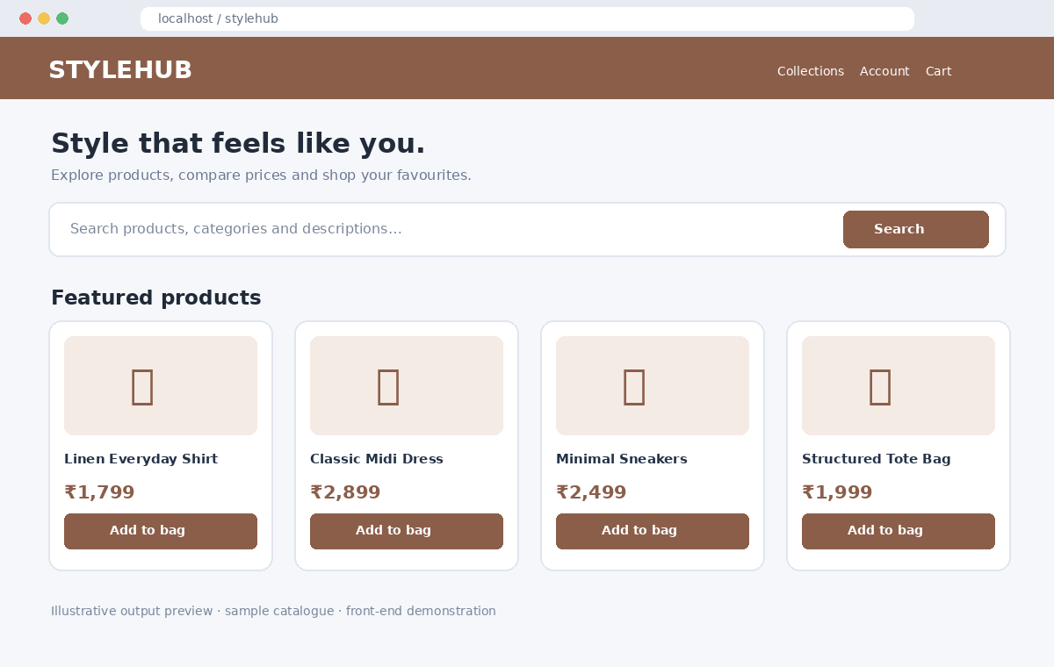

7. Test Cases
Test | Input / Action | Expected Result | Status
TC01 | Open HTML file | Store homepage appears | Verify in browser
TC02 | Search for a product keyword | Matching products are displayed | Verify in browser
TC03 | Filter by a category | Only matching category products appear | Verify in browser
TC04 | Add and remove products | Cart count and total update | Verify in browser
TC05 | Checkout with empty cart | Prompt asks user to add an item | Verify in browser

8. Result
The stylehub online fashion shopping platform front-end demonstration has been created with a searchable catalogue, category filtering, cart updates and checkout feedback.
Note: Product data and checkout are local demo behaviour. Real account authentication, inventory, order storage, payment processing and order tracking require backend and payment-gateway integration.

9. How to Run
1. Extract the ZIP file.
2. Open Experiment_10_Source.html in a modern browser.
3. Search and filter the product catalogue, add/remove items and test checkout.
4. Capture a live browser screenshot if required by the faculty.

