INTERNET PROGRAMMING LAB

EXPERIMENT 9
TechSavvy Online Electronics Shopping Platform
Student Name: Thalamati Aasritha
Register Number: 192311008
Batch: CSE
Date: 26/10/2026
Submitted as part of the Internet Programming Laboratory

1. Aim
To design and implement the techsavvy online electronics shopping platform using HTML5, CSS3 and JavaScript, with product browsing, category filtering, cart management and a sample checkout flow.

2. Problem Description
The TechSavvy platform allows customers to browse electronics such as smartphones, laptops, tablets and accessories. Users can search and filter products, inspect descriptions and prices, add products to a cart, remove items and proceed to a sample checkout. The source brief also describes customer accounts, wish lists, order tracking, reviews and administrator product maintenance.

3. Software and Technologies
• HTML5 — page structure
• CSS3 — responsive layout and styling
• JavaScript — search, category filtering, cart operations and checkout feedback
• Google Chrome, Safari, Firefox or another modern browser

4. Algorithm / Procedure
- Load the homepage and display the product categories.
- Show the available products with names, descriptions and prices.
- Allow the user to search by keyword or filter by category.
- Add selected products to the cart and update the item count and total.
- Allow removal of cart items and recalculate the total.
- Validate checkout state and display a demo checkout message.

5. Program Code (HTML, CSS and JavaScript)
Save the complete code as Experiment_9_Source.html and open it in a browser. The standalone source is also included separately in the ZIP package.
<!DOCTYPE html><html lang="en"><head><meta charset="UTF-8"><meta name="viewport" content="width=device-width,initial-scale=1"><title>TechSavvy | Gadgets</title>
<style>
*{box-sizing:border-box}body{margin:0;font-family:Arial,sans-serif;background:#f4f7fb;color:#17233b}header{background:#102b4e;color:#fff;padding:20px 6%;display:flex;justify-content:space-between;align-items:center}header strong{font-size:25px}nav a{color:#fff;text-decoration:none;margin-left:20px}.hero{padding:42px 6%;background:linear-gradient(115deg,#dbeafe,#f8fafc)}.hero h1{font-size:38px;margin:0 0 10px}.search{display:flex;gap:10px;max-width:760px;margin-top:22px}.search input{flex:1}input,select{padding:12px;border:1px solid #d3dce8;border-radius:8px;min-width:0}button{background:#176fe5;color:#fff;border:0;padding:12px 17px;border-radius:8px;cursor:pointer;font-weight:bold}.layout{display:grid;grid-template-columns:210px 1fr;gap:22px;padding:28px 6%}.side,.card,.cart{background:white;border-radius:14px;padding:20px;box-shadow:0 6px 22px #12233b0c}.side button{display:block;width:100%;margin:8px 0;text-align:left;background:#eef4ff;color:#24466f}.grid{display:grid;grid-template-columns:repeat(auto-fit,minmax(210px,1fr));gap:16px}.product .icon{height:105px;border-radius:10px;background:#eaf1fc;display:grid;place-items:center;font-size:48px}.product h3{margin-bottom:5px}.muted{color:#6b7890;font-size:14px}.price{font-size:22px;font-weight:bold;color:#176fe5}.cart{margin:0 6% 30px}.hidden{display:none}footer{text-align:center;padding:22px;color:#6b7890}@media(max-width:700px){.layout{grid-template-columns:1fr}.hero h1{font-size:29px}.search{flex-direction:column}header{align-items:flex-start;gap:12px;flex-direction:column}}
</style></head><body>
<header><strong>⚡ TechSavvy</strong><nav><a href="#products">Shop gadgets</a><a href="#cart">Cart <span id="cartCount">0</span></a></nav></header>
<section class="hero"><p class="muted">TECH THAT MOVES YOU</p><h1>Find your next favourite gadget.</h1><p>Explore smartphones, laptops, tablets and accessories.</p><form class="search" id="searchForm"><input id="query" placeholder="Search smartphones, laptops, accessories…"><button>Search products</button></form></section>
<main class="layout"><aside class="side"><h3>Categories</h3><button onclick="filter('All')">All products</button><button onclick="filter('Smartphones')">Smartphones</button><button onclick="filter('Laptops')">Laptops</button><button onclick="filter('Tablets')">Tablets</button><button onclick="filter('Accessories')">Accessories</button><p class="muted">Demo catalogue · sample prices</p></aside><section id="products"><h2>Featured gadgets</h2><p class="muted">Browse products, search the catalogue and add items to your cart.</p><div class="grid" id="grid"></div></section></main>
<section class="cart" id="cart"><h2>Your cart</h2><div id="cartItems" class="muted">Your cart is empty.</div><p id="total" class="price"></p><button onclick="checkout()">Proceed to checkout</button><p id="msg" class="muted"></p></section><footer>TechSavvy · Internet Programming Lab demo</footer>
<script>
const products=[{id:1,name:'Nova X Pro Smartphone',cat:'Smartphones',price:42999,icon:'📱',desc:'256 GB · OLED display'},{id:2,name:'AeroBook 14 Laptop',cat:'Laptops',price:68999,icon:'💻',desc:'16 GB RAM · SSD storage'},{id:3,name:'TabView S Tablet',cat:'Tablets',price:27999,icon:'▣',desc:'11-inch display · Wi-Fi'},{id:4,name:'Pulse Wireless Earbuds',cat:'Accessories',price:3999,icon:'🎧',desc:'Noise reduction · USB-C'},{id:5,name:'PowerGo 20K Power Bank',cat:'Accessories',price:2499,icon:'🔋',desc:'20,000 mAh · Fast charge'},{id:6,name:'Nova Lite Smartphone',cat:'Smartphones',price:18999,icon:'📲',desc:'128 GB · Dual camera'}];
let active='All',cart=[];
function render(){let q=(document.getElementById('query').value||'').toLowerCase();let list=products.filter(p=>(active==='All'||p.cat===active)&&(p.name+' '+p.cat+' '+p.desc).toLowerCase().includes(q));document.getElementById('grid').innerHTML=list.map(p=>`<article class="card product"><div class="icon">${p.icon}</div><h3>${p.name}</h3><p class="muted">${p.desc}</p><p class="price">₹${p.price.toLocaleString('en-IN')}</p><button onclick="add(${p.id})">Add to cart</button></article>`).join('')||'<p>No products match your search.</p>';drawCart()}
function filter(c){active=c;render()}
function add(id){cart.push(products.find(p=>p.id===id));render()}
function drawCart(){document.getElementById('cartCount').textContent=cart.length;document.getElementById('cartItems').innerHTML=cart.length?cart.map((p,i)=>`${p.name} — ₹${p.price.toLocaleString('en-IN')} <button onclick="removeItem(${i})" style="padding:5px 9px;margin:4px">Remove</button>`).join('<br>'):'Your cart is empty.';document.getElementById('total').textContent=cart.length?'Total: ₹'+cart.reduce((s,p)=>s+p.price,0).toLocaleString('en-IN'):''}
function removeItem(i){cart.splice(i,1);render()}
document.getElementById('searchForm').onsubmit=e=>{e.preventDefault();render()}
function checkout(){document.getElementById('msg').textContent=cart.length?'Demo checkout ready. No real payment has been processed.':'Please add a product before checkout.'}
render();
</script></body></html>

6. Output Screenshot
This illustrative browser-style preview shows the intended interface. It is a designed preview, not a screenshot captured from a live browser execution.
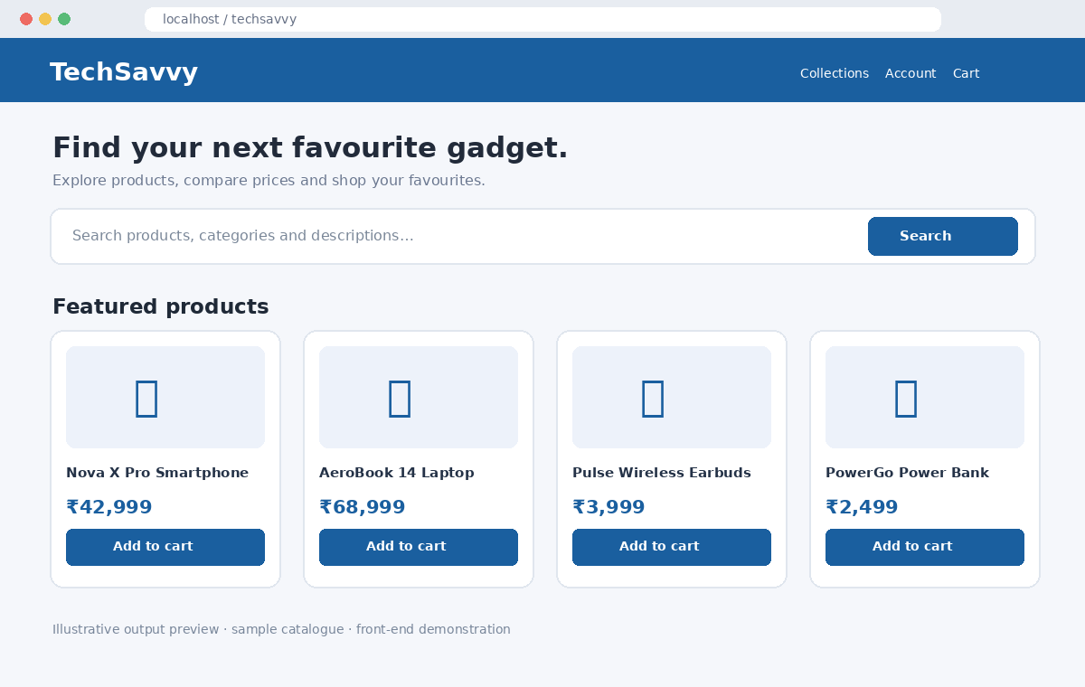

7. Test Cases
Test | Input / Action | Expected Result | Status
TC01 | Open HTML file | Store homepage appears | Verify in browser
TC02 | Search for a product keyword | Matching products are displayed | Verify in browser
TC03 | Filter by a category | Only matching category products appear | Verify in browser
TC04 | Add and remove products | Cart count and total update | Verify in browser
TC05 | Checkout with empty cart | Prompt asks user to add an item | Verify in browser

8. Result
The techsavvy online electronics shopping platform front-end demonstration has been created with a searchable catalogue, category filtering, cart updates and checkout feedback.
Note: Product data and checkout are local demo behaviour. Real account authentication, inventory, order storage, payment processing and order tracking require backend and payment-gateway integration.

9. How to Run
1. Extract the ZIP file.
2. Open Experiment_9_Source.html in a modern browser.
3. Search and filter the product catalogue, add/remove items and test checkout.
4. Capture a live browser screenshot if required by the faculty.

