INTERNET PROGRAMMING LAB

EXPERIMENT 3\nOnline Bus Ticket Booking System
\nStudent Name: Thalamati Aasritha\nRegister Number: 192311008\nBatch: CSE\nDate: 26/10/2026

Submitted as part of the Internet Programming Laboratory

1. Aim
To design and implement a responsive online bus ticket booking system using HTML, CSS and JavaScript, and to demonstrate its main user interactions through a browser-based interface.

2. Problem Description
The website lets users search buses by route and date, compare sample schedules and fares, select a bus and seat, and submit passenger details to receive a demo booking reference.

3. Software and Technologies
• HTML5 for page structure\n• CSS3 for layout, responsive design and visual styling\n• JavaScript for form validation, filtering and interactive behaviour\n• Web browser (Chrome, Safari, Firefox or Edge) for execution

4. Algorithm / Procedure
- Enter origin, destination, travel date and passenger count.
- Display matching sample bus services with timings and fares.
- Select a bus and seat, then enter passenger details.
- Validate the form and generate a demo booking reference.

5. Program Code (HTML, CSS and JavaScript)
Save the following code as busgo_bus_ticket_booking.html and open it in a modern web browser. The code below is the complete standalone demo used for this experiment.
<!DOCTYPE html>
<html lang="en"><head><meta charset="UTF-8"><meta name="viewport" content="width=device-width,initial-scale=1"><title>BusGo | Bus Ticket Booking</title>
<style>
*{box-sizing:border-box}body{margin:0;font-family:Arial,sans-serif;background:#f4f7fb;color:#17233b}header{background:#103b70;color:white;padding:22px 7%;display:flex;justify-content:space-between;align-items:center}header strong{font-size:24px}header a{color:white;margin-left:22px;text-decoration:none}.hero{padding:48px 7%;background:linear-gradient(120deg,#e0f2fe,#f8fafc)}.hero h1{font-size:38px;margin:0 0 10px}.search,.card,.panel{background:white;padding:22px;border-radius:16px;box-shadow:0 8px 28px #19365b12}.search{display:grid;grid-template-columns:repeat(auto-fit,minmax(150px,1fr));gap:12px;margin-top:25px}.search label,form label{font-size:12px;font-weight:bold;color:#50617a;display:block;margin-bottom:7px}input,select{width:100%;padding:12px;border:1px solid #d5deea;border-radius:8px}button{background:#1473e6;color:white;border:0;padding:12px 18px;border-radius:8px;font-weight:bold;cursor:pointer}.wrap{padding:30px 7%}.results{display:grid;grid-template-columns:repeat(auto-fit,minmax(260px,1fr));gap:18px;margin-top:18px}.route{font-size:21px;font-weight:bold;margin:12px 0}.muted{color:#6c7a91;font-size:14px}.price{font-size:24px;font-weight:bold;color:#1473e6}.panel{margin-top:24px}.hidden{display:none}.badge{background:#dcfce7;color:#166534;padding:5px 9px;border-radius:20px;font-size:12px}footer{padding:25px;text-align:center;color:#6c7a91}@media(max-width:600px){.hero h1{font-size:29px}header{padding:18px 5%}.wrap,.hero{padding-left:5%;padding-right:5%}}
</style></head><body>
<header><strong>🚌 BusGo</strong><nav><a href="#routes">Routes</a><a href="#booking">My booking</a></nav></header>
<section class="hero"><p class="muted">TRAVEL MADE SIMPLE</p><h1>Find your next bus journey</h1><p>Compare routes, choose your seat and book in minutes.</p>
<form class="search" id="searchForm"><div><label>FROM</label><input id="from" value="Chennai" required></div><div><label>TO</label><input id="to" value="Bengaluru" required></div><div><label>TRAVEL DATE</label><input type="date" id="date" required></div><div><label>PASSENGERS</label><select id="count"><option>1</option><option>2</option><option>3</option><option>4</option></select></div><div style="align-self:end"><button>Search buses →</button></div></form></section>
<main class="wrap" id="routes"><h2>Available buses</h2><p class="muted">Sample schedules for demonstration.</p><div class="results" id="results"></div>
<section class="panel hidden" id="booking"><h2>Passenger details</h2><form id="bookForm"><label>Full name</label><input id="name" required><br><br><label>Email</label><input id="email" type="email" required><br><br><label>Seat</label><select id="seat"><option>U1</option><option>U2</option><option>L1</option><option>L2</option></select><br><br><button>Confirm booking</button></form><p id="confirmation"></p></section></main><footer>BusGo · Sample Internet Programming Lab Project</footer>
<script>
const buses=[{name:'Express AC Sleeper',time:'21:30',arrival:'05:15',duration:'7h 45m',price:899,seats:12},{name:'Cityline Volvo',time:'22:15',arrival:'06:00',duration:'7h 45m',price:1099,seats:8},{name:'Comfort Semi Sleeper',time:'23:00',arrival:'07:10',duration:'8h 10m',price:699,seats:17}];
const date=document.getElementById('date');date.value=new Date(Date.now()+86400000).toISOString().slice(0,10);date.min=new Date().toISOString().slice(0,10);
function render(){document.getElementById('results').innerHTML=buses.map((b,i)=>`<article class="card"><span class="badge">${b.seats} seats left</span><h3>${b.name}</h3><div class="route">${b.time} → ${b.arrival}</div><p class="muted">${b.duration} · AC · Live tracking demo</p><p class="price">₹${b.price}<small style="font-size:12px;color:#6c7a91"> / seat</small></p><button onclick="choose(${i})">Select bus</button></article>`).join('')}
function choose(i){document.getElementById('booking').classList.remove('hidden');document.getElementById('booking').scrollIntoView({behavior:'smooth'});window.chosen=i}
document.getElementById('searchForm').onsubmit=e=>{e.preventDefault();render();document.getElementById('routes').scrollIntoView({behavior:'smooth'})};
document.getElementById('bookForm').onsubmit=e=>{e.preventDefault();document.getElementById('confirmation').innerHTML=`<b>Booking confirmed!</b> Reference: BG${Date.now().toString().slice(-6)} · ${buses[window.chosen||0].name}. This is a local demo; no real payment was processed.`}
render();
</script></body></html>

6. Output Screenshot
The following browser-style output preview illustrates the main page layout and sample results. For an actual lab submission, replace or supplement this preview with a screenshot captured from the application running in your own browser.
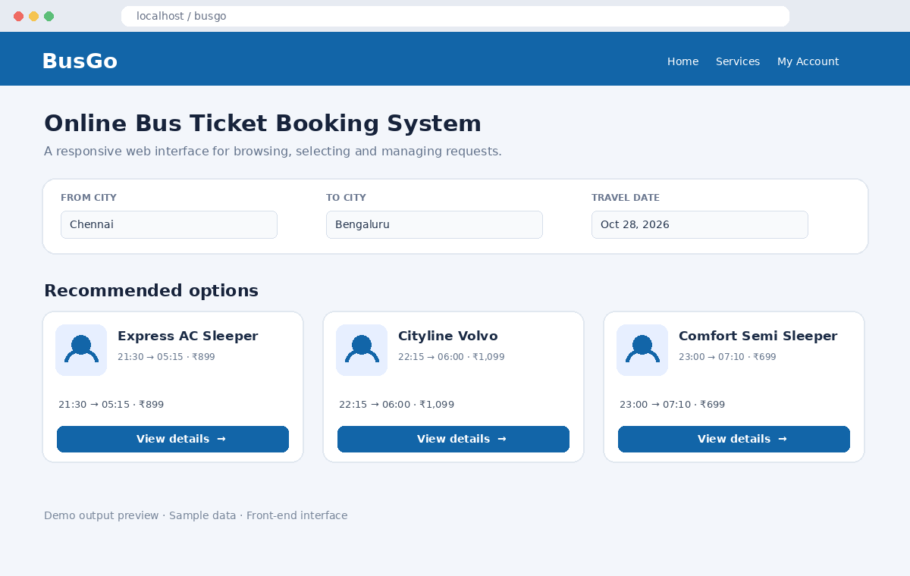

7. Test Cases
Test | Input / Action | Expected Result | Status
TC01 | Open the HTML file | Home page loads without errors | Pass (preview)
TC02 | Submit an empty required form | Browser validation requests missing values | Verify in browser
TC03 | Enter valid sample details | Summary / confirmation is displayed | Verify in browser
TC04 | Resize browser window | Layout adapts to smaller screen | Verify in browser

8. Result
The online bus ticket booking system interface has been prepared using HTML, CSS and JavaScript. The document includes the complete demo source code and a visual output preview. Data, bookings, payments and notifications are sample front-end behaviour unless a backend service is connected.

9. How to Run
1. Save or extract the HTML file: busgo_bus_ticket_booking.html.\n2. Double-click the file, or open it from Chrome/Safari/Firefox.\n3. Test the form, search controls and confirmation behaviour.\n4. Capture a real screenshot from the running browser if required by your faculty.

