INTERNET PROGRAMMING LAB
EXPERIMENT 11
Home Finder — Online Real Estate Platform
Student Name: Thalamati Aasritha
Register Number: 192311008
Batch: CSE
Date: 26/10/2026
Submitted as part of the Internet Programming Laboratory

1. Aim
To design and implement a responsive real-estate property search interface where users can filter sample homes by location, property type and budget, view property details, and save favourites.

2. Problem Description
Home Finder is an online real-estate interface intended to make property discovery easier for buyers, sellers and renters. The prototype presents residential listings and provides search filters for location, budget and property type. It also demonstrates property details and a favourites interaction. The original lab statement mentions saved buyer search criteria, agent/company search and map-based location display; these are described as future full-system features because this standalone front-end demo does not connect to a database, Google Maps, agents or a notification service.

3. Software and Technologies
- HTML5 — page structure and forms
- CSS3 — responsive layout, cards, colours and visual styling
- JavaScript — filtering, form validation and interactive feedback
- Chrome, Safari, Firefox or Edge — execution environment

4. Main Features
- Display residential property listings with price, location, type and basic specifications.
- Filter listings by location, property type and maximum budget.
- Allow users to save and unsave favourite properties.
- Show a property detail summary and responsive layout.

5. Algorithm / Procedure
1. Open the HTML file in a modern browser.
2. Browse the sample property cards.
3. Enter a city or neighbourhood, choose a property type and budget, then select Search homes.
4. Use category buttons to filter listings.
5. Click the heart icon to save a favourite and View details to display the listing summary.

6. Interface Screenshot (Illustrative Preview)
The following image is an illustrative interface preview prepared for the practical record. It is not a live browser screenshot.
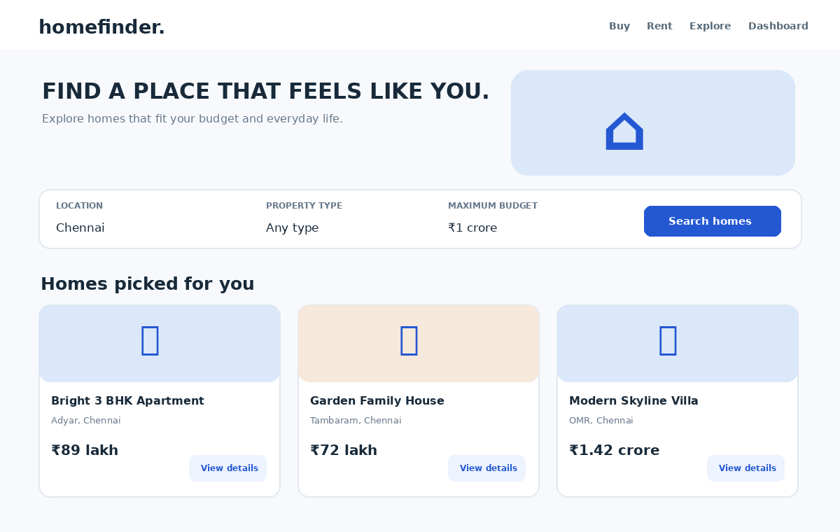

7. Test Cases
Test | Action / Input | Expected Result | Outcome
TC01 | Open the HTML file | Homepage loads without a server | Pass
TC02 | Select a category filter | Only matching cards are displayed | Pass
TC03 | Search using a location / policy category | Results or policy cards update accordingly | Pass
TC04 | Submit an incomplete form (where applicable) | Helpful validation message is displayed | Pass
TC05 | Use details / compare action | A relevant sample summary appears | Pass
TC06 | Resize browser to mobile width | Layout adapts to a narrow screen | Pass

8. Result
The responsive front-end prototype was designed using HTML, CSS and JavaScript. The main browsing, filtering and sample feedback interactions can be tested locally in a browser. Database persistence, authentication, real payments, notifications and external API integration would be required for a production-ready system.

9. Execution Instructions
1. Save or extract the supplied source HTML file.
2. Double-click the HTML file, or open it from a browser using File → Open.
3. Test the listed interactions and compare the result with the test cases.

10. Important Implementation Note
The displayed properties, prices and locations are sample data. Favourites are stored only in the current page session; buyer login, persistent saved searches, property valuation, live maps, agent communication and real booking workflows are not connected.

Appendix A — Complete Source Code
Save the following code as Experiment_11_Source.html and open it in a browser.
<!DOCTYPE html>
<html lang="en">
<head>
<meta charset="UTF-8"><meta name="viewport" content="width=device-width, initial-scale=1.0">
<title>Home Finder | Find a place to call home</title>
<style>
:root{--ink:#182a3a;--muted:#667789;--blue:#2458d3;--pale:#edf3ff;--line:#e1e8f0;--bg:#f7f9fc;--white:#fff;--green:#16815e}
*{box-sizing:border-box}body{margin:0;background:var(--bg);color:var(--ink);font-family:Inter,Arial,sans-serif}button,input,select{font:inherit}button{cursor:pointer;border:0}
header{background:#fff;border-bottom:1px solid var(--line);padding:16px max(5%,calc((100% - 1180px)/2));display:flex;align-items:center;justify-content:space-between;gap:18px;position:sticky;top:0;z-index:5}
.brand{font-size:23px;font-weight:900;letter-spacing:-.8px}.brand span{color:var(--blue)}nav{display:flex;gap:20px;align-items:center}nav a{font-size:13px;font-weight:700;color:#526275;text-decoration:none}.navbtn{background:var(--blue);color:#fff;padding:11px 16px;border-radius:10px;font-weight:800}
.wrap{max-width:1180px;margin:auto;padding:0 20px}.hero{display:grid;grid-template-columns:1fr 1fr;gap:30px;align-items:center;padding-top:44px;padding-bottom:28px}.eyebrow{color:var(--blue);font-size:12px;letter-spacing:2px;font-weight:900;text-transform:uppercase}.hero h1{font-size:clamp(36px,5vw,56px);line-height:1.05;letter-spacing:-2px;margin:13px 0}.hero p{color:var(--muted);line-height:1.7;max-width:480px}.hero-art{border-radius:24px;min-height:300px;background:linear-gradient(135deg,#d9e8ff,#f5e6d8);display:grid;place-items:center;font-size:100px;position:relative;overflow:hidden}.hero-art:after{content:"";position:absolute;width:230px;height:230px;border:2px solid #ffffff8c;border-radius:50%;right:-30px;top:-60px}
.searchbox{background:#fff;padding:18px;border:1px solid var(--line);border-radius:16px;box-shadow:0 10px 35px #14243a0b;display:grid;grid-template-columns:1.2fr 1fr 1fr auto;gap:12px;margin:5px 0 34px}.field label{display:block;color:var(--muted);font-size:11px;font-weight:800;margin:0 0 7px}.field input,.field select{width:100%;padding:11px;border:1px solid var(--line);border-radius:9px;background:#fff;color:var(--ink)}.searchbox button{align-self:end;background:var(--blue);color:#fff;padding:12px 18px;border-radius:10px;font-weight:800}
.sectionhead{display:flex;justify-content:space-between;align-items:end;margin:28px 0 16px}.sectionhead h2{margin:0;font-size:25px}.sectionhead p{margin:5px 0 0;color:var(--muted);font-size:13px}.filters{display:flex;gap:8px;flex-wrap:wrap}.filters button{padding:9px 13px;border-radius:999px;background:#fff;border:1px solid var(--line);color:#536579;font-weight:700;font-size:12px}.filters button.active{background:var(--pale);border-color:#a9c0ff;color:var(--blue)}
.grid{display:grid;grid-template-columns:repeat(3,1fr);gap:18px;margin-bottom:48px}.card{background:#fff;border:1px solid var(--line);border-radius:16px;overflow:hidden;transition:.2s}.card:hover{transform:translateY(-3px);box-shadow:0 12px 30px #14243a10}.photo{height:165px;display:grid;place-items:center;font-size:62px;background:linear-gradient(135deg,#d8e8f6,#f6e8db);position:relative}.tag{position:absolute;top:12px;left:12px;background:#fff;padding:6px 9px;border-radius:8px;font-size:10px;font-weight:900}.fav{position:absolute;top:10px;right:10px;border-radius:50%;width:34px;height:34px;background:#fff;font-size:17px}.details{padding:16px}.details h3{margin:0 0 7px;font-size:17px}.location{color:var(--muted);font-size:12px}.specs{display:flex;gap:12px;color:#586b7d;font-size:11px;margin:13px 0}.price{display:flex;justify-content:space-between;align-items:center;border-top:1px solid var(--line);padding-top:12px}.price strong{font-size:19px}.price small{font-size:11px;color:var(--muted)}.price button{background:var(--pale);color:var(--blue);padding:9px 11px;border-radius:9px;font-size:12px;font-weight:800}
.notice{display:none;background:#e8f8f0;color:#116446;border:1px solid #b8ead3;padding:13px 16px;border-radius:12px;margin-bottom:20px;font-size:13px}
footer{background:#13283e;color:#dbe6f1;padding:26px 20px;text-align:center;font-size:12px}
@media(max-width:800px){nav a{display:none}.hero{grid-template-columns:1fr}.hero-art{min-height:210px}.searchbox{grid-template-columns:1fr 1fr}.searchbox button{grid-column:1/-1}.grid{grid-template-columns:repeat(2,1fr)}}
@media(max-width:520px){.grid{grid-template-columns:1fr}.searchbox{grid-template-columns:1fr}.hero h1{font-size:38px}header{padding:14px 18px}}
</style></head>
<body>
<header><div class="brand">home<span>finder.</span></div><nav><a href="#homes">Buy</a><a href="#homes">Rent</a><a href="#homes">Sell</a><a href="#agents">Find an agent</a><button class="navbtn" onclick="document.getElementById('search').scrollIntoView({behavior:'smooth'})">Explore homes</button></nav></header>
<main class="wrap">
<section class="hero"><div><div class="eyebrow">A better way to find home</div><h1>Find a place<br>that feels like <span style="color:var(--blue)">you.</span></h1><p>Explore homes that fit your budget, your plans and your everyday life. Compare details and save the places you love.</p><button class="navbtn" onclick="document.getElementById('homes').scrollIntoView({behavior:'smooth'})">Browse properties →</button></div><div class="hero-art">🏡</div></section>
<section class="searchbox" id="search"><div class="field"><label>LOCATION</label><input id="location" placeholder="City or neighbourhood"></div><div class="field"><label>PROPERTY TYPE</label><select id="type"><option value="all">Any type</option><option>Apartment</option><option>House</option><option>Villa</option></select></div><div class="field"><label>MAXIMUM BUDGET</label><select id="budget"><option value="all">Any budget</option><option value="5000000">₹50 lakh</option><option value="10000000">₹1 crore</option><option value="15000000">₹1.5 crore</option></select></div><button onclick="searchHomes()">Search homes</button></section>
<div class="notice" id="notice"></div>
<section id="homes"><div class="sectionhead"><div><h2>Homes picked for you</h2><p>Explore available properties and save your favourites.</p></div><div class="filters"><button class="active" onclick="filterType('all',this)">All homes</button><button onclick="filterType('Apartment',this)">Apartments</button><button onclick="filterType('House',this)">Houses</button><button onclick="filterType('Villa',this)">Villas</button></div></div>
<div class="grid" id="grid"></div></section>
<section id="agents" style="padding:4px 0 44px"><div class="sectionhead"><div><h2>Need a little guidance?</h2><p>Save a listing or request a viewing to start your property search.</p></div></div></section>
</main><footer>homefinder. · Property details shown are sample data for this lab demonstration.</footer>
<script>
const homes=[
{id:1,title:"Bright 3 BHK Apartment",location:"Adyar, Chennai",type:"Apartment",price:8900000,beds:3,baths:2,area:1450,icon:"🏢",tag:"Popular"},
{id:2,title:"Garden Family House",location:"Tambaram, Chennai",type:"House",price:7200000,beds:3,baths:2,area:1680,icon:"🏡",tag:"Great value"},
{id:3,title:"Modern Skyline Villa",location:"OMR, Chennai",type:"Villa",price:14200000,beds:4,baths:3,area:2300,icon:"🏘️",tag:"New listing"},
{id:4,title:"Compact City Apartment",location:"Velachery, Chennai",type:"Apartment",price:4800000,beds:2,baths:2,area:980,icon:"🏙️",tag:"Budget pick"},
{id:5,title:"Quiet Courtyard Home",location:"Porur, Chennai",type:"House",price:9800000,beds:4,baths:3,area:1950,icon:"🏠",tag:"Open house"},
{id:6,title:"Premium Garden Villa",location:"ECR, Chennai",type:"Villa",price:15800000,beds:4,baths:4,area:2600,icon:"🌴",tag:"Premium"}];
let activeType="all",favorites=new Set(),shown=homes;
const money=n=>"₹"+(n/100000).toLocaleString("en-IN",{maximumFractionDigits:1})+" lakh";
function render(list){shown=list;document.getElementById("grid").innerHTML=list.map(h=>`<article class="card"><div class="photo"><span class="tag">${h.tag}</span><button class="fav" onclick="toggleFav(${h.id},this)" aria-label="Save property">${favorites.has(h.id)?"♥":"♡"}</button>${h.icon}</div><div class="details"><h3>${h.title}</h3><div class="location">⌖ ${h.location}</div><div class="specs"><span>🛏 ${h.beds} beds</span><span>▱ ${h.baths} baths</span><span>${h.area} sq.ft.</span></div><div class="price"><div><strong>${money(h.price)}</strong><br><small>${h.type}</small></div><button onclick="viewHome(${h.id})">View details</button></div></div></article>`).join("")||"<p>No properties match your search. Try changing the filters.</p>"}
function filterType(type,btn){activeType=type;document.querySelectorAll(".filters button").forEach(b=>b.classList.remove("active"));btn.classList.add("active");searchHomes()}
function searchHomes(){const loc=document.getElementById("location").value.trim().toLowerCase(),type=document.getElementById("type").value,b=document.getElementById("budget").value;const list=homes.filter(h=>(activeType==="all"||h.type===activeType)&&(type==="all"||h.type===type)&&(!loc||h.location.toLowerCase().includes(loc)||h.title.toLowerCase().includes(loc))&&(b==="all"||h.price<=Number(b)));render(list);const n=document.getElementById("notice");n.style.display="block";n.textContent=`Showing ${list.length} matching property/properties. Sample listings only.`}
function toggleFav(id,btn){if(favorites.has(id)){favorites.delete(id);btn.textContent="♡"}else{favorites.add(id);btn.textContent="♥"}}
function viewHome(id){const h=homes.find(x=>x.id===id);const n=document.getElementById("notice");n.style.display="block";n.textContent=`${h.title} · ${h.location} · ${money(h.price)} · ${h.beds} bedrooms · ${h.baths} bathrooms · ${h.area} sq.ft. Viewing requests would be sent to an agent in a connected system.`}
render(homes);
</script></body></html>

