INTERNET PROGRAMMING LAB
EXPERIMENT 12
InsureEasy — Online Insurance Management Platform
Student Name: Thalamati Aasritha
Register Number: 192311008
Batch: CSE
Date: 26/10/2026
Submitted as part of the Internet Programming Laboratory

1. Aim
To create a responsive insurance information and management interface that lets users explore sample health, auto and home policies, compare illustrative premiums, and view a demo policy summary.

2. Problem Description
InsureEasy is an online insurance management interface for exploring and comparing health, auto and home policies. The prototype displays sample policy descriptions and illustrative premiums, and demonstrates a policy-summary form and claim-support guidance. The original lab statement includes customer and agent roles, admin approval of agent accounts, policy management and SMS reminders. Those backend operations require a server, database and messaging integration and are not represented as live services in this front-end-only demonstration.

3. Software and Technologies
- HTML5 — page structure and forms
- CSS3 — responsive layout, cards, colours and visual styling
- JavaScript — filtering, form validation and interactive feedback
- Chrome, Safari, Firefox or Edge — execution environment

4. Main Features
- Present health, auto and home insurance categories.
- Filter policies by category and compare illustrative premium and coverage information.
- Validate sample policy dashboard fields and display a policy summary.
- Provide a simple claims-support guidance interaction.

5. Algorithm / Procedure
1. Open the HTML file in a modern browser.
2. Select All policies, Health, Auto or Home to filter the policy cards.
3. Click Compare policy to view an illustrative comparison summary.
4. Enter a name and sample policy number in My policy dashboard and click View policy summary.
5. Use Explore claim support to display the demo guidance.

6. Interface Screenshot (Illustrative Preview)
The following image is an illustrative interface preview prepared for the practical record. It is not a live browser screenshot.
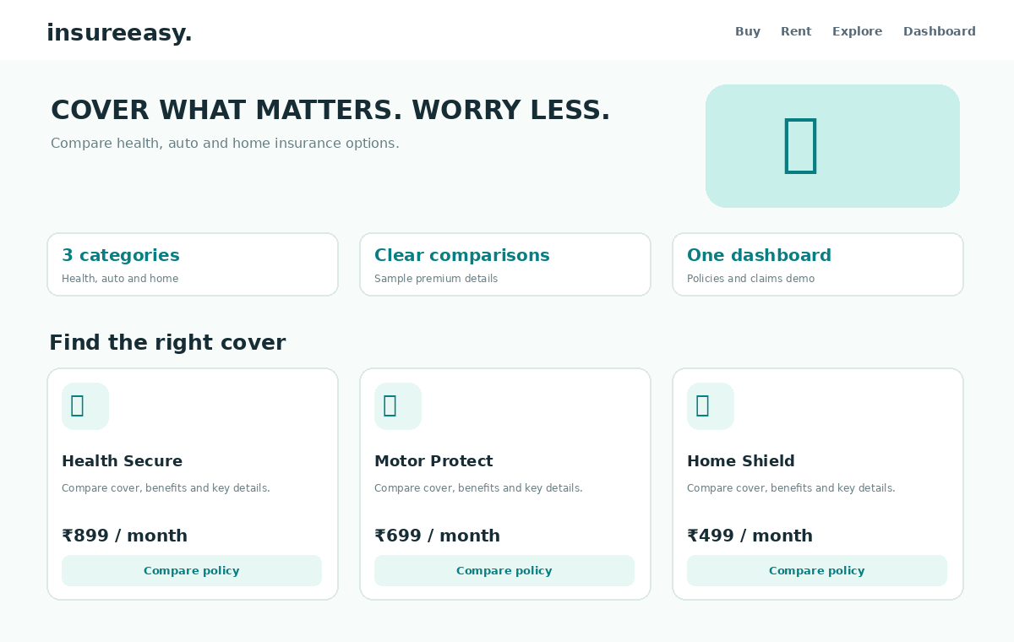

7. Test Cases
Test | Action / Input | Expected Result | Outcome
TC01 | Open the HTML file | Homepage loads without a server | Pass
TC02 | Select a category filter | Only matching cards are displayed | Pass
TC03 | Search using a location / policy category | Results or policy cards update accordingly | Pass
TC04 | Submit an incomplete form (where applicable) | Helpful validation message is displayed | Pass
TC05 | Use details / compare action | A relevant sample summary appears | Pass
TC06 | Resize browser to mobile width | Layout adapts to a narrow screen | Pass

8. Result
The responsive front-end prototype was designed using HTML, CSS and JavaScript. The main browsing, filtering and sample feedback interactions can be tested locally in a browser. Database persistence, authentication, real payments, notifications and external API integration would be required for a production-ready system.

9. Execution Instructions
1. Save or extract the supplied source HTML file.
2. Double-click the HTML file, or open it from a browser using File → Open.
3. Test the listed interactions and compare the result with the test cases.

10. Important Implementation Note
All policy premiums and coverage descriptions are illustrative, not insurance advice or live offers. The prototype does not issue policies, process payments, access real policy records or send SMS alerts. A production system should use secure authentication, server-side validation, protected customer data and approved insurer integrations.

Appendix A — Complete Source Code
Save the following code as Experiment_12_Source.html and open it in a browser.
<!DOCTYPE html>
<html lang="en">
<head><meta charset="UTF-8"><meta name="viewport" content="width=device-width, initial-scale=1.0"><title>InsureEasy | Insurance made clearer</title>
<style>
:root{--ink:#172d35;--muted:#667d83;--teal:#087e83;--mint:#e7f7f4;--line:#dce9e8;--bg:#f7fbfa;--white:#fff;--orange:#ffb15c}
*{box-sizing:border-box}body{margin:0;background:var(--bg);color:var(--ink);font-family:Inter,Arial,sans-serif}button,input,select{font:inherit}button{cursor:pointer;border:0}
header{display:flex;align-items:center;justify-content:space-between;gap:18px;padding:16px max(5%,calc((100% - 1160px)/2));background:#fff;border-bottom:1px solid var(--line);position:sticky;top:0;z-index:4}.brand{font-size:22px;font-weight:900;letter-spacing:-.7px}.brand span{color:var(--teal)}nav{display:flex;align-items:center;gap:20px}nav a{text-decoration:none;color:#5e7278;font-size:13px;font-weight:700}.btn{background:var(--teal);color:white;border-radius:10px;padding:12px 16px;font-weight:800;font-size:13px}
.wrap{max-width:1160px;margin:auto;padding:0 20px}.hero{display:grid;grid-template-columns:1.1fr .9fr;gap:32px;align-items:center;padding:45px 0 30px}.eyebrow{text-transform:uppercase;letter-spacing:2px;font-size:11px;color:var(--teal);font-weight:900}.hero h1{font-size:clamp(36px,5vw,54px);letter-spacing:-2px;line-height:1.08;margin:12px 0}.hero p{color:var(--muted);line-height:1.7;max-width:500px}.heroart{min-height:270px;background:linear-gradient(140deg,#c9efea,#eff8d9);border-radius:24px;display:grid;place-items:center;font-size:92px;position:relative}.heroart:after{content:"";position:absolute;width:180px;height:180px;border:2px solid #ffffffb8;border-radius:50%;top:24px;right:26px}
.summary{display:grid;grid-template-columns:repeat(3,1fr);gap:14px;margin:15px 0 28px}.stat{background:#fff;border:1px solid var(--line);border-radius:14px;padding:17px}.stat strong{display:block;font-size:22px;color:var(--teal)}.stat span{font-size:12px;color:var(--muted)}
h2{font-size:25px;letter-spacing:-.6px;margin:0}.sub{color:var(--muted);font-size:13px;margin:7px 0 17px}.tabs{display:flex;gap:9px;flex-wrap:wrap;margin:18px 0}.tabs button{padding:10px 15px;background:#fff;border:1px solid var(--line);border-radius:999px;font-size:12px;font-weight:800;color:#587076}.tabs button.active{background:var(--mint);border-color:#9edbd4;color:var(--teal)}
.cards{display:grid;grid-template-columns:repeat(3,1fr);gap:16px;margin-bottom:34px}.card{background:#fff;border:1px solid var(--line);border-radius:16px;padding:19px;display:flex;flex-direction:column;min-height:240px}.icon{width:47px;height:47px;border-radius:14px;background:var(--mint);display:grid;place-items:center;font-size:24px}.card h3{font-size:17px;margin:14px 0 7px}.card p{font-size:12px;line-height:1.6;color:var(--muted);margin:0 0 14px}.card .price{font-size:20px;font-weight:900;margin-top:auto}.card small{font-size:11px;color:var(--muted);font-weight:500}.card button{margin-top:13px;background:#eaf6f5;color:var(--teal);border-radius:9px;padding:10px;font-weight:800;font-size:12px}
.panel{background:#fff;border:1px solid var(--line);border-radius:18px;padding:23px;margin-bottom:40px}.formgrid{display:grid;grid-template-columns:repeat(3,1fr);gap:13px}.field label{display:block;font-size:11px;font-weight:800;color:var(--muted);margin-bottom:7px}.field input,.field select{width:100%;padding:12px;border:1px solid var(--line);border-radius:9px;background:#fff}.panel .btn{margin-top:15px}.notice{display:none;margin-top:14px;background:var(--mint);color:#08686c;padding:12px;border-radius:10px;font-size:13px}
footer{background:#17383c;color:#d9eeee;text-align:center;padding:24px;font-size:12px}
@media(max-width:780px){nav a{display:none}.hero{grid-template-columns:1fr}.heroart{min-height:210px}.cards{grid-template-columns:repeat(2,1fr)}.formgrid{grid-template-columns:1fr 1fr}}
@media(max-width:520px){.cards,.summary,.formgrid{grid-template-columns:1fr}.hero h1{font-size:38px}header{padding:14px 18px}}
</style></head><body>
<header><div class="brand">insure<span>easy.</span></div><nav><a href="#policies">Explore policies</a><a href="#mycover">My coverage</a><a href="#claims">Claims</a><button class="btn" onclick="document.getElementById('mycover').scrollIntoView({behavior:'smooth'})">My dashboard</button></nav></header>
<main class="wrap"><section class="hero"><div><div class="eyebrow">Protection, made understandable</div><h1>Cover what matters.<br><span style="color:var(--teal)">Worry less.</span></h1><p>Compare health, motor and home insurance options in one simple place. Understand the essentials before choosing a policy.</p><button class="btn" onclick="document.getElementById('policies').scrollIntoView({behavior:'smooth'})">Compare policies →</button></div><div class="heroart">🛡️</div></section>
<div class="summary"><div class="stat"><strong>3 categories</strong><span>Health, auto and home</span></div><div class="stat"><strong>Clear comparisons</strong><span>Review cover and sample premium</span></div><div class="stat"><strong>One dashboard</strong><span>Policies, payments and claims demo</span></div></div>
<section id="policies"><h2>Find the right cover</h2><p class="sub">Choose a category and compare sample policy options.</p><div class="tabs"><button class="active" onclick="showType('all',this)">All policies</button><button onclick="showType('Health',this)">Health</button><button onclick="showType('Auto',this)">Auto</button><button onclick="showType('Home',this)">Home</button></div><div class="cards" id="cards"></div></section>
<section class="panel" id="mycover"><h2>My policy dashboard</h2><p class="sub">Enter sample details to view a policy summary. This demo does not purchase insurance or collect payments.</p><div class="formgrid"><div class="field"><label>FULL NAME</label><input id="name" placeholder="Your name"></div><div class="field"><label>POLICY TYPE</label><select id="policy"><option>Health</option><option>Auto</option><option>Home</option></select></div><div class="field"><label>POLICY NUMBER</label><input id="number" placeholder="e.g. IE-1024"></div></div><button class="btn" onclick="viewPolicy()">View policy summary</button><div class="notice" id="notice"></div></section>
<section class="panel" id="claims"><h2>Claims & reminders</h2><p class="sub">Use this sample action to understand the intended dashboard flow.</p><button class="btn" onclick="claimHelp()">Explore claim support</button><div class="notice" id="claimnotice"></div></section>
</main><footer>InsureEasy · Educational front-end prototype. Premiums and policy information are illustrative only.</footer>
<script>
const policies=[
{type:"Health",icon:"🩺",name:"Health Secure",desc:"Hospitalisation cover, cashless network overview and wellness benefits.",price:899,unit:"/ month",cover:"₹5 lakh"},
{type:"Health",icon:"💚",name:"Family Health Plus",desc:"A sample family floater plan with preventive care highlights.",price:1499,unit:"/ month",cover:"₹10 lakh"},
{type:"Auto",icon:"🚗",name:"Motor Protect",desc:"Explore own-damage and third-party cover considerations.",price:699,unit:"/ month",cover:"Vehicle cover"},
{type:"Auto",icon:"🛵",name:"Everyday Drive",desc:"A sample two-wheeler policy with renewal reminders.",price:299,unit:"/ month",cover:"Two-wheeler"},
{type:"Home",icon:"🏠",name:"Home Shield",desc:"Illustrative cover for home structure and selected belongings.",price:499,unit:"/ month",cover:"Home & contents"},
{type:"Home",icon:"🔑",name:"Renters Essentials",desc:"A sample option focused on belongings and personal liability.",price:199,unit:"/ month",cover:"Belongings"}
];let current="all";
function render(){const arr=policies.filter(p=>current==="all"||p.type===current);document.getElementById("cards").innerHTML=arr.map(p=>`<article class="card"><div class="icon">${p.icon}</div><h3>${p.name}</h3><p>${p.desc}</p><div class="price">₹${p.price.toLocaleString("en-IN")} <small>${p.unit} · ${p.cover}</small></div><button onclick="compare('${p.name}')">Compare policy</button></article>`).join("")}
function showType(t,b){current=t;document.querySelectorAll(".tabs button").forEach(x=>x.classList.remove("active"));b.classList.add("active");render()}
function compare(name){const p=policies.find(x=>x.name===name);const n=document.getElementById("notice");n.style.display="block";n.textContent=`${p.name}: sample premium ₹${p.price.toLocaleString("en-IN")}${p.unit}; indicative cover: ${p.cover}. Review exclusions, limits and official policy wording before making a real decision.`;document.getElementById("mycover").scrollIntoView({behavior:"smooth"})}
function viewPolicy(){const name=document.getElementById("name").value.trim(),type=document.getElementById("policy").value,num=document.getElementById("number").value.trim(),n=document.getElementById("notice");n.style.display="block";if(!name||!num){n.textContent="Please enter your name and a sample policy number.";return}n.textContent=`Demo summary for ${name}: ${type} insurance · Policy ${num}. No live policy record was accessed.`}
function claimHelp(){const n=document.getElementById("claimnotice");n.style.display="block";n.textContent="Claim support demo: prepare your policy number, incident details and relevant documents. Submit claims only through your insurer’s official secure channel."}
render();
</script></body></html>

