INTERNET PROGRAMMING LAB
EXPERIMENT 14
ReNewMarket – Second-Hand Goods Marketplace
Student Name | Thalamati Aasritha
Register Number | 192311008
Batch / Department | CSE
Date | 28/10/2026

1. Aim
To create a responsive marketplace interface where users can browse second-hand goods, search and filter listings, publish an item for sale, and demonstrate order-status management.

2. Software and Technologies Required
Visual Studio Code or any text editor, a modern web browser, HTML5, CSS3, and JavaScript.

3. Description
ReNewMarket is a frontend prototype for a second-hand marketplace. Buyers can browse listings, filter by category and condition, search for items, and inspect details. Sellers can publish listings, while an order-management table demonstrates logistics-status updates.

4. Key Features
- Shows second-hand products across electronics, furniture, clothing, collectibles, and home/living categories.
- Supports text search, condition filtering, and price sorting.
- Displays listing title, condition, seller, category, description, and price.
- Includes a seller form to publish a new item listing.
- Provides sample order records and controls to update logistics status.

5. Procedure / Algorithm
1. Build the layout with navigation, hero banner, category sidebar, listing cards, seller form, and order table.
2. Use CSS grid and responsive breakpoints for desktop and mobile layouts.
3. Store sample listings and sample orders in JavaScript arrays.
4. Implement category selection, keyword search, condition filtering, and price sorting.
5. Validate required listing fields and add submitted listings to the page.
6. Implement order status controls for Pending, Packed, Shipped, and Received.

6. Screenshots and Output
Screenshots below were captured from the HTML page rendered in a Chromium browser.
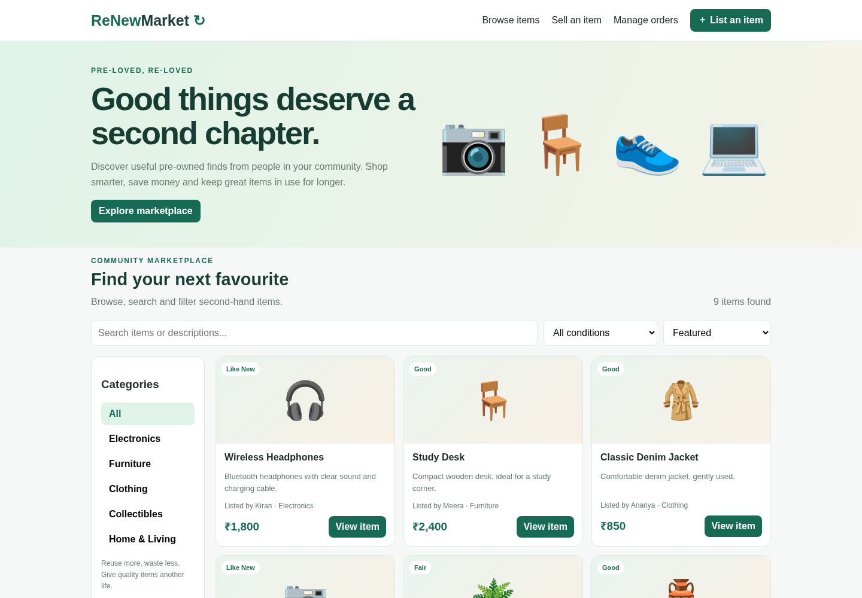
Figure 1. Homepage and navigation
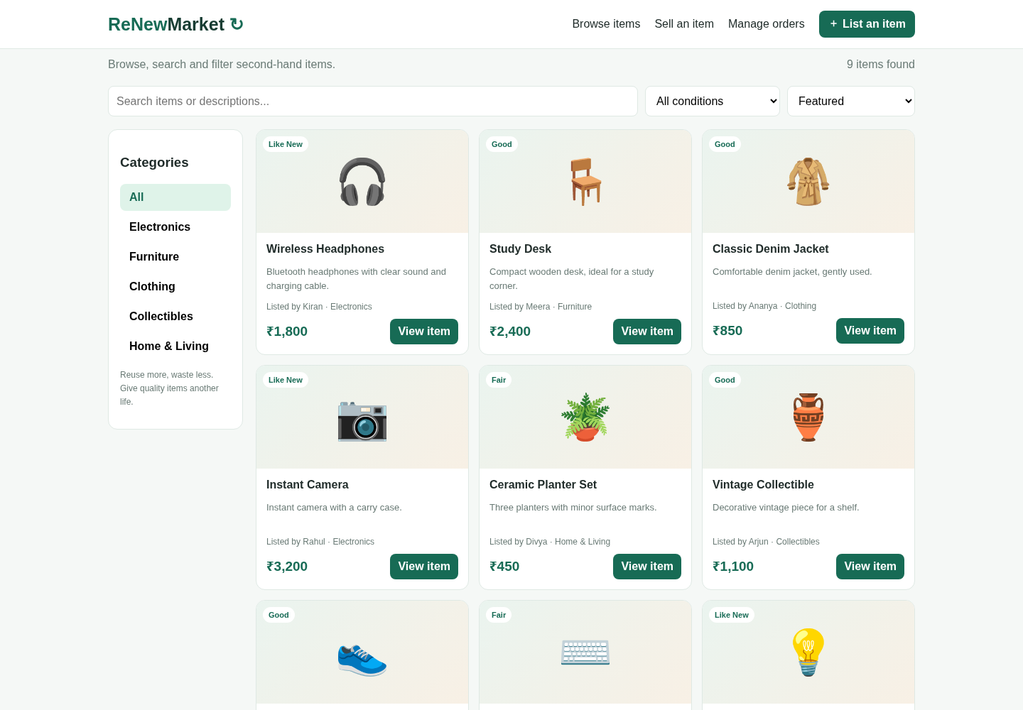
Figure 2. Product catalogue and browsing controls
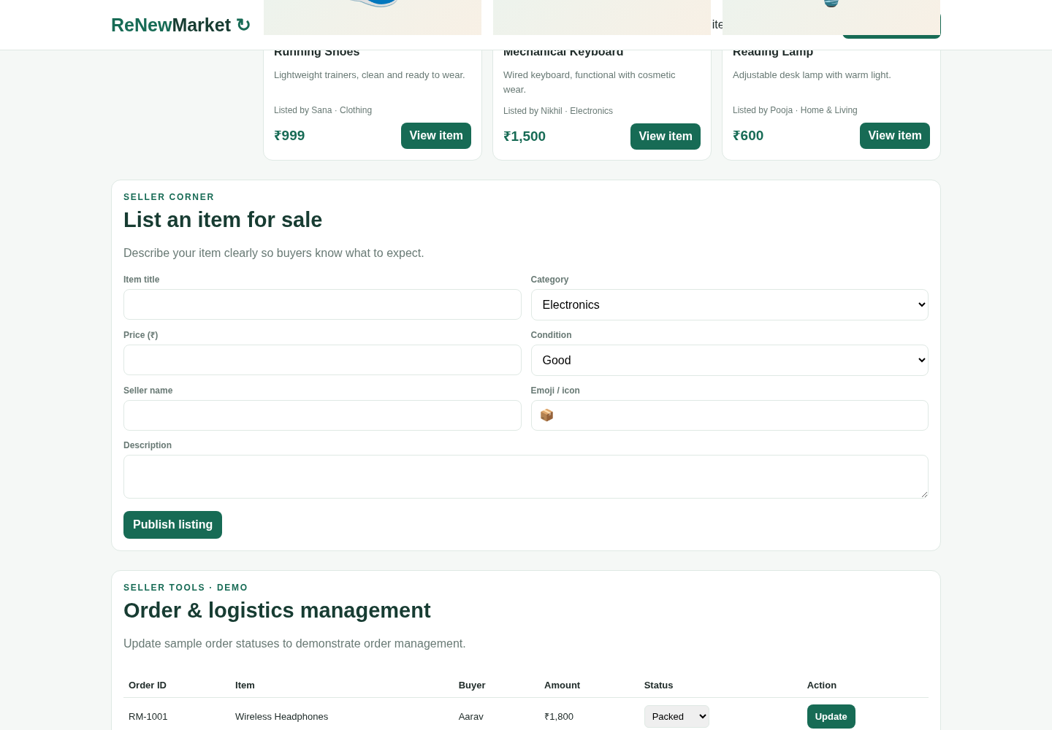
Figure 3. Form interaction area
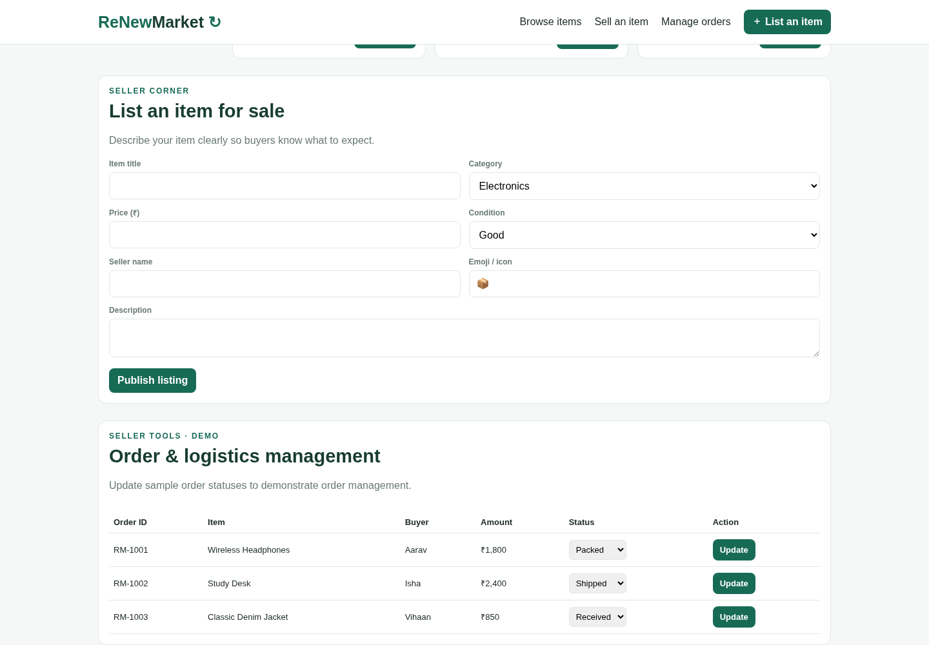
Figure 4. Order and logistics management

7. Test Cases
Test | Expected / Observed Behaviour | Result
Open website | Page loads with the ReNewMarket header and marketplace banner. | Pass
Category filter | Selecting Electronics displays electronics listings only. | Pass
Condition filter | Selecting a condition filters the displayed results. | Pass
Search listing | Typing a listing keyword narrows product cards. | Pass
Publish listing | A valid seller form submission adds the listing. | Pass
Update order | Changing a sample order status updates the displayed status. | Pass

8. Result
The ReNewMarket frontend demonstration was developed successfully. It supports marketplace browsing, category and condition filtering, search, listing creation, and sample logistics-status updates.

9. Limitations
This is a client-side demonstration. Product and order changes exist only in JavaScript memory for the current page session. Real authentication, permanent database storage, live tracking, email/SMS notifications, and payment processing are not connected.

10. Source Code and Execution
The complete runnable source code is supplied separately as Question_14_ReNewMarket.html. Open it directly in a browser, or open it in Visual Studio Code and choose Open with Live Server.

