INTERNET PROGRAMMING LAB
EXPERIMENT 13
BlossomGifts – Online Flower and Gift Ordering Website
Student Name | Thalamati Aasritha
Register Number | 192311008
Batch / Department | CSE
Date | 28/10/2026

1. Aim
To design and develop a responsive online flower and gift ordering website that presents products by category and supports product searching, a shopping bag, delivery scheduling, and basic product administration.

2. Software and Technologies Required
Visual Studio Code or any text editor, a modern web browser, HTML5, CSS3, and JavaScript.

3. Description
BlossomGifts is a frontend prototype for an online gifting store. Visitors can browse products by category, search and sort the catalogue, add products to a bag, and submit a delivery request. A product-management area demonstrates adding catalogue entries.

4. Key Features
- Displays flower arrangements, gift hampers, personalised gifts, and plants.
- Filters products by category and searches product names and descriptions.
- Sorts products by price and allows users to add products to a shopping bag.
- Provides a delivery request form with sender, recipient, date, preferred time, and gift message.
- Includes a product-management form for adding items to the catalogue.

5. Procedure / Algorithm
1. Create the HTML structure for the header, hero section, product catalogue, delivery form, and product-management form.
2. Apply CSS for colours, product cards, responsive grid, form controls, and mobile layout.
3. Create a JavaScript product array and render products dynamically.
4. Implement category filtering, text search, price sorting, and shopping-bag count updates.
5. Validate the delivery date and display a demo confirmation on form submission.
6. Allow a new product to be added to the in-memory catalogue through the admin form.

6. Screenshots and Output
Screenshots below were captured from the HTML page rendered in a Chromium browser.
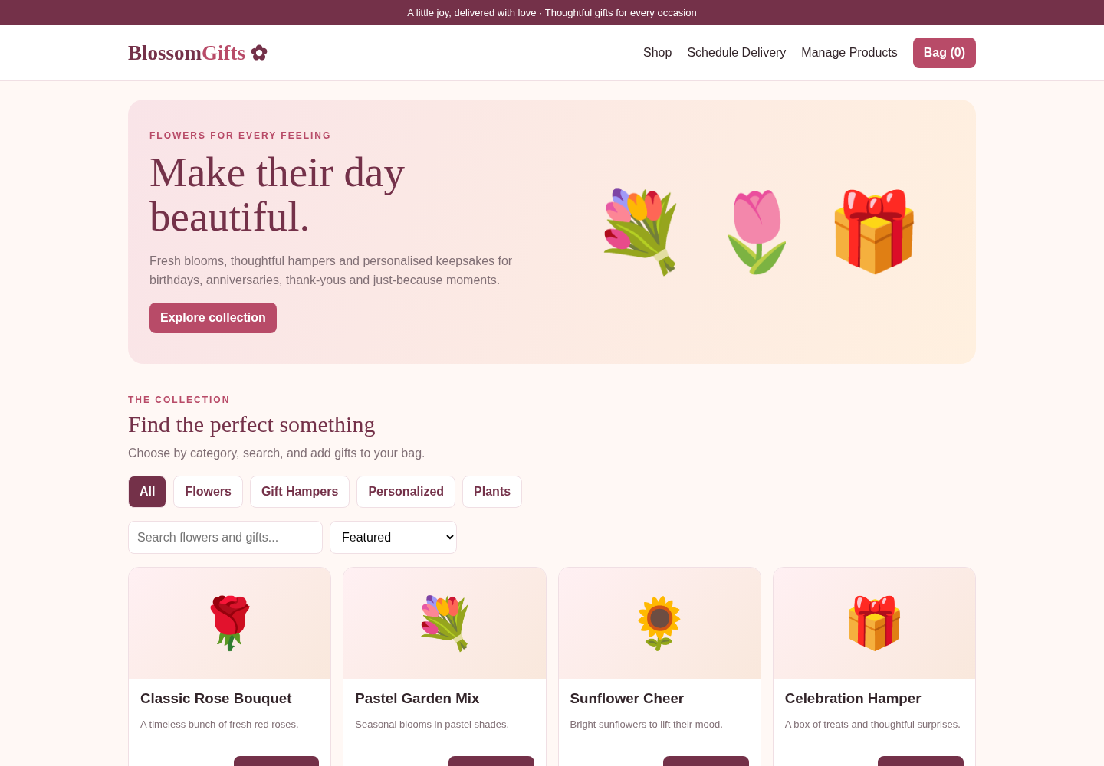
Figure 1. Homepage and navigation
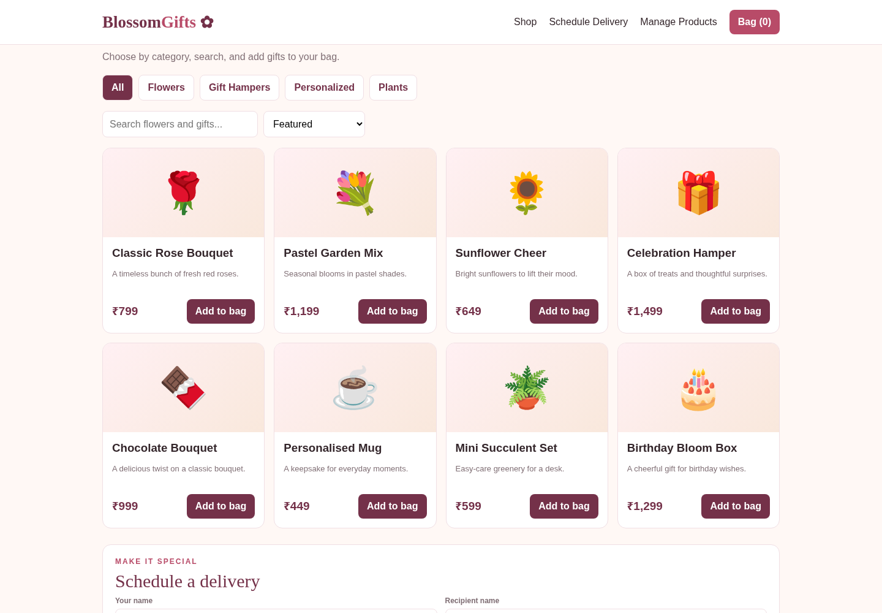
Figure 2. Product catalogue and browsing controls
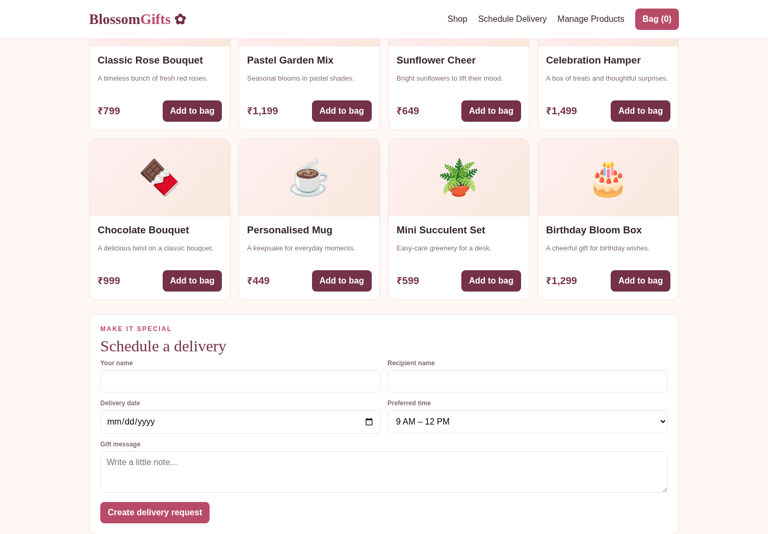
Figure 3. Form interaction area

7. Test Cases
Test | Expected / Observed Behaviour | Result
Open website | Page loads and displays BlossomGifts branding and hero section. | Pass
Category filter | Selecting a category displays products from that category. | Pass
Search products | Typing a product name filters the catalogue. | Pass
Shopping bag | Adding a product increments the bag count. | Pass
Delivery request | Valid delivery details display a confirmation message. | Pass
Add product | Submitting the product form adds a product card. | Pass

8. Result
The BlossomGifts frontend demonstration was developed successfully. It provides category browsing, search and sorting, a shopping bag, a delivery request form, and basic product addition.

9. Limitations
This is a client-side demonstration. Product and order changes exist only in JavaScript memory for the current page session. Real authentication, permanent database storage, live tracking, email/SMS notifications, and payment processing are not connected.

10. Source Code and Execution
The complete runnable source code is supplied separately as Question_13_BlossomGifts.html. Open it directly in a browser, or open it in Visual Studio Code and choose Open with Live Server.

