STRATEGIC MARKET ANALYSIS
AI Smart Toy Startup
Market Research • Business Analytics • Go-To-Market Strategy
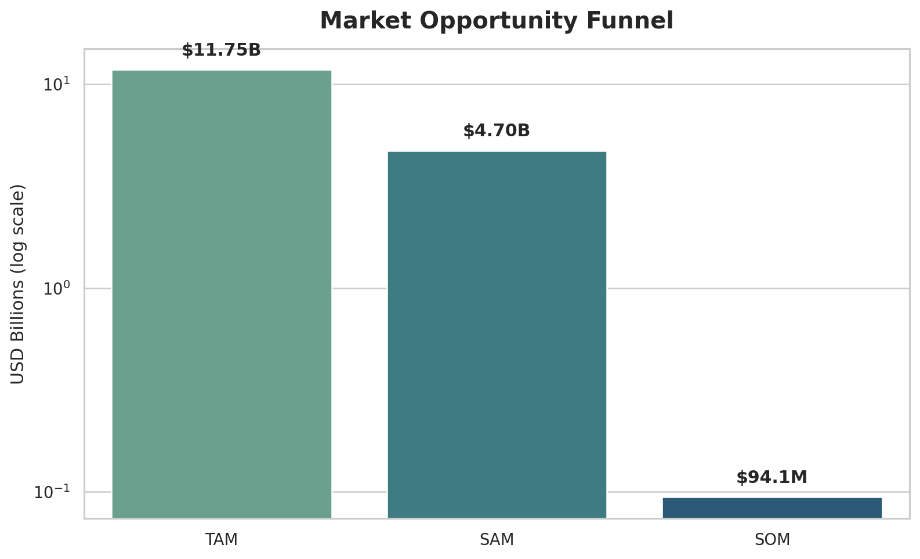
Portfolio Project Report
Based on the supplied Bern Go-To-Market Strategy market report

Executive Summary
This project converts the Bern AI smart toy market study into a structured business analytics case. The objective is to quantify the market opportunity, identify launch geographies, define customer and product positioning, evaluate distribution routes, and create a measurable GTM plan supported by SQL analytics, Python visualization, and a Power BI-ready dashboard design.
- The report uses a $33.59B U.S. toy market base and a 35% educational/interactive assumption to estimate an $11.75B TAM.
- Applying a 40% demographic focus gives a $4.70B SAM; a 2% penetration assumption produces an estimated $94.05M SOM.
- California ranks first for launch readiness with 28/30, followed by Massachusetts (24), New York (23), Washington (21), and Texas (21).
- Key purchase barriers include privacy and data security, unreliable functionality, price justification, and age-appropriate design.
- The GTM recommendation combines content, demos, community trust, referral loops, transparent AI safety, and hybrid online/offline distribution.

1. Project Overview

1.1 Problem Statement
How can Bern validate the commercial attractiveness of an AI-powered smart teddy in the U.S., prioritize launch markets, define a differentiated product and pricing proposition, and build a scalable go-to-market engine that converts parent interest into sustainable adoption and retention?

1.2 Business Objectives
- Estimate market opportunity using TAM, SAM and SOM.
- Prioritize U.S. states using demand, technology/regulatory readiness and purchasing power.
- Identify customer pain points and high-value use cases.
- Define product differentiation, positioning and pricing direction.
- Build acquisition, qualification, nurturing, conversion and retention strategies.
- Map online/offline distribution opportunities.
- Create a KPI framework and analytics layer for decision-making.

2. Data Foundation & Methodology
The source is a 49-page Bern Go-To-Market Strategy report. For portfolio analytics, the figures and tables were normalized into small, reproducible CSV datasets. The structured files preserve the report values and assumptions rather than inventing transaction-level customer behavior.
- Market sizing and growth figures.
- TAM/SAM/SOM assumptions.
- State-level scoring across child population, technology/regulation, and income.
- Online marketplace traffic and U.S. business exposure.
- Offline retailer presence by target city.
- KPI benchmark ranges and strategic tracking metrics.

3. Market Opportunity Assessment
The study frames AI smart toys as a high-growth niche inside the broader toy market. It cites a 2024 market size of $2.25B and a 2034 projection of $8.46B, equivalent to a 14.2% CAGR. The U.S. toy market base used for opportunity sizing is $33.59B.


3.1 TAM, SAM and SOM Logic
market_level | value | unit | basis
TAM | 11.75 | USD Billion | 35% of $33.59B U.S. toy market
SAM | 4.7 | USD Billion | 40% of TAM for age/demographic focus
SOM | 94.052 | USD Million | 2% of SAM market penetration assumption

Interpretation: the funnel is assumption-driven. It is useful for strategic sizing and scenario planning, not as a forecast of booked revenue. The strongest portfolio takeaway is the analytical logic: move from total category value to relevant segment, then to reachable demographic focus, then to realistic early penetration.

3.2 Key Market Risks
- Price-value gap: the report contrasts common toy prices around $10-$15 with AI-enabled products around $60-$75.
- Privacy and compliance: COPPA, toy safety requirements and ethical data handling are central trust constraints.
- Reliability: malfunctions, weak responsiveness and connectivity problems can reduce repeat use.
- Expectation management: overpromised AI capabilities can quickly damage parent trust and customer satisfaction.

4. Customer & Market Segmentation
The market-entry scoring model evaluates three dimensions: child population, technology adoption/regulatory environment, and median salary/purchasing power. Each dimension is scored from 1 to 10, with a total score out of 30.
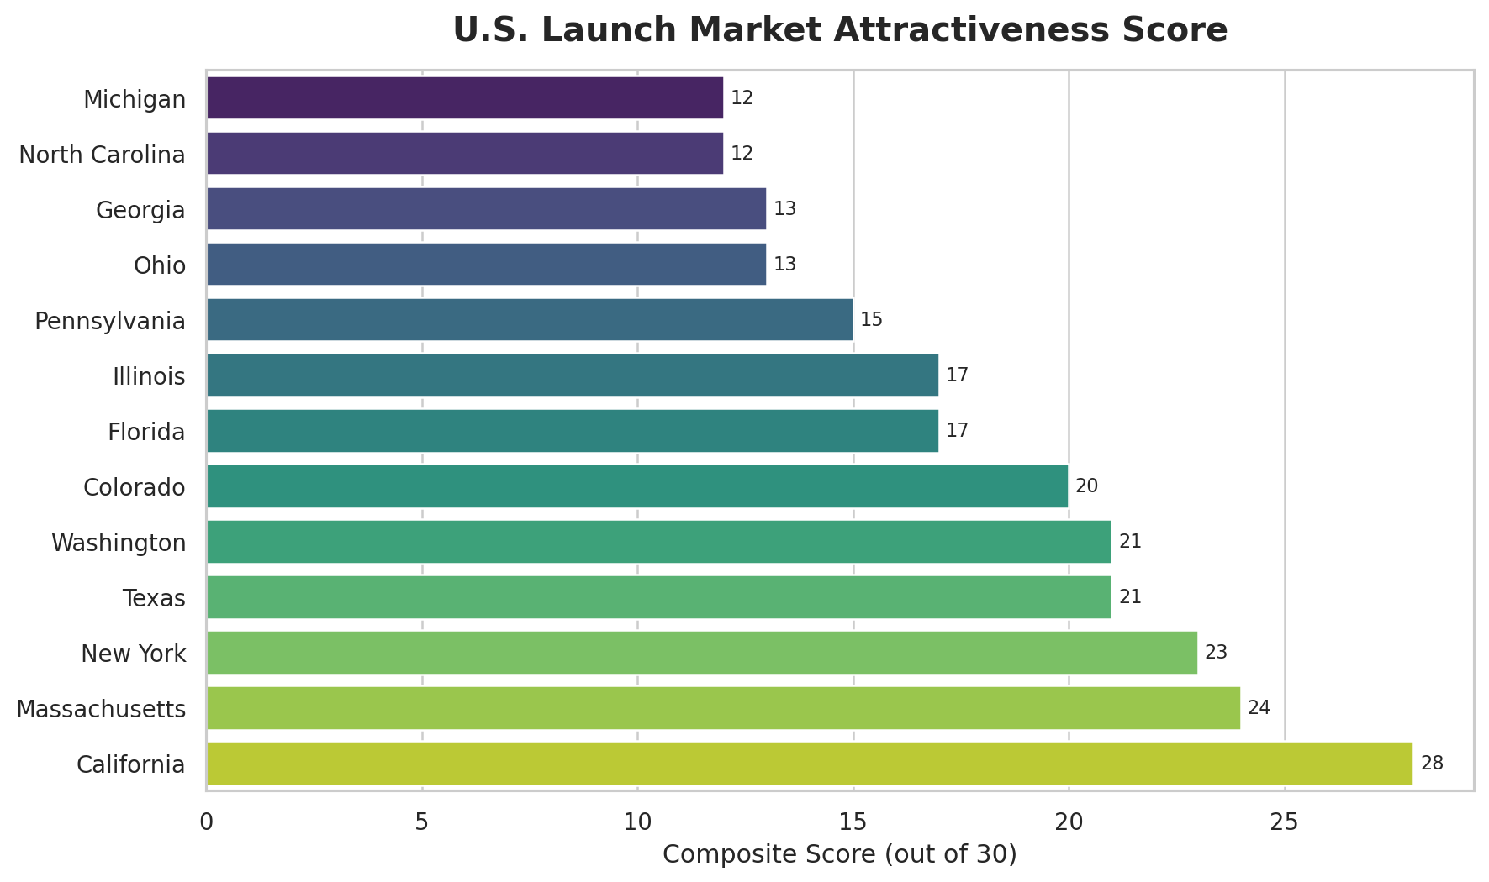
state | child_population_score | tech_policy_score | income_score | total_score
California | 10 | 10 | 8 | 28
Massachusetts | 5 | 9 | 10 | 24
New York | 7 | 8 | 8 | 23
Washington | 4 | 8 | 9 | 21
Texas | 9 | 7 | 5 | 21
Colorado | 6 | 7 | 7 | 20
Illinois | 7 | 4 | 6 | 17
Florida | 8 | 5 | 4 | 17

4.1 Priority Launch Markets
- California - strongest overall score (28/30), combining scale and technology readiness.
- Massachusetts - high-income and advanced technology environment.
- New York - balanced demand, infrastructure and spending power.
- Washington - technology hub with strong purchasing power.
- Texas - very large child population and meaningful scale potential despite lower income score.

4.2 Priority Customer Segments
- Dual-income parents seeking safe, engaging, screen-light support for children.
- Single-parent households where time pressure increases the value of reliable companionship and learning support.
- Parents of children in therapy, where conversational transcripts and emotional cues may support caregiver awareness.
- Parents who value educational, personalized and interactive products over passive toys.

5. Competitive & Product Strategy
The report identifies three direct and three indirect competitors and recommends differentiation around emotional intelligence, personalization, parent visibility, and child-safe AI. The strategic goal is not to compete as “another smart toy,” but to position Bern as an emotionally aware learning companion that creates value for both child and caregiver.

5.1 Core Value Proposition
- Advanced emotional detection through voice tone, language and behavioral cues.
- Interactive learning through conversations, stories, games and guided activities.
- Parent and therapist progress insights.
- Personalized interactions that adapt over time.
- Privacy-first and compliance-aware AI integration.

5.2 Recommended Product Differentiators
- Digital Diary: conversational memory and parent-visible transcripts.
- Real-time parent alerts for negative emotional signals, subject to safe design and consent.
- Parent-guided learning quests using customizable prompts.
- Advanced personalization and configurable responses.
- Educational modules, expanded story library and activity tracking.

5.3 Pricing Strategy
The report suggests cost-plus pricing for the physical teddy and a freemium model for the companion app. Free features can prove core value; paid tiers can monetize personalization, advanced analytics, custom learning prompts, expanded content and deeper activity tracking. The major business requirement is to justify premium pricing by connecting features to measurable parent value, not technology novelty alone.

6. Growth & GTM Strategy

6.1 Funnel Design
- Awareness / Lead Generation: product demos, social content, SEO, e-books, influencers, events and an interactive website.
- Evaluation / Lead Qualification: money-back guarantee, privacy transparency, live Q&A and personalized recommendations.
- Engagement / Lead Nurturing: segmented email journeys, retargeting, content marketing and parent communities.
- Decision / Conversion: limited-time incentives, referral loops, gift positioning, school demos, seamless checkout and setup support.
- Post-purchase / Retention: customer service, software updates, usage guidance, NPS, retention and active-user tracking.

6.2 Marketing Channels
- Instagram and Facebook for parent-facing proof, demos, UGC and storytelling.
- LinkedIn for partnerships, product credibility and institutional updates.
- YouTube for setup guides, product demonstrations and interactive content.
- Parent communities, schools, daycares, bookstores, blogs, fairs and niche groups for trust-building and product trial.

7. Distribution Strategy
The report emphasizes a hybrid model. Physical retail is important because toys are tactile and parents may want to evaluate quality in person, while e-commerce expands selection, convenience, reviews and reach.
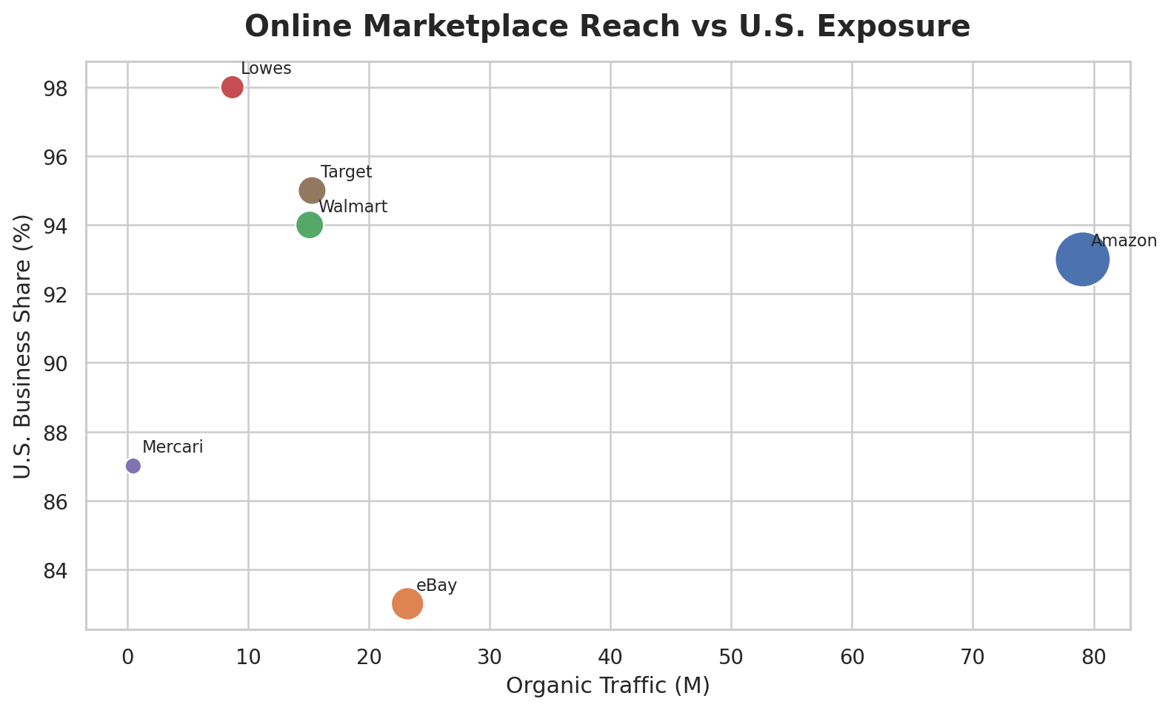

7.1 Online Marketplaces
platform | organic_traffic_m | traffic_unit | us_business_share_pct
Amazon | 79.1 | M | 93
eBay | 23.2 | M | 83
Walmart | 15.1 | M | 94
Lowes | 8.7 | M | 98
Mercari | 0.4894 | M | 87
Target | 15.3 | M | 95

7.2 Offline Retail Footprint
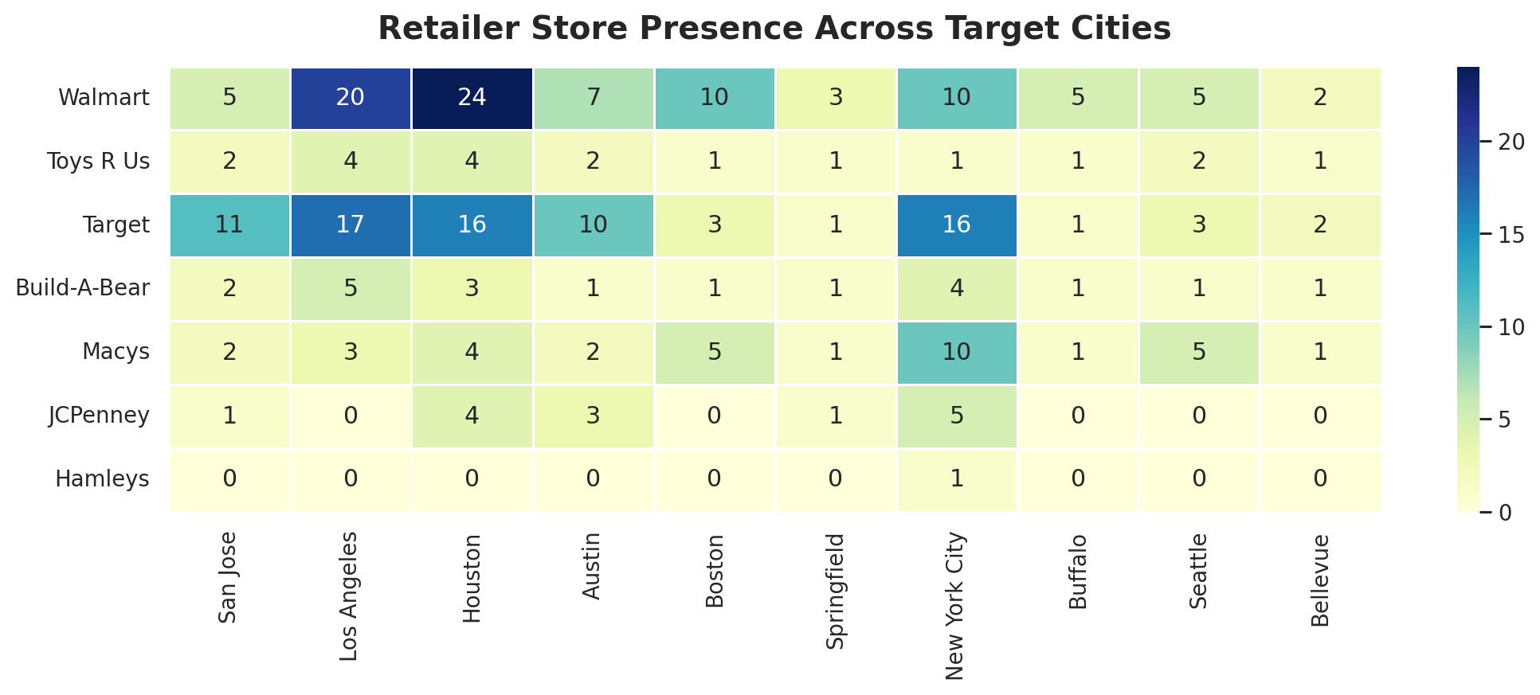
- Use interactive in-store demos to show AI capabilities instead of relying only on shelf packaging.
- Reduce retailer risk through clear rollout plans, product education and, where commercially feasible, inventory-risk sharing.
- Prioritize retailers with stronger presence in target cities and a customer base compatible with premium family products.

8. KPI & Measurement Framework
The KPI framework links marketing activity to commercial outcomes and product quality. A strong dashboard should avoid vanity metrics in isolation and connect top-of-funnel engagement to conversion, product use, retention and advocacy.
category | kpi | benchmark | interpretation
Digital | View-to-like ratio | 1-5% | Engagement quality benchmark
Digital | CTR | 2-5% | Ad-to-landing-page benchmark
Website | Sign-up rate | 2-5% | Strong sites may exceed 11%
Website | Bounce rate | <=40% | Above 55% indicates improvement needed
Retention | Annual churn | 4-7% | Report notes manageable range
Product | DAU / MAU | Track | Active-use intensity
Product | Avg engagement time | Track | Depth of product engagement
AI | Response accuracy | Track | Quality of AI interaction
Loyalty | NPS | Track | Referral likelihood

8.1 Core KPI Formulas
- Retention Rate = ((Active users at end - New users) / Active users at start) × 100.
- Churn Rate = (Users lost / Total users) × 100.
- CTR = Clicks / Impressions × 100.
- Conversion Rate = Desired actions / Eligible visitors × 100.
- Repeat Purchase Rate = Repeat customers / Total customers × 100.

9. SQL Analytics: Business Problems Solved
The SQL layer turns the report tables into reproducible business questions. Below are representative portfolio queries and the insight each query supports.

Q1. Which states should Bern launch in first?
SELECT state, child_population_score, tech_policy_score, income_score, total_score
FROM state_market_scores
ORDER BY total_score DESC
LIMIT 5;
Output / Business Meaning: California 28, Massachusetts 24, New York 23, Washington 21, Texas 21.

Q2. Which online platforms have the strongest reach?
SELECT platform, organic_traffic_m, us_business_share_pct
FROM online_platforms
ORDER BY organic_traffic_m DESC;
Output / Business Meaning: Amazon leads the report table with 79.1M organic traffic, followed by eBay.

Q3. Which platforms combine traffic and U.S. exposure?
SELECT platform, organic_traffic_m, us_business_share_pct,
ROUND(organic_traffic_m * us_business_share_pct/100,2) AS traffic_exposure_index
FROM online_platforms
ORDER BY traffic_exposure_index DESC;
Output / Business Meaning: This creates a simple prioritization index that rewards both reach and U.S. relevance.

Q4. Which retailers have the largest target-city footprint?
SELECT retailer, (`San Jose` + `Los Angeles` + Houston + Austin + Boston + Springfield + `New York City` + Buffalo + Seattle + Bellevue) AS total_target_city_stores
FROM offline_retailer_presence
ORDER BY total_target_city_stores DESC;
Output / Business Meaning: This supports retailer partnership prioritization for physical demos and distribution.

Q5. How should state expansion be tiered?
SELECT state, total_score,
CASE WHEN total_score >= 23 THEN 'Tier 1 - Launch' WHEN total_score >= 20 THEN 'Tier 2 - Expand' WHEN total_score >= 15 THEN 'Tier 3 - Test' ELSE 'Tier 4 - Later' END AS market_tier
FROM state_market_scores
ORDER BY total_score DESC;
Output / Business Meaning: A tiered model prevents spreading GTM resources evenly across markets with different attractiveness.

10. Python EDA & Visualization
Python is used to explore the structured report data and create portfolio-ready visuals. Seaborn supports clean comparative and heatmap analysis, while Plotly powers interactive charts where users can hover to inspect scores, platform details and other metrics.

10.1 Example Python Stack
import pandas as pd
import seaborn as sns
import matplotlib.pyplot as plt
import plotly.express as px

states = pd.read_csv('data/state_market_scores.csv')
fig = px.bar(states, x='state', y='total_score', hover_data=['child_population_score','tech_policy_score','income_score'])
fig.show()

10.2 Visualization Design Principles
- Avoid putting three dense visuals in one row; give labels enough horizontal and vertical space.
- Use horizontal bars for long state/retailer names.
- Use a donut only for a true part-to-whole assumption, not for unrelated percentages.
- Use scatter/bubble charts for reach-vs-exposure tradeoffs.
- Use heatmaps when comparing many retailers across many cities.
- Use Plotly tooltips to reveal detail without crowding labels.

11. Power BI Dashboard Design
Recommended title: AI Smart Toy Intelligence. Use a centered title, five KPI cards, and spacious two-visual rows. The dashboard should prioritize decision flow rather than visual density.
- Row 1: KPI cards - U.S. Toy Market, TAM, SAM, SOM, CAGR.
- Row 2: State priority horizontal bar + TAM assumption donut.
- Row 3: Online marketplace bubble chart + retailer total-store bar chart.
- Row 4: Full-width retailer-city heatmap.
- Slicers: Market Tier, State, Retailer and Platform.
- Hover tooltips: show component scores, traffic, U.S. business share, city store counts and calculated priority indices.

11.1 Dashboard Story
A viewer should be able to answer four questions in under a minute: How large is the opportunity? Where should Bern launch? Which channels deserve priority? Which KPIs should management monitor after launch?

12. Strategic Recommendations
Launch narrowly before scaling: Prioritize California, Massachusetts and New York for the first evidence-building phase; use Washington and Texas as the next expansion wave.
Make trust a product feature: Treat privacy, child safety, local processing choices, transparent data handling and clear parental controls as positioning pillars, not compliance footnotes.
Prove premium value: Use demos, trials/guarantees, parent testimonials and measurable learning/engagement outcomes to reduce resistance to premium pricing.
Use hybrid distribution: Combine Amazon/e-commerce reach with physical demonstrations in high-density retail markets, schools, daycares and community events.
Build a measurable funnel: Track CTR and sign-up at awareness, checkout conversion at purchase, DAU/MAU and engagement time after onboarding, then retention, churn, NPS and repeat purchase over time.
Scale personalization carefully: Use personalization, parent-guided learning and emotional support as premium levers while maintaining age appropriateness, explainability and safety boundaries.

13. Conclusion
The Bern market study supports a credible U.S. opportunity for an AI-enabled smart toy, but the strongest strategy is not broad national expansion from day one. A focused launch in the highest-scoring states, privacy-first positioning, premium value proof, hybrid distribution and disciplined funnel measurement provide a more defensible path. The analytics layer created in this project translates the qualitative market report into structured data, SQL questions, Python visualizations and a Power BI-ready decision framework, making the recommendation reproducible and portfolio-ready.

