CredResolve Collections Analytics
Forensic Data Analyst Assignment
Submission-ready analytical report | Synthetic 30K-account collections dataset

Executive Summary
The reported 11% month-on-month recovery increase is numerically true for February to March 2026: raw successful-payment recovery rises 10.99%, and after payment-ID deduplication it rises 11.03%. However, this is a one-month spike rather than evidence of a sustained operational improvement. On the defensible targeted-exposure denominator, the recovery rate rises 25.86% in March and remains 26.17% after standardizing to February DPD × risk × loan mix. Across complete months January-July, the recovery trend is statistically flat (p=0.89).
The recommended investment area is Better Borrower Targeting, but not as an unconditional ₹10 Cr deployment. Current targeting priority is not monotonic with recovery, so ranking quality can be improved; yet the supplied data does not prove causal lift. Annualized targeted exposure is about ₹2353 Cr, so a one-year ₹10 Cr investment needs roughly 0.43 percentage points incremental recovery to break even. A randomized holdout should be the funding gate.
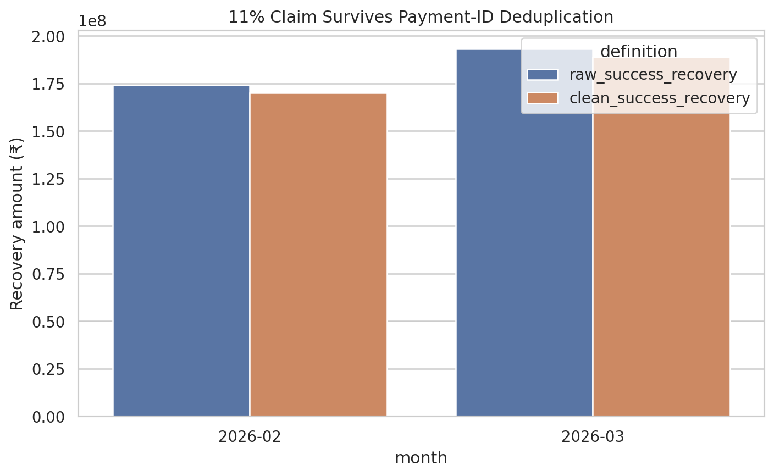

1. Assignment Interpretation and Analytical Philosophy
The assignment is a data-forensics and business-decision exercise. The correct objective is not to reproduce existing reporting; it is to reconstruct the business truth from contradictory sources, quantify the effect of cleaning/definitions, distinguish fact from correlation, and make an investment decision with uncertainty visible.
- Question 1 - What happened? Reconstruct trustworthy monthly performance.
- Question 2 - Why? Decompose by portfolio, DPD, geography, agent/campaign/channel/vendor/time/frequency.
- Question 3 - Is +11% real? Independently define recovery metrics and reconcile the claim.
- Question 4 - Where to invest ₹10 Cr? Compare evidence, economics, downside, and confidence.

2. Data Inventory and Coverage
Dataset | Rows | Columns | Exact duplicates
borrowers | 30,600 | 8 | 600
accounts | 30,000 | 11 | 0
agents | 30,000 | 8 | 0
agent_sessions | 15,000 | 7 | 0
campaigns | 120 | 7 | 0
daily_targeting | 45,000 | 7 | 0
calls | 91,350 | 11 | 1,271
call_attempts | 120,000 | 9 | 0
call_dispositions | 35,000 | 8 | 0
whatsapp_events | 60,600 | 8 | 600
sms_events | 45,000 | 8 | 0
field_visits | 25,000 | 10 | 0
promises_to_pay | 18,000 | 9 | 0
payments | 25,500 | 9 | 486
vendor_telephony | 15 | 6 | 0
complaints | 8,000 | 9 | 0
account_status_history | 60,000 | 8 | 0
Coverage limitation: operational events run from 1 Jan 2026 through 8 Aug 2026. This is materially shorter than the “approximately 12 months” stated in the assignment. August is a partial month and is not used for trend conclusions.

3. Source-of-Truth and Golden Dataset Decisions
Area | Decision | Reason
Entity key | account_id | Stable across event tables; event borrower_id is contradictory.
Borrower attributes | accounts.borrower_id → latest borrower master | Prevents random event borrower IDs from corrupting geography/identity.
Payment event key | payment_id | Payment reference repeats across accounts and amounts.
Valid recovery | SUCCESS only | FAILED/PENDING/REVERSED are not realized cash recovery.
Monthly denominator | Unique targeted-account outstanding exposure | Auditable operational eligibility denominator; avoids attempt/message denominator inflation.
Trend window | Jan-Jul 2026 | Aug is only 8 days.
Agent identity | agent_id only | employee_code is many-to-many and unsuitable for canonical identity.
Golden grain: one row per targeted account per month. The golden table contains account/borrower attributes, targeting information, channel activity, PTP activity, recovery, and calculated recovery rate. This design makes denominators explicit and prevents event-level duplicates from multiplying account exposure.

4. Data Quality and Forensics
- Payments: 486 exact duplicate rows; 500 duplicated payment IDs.
- Calls: 1,271 exact duplicate rows.
- WhatsApp: 600 exact duplicate rows.
- Borrower identity: event borrower_id disagrees with accounts.borrower_id in approximately 98% of event rows.
- Timestamp contradictions: 15,354 borrower rows have updated_at before created_at; 30,191 status-history rows have recorded_at before event_at.
- Mixed source time zones exist; calling-hour analysis is normalized to Asia/Kolkata where row timezone is available.
- Cost data is absent; cost-per-₹ recovered cannot be directly measured without explicit assumptions.
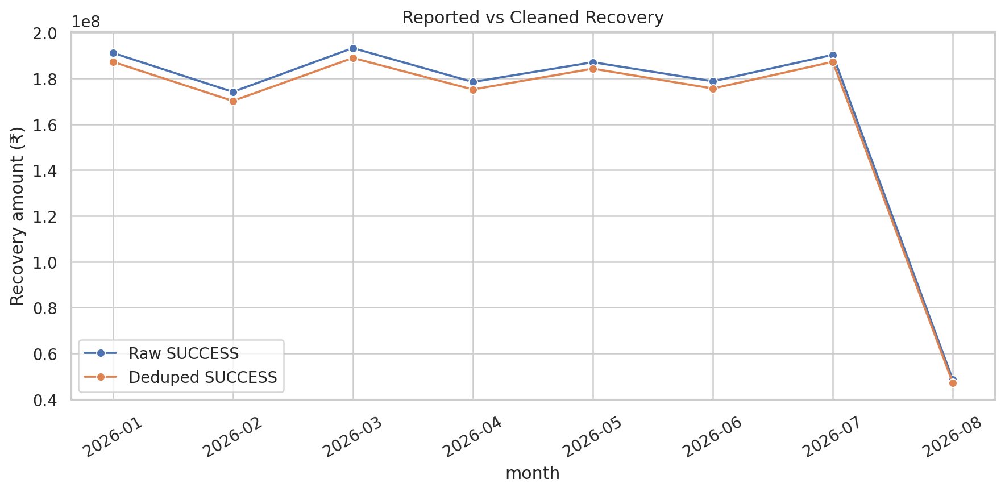

5. KPI Definitions
Metric | Definition | Why
Recovery | Sum of deduped SUCCESS payment amount | Cash-realized, reproducible.
Targeted recovery rate | Targeted-account recovery / targeted outstanding exposure | Controls operational denominator.
Contact rate | Answered calls / deduped calls | Simple telephony outcome.
RPC rate | Right-party dispositions / dispositioned calls | Avoids >100% contradictions with call-status data.
PTP rate | PTP dispositions / RPC dispositions | Normalized promise generation.
PTP kept rate | KEPT / (KEPT + BROKEN) for due PTPs | Excludes open/not-yet-due promises.
Recovery/account | Recovery / targeted accounts | Portfolio-normalized productivity.
Recovery/agent-hour | Portfolio recovery / valid session hours | Proxy only; payments lack direct agent owner.
Channel conversion | 7-day last meaningful touch attribution | Auditable but sensitive to window; not causal.

6. What Happened? - 11% Claim Reconciliation
Measure | Feb 2026 | Mar 2026 | Change
Raw SUCCESS recovery | ₹17.41 Cr | ₹19.32 Cr | +10.99%
Deduped SUCCESS recovery | ₹17.01 Cr | ₹18.89 Cr | +11.03%
Targeted recovery rate | 1.550% | 1.951% | +25.86% relative
Mix-adjusted targeted rate | 1.550% | 1.955% | +26.17% relative
Conclusion - Fact: the +11% Feb→Mar recovery arithmetic is real after primary-key deduplication. Strong Evidence: the improvement is not explained by DPD/risk/loan mix; bootstrap 95% interval for targeted-rate relative change is approximately 7.9% to 47.9%. But the business statement “recovery is improving” is misleading if interpreted as a sustained trend: the Jan-Jul clean-recovery trend p-value is 0.89, and April falls after March.
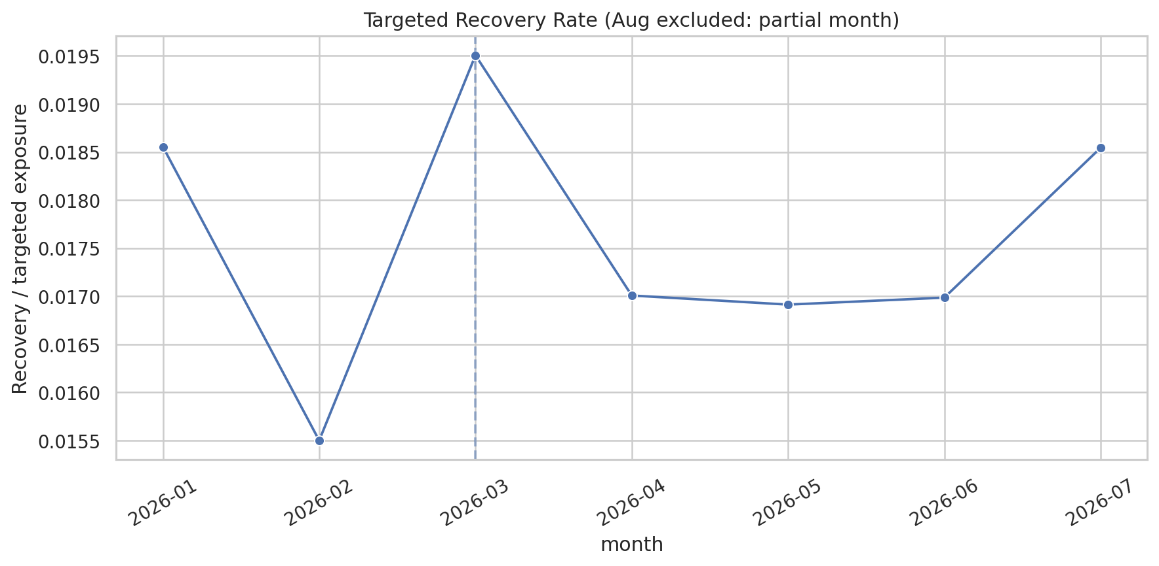

7. Why Did It Happen? - Driver Investigation
The supplied synthetic data does not contain a single causal driver that explains March. Segment results are useful for targeting and operating design, but are classified as correlation unless randomized or identified through a credible natural experiment.
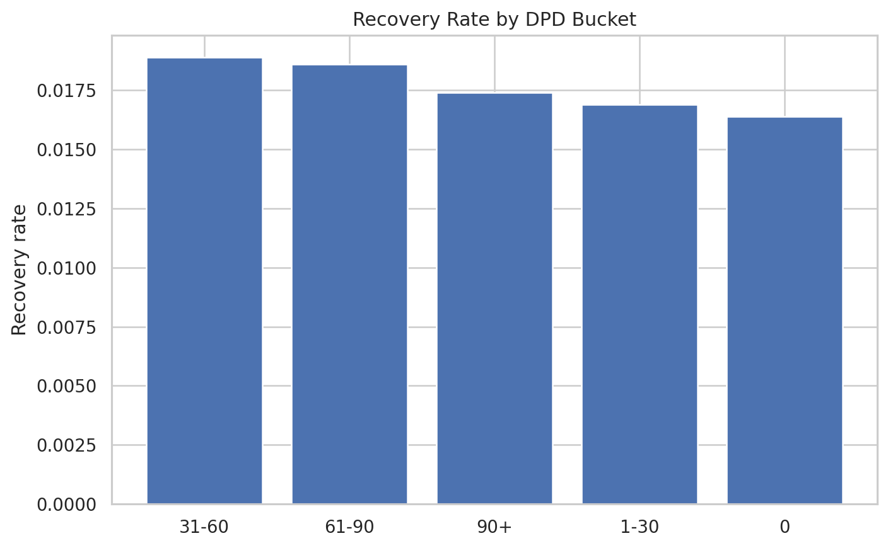
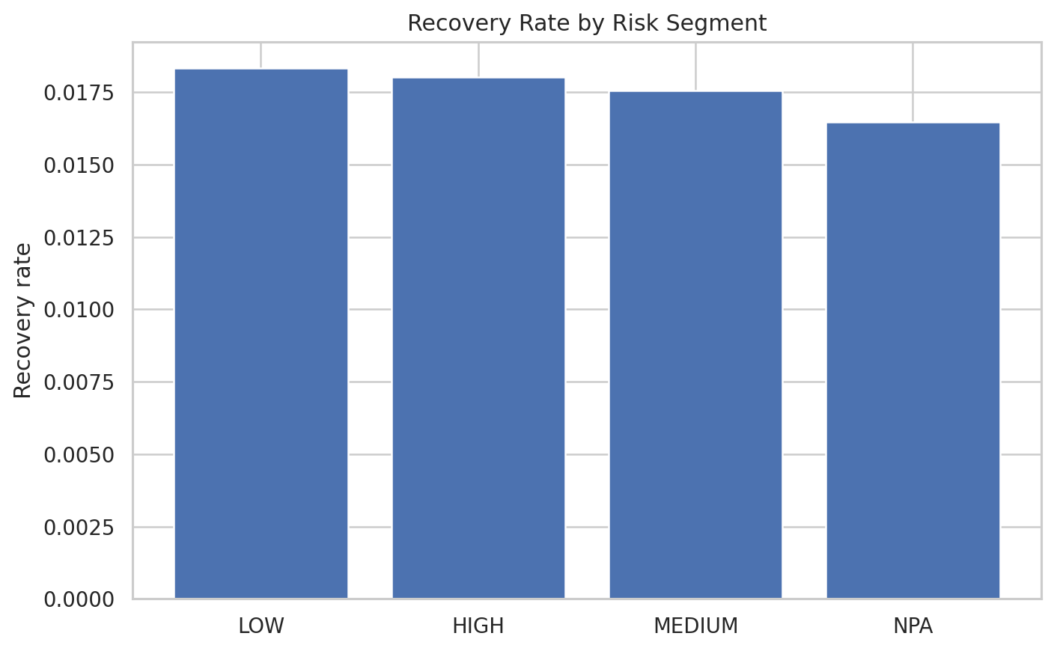
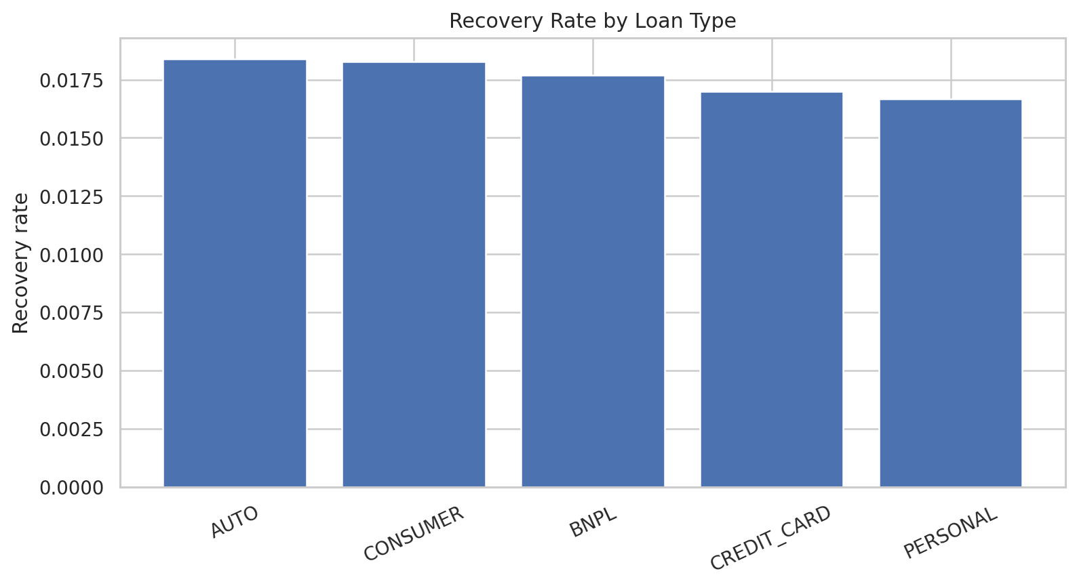
Correlations: 31-60 DPD has the highest observed recovery rate among DPD groups, LOW/HIGH outperform NPA modestly, and AUTO/CONSUMER outperform PERSONAL/CREDIT_CARD. These are ranking signals, not causal effects.
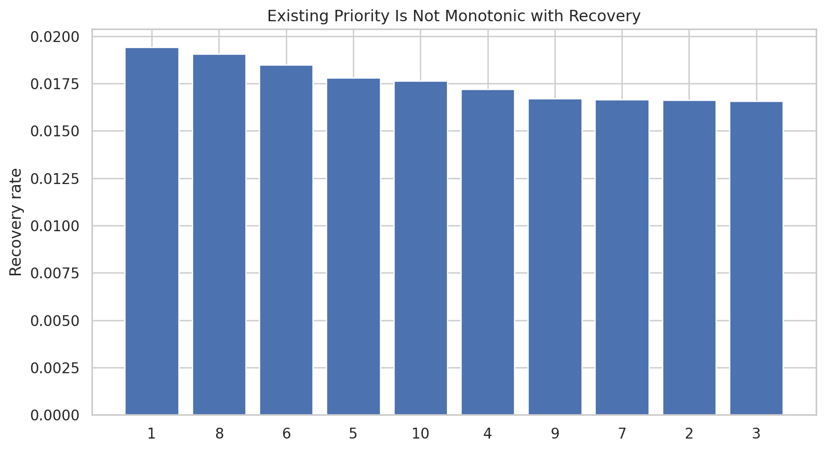
Strong Evidence of targeting headroom: the existing priority field is not monotonic with observed recovery. A well-calibrated priority score should normally rank expected value more consistently; this motivates a targeting experiment.
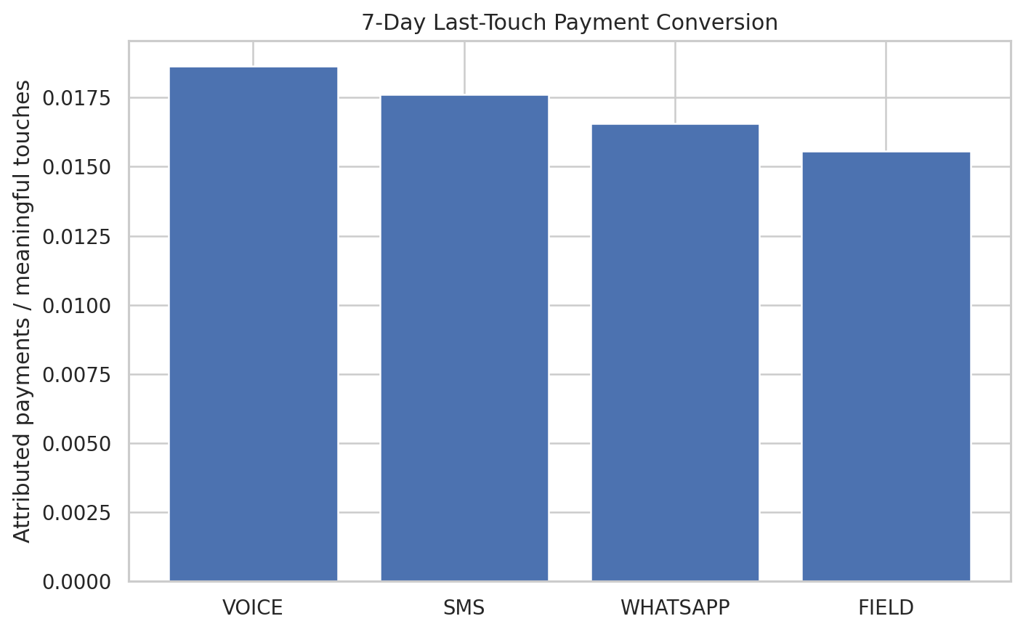
Channel last-touch conversion is tightly clustered. Voice is highest in this 7-day attribution view, but only ~9% of successful payments have a meaningful interaction in the prior seven days, so channel causality cannot be claimed from last-touch attribution.
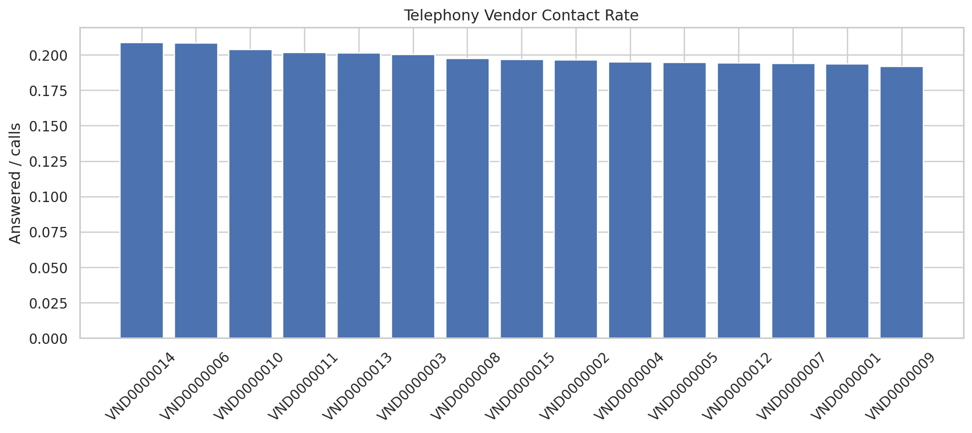
Telephony vendor contact rates vary only modestly (~19-21%), providing no evidence of a system-wide telephony failure large enough to justify a ₹10 Cr infrastructure bet from this dataset alone.
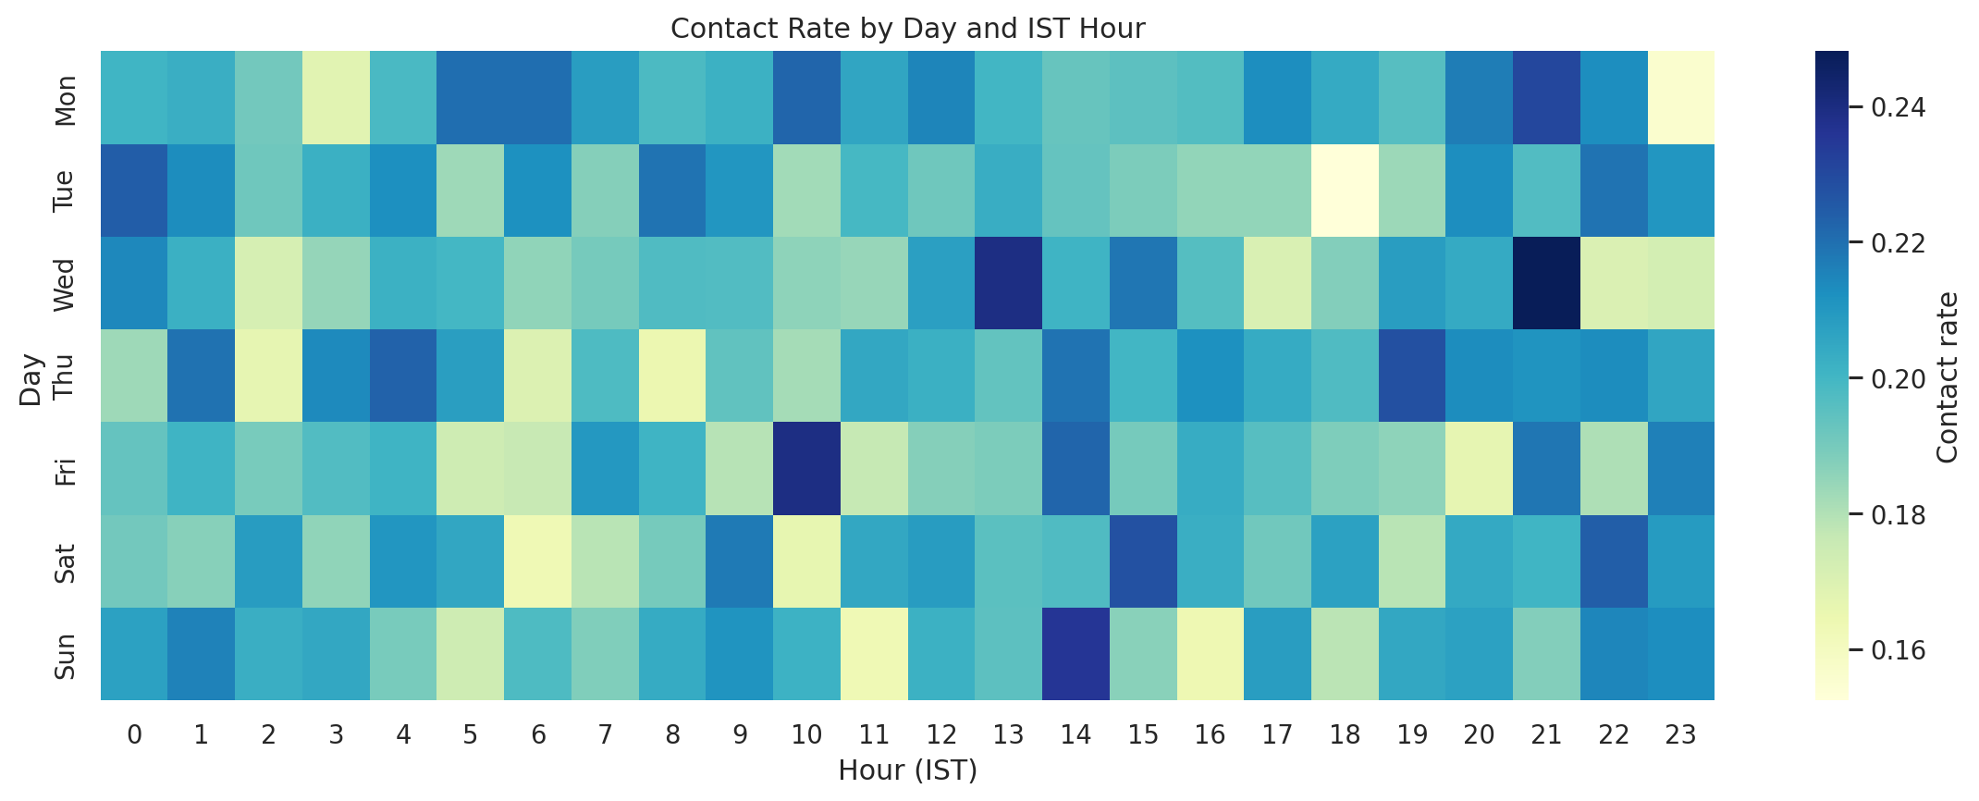
Calling-time patterns are normalized to IST. Use these as scheduling correlations; routing different borrower types into different hours can confound observed contact rates.
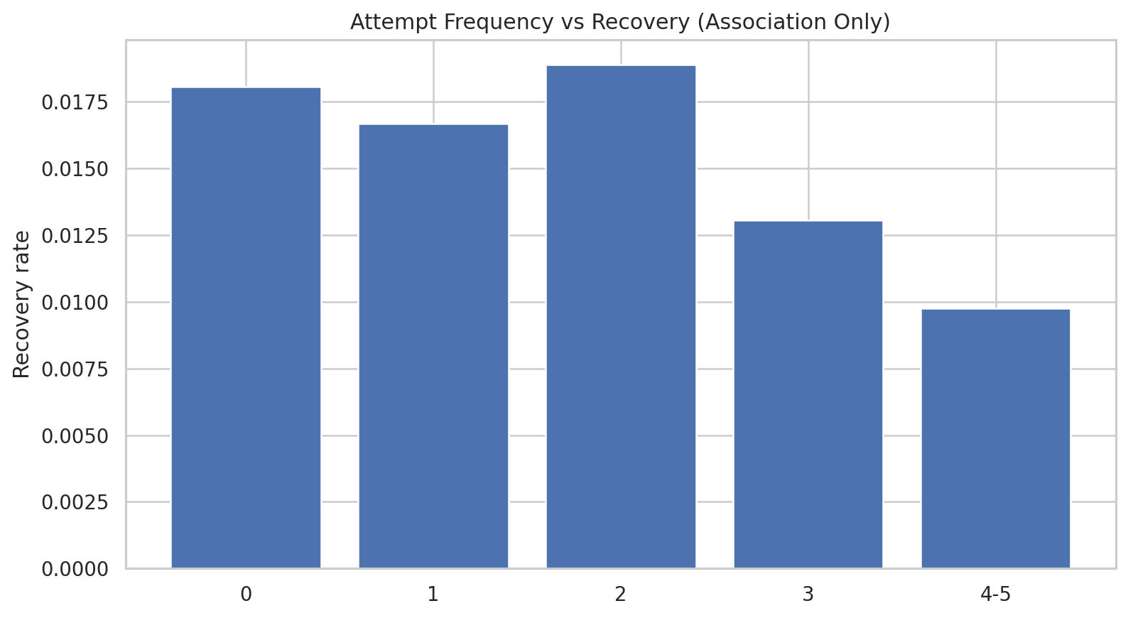
Attempt frequency is also selection-biased: difficult accounts may receive more attempts. The chart is therefore diagnostic, not a causal recommendation to increase/decrease attempts.

8. Statistical Investigation and Bias Checks
Risk | How checked | Result / treatment
Mix effects | Feb-weight standardization across DPD × risk × loan | March relative lift remains ~26.2%
Selection bias | Targeted-only denominator and explicit non-random targeting caveat | Not eliminated; experiment required.
Survivorship bias | Use targeted account-month denominator, not only contacted/paying accounts | Reduced, but historical active-status snapshots absent.
Simpson’s paradox | Compare aggregate and segment-standardized rates | No evidence that these three mix dimensions explain March spike.
Attribution-window bias | Use stated 7-day last-touch and label as non-causal | Sensitivity should be rerun at 3/14 days in production.
Time-series effects | Exclude partial Aug; Jan-Jul trend regression | No sustained trend.

9. Counterfactual - What If Targeting Had Not Changed?
The assignment asks for a counterfactual assuming targeting changed mid-period. The delivered files do not contain a clean switch flag or a stable untreated comparison population. Therefore an apparently precise retrospective causal estimate would be fabricated. The proposed identification strategy is a stratified randomized holdout: randomize eligible accounts within DPD × risk × loan/client/geography strata; treatment receives new ranking/routing, control retains current targeting; primary outcome is 30-day recovery / opening exposure; estimate intention-to-treat lift with robust confidence intervals. Guardrails: complaints, contact frequency, PTP kept, and borrower opt-outs.
If leadership insists on retrospective analysis, use matched Difference-in-Differences only after validating stable treatment assignment, overlap, and parallel pre-trends. Propensity scores can improve balance but cannot solve unmeasured confounding.

10. ₹10 Cr Investment Recommendation
Recommendation: Better Borrower Targeting - stage-gated. Reasons: (1) current priority is poorly calibrated to recovery, (2) measurable segment spread exists, (3) telephony vendor differences are small, (4) no direct AI-voice treatment exists, (5) field/digital cost data is absent, and (6) adding agents cannot be justified without marginal capacity/cost evidence.
Scenario | Incremental lift | Annual recovery | 1-year ROI | Break-even
Downside | 0.10 pp | ₹2.35 Cr | -76.5% | 51.0 mo
Evidence-based base | 0.20 pp | ₹4.69 Cr | -53.1% | 25.6 mo
Upside / hurdle | 0.50 pp | ₹11.76 Cr | 17.6% | 10.2 mo
Break-even hurdle: approximately 0.43 percentage points incremental recovery on annualized targeted exposure. Because the observational backtest does not prove this threshold, the optimal bank-grade decision is to reserve the ₹10 Cr budget for targeting but release it in tranches after an experiment validates lift. Confidence in “targeting is the best candidate” = Medium; confidence in a positive one-year ROI at full ₹10 Cr = Low with current data.

11. Production Analytics Design
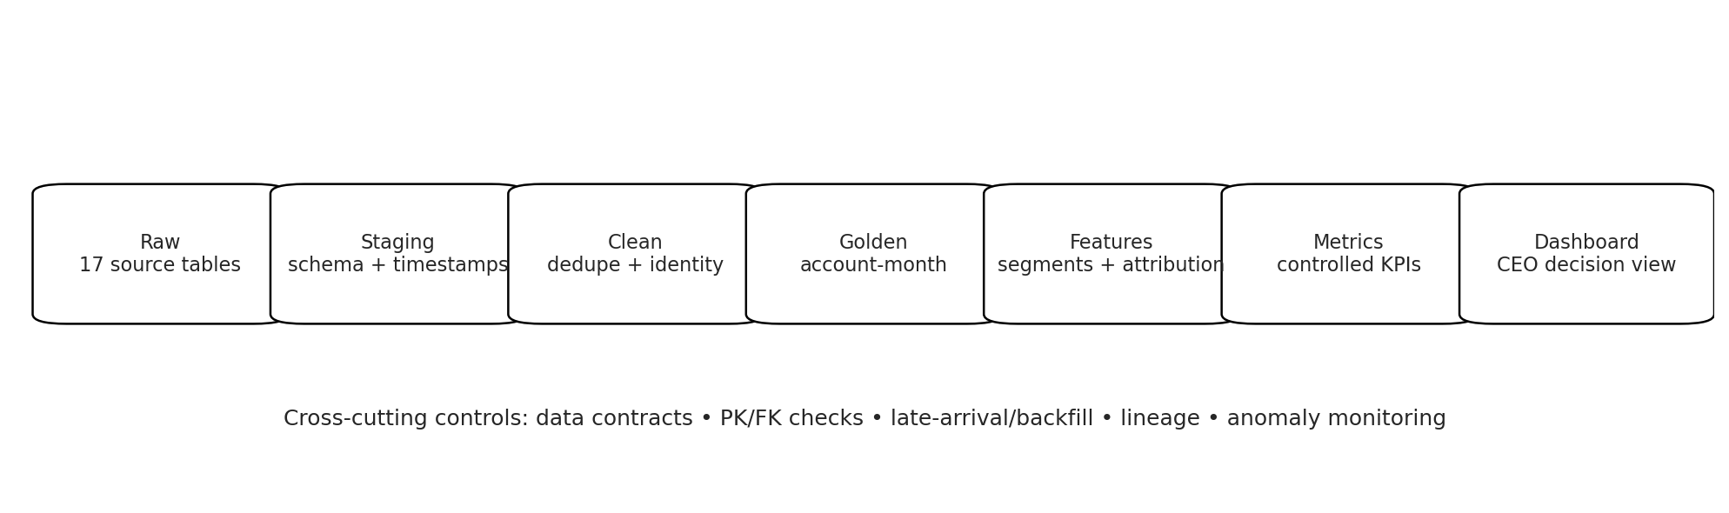
- Data contracts: explicit PKs, timestamp timezone, allowed statuses/disposition mappings, schema versions.
- Primary keys: account_id, payment_id, call_id, target_id, message/event IDs; enforce uniqueness after staging.
- Lineage: every executive KPI traces to golden account-month and source records.
- Incremental processing: watermark by ingestion/recorded timestamp; partition events by event date.
- Late arrivals/backfills: rolling reprocess window plus idempotent MERGE keyed by event ID.
- Quality monitoring: uniqueness, referential integrity, borrower/account mismatch, negative/implausible time order, partial-day completeness, distribution shifts.
- Anomaly detection: monthly/day-level recovery, target denominator, vendor contact rate, attribution share and duplicate-rate control charts.

12. Deliverables and How to Use the Repository
- README.md - front-page executive summary and reproducibility instructions.
- notebooks/collections_forensic_analysis.ipynb - reasoning and evidence.
- sql/ - production-style staging, cleaning, golden, metrics and forensic queries.
- data/golden/golden_account_month.csv - final analytical layer.
- reports/data_quality_summary.csv - detected issues and impact.
- dashboard/executive_dashboard.html - hoverable one-screen CEO dashboard.
- reports/Executive_Memo.pdf - two-page leadership memo.
- architecture/production_architecture.png - implementation-ready flow.

13. Final Conclusions by Assignment Part
Part | What was done | Concluded result
Golden dataset | Defined account-month grain, canonical keys, dedupe, identity resolution and explicit denominators. | Trust account_id; event borrower_id is unusable for segmentation.
Data forensics | Audited duplicates, references, timestamps, identities, partial period and denominator risks. | Material data issues exist; cleaning changes rupee totals but not the 11% direction.
Statistical investigation | Mix standardization, bootstrap uncertainty, trend test, bias review. | March spike survives mix adjustment; no sustained Jan-Jul improvement.
11% claim | Compared raw, cleaned and targeted-exposure metrics. | Numerically true for Feb→Mar; misleading if stated as structural performance improvement.
Counterfactual | Assessed identifiability and designed randomized holdout / DiD fallback. | No defensible causal switch estimate from supplied files alone.
₹10 Cr | Compared evidence across telephony, agents, AI voice, targeting, digital and field; modeled hurdle/scenarios. | Targeting is best candidate, but stage-gate until ≥ break-even lift is proven.
Production design | Designed raw→staging→clean→golden→feature→metrics→dashboard with controls. | Practical engineering path with lineage, backfills and monitoring.

