
END-TO-END DATA ANALYTICS PROJECT REPORT
VYORIUS DRONES PVT. LTD.
Enterprise Operations • Business Intelligence • AI Decision Support

Dataset | 15,000 mission & telemetry records • 62 fields
Coverage | 2021 to July 2026 • 680 drones • 450 customers
Technology | SQL • Python • Power BI • DAX • Scikit-learn
Project Type | Portfolio analysis based on synthetic operational data

Executive Summary
This project converts mission-level drone operations data into an executive analytics system. The work covers data quality, SQL KPI reporting, Python exploratory analysis, operational root-cause analysis, commercial performance, fleet optimization, Power BI dashboard design and AI-assisted decision support.
- Analyzed 15,000 mission records across DJI, Autel, Parrot and custom/PX4-ArduPilot platforms.
- Observed an overall mission success rate of 83.77%, delay rate of 14.13% and failure rate of 1.43%.
- Measured ₹176.97M revenue and ₹154.00M gross margin in the synthetic dataset.
- Built a 25+ KPI reporting framework spanning reliability, maintenance, fleet health, customer, revenue and profitability.
- Designed AI prototypes for predictive maintenance and mission scheduling risk prioritization.
Important interpretation note: The source contains mission revenue but no invoice-level recurring billing. Any MRR view is therefore labelled MRR Proxy / Monthly Revenue Trend.

1. Problem Statement
Enterprise drone programs operate across mixed hardware, mission types, customers and environmental conditions. The business challenge is to understand whether missions are being completed reliably, what is creating delay/downtime, which assets and customer segments are economically attractive, and how data/AI can improve scheduling and maintenance decisions.

Business Questions
- What is the overall mission reliability and operational efficiency of the fleet?
- Which manufacturers and drone models perform most reliably?
- What conditions and root causes drive failed or delayed missions?
- Which drones create disproportionate maintenance cost and downtime?
- Which industries, mission types and subscription plans contribute most revenue and margin?
- Where can fleet capacity be rebalanced to improve utilization?
- How can AI support maintenance prioritization, scheduling and future autonomous planning?

2. Dataset & Data Preparation
The dataset contains 15,000 rows and 62 columns from 2021-01-01 to 2026-07-31. It includes mission identifiers, drone/platform details, environmental telemetry, battery and GPS metrics, operators, maintenance, customer segments and financial outcomes.

Key Data Domains
Domain | Example Fields | Analytical Use
Mission | status, type, duration, distance, delay | Success, delay, efficiency
Drone / Platform | manufacturer, model, autopilot, firmware | Vendor/model benchmarking
Telemetry | battery, GPS, signal, wind, payload | Risk and reliability analysis
Maintenance | cycles, service age, downtime, cost | Predictive maintenance
Customer | industry, plan, rating | Segmentation and retention proxy
Finance | revenue, operating cost, gross margin | Commercial analytics

Data Quality Decisions
- Converted mission_date to a date type and derived month/year time dimensions.
- Kept missing failure_reason values because they are logically expected for successful missions.
- Kept the small number of missing customer ratings as null rather than fabricating ratings.
- Created explicit proxy labels where the raw data does not support a strict finance definition, especially MRR and retention.

3. KPI Framework
The project uses an executive KPI layer that can be computed in SQL and recreated as DAX measures in Power BI.
KPI | Observed Result | Why It Matters
Mission Success Rate | 83.77% | Core reliability
Delay Rate | 14.13% | Schedule/service quality
Failure Rate | 1.43% | Operational risk
Average Battery Health | 89.59% | Fleet health
Maintenance Due Rate | 34.32% | Maintenance workload
Revenue | ₹176.97M | Commercial scale
Gross Margin % | 87.02% | Unit economics
Unique Drones | 680 | Fleet scale
Unique Customers | 450 | Customer coverage

4. SQL Business Analysis
The SQL layer contains 25 structured queries. It is designed to show both technical SQL ability and business problem solving. The full script is included in the GitHub package.

Representative SQL Problems
- Executive scorecard: total missions, success/failure/delay, fleet size, customers, revenue, cost and margin.
- Manufacturer/model reliability: compare success, battery health, downtime and maintenance burden.
- Root-cause analysis: rank failed and delayed mission reasons.
- Maintenance analytics: battery bands, service age, downtime and maintenance cost.
- Commercial analytics: industry, plan, mission type and geographic revenue/margin.
- Customer retention proxy: identify customers active in consecutive calendar years.
- Window functions: rolling three-month revenue and year-over-year growth.
- Management exception list: surface missions/assets with failure, delay, weak battery/signal or maintenance due.
Example query pattern:
SELECT manufacturer,
COUNT(*) AS missions,
ROUND(100*AVG(mission_status='Completed'),2) AS success_rate_pct,
ROUND(SUM(downtime_hours),2) AS downtime_hours
FROM drone_operations
GROUP BY manufacturer
ORDER BY success_rate_pct DESC;

5. Python EDA & Findings
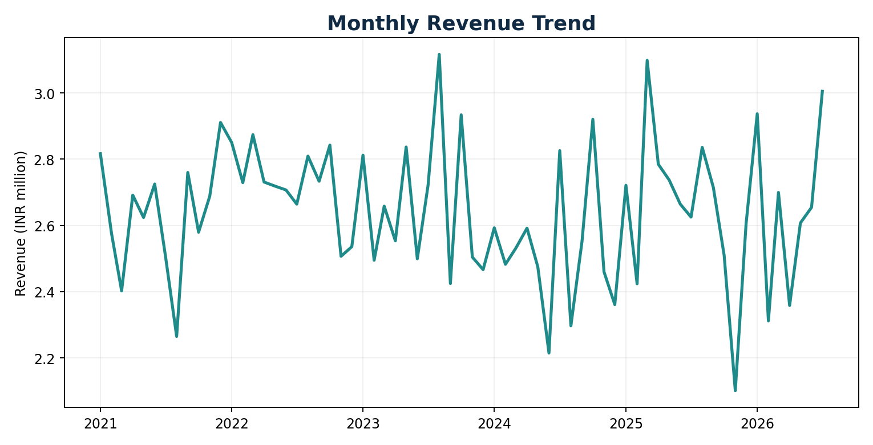
Figure 1. Monthly mission-revenue trend across the observation period.

Reliability by Manufacturer
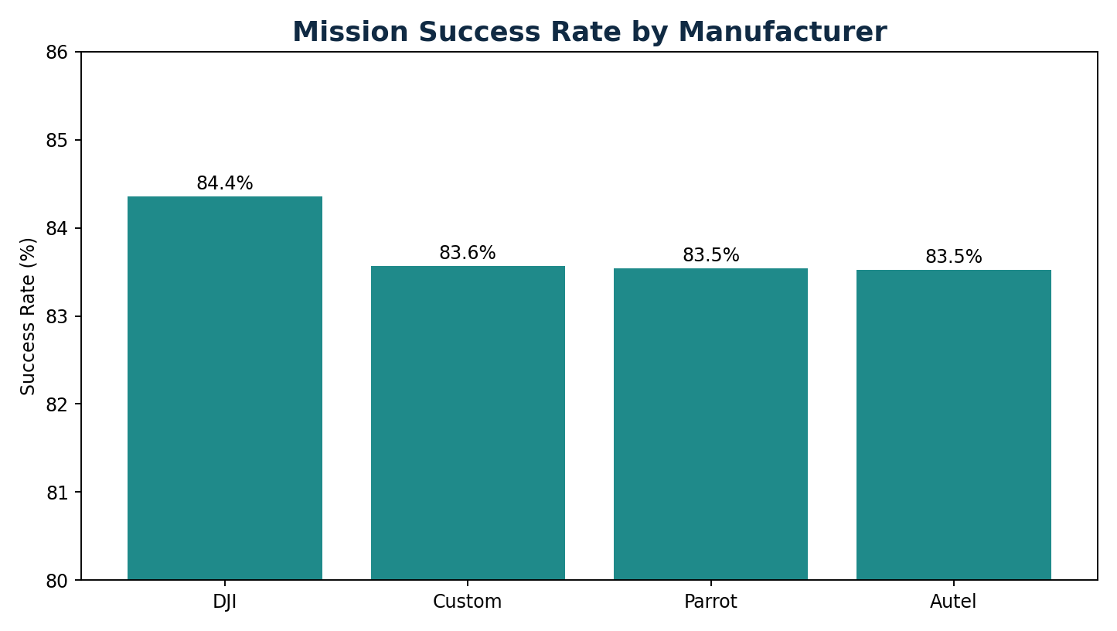
DJI has the highest observed success rate (84.35%) among the manufacturer groups. The differences are relatively small, so the practical conclusion is to benchmark models using multiple dimensions—success, downtime, maintenance cost and margin—rather than success alone.

Root-Cause Analysis
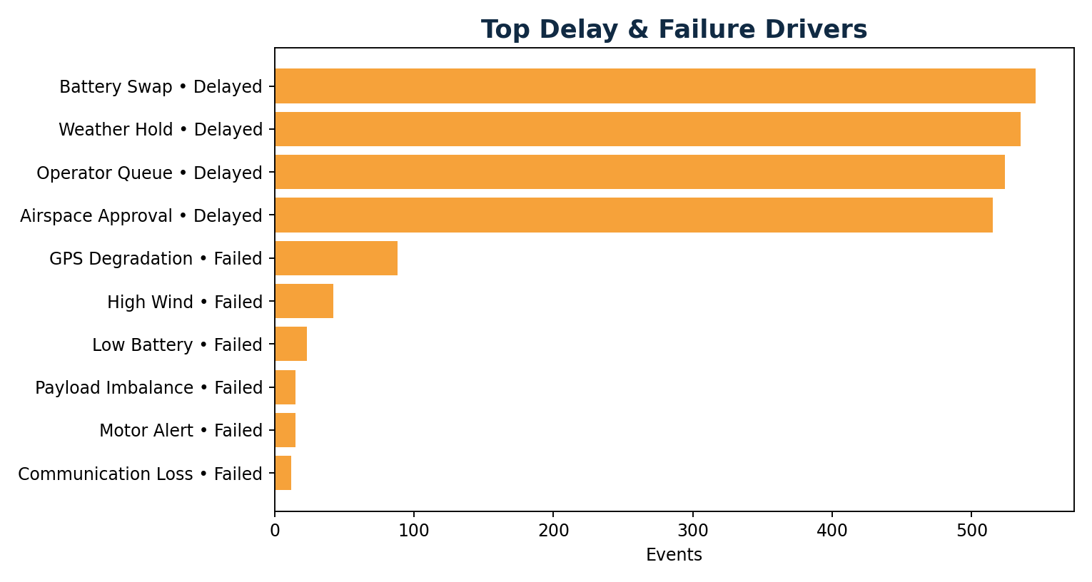
Among failed missions, GPS Degradation is the largest observed cause (88 events), followed by High Wind (42). For delayed missions, Battery Swap, Weather Hold, Operator Queue and Airspace Approval dominate. This separates technical reliability problems from planning/operations bottlenecks.

Commercial Findings
Mining generates the highest total revenue in the dataset, while Logistics has the lowest observed industry success rate (81.91%). This suggests commercial prioritization should combine revenue opportunity with service reliability and margin.

6. Power BI Dashboard Design
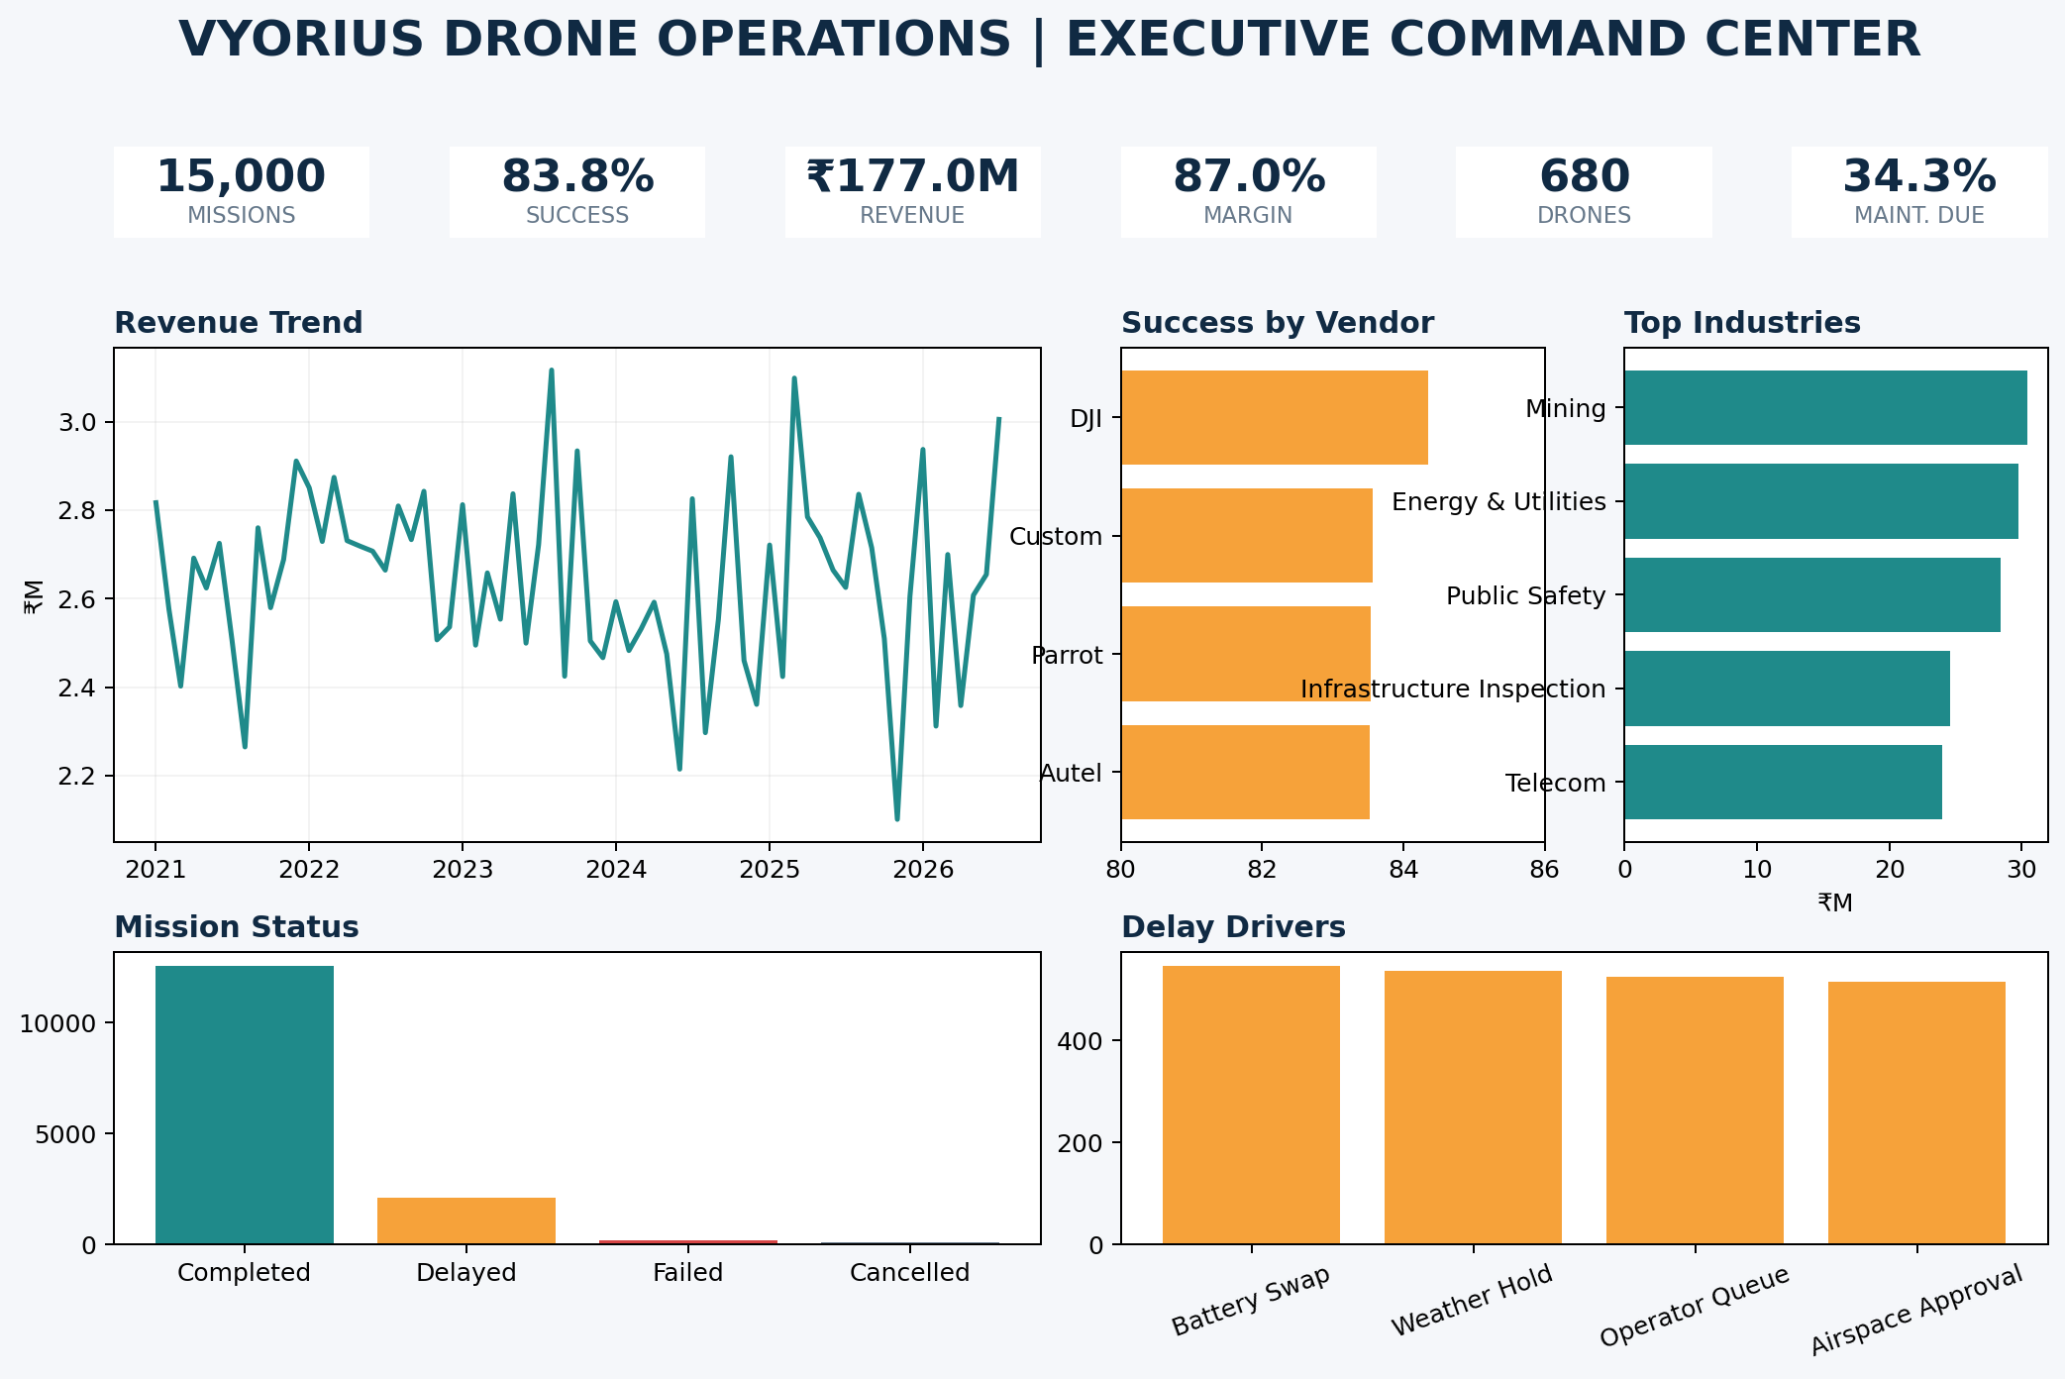
The dashboard is designed as a five-page report: Executive Command Center, Fleet & Maintenance, Reliability & Root Cause, Customer & Commercial Analytics, and AI Decision Support. Power BI report-page tooltips should be used so hovering on vendors, industries, models and mission types reveals contextual KPI cards without overcrowding the canvas.

Recommended Interactions
- Global slicers: Year, Quarter, Manufacturer, Model, Industry, Plan and Mission Type.
- Drill-through from manufacturer/model charts to mission-level detail.
- Report-page tooltips with missions, success rate, revenue, battery health and downtime.
- Conditional formatting for battery health, downtime, maintenance due and high-risk exceptions.
- Cross-highlighting between revenue, mission status, industry and vendor visuals.

7. AI-Powered Scheduling & Predictive Maintenance
The strongest way to explain the AI work is as decision support built on top of historical analytics. The project does not claim autonomous flight control. Instead, it turns operational signals into risk and priority scores that a planner can review.

7.1 Predictive Maintenance Prototype
A Random Forest classifier was trained to predict whether maintenance is due using pre-maintenance features only: battery health, charge cycles, days since last service, manufacturer/model/platform, mission distance/duration and payload utilization. On a held-out 20% split of this synthetic dataset, the POC achieved ROC-AUC 0.987 and accuracy 0.990. Because the data is synthetic, these figures demonstrate technical feasibility only and should not be presented as real-world production accuracy.
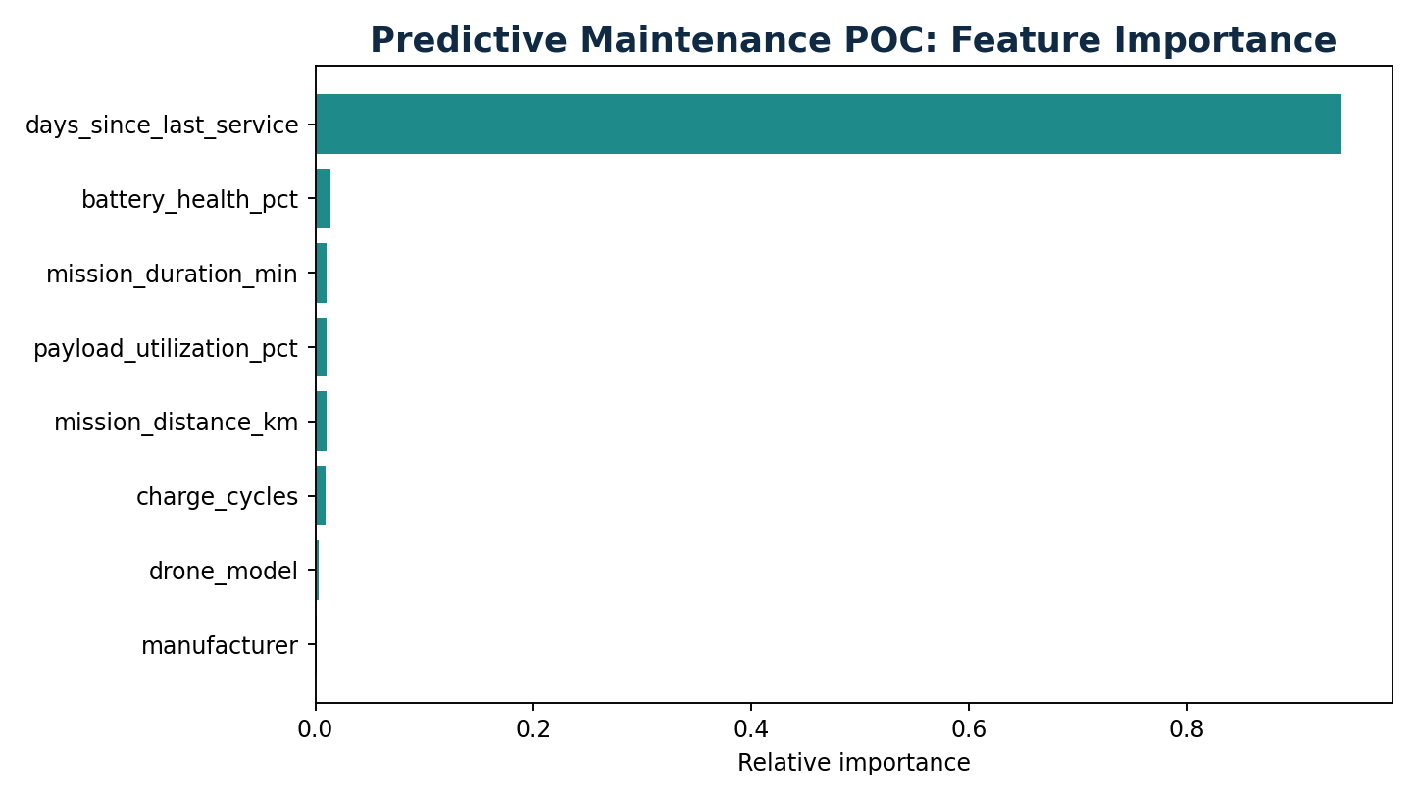

7.2 AI-Assisted Mission Scheduling
For scheduling, each candidate mission is assigned a pre-flight risk score using variables available before takeoff: wind speed, signal strength, GPS accuracy, battery health/start charge, payload utilization, maintenance readiness and service age. The system then converts the score into an action: Schedule First, Review Conditions, or Defer/Reassign.
- Low risk: healthy battery, acceptable wind/GPS/signal and no maintenance flag → schedule first.
- Medium risk: one or more borderline conditions → planner review or choose a safer time slot.
- High risk: poor operational conditions or maintenance risk → defer, service the asset or reassign another drone.
- This can be upgraded later with weather forecasts, airspace windows, customer SLA priority and optimization algorithms.

7.3 Fleet Optimization
The project creates a drone-level score combining mission volume, mission success, battery health, gross margin, downtime and maintenance cost. This identifies underutilized healthy drones that can absorb work and overburdened/high-maintenance drones that should be relieved or serviced.

7.4 Multi-Vendor Interoperability
A common analytics schema standardizes metrics across DJI, Autel, Parrot, PX4 and ArduPilot-based records. This gives management one vocabulary for mission status, battery, GPS, payload, downtime, maintenance and profitability regardless of vendor. In a production platform, vendor APIs would be transformed into this canonical schema before KPI calculation.

7.5 Autonomous Mission Planning Roadmap
A realistic product roadmap is: historical reporting → predictive risk → human-approved scheduling recommendations → constraint-based route/slot optimization → controlled autonomous mission planning. Constraints would include geofences, payload, battery reserve, wind, GPS/RTK quality, airspace permissions, maintenance state and customer SLA.

8. Business Strategies & Recommendations
Area | Recommendation
Reliability | Prioritize GPS-quality monitoring and high-wind operating rules because these are leading observed failure drivers.
Maintenance | Use predictive maintenance risk to service assets before risk turns into downtime or failed missions.
Scheduling | Add pre-flight risk scoring and automatically recommend safer drones/time slots; keep human approval in the loop.
Fleet utilization | Rebalance missions from high-downtime/high-maintenance drones toward healthy underutilized assets.
Operations | Reduce operator queues and battery-swap delays through capacity planning, spare-battery readiness and shift scheduling.
Commercial | Target high-revenue industries while watching service reliability and margin rather than revenue alone.
Product | Expose one cross-vendor command center with standardized telemetry and exception alerts.
AI roadmap | Add weather/airspace forecasts and constraint optimization before claiming autonomous scheduling.

9. Conclusions
The analysis shows how an enterprise drone dataset can be turned into an operational decision system rather than a collection of charts. SQL answers structured business questions, Python validates patterns and creates reproducible EDA, Power BI packages KPIs for executives, and AI prototypes translate telemetry into maintenance and scheduling recommendations. The strongest portfolio positioning is to emphasize business impact, transparent assumptions and a phased AI roadmap.

10. GitHub Publishing Checklist
- Create repository: vyorius-drone-operations-analytics.
- Upload the provided folder structure exactly as generated.
- Keep README.md at repository root so GitHub renders it automatically.
- Add repository topics: data-analytics, sql, python, power-bi, eda, machine-learning, drone-analytics, business-intelligence.
- Pin the repository to your profile and use the dashboard preview as the social/portfolio visual.
- Do not upload confidential internship data, API keys, credentials or proprietary client information without permission.
- For the strongest portfolio story, add a short LinkedIn post that links to the repository and states 3 quantified findings.

11. Interview Explanation
I worked on an end-to-end drone operations analytics project using 15,000 mission and telemetry records. I started by defining operational and commercial KPIs such as mission success, delays, battery health, fleet downtime, maintenance cost, revenue and margin. I used SQL to answer business questions around vendor reliability, failure causes, fleet utilization, industry economics and retention proxies, and Python for EDA and visual validation. I then designed a Power BI command center for executives. For AI, I built a predictive-maintenance proof of concept and an AI-assisted scheduling score that ranks missions using pre-flight conditions such as wind, GPS, signal, battery and maintenance readiness. The recommendations focused on predictive maintenance, workload balancing, cross-vendor standardization and a phased path toward autonomous mission planning.

Appendix A — Files Included
- README.md — GitHub portfolio narrative
- sql/vyorius_business_queries.sql — 25 business SQL queries
- sql_outputs/ — saved KPI and analysis outputs
- python/eda_analysis.py — reproducible EDA
- python/ai_decision_support.py — predictive maintenance + scheduling POC
- notebooks/vyorius_eda_business_analysis.ipynb — code + outputs
- dashboard/powerbi_measures.dax — Power BI measures
- dashboard/powerbi_build_guide.md — exact dashboard build steps
- dashboard/interactive_dashboard.html — hover-enabled portfolio dashboard
- data/processed/ — KPI, trends, fleet score and AI recommendation outputs

