SCALEIQ
Website content

Homepage
Hero
Building the Digital Energy Ecosystem.
ScaleIQ combines a growing portfolio of energy-technology companies with a proven engineering practice, giving the energy industry a partner it can build on for the long term.
CTA: Explore our portfolio / See our services
Opening overview
ScaleIQ is a platform for energy technology. We invest in companies serving oil and gas, utilities, and renewables, and our own engineering practice designs and delivers the software and AI systems the industry runs on. Capital where it is needed. Engineering depth where it counts.
ScaleIQ Capital
ScaleIQ Capital invests in energy-technology companies with strong products and the ambition to grow further. Our first partner, Oges, has served the oil and gas industry since 2015, with active deployments at ONGC, Cairn, and OIL India.
Every company we back keeps its name, its leadership, and its independence. What it gains is capital, structure, and a wider network to grow into.
CTA: See our portfolio/become our portfolio company
ScaleIQ Operations
ScaleIQ Operations is our engineering practice for the energy industry, delivering software, AI, and product development for oil and gas companies, energy majors, GCCs, renewables and utilities, energy ISVs, and oil service companies.
It is the same engineering capability our portfolio companies draw on to grow faster.
CTA: See how we work / Case Studies
Who ScaleIQ is for
Building an energy-technology company and thinking about what's next? See what changes when you partner with us.
Links to: For Portfolio Companies
Running an energy operation that needs a technology partner who already speaks the language? See why teams choose ScaleIQ Operations.
Links to: Whom We Serve
Work with founders, operators, or energy-technology deals? See what a partnership with ScaleIQ looks like.
Links to: For Partners
Metrics strip
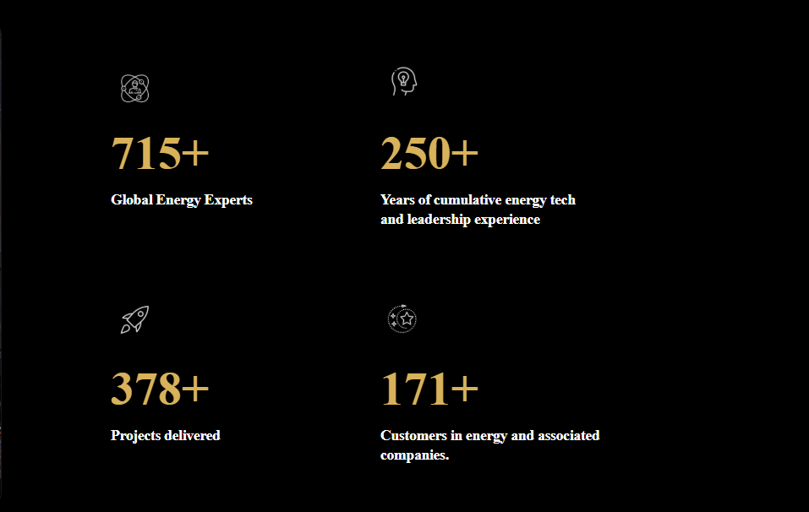
Footer line
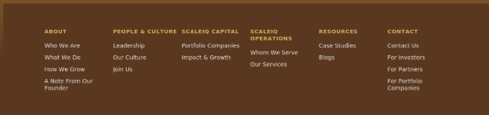
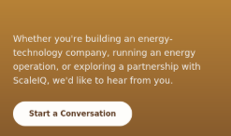
content will e like this – colour/theme need to be correct/match as per the final theme.
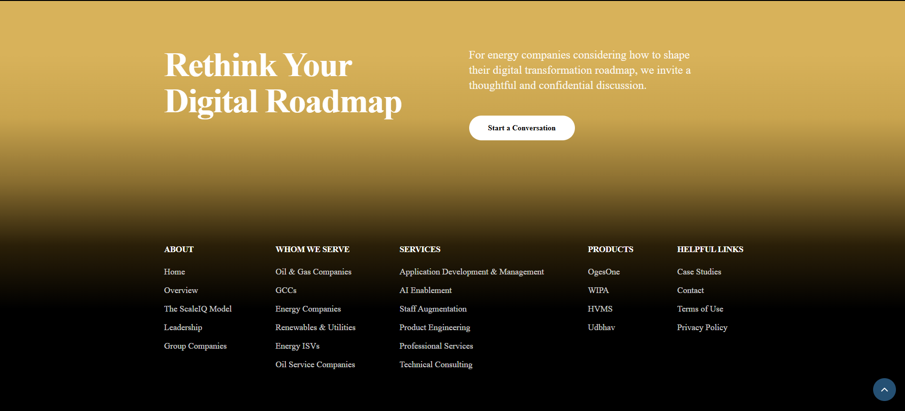
About Us > Who We Are
About Us — Who We Are
ScaleIQ is built around one idea: energy technology deserves patient capital and serious engineering, in equal measure.
We invest in energy-technology companies with strong products and committed teams, and give them the resources to grow further. Alongside that, our engineering practice designs and delivers the digital systems that oil and gas companies, energy majors, and utilities depend on every day.
Most platforms choose one side of that equation. They either write cheques or they write code. ScaleIQ does both, under one roof, which means every company we work with gets more than capital, or more than a delivery team. They get a partner that understands the industry from the inside, because we operate in it ourselves.
That combination shapes how we work. When we invest in a company, we bring engineering judgment to the table, not just a board seat. When we deliver a project for a client, we bring the discipline of an owner, not just a vendor's checklist.
Energy technology is a demanding space to build in: long sales cycles, exacting safety standards, customers who cannot afford downtime. ScaleIQ exists because that space needs a partner built specifically for it, not a generalist investor or a generalist IT vendor stretched across industries it doesn't know.
About Us > What We Do
About Us — What We Do
We invest in energy-technology companies with strong products and loyal customers, giving them capital and the structure to scale.
We also build. Our engineering practice delivers digital engineering, AI, and product development for the energy industry, from oil and gas companies to renewables and utilities, work that spans application development, staff augmentation, product engineering, and technical consulting.
For a founder, that means ScaleIQ can offer more than a term sheet. It means access to an engineering bench that already understands the technical and regulatory realities of energy, from day one of the partnership.
For a client, it means the team building your platform isn't guessing at energy workflows. It's the same team, and the same standard, we hold our own portfolio companies to.
Every company we work with, whether we've invested in it or we're building for it, keeps its identity and its customers. What changes is what it can reach next.
About Us > How We Grow
About Us — How We Grow
Growth at ScaleIQ comes from two directions that reinforce each other.
On one side, we invest in energy-technology companies with strong fundamentals and help them scale, through capital, governance, and access to a wider network of peers solving similar problems.
On the other, our engineering practice grows by deepening relationships across the energy industry, taking on more complex, higher-value work for oil and gas companies, energy majors, and utilities.
The two reinforce each other in ways a purely financial investor, or a purely technical vendor, cannot replicate. Companies we invest in gain access to engineering depth built over years in this industry specifically. Our engineering practice gains a pipeline of proven products and sharper domain expertise with every new company that joins.
Over time, this compounds. Each new investment strengthens the engineering bench available to the portfolio. Each new client engagement sharpens the expertise we bring to our next investment. It's a model built to get better with scale, not just bigger.
Our People and Culture > Leadership
Leadership
ScaleIQ is led by a team with deep roots in energy technology, engineering delivery, and corporate growth. Between them, our leadership has spent years inside the industry we serve, not observing it from a distance, which shapes how we evaluate every investment and every engagement we take on.
Rajeev Sonthalia — Chief Executive Officer
Chitwan Garg — Chief Business Officer
Amit Ranjan — Chief Solutions Architect
Rajvardhan Singh — Corporate Development
Plus a core team of six others.
Each portfolio company retains its own leadership and its own decision-making. Our leadership team's role is to support that growth, not run it from a distance.
Our People and Culture > Our Culture
Our Culture
ScaleIQ works in an industry where mistakes are expensive and downtime is not an option. That reality shapes our culture more than any values poster could.
We hire people who want to go deep into a hard problem rather than skim across many easy ones. Energy technology rewards patience and precision, and we build teams around people who bring both.
We work in small, accountable groups. Whether it's an engineering team delivering for a client, or a team supporting a portfolio company through its first year with ScaleIQ, ownership sits close to the work. Decisions get made by the people closest to the problem, not passed up a chain.
Because our work spans both investing and engineering, our people move between contexts more than most. An engineer on a client project one quarter might be supporting a due diligence review the next. That breadth is intentional. It keeps judgment sharp on both sides of what we do.
First draft — sharpen this once you tell me the one or two things ScaleIQ actually does differently day to day. Real photos or a short team quote would carry this page more than any more paragraphs would.
Our People and Culture > Join Us
Join Us
ScaleIQ is a small team doing two demanding things at once: investing in energy-technology companies, and building the systems that run the energy industry.
If you join us, you won't be boxed into one lane. Our engineers work on live client delivery and get pulled into portfolio company reviews. Our investment team works alongside engineering leads, not around them.
We look for people who already know energy, or want to. The industry has a steep learning curve, and we'd rather invest in that learning early than hire around it.
Needs from you: current open roles or a standing "always hiring for X, Y" line, and an application link. I've kept this page short until that's confirmed rather than inventing openings.
ScaleIQ Capital > Portfolio Companies
Portfolio Companies
ScaleIQ invests in energy-technology companies with strong products, loyal customers, and leadership teams ready to grow further.
Our first investment, Oges, has served the oil and gas industry since 2015, with active deployments at ONGC, Cairn, and OIL India, through OgesOne, WIPA, HVMS, and Udbhav.
What changes, and what doesn't
Before ScaleIQ, growing an energy-technology company usually means choosing between two hard paths: raise outside capital and give up control, or grow slowly on your own cash flow and watch competitors with deeper pockets move faster.
After joining ScaleIQ, that choice disappears. You keep your name, your leadership, and your customers. What you gain is capital without a boardroom takeover, an engineering bench that already understands energy workflows, and a network of peer companies who've already solved the scaling problems you're facing now.
Founders who partner with ScaleIQ don't hand over their company. They add a partner who happens to have already built what they're trying to build next.
Slot for a founder testimonial or short video here, once Oges leadership is ready to give one — this is the single strongest piece of proof this page can carry.
CTA: See what's next for your company → For Portfolio Companies (Contact Us)
ScaleIQ Capital > Impact & Growth
Impact & Growth
We measure our impact the way our portfolio companies do: by what they can do after joining ScaleIQ that they could not do before.
– Faster product development, supported by an engineering practice built specifically for the energy industry, not a generalist dev shop learning the domain on the client's clock.
– A network of peer companies working through similar challenges, from regulatory hurdles to enterprise sales cycles in oil and gas.
– Capital for growth, without giving up control of the business you built.
Impact compounds over time. Every company we invest in makes the next one stronger, through shared engineering resources, shared industry relationships, and a growing base of proof that this model works in energy technology specifically.
ScaleIQ Operations > Whom We Serve
Whom We Serve
ScaleIQ Operations has spent over a decade building digital systems for the energy industry, across oil and gas companies, GCCs, energy majors, renewables and utilities, energy ISVs, and oil service companies.
Existing six segment write-ups stay as they are below this intro — factual and specific, which is what this section needs.
Why teams choose ScaleIQ Operations
Energy companies don't have the luxury of a vendor that's still learning the industry. Downtime costs money and, in some cases, safety. That's why the teams delivering your project already understand upstream, midstream, and downstream workflows, the compliance standards you operate under, and the systems you're likely already running.
We also bring something most engineering vendors can't: a stake in getting it right beyond the contract. The same engineering standard we apply to client work is the standard we hold our own portfolio companies to. There's no B-team held back for internal projects.
Choosing ScaleIQ Operations means choosing a team that speaks your industry's language on day one, not by month six.
ScaleIQ Operations > Our Services
Our Services
ScaleIQ Operations works across the full energy technology stack: application development and management, AI enablement, staff augmentation, product engineering, professional services, and technical consulting, with the same engineering standard we bring to our own portfolio companies.
Existing six service write-ups stay as they are below this intro, for the same reason.
Whatever the engagement, from a short staff augmentation contract to a multi-year product build, you get engineers who already understand energy workflows, and a delivery standard shaped by running our own technology companies, not just servicing them.
Resources > Case Studies
Case Studies
Seventeen case studies across six categories: Reservoir & Subsurface, Drilling & Completions, Fleet & Field Operations, Safety & Risk Intelligence, Well Intervention, and Innovation Ecosystems.
Filter by category. Existing 17 case studies stay as they are — this page only needs the intro line and the filter UI.
Resources > Blogs
Blogs
Perspectives from inside ScaleIQ, on digital transformation, energy technology, and what it takes to scale a company in this industry.
Blog 1 ("Why Digital Transformation Fails to Deliver Expected Outcomes in Complex Operations," Rajeev Sonthalia) is complete and stays as is. Blogs 2 and 3 have titles only — send source notes or a transcript and I'll draft both in the same voice.
Contact Us > Contact Us
Contact Us
Have a question about ScaleIQ, our portfolio, or our work in energy technology? Get in touch.
Form fields: Name, Company, Email, Message.
Contact Us > For Investors
For Investors
ScaleIQ Capital is backed by investors who share our view that energy technology deserves a platform built specifically for it.
Fund performance, portfolio updates, and investor reporting are available to registered investors.
CTA: Request access. Gated login/backend is a later phase per the technical roadmap — this page is intentionally short until that's built.
Contact Us > For Partners
For Partners
ScaleIQ partners with the people who help us find, evaluate, and grow great energy-technology companies: M&A advisors, technology partners, and industry specialists who know this space as well as we do.
If you work with founders who are ready to scale, or with energy operators looking for a delivery partner, we're worth a conversation. You get a partner that moves fast on evaluation, pays fair value for genuine deal flow, and treats a referral as the start of a relationship, not a one-time transaction.
CTA: Start the conversation — contact form below.
Contact Us > For Portfolio Companies
For Portfolio Companies
Thinking about what's next for the company you've built?
If you're a founder or leadership team in energy technology weighing your options, whether that's raising capital, planning an exit, or simply growing faster than your current resources allow, we'd like to talk.
Tell us about your company below. Every conversation stays confidential, and there's no obligation attached to a first call.
What we look for
– Founder-led or founder-influenced leadership
– An established product with paying customers in oil & gas, energy majors, GCCs, renewables & utilities, energy ISVs, or oil service companies
– Ambition to grow further, not exit the industry
Form fields: Company name, Your role, Brief description, Email.
Notes for you (not site copy)
1. Metrics strip still has no real numbers. A blank or invented metrics strip both look worse than skipping the section — send real figures and I'll drop them in.
2. Portfolio Companies page has a testimonial slot waiting on Oges leadership — this is the highest-leverage piece of proof missing from the whole site.
3. Our Culture and Join Us are first drafts built from reasonable inference about the business, not from anything you've told me directly — flagged inline above, worth a real read before they go live.
4. Blog 2 and 3 need source material from you before I can draft them.

