Proposal
Enhancing the Authenticity of Online Discussions on Social Media Platforms with Transformer Model

Introduction
Social media platforms have revolutionized communication and information sharing, making them central to modern life. However, they are increasingly used to spread fake news and facilitate online Hate speech, posing significant challenges to societal trust, and quality. Fake news misleads the public and manipulates opinions, while online Hate speech foster hostility and harm. These issues often overlap, amplifying their impact and making their detection a critical priority.
Current detection systems primarily focus on fake news and Hate speech as separate problems. While this approach has led to advancements in combating these issues individually, it overlooks the interconnected nature of misinformation and harmful behavior. Addressing these challenges together is essential to develop more comprehensive solutions.
Transformer-based models, particularly BERT, have shown remarkable success in text classification tasks. However, their application to multitask detection of fake news and Hate speech remains underexplored. This research seeks to fill the gap by evaluating the performance of separate versus unified detection models and analyzing the trends in transformer architectures, such as encoders, decoders, and hybrids.
By enhancing detection methods, this study aims to contribute to online environments, and foster informed public engagement. The findings will provide valuable insights into AI-driven solutions for improving social media safety and the integrity of digital spaces.

Problem Statement
The spread of misinformation and harmful behaviors on social media platforms has created significant challenges to fostering authentic online environments. The rapid spread of fake news manipulates public opinion, undermines societal trust, and intensify the polarization of communities. Meanwhile, threatening and abusive interactions ruin the quality of discourse, deterring meaningful engagement and amplifying negativity.
Fake news and online Hate speech are often studied as separate problems, but in reality, they can overlap. For example, fake news can incite harmful behavior, and Hate speech can spread false information. Existing approaches fail to address this overlap effectively. Moreover, different types of transformer models, such as encoders, decoders, and hybrid architectures, have not been compared for this task. This study will address these gaps by exploring the best approaches for combined detection and analyzing their impact on online safety & security.

Research Questions

Q1. How does the performance of separate BERT models trained individually on fake news and hate speech datasets compare to a single BERT model trained unified on both datasets and which approach yields better results for combined detection tasks?

Q2. What are the conclusions be drawn from the combined detection of fake news and Hate speech? How can it contribute to fostering informed public engagement, and enhancing the quality of social media?

Q3. What are the trends in different transformer models ( Encoder, Decoder, Hybrid ) while detecting online Hate speech & fake news detection?
Literature Review
The challenges posed by misinformation and online Hate speech have been extensively studied, but their overlap and combined detection remain underexplored. This section reviews recent works on fake news detection, hate speech detection, and the application of transformer-based models, connecting them to the research questions outlined.

Fake News Detection:

Recent work on disinformation, such as the DeFaktS dataset, highlights the importance of fine-grained detection using transformer models like BERT. This study is relevant to Research Question 1, as it informs the comparison of separate versus unified BERT models for fake news detection. [1]
Hate Speech Detection:

Gupta and Chauhan (2022) conducted a comprehensive survey on hate speech and toxicity detection in online platforms. Their findings highlight the evolving role of transformer models, including BERT and hybrid architectures, in identifying abusive, identity-targeted, and harmful content. This work is critical for understanding trends in transformer models, contributing to Research Question 3 by exploring advanced architectures for hate speech detection. [2]

Sazany (2018) also explored hate speech detection, focusing on the application of deep learning methods. Their implementation demonstrated the effectiveness of contextualized word embeddings in recognizing nuanced hate speech across languages. These insights provide foundational knowledge for enhancing detection systems that can adapt to diverse linguistic contexts. [4]

Safe Social Media Interaction:

Singh and Sharma (2023) propose semantic network-based methods to model threats in online communication. While their primary focus is on threat detection, their approach highlights the value of understanding relational patterns in text to improve interaction quality. By adapting these methods to address both misinformation and hate speech, this research aligns with Research Question 2, which focuses on fostering safe and authentic discussions by reducing harmful content. [3]

This literature highlights the potential of transformer models, particularly BERT and hybrid architectures, to enhance detection accuracy and efficiency in both areas. This research aims to fill that gap by exploring the comparative effectiveness of separate versus unified models, analyzing the trends in transformer architectures, and the broader societal benefits of improving digital safety.

Objectives
- Evaluate the Effectiveness of Multi-task Learning: Assess the comparative performance of separate versus unified BERT models in detecting fake news and online Hate speech. This involves training:
- Dedicated models specialized for individual tasks (fake news and Hate speech).
- A multitask BERT model addressing both tasks simultaneously.
- Model Optimization for Combined Detection: Investigate how integrating fake news and hate speech detection within a single framework enhances model efficiency, improves predictive accuracy, and minimizes computational overhead.

- Impact on Online Safety and Awareness: Measure the societal impact of improved detection mechanisms in reducing harmful content, raising public awareness, and fostering safer social media interactions.

- Explore Transformer Architectures: Analyze the capabilities and trends of advanced transformer models (encoder-based, decoder-based, and hybrid architectures) in handling the complexity of misinformation and harmful content.

Diagram 1:
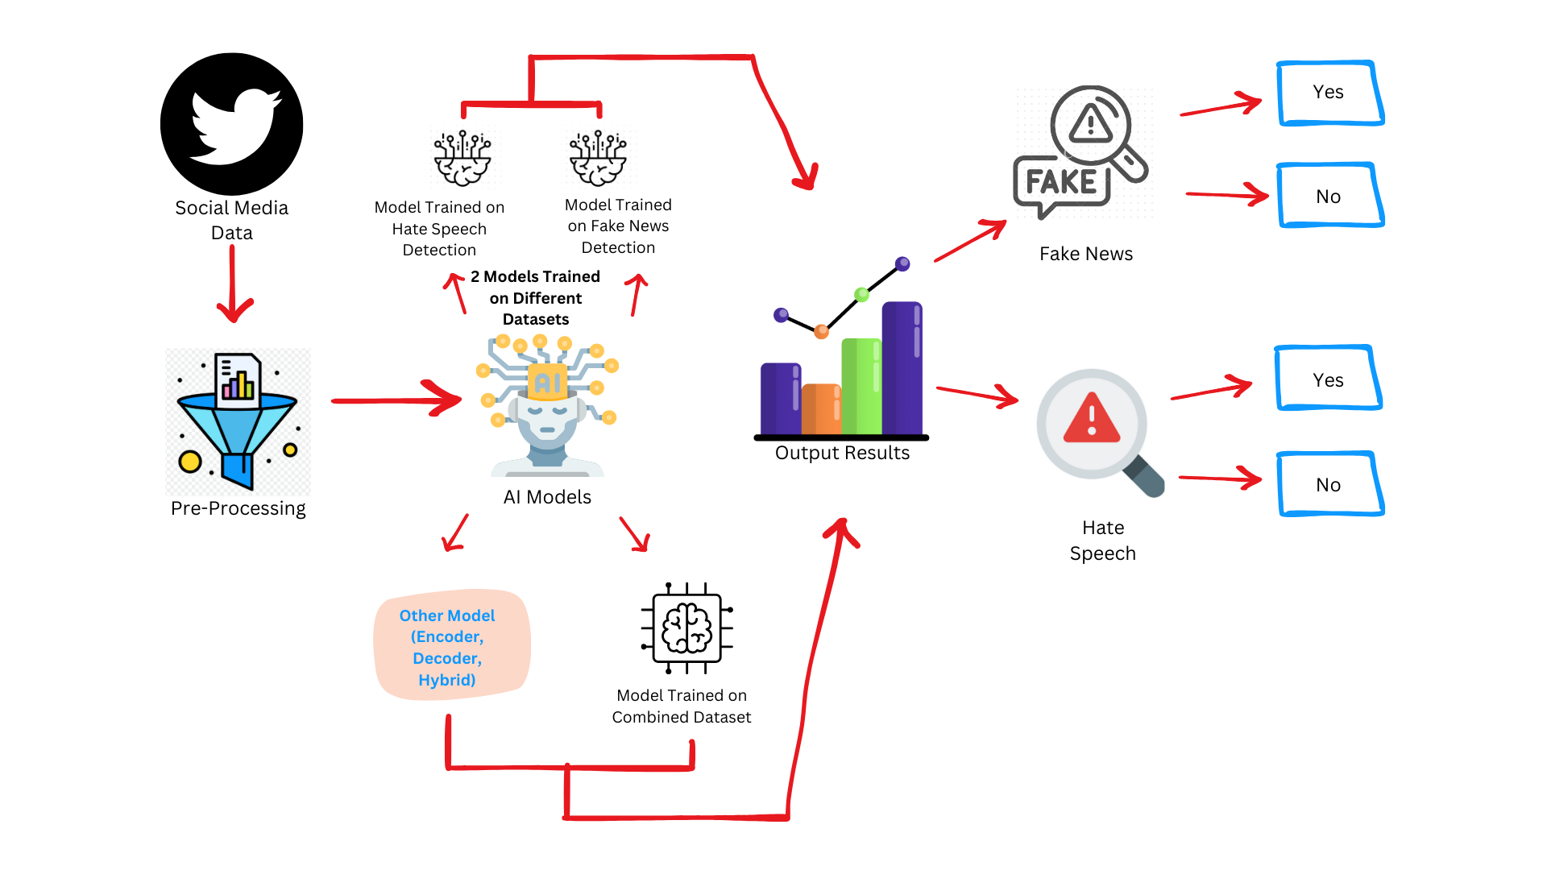

Scope of Metrics:
The effectiveness of the models will be evaluated based on:

Fake News Detection Metrics: To evaluate fake news detection, the system will analyze textual features derived from disinformation indicators, including but not limited to.
- Semantic Inconsistency: Identifying contradictions or logical errors within the content to flag unreliable posts.
- Polarization: Detecting friend-foe framing narratives in fake news articles.
- Vagueness of Phrasing: Analyzing the use of indirect expressions or hedging words.
- Authenticity and Referencing of Information: Measuring the use of reliable references versus false or absent contextualized sources. These features represent key characteristics for distinguishing fake news content, ensuring that the system can provide good detection capabilities.

Hate Speech Detection Metrics: The system will use GAHD dataset to evaluate hate speech detection performance, focusing on the following.
- gahd_id: Each entry will be uniquely identified to ensure traceability during model evaluation.
- text: The textual content will be analyzed for harmful language patterns, considering both explicit and implicit hate speech.
- label: Entries labeled as 0 (not hate speech) or 1 (hate speech) will be used to train and validate the detection system.
- round: The dataset's creation rounds will provide insights into the evolution of hate speech patterns, allowing for iterative model improvement.

Methods:

Input Data Collection and Preprocessing:
- Data Sources: Social media platforms dataset will be used as well as datasets related to fake news (e.g., DeFaktS) and harmful content (e.g., Hate speech) will be integrated.
- Preprocessing:
- Tokenization and cleaning of text to remove noise such as special characters, URLs, and stop words.
- Annotation of data for binary outputs: Fake News (1 or 0) and Hate speech (1 or 0).
- Linguistic and semantic feature extraction based on key indicators such as semantic inconsistency, polarization, and vagueness of phrasing.
- Model Training Approaches:
  - Separate Models: Train individual BERT models for fake news and hate speech detection tasks. Each model will be fine-tuned on its respective dataset.
  - Unified Multi-task Model: Implement a multitask BERT model using shared encoder layers and task-specific for fake news and hate speech detection.
  - Comparison Metrics: Evaluate models using accuracy, F1-score, precision, & recall to determine performance.

- Transformer Architecture Exploration: Experiment with encoder-based (BERT), decoder-based (GPT), and hybrid models for comparative performance analysis.

- Output Generation: The models will produce binary outputs for each task:
  - Fake News Detection: Fake (1) or Not Fake (0).
  - Hate Speech Detection: Hate Speech (1) or No Hate Speech (0).

- Evaluation of Combined Detection Impact:
- Measure improvements in predictive performance when fake news and Hate speech are detected simultaneously.
- Conduct comparative analysis on datasets processed through separate versus unified models to assess accuracy gains and computational efficiency.

- Societal Analysis: Study how these methods can help make online spaces safer and improve the way people interact on social media.

Conclusion
This research will help us understand the best way to detect both fake news and online Hate speech at the same time. It will show whether separate or unified models work better and highlight the trends in transformer models for these tasks. The findings will also explore how better detection can make online spaces safer and encourage healthy public discussions.

References:
- Baly, R., Horne, B. D., & Adali, S. (2023). DeFaktS: A German Dataset for Fine-Grained Disinformation Detection through Social Media Framing. In Proceedings of the 2023 International Conference on Data Science and Advanced Analytics (DSAA). IEEE.
Link
- Gupta, S., & Chauhan, V. (2022). Hate Speech, Toxicity Detection in Online Social Media: A Recent Survey of State of the Art and Opportunities. Social Media Studies, 12(3), 45-63.
Link
- Singh, R., & Sharma, K. (2023). Threat Modelling and Detection Using Semantic Network for Improving Social Media Safety. Journal of Cybersecurity Studies, 5(4), 198-210.
Link
- Sazany, E.: Deep learning-based implementation of hate speech identification on texts in Indonesian : Preliminary Study. In: 2018 International Conference on Applied Information Technology and Innovation (ICAITI) Deep. IEEE, pp 114–117 (2018) Link

