# Generated Assessment Questions

@title Central Middle — Derived Assessment

@description Two generated quantitative math questions similar to the base examples.

// Use this block for each question when adding Multiple Choice Questions (MCQ)

@question Each student at Riverside Prep chooses a uniform consisting of 1 shirt, 1 pair of pants, and 1 hat. The table shows the available options for each item. How many different complete uniforms are possible?

@instruction Select the number of possible uniform combinations from the options.

@difficulty easy

@Order 1

@option (A) 18

@option (B) 24

@@option (C) 36

@option (D) 48

@option (E) 72

@explanation

There are 4 shirt choices, 3 pants choices, and 3 hat choices. Total combinations = 4 × 3 × 3 = 36.

@subject Quantitative Math

@unit Numbers and Operations

@topic Combinations / Counting

@plusmarks 1

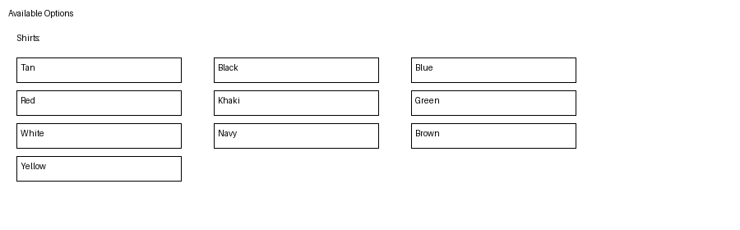

@question The top view of a rectangular box containing 8 identical tightly packed spherical balls arranged in two rows of four is shown. If each ball has radius $2$ cm, which of the following is closest to the dimensions (height × width × length), in centimeters, of the rectangular package?

@instruction Choose the correct dimensions from the options.

@difficulty moderate

@Order 2

@option (A) $4 \times 8 \times 16$

@option (B) $2 \times 8 \times 16$

@@option (C) $4 \times 12 \times 18$

@option (D) $6 \times 8 \times 16$

@option (E) $8 \times 12 \times 24$

@explanation

Top view shows two rows and four columns of circles (diameter = 4 cm). Width (short side) = 2 rows × 4 cm = 8 cm. Length = 4 columns × 4 cm = 16 cm. Height must accommodate one layer of balls: diameter = 4 cm. So dimensions: $4 \times 8 \times 16$.

@subject Quantitative Math

@unit Geometry and Measurement

@topic Solid Figures / Coordinate Geometry

@plusmarks 1

