EXPERIMENT- 1

Student Name: Aastha
UID: 23BAI70432
Branch: BE CSE AIML
Section/Group: 23AIT_KRG-G2
Semester: 6th
Date of Performance: 14/01/26
Subject Name: FULLSTACK-II
Subject Code: 23CSH-382

AIM:
To design and implement the foundational frontend architecture of the EcoTrack application using modern React practices, Vite tooling, and ES6+ JavaScript features.

OBJECTIVES:
• To set up a React project using Vite with proper project structure
• To understand component-based architecture in React
• To apply ES6 array methods (map, filter, reduce) for data-driven UI rendering
• To separate concerns using components, pages, and data modules

IMPLEMENTATION/CODE:
Logs.js
1 | export const logs = [
2 | { id: 1, activity: "Car Travel", carbon: 4 },
3 | { id: 2, activity: "Electricity Usage", carbon: 6 },
4 | { id: 3, activity: "Cycling", carbon: 0 },
5 | ];

1)SUM :
Dashboard.jsx-
0 | import { logs } from "../data/logs";
1 | ​
2 | console.log("Dashboard loaded", logs);
3 | ​
4 | const Dashboard = () => {
5 | const totalCarbon = logs.reduce(
6 | (sum, log) => sum + log.carbon,
7 | 0
8 | );
9 | ​
10| return (
11| <div>
12| <h2>Dashboard</h2>
13| <p>Total Carbon Footprint: {totalCarbon} Kg</p>
14| </div>
15| );
16| };
17| ​
18| export default Dashboard;

App.jsx
1 | import "./App.css";
2 | import Log from "./pages/Logs";
3 | ​
4 | function App() {
5 | return <Log />;
6 | }
7 | ​
8 | export default App;

2)COUNT>=4
Logs.jsx
1 | import { logs } from "../data/logs";
2 | ​
3 | const Log = () => {
4 | const filteredLogs = logs.filter((log) => log.carbon >= 4);
5 | ​
6 | return (
7 | <div>
8 | <h2>Logs (Carbon ≥ 4)</h2>
9 | ​
10| <ul>
11| {filteredLogs.map((log) => (
12| <li key={log.id}>
13| ID: {log.id} — Activity: {log.activity}
14| </li>
15| ))}
16| </ul>
17| </div>
18| );
19| };
20| ​
21| export default Log;

App.jsx
1 | import "./App.css";
2 | import Dashboard from "./pages/Dashboard";
3 | ​
4 | function App() {
5 | return <Dashboard />;
6 | }
7 | ​
8 | export default App;

OUTPUT:
1)SUM

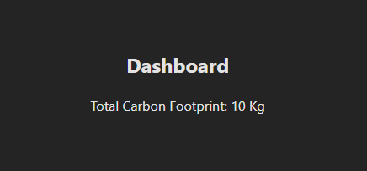

2)COUNT>=4
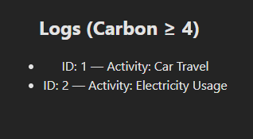

LEARNING OUTCOMES:
- Set up a modern frontend application using Vite with React and organize the project structure effectively.
- Apply component-based architecture in React to separate data, logic, and UI concerns.
- Use ES6 array methods such as map, filter, and reduce for data-driven rendering and computations.
- Implement functional React components to dynamically display and process application data.
- Demonstrate clean and modular coding practices suitable for real-world frontend applications.

