Price Elasticity and Format-Flavor Substitution in Sports Nutrition: A Nested-Logit Analysis of Differentiated Consumer Goods
Aastha Boora
University at Albany
BFIN515: Economic Analysis (October 2026)
GitHub Repository: https://github.com/AasthaBoora/Price-Elasticity-Substitution-in-Sports-Nutrition-A-Nested-Logit-Analysis
Abstract
I estimate own-price elasticities and cross-brand substitution across two differentiated formats — whey powders and protein bars — using a Berry (1994) nested logit estimated by Berry inversion with cluster-robust OLS on 861 product–flavour SKUs (157 products, 11 flavour markets), validated against a 274-week promotional panel. The price coefficient is $-0.3633$ ($t=-4.11$) and $σ=0.8311$ ($t=17.54$), with $R^{2}=0.806$. Every SKU is elastic (mean $-3.45$): bars average $-5.22$ versus powders $-3.09$, and substitution is almost entirely within format. A three-tier validation ladder shows strong internal fit, hold-out performance below a naive benchmark, and no ability to predict promotional lift from a panel with a zero price coefficient. I derive asymmetric format-pricing, flavour-portfolio, and promotional-calendar recommendations, and delineate where static choice models may and may not guide pricing.
JEL classification: L81, M31, D12.
Keywords: nested logit, price elasticity, demand estimation, sports nutrition, promotion evaluation.

1. Business Question
How should category directors and brand pricing managers set list prices and promotional depth across supplement formats and flavour profiles? A brand such as Optimum Nutrition, Quest or BSN sells both a format — powder tubs versus protein bars — and a flavour profile within each format. Each cell of that grid has its own demand sensitivity, and pricing one cell moves the others through substitution.
Mispricing cuts both ways. A deeply funded bar promotion may only transfer units from the brand’s own powder tubs — cannibalizing margin instead of growing the category. Uniform pricing forfeits genuinely inelastic niche flavours: the loyalty that lets a Birthday Cake powder carry a premium. Both errors share one root — pricing without estimates of own-price elasticity and of the cross-elasticity structure that says who takes whose volume.
Brand managers need these estimates to set list prices, design price-pack architecture, and choose which SKUs fund promotions. Retail category buyers need them to allocate shelf space, sequence promotional calendars, and negotiate vendor funding: knowing that a temporary price cut on a bar moves volume almost exclusively between bars — and essentially never into powders — changes how promotions are bundled. I deliver both sets of estimates, with an honest account of where they can and cannot be trusted.

2. Data
Demand models can be supported at Level 1 (category series), Level 2 (product-level shares, prices, characteristics, ownership), or transaction microdata (Dong, 2026). My data sit squarely at Level 2 — enough to estimate differentiated demand, but without cost shifters or time-varying consumer states, a boundary that matters below.
Estimation sample. I use a public retail catalogue (Kaggle, Sports nutrition supplements; 2,719 SKUs, 108 brands). I retain the five protein-powder categories and protein bars with at least one review; assign each SKU to a bar or powder nest by category and product form, reassigning 75 misclassified rows; map flavour strings to flavour markets; and split each parent product’s review mass across its flavour SKUs as the share proxy. The result is $N=861$ SKUs across 157 products and 11 flavour markets (715 powder, 146 bar), with outside-good shares of $0.884$–$0.997$. Price per serving averages $\$1.64$ — $\$1.45$ for powders versus $\$2.58$ for bars, a 77% format premium.
Validation panel. A second Kaggle panel (Supplement Sales Data, Apache 2.0) covers 16 products over 274 weeks (4,384 product-weeks, 2020–2025) with units, prices, and discounts. Weeks averaging at least 13% discount — 1,680 promotional product-weeks — form the held-out regime in Section 5. Neither dataset contains Myprotein or Barebells (verified by search), so those brands enter only as market context.
Limitations. Review mass proxies sales; the catalogue is cross-sectional, projecting all time variation onto cross-sectional variation; and zero-review products are dropped, conditioning on observed demand. These boundaries motivate the fixed-effects design and bound Sections 5–6. (Sample exhibits: E1, E2, ET1.)

3. Method
I estimate a Berry (1994) Level-2 aggregate nested logit by two-step OLS with standard errors clustered on the 157 parent products. Consumers choose among products nested in powders or bars versus an outside good, with conditional within-nest shares following the nested-logit GEV distribution. Inverting the share system (Berry, 1994) gives my estimating equation:
$$ln(s_{jt}/s_{0t})=x_{jt}β-α⋅{\text{PPS}}_{jt}+σln(s_{j|g,t})+ξ_{jt},$$
which I estimate by constructing both share terms from observed shares and running OLS with flavour-profile fixed effects.
The nesting parameter $σ∈[0,1)$ governs within-nest substitution. As $σ→0$ the model collapses to multinomial logit, whose IIA restriction implies — counterfactually here — that powder loyalists and bar shoppers divert identically. As $σ→1$, goods within a nest become near-perfect substitutes and substitution mass concentrates inside the nest, eliminating the cross-format substitution that IIA would impose.
Closed-form own, intra-nest, and inter-nest elasticities follow by differentiating the share system; I verified them against five-point numerical differentiation (maximum deviation below ${10}^{-9}$) and aggregate them to brand level as share-weighted sums.
Two devices address unobserved quality $ξ_{jt}$. Flavour-profile fixed effects absorb market-level taste shocks, so $α$ is identified from price dispersion within a flavour market, net of nest membership. Product-level clustering allows arbitrary correlation across a parent product’s variants. Without cost instruments, $α$ may absorb correlated unobserved quality, so I treat all magnitudes as upper bounds.

4. Results
Table 1 reports the main estimates. The price-per-serving coefficient is $-0.3633$ (SE $=0.0884$, $t=-4.11$, $p<0.001$): a one-dollar increase in price per serving cuts $ln(s_{jt}/s_{0t})$ by 0.36 within a flavour market. The nesting parameter is $σ=0.8311$ (SE $=0.0474$, $t=17.54$) — decisively above zero, so IIA is rejected and substitution is overwhelmingly within format. Fit is strong for cross-sectional demand work ($R^{2}=0.806$). A log-price robustness spec gives $β=-0.7407$ ($p<0.001$) and $σ=0.8223$, so the conclusions do not depend on price functional form.
Table 1 — Nested-logit estimates (Berry inversion, two-step OLS, clustered SEs)
 | Main spec (PPS, $) | Log-price spec
Price coefficient | $-0.3633$ (0.0884) | $-0.7407$ (0.1645)
$t$-statistic | $$-4.11$$ | $$-4.50$$
Nesting parameter $σ$ | 0.8311 (0.0474) | 0.8223
$R^{2}$ / Adjusted | 0.806 / 0.803 | —
Observations | 861 | 861
Table 2 converts the estimates into elasticities over all 861 SKUs. Mean own-price elasticity is $-3.453$ (median $-2.940$; range $-11.25$ to $-1.06$); every SKU is elastic and 81% exceed $|E|=2$. The decisive split: powders average $-3.091$ versus bars $-5.221$ — bar demand is far more price-sensitive, consistent with smaller purchase size, lower switching costs, and a denser competitive set.
Table 2 — Format elasticity summary (own-price elasticities, $N=861$)
Statistic | All SKUs | Protein powders | Protein bars
Mean | $$-3.453$$ | $$-3.091$$ | $$-5.221$$
Median | $$-2.940$$ | — | —
Range | $-11.25$ / $-1.06$ | — | —
Share with $|E|>1$ | 100% | 100% | 100%
The three focal markets sharpen the reading (Exhibit ET2). Mocha/Coffee (26 SKUs) averages $-3.19$ with intra-nest cross-elasticity of $0.099$ against inter-nest of $0.00013$ — roughly 760 times more intense within format. Salted Caramel (23 SKUs) is the most contested at $-4.10$, with intra-nest $0.317$ and brand-level cross-effects up to $3.54$; Birthday Cake averages $-3.24$. Substitution is asymmetric: Dymatize’s share responds to an Optimum Nutrition price change with elasticity $0.913$, while Optimum responds to Dymatize with only $0.092$ — volume flows toward the dominant incumbent (matrices: Exhibits ET3, E3a–E3c).
A counterfactual sweep of the Mocha leader’s price across $±40\%$ (Exhibit E4) shows the same structure dynamically: the leader’s own curve is steep ($-1.96$) and diversion flows almost entirely to other powders while rival bar lines stay flat. In-sample fit (Exhibit E5) clusters tightly on the 45-degree line for large markets, with dispersion concentrated in small markets — foreshadowing Section 5.

5. Validation
I evaluate the model on Dong’s (2026) multi-tiered validation ladder, which separates internal fit from increasingly demanding out-of-sample tests.
Level A — internal fit. $R^{2}=0.806$ and in-sample share RMSPE $=0.032$ confirm that the inversion, nests, and fixed effects are correctly specified — coherence, not predictive validity, since the same moments both estimate and evaluate the parameters.
Level B — same-setting hold-out. A deterministic hash assigns 210 of 861 SKUs to hold-out; re-estimated on the remaining 80% ($β=-0.2826$, $σ=0.8560$), I predict held-out shares. Against a naive market-mean benchmark, the nested model loses: RMSPE $=0.0871$ versus $0.0719$, correlation $0.587$ versus $0.686$. Plain logit does better still ($0.065$ / $0.752$): with $\hat{σ}≈0.86$, unequal within-nest shares over-share the wrong product in small, partially observed markets. The nested structure that earns the high $R^{2}$ overfits (Exhibit E6a).
Levels C/D — promotional regime. Withholding the 105 weeks averaging at least 13% discount (1,680 product-weeks) and estimating on regular weeks, hold-out RMSPE is $0.0053$ (MAPE $6.77\%$), but correlation is $-0.0039$ against a naive benchmark of $0.0051$: levels are captured, product-level movement is not (Exhibit E6b). The sharpest test is promotional lift — actual mean lift is $+0.000032$ while predicted lift is $-5×{10}^{-9}$ (RMSE $=0.0812$), four orders of magnitude too small at the mean. The cause is identifiable: the panel’s own price coefficient is $-0.0004$ ($p=0.87$) and the raw price–units correlation is $0.014$. The panel contains no detectable price response from which any choice model could learn (Exhibit E7).
Table 3 — Validation ladder summary (Dong, 2026)
Tier | Exercise | Model | Benchmark | Verdict
A — Internal fit | In-sample; $N=861$ | $R^{2}=0.806$; RMSPE $=0.032$ | — | Coherence, not prediction
B — Hold-out | 210 SKUs | 0.0871; corr 0.587 | 0.0719; 0.686 | Loses to naive; plain logit wins
C/D — Regime | 1,680 product-weeks | 0.0053; corr $-0.0039$ | 0.0051 | Levels only; lift unpredicted
The pattern — accurate levels, absent spikes — is what static discrete-choice theory predicts: nested logit is a stock model mapping current prices and fixed taste to shares, while promotions are flow phenomena driven by stockpiling, forward-buying, and anticipation, none of which enters $δ_{jt}$. I therefore validate the model for structural uses — ranking elasticities, mapping substitution, setting long-run list prices — and invalidate it for forecasting event-level promotional lift.

6. Recommendation
Asymmetric format pricing. Hold baseline prices on powders ($-3.09$), which are inelastic relative to bars: broad powder discounting buys little volume while conceding margin on every unit, and implied Lerner margins ($1/|E|≈0.36$) leave room to price at or above current levels. Direct discount funding to bars ($-5.22$), where a 10% cut buys roughly 50% more volume — and because inter-nest cross-elasticities are about $0.0001$, a bar promotion will not erode powder margins. Rival bar price moves, felt at cross-elasticities up to $4.3$, should be matched within the bar line.
Flavour portfolio. Treat Salted Caramel ($-4.10$, cross-switching $0.317$) as a customer-acquisition loss leader: price efficiently pulls trial from competitors, but loyalty is shallow, so keep discounts shallow and short. Treat Mocha/Coffee ($-3.19$, lowest cross-substitution at $0.099$) as the margin-harvesting set that supports list-price increases and premium price-pack architecture. Birthday Cake powder ($-2.50$, the least elastic focal cell) completes the ladder as a premium-margin contributor rather than a promotional vehicle.
Promotional calendar. Plan calendars on the model’s validated structural claims, not its invalidated forecasts: price cuts induce temporary switching within nests — concentrated in bars — and do not expand cross-category consumption. So (i) never discount competing same-nest brands in the same week, which would split a fixed demand pool at double margin cost; (ii) use format-exclusive deal periods so each promotion adds incremental nest volume; and (iii) measure lift with experimental price variation — A/B tests or hold-out stores — because a panel whose price coefficient is statistically zero cannot support model-based lift forecasting.
Boundary conditions. I treat all magnitudes as directional upper bounds: the price coefficient is identified without cost instruments, shares proxy reviews rather than units, and both hold-out exercises temper point predictions. Within those bounds — ranking SKUs, structuring price relationships, and allocating promotion depth by format — the estimates give a defensible quantitative foundation for the pricing decisions framed in Section 1.

References
- Berry, S. (1994). Estimating Discrete-Choice Models of Product Differentiation. RAND Journal of Economics, 25(2), 242–262.
- Berry, S., Levinsohn, J., & Pakes, A. (1995). Automobile Prices in Market Equilibrium. Econometrica, 63(4), 841–890.
- Dong, T. (2026). Supply and Demand Functions: A Survey by Data Availability. University at Albany. SSRN Working Paper 7399858. https://papers.ssrn.com/sol3/papers.cfm?abstract_id=7399858
- McFadden, D. (1974). Conditional Logit Analysis of Qualitative Choice Behavior. In P. Zarembka (Ed.), Frontiers in Econometrics (pp. 105–142). Academic Press.
- Train, K. (2009). Discrete Choice Methods with Simulation (2nd ed.). Cambridge University Press.
- Kaggle dataset: Sports nutrition supplements (daniyaljavaid). https://www.kaggle.com/datasets/daniyaljavaid/sports-nutrition-supplements (licence not stated by publisher).
- Kaggle dataset: Supplement Sales Data (zahidmughal2343). https://www.kaggle.com/datasets/zahidmughal2343/supplement-sales-data (Apache 2.0).

Exhibits & Appendix
All figures and supplementary matrices referenced in Sections 1–6 are collected here (excluded from the page count).

Figures
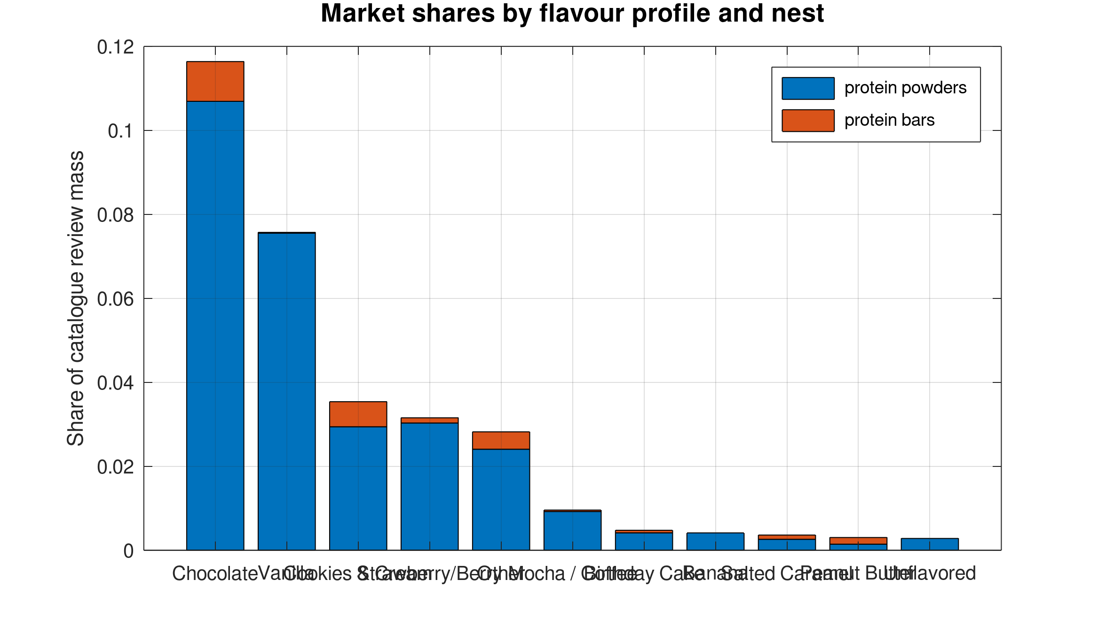
Review mass distribution across flavour profiles and nests
Exhibit E1: Review mass distribution across flavour profiles and product nests. Volume concentrates in Chocolate/Vanilla; Mocha, Birthday Cake, and Salted Caramel form the long tail.
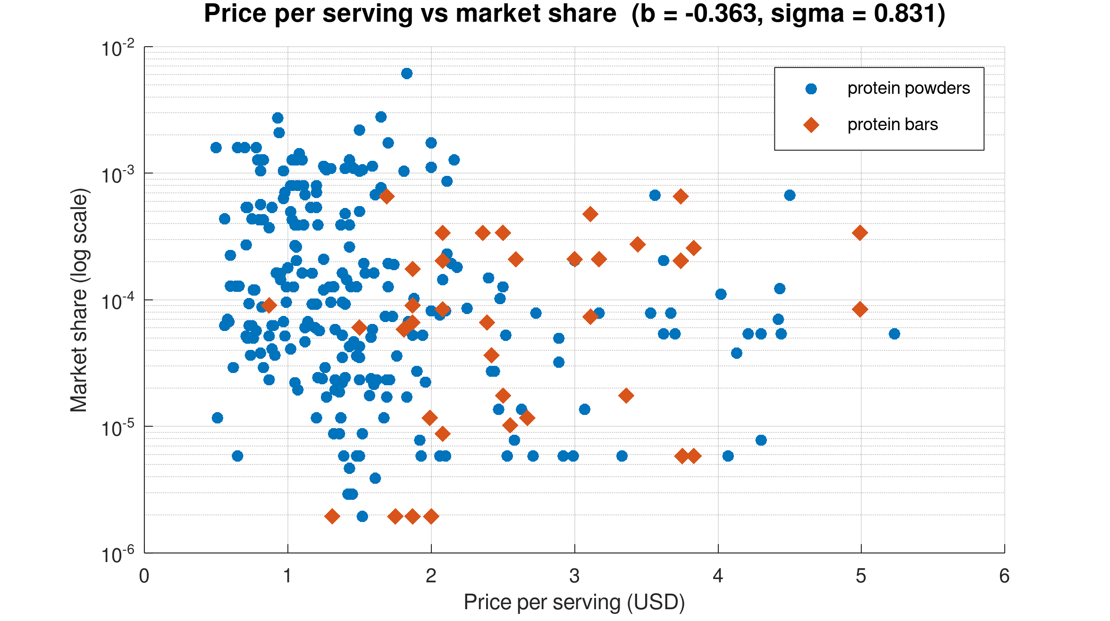
Price per serving against log market share by nest
Exhibit E2: Price per serving against log market share by nest, showing the distinct price clusters of bars ($\$2.58$ mean) versus powders ($\$1.45$ mean).
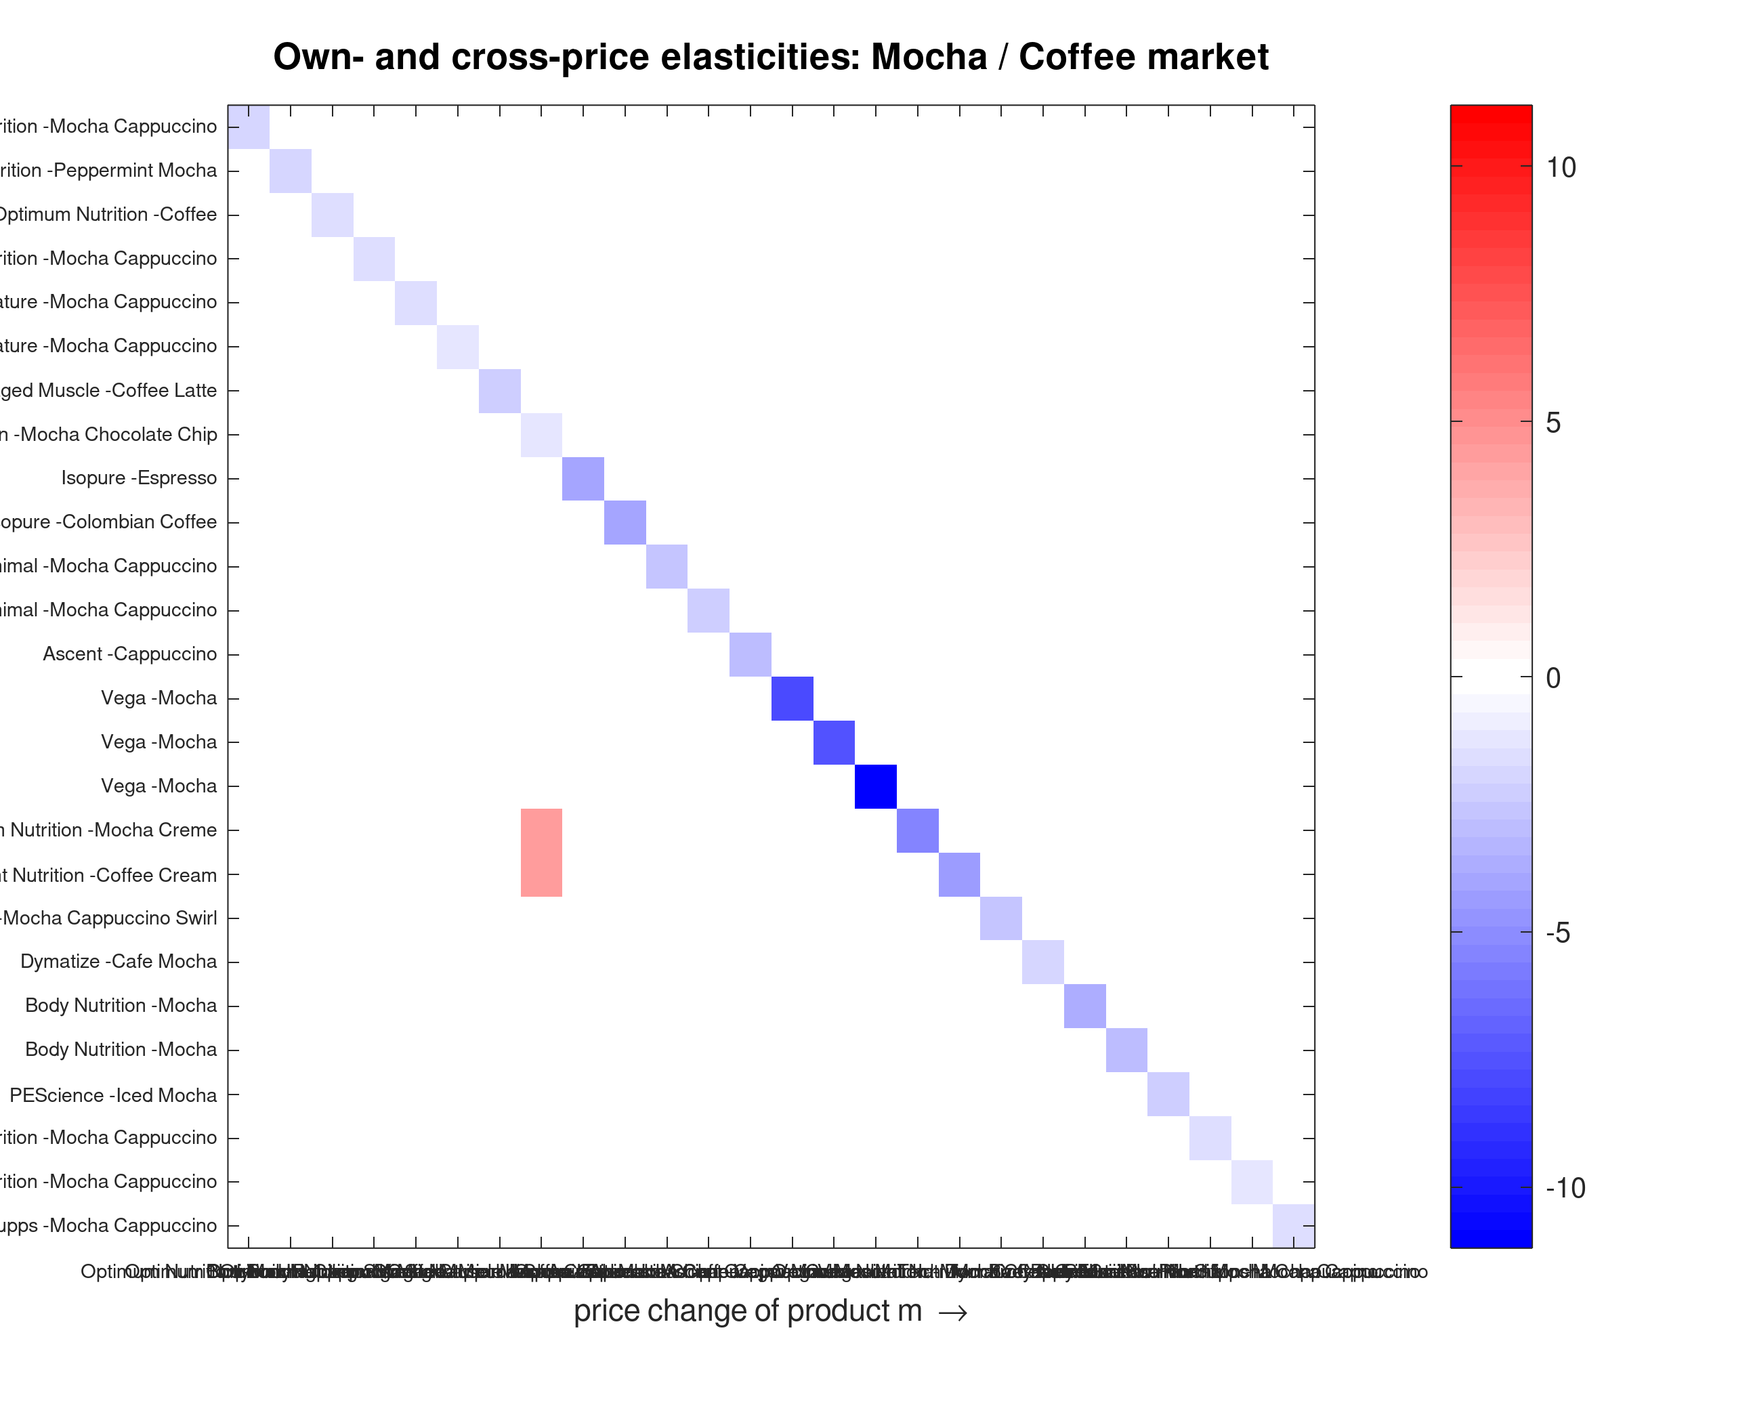
Elasticity heatmap — Mocha/Coffee
Exhibit E3a: Own- and cross-price elasticity matrix — Mocha/Coffee (26 products). Deep-blue diagonal = own-elasticity; red blocks = intra-nest substitution.
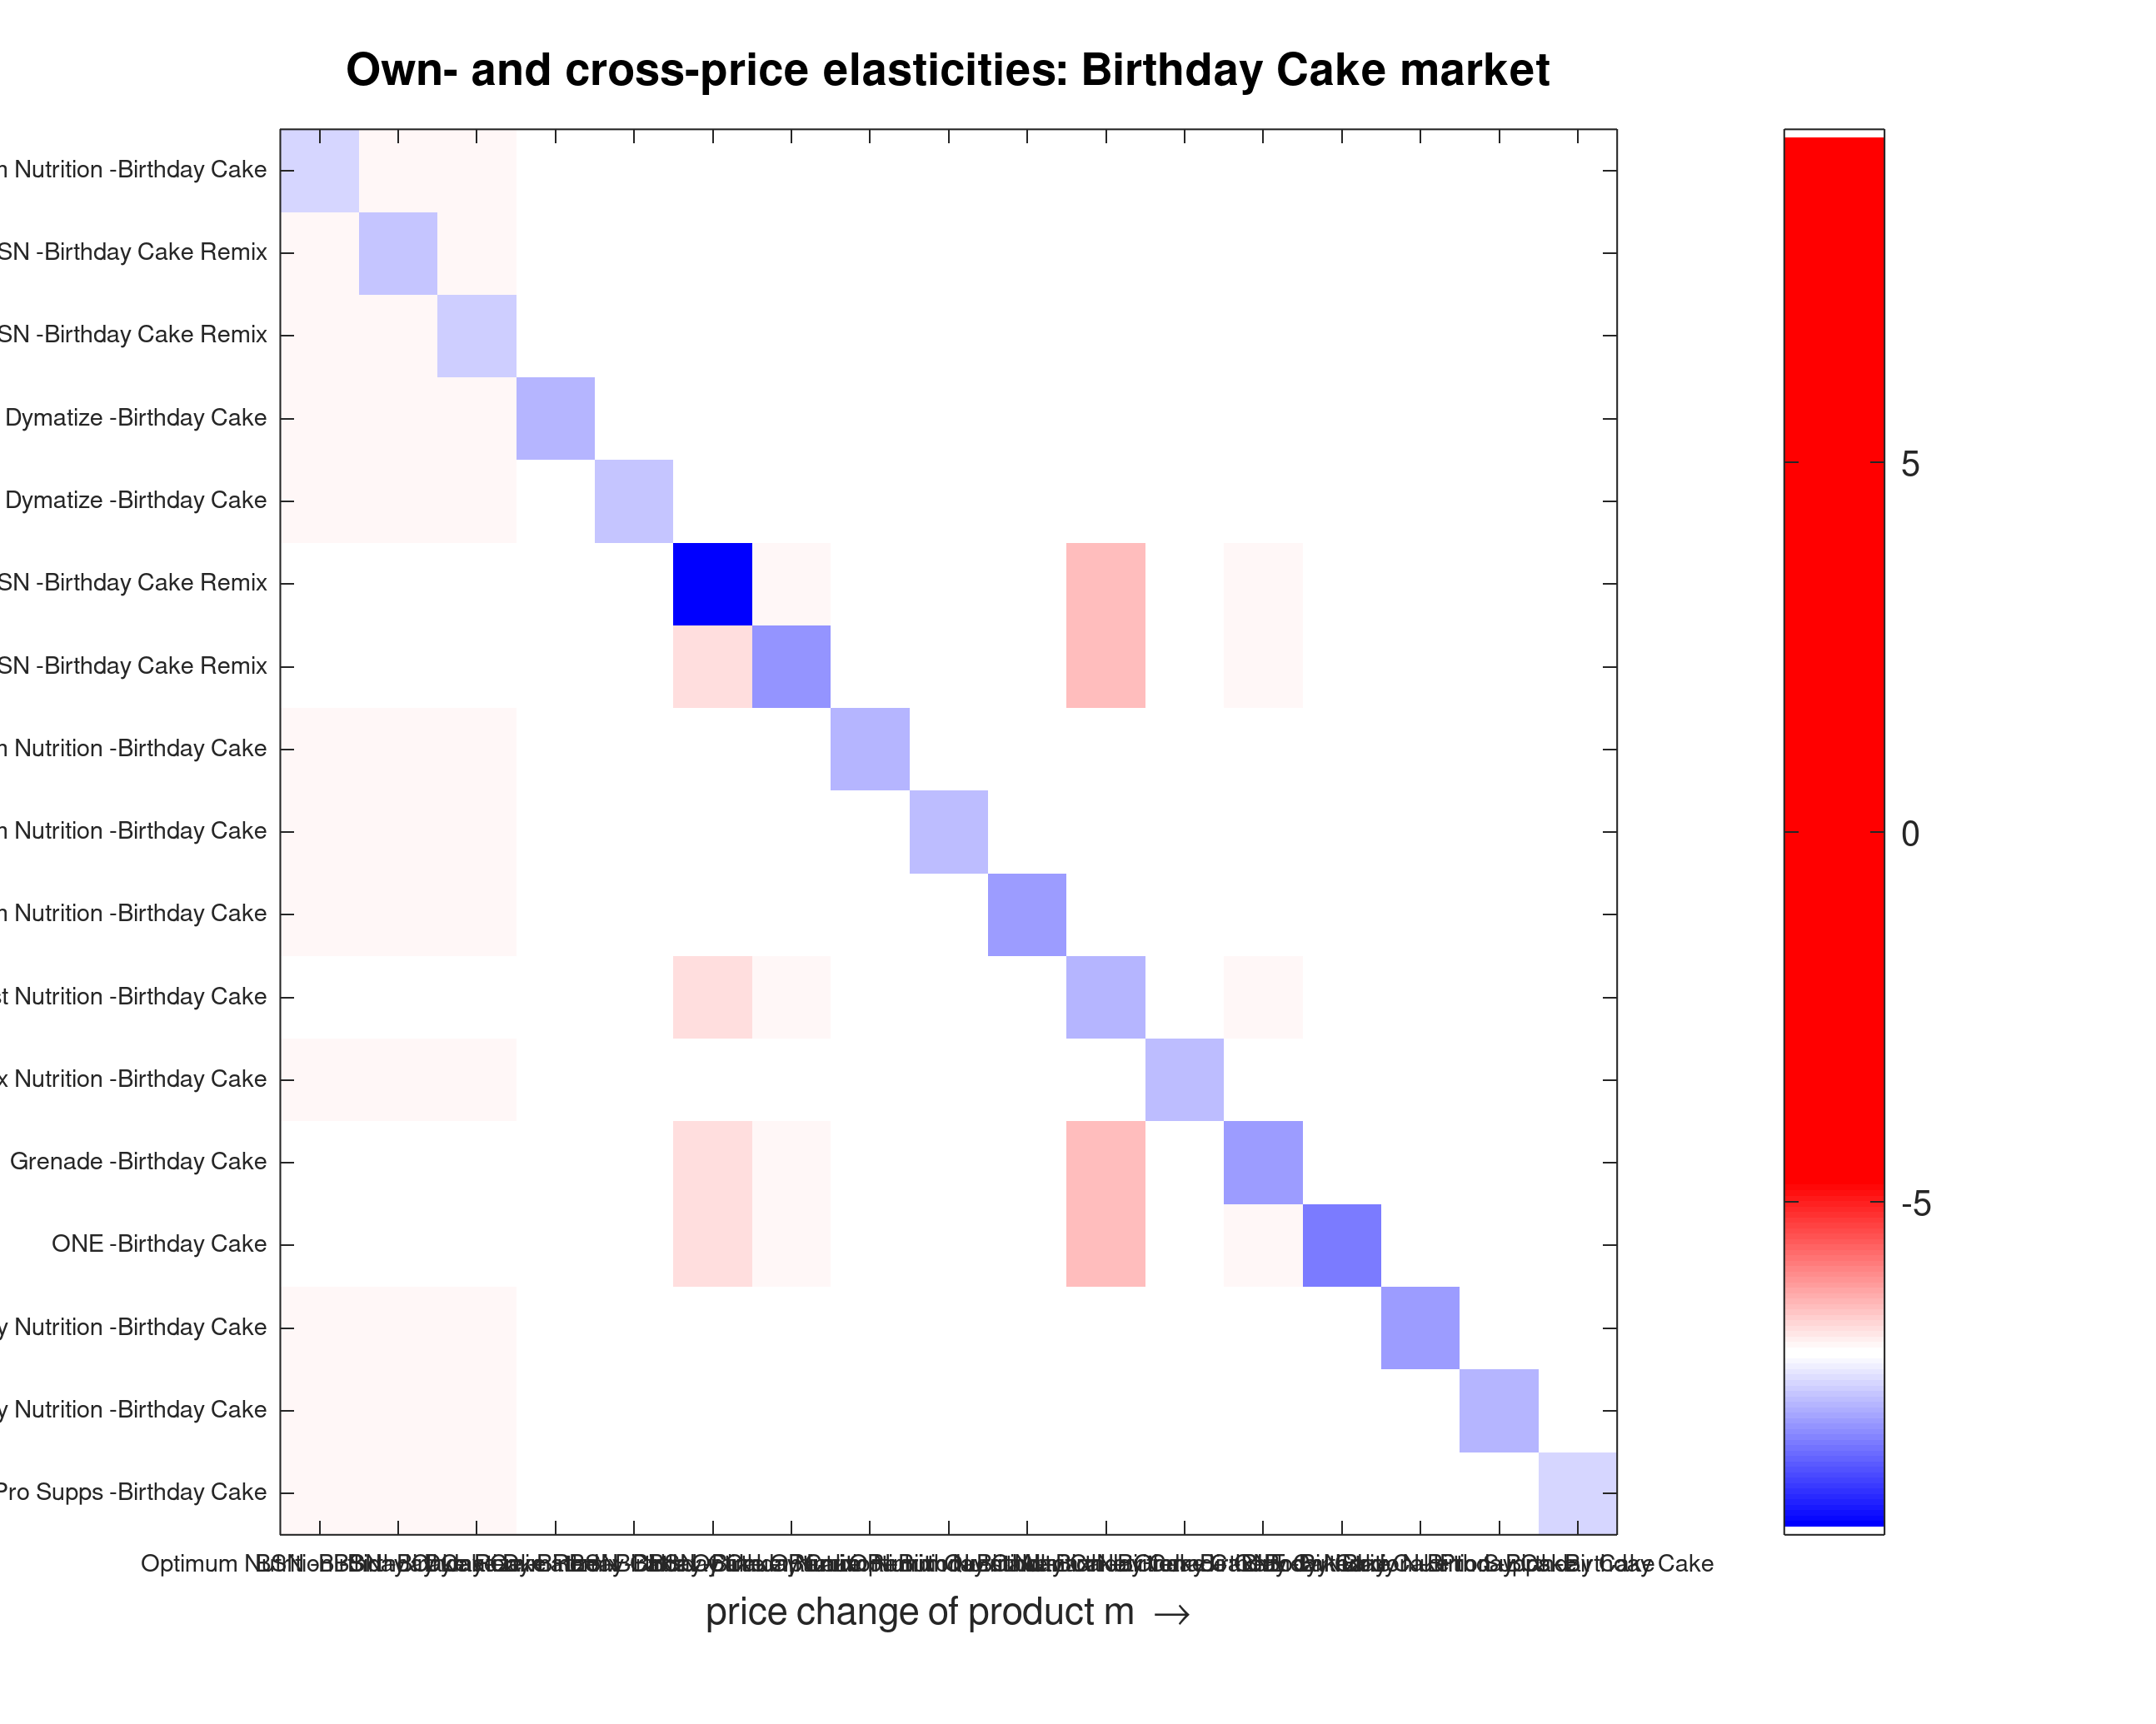
Birthday Cake elasticity heatmap
Exhibit E3b: Elasticity matrix — Birthday Cake (17 products).
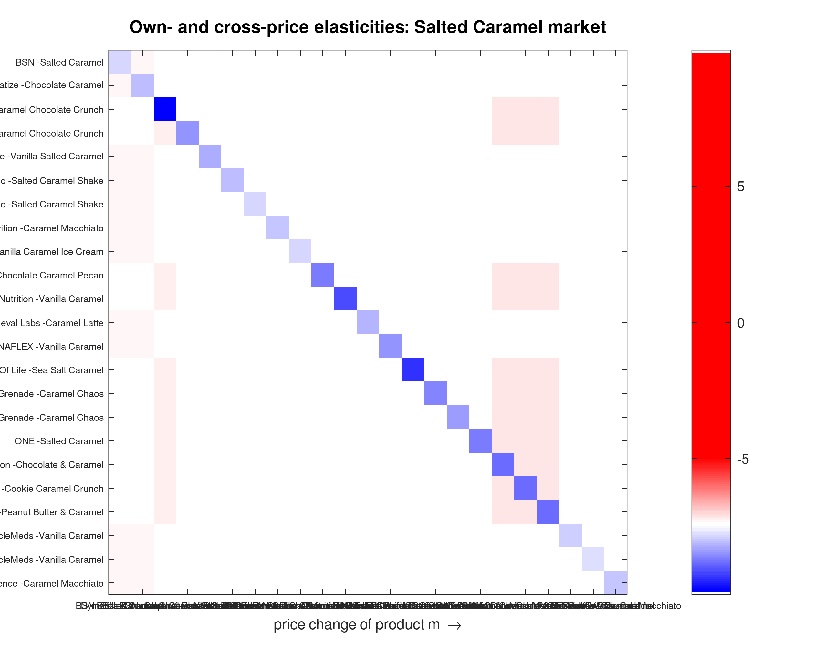
Salted Caramel elasticity heatmap
Exhibit E3c: Elasticity matrix — Salted Caramel (23 products). The bar block is uniformly deeper red, reflecting the higher switching rates of Exhibit ET2.
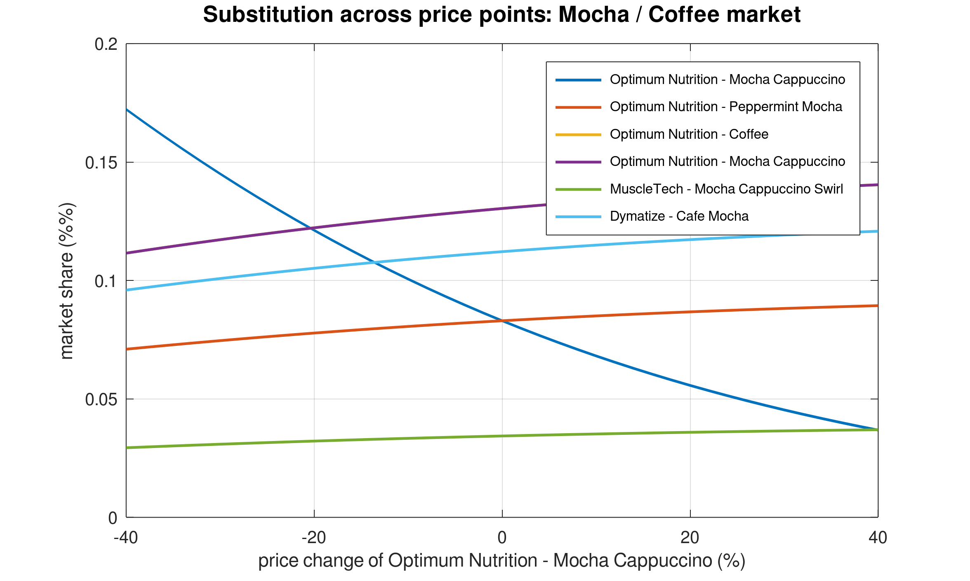
Counterfactual price sweep
Exhibit E4: Counterfactual price simulation — share diversion from Optimum Nutrition Mocha Cappuccino across a $±40\%$ price sweep, all other prices fixed.
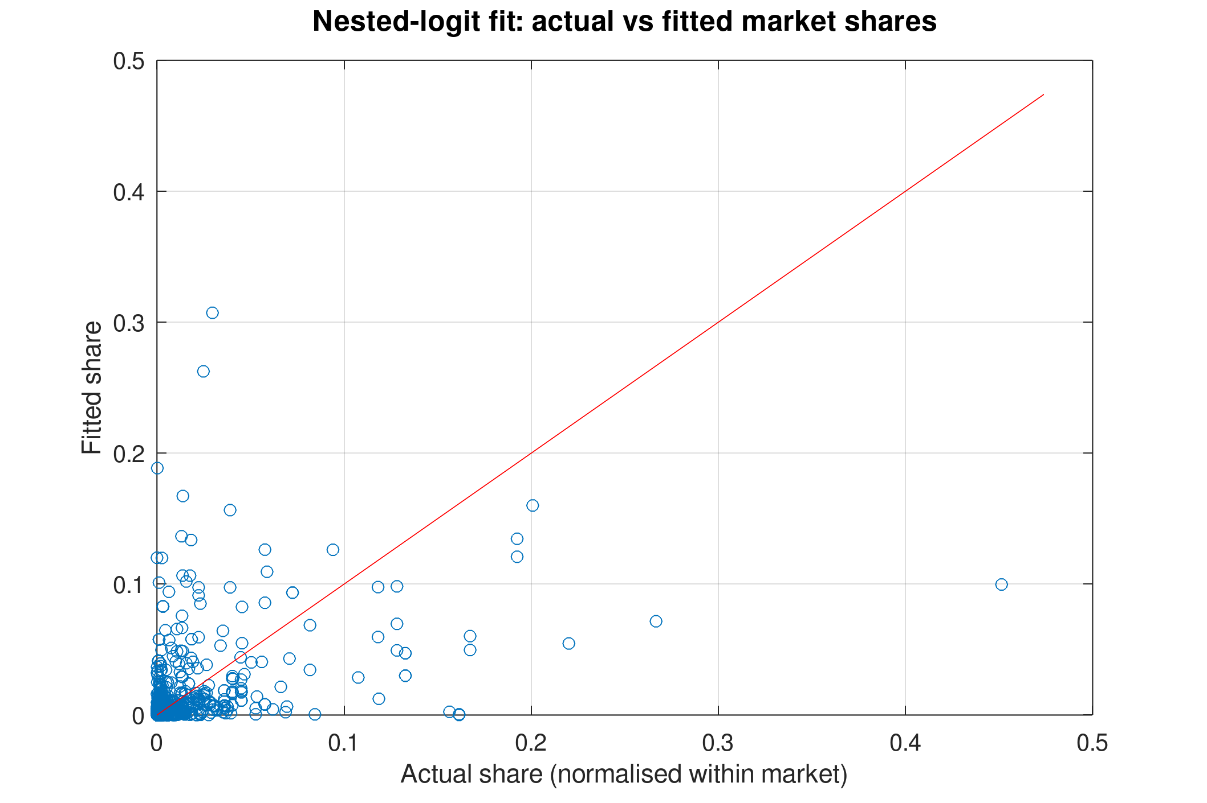
Actual versus fitted market shares
Exhibit E5: Actual versus fitted market shares (in-sample, $N=861$, normalised within flavour market; RMSPE $=0.032$).
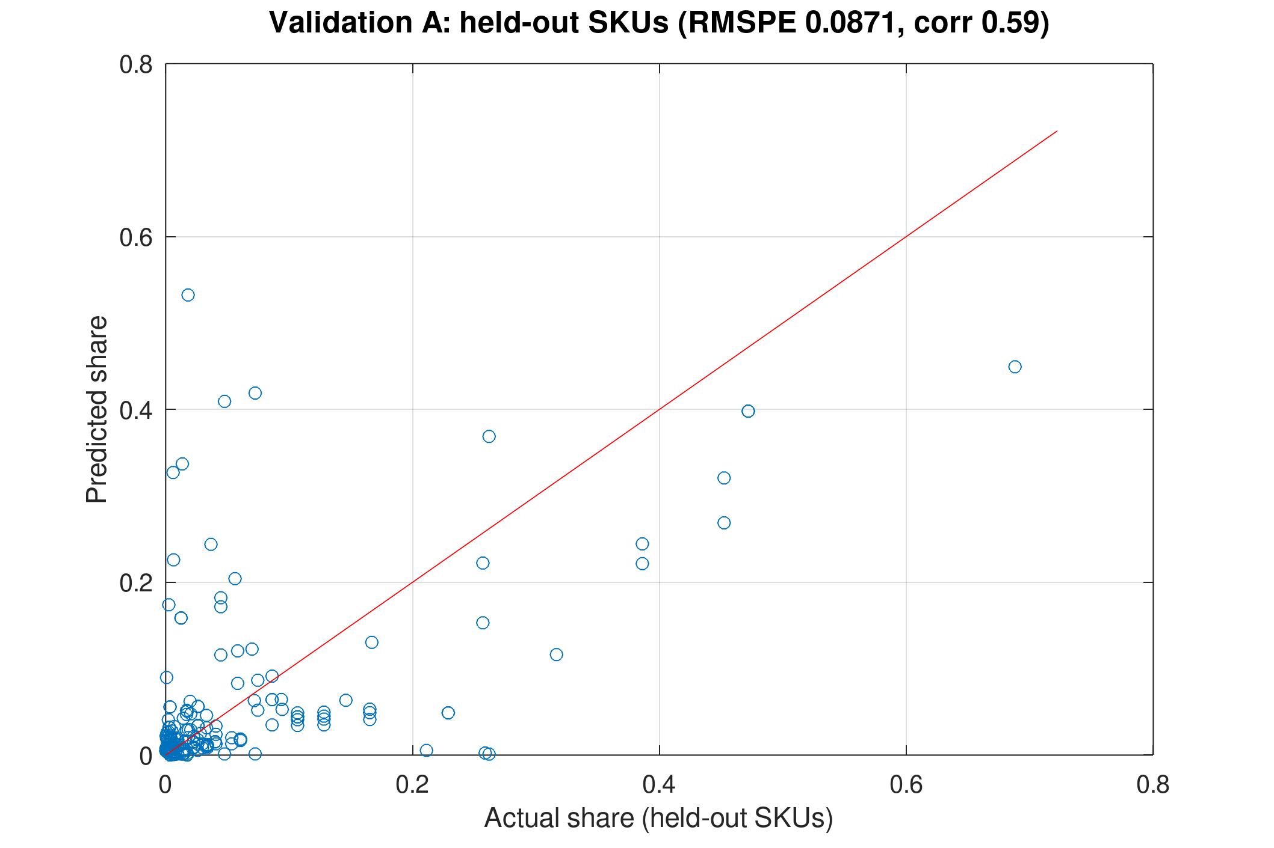
Level B hold-out: 210 held-out SKUs
Exhibit E6a: Level B — actual versus predicted shares for 210 held-out catalogue SKUs (RMSPE $=0.0871$, correlation $=0.587$; naive benchmark $0.0719$ / $0.686$).
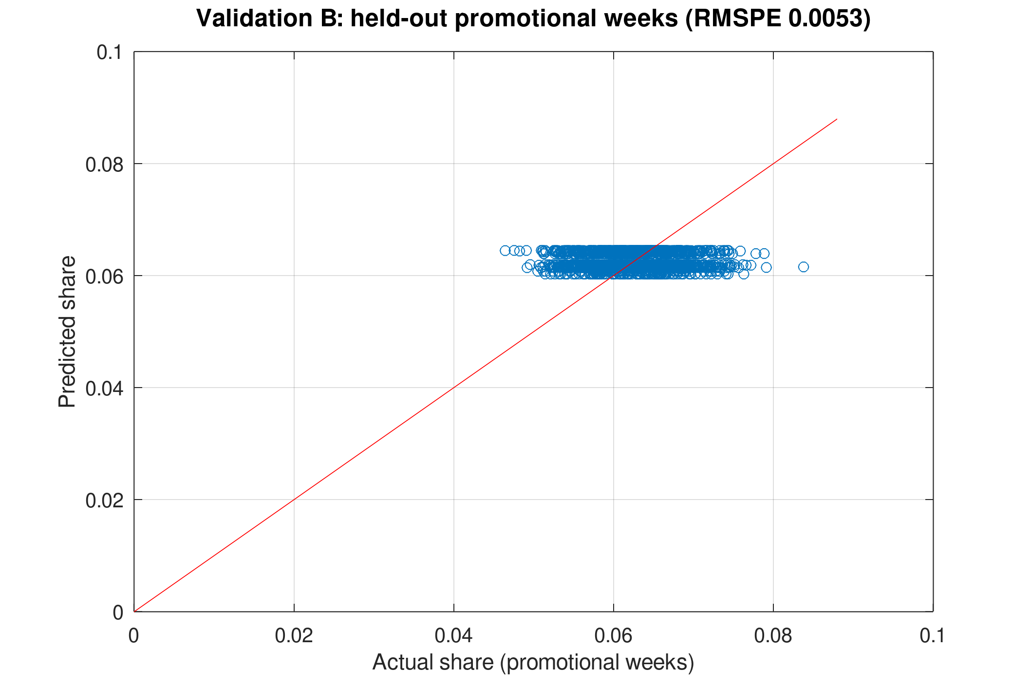
Level C/D hold-out: promotional weeks
Exhibit E6b: Level C/D — actual versus predicted shares across 1,680 held-out promotional product-weeks (RMSPE $=0.0053$, MAPE $=6.77\%$, correlation $=-0.0039$).
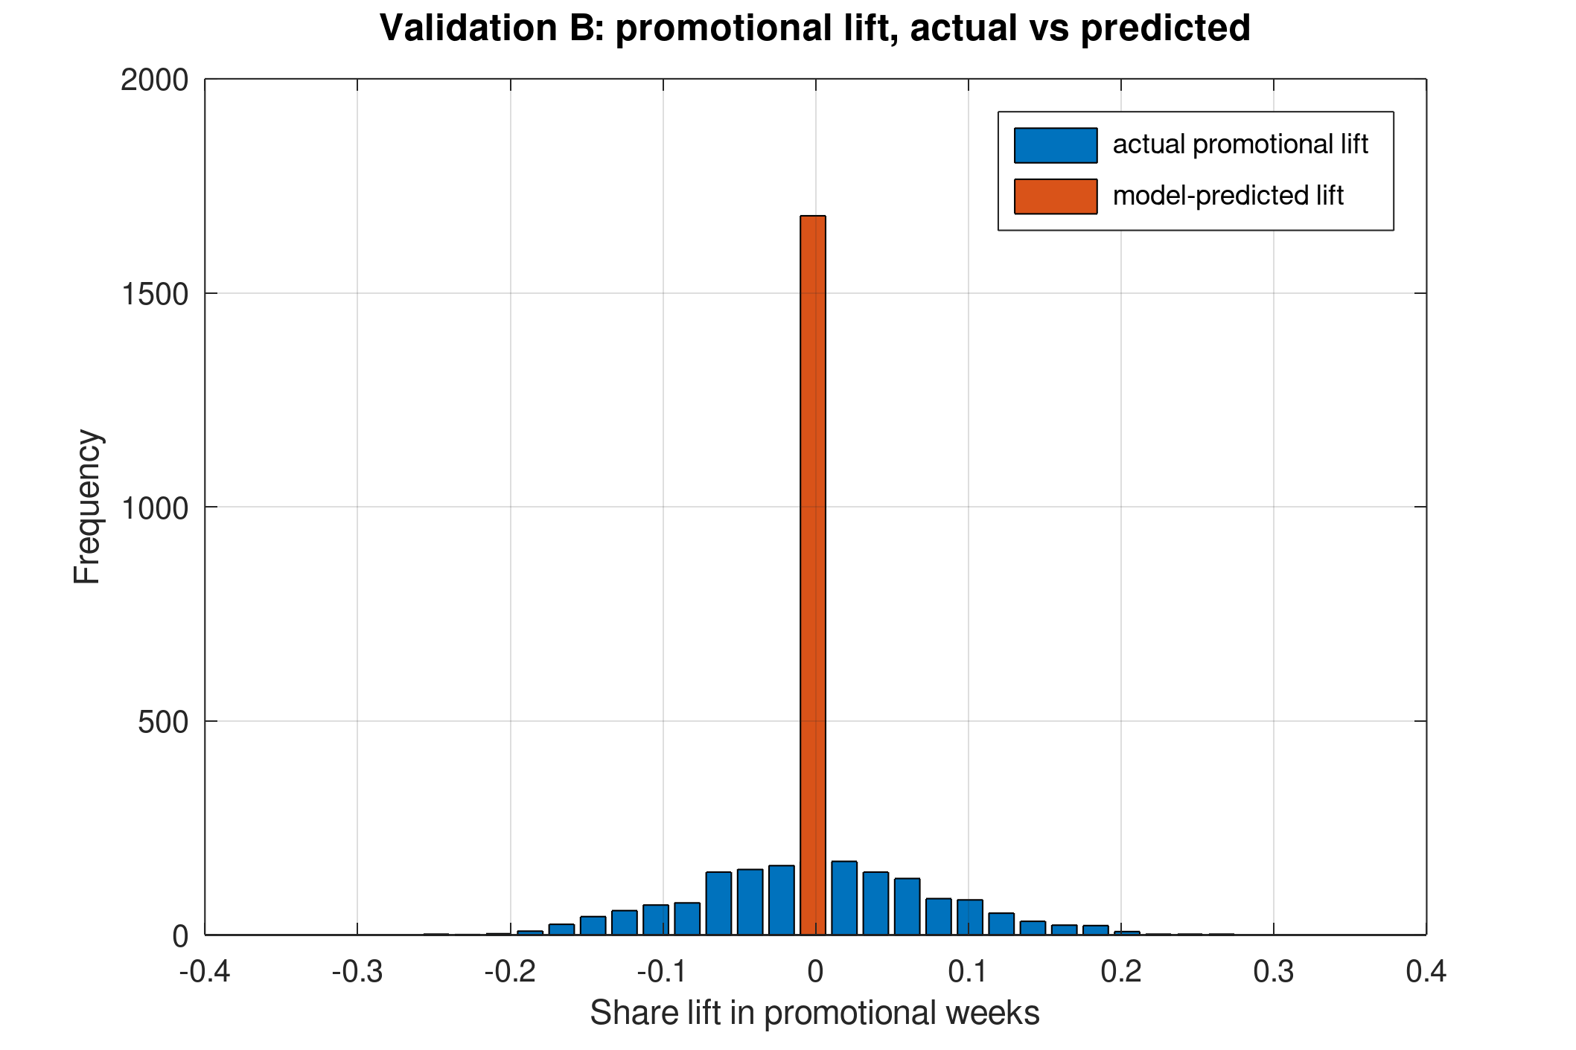
Promotional lift: actual versus predicted
Exhibit E7: Actual versus model-predicted promotional share lift (actual mean $+0.000032$, predicted mean $-0.000000005$, RMSE $=0.0812$).

Supplementary tables
Exhibit ET1 — The two datasets mapped to Level-2 fields
Feature | Catalogue (estimation) | Panel (validation)
Source | Kaggle: Sports nutrition supplements (bodybuilding.com listings; licence not stated) | Kaggle: Supplement Sales Data (Apache 2.0)
Units | 2,719 SKUs, one cross-section | 4,384 product-weeks (16 products × 274 weeks)
Shares | Review-mass proxy; $s_{0}=0.884$–$0.997$ | Weekly units → share (outside share fixed at 0.5)
Prices | Price and price per serving | Weekly retail price and % discount
Characteristics | Format, flavour, servings, ratings | Product name, category, platform, location
Ownership | Brand (108 source brands; 61 in sample) | Product identity
Role | Estimation, $N=861$ | Validation, 1,680 promotional product-weeks
Exhibit ET2 — Focal flavour markets
 | Mocha / Coffee | Birthday Cake | Salted Caramel
SKUs / brands | 26 / 15 | 17 / 9 | 23 / 14
Powder / bar SKUs | 23 / 3 | 12 / 5 | 12 / 11
Mean own-elasticity | $$-3.194$$ | $$-3.236$$ | $$-4.095$$
— powder / bar | $-3.146$ / $-3.566$ | $-2.504$ / $-4.993$ | $-2.412$ / $-5.930$
Intra-nest cross (mean) | $$0.099$$ | $$0.276$$ | $$0.317$$
Inter-nest cross (mean) | $$0.00013$$ | $$0.00013$$ | $$0.00009$$
Largest brand-level cross | $4.315$ (Convenient Nutrition $←$ Quest) | $2.481$ (bars $←$ Quest) | $3.538$ (Quest $←$ OhYeah!)
Exhibit ET3 — Brand-level own elasticities and largest cross-exposures, Mocha/Coffee
Brand | Own (brand-level) | Largest cross-in (source; value)
Animal | $$-2.459$$ | Optimum Nutrition; 0.913
Ascent | $$-3.005$$ | Optimum Nutrition; 0.913
Body Nutrition | $$-3.174$$ | Optimum Nutrition; 0.913
Bodybuilding.com Signature | $$-1.298$$ | Optimum Nutrition; 0.913
Convenient Nutrition | $$-4.282$$ | Quest Nutrition; 4.315
Dymatize | $$-1.822$$ | Optimum Nutrition; 0.913
Isopure | $$-4.059$$ | Optimum Nutrition; 0.913
Kaged Muscle | $$-2.221$$ | Optimum Nutrition; 0.913
MuscleTech | $$-2.780$$ | Optimum Nutrition; 0.913
Optimum Nutrition | $$-1.085$$ | MuscleTech; 0.317
PEScience | $$-2.399$$ | Optimum Nutrition; 0.913
Pro Supps | $$-1.561$$ | Optimum Nutrition; 0.913
Quest Nutrition | $$-1.063$$ | Convenient Nutrition; 0.020
Universal Nutrition | $$-1.324$$ | Optimum Nutrition; 0.913
Vega | $$-8.476$$ | Optimum Nutrition; 0.913

A. Flavour-profile market sizes
Market | SKUs | Market | SKUs
Chocolate | 305 | Salted Caramel | 23
Vanilla | 191 | Peanut Butter | 24
Other | 116 | Mocha / Coffee | 26
Cookies & Cream | 82 | Birthday Cake | 17
Strawberry/Berry | 54 | Banana | 13
 |  | Unflavored | 10
Total $N=861$ (715 powder, 146 bar); two single-nest markets (Banana, Unflavored) are powders only.

B. Full brand-level elasticity matrix — Mocha/Coffee
Rows: responding brand (aggregate share); columns: brand whose uniform price changes. Diagonal = brand-level own elasticity.
 | Animal | Ascent | Body Nutr. | Signature | Conv. Nutr. | Dymatize | Isopure | Kaged | MuscleTech | Opt. Nutr. | PEScience | Pro Supps | Quest | Universal | Vega
Animal | $$-2.459$$ | 0.007 | 0.074 | 0.111 | 0.000 | 0.093 | 0.039 | 0.081 | 0.317 | 0.913 | 0.010 | 0.009 | 0.000 | 0.031 | 0.164
Ascent | 0.057 | $$-3.005$$ | 0.074 | 0.111 | 0.000 | 0.093 | 0.039 | 0.081 | 0.317 | 0.913 | 0.010 | 0.009 | 0.000 | 0.031 | 0.164
Body Nutrition | 0.057 | 0.007 | $$-3.174$$ | 0.111 | 0.000 | 0.093 | 0.039 | 0.081 | 0.317 | 0.913 | 0.010 | 0.009 | 0.000 | 0.031 | 0.164
Bodybuilding.com Signature | 0.057 | 0.007 | 0.074 | $$-1.298$$ | 0.000 | 0.093 | 0.039 | 0.081 | 0.317 | 0.913 | 0.010 | 0.009 | 0.000 | 0.031 | 0.164
Convenient Nutrition | 0.000 | 0.000 | 0.000 | 0.000 | $$-4.282$$ | 0.000 | 0.000 | 0.000 | 0.001 | 0.135 | 0.000 | 0.000 | 4.315 | 0.000 | 0.000
Dymatize | 0.057 | 0.007 | 0.074 | 0.111 | 0.000 | $$-1.822$$ | 0.039 | 0.081 | 0.317 | 0.913 | 0.010 | 0.009 | 0.000 | 0.031 | 0.164
Isopure | 0.057 | 0.007 | 0.074 | 0.111 | 0.000 | 0.093 | $$-4.059$$ | 0.081 | 0.317 | 0.913 | 0.010 | 0.009 | 0.000 | 0.031 | 0.164
Kaged Muscle | 0.057 | 0.007 | 0.074 | 0.111 | 0.000 | 0.093 | 0.039 | $$-2.221$$ | 0.317 | 0.913 | 0.010 | 0.009 | 0.000 | 0.031 | 0.164
MuscleTech | 0.057 | 0.007 | 0.074 | 0.111 | 0.000 | 0.093 | 0.039 | 0.081 | $$-2.780$$ | 0.913 | 0.010 | 0.009 | 0.000 | 0.031 | 0.164
Optimum Nutrition | 0.057 | 0.007 | 0.074 | 0.110 | 0.000 | 0.092 | 0.039 | 0.081 | 0.317 | $$-1.085$$ | 0.010 | 0.009 | 0.009 | 0.031 | 0.164
PEScience | 0.057 | 0.007 | 0.074 | 0.111 | 0.000 | 0.093 | 0.039 | 0.081 | 0.317 | 0.913 | $$-2.399$$ | 0.009 | 0.000 | 0.031 | 0.164
Pro Supps | 0.057 | 0.007 | 0.074 | 0.111 | 0.000 | 0.093 | 0.039 | 0.081 | 0.317 | 0.913 | 0.010 | $$-1.561$$ | 0.000 | 0.031 | 0.164
Quest Nutrition | 0.000 | 0.000 | 0.000 | 0.000 | 0.020 | 0.000 | 0.000 | 0.000 | 0.001 | 0.001 | 0.000 | 0.000 | $$-1.063$$ | 0.000 | 0.000
Universal Nutrition | 0.057 | 0.007 | 0.074 | 0.111 | 0.000 | 0.093 | 0.039 | 0.081 | 0.317 | 0.913 | 0.010 | 0.009 | 0.000 | $$-1.324$$ | 0.164
Vega | 0.057 | 0.007 | 0.074 | 0.111 | 0.000 | 0.093 | 0.039 | 0.081 | 0.317 | 0.913 | 0.010 | 0.009 | 0.000 | 0.031 | $$-8.476$$

C. Additional output files
Full product-level elasticity matrices, brand matrices for Birthday Cake and Salted Caramel, per-SKU own elasticities, and hold-out prediction files are provided in output/ (elasticity_matrix_*.csv, brand_matrix_*.csv, own_elasticities.csv, panel_holdout_predictions.csv, estimation_summary.csv, reference_results.json). Reproduction scripts: scripts/nested_logit_analysis.m (MATLAB/GNU Octave) and scripts/reference_analysis.py (Python), which independently reproduce all reported statistics to within $5×{10}^{-4}$.

