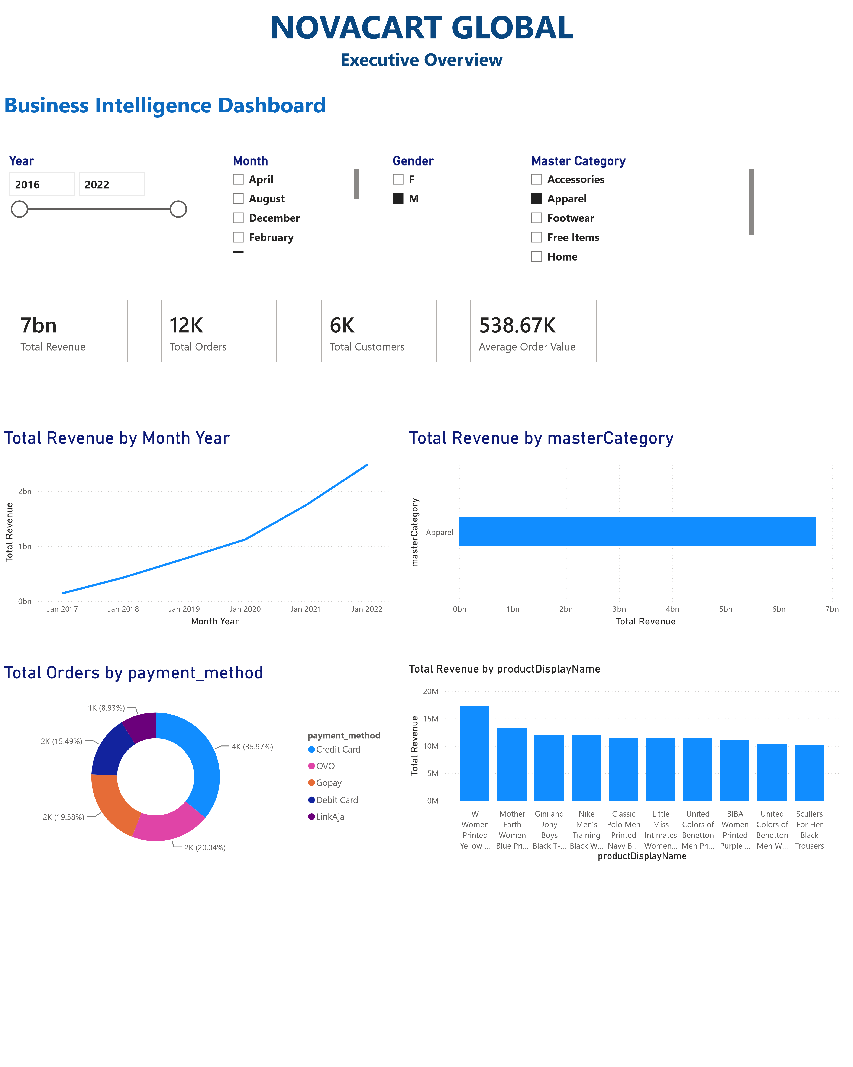

Power BI Desktop
CUSTOMER INSIGHTS
51K Total Customers 36K Male Customers | Android  iOS | 64K  Female Customers
Customer Growth Gender Distribution
0
K
10
K
20
K
K
30
40
K
Year
T
otal Customers
2016
2017
2018
2019
2020
2021
2022
33
K (64.19%
)
18
K (35.81%
)
gender
F
M
Customer Acquisition Trend New Customers by Join Year
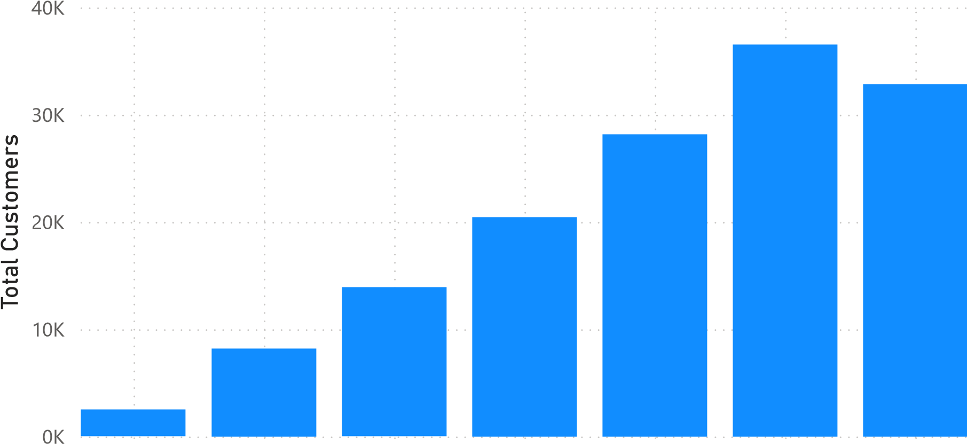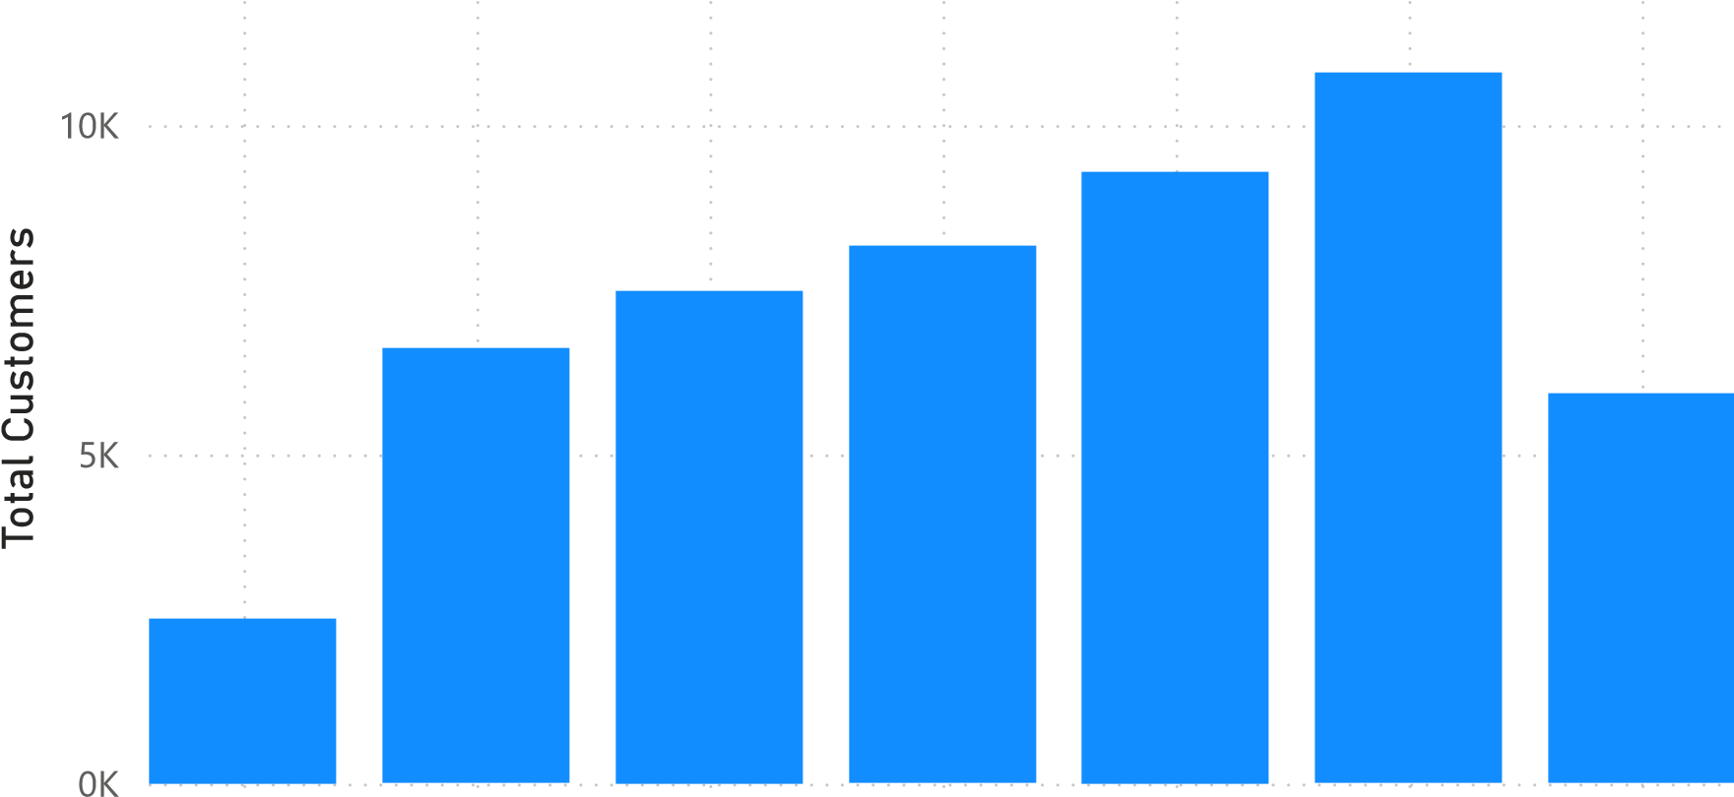
2016 2017 2018 2019 2020 2021 2022 2016 2017 2018 2019 2020 2021 2022
Year Year
