 | SR UNIVERSITY  Campus Warangal
 | Program: II - B. Tech (CS& AI) Batch: 67
 | Name: Aastha Labh Reg. No:2503A520P5
 | Department: Computer Science and AI Semester: I
 | AI Assisted Coding-Assignment Date:22.09.2026

TASK 1
- Question
A hospital has a hierarchical structure. Represent the following using a Tree:
Hospital
├── Cardiology
│ ├── ICU
│ └── General Cardiology
├── Neurology
│ ├── Stroke Unit
│ └── Neuro ICU
└── Orthopedics
Requirements
Create tree nodes.
Add child departments.
Display the hierarchy.
Search for a department.
Count total departments.
Test at least three search cases.

- Prompt
create a python tree structure to represent a hospital department hierarchy. Implement adding child nodes, displaying the hierarchy, searching for a department, counting total departments and test at least three search cases.

- Code
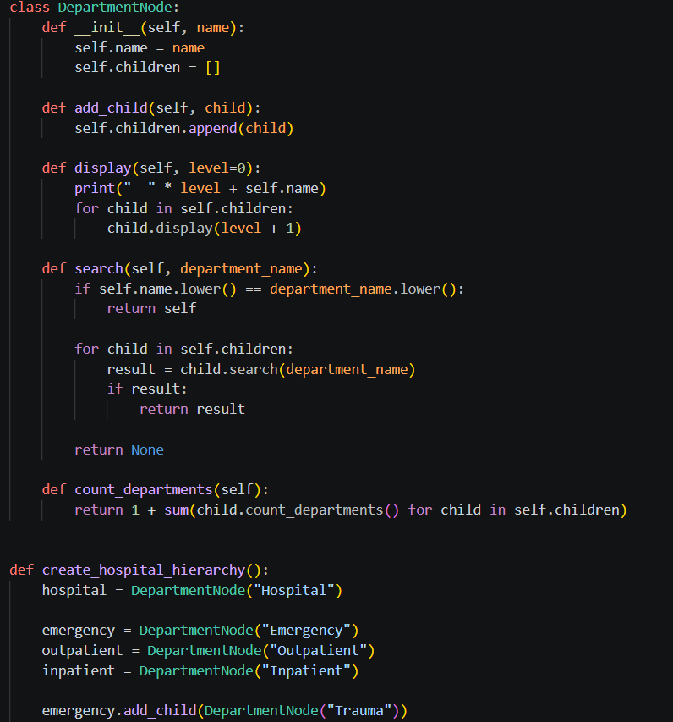
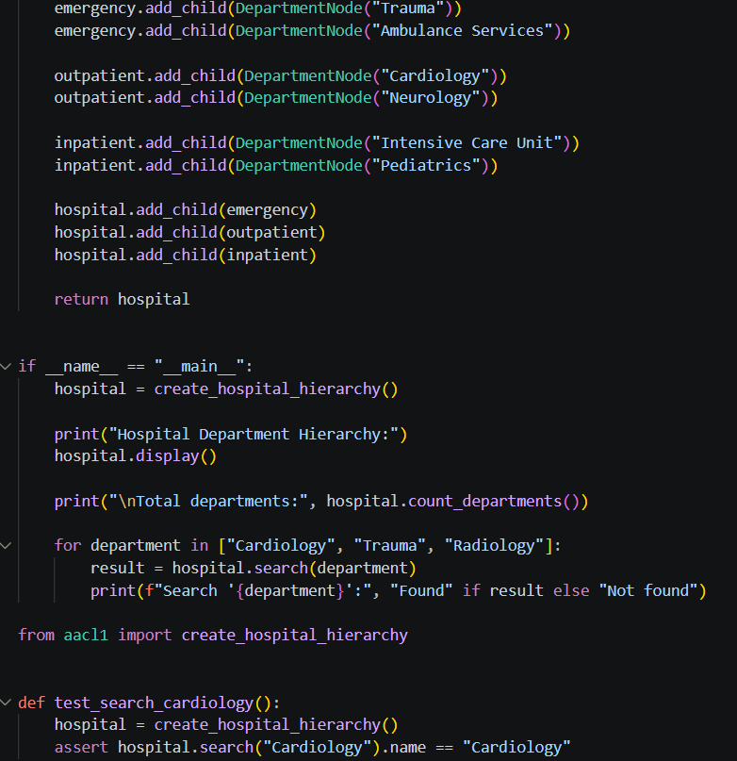
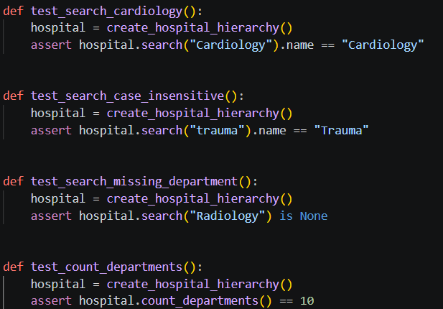
- Output

Hospital Department Hierarchy:
Hospital
Emergency
Trauma
Ambulance Services
Outpatient
Cardiology
Neurology
Inpatient
Intensive Care Unit
Pediatrics

Total departments: 10
Search 'Cardiology': Found
Search 'Trauma': Found
Search 'Radiology': Not found

- Observation
The tree data structure successfully represents hierarchical relationships (such as hospital departments and sub-departments), allowing efficient navigation, node counting, and searching compared to flat lists.

TASK 2
- Question
Represent hospital locations as a Graph. Each location is a node and each connection is an edge.
Reception ─── Pharmacy
│ │
│ │
ICU ─────── Emergency
│
Laboratory
Requirements
Add hospital locations as nodes.
Add connections as edges.
Display the graph using an adjacency list.
Check whether two locations are connected.
Find a route using BFS or DFS.
Test at least three source-destination pairs.

- Prompt
create a python graph structure for hospital locations where each location is a node and each connection is an edge. Display the graph using an adjacency list and Check whether two locations are connected also Find a route using BFS or DFS. Test at least three source-destination pairs.

- Code
- from collections import deque

- class HospitalGraph:
- def __init__(self):
- self.graph = {}

- def add_location(self, location):
- if location not in self.graph:
- self.graph[location] = []

- def add_connection(self, location1, location2):
- self.add_location(location1)
- self.add_location(location2)

- self.graph[location1].append(location2)
- self.graph[location2].append(location1)

- def display(self):
- print("Hospital Graph:")
- for location, connections in self.graph.items():
- print(f"{location}: {', '.join(connections)}")

- def is_connected(self, source, destination):
- return self.find_route(source, destination) is not None

- def find_route(self, source, destination):
- if source not in self.graph or destination not in self.graph:
- return None

- queue = deque([[source]])
- visited = {source}

- while queue:
- route = queue.popleft()
- current = route[-1]

- if current == destination:
- return route

- for neighbor in self.graph[current]:
- if neighbor not in visited:
- visited.add(neighbor)
- queue.append(route + [neighbor])

- return None

- if __name__ == "__main__":
- hospital = HospitalGraph()

- hospital.add_connection("Main Entrance", "Emergency")
- hospital.add_connection("Main Entrance", "Outpatient")
- hospital.add_connection("Emergency", "Radiology")
- hospital.add_connection("Emergency", "Pharmacy")
- hospital.add_connection("Outpatient", "Cardiology")
- hospital.add_connection("Outpatient", "Laboratory")
- hospital.add_connection("Radiology", "Surgery")

- hospital.display()

- test_pairs = [
- ("Main Entrance", "Surgery"),
- ("Outpatient", "Pharmacy"),
- ("Cardiology", "Laboratory"),
- ]

- print("\nConnection and routes:")
- for source, destination in test_pairs:
- route = hospital.find_route(source, destination)
- print(f"{source} -> {destination}")
- print("Connected:", hospital.is_connected(source, destination))
- print("Route:", " -> ".join(route) if route else "No route")

- Output
Hospital Graph:
Main Entrance: Emergency, Outpatient
Emergency: Main Entrance, Radiology, Pharmacy
Outpatient: Main Entrance, Cardiology, Laboratory
Radiology: Emergency, Surgery
Pharmacy: Emergency
Cardiology: Outpatient
Laboratory: Outpatient
Surgery: Radiology

Connection and routes:
Main Entrance -> Surgery
Connected: True
Route: Main Entrance -> Emergency -> Radiology -> Surgery
Outpatient -> Pharmacy
Connected: True
Route: Outpatient -> Main Entrance -> Emergency -> Pharmacy
Cardiology -> Laboratory
Connected: True
Route: Cardiology -> Outpatient -> Laboratory

- Observation
The graph data structure accurately models interconnected hospital locations and routes using nodes and edges (represented via an adjacency list), enabling effective connectivity checks and pathfinding using BFS or DFS.

TASK 3
- Question
In an emergency department, patients are treated according to severity rather than simple arrival order. Implement a Priority Queue using a Heap.
Priority 1 → Critical
Priority 2 → Serious
Priority 3 → Moderate
Priority 4 → Normal
Requirements
Add a patient with a priority value.
View the highest-priority patient.
Remove/serve the highest-priority patient.
Display waiting patients.
Handle at least one tie in priority appropriately.
Test insertion and removal operations.

- Prompt
create a python Heap structure for priority queue where add a patient with priority value, View the highest-priority patient, and Remove/serve it then Display waiting patients, Handle at least one tie in priority appropriately and Test insertion and removal operations.

- Code
- import heapq

- class PatientPriorityQueue:
- def __init__(self):
- self.waiting_patients = []
- self.next_order = 0

- def add_patient(self, name, priority):
- # Higher priority values are served first.
- # The order value handles ties using FIFO order.
- heapq.heappush(
- self.waiting_patients,
- (-priority, self.next_order, name)
- )
- self.next_order += 1

- def view_highest_priority(self):
- if not self.waiting_patients:
- return None

- priority, order, name = self.waiting_patients[0]
- return name, -priority

- def serve_patient(self):
- if not self.waiting_patients:
- return None

- priority, order, name = heapq.heappop(self.waiting_patients)
- return name, -priority

- def display_waiting_patients(self):
- patients = sorted(self.waiting_patients)

- print("Waiting patients:")
- for priority, order, name in patients:
- print(f"{name} - Priority: {-priority}")

- def test_insertion():
- queue = PatientPriorityQueue()
- queue.add_patient("Alice", 2)
- queue.add_patient("Bob", 5)

- assert queue.view_highest_priority() == ("Bob", 5)

- def test_removal():
- queue = PatientPriorityQueue()
- queue.add_patient("Alice", 2)
- queue.add_patient("Bob", 5)

- assert queue.serve_patient() == ("Bob", 5)
- assert queue.view_highest_priority() == ("Alice", 2)

- def test_priority_tie():
- queue = PatientPriorityQueue()
- queue.add_patient("Alice", 4)
- queue.add_patient("Bob", 4)

- # Patients with equal priority are served in insertion order.
- assert queue.serve_patient() == ("Alice", 4)
- assert queue.serve_patient() == ("Bob", 4)

- if __name__ == "__main__":
- patients = PatientPriorityQueue()

- patients.add_patient("Alice", 3)
- patients.add_patient("Bob", 5)
- patients.add_patient("Charlie", 5) # Tie handled by insertion order
- patients.add_patient("Diana", 2)

- patients.display_waiting_patients()

- print("\nHighest-priority patient:", patients.view_highest_priority())

- print("Serving patient:", patients.serve_patient())
- print("Serving patient:", patients.serve_patient())

- print()
- patients.display_waiting_patients()

- test_insertion()
- test_removal()
- test_priority_tie()

- print("\nAll tests passed.")

- Output
Waiting patients:
Bob - Priority: 5
Charlie - Priority: 5
Alice - Priority: 3
Diana - Priority: 2

Highest-priority patient: ('Bob', 5)
Serving patient: ('Bob', 5)
Serving patient: ('Charlie', 5)

Waiting patients:
Alice - Priority: 3
Diana - Priority: 2

All tests passed.

- Observation
The priority queue implemented using a heap efficiently manages patient severity levels, ensuring that critical patients are always viewed and served first regardless of arrival order, while properly handling ties.

TASK 4
- Question
A hospital application needs an autocomplete feature. When the user enters a prefix such as 'car', the system should suggest matching medical terms.
Input prefix: "car"
Possible output:
cardiology
cardiac
carcinoma
care
Requirements
Create a Trie.
Insert medical words.
Search for an exact word.
Check whether a prefix exists.
Display/autocomplete words beginning with a prefix.
Test at least three different prefixes.

- Prompt
create a python trie for hospital app autocomplete feature. Insert medical words then Search for an exact word, Check whether a prefix exists and Display/autocomplete words beginning with a prefix. For referrence : Input prefix: "car"
Possible output:
cardiology
cardiac
carcinoma
care
Test at least three different prefixes.
- Code
- class TrieNode:
- def __init__(self):
- self.children = {}
- self.is_word = False

- class HospitalTrie:
- def __init__(self):
- self.root = TrieNode()

- def insert(self, word):
- current = self.root

- for character in word.lower():
- if character not in current.children:
- current.children[character] = TrieNode()
- current = current.children[character]

- current.is_word = True

- def search_exact(self, word):
- current = self.root

- for character in word.lower():
- if character not in current.children:
- return False
- current = current.children[character]

- return current.is_word

- def prefix_exists(self, prefix):
- current = self.root

- for character in prefix.lower():
- if character not in current.children:
- return False
- current = current.children[character]

- return True

- def autocomplete(self, prefix):
- current = self.root

- for character in prefix.lower():
- if character not in current.children:
- return []
- current = current.children[character]

- words = []

- def collect_words(node, current_word):
- if node.is_word:
- words.append(current_word)

- for character in sorted(node.children):
- collect_words(
- node.children[character],
- current_word + character
- )

- collect_words(current, prefix.lower())
- return words

- def test_exact_search(trie):
- assert trie.search_exact("cardiology")
- assert trie.search_exact("CARDIAC")
- assert not trie.search_exact("cancer")

- def test_prefix_search(trie):
- assert trie.prefix_exists("car")
- assert trie.prefix_exists("neu")
- assert not trie.prefix_exists("xyz")

- def test_autocomplete(trie):
- assert trie.autocomplete("car") == [
- "carcinoma",
- "cardiac",
- "cardiology",
- "care",
- ]

- assert trie.autocomplete("neu") == [
- "neurology",
- "neurosurgery",
- ]

- assert trie.autocomplete("rad") == [
- "radiology",
- "radiotherapy",
- ]

- if __name__ == "__main__":
- trie = HospitalTrie()

- medical_words = [
- "cardiology",
- "cardiac",
- "carcinoma",
- "care",
- "neurology",
- "neurosurgery",
- "radiology",
- "radiotherapy",
- "surgery",
- ]

- for word in medical_words:
- trie.insert(word)

- print("Exact search:")
- for word in ["cardiology", "CARDIAC", "cancer"]:
- print(f"{word}: {trie.search_exact(word)}")

- print("\nAutocomplete results:")
- for prefix in ["car", "neu", "rad"]:
- print(f"{prefix}: {trie.autocomplete(prefix)}")

- test_exact_search(trie)
- test_prefix_search(trie)
- test_autocomplete(trie)

- print("\nAll tests passed.")

- Output
Exact search:
cardiology: True
CARDIAC: True
cancer: False

Autocomplete results:
car: ['carcinoma', 'cardiac', 'cardiology', 'care']
neu: ['neurology', 'neurosurgery']
rad: ['radiology', 'radiotherapy']

All tests passed.

- Observation
The Trie data structure provides fast prefix-based searching and autocomplete functionality for medical terms and drugs, offering a distinct performance advantage over linear lists for prefix queries.

TASK 5
