**DAY-2 MYSQL PRACTICE(DML)**

1. Created 2 tables

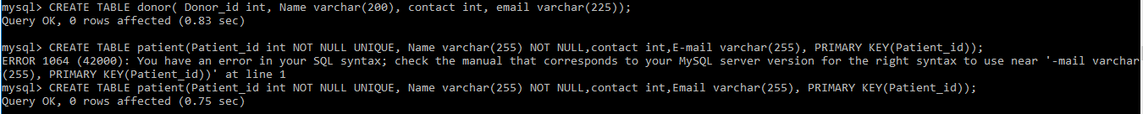

1. Altering table column.

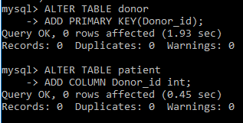

1. Tables, Columns in the table.

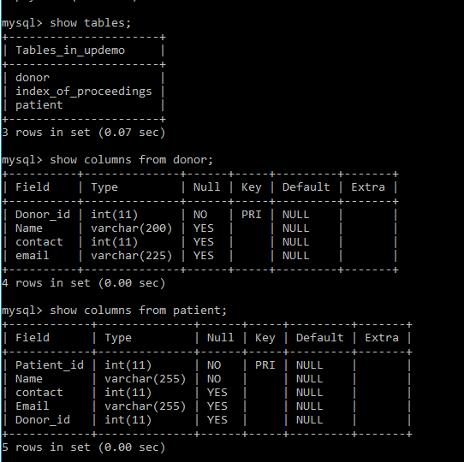

1. Adding Foreign Key

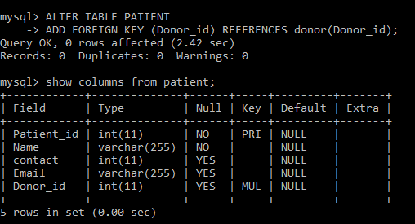

1. Table data display.

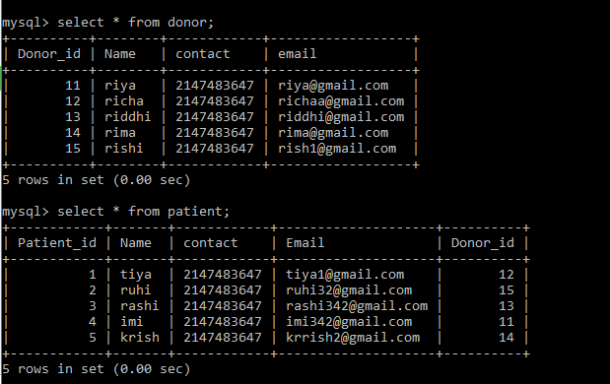

1. Delete

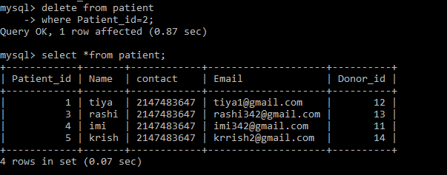

1. UPDATE

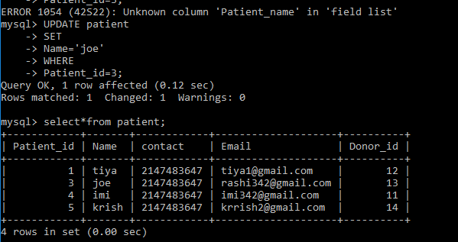

1. SEQUENCE

