**LAB-1**

1. Different networking devices -

**Network Router:**

A router is a network device which is responsible for routing traffic from one to another network.

**Network Hub:**

Network Hub is a networking device which is used to connect multiple network hosts. A network hub is also used to do data transfer. The data is transferred in terms of packets on a computer network. So when a host sends a data packet to a network hub, the hub copies the data packet to all of its ports connected to.

**Modem:**

A modem stands for (**Mo**dulator+**De**modulator). That means it modulates and demodulates the signal between the digital data of a computer and the analog signal of a telephone line.

**Bridge:**

If a router connects two different types of networks, then a bridge connects two subnetworks as a part of the same network. You can think of two different labs or two different floors connected by a bridge.

1. Network type and topology -

Network Topology is the schematic description of a network arrangement, connecting various nodes (sender and receiver) through lines of connection.

Different types of Network topology:

* **Bus Topology**
* **Ring Topology**

## **Star Topology**

## **Mesh Topology**

## **Tree Topology**

## **Hybrid Topology:**

It is two different types of topologies which is a mixture of two or more topologies.

Our department has hybrid topology.

1. File and printer sharing in different operating systems -

In windows:

* **Control panel ->** **View network status and tasks -> Change advanced sharing setting**
* Choose **turn on file and printer sharing** and tap **Save Changes**

1. Network address configuration in different operating systems?

* Open control panel -> adapter settings
* Click on the **Internet Protocol Version 4 (TCP/IPv4)**. Next click on the **Properties** button.
* Next click the **Use the following DNS server addresses**. In the **Preferred DNS Server** and **Alternate DNS server** input the numbers. Then click **Ok**.

1. Finding IP and MAC address in different operating systems?

* windows: **ipconfig**
* Linux : **ifconfig**

1. Work group and domain configuration?

A workgroup is a type of peer-to-peer network. Computers in this kind of network can allow each other access to their files, printers, or Internet connection. In order to do this, every user must have an account on each of the workgroup’s computers that they require access to. These settings and access are managed by each computer’s user.

Steps to join a workgroup:

1. **Navigate to Control Panel, System and Security and System** to access your computer details.  
2. **Find Workgroup and select Change settings.**  
3. **Select Change next to ‘To rename this computer or change its domain’.**  
4. **Type in the name of the Workgroup you want to join and click OK.**  
5. Reboot your computer for the changes to take effect.  
6. **Navigate to Control Panel, Network and Internet and View network computers and devices** to see other machines within that Workgroup.

A domain, on the other hand, is a client/server network in which the security and resource management is centralized. This means that a singular administration has control over the domain and allows which users have access to which files. In a domain, there is a one single database for domain users. A user can log on at any workstation via their account and access the files.

Steps to add a domain user or group:

1. In the **Users / Groups** window, click **Add.**
2. In the **Enter User or Group names** dialog box, select domain users or groups by doing one of the following:
   * In the **Enter User or Group names** field, type a user or group that exists in the domain or as a local user or group on the computer. Then click **Check Names** to resolve it to the full existent name.
   * Click **Find** to open the standard **Select Users or Groups** dialog box. Then select domain users or groups.
3. Click **OK**.

The domain users or groups are added.

1. Use of utilities:

(i) arp: (Address Resolution Protocol)

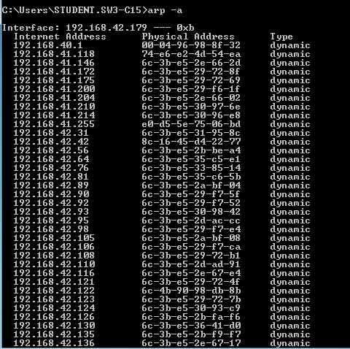

(ii) ipconfig/ifconfig:

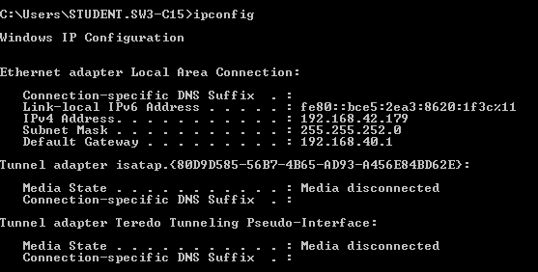

(iii) tracert:

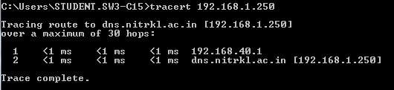

(iv) nslookup:

