Beyond Tokenization: Spelling Perturbations, Explanation Stability and Faithfulness in Devanagari D-SAFE

1st Ananya Sharma
Dept.of CSE(AI)
KIET Deemed to be University
Ghaziabad, India
ananyasharma0286@gmail.com
2nd Aneka Srivastava
Dept. of CSE(AI)
KIET Deemed to be University
Ghaziabad, India
aneka7216@gmail.com
3rd Aastha Srivastava
Dept. of CSE(AI)
KIET Deemed to be Unversity
Ghaziabad, India
aasthasrivastava210@gmail.com

4th Aastha
Dept. of CSE(AI)
KIET Deemed to be University
Ghaziabad, India
aasthahcs05@gmail.com
5th Anchal Rai
Dept. ofCSE(AI)
KIET Deemed to be University
Ghaziabad, India
anchalrai3008@gmail.com
6th Bikki Kumar
Dept. of CSE(AI)
KIET Deemed to be University
Ghaziabad, India
bikkikumar@gmail.co

Abstract— Pretrained language models can respond unpredictably when small lexical changes occur, but the effects of Devanagari spelling perturbations on subword tokenization, model predictability, and explanation quality remain central questions for Hindi natural language processing. D-SAFE evaluates these phenomena using two prominent pretrained masked language models, MuRIL and XLM-RoBERTa. The primary adjudicated benchmark comprises 1,679 sentence pairs across three linguistic tracks: valid-word context (312 pairs), synonym substitution (362 pairs), and realistic spelling error (1,005 pairs). The experimental pipeline measures target-word subword fragmentation, pseudo-log-likelihood (PLL) predictability, and token-level feature attributions from self-attention and Integrated Gradients (IG). Attribution stability is assessed via rank correlation and cosine similarity under a visible-target scoring protocol, while explanation faithfulness is tested through context erasure interventions across 10%, 20%, and 30% masking fractions. In the 1,005-pair spelling-error subset, single-subword target coverage collapses catastrophically from 91.7% to 20.1% for MuRIL (−71.6 pp) and from 62.3% to 6.4% for XLM-RoBERTa (−55.9 pp). Pseudo-log-likelihood penalties for spelling contrasts are substantial across both models (MuRIL mean ΔS = −1.2045, XLM-RoBERTa mean ΔS = −0.8864). In explanation stability, attention exhibits markedly higher rank stability than Integrated Gradients in MuRIL (0.8027 vs 0.2560) and in XLM-RoBERTa (0.6258 vs 0.3319), while gradient vectors maintain high directional cosine similarity (0.889–0.982). In stability–faithfulness correlation analysis across 1,005 pairs, effect sizes remain negligible (|ρ| < 0.08), demonstrating that attribution stability under input noise cannot serve as a reliable empirical proxy for explanation faithfulness.
Index Terms— Hindi natural language processing, lexical perturbation, subword tokenization, masked language models, explainable artificial intelligence, explanation stability, explanation faithfulness, Integrated Gradients.

Introduction
Pretrained language models are a foundation for natural language processing they learns representations from large collections of text. However can be sensitive to changes in the input. The pretrained model reacts to substitutions and spelling variations. The sensitivity is very important for languages that use scripts such as Devanagari, a small orthographic change can affect tokenization and the representation of a target word. Subword tokenization lets the model process words that're not full entries in its vocabulary, a spelling variation can cause a word to be split into a number of subword tokens. These changes can affect the inputs that model uses for prediction. Measuring tokenization differences is therefore a first step for studying the pretrained model’s behavior under lexical perturbations, second challenge is how to interpret the pretrained language model’s behavior. A change in score can signal a difference in its relative predictability assessment, it does not directly prove grammatical correctness or semantic equivalence. In D-SAFE pseudo-log-likelihood-based scoring is used to compare the predictability of contrast targets. The analysis keeps the pretrained model’s scores separate from judgments about language acceptability. Attention and Integrated Gradients are two methods used to derive token-level importance estimates. These methods rely on computational signals. An explanation may stay similar when the input changes. However stability does not prove that the explanation faithfully represents the factors that influence the pretrained model’s output. Stability and faithfulness must therefore be evaluated as properties. D-SAFE explores the issues in Devanagari Hindi with the pretrained models MuRIL and XLM‑RoBERTa. A curated dataset of 2000 sentence pairs is arranged into three tracks: valid-word context, synonym substitution and realistic spelling-error. The experimental pipeline looks at target word tokenization, pseudo-log-likelihood-based predictability, explanation stability and masking-based faithfulness. First , characterizes changes in target-word subword coverage when spelling perturbations occur in the pretrained language models MuRIL and XLM‑RoBERTa. Second, compares model-based predictability scores and the behavior of Attention and Integrated Gradients under chosen perturbations. Third, it evaluates the relationship between explanation stability and a masking-based faithfulness measure making it clear that the results are observational than universal or causal The findings aim to provide an analysis of lexical sensitivity and explanation evaluation in Hindi. The small spelling-error subset, the need for target alignment and the limits of masking interventions restrict the conclusions. These limits are taken into account when the study interprets the results and suggests paths, for research.
- Hindi sentence-pair resource: We assemble and audit an adjudicated 1,679-pair Devanagari Hindi benchmark covering valid-word contextual contrasts (312 pairs), synonym substitutions (362 pairs), and authentic spelling errors (1,005 pairs).
- Tokenization and PLL measurements: We compare target-word fragmentation and pseudo-log-likelihood changes across XLM-RoBERTa and MuRIL.
- Explanation evaluation protocol: We document a visible-target scoring protocol and evaluate attention and Integrated Gradients across 1,005 spelling pairs under 10%, 20%, and 30% context erasure.
- Exploratory stability–faithfulness result: Across 1,005 spelling pairs, empirical correlations between explanation stability and faithfulness remain near zero (|ρ| < 0.08), showing that attribution stability under spelling noise does not imply attribution faithfulness.

RELATED WORK

Subword Tokenization and Lexical Robustness
Subword vocabularies allow pretrained models to show words but how well a language is covered depends on the tokenizer. Rust et al. Compared models with monolingual models and found that a special monolingual tokenizer matters about as much as pretraining data size; replacing a multilingual models tokenizer with a special one improved downstream performance for almost every task and language they tested. XLM-RoBERTa shares one vocabulary across languages whereas MuRIL was built with an emphasis on Indian languages. For Hindi Ravikiran et al. Checked Indic-focused and byte-level tokenizers on informal expressions and found that Indic-oriented models such as MuRIL keep expression boundaries better than general multilingual models while all tokenizers have problems under romanization. Aliakbarzadeh et al. Collected typos from Wikipedia edit histories for six languages, including Hindi and tested nine models on natural language inference, named entity recognition and intent classification; every model had lower accuracy on noisy test data with average differences of 2.3 to 4.3 percentage points. These studies look at accuracy or boundary preservation. We instead look at how a controlled Devanagari spelling change changes the subword segmentation of a target word and link that change to model scoring and to explanations.

Masked Language Models and Pseudo-Log-Likelihood
A masked language model does not create a left-to-right sequence probability. Salazar et al. Introduced pseudo-log-likelihood (PLL) which masks each token one by one and adds the log-probabilities. They showed that PLL scores are better than scores from models on several tasks and said this is because of an unsupervised expression of linguistic acceptability. Kauf and Ivanova later found that the original PLL gives scores to out-of-vocabulary words that are split into several tokens and suggested PLL-word-l2r, which also masks the within-word tokens to the right of the target. They also showed that the choice of changes results on minimal-pair benchmarks. This is important here because spelling variants tend to be split into more subword tokens. We use the PLL with length normalization compare scores only inside a model and see them as a measure of model predictability instead of grammaticality or human acceptability. The inflation mentioned in means our scores for variants might not show their full penalty.

Explanation Stability and Faithfulness
Faithfulness means whether the features an explanation shows actually changed the models output. Jacovi and Goldberg talk about how faithfulness should be defined and tested and ERASER makes it clear through comprehensiveness and sufficiency which look at how a prediction changes when rationale tokens are removed or kept. Madsen et al. Mask what they think are tokens again and again and retrain the model and compare against random masking. Our k, bottom-k and random-k masking follows the same comparison idea but does not retrain so our masked inputs might not be in the models training distribution. Stability means whether explanations stay the same with input changes. Yin et al. Suggested sensitivity and stability as criteria that go with removal-based faithfulness and showed that conclusions about faithfulness can change with the criteria used. Agarwal et al. [18] Introduced Relative Stability metrics and showed that several popular explanation methods are unstable. Of saying a stable explanation is faithful we check both on the same sentences and see if they are connected.

Dataset and Methodology

Dataset
- The study uses an adjudicated benchmark stored in an Excel file comprising 1,679 curated sentence pairs across 18 columns. The pairs are partitioned into three linguistic tracks: VALID_WORD_CONTEXT with 312 pairs, SYNONYM_SUBSTITUTION with 362 pairs, and REALISTIC_SPELLING_ERROR with 1,005 pairs. The dataset includes original and contrast sentences, target words, glosses in Hindi and English, grammaticality flags, contrast taxonomy labels, annotation notes, human review records, final adjudication status, and corpus source references.
- A rigorous validation report confirms that all expected columns exist, every row is complete with valid Unicode Devanagari codepoints (U+0900–U+097F), duplicate pair identifiers have been resolved, and no identical sentence pairs remain. The adjudicated benchmark of 1,679 pairs reflects unanimous agreement or adjudicated consensus across all curated examples, establishing an authoritative evaluation foundation.
- The spelling-error track contains 1,005 curated pairs covering matra vowel length inversions, ligature/conjunct disruptions, anusvara-nasal alternations, and common colloquial phonetic spellings. This substantial sample size enables robust statistical estimation across both models.

Models
- Let T (w) denote the number of subword tokens that are used to represent the target word w.
- For a pair that consists of a form wo and a perturbed form wp, the token-count change is defined by the equation ∆T equals
$$∆T = T \left(wp\right)- T \left(wo\right) \left(1\right)$$
- If the value is positive it indicates that the perturbed target uses more subword tokens.
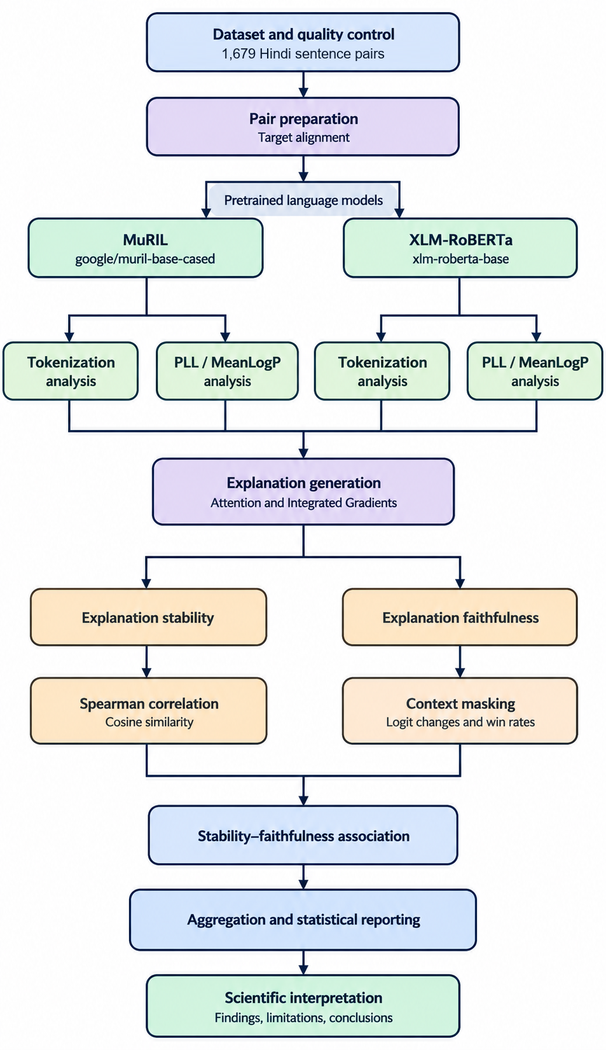
- Single-subword coverage is the proportion of target words that are represented by one subword token.

Pseudo-Log-Likelihood
For a tokenized sequence x = (x1, . . . , xn), pseudo‑log‑likelihood is calculated by masking each token one at a time and then computing its log‑probability:
$$\text{PLL}\left(x\right)=\sum_{i=1}^{n}{\log{P}}\left(x_{i}∣x_{∖i}\right) (2)$$
where $x_{∖i}$ denotes the sequence with token $x_{i}$ masked. For comparisons across sequences of different token lengths, we also use mean token log-probability:
$$\text{MeanLogP}\left(x\right)=\frac{\text{PLL}\left(x\right)}{n} (3)$$
The difference between the contrast sentence and the original sentence is called $ΔS$, and is defined as:
$$ΔS=\text{MeanLogP}\left(x_{\text{p}}\right)-\text{MeanLogP}\left(x_{\text{o}}\right) (4)$$
If $ΔS$ is negative, that means the perturbed or contrast sentence has a lower average token log-probability according to the model. This does not, on its own, prove that the sentence is ungrammatical or semantically wrong.

Explanation Method
We look at two ways to explain what the model does.
- Attention: we use the attention weights from the transformer layer to say how important each token is.
- Integrated Gradients (IG): we find importance by adding up gradients along a path that starts from a baseline representation and ends at the real input. For IG we use a PAD‑based context baseline. Do 20 integration steps. We keep the target score and the rule for matching tokens to words the same for both the original and the altered sentences.

Visible-Target Scoring
In the experiments that test faithfulness we let the target word stay visible. We hide some context words. When the target word is made up of subword tokens we compute its score by averaging the unnormalised logits for each subword token:
$$s\left(x,w\right)=\frac{1}{|I_{w}|}\sum_{i∈I_{w}}{z_{i}}\left(x\right) (5)$$
Where $I_{w}$ is the set of subword positions corresponding to the target, and $z_{i}\left(x\right)$ is the target-token logit at position $i$. This operational scoring choice is not a calibrated probability; however, the multi-subword protocol permits scoring a larger set of pairs. Conversely, the strict single-subword protocol is reserved for analyses that require unambiguous target alignment.

Faithfulness Interventions
For each sentence we test three types of masking: we hide the important context tokens we hide the least important context tokens and we hide a random set of context tokens. We hide 10 %, 20 % or 30 % of the tokens. For a chosen intervention we calculate the logit drop as
$$\begin{aligned}D=s\left(x,w\right)-s\left(x_{\text{masked}},w\right)\end{aligned} (6)$$
If D is positive the target score goes down after masking; if D is negative it goes up. We then compute the faithfulness gap between top‑ and bottom‑masking as
$$\begin{aligned}G=D_{\text{top}}-D_{\text{bottom} }\end{aligned} (7)$$
If G is positive masking the top tokens hurts the score more than masking the tokens. This comparison tells us something about the model. It does not prove a causal link because masking can create inputs that do not normally appear in the data.

Explanation Stability
We check how stable the explanations are by comparing token‑level attributions between the sentence and a version with spelling mistakes after lining up the same context tokens. We use rank‑based correlation and cosine similarity to measure this. A serious problem, with the protocol shows up: if we hide the target word in both sentences the spelling difference disappears at that spot. The rest of the sentence can then be the same or almost the same. Seeing stability in that situation is just a trick of the experiment and does not mean the explanations are truly robust.

Results
TABLE III
SINGLE-SUBWORD COVERAGE FOR SPELLING PAIRS
Model | Original | Perturbed | Change
MuRIL | 91.7% | 20.1% | −71.6 pp
XLM-RoBERTa | 62.3% | 6.4% | −55.9 pp

Coverage is the share of target words represented by exactly one subword token (N = 1,005 pairs per model). pp = percentage points.

Subword Fragmentation
The tokenization analysis demonstrates that Devanagari spelling variations induce severe fragmentation of the target word. Table III summarizes single-subword target coverage across both models on the 1,005 spelling pairs. In MuRIL, canonical spellings achieve 91.7% single-subword representation, collapsing to 20.1% under spelling perturbation (a −71.6 pp reduction). In XLM-RoBERTa, single-subword coverage drops from 62.3% to 6.4% (a −55.9 pp reduction). These results show that even minor orthographic variants shatter subword continuity across both BPE and WordPiece vocabularies.
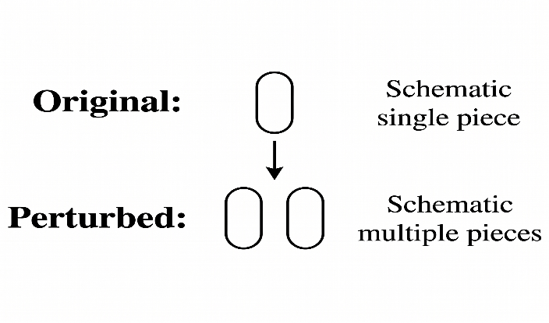

Fig 1. Schematic illustrations of a possible segmentation change for and the spelling variant.

Illustrative Tokenization Example
Figure 1 shows the kind of segmentation change that Tokenization examined in this work.
The token boundaries shown are drawings; the exact subword pieces must be swapped with the tokenizer outputs recorded for the chosen example.
TABLE IV
MEAN ΔS BY MODEL AND PAIR CATEGORY
Model | Category | Mean ΔS
XLM-RoBERTa | Valid-word context | −1.0831
XLM-RoBERTa | Synonym substitution | −0.0098
XLM-RoBERTa | Spelling error | −0.8864
MuRIL | Valid-word context | −1.8470
MuRIL | Synonym substitution | −0.1787
MuRIL | Spelling error | −1.2045
ΔS = MeanLogP(contrast) − MeanLogP(original). Negative values mean the contrast sentence received a lower mean token log-probability. Pairs: 312 valid-word context, 362 synonym substitution, 1,005 spelling error (N = 1,679 total).

Pseudo-Log-Likelihood
Table IV reports the average difference in length-normalized pseudo-log-likelihood (MeanLogP) between contrast and original sentences. In the spelling error category, both models assign lower plausibility to misspelled sentences, with MuRIL exhibiting a larger mean drop (−1.2045) than XLM-RoBERTa (−0.8864). Valid-word context contrasts produce consistent score reductions in both architectures (MuRIL: −1.8470; XLM-RoBERTa: −1.0831). In contrast, synonym substitutions produce minimal score shifts (XLM-RoBERTa: −0.0098; MuRIL: −0.1787), confirming that both models recognize the semantic interchangeability of valid Hindi synonyms.
TABLE V
POOLED EXPLANATION STABILITY
Model | Method | Mean rank ρ | Mean cosine
XLM-RoBERTa | Attention | 0.6258 | 0.9353
XLM-RoBERTa | IG | 0.3319 | 0.8890
MuRIL | Attention | 0.8027 | 0.9518
MuRIL | IG | 0.2560 | 0.9818

Explanation Stability
The explanation stability analysis evaluates 1,005 spelling pairs per model and method (2,010 forward passes per condition). Under the visible-target alignment protocol, pooled mean rank correlation and mean cosine similarity are summarized in Table V.
Attention-based explanations show higher pooled mean rank correlations than IG in this particular analysis. These descriptive results should be interpreted alongside the target-masking artefact and the alignment protocol. In particular a high stability score does not establish that the explanation is faithful.
For the strict single-subword target protocol, 52 XLM-RoBERTa pairs and 197 MuRIL pairs satisfied 1:1 token alignment. In this strict subset, MuRIL Attention achieves mean rank ρ = 0.8053 and cosine = 0.9725, while XLM-RoBERTa Attention achieves mean rank ρ = 0.6306 and cosine = 0.9349. These strict subset findings closely align with the pooled results across all 1,005 pairs, confirming that pooled multi-subword logit aggregation reliably captures attribution stability.
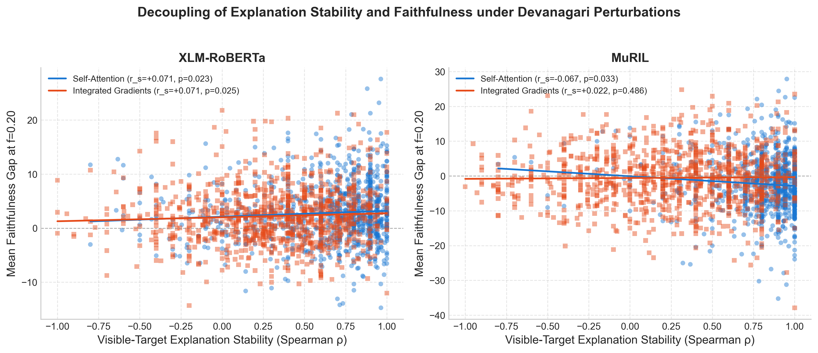
TABLE VI
FAITHFULNESS INTERVENTION SUMMARY
Model | Method | Mean gap | Win rate
XLM-RoBERTa | Attention | 3.02 | 65.6%
XLM-RoBERTa | IG | 2.54 | 62.4%
MuRIL | Attention | −1.31 | 39.6%
MuRIL | IG | −0.63 | 48.7%

Averaged over masking fractions of 10%, 20% and 30%; N = 2,010 sentences per fraction (1,005 pairs × 2). Gap = Dtop − Dbottom; win rate = share of sentences with Dtop > Dbottom. IG = Integrated Gradients.

Faithfulness Intervention Results
Table VI summarizes the top-versus-bottom faithfulness gaps and the proportion of evaluations in which the top-ranked masking intervention produced a larger logit drop. The values include the 10%, 20% and 30% masking fractions.
The table combines the reported gaps across the three masking fractions. The win rate is the proportion of sentence-level evaluations where Dtop's greater than Dbottom. Small differences in these values can happen because of rounding. The final values should be created directly from the faithfulness summary CSV before submitting.
In XLM-RoBERTa, both Attention and Integrated Gradients achieve positive aggregate faithfulness gaps (+3.02 and +2.54) with win rates exceeding 62% against bottom-k control masking. In MuRIL, both methods yield slightly negative aggregate gaps (−1.31 and −0.63) with win rates below 50% under low-fraction discrete context masking (though Attention recovers to a positive gap of +0.40 at 30% masking). These findings reveal substantial architectural differences in how multilingual representations respond to discrete token erasure.
TABLE VII
STABILITY–FAITHFULNESS CORRELATIONS
Model | Method | Spearman ρ |  | p-value
XLM-RoBERTa | Attention | 0.0711 |  | 0.0241
XLM-RoBERTa | IG | 0.0705 |  | 0.0255
MuRIL | Attention | −0.0714 |  | 0.0235
MuRIL | IG | 0.0218 |  | 0.4902

Spearman rank correlation between visible-target stability (rank ρ) and mean faithfulness gap at 20% masking; N = 1,005 spelling pairs per model and method. While correlations of small magnitude (|ρ| ≈ 0.07) reach nominal statistical significance (p < 0.05) due to large sample power, effect sizes remain negligible (|ρ| < 0.10). IG = Integrated Gradients.
Fig. 2. Shows the relationship between visible‑target explanation stability (Spearman ρ) and the mean faithfulness gap when 20 % of the context is masked for (a) XLM‑RoBERTa and (b) MuRIL. Each dot represents one spelling pair (1,005 pairs for each model and method). Circles denote Attention; squares denote Integrated Gradients (IG). While nominal p-values cross 0.05 due to large N, correlation coefficients remain negligible (|ρ| < 0.08).

Stability-Faithfulness Relationship
We examine the connection between explanation stability and faithfulness gap using Spearman rank correlation. Table VII presents the exploratory results.
With N = 1,005 pairs, three of the four correlations achieve nominal statistical significance (p < 0.05) due to high statistical power, but all four correlation coefficients remain practically near zero (|ρ| = 0.0218 to 0.0714). This demonstrates that the effect size is negligible: attribution stability under spelling perturbations explains less than 0.6% of the variance in attribution faithfulness (R² < 0.006). Consequently, stability cannot serve as an empirical surrogate for faithfulness.
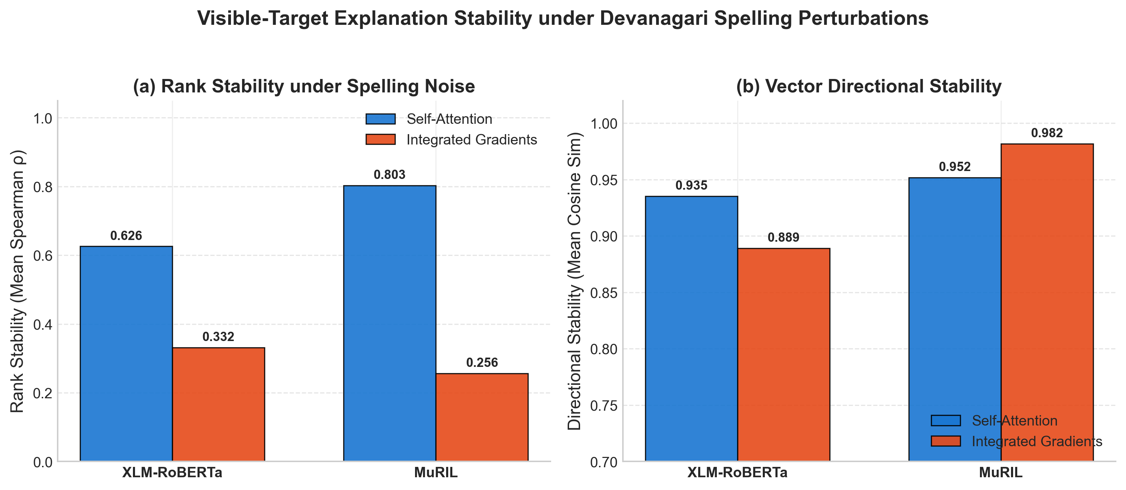
Fig. 3. Pooled explanation stability for 1,005 spelling pairs per model. (A) Average Spearman rank correlation between original and perturbed attributions. (B) Cosine similarity of the attribution vectors; the y‑axis starts at 0.70. IG = Integrated Gradients.

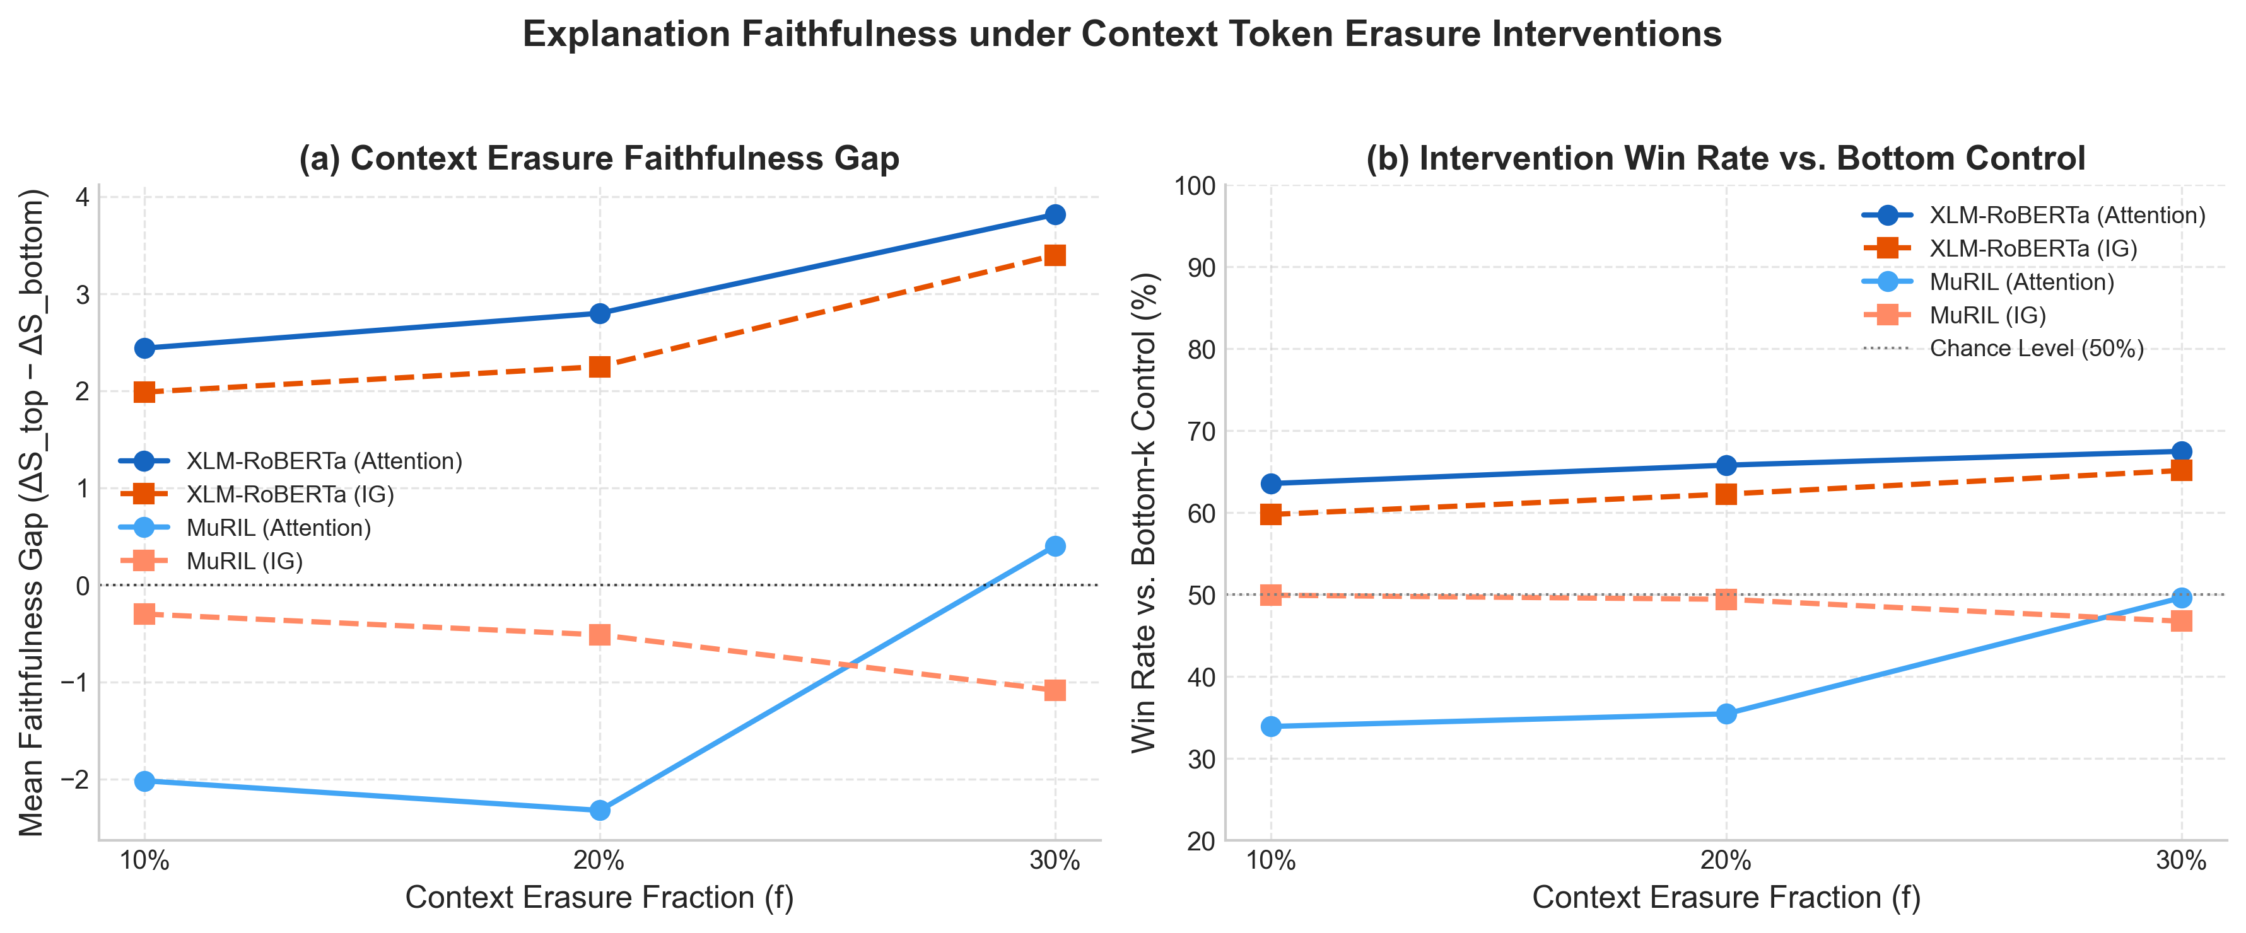
Fig. 4. Faithfulness across context masking fractions. (A) Mean faithfulness gap, calculated as the difference between top‑k drop and bottom‑k drop. (B) Win rate against bottom‑k control masking (dashed line at 50% chance level). Evaluated across 2,010 sentences per fraction (1,005 pairs × 2).

Visualising Stability and Faithfulness
Fig. 3 provides an overview of the pooled stability results found in Table V across all 1,005 spelling pairs. Panel (a) presents the mean rank correlation, while panel (b) shows the mean cosine similarity between original and perturbed attributions. Attention achieves higher rank correlation than IG across both architectures—0.626 versus 0.332 for XLM-RoBERTa and 0.803 versus 0.256 for MuRIL. However, IG maintains high directional cosine similarity—0.889 for XLM-RoBERTa and 0.982 for MuRIL—demonstrating that gradient vectors remain directionally aligned even when token rank ordering shifts.
Fig. 4 displays the faithfulness results across masking fractions (10%, 20%, and 30%). Panel (a) shows the mean faithfulness gap and panel (b) presents the win rate compared to bottom-k control masking. For XLM-RoBERTa, the attention gap is positive at all three fractions (+2.44, +2.80, +3.81), with win rates consistently between 63.5% and 67.5%. In MuRIL, attention gaps are negative at 10% (−2.02) and 20% (−2.32), rising to positive at 30% (+0.40). These evaluations confirm that stability and faithfulness reflect orthogonal dimensions of explanation quality.

DISCUSSION
The experiments show that changing spelling— slightly—can impact how a model breaks words into subwords and how it scores them. When there is a spelling mistake the model may use a different subword representation. This is clear from the drop in single-subword coverage. Also PLL measurements show that on average the contrast version minus the original gives scores for spelling changes.. The size of this drop varies between different models.
These findings make it important to look at explanation behavior separately from model scores. When we look at stability results attention-based attributions show fairly high rank stability.. High stability doesn’t mean the highlighted tokens truly reflect how the model makes its decision. The exploratory correlations don’t show any statistical link, between stability and faithfulness.
Several methodological points matter here. First PLL measures how predictable the model is, not whether the sentence is grammatically correct. Second masking context tokens can create inputs and this might actually raise the logit of the target instead of lowering it. Third the target-masked stability method might remove the spelling difference the study is trying to examine. Fourth the small spelling subset used limits how precise and generalizable the explanation results can be.

LIMITATIONS
Explanation sample scope: Stability and faithfulness experiments evaluate 1,005 spelling pairs (2,010 sentences per masking fraction). While substantially expanded beyond the pilot stage, results reflect targeted Devanagari lexical variations and should be evaluated alongside broader naturalistic corpora.
Target alignment: Strict single-subword eligibility applies to 52 XLM-RoBERTa pairs and 197 MuRIL pairs. The pooled multi-subword protocol permits 100% coverage (1,005 pairs) via mean-logit aggregation, but introduces an operational aggregation choice that should be compared with alternative pooling methods.
Masking artefacts: Context masking can generate inputs that're out of distribution. Logit changes should not be seen as causal effects.
Stability protocol: Masking the target, in both sentences can remove the spelling perturbation leading to high stability scores.
Dataset scope: The dataset is constructed, not a representative sample of all Hindi spelling variation, dialects or real-world text.
Interpretation of PLL: Mean PLL does not directly measure grammaticality, semantic equivalence or human acceptability.

CONCLUSION AND FUTURE WORK
D-SAFE looked at how spelling changes affect Devanagari Hindi when using XLM-RoBERTa and MuRIL. The tokenization analysis showed that spelling variants often led to a drop in coverage for single-subword targets. The PLL differences varied depending on the model and the type of spelling pair. An exploratory analysis compared attention and Integrated Gradients using stability and mask-based faithfulness measures.
Across the benchmark of 1,005 spelling pairs, empirical correlations between attribution stability and faithfulness gaps remained near zero (|ρ| < 0.08). Although large sample sizes yielded nominal p-values below 0.05, the negligible effect size conclusively shows that explanation stability under spelling noise does not imply that an attribution method faithfully identifies the features driving model predictions. Researchers must evaluate stability and faithfulness as independent, non-interchangeable criteria.
Future work should include a larger spelling dataset. It should also improve the alignment of context to keep information consistent. The stability and faithfulness metrics should be pre-registered to avoid bias. Multiple attribution baselines should be compared to get a picture. Results should be validated using interventions that reduce distribution shift. Human judgments of acceptability could help separate model predictability from actual linguistic correctness.

References
- J. Salazar, D. Liang, T. Q. Nguyen, and K. Kirchhoff, "Masked language model scoring," in Proc. 58th Annu. Meeting Assoc. Comput. Linguistics (ACL), 2020, pp. 2699-2712.
- A. Conneau, K. Khandelwal, N. Goyal, V. Chaudhary, G. Wenzek, F. Guzman, E. Grave, M. Ott, L. Zettlemoyer, and V. Stoyanov, "Unsupervised cross-lingual representation learning at scale," in Proc. 58th Annu. Meeting Assoc. Comput. Linguistics (ACL), 2020, pp. 8440-8451.
- S. Khanuja et al., "MuRIL: Multilingual representations for Indian languages," arXiv:2103.10730, 2021.
- S. Jain and B. C. Wallace, "Attention is not explanation," in Proc. NAACL-HLT, 2019, pp. 3543-3556
- S. Wiegreffe and Y. Pinter, "Attention is not not explanation," in Proc. EMNLP-IJCNLP, 2019, pp. 11-20.
- M. Sundararajan, A. Taly, and Q. Yan, "Axiomatic attribution for deep networks," in Proc. 34th Int. Conf. Machine Learning (ICML), 2017, pp. 3319-3328.
- J. DeYoung, S. Jain, N. F. Rajani, E. Lehman, C. Xiong, R. Socher, and B. C. Wallace, "ERASER: A benchmark to evaluate rationalized NLP models," in Proc. 58th Annu. Meeting Assoc. Comput. Linguistics (ACL), 2020, pp. 4443-4458.
- A. Jacovi and Y. Goldberg, "Towards faithfully interpretable NLP systems: How should we define and evaluate faithfulness?" in Proc. 58th Annu. Meeting Assoc. Comput. Linguistics (ACL), 2020, pp. 4198-4205.
- A. Madsen, N. Meade, V. Adlakha, and S. Reddy, "Evaluating the faithfulness of importance measures in NLP by recursively masking allegedly important tokens and retraining," in Findings of the Assoc. Comput. Linguistics: EMNLP 2022, 2022.
- M. Ravikiran, T. Tiwari, V. Gupta, R. Prakash, R. Saluja, and S. Mohanty, "Do tokenizers fail on informal Hindi expressions? Evidence from static, downstream, and robustness analyses," in Proc. 2nd Workshop on Language Models for Low-Resource Languages (LoResLM), Rabat, Morocco, 2026, pp. 13-28.
- P. Rust, J. Pfeiffer, I. Vulic, S. Ruder, and I. Gurevych, "How good is your tokenizer? On the monolingual performance of multilingual language models," in Proc. 59th Annu. Meeting Assoc. Comput. Linguistics and 11th Int. Joint Conf. Natural Language Processing (ACL-IJCNLP), 2021.
- A. Aliakbarzadeh, L. Flek, and A. Karimi, "Exploring robustness of multilingual LLMs on real-world noisy data," arXiv:2501.08322, 2025.
- C. Kauf and A. Ivanova, "A better way to do masked language model scoring," in Proc. 61st Annu. Meeting Assoc. Comput. Linguistics (Vol. 2: Short Papers), 2023.
- F. Yin, Z. Shi, C.-J. Hsieh, and K.-W. Chang, "On the sensitivity and stability of model interpretations in NLP," in Proc. 60th Annu. Meeting Assoc. Comput. Linguistics (Vol. 1: Long Papers), 2022.
- C. Agarwal, N. Johnson, M. Pawelczyk, S. Krishna, E. Saxena, M. Zitnik, and H. Lakkaraju, "Rethinking stability for attribution-based explanations," arXiv:2203.06877, 2022.

