# ML+ Devops = MLOps

MLOps is a practice for collaboration and communication between data scientists and operations professionals to help manage production ML lifecycle.

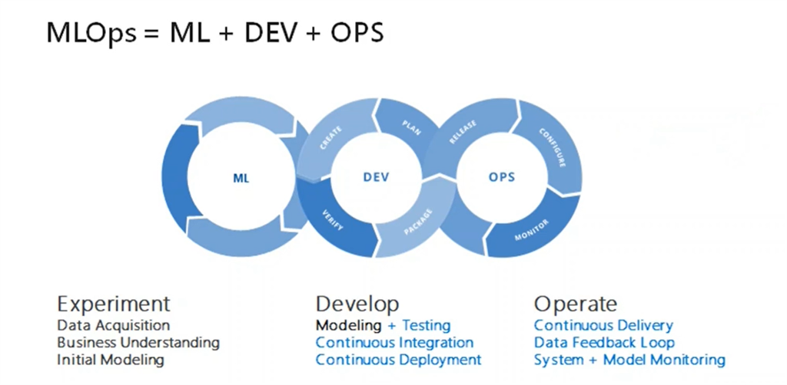

Ever wondered why most of the machine learning models are never implemented as no measure is there to monitor them continuously but here is the solution to our problem i.e MLOps.

So with the guidance of Vimal daga sir amd linux world I have created a project which integrates these superb technologies.

In this I have implemented a sequence of jobs for the same which are decribed as below:

1: Create container image that’s has Python3 and Keras or numpy installed using dockerfile.

As my laptop is 7 year old and does not support tensorflow I have created a regression model decribed below.

2. When we launch this image, it should automatically starts train the model in the container.

3. Create a job chain of job1, job2, job3, job4 and job5 using build pipeline plugin in Jenkins

Job1 : Pull the Github repo automatically when some developers push repo to Github.

Job2 : When we launch this image, it should automatically starts train the model in the container ( eg. If code uses CNN, then Jenkins should start the container that has already installed all the softwares required for the cnn processing).

Job3 : Train your model and predict accuracy or metrics.

Job 4 : if metrics accuracy is less than 80% , then tweak the machine learning model architecture.

Job 5: Retrain the model or notify that the best model is being created

JOB 6: Create One extra job job6 for monitor : If container where app is running. fails due to any reason then this job should automatically start the container again from where the last trained model left

Initially I created a dockerfile and build it so that we have our own image now. And then I pushed the image to github using gitbash.

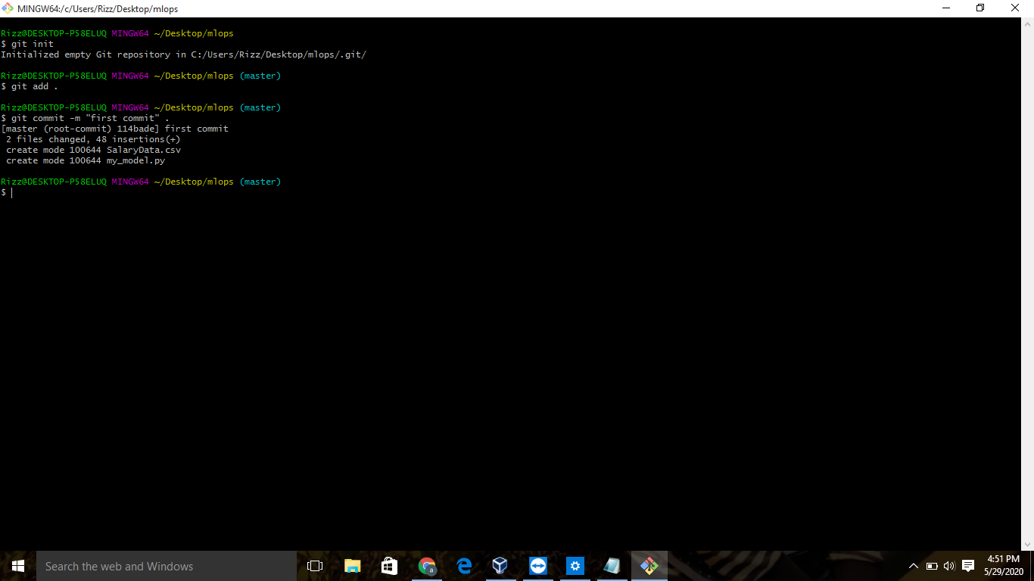

Now job 1 Pull the Github repo automatically when some developers push repo to Github as shown below :

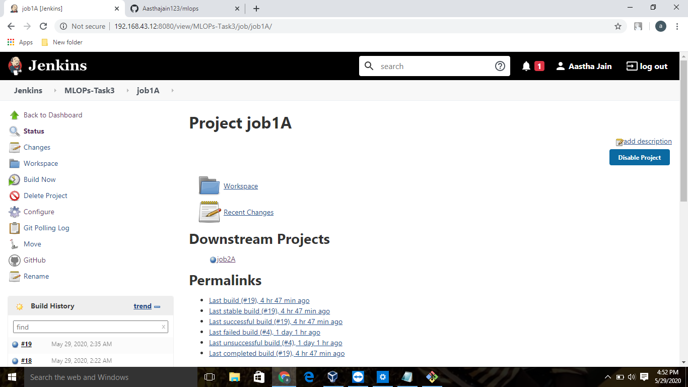

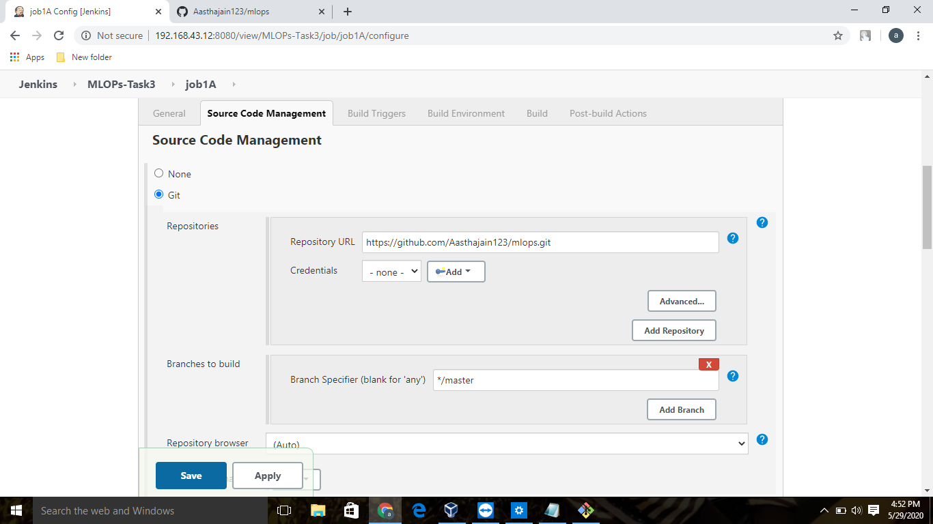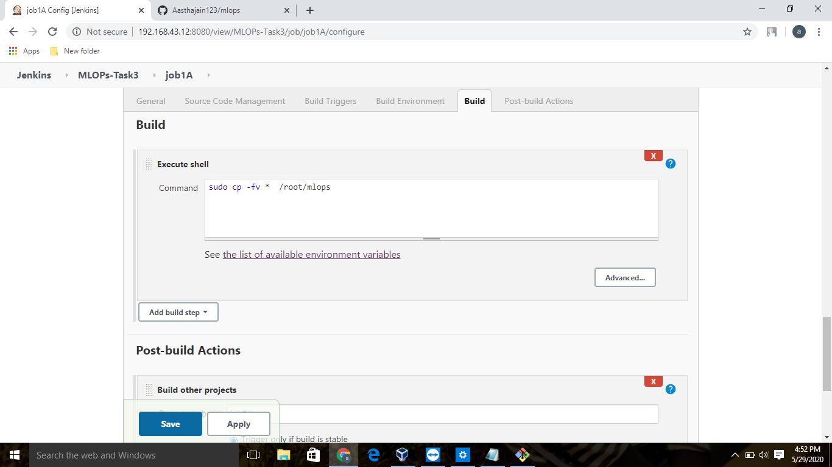

: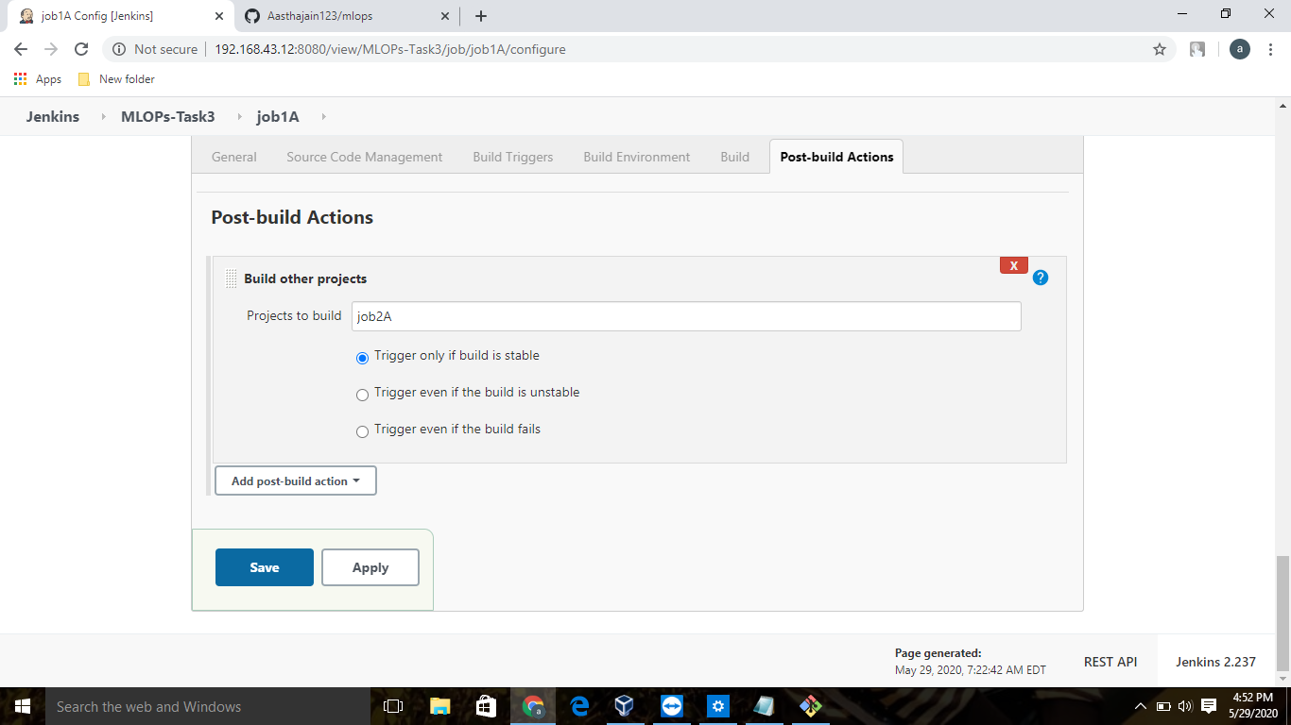

Now job 2, When we launch this image, it should automatically starts train the model in the container as shown below 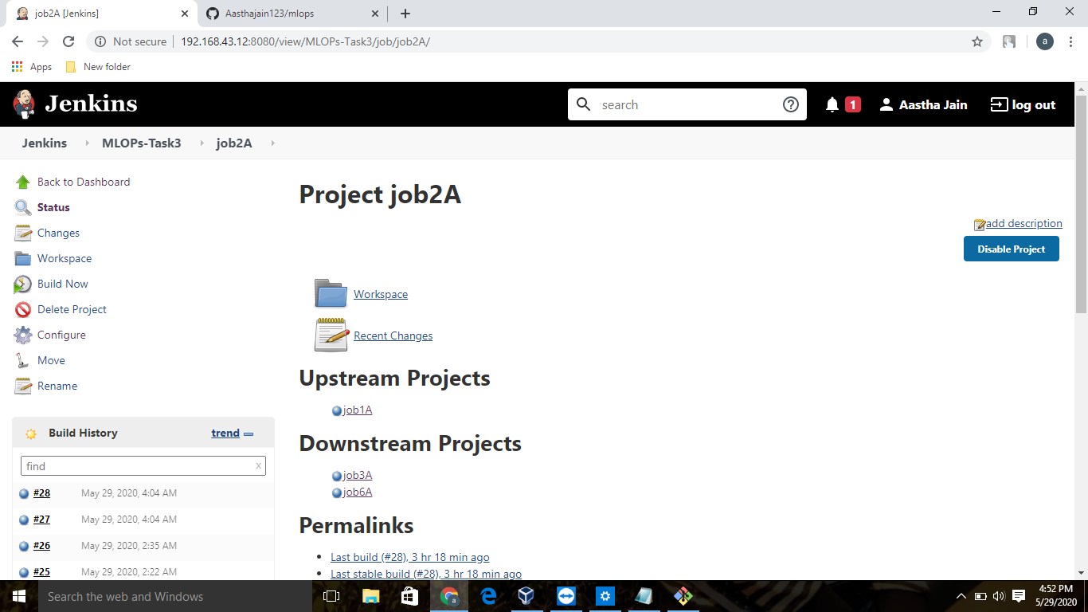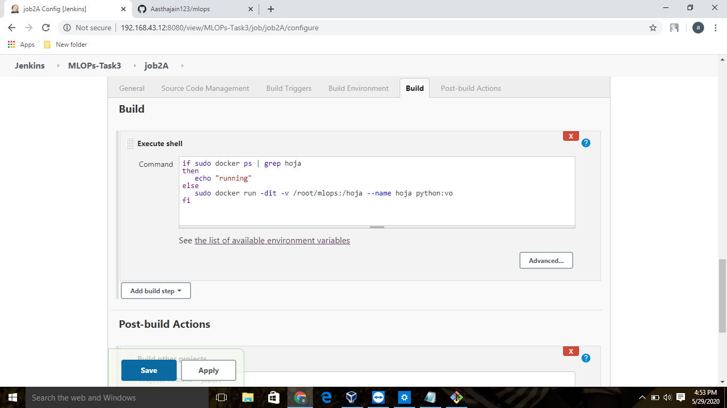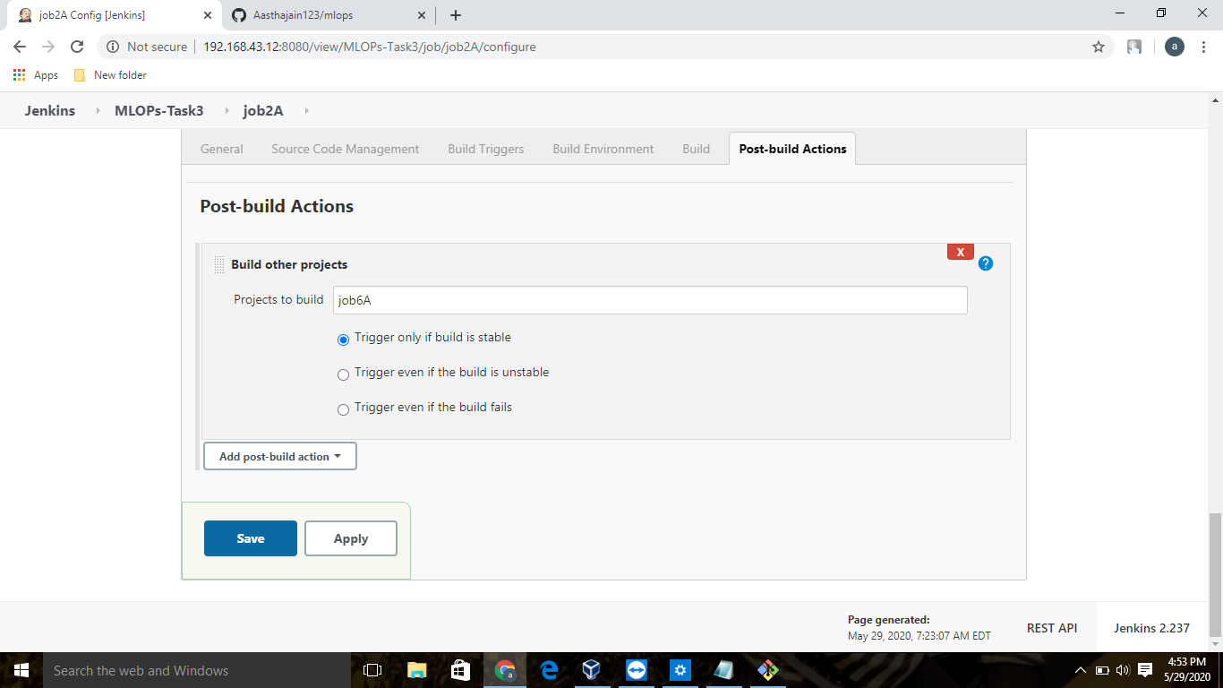

Now job 3 is to Train your model and predict accuracy or metrics as shown below: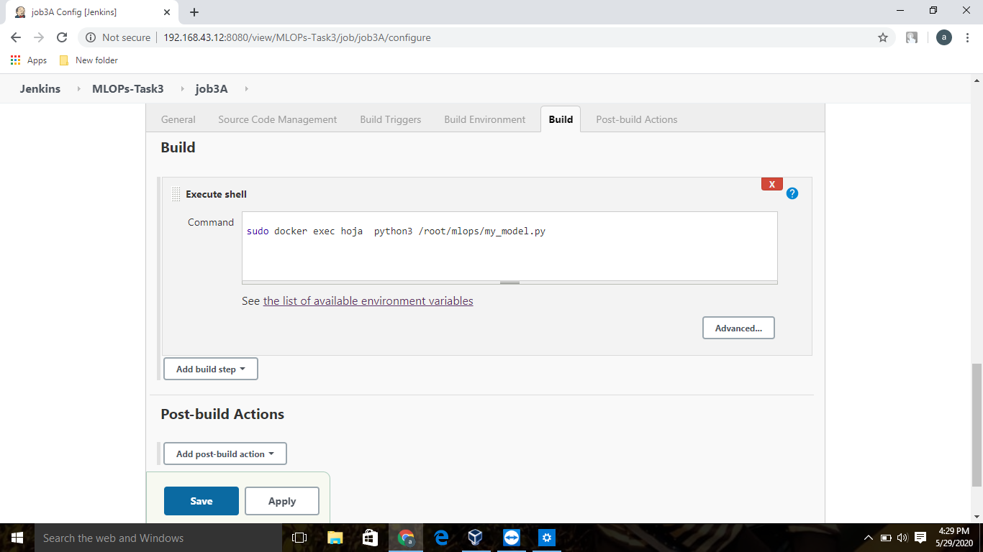

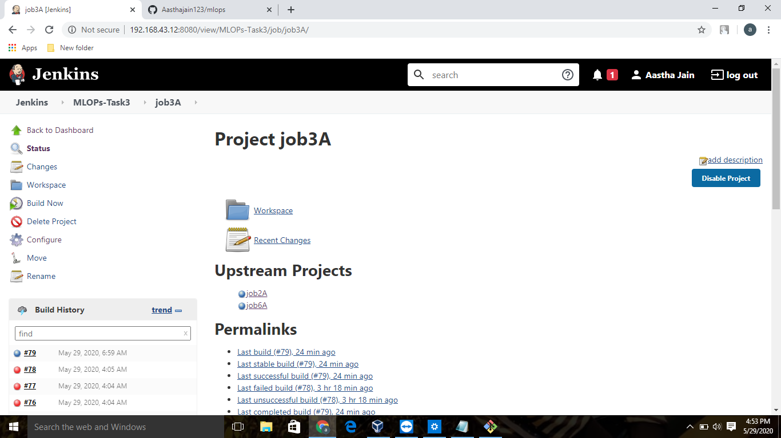

Job 4 will now : if metrics accuracy is less than 80% , then tweak the machine learning model architecture 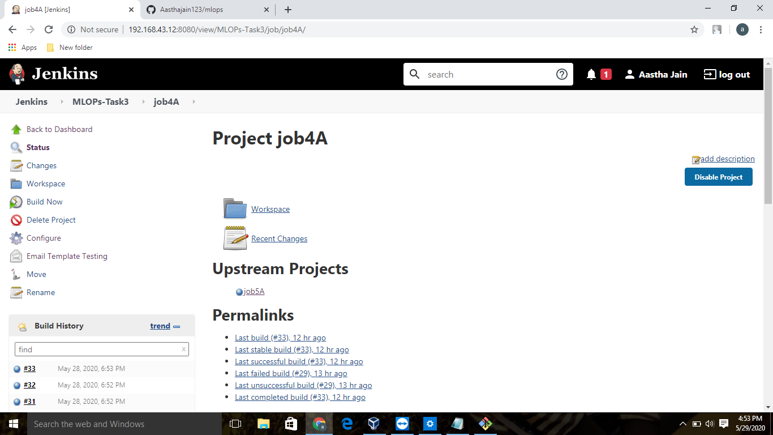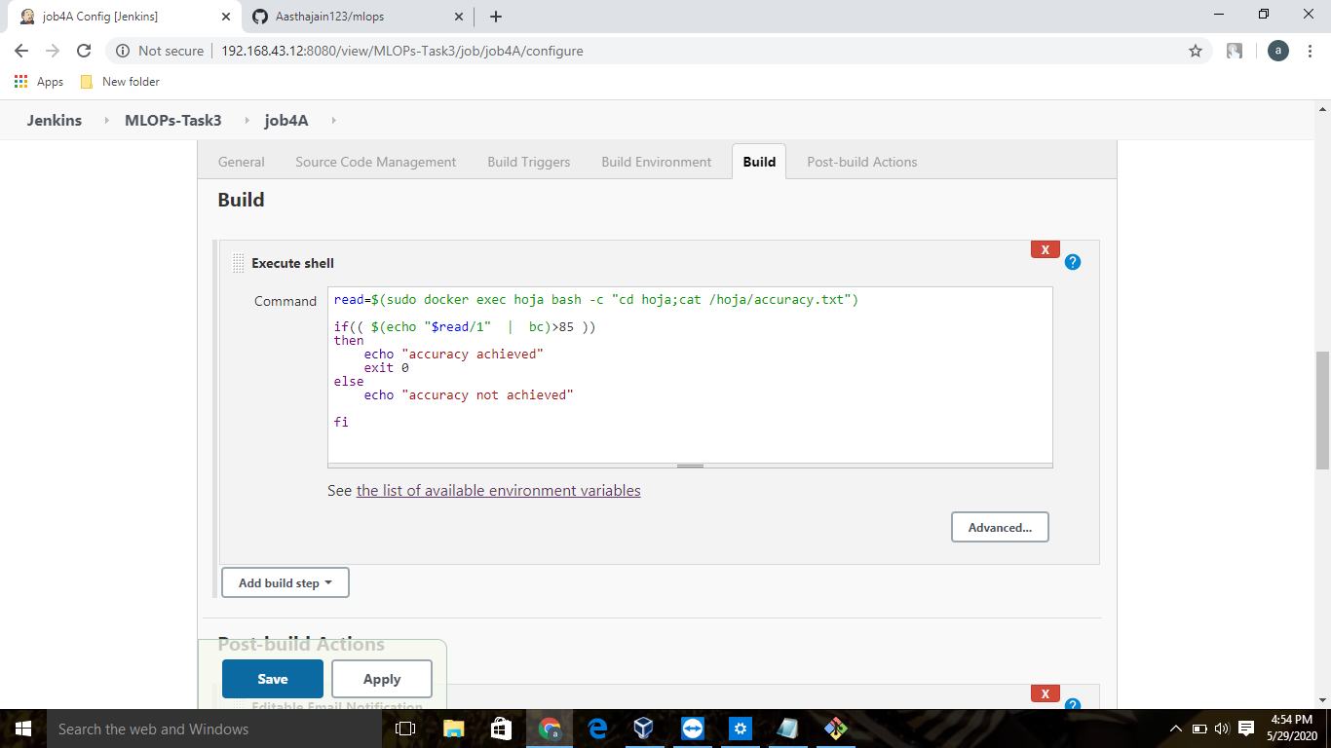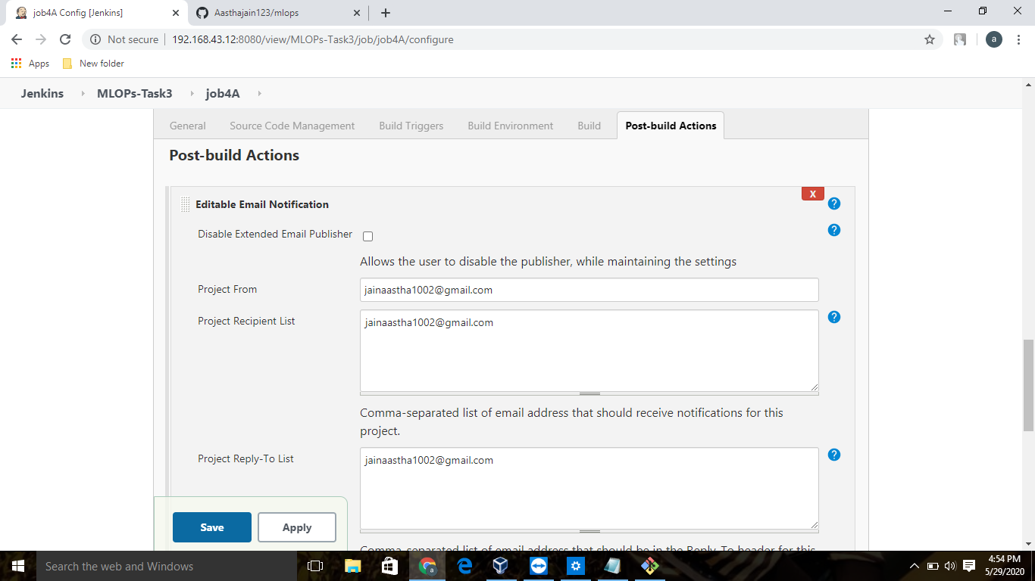

Job 5 will now Retrain the model or notify that the best model is being created as :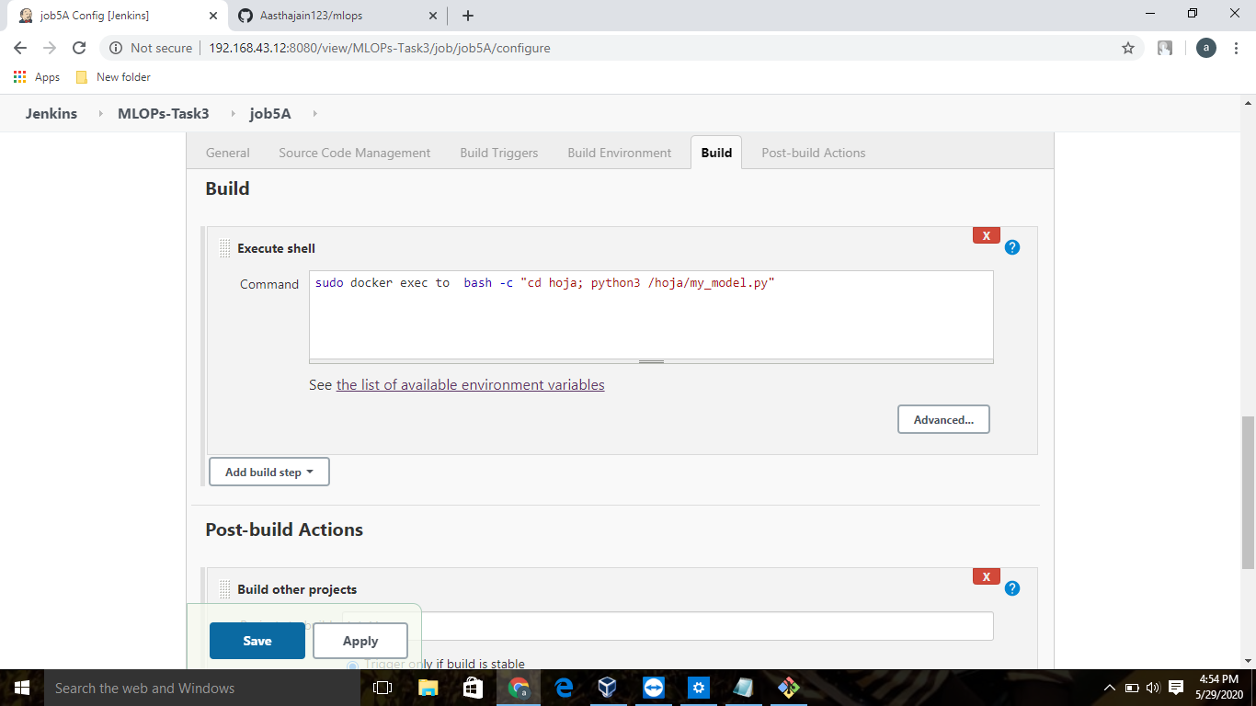

Duty of job 6 is to Create One extra job job6 for monitor : If container where app is running. fails due to any reason then this job should automatically start the container again from where the last trained model left

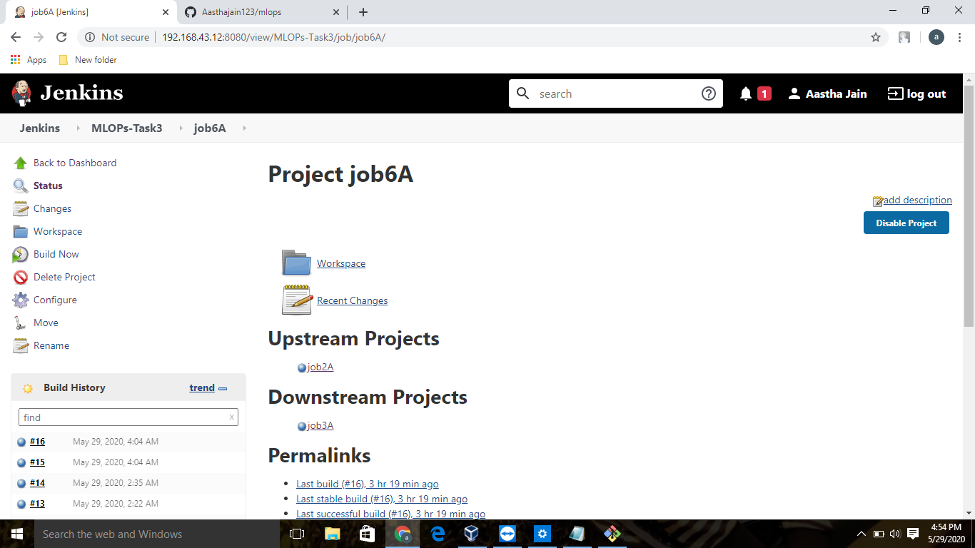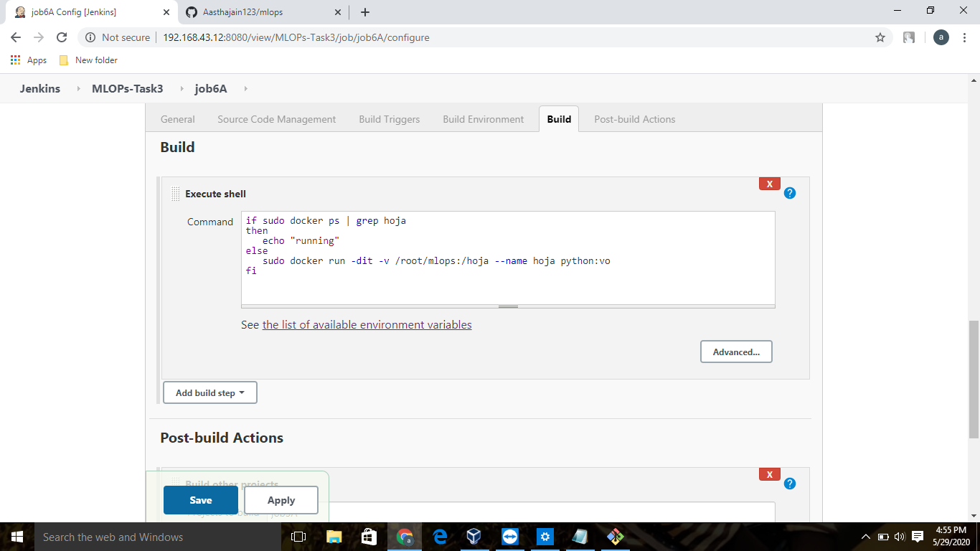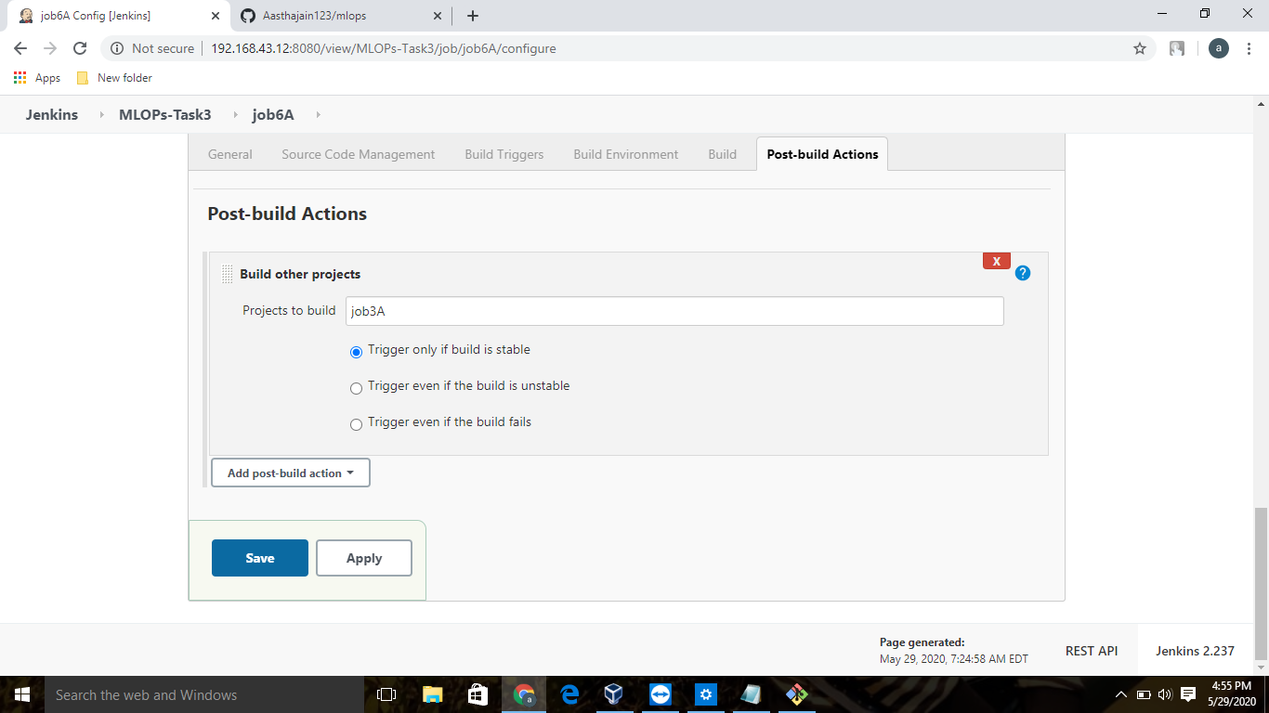

After doing this the series of jobs will look like:

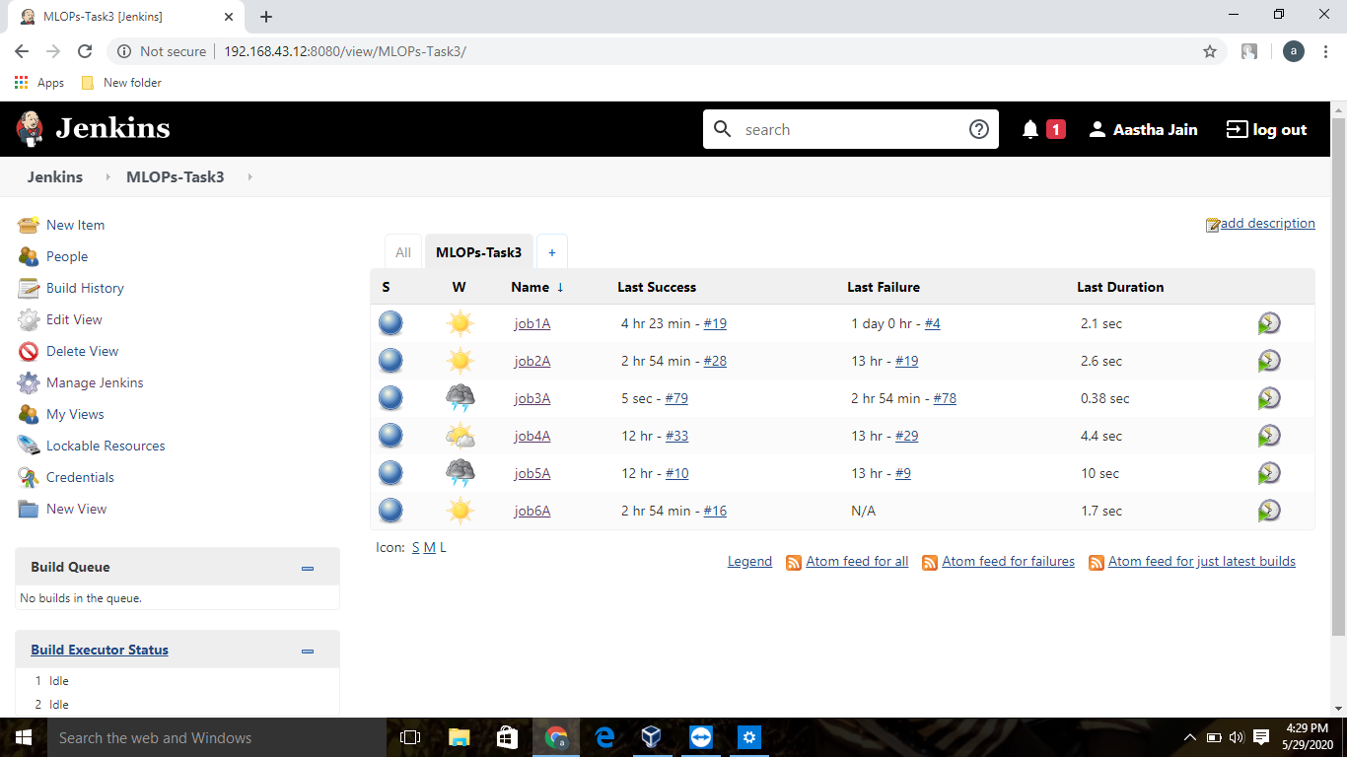

And at last the email will be generated .

All thanks to vimal sir for teaching us these new technologies and how to integrate them.