Sales Trend Analysis

Sales Trend Visualization Project

1. Install & Load Libraries
#install.packages(c("dplyr", "ggplot2"))
library(dplyr)
## Warning: package 'dplyr' was built under R version 4.5.3
##
## Attaching package: 'dplyr'
## The following objects are masked from 'package:stats':
##
## filter, lag
## The following objects are masked from 'package:base':
##
## intersect, setdiff, setequal, union
library(ggplot2)
## Warning: package 'ggplot2' was built under R version 4.5.3

2. Load Dataset
data <- read.csv("train.csv")
cat("DATASET OVERVIEW\n")
## DATASET OVERVIEW
cat("Rows:", nrow(data), "\n")
## Rows: 9800
cat("Columns:", ncol(data), "\n\n")
## Columns: 18
str(data)
## 'data.frame': 9800 obs. of 18 variables:
## $ Row.ID : int 1 2 3 4 5 6 7 8 9 10 ...
## $ Order.ID : chr "CA-2017-152156" "CA-2017-152156" "CA-2017-138688" "US-2016-108966" ...
## $ Order.Date : chr "08/11/2017" "08/11/2017" "12/06/2017" "11/10/2016" ...
## $ Ship.Date : chr "11/11/2017" "11/11/2017" "16/06/2017" "18/10/2016" ...
## $ Ship.Mode : chr "Second Class" "Second Class" "Second Class" "Standard Class" ...
## $ Customer.ID : chr "CG-12520" "CG-12520" "DV-13045" "SO-20335" ...
## $ Customer.Name: chr "Claire Gute" "Claire Gute" "Darrin Van Huff" "Sean O'Donnell" ...
## $ Segment : chr "Consumer" "Consumer" "Corporate" "Consumer" ...
## $ Country : chr "United States" "United States" "United States" "United States" ...
## $ City : chr "Henderson" "Henderson" "Los Angeles" "Fort Lauderdale" ...
## $ State : chr "Kentucky" "Kentucky" "California" "Florida" ...
## $ Postal.Code : int 42420 42420 90036 33311 33311 90032 90032 90032 90032 90032 ...
## $ Region : chr "South" "South" "West" "South" ...
## $ Product.ID : chr "FUR-BO-10001798" "FUR-CH-10000454" "OFF-LA-10000240" "FUR-TA-10000577" ...
## $ Category : chr "Furniture" "Furniture" "Office Supplies" "Furniture" ...
## $ Sub.Category : chr "Bookcases" "Chairs" "Labels" "Tables" ...
## $ Product.Name : chr "Bush Somerset Collection Bookcase" "Hon Deluxe Fabric Upholstered Stacking Chairs, Rounded Back" "Self-Adhesive Address Labels for Typewriters by Universal" "Bretford CR4500 Series Slim Rectangular Table" ...
## $ Sales : num 262 731.9 14.6 957.6 22.4 ...
head(data)
## Row.ID Order.ID Order.Date Ship.Date Ship.Mode Customer.ID
## 1 1 CA-2017-152156 08/11/2017 11/11/2017 Second Class CG-12520
## 2 2 CA-2017-152156 08/11/2017 11/11/2017 Second Class CG-12520
## 3 3 CA-2017-138688 12/06/2017 16/06/2017 Second Class DV-13045
## 4 4 US-2016-108966 11/10/2016 18/10/2016 Standard Class SO-20335
## 5 5 US-2016-108966 11/10/2016 18/10/2016 Standard Class SO-20335
## 6 6 CA-2015-115812 09/06/2015 14/06/2015 Standard Class BH-11710
## Customer.Name Segment Country City State
## 1 Claire Gute Consumer United States Henderson Kentucky
## 2 Claire Gute Consumer United States Henderson Kentucky
## 3 Darrin Van Huff Corporate United States Los Angeles California
## 4 Sean O'Donnell Consumer United States Fort Lauderdale Florida
## 5 Sean O'Donnell Consumer United States Fort Lauderdale Florida
## 6 Brosina Hoffman Consumer United States Los Angeles California
## Postal.Code Region Product.ID Category Sub.Category
## 1 42420 South FUR-BO-10001798 Furniture Bookcases
## 2 42420 South FUR-CH-10000454 Furniture Chairs
## 3 90036 West OFF-LA-10000240 Office Supplies Labels
## 4 33311 South FUR-TA-10000577 Furniture Tables
## 5 33311 South OFF-ST-10000760 Office Supplies Storage
## 6 90032 West FUR-FU-10001487 Furniture Furnishings
## Product.Name Sales
## 1 Bush Somerset Collection Bookcase 261.9600
## 2 Hon Deluxe Fabric Upholstered Stacking Chairs, Rounded Back 731.9400
## 3 Self-Adhesive Address Labels for Typewriters by Universal 14.6200
## 4 Bretford CR4500 Series Slim Rectangular Table 957.5775
## 5 Eldon Fold 'N Roll Cart System 22.3680
## 6 Eldon Expressions Wood and Plastic Desk Accessories, Cherry Wood 48.8600

3. Missing Values Before Cleaning
cat("MISSING VALUES BEFORE CLEANING\n")
## MISSING VALUES BEFORE CLEANING
missing_before <- colSums(is.na(data))
print(missing_before[missing_before > 0])
## Postal.Code
## 11
Insight: Dataset contains missing values that need cleaning.

4. Data Cleaning
data$Order.Date <- as.Date(data$Order.Date, format="%m/%d/%Y")
data <- na.omit(data)

5. Feature Engineering
data$Year <- format(data$Order.Date, "%Y")
data$Month <- format(data$Order.Date, "%m")

6. Missing Values After Cleaning
cat("MISSING VALUES AFTER CLEANING\n")
## MISSING VALUES AFTER CLEANING
print(colSums(is.na(data)))
## Row.ID Order.ID Order.Date Ship.Date Ship.Mode
## 0 0 0 0 0
## Customer.ID Customer.Name Segment Country City
## 0 0 0 0 0
## State Postal.Code Region Product.ID Category
## 0 0 0 0 0
## Sub.Category Product.Name Sales Year Month
## 0 0 0 0 0
Insight: Dataset is now clean and ready for analysis.

7. Monthly Sales Analysis
monthly_sales <- data %>%
group_by(Year, Month) %>%
summarise(Total_Sales = sum(Sales), .groups = "drop")
print(monthly_sales)
## # A tibble: 48 × 3
## Year Month Total_Sales
## <chr> <chr> <dbl>
## 1 2015 01 19546.
## 2 2015 02 11679.
## 3 2015 03 6716.
## 4 2015 04 12455.
## 5 2015 05 15165.
## 6 2015 06 11884.
## 7 2015 07 10076.
## 8 2015 08 26798.
## 9 2015 09 17159.
## 10 2015 10 10113.
## # ℹ 38 more rows
Insight: Sales fluctuate across months indicating seasonal trends.

8. Monthly Sales Trend Graph
monthly_sales$Date <- as.Date(paste(monthly_sales$Year, monthly_sales$Month, "01", sep="-"))
ggplot(monthly_sales, aes(x = Date, y = Total_Sales)) +
geom_line() +
ggtitle("Monthly Sales Trend") +
xlab("Time") +
ylab("Sales")
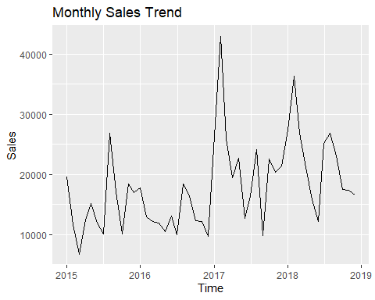
Insight: Shows overall sales growth and fluctuations over time.

9. Year-wise Sales
yearly_sales <- data %>%
group_by(Year) %>%
summarise(Total_Sales = sum(Sales), .groups = "drop")
print(yearly_sales)
## # A tibble: 4 × 2
## Year Total_Sales
## <chr> <dbl>
## 1 2015 176987.
## 2 2016 157449.
## 3 2017 264960.
## 4 2018 266348.
best_year <- yearly_sales[which.max(yearly_sales$Total_Sales), ]
cat("Best performing year:", best_year$Year)
## Best performing year: 2018
ggplot(yearly_sales, aes(x = Year, y = Total_Sales)) +
geom_bar(stat = "identity", fill="lightgreen") +
ggtitle("Year-wise Sales") +
xlab("Year") +
ylab("Sales")
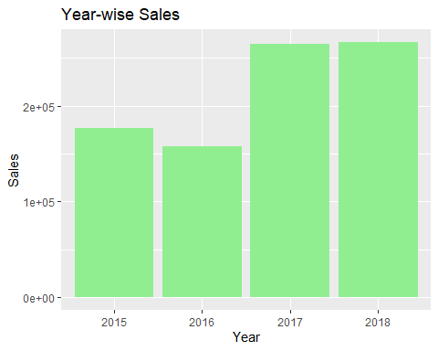
Insight: Identifies the year with highest business performance.

10. Region-wise Sales
region_sales <- data %>%
group_by(Region) %>%
summarise(Total_Sales = sum(Sales), .groups = "drop")
print(region_sales)
## # A tibble: 4 × 2
## Region Total_Sales
## <chr> <dbl>
## 1 Central 208805.
## 2 East 239608.
## 3 South 146174.
## 4 West 271157.
top_region <- region_sales[which.max(region_sales$Total_Sales), ]
cat("Top region:", top_region$Region)
## Top region: West
ggplot(region_sales, aes(x = Region, y = Total_Sales)) +
geom_bar(stat = "identity", fill="skyblue") +
ggtitle("Region-wise Sales") +
xlab("Region") +
ylab("Sales")
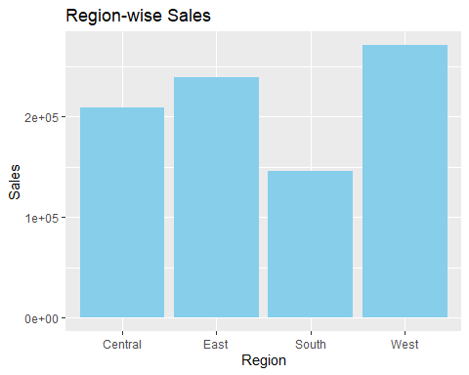
Insight: Shows which geographical region generates highest revenue.

11. Category-wise Sales
category_sales <- data %>%
group_by(Category) %>%
summarise(Total_Sales = sum(Sales), .groups = "drop")
print(category_sales)
## # A tibble: 3 × 2
## Category Total_Sales
## <chr> <dbl>
## 1 Furniture 280443.
## 2 Office Supplies 252956.
## 3 Technology 332344.
top_category <- category_sales[which.max(category_sales$Total_Sales), ]
cat("Top category:", top_category$Category)
## Top category: Technology
ggplot(category_sales, aes(x = Category, y = Total_Sales)) +
geom_bar(stat = "identity", fill="pink") +
ggtitle("Category-wise Sales") +
xlab("Category") +
ylab("Sales")
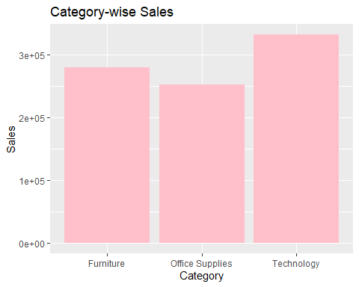
Insight: Identifies most profitable product category.

12. Final Conclusion
cat("FINAL INSIGHTS SUMMARY\n")
## FINAL INSIGHTS SUMMARY
cat("1. Sales show seasonal fluctuations.\n")
## 1. Sales show seasonal fluctuations.
cat("2. Business performance varies year-wise.\n")
## 2. Business performance varies year-wise.
cat("3. Certain regions generate higher revenue.\n")
## 3. Certain regions generate higher revenue.
cat("4. Some categories dominate sales.\n")
## 4. Some categories dominate sales.

