Methodology Report
Data-Driven Insights for Airbnb Listings: NYC

1. Introduction
This report outlines the methodology employed to analyse Airbnb listings in New York City (NYC). The objective was to derive actionable insights to improve host acquisition, optimize property listings, and enhance customer experience. The analysis was divided into two primary presentations:
- PPT1: Tailored for Data Analysis Managers and Lead Data Analysts, focusing on data exploration and insights.
- PPT2: Directed towards the Head of Acquisitions and Operations, NYC & Head of User Experience, NYC, emphasizing actionable strategies based on the insights derived.

2. Data Acquisition and Sources
The dataset used for this analysis was obtained from Airbnb's public listings for NYC, encompassing various attributes such as:
- Property Details: Listing ID, host ID, property type (Entire home/apt, Private room, Shared room), price, number of bedrooms, etc.
- Location Information: Neighbourhood, latitude, longitude.
- Customer Reviews: Total reviews, reviews per month, etc.

3. Data Cleaning
Ensuring data integrity was paramount for accurate analysis. The following steps were undertaken:
3.1 Handling Missing and Erroneous Values
- Missing Values:
  - Critical Columns: Rows with missing values in essential columns (e.g., price, neighbourhood, room type) were removed to maintain dataset integrity.
- Erroneous Values:
  - Replaced erroneous entries such as #NAME? with UNKNOWN to standardize the dataset.

3.2 Data Type Verification
- Ensured all columns had appropriate data types:
  - IDs: Converted to integers.
  - Text Fields: Ensured as strings.
  - Numeric Fields: Verified and formatted correctly (e.g., price as float).

4. Data Preparation
4.1 Feature Engineering
- Reviews per Month: Utilized existing metrics to analyse trends in customer engagement over time.
- Average Price Calculation:
  - Calculated the average price per neighbourhood to understand regional pricing trends.
4.2 Data Transformation
- Normalized data where necessary to ensure consistency across different scales.
- Created new metrics to support deeper insights, such as:
  - Review Engagement Index: Combining total reviews and monthly review counts to gauge engagement levels.

5. Visualization Creation
5.1 Presentation I (PPT1): Data Analysis Managers and Lead Data Analysts
5.1.1 Property Distribution by Price (Pie Chart)
- Purpose: To illustrate the distribution of different property types based on pricing.
- Insights Derived:
  - Entire homes/apartments constitute ~57% of listings.
  - Significant presence of private and shared rooms.
- Usage: Helps in understanding the market segmentation based on property types.
5.1.2 Top 5 Neighbourhoods Based on Host ID (Bar Chart)
- Purpose: To identify the most active neighbourhoods in terms of host presence.
- Insights Derived:
  - Williamsburg has the highest number of hosts, followed by Bedford and Harlem.
- Usage: Indicates areas with high listing activity, useful for market saturation analysis.
5.1.3 Popularity of Grouped Neighbourhoods Based on Reviews (Bar Chart)
- Purpose: To rank neighbourhoods based on the volume of reviews.
- Insights Derived:
  - Manhattan and Brooklyn dominate in terms of review volume.
- Usage: Reflects customer engagement and demand in different regions.
5.2 Presentation II (PPT2): Head of Acquisitions and Operations, NYC & Head of User Experience, NYC
5.2.1 Pricing by Neighbourhood (Bar Chart)
- Purpose: To compare average property prices across different neighbourhoods.
- Insights Derived:
  - Fort Wadsworth and Woodrow have the highest average prices ($800 and $700 respectively).
  - Tribeca and Seagate offer luxury options at more affordable prices (~$490.64 and ~$487.86).
  - Manhattan and The Bronx have high max prices but lower average prices, indicating a mix of luxury and affordable listings.
- Usage: Guides strategic acquisition and pricing decisions based on neighbourhood pricing trends.
5.2.2 Reviews per Month vs. Total Reviews (Scatter Plot)
- Purpose: To analyse the relationship between monthly review counts and total reviews, segmented by room type.
- Insights Derived:
  - Shared rooms have higher monthly reviews in lower price ranges, indicating high engagement.
  - Entire homes/apartments show fewer monthly reviews despite higher prices.
  - Private rooms exhibit moderate review counts across price points.
- Usage: Identifies areas for improving customer engagement and review generation strategies.

5.2.3 Heatmap (Geographical Distribution)
- Purpose: To visualize the geographical concentration of Airbnb listings across NYC.
- Insights Derived:
  - Manhattan and Brooklyn are hotspots with the highest listing densities.
  - Lower-density areas like parts of Queens and Staten Island present untapped potential.
- Usage: Informs targeted acquisition and marketing efforts in high-demand and emerging regions.

6. Tools and Technologies
The analysis was conducted using the following tools:
- Data Cleaning and Preparation: Python (Pandas, NumPy)
- Data Visualization: Power BI
- Reporting: Microsoft Word and PowerPoint
7. Summary of Key Steps
- Data Cleaning:
  - Replaced missing/erroneous values with standardized entries.
  - Removed rows with critical missing data to ensure dataset integrity.
- Data Preparation:
  - Grouped neighbourhoods into broader categories.
  - Utilized existing metrics like "reviews per month" for trend analysis.
  - Calculated average prices and identified outliers.
- Visualization Creation:
  - Developed targeted visualizations to support insights for both analytical and strategic presentations.
  - Ensured clarity and relevance of each chart to the respective audience.

8. Recommendations
Based on the analysis and insights drawn from the dataset, the following recommendations are made to enhance Airbnb’s operations and customer experience, targeted at the respective audiences of Presentation I and Presentation II:
- For Data Analysis Managers & Lead Data Analysts (Presentation I):
  - Data Quality and Improvement: Continuously monitor and address data quality issues, such as missing or inconsistent values, to ensure reliable insights. Implement data validation processes to flag anomalies, particularly in important columns like host type and pricing.
  - Advanced Segmentation and Clustering: Utilize clustering techniques to segment customers and properties based on key features such as pricing, location, and customer ratings. This will help identify patterns and make data-driven decisions for property acquisition.
  - Predictive Modelling for Pricing & Occupancy: Develop models to forecast property occupancy and adjust pricing strategies based on demand trends and property attributes.
- For Heads of Acquisitions & Operations, and Heads of User Experience (Presentation II):
  - Property Acquisition: Acquire properties in high-demand neighbourhoods like Manhattan, Brooklyn, and Upper West Side, with a focus on properties that offer sought-after amenities such as pet-friendly options or swimming pools.
  - Optimized Pricing Strategy: Adjust pricing for properties in high-demand areas to maximize revenue, while offering discounts and promotions for underperforming neighbourhoods to increase visibility and bookings.
  - User Experience Enhancement: Prioritize listings with high customer satisfaction, positive reviews, and unique features (e.g., spacious homes, scenic views) in the top search results to increase their visibility on the platform.
  - Targeted Marketing for Unpopular Listings: Provide special offers or marketing strategies for properties with low occupancy, focusing on improving their visibility and attracting customers in less competitive areas.

9. Conclusion
- For Data Analysis Managers & Lead Data Analysts:
  - Focus on technical data validation and advanced segmentation strategies to support the next phases of acquisition.
  - Suggest improving data collection methods to track trends in emerging neighbourhoods or customer preferences.
- For Heads of Acquisitions & Operations:
  - Acquire properties in trending neighbourhoods with high customer satisfaction, considering demand for specific property types (e.g., super hosts, amenities).
  - Adjust pricing strategies based on popular price ranges, and focus on high-demand neighbourhoods to increase revenue.
- For Heads of User Experience:
  - Focus on improving listings for properties in less popular areas by offering competitive pricing or unique experiences.
  - Optimize property order in the app and website to give better visibility to listings with high occupancy potential, ensuring they appear at the top in relevant searches.

In conclusion, this analysis offers targeted, actionable insights that will help Airbnb improve its property acquisition, pricing strategies, and user experience. For Presentation I, the recommendations focus on the technical aspects of data analysis, predictive modelling, and advanced segmentation techniques to support data-driven decisions. For Presentation II, the focus is on actionable strategies for property acquisition, pricing adjustments, and user experience improvements to help Airbnb optimize its listings and attract more customers. By implementing these strategies, Airbnb can enhance both its operational efficiency and customer satisfaction, leading to increased revenue in the coming months.

Data Cleaning:
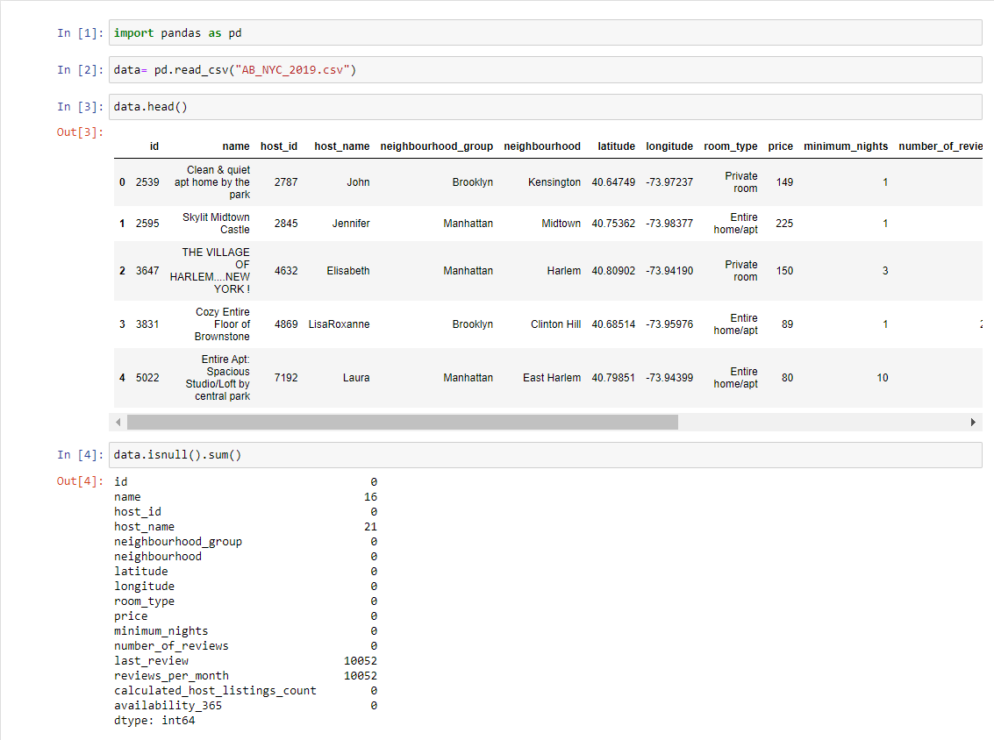
Data before Cleaning

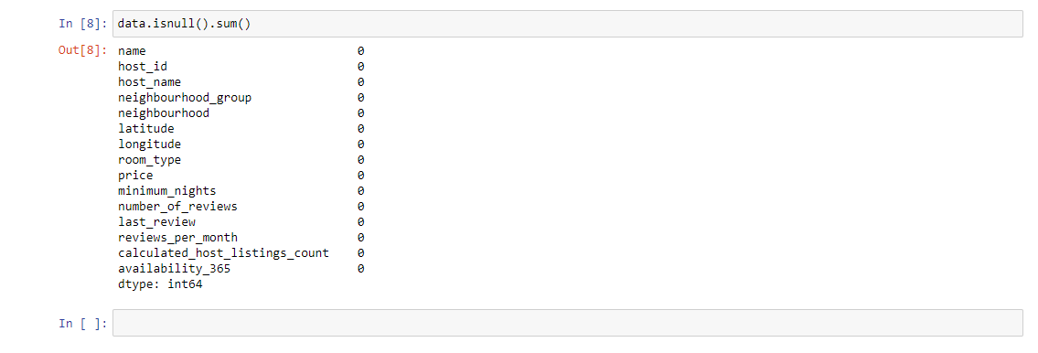
Data after Cleaning

