**Date:**

February 26th, 2017

**Team Members:**

Ashiish Shrestha

Kenneth Balogh

**Application URL:**

                TBD

**Project Description:**

For our project, we have chosen to implement a Food Ordering System. Our application will provide a database of restaurants that allows a user to order food from one of them. Similar to services such as Grubhub or UberEats, we modeled entities that allow to user to get as much information about the restaurants as possible.  One unique feature is that we allow a user to select foods based on taste such as sweet, sour, hot ,etc. The following entities were modeled: Restaurants, User, Menu, Invoice, Ratings, Cuisine, Taste and Payments.

We plan on using real world data to build up a sample database. We will look at services such as yelp to create the restaurants and the associated data we mention below. The user will interact with the data through a webpage. They will login and will be able to query restaurants based on the attributes and rules below.  After selecting the restaurant, they will be able to order from the restaurants menu. They will then be able to pay the invoice based on their stored credit card information. The user will be able to rate the restaurant they ordered from.

**Entity Sets, Relationship Sets and Business Rules:**

Restaurants:

* The Restaurants has a primary key: restaurant id (rid)
* The other attributes are: name, address, phone number
* A Restaurant has at least one Menu
* A restaurant has at least one Cuisine

Users:

* The User has a primary key: user id (uid)
* The other attributes are: name, address, phone number, email
* A user has at least one payment

Menus:

* The Menu has a primary key: menu id (mid)
* The other attributes are: name, description, price
* A menu has at least one taste

Ratings:

* The Rating has a primary key: menu id (raid)
* The other attributes are: stars, comments
* A rating rates exactly one Restaurant, User pair

Invoices:

* The Invoices has a primary key: invoice id (tid)
* The other attributes are: date, description, amount
* An invoice has only one payment
* An invoice has only one user
* An invoice has only one restaurant

Cuisines:

* The Cuisines has one attribute that is its primary key: cuisine name (name)

Tastes:

* The Tastes has one attribute that is its primary key: flavor (flavor)

Payments:

* The payments has a primary key: card number (card#)
* The other attributes are:  expiration date, cvc number and zipcode
* A payment only has one user

We utilized the ER digram to translate into the relational schema. Based on the schema we knew that Users, Cuisines, Tastes and Restaurants did not require any foreign keys so we built those tables first. Then we built the remaining tables ensuring that we had the proper foreign keys identified. (add more comments)

When building the data tables we looked at real restaurants around the university. We used the restaurant’ name, address and phone number when populating the restaurants table. We looked at menus and created items so that we could demonstrate different searches such as cuisine and tastes. We generated generic invoices so that we could demonstrate the “Past Orders” query.

The user of the system is prompted with a login page Figure 1 below. This requires the user enter an email and password. We populated the database with ten different users. The user with the most entries is Joe Drexel. The email is [joedrexel@drexel.net](mailto:joedrexel@drexel.net) and the password is: default. Based on the user’s information this is the first search done on the database looking for both an email and password that must match. Once logged in the user is presented with a list of restaurants they can order from, along with the average rating of each restaurant. The user can search for different cuisines or flavors to narrow the query results as seen in Figure 2. Depending on the selected options it will run several different queries on the database to show the results. The user can also see their previous orders by clicking the Past Orders Button. This runs the a query to display all the orders from that user and totals up all the orders at the bottom of the page. These are just a few of the queries that are run to display information to user.

The user can click the order button on restaurant to get list of all the menu options at a restaurant. Restaurants such as Chipotle and BBQ Ribs have the most items loaded.

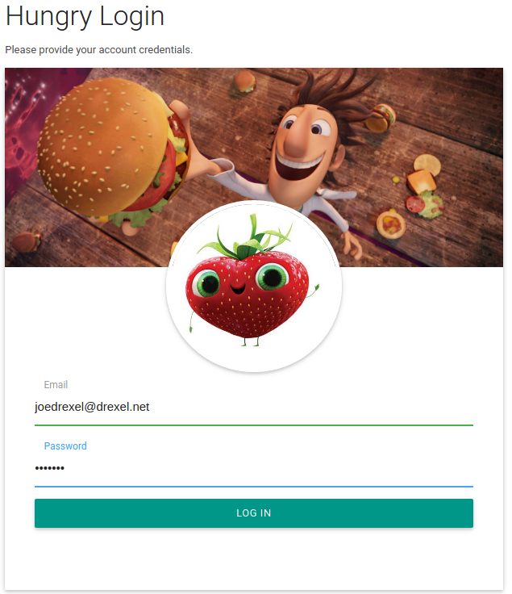

Figure 1 Login Page

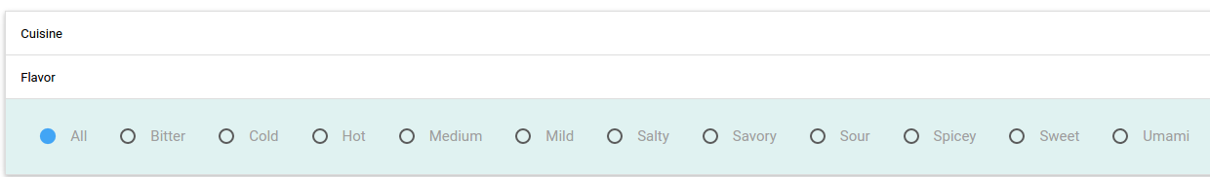

Figure 2 Example of Selecting Flavor or Cuisine

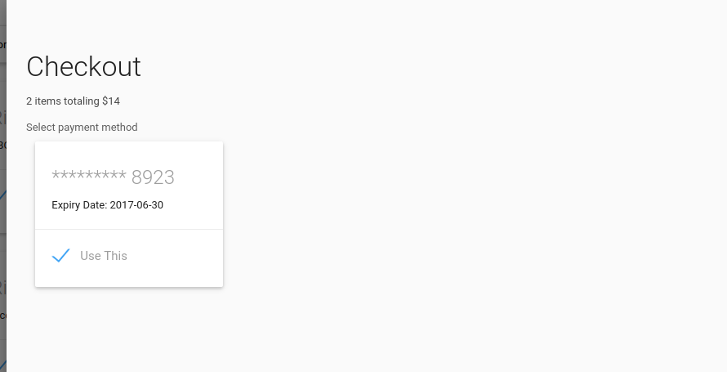

After checkout invoices is updated and show in past orders

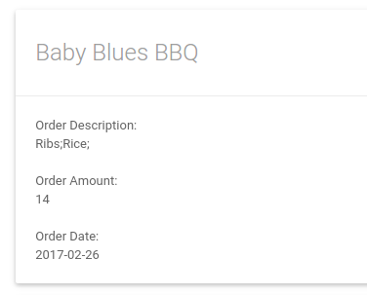

UPDATE ER Diagram

