AATHI RAJ FRONT-END DEVELOPER

Inventive Front-End Developer,

Broad expertise in UI/UX & Design,

JavaScript /Es6 / ES2017,

React areas with Willingness to

Learn Master Back-End

Development and Web Servers

Administration.

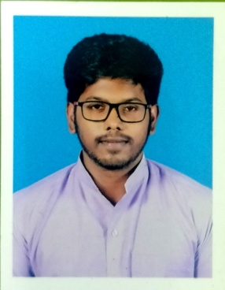

Phone: (+91)-877-891-4462.

Email:**[aathiraj1206@gmail.com](mailto:aathiraj1206@gmail.com).**

LinkedIn: Aathi Raj H

Key Skills

Front-End

* **HTML, CSS/SASS**
* **Bootstrap**
* **Babel**
* **JavaScript ES6 / ES2015**
* **Express.js**
* **React Js, Redux.**

Back-End

* **Node.js**
* **Python**

Cloud Environment

* **AWS Cloud9**

Databases

* **MySQL**
* **MongoDB / Mongoose**

Projects

Harch –Website to make blog posts

* **A Blog post website that resembles an article lookalike page that delivers our ideas to the page.**
* **Integration with 3rd party API’s, Google Maps, ForeCast.io, OpenWeatherMap**

PicLoader – Website to Search Images

* **A React Based Prototype project, I’ve used Unsplash developers API to get images.**
* **A well Structured Pic Loader with a SearchBar to search the pictures fetched from API.**

Ytube – VideoPlayer

* **A Video Player, Completely React based. It fetches data from YouTube API.**
* **WebApp, which could show all videos requested by the client / user.**

Educational History

|  |  |  |  |
| --- | --- | --- | --- |
| Course | College / School | Year Of  Passing | Percentage |
| MCA  ( Master Of  Computer  Application ) | **Sastra Deemed University, Thanjavore** | **2020-2021** | **____** |
| B.Sc  Physics | **V.O.Chidambaram College,Thoothukudi.**  **Manonmaniam University** | **2017-2020** | **7.75** |
| Higher  Secondary | **St.Thomas Matriculation Higher Secondary**  **School** | **2017** | **82.83%** |
| SSLC | **St.Thomas Matriculation Higher Secondary**  **School** | **2015** | **94.40%** |

Area of Interest

* React Based Websites
* Full Fledged Sites with Node.js
* UI/UX design

Achievements

* District level Tennis Player.
* Got Runners Cup in Inter-College Competition SouthZone.

Additional Information

* English : Fluent Expertise
* Good Communication Skills
* Good Leadership Skills
* TeamWork
* Problem Solving

WorkShop

* Completed Web Development Course in Udemy
* Pursuing React Development Course in Udemy

Personal Info

|  |  |
| --- | --- |
| Father’s Name | Hari Ram T A |
| Mother’s Name | Jeya Chitra Devi R |
| Date.Of.Birth | 12.06.2000 |
| Gender | Male |
| Marital Status | Single |
| Languages Known | English & Tamil |
| Hobbies | Reading Documents, Playing Tennis, Swimming, |

Declaration

I hereby declare that the above information furnished above is true to best of my knowledge.