**MOHAMMED AATHIF**

**191921057**

**---------------------------------------------------------------------------------------------**

**Abstract:**

The developed application using Angular and JSON Server API consists of two main components, the User and the Admin. The User component includes a home page with project description and a feedback form, a Health care page showing different departments and drugs, and an Enquiry page for user complaints. The admin component includes an Admin page for adding, editing, and deleting drugs and a feedback and enquiry section for user input. Any changes made by the user are reflected in real-time. This application provides a user-friendly interface for accessing healthcare information and submitting complaints, while also allowing for easy management of drug information by the Admin.

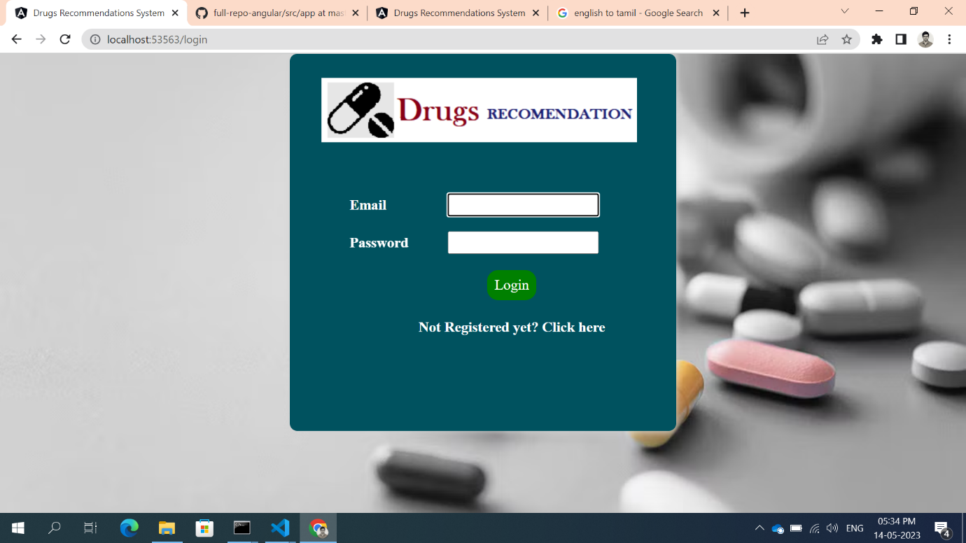

**Fig .1.**

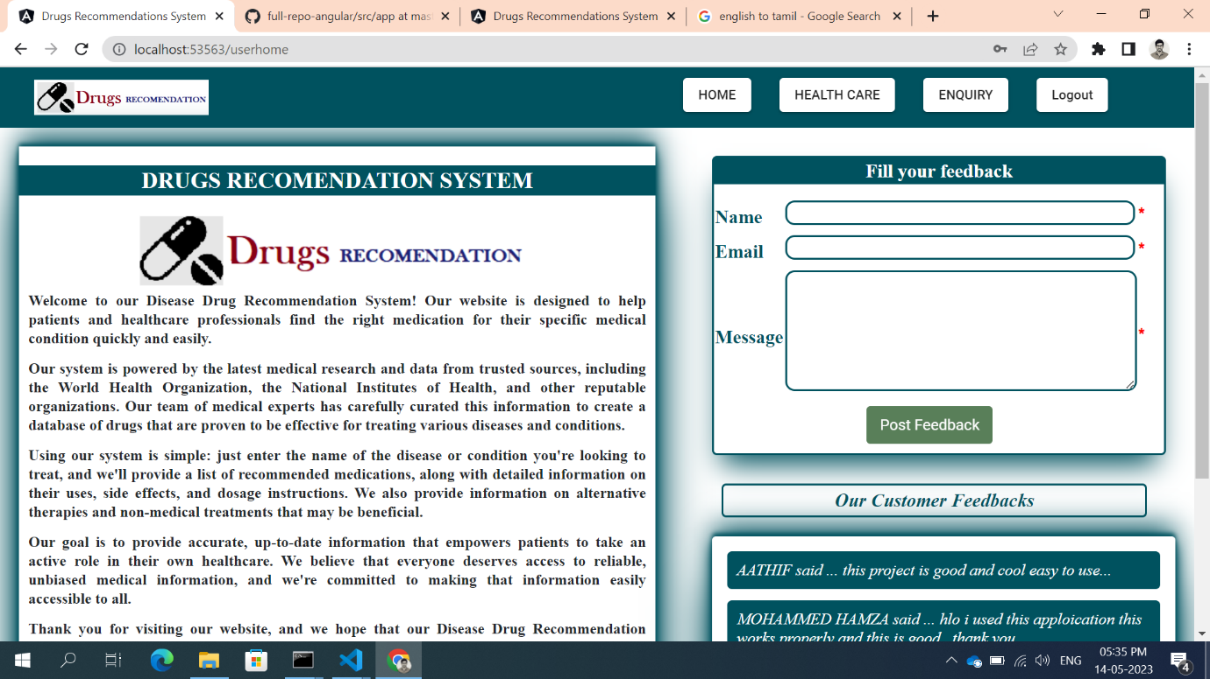

**Fig.1.** Show that Home page in that Product discription, feedback form added if user give a feedback that should reflect in user page as well as admin page.

**Fig. 2.**

**Fig. 2.** Shows that Healthcare page include 2 things various diseases and drugs if I click diseases that will route to new page there it will show descriptions like causes, symptoms, and precautions of that particular diseases. And next things is drugs so many drugs are added user can filter it and check the drugs.

**Fig. 3.**

**Fig.3.** Show that discriptions like causes, symptoms, and precautions of that particular diseases.

**Fig. 4.**

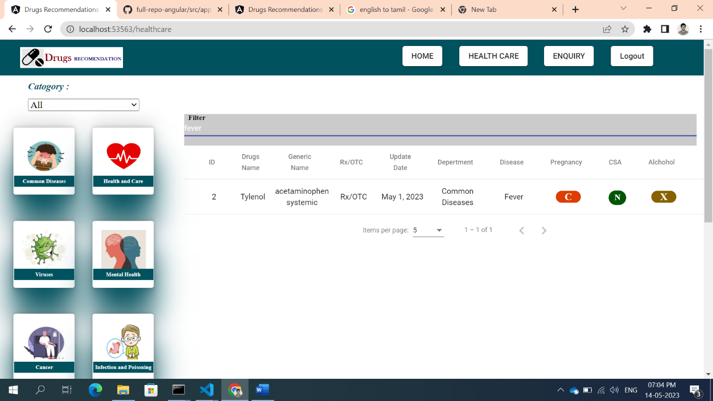

**Fig. 4.** Shows in drugs user can filter which dieases they want to search drugs.

**Fig. 5.**

**Fig. 5.** Shows that user can raise complaints regrading products, drugs and all it will reflect in admin page admin can see the user complaints.

**Fig. 6.**

**Fig. 6.** Shows admin page if admin click add drugs it will show on form in that admin can add , edit, delete drugs if any change made by admin it will reflect user page also.

**Fig. 7.**

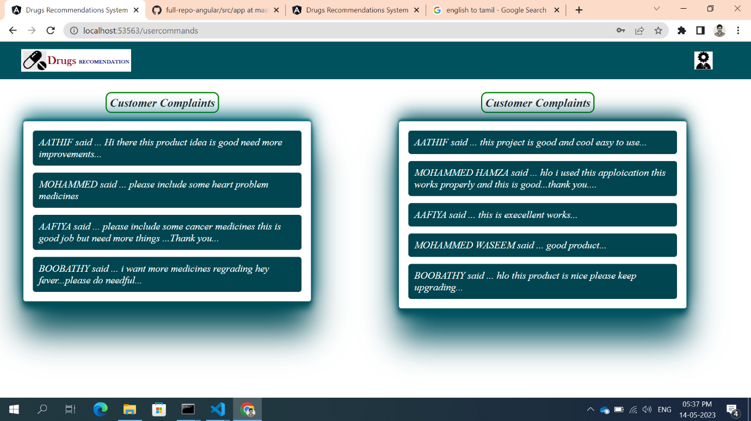

**Fig. 7.** Admin can have access to see the user feedbacks, and enquiry.