Bites-N-Wheels — Final Database Schema & ER Design
MVP data model for a 6–10 day implementation

1. Design decision
The database is designed around the project's core idea: food trucks are mobile, so a customer should be able to discover food together with a truck's planned station and ETA. Orders are the main transactional source for demand analytics. The schema avoids putting repeating lists into a single column and keeps truck, menu, station, schedule, order and notification data normalized.

2. Final MVP entities
Entity | Purpose
USER | Customers, truck owners and admins. One table with a role field instead of separate duplicate user tables.
TRUCK | Food-truck profile owned by a truck owner.
MENU | A truck's menu version/list for a day or active period.
MENU_ITEM | Individual food item with price, category/tag, veg/non-veg and availability.
STATION | Reusable physical station/location.
TRUCK_SCHEDULE | A truck's planned visit to a station with date and arrival/departure time.
ORDER | Customer order or truck-entered offline order; stores status, type, schedule and total.
ORDER_ITEM | Items inside an order; preserves price_at_order for historical correctness.
NOTIFICATION | In-app notifications such as order-ready or ETA changed.
DEMAND_INSIGHT | Optional persisted result of demand analysis/suggestion; analytics can also be generated on demand.

3. ER diagram
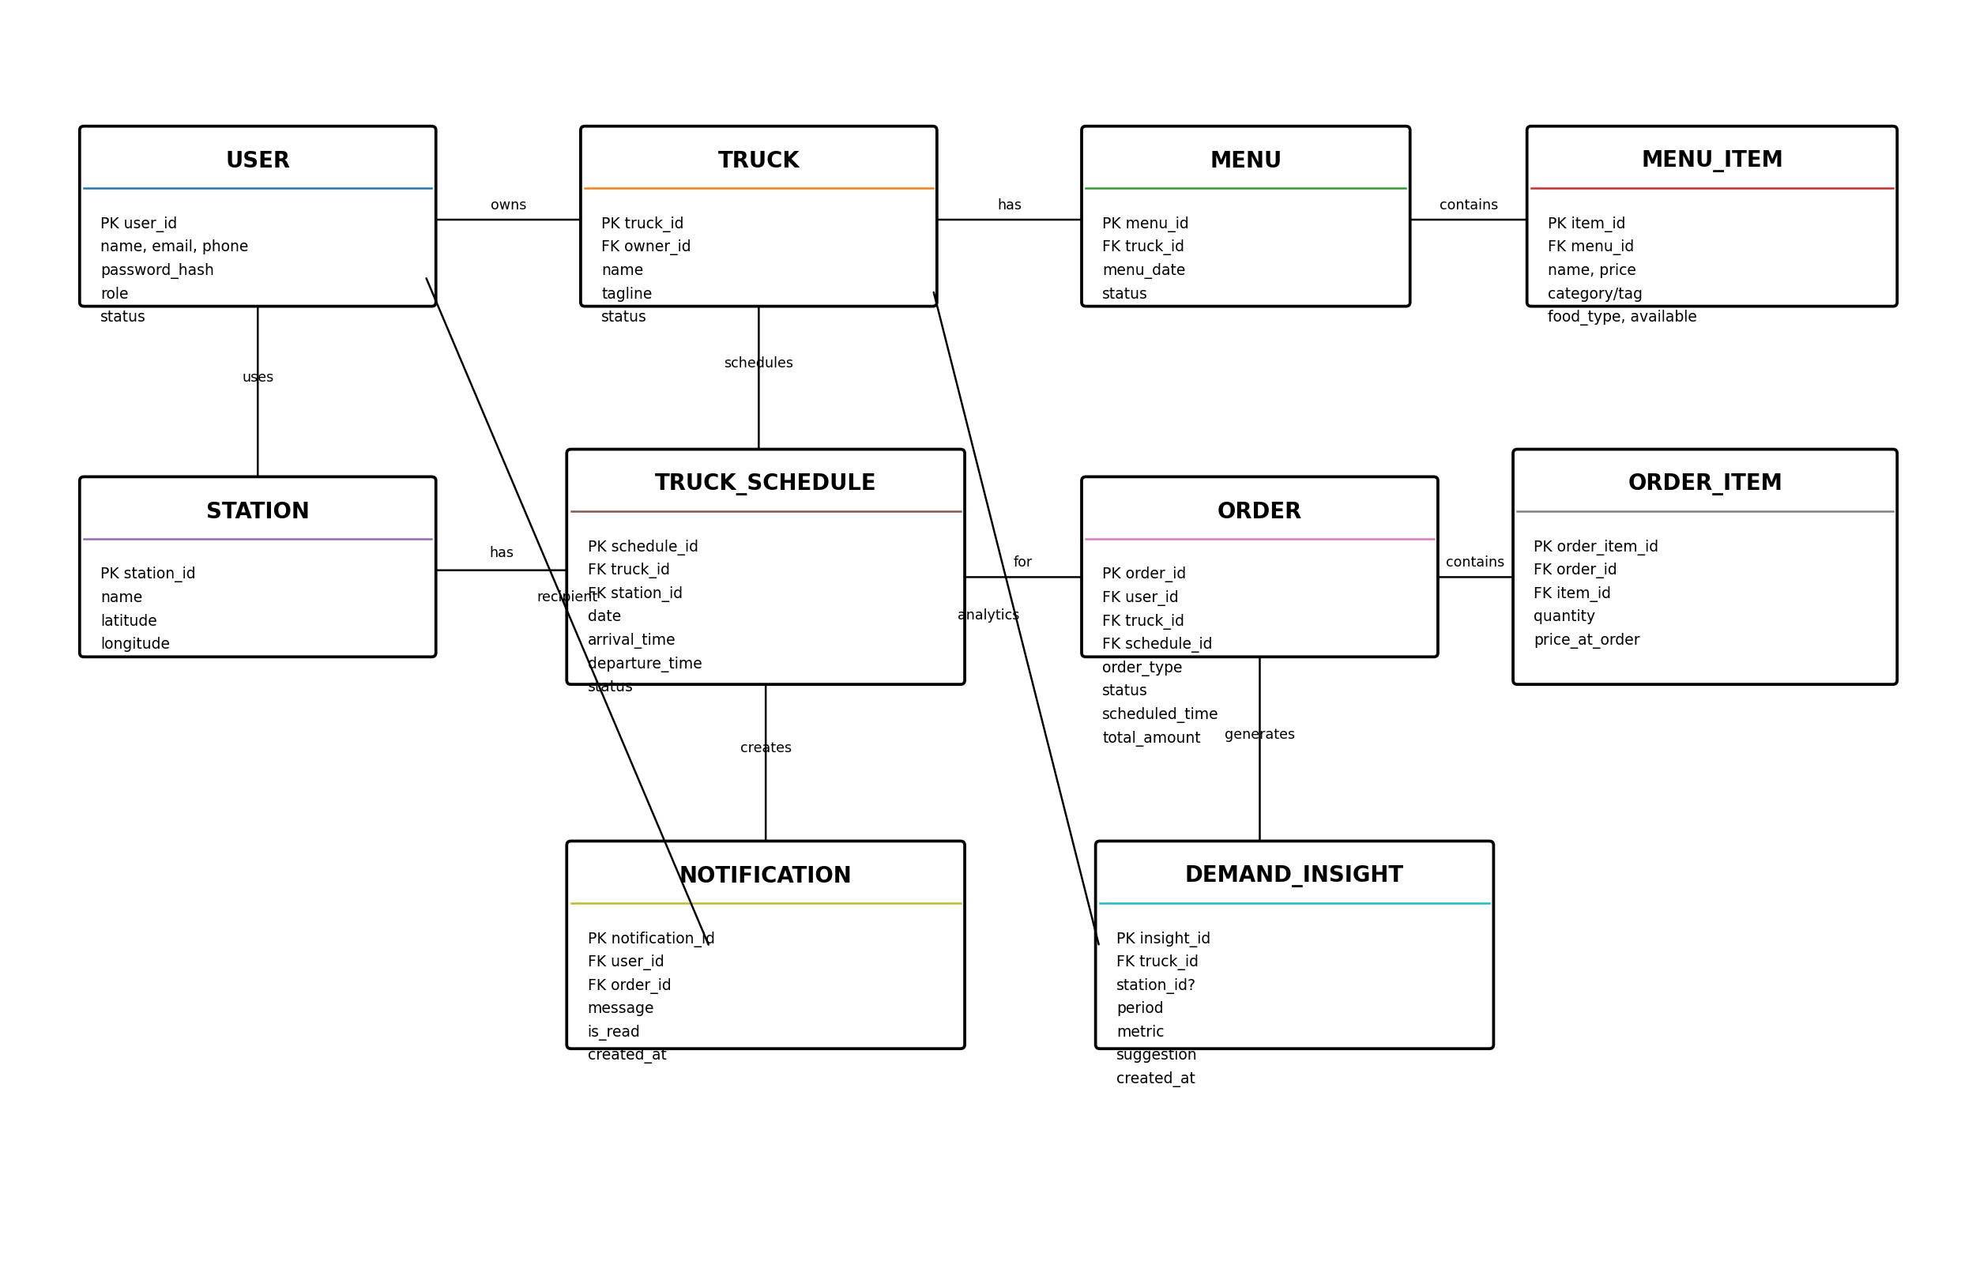
Note: DEMAND_INSIGHT is not required for the first working analytics version. A service can calculate insights directly from ORDER/ORDER_ITEM/TRUCK_SCHEDULE data.

4. Detailed table definitions

USER
Column | Type | Key/Constraint | Meaning
user_id | BIGINT | PK | Unique user identifier
name | VARCHAR | NOT NULL | Display name
email | VARCHAR | UNIQUE, NOT NULL | Login/contact email
phone | VARCHAR | UNIQUE | Phone number
password_hash | VARCHAR | NOT NULL | Never store plain password
role | VARCHAR/ENUM | NOT NULL | CUSTOMER / TRUCK_OWNER / ADMIN
status | VARCHAR/ENUM | NOT NULL | ACTIVE / SUSPENDED

TRUCK
Column | Type | Key/Constraint | Meaning
truck_id | BIGINT | PK | Unique truck
owner_id | BIGINT | FK → USER | Truck owner; must have TRUCK_OWNER role
name | VARCHAR | NOT NULL | Truck name
tagline | VARCHAR | NULL | Cuisine/brand description
status | VARCHAR/ENUM | NOT NULL | ACTIVE / INACTIVE / SUSPENDED

MENU
Column | Type | Key/Constraint | Meaning
menu_id | BIGINT | PK | Menu identifier
truck_id | BIGINT | FK → TRUCK | Owner truck
menu_date | DATE | NOT NULL | Date this menu is used; useful for today's menu
status | VARCHAR/ENUM | NOT NULL | DRAFT / CONFIRMED / CLOSED

MENU_ITEM
Column | Type | Key/Constraint | Meaning
item_id | BIGINT | PK | Food item identifier
menu_id | BIGINT | FK → MENU | Menu containing the item
name | VARCHAR | NOT NULL | Food name
description | TEXT | NULL | Description
price | DECIMAL | NOT NULL | Current selling price
category_tag | VARCHAR | NOT NULL | Pizza, Chinese, South Indian, Dessert, etc.
food_type | VARCHAR/ENUM | NOT NULL | VEG / NON_VEG
available | BOOLEAN | NOT NULL | Can currently be ordered

STATION
Column | Type | Key/Constraint | Meaning
station_id | BIGINT | PK | Reusable station
name | VARCHAR | NOT NULL | Station/place name
latitude | DECIMAL | NULL | For Leaflet/OpenStreetMap display
longitude | DECIMAL | NULL | For Leaflet/OpenStreetMap display

TRUCK_SCHEDULE
Column | Type | Key/Constraint | Meaning
schedule_id | BIGINT | PK | Planned visit
truck_id | BIGINT | FK → TRUCK | Truck
station_id | BIGINT | FK → STATION | Destination station
service_date | DATE | NOT NULL | Day of journey
arrival_time | TIMESTAMP/TIME | NOT NULL | Expected arrival
departure_time | TIMESTAMP/TIME | NULL | Expected departure
status | VARCHAR/ENUM | NOT NULL | PLANNED / ARRIVING / OPEN / CLOSED / CANCELLED

ORDER
Column | Type | Key/Constraint | Meaning
order_id | BIGINT | PK | Order identifier/token
user_id | BIGINT | FK → USER | Customer; nullable only if business rule permits anonymous offline sale
truck_id | BIGINT | FK → TRUCK | Truck fulfilling order
schedule_id | BIGINT | FK → TRUCK_SCHEDULE | Station/time associated with order
order_type | VARCHAR/ENUM | NOT NULL | ONLINE / OFFLINE
status | VARCHAR/ENUM | NOT NULL | PENDING / ACCEPTED / REJECTED / PREPARING / READY / COMPLETED / CANCELLED
scheduled_time | TIMESTAMP | NULL | Used for preorder
total_amount | DECIMAL | NOT NULL | Order total
created_at | TIMESTAMP | NOT NULL | Creation time

ORDER_ITEM
Column | Type | Key/Constraint | Meaning
order_item_id | BIGINT | PK | Line item
order_id | BIGINT | FK → ORDER | Parent order
item_id | BIGINT | FK → MENU_ITEM | Ordered food
quantity | INT | NOT NULL | Must be > 0
price_at_order | DECIMAL | NOT NULL | Snapshot of price at purchase

NOTIFICATION
Column | Type | Key/Constraint | Meaning
notification_id | BIGINT | PK | Notification identifier
user_id | BIGINT | FK → USER | Recipient
order_id | BIGINT | FK → ORDER | Optional related order
message | TEXT | NOT NULL | Notification text
is_read | BOOLEAN | NOT NULL | Read/unread
created_at | TIMESTAMP | NOT NULL | Creation time

DEMAND_INSIGHT
Column | Type | Key/Constraint | Meaning
insight_id | BIGINT | PK | Insight identifier
truck_id | BIGINT | FK → TRUCK | Truck receiving insight
station_id | BIGINT | FK → STATION | Optional recommended station
period_start | DATE | NOT NULL | Analysis start
period_end | DATE | NOT NULL | Analysis end
metric | VARCHAR | NOT NULL | Orders, revenue, item demand, etc.
suggestion | TEXT | NOT NULL | Human-readable suggestion
created_at | TIMESTAMP | NOT NULL | Generated time

5. Relationships and cardinality
Relationship | Cardinality | Reason
USER → TRUCK | 1 : 0..N | A truck owner may own one or more trucks; each truck has one owner.
TRUCK → MENU | 1 : N | A truck can have multiple dated/active menus.
MENU → MENU_ITEM | 1 : N | A menu contains multiple items.
TRUCK → TRUCK_SCHEDULE | 1 : N | A truck can visit many stations over many dates.
STATION → TRUCK_SCHEDULE | 1 : N | A station can be visited by many trucks at different times.
USER → ORDER | 1 : N | A customer can place many orders.
TRUCK → ORDER | 1 : N | A truck fulfills many orders.
TRUCK_SCHEDULE → ORDER | 1 : N | Orders can be associated with the station/time at which the truck serves.
ORDER → ORDER_ITEM | 1 : N | An order contains one or more line items.
MENU_ITEM → ORDER_ITEM | 1 : N | An item can appear in many historical orders.
USER → NOTIFICATION | 1 : N | A user receives many notifications.
TRUCK → DEMAND_INSIGHT | 1 : N | Insights are generated for a truck.

6. Important normalization decisions
- Do not store multiple menu item names/prices in one MENU column. MENU_ITEM holds one item per row.
- Do not store station1, station2, station3 inside TRUCK. STATION and TRUCK_SCHEDULE represent the repeating relationship.
- Do not store all order items in ORDER as a comma-separated string. ORDER_ITEM resolves the one-to-many relationship.
- Keep price_at_order in ORDER_ITEM so historical orders remain correct after a menu price changes.
- Use role/status fields in USER rather than creating duplicate customer/owner login tables.
- Use foreign keys to enforce valid ownership and relationships.
- Use UNIQUE constraints on email/phone where appropriate.
- Use DECIMAL for money, not floating-point types.

7. Business rules to enforce
- A truck owner may modify only trucks they own.
- A customer can order only from an active truck and an available menu item.
- A preorder must fall inside the truck's planned service window.
- A truck schedule must not overlap another schedule for the same truck.
- If the product decision is 'one truck per station/time', prevent overlapping schedules across different trucks too; otherwise warn rather than hard-block.
- Order status transitions should be controlled: PENDING → ACCEPTED → PREPARING → READY → COMPLETED; cancellation/rejection handled only in allowed states.
- Changing a truck schedule/ETA should update the customer-facing planned ETA; it must not rewrite historical order data.
- Analytics should include both ONLINE and OFFLINE orders when calculating actual demand.

8. Analytics query concept
The MVP does not need an AI/ML model. Use SQL aggregation over the last 7 days, for example by truck, station, date and time window. The Spring service converts the result into a simple suggestion such as: 'Station B had the highest order volume from 6–8 PM in the last 7 days.'

9. Recommended indexes
- USER(email)
- TRUCK(owner_id, status)
- MENU(truck_id, menu_date)
- MENU_ITEM(menu_id, category_tag, available)
- TRUCK_SCHEDULE(truck_id, service_date, arrival_time)
- TRUCK_SCHEDULE(station_id, service_date, arrival_time)
- ORDER(user_id, created_at)
- ORDER(truck_id, status, created_at)
- ORDER(schedule_id)
- ORDER_ITEM(order_id)

