**Personalized Learning**

A Project Report

submitted in partial fulfillment of the requirements

of

……………. Track Name ……

by

**Name of Student: AATHILA FARVIN.A**

**Email id:** [**aathilafarveen@gmail.com**](mailto:aathilafarveen@gmail.com)

**NM Id:F4067A6A04BE88D953D414DFCD8F6B73**

Under the Guidance of

**(P.Raja, Master Trainer, Edu net Foundation)**

**ACKNOWLEDGEMENT**

We would like to take this opportunity to express our deep sense of gratitude to all individuals who helped us directly or indirectly during this thesis work.

I am really grateful and wish my profound indebtedness to Supervisor **P.RAJA** Deep Knowledge & keen interest of my supervisor in the field of Machine Learning to carry out this project. His endless patience, scholarly guidance, continual encouragement, constant and energetic supervision, constructive criticism, valuable advice, reading many inferior drafts and correcting them at all stages have made it possible to complete this project.

I would like to express my heartiest gratitude to **Mohamed Azarudheen**, Department of MECHANICAL, for his kind help to finish my project.

I would also generously welcome each one of those individuals who have helped me straightforwardly or in a roundabout way in making this project a win. In this unique situation, I might want to thank the various staff individuals, both educating and non-instructing, which have developed their convenient help and facilitated my undertaking.

Finally, I must acknowledge with due respect the constant support and patients of my parents.

#### 

**ABSTRACT**

Personalized learning: The simple, the complicated, the complex

This qualitative case study explores the perspectives of Australian secondary school teachers on implementing PL. The study uses complexity theory to examine the teachers' perspectives and suggests that complexity theory can help teachers navigate the issues of implementing PL.

Personalised learning in higher education for health sciences

This abstract discusses personalized learning as an educational approach that tailors learning to the needs and preferences of individual learners. The abstract also notes that advances in educational technology have made it possible to implement personalized learning in various contexts.

A systematic literature review of personalized learning terms

This paper reviews recent research literature on personalized learning and the terms used to characterize learning. The paper emphasizes that learning is a personalized experience that can be enhanced through technology integration.

This paper discusses how artificial intelligence technology can be used to innovate personalized learning. The paper also promotes the teaching reform from “teacher centered” to “student-centered”.Personalized learning is an educational approach that tailors instruction, content, and pace to the unique needs, strengths, and interests of individual learners. Unlike traditional models, which often employ a one-size-fits-all methodology, personalized learning leverages data, technology, and adaptive practices to create a more student-centered experience. Key elements include individualized learning paths, flexible pacing, and a focus on student agency, allowing learners to take a more active role in their education. This approach has shown promise in improving engagement, motivation, and achievement, as it enables learners to build on their strengths and address specific gaps in knowledge. However, implementing personalized learning poses challenges, including the need for professional development, resources, and robust data systems. As education continues to evolve, personalized learning represents a pivotal shift towards inclusivity and equity, aiming to better prepare students for diverse and dynamic future pathways.

**Table of the Contents**

Abstract: 3

List of Figures

List of Tables

**Chapter 1.**  **Introduction**

1.1 Problem Statement

1.2 Motivation

1.3 Objectives

1.4. Scope of the Project

**Chapter 2.**  **Literature Survey**

**Chapter 3.**  **Proposed Methodology**

**Chapter 4.**  **Implementation and Results**

**Chapter 5. Discussion and Conclusion**

**References**

**LIST OF FIGURES**

|  |  |  |
| --- | --- | --- |
| **Figure No** | **Name of the Figure** | **Page No.** |
|  | **Personalized Learning (system view)** | **6** |
|  | **Key Elements Of Personalized Learning** | **10** |
|  | **AI In Personalized Learning** | **13** |
|  | **Path Of Personalization** | **15** |
|  |  |  |
|  |  |  |
|  |  |  |
|  |  |  |
|  |  |  |

**CHAPTER 1**

**Introduction**

In recent years, the field of education has undergone a profound shift from traditional, standardized instruction toward more personalized approaches that address the unique needs and preferences of each learner. Personalized learning, at its core, is designed to tailor educational experiences to fit individual students' strengths, weaknesses, interests, and learning paces. Unlike conventional models, where a uniform curriculum is delivered to all students regardless of their abilities or backgrounds, personalized learning seeks to empower students by providing them with more control over their learning journey. This approach includes a variety of strategies, such as adaptive technology, data-driven insights, and customized curricula, which allow teachers to meet students where they are and to scaffold their progress more effectively.

The push for personalized learning has been driven by advances in educational technology and a growing recognition of the diverse needs of students in modern classrooms. Research highlights that students are more engaged and motivated when their learning is tailored to their personal goals and preferences. By adopting this approach, educators aim to create a more equitable learning environment, where each student can reach their fullest potential, regardless of background or learning style.

Despite its promise, implementing personalized learning on a large scale comes with challenges. It requires substantial investment in resources, professional development, and new data management systems to support teachers in identifying and responding to individual student needs. Nonetheless, personalized learning represents a fundamental shift in education, aiming to foster deeper engagement, self-directed learning, and academic success for all students. This introduction explores the principles, benefits, and potential challenges of personalized learning, setting the stage for understanding its impact on contemporary education.

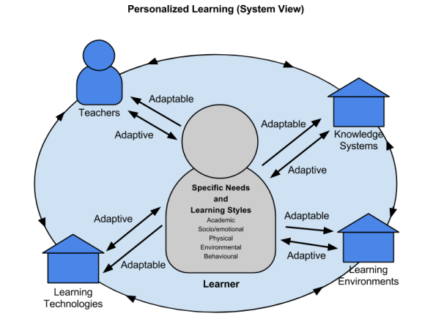

**Figure 1:Personalized Learning (system view)**

* 1. **Problem statement:**

The traditional education system struggles to meet the diverse learning needs of students. A personalized learning approach, while proven to improve engagement and outcomes, faces substantial barriers in implementation. These include difficulties in accurately assessing individual learning needs, developing adaptive learning technologies, providing appropriate teacher training, and ensuring equitable access to personalized resources. The gap between the theoretical benefits of personalized learning and its practical application in diverse educational settings needs to be bridged.

With the increasing integration of technology in education, there is a growing opportunity to shift from standardized education to more individualized, **personalized learning** experiences. Personalized learning allows for the tailoring of content, pacing, and instructional methods to meet the unique needs of each learner. Despite its potential, scaling personalized learning systems presents significant challenges in terms of technology, teacher training, resource allocation, and assessment models.

Students and teachers may need to change their ideas about how people learn. Students may be used to receiving information directly from the teacher, and may need help learning to grapple with content independently.

Students may learn at different paces, which can be challenging for teachers to manage. Teachers can try setting minimum paces, allowing time for catch-ups, and creating alternative pathways for students who are ready to move ahead.

The potential of personalized learning to improve educational equity may be limited by the broader context in which teaching and learning takes place. For example, in industrialized countries, too much technology may crowd out the benefits of human contact between teachers and students.

* 1. **OBJECTIVES:**

The primary objective of personalized learning is to create a student-centered educational experience that caters to each learner’s unique needs, strengths, and interests. This approach aims to improve student engagement, motivation, and achievement by providing a flexible, adaptive learning environment where each learner can progress at their own pace and follow a customized learning pathway. Specific objectives of personalized learning include:

**1. *Enhancing Student Engagement:\*** By aligning learning activities with students’ personal interests and goals, personalized learning aims to make education more relevant and engaging, fostering a deeper connection to the content.

**2. *Promoting Mastery of Skills:\*** Personalized learning emphasizes mastery over content acquisition, encouraging students to fully understand each concept before moving on. This helps students build a stronger foundation and reduces gaps in knowledge.

**3. *Supporting Individual Learning Paths and Pace:\*** Personalized learning respects that each student learns differently and at a different pace, allowing them to progress as they master content, rather than conforming to a rigid curriculum schedule.

**4. *Fostering Student Agency and Ownership:\*** By allowing students to have more control over their learning choices, personalized learning encourages them to take ownership of their educational journey, developing autonomy and lifelong learning skills.

**5. *Encouraging Equitable Outcomes:\*** Personalized learning seeks to address diverse needs within the classroom, providing additional support where necessary to ensure all students, regardless of background or ability, have the opportunity to succeed.

**1.3 SCOPE OF THE OBJECT:**

The scope of personalized learning encompasses a wide range of practices, technologies, and instructional strategies designed to adapt the educational experience to individual student needs. It aims to transform traditional teaching methods, making learning more dynamic, responsive, and student-centered. Key areas within the scope of personalized learning include:

1. **\*Adaptive Learning Technologies:\*** Leveraging digital platforms and artificial intelligence, personalized learning uses adaptive software to analyze student progress and customize content in real time. This ensures that students are continually challenged at the right level and receive immediate feedback to reinforce learning.

2. **\*Individualized Learning Plans (Imps):\*** Personalized learning involves developing tailored learning pathways for each student, often through Individualized Learning Plans. These ILPs outline specific goals, strategies, and milestones based on the learner’s strengths, challenges, and interests.

3. **\*Flexible Pacing and Scheduling:\*** Personalized learning accommodates different learning speeds, allowing students to advance as they master content rather than adhering to a fixed curriculum pace. This helps slow learners receive the necessary time to understand concepts while enabling advanced learners to move forward without being held back.

**4. *Student Agency and Choice:\*** This approach provides students with opportunities to make choices about what, how, and when they learn. By giving students a voice in their education, personalized learning promotes greater ownership and motivation, making them active participants in their educational journey.

**5. *Data-Driven Insights for Teachers:\*** Personalized learning relies on data collection and analytic to provide teachers with a clear picture of each student’s performance, strengths, and needs. Educators can then make informed instructional decisions, provide targeted interventions, and modify lesson plans to support individual learning.

**6. *Project-Based and Experiential Learning:\*** Personalized learning often includes project-based learning (PBL) and experiential learning activities that allow students to engage with real-world problems. This hands-on approach makes learning more meaningful and relevant, enhancing skill application beyond the classroom.

**7. *Social and Emotional Learning (SEL):\*** Recognizing the role of emotional and social well-being in academic success, personalized learning often incorporates SEL practices, helping students build resilience, self-regulation, and empathy as part of a holistic education model.

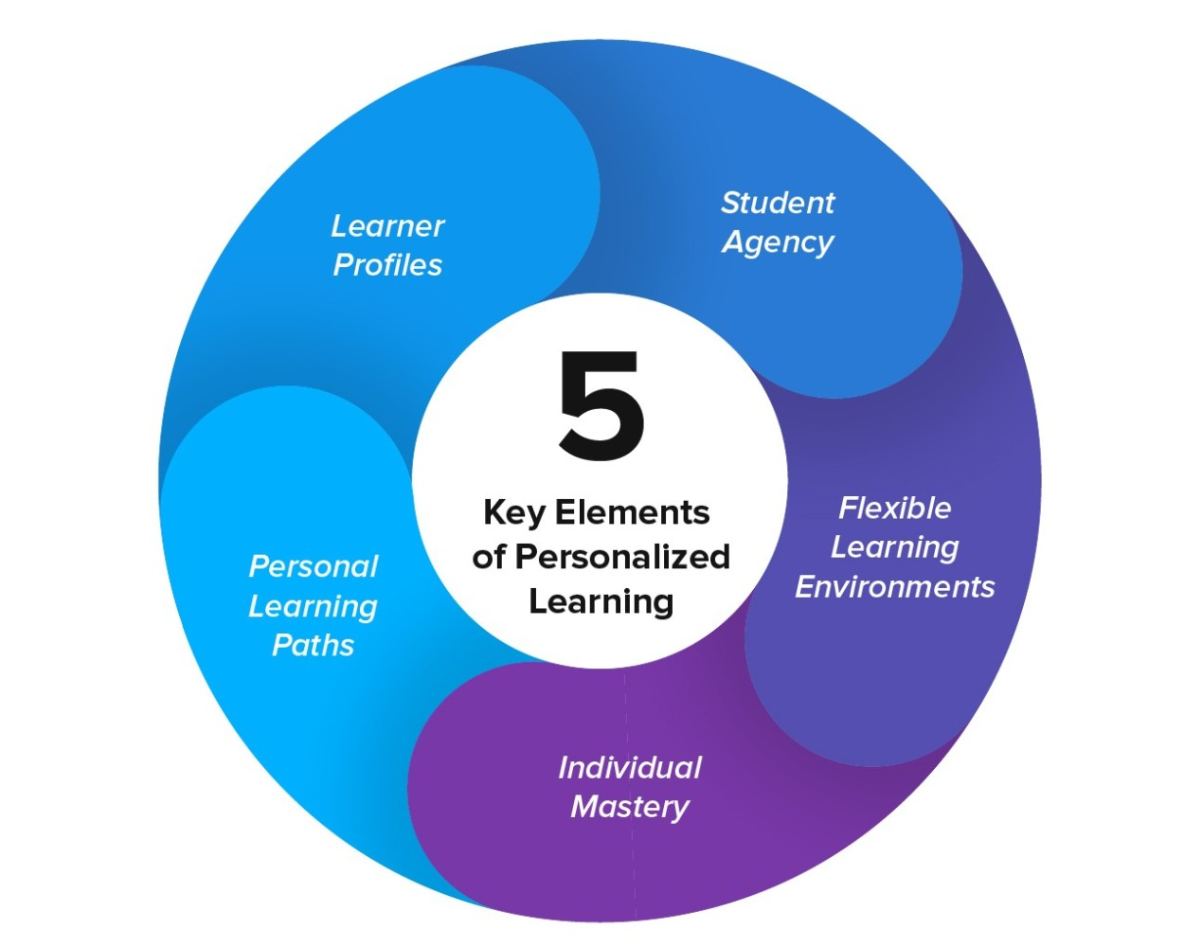

**Fig2;Key Elements Of Personalized Learning**

**CHAPTER 2**

**LITERATURE SURVEY**

A literature survey on personalized learning involves reviewing and synthesizing existing research, theories, and practices related to tailoring educational experiences to meet individual learners' needs, preferences, and interests. Here’s an overview of key themes, findings, and trends in the field

**1. Definition and Conceptual Framework**

Personalized Learning: Often defined as an educational approach that aims to customize learning experiences to individual students. This can include adapting content, pace, and learning strategies.

**Key Components:** Personalization can involve differentiated instruction, learner autonomy, and the use of technology to facilitate tailored learning paths.

**2. Theoretical Foundations**

**Constructive Theories:** Emphasize the role of the learner in constructing knowledge, suggesting that personalized learning aligns with how individuals learn best.

**Self-Determination Theory:** Highlights the importance of autonomy, competence, and relatedness in motivating learners, which is central to personalized learning approaches.

**3. Technological Integration**

**Learning Management Systems (LMS):** Platforms like Module and Canvas that allow for personalized content delivery and tracking of student progress.

**Adaptive Learning Technologies:** Tools that adjust the difficulty of tasks based on student performance, such as Dream-box and K newton.

**Data Analytic:** The use of learning analytic to inform instructional decisions and personalize learning experiences based on student data.

**4. Implementation Strategies**

**Blended Learning Models:** Combining online digital media with traditional face-to-face classroom methods to provide personalized learning opportunities.

**Project-Based Learning:** Encouraging students to engage in projects that align with their interests and learning goals.

**Competency-Based Education:** Allowing students to progress through a curriculum at their own pace, based on mastery of skills rather than time spent in class.

**5. Benefits of Personalized Learning**

**Increased Engagement:** Tailored learning experiences can lead to higher student motivation and engagement.

**Improved Learning Outcomes:** Research indicates that personalized learning can lead to better academic performance and deeper understanding of material.

**Equity in Education:** Personalized approaches can help address diverse learning needs, potentially reducing achievement gaps.

**6. Challenges and Considerations**

**Capability:** Implementing personalized learning at scale can be resource-intensive and complex.

**Teacher Training:** Educators may require professional development to effectively implement personalized learning strategies.

Data Privacy: The use of technology and data analytic raises concerns about student privacy and data security.

**7. Future Directions**

**Research Gaps:** More longitudinal studies are needed to assess the long-term impacts of personalized learning.

**Policy Development:** Educational policies must evolve to support personalized learning initiatives and ensure equitable access to resources.

**Integration of AI:** The potential for artificial intelligence to further enhance personalized learning experiences through predictive analytic and tailored content delivery.

**CHAPTER 3**

**PROPOSED METHODOLOGY**

Creating a personalized learning methodology involves tailoring educational experiences to meet the individual needs, preferences, and interests of each learner. Here’s a proposed methodology that can be adapted for various educational settings:

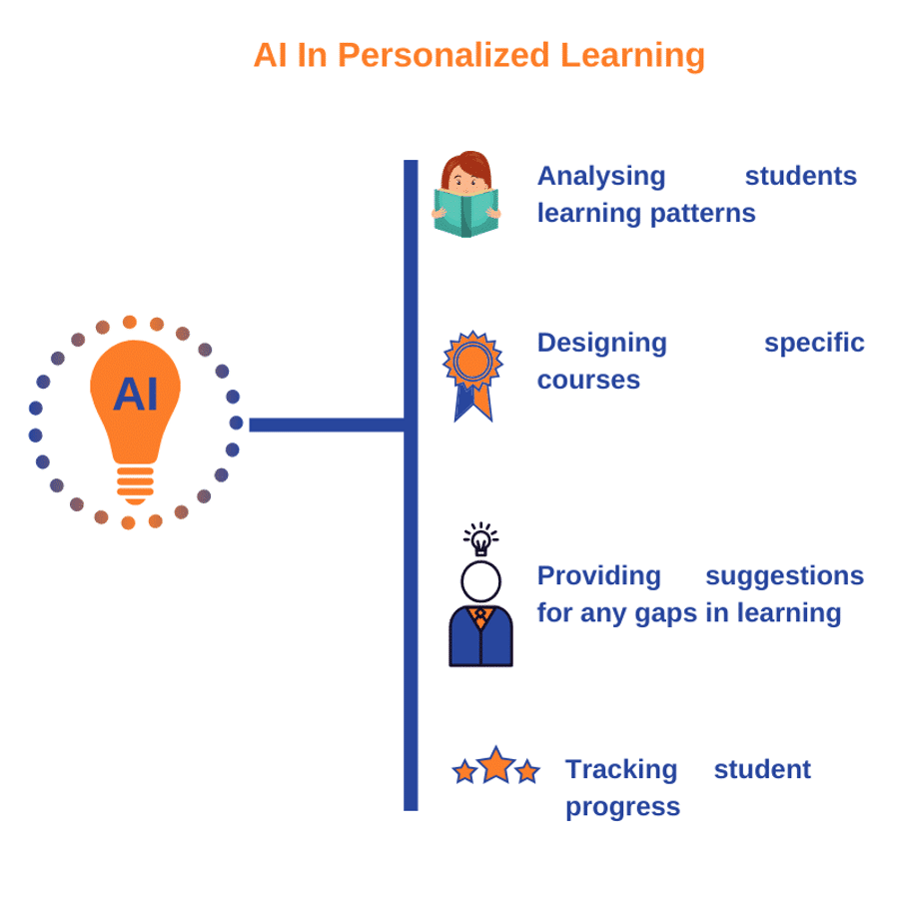

**Fig3: AI In Personalized Learning**

**1. Assessment and Data Collection**

**Initial Assessment:** Conduct diagnostic assessments to understand students' current knowledge, skills, learning styles, and interests.

**Ongoing Assessment:** Use formative assessments (quizzes, reflections, projects) to gather data on student progress and adapt learning paths accordingly.

**2. Goal Setting**

**Individual Learning Goals:** Collaborate with students to set specific, measurable, achievable, relevant, and time-bound (SMART) goals based on their assessments.

**Personal Learning Plans:** Develop personalized learning plans that outline the goals, strategies, and resources for each student.

**3. Curriculum Design**

**Flexible Curriculum:** Design a curriculum that allows for choice and flexibility, enabling students to select topics or projects that interest them.

**Modular Learning:** Break down content into modules that can be completed at the student’s own pace, allowing for deeper exploration of topics.

**4. Instructional Strategies**

**Differentiated Instruction:** Use a variety of teaching methods (e.g., direct instruction, collaborative learning, hands-on activities) to cater to different learning styles.

**Blended Learning:** Incorporate online resources and tools to complement traditional teaching methods, providing students with access to a wider range of materials.

**5. Technology Integration**

**Learning Management Systems (LMS):** Utilize LMS platforms to track progress, provide resources, and facilitate communication between students and educators.

**Adaptive Learning Technologies:** Implement software that adjusts the difficulty of tasks based on student performance, ensuring that each learner is challenged appropriately.

**6. Feedback and Reflection**

**Regular Feedback:** Provide timely and constructive feedback to help students understand their progress and areas for improvement.

**Self-Reflection:** Encourage students to reflect on their learning experiences, goals, and strategies, fostering a growth mindset.

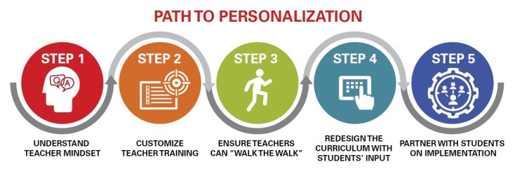

**Fig4: Path Of Personalization**

**7. Collaboration and Community**

**Peer Learning:** Facilitate opportunities for students to work together, share knowledge, and support each others learning journeys.

**Family Involvement:** Engage families in the learning process by keeping them informed and involved in their child’s educational goals and progress.

**8. Continuous Improvement**

**Data Analysis:** Regularly analyze assessment data to identify trends, successes, and areas needing adjustment in the personalized learning approach.

**Professional Development:** Provide ongoing training for educators to enhance their skills in personalized learning strategies and technology integration.

**9. Capability and Sustainability**

**Pilot Programs:** Start with pilot programs to test and refine personalized learning strategies before scaling them across the institution.

**Resource Allocation:** Ensure that adequate resources (time, technology, training) are allocated to support personalized learning initiatives.

**CHAPTER 4**

**Implementation and Result**

Personalized learning is an educational approach that tailors instruction, resources, and learning activities to the unique needs, preferences, and goals of each student. Implementing it requires thoughtful planning, technology integration, and continuous evaluation. Below is an outline of how personalized learning can be implemented and its common results.

**1. Implementation of Personalized Learning**

**a. Setting Learning Goals**

Develop personalized learning plans based on students' strengths, weaknesses, and

Involve students in setting their own learning goals, which fosters autonomy and engagement.

**b. Flexible Learning Pathways**

Allow students to progress at their own pace, particularly useful for subjects like mathematics and science where understanding foundation concepts is essential.

Use adaptive learning technologies (e.g., educational apps or platforms) that provide tailored pathways based on each student’s performance and progress.

**c. Technology and Data Integration**

Utilize data from assessments and assignments to track individual student progress and identify areas where they need more support or are ready to advance.

Implement tools such as Learning Management Systems (LMS), AI-based tutoring systems, and digital content platforms to support customized instruction.

**d. Student-Centered Assessment**

Move beyond traditional assessments and use formative assessments, self-assessments, and project-based assessments to gain a clearer picture of each student’s understanding.

Provide ongoing feedback, helping students to reflect on their progress and adjust their goals as needed.

**e. Collaboration and Mentor ship**

Encourage collaboration between students through group projects that allow them to learn from each other.

Teachers, mentors, and peers play an essential role in supporting students in a personalized learning environment by offering guidance tailored to their needs.

**2. Results of Personalized Learning**

**a. Increased Engagement and Motivation**

Students often feel more motivated and engaged when they have control over their learning paths and when instruction is relevant to their interests.

**b. Improved Academic Outcomes**

Studies have shown that personalized learning can lead to higher academic achievement, particularly for students who struggle in traditional settings.

It allows advanced learners to move ahead while giving additional time to those who need it, resulting in improved mastery of content.

**c. Enhanced Student Autonomy**

By setting their own goals and working at their own pace, students develop self-regulation, responsibility, and a sense of ownership over their learning.

**d. Better Teacher-Student Relationships**

Teachers often gain more insight into students’ strengths, weaknesses, and interests, allowing them to form stronger, more supportive relationships.

**e. Development of 21st-Century Skills**

Personalized learning encourages skills like critical thinking, problem-solving, adaptability, and digital literacy, which are essential for success in today’s world.

Challenges to Consider

Implementing personalized learning can face obstacles, such as ensuring equitable access to technology, balancing curriculum requirements with individualized learning, and providing teachers with adequate training and resources to support personalized approaches.

Final Thoughts

Personalized learning has the potential to transform education by fostering a more engaging, student-centered experience. With the right implementation, it can lead to meaningful academic and personal growth for students.

**CHAPTER 5**

**Discussion and Conclusion**

**GIT HUB LINK OF THE PROJECT:**

[**https://github.com/Aathilafarvin/Aathilafarvin.git**](https://github.com/Aathilafarvin/Aathilafarvin.git)

**Discussion on Personalized Learning**

Personalized learning, an instructional approach that tailors education to individual learners' needs, abilities, and interests, has gained significant attention for its potential to enhance student engagement, satisfaction, and academic outcomes. The effectiveness of personalized learning is shaped by multiple factors, including technology integration, instructional design, and teacher support, which allow the adaptation of content, pacing, and assessment based on each learner's unique profile. Here are some key discussion points on personalized learning:

**1. *Role of Technology*:** Technology enables salable personalized learning through adaptive learning software, AI-driven recommendations, and data analytic. These tools support teachers in identifying individual learning needs, tracking progress, and providing targeted interventions. However, effective use requires proper infrastructure, teacher training, and careful management of data privacy.

**2. *Student-Centered Approach*:** Personalized learning fosters a student-centered environment, allowing students to have a say in what, how, and at what pace they learn. This often improves engagement and motivation as students feel a sense of ownership over their learning. Yet, it also requires students to be self-directed, which may not be ideal for younger or less-motivated learners without sufficient support.

**3. *Teacher's Role in Personalization\***: Teachers play a crucial role in implementing personalized learning by designing flexible lesson plans, facilitating individual or small-group instruction, and providing continuous feedback. Despite the shift toward technology-driven solutions, the human element remains essential to understanding student context, interpreting data insights, and fostering social-emotional learning.

**4. *Challenges of Personalized Learning\***: Barriers include high implementation costs, varying teacher readiness, limited resources, and the risk of widening achievement gaps. Some schools may struggle with the necessary technology and training costs, while teachers may find it challenging to adapt to individualized instructional practices. Additionally, the potential to reinforce inequities in access to technology and learning resources must be carefully managed.

**5. *Impact on Learning Outcomes*:** Research shows that personalized learning can yield positive outcomes in student performance, particularly for students who benefit from individualized pacing and feedback. However, it is still debated whether it produces significantly better results than traditional methods across all subjects and learner demographics. Long-term studies are needed to evaluate the effectiveness and sustainability of personalized learning.

**Conclusions**

Personalized learning offers a promising shift towards a more inclusive, adaptable, and student-focused approach to education. While evidence suggests that personalized learning can enhance student engagement and improve academic outcomes, the approach requires careful planning, adequate resources, and skilled educators to succeed. As technology and educational strategies evolve, the potential for personalized learning will likely grow. However, stakeholders must address challenges like infrastructure inequality, teacher training, and ethical data use to ensure that personalized learning benefits all students equitably.

In conclusion, personalized learning is not a one-size-fits-all solution but rather an approach that, when thoughtfully implemented, can significantly enhance the educational experience by catering to individual learning needs. Balancing the promise of personalization with the practical realities of educational contexts will be key to making this approach an integral part of effective teaching and learning.

**REFERENCES**

1. Eke, H.N.: Modeling LIS students’ intention to adopt e-learning: a case from University of Nigeria, Nsukka. Libr. Philos. Pract. 1, 113 (2011).

2. Shishehchi, S., Banihashem, S.Y., Zin, N.A.M., Noah, S.A.M.: Review of personalized recommendation techniques for learners in e-learning systems. In: Proceeding of International Conference on Semantic Technology and Information Retrieval (STAIR), pp. 277–281. IEEE, New York (2011)

3.Linden, G., Smith, B., York, J.: Amazon.com recommendations: item-to-item collaborative filtering. Internet Comput. IEEE 7(1), 76–80 (2003)

1. Capuano, N., Iannone, R., Gaeta, M., Miranda, S., Ritrovato, P., Salerno, S.: A recommender system for learning goals. In: Information Systems, E-learning, and Knowledge Management Research, pp. 515–521. Springer (2013)
2. Manouselis, N., Drachsler, H., Verbert, K., Duval, E.: Recommender Systems for Learning. Springer (2013). Tseng, C.: Cluster-Based Collaborative Filtering Recommendation Approach. Masters Thesis, Information Management Department, National Sun Yat-sen University