**EXP 2 EMPLOYEE DATABASE**

**Aim:**

Consider the employee database given below

**emp** (emp_id,emp_name, Street_No, city)

**works** (emp_id, company name, salary)

**company** (company name, city)

**manages** (emp_id, manager_id)

**Note: Emp_id should start with ‘E’ in Emp table and emp_id in works table must be the emp_id from emp table .emp_id and manager_id in manages table must be the emp_id from emp table**

1. Find the names of all employees who work for SBI.

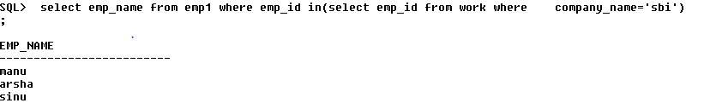

1. Find all employees in the database who live in the same cities as the companiesfor which they work.

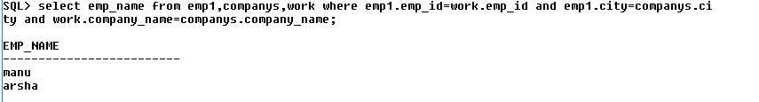

1. Find all employees who earn more than the average salary of all employeesof their company.

select emp_name from emp1 e,work w where e.emp_id=w.emp_id and w.salary>(select avg(salary) from work q where w.company_name=q.company_name);

EMP_NAME

------------

anu

arsha

d. Give all managers of SBI a 10 percent raise

update work set salary=salary+salary*0.1 where company_name='sbi' and emp_id in (select manager_id from manager);

.

select * from work;

EMP_ID COMPANY_NAME SALARY

------------------------- ------------------------- ----------

E01 sbi 253000

E02 hdfc 645980

E04 federal 30000

E07 sbt 320000

E06 sbi 4950000

E03 sbi 77000

E08 hdfc 390000

e. Find the company that has the most employees

select company_name from work,emp1 group by company_name having count(emp_name)=(select max(count(emp_name)) from work,emp1 group by company_name);

COMPANY_NAME

-------------

sbi

f. Find those companies whose employees earn a higher salary, on average than the

average salary at Indian Bank.

select company_name from work GROUP BY company_name having avg(salary)>(select avg(salary) from work where company_name='indianbank' GROUP BY company_name);

no rows selected

g. Query to find name and salary of all employees who earn more than each employee

of ‘Indian Bank’

select emp_name,salary from work,emp1 where salary>(select max(salary) from work where company_name='indianbank' group by company_name) and emp1.emp_id=work.emp_id;

no rows selected

create table emp1(Emp_id varchar(10)check(Emp_id like 'E%')primary key,emp_name varchar(25),str eet_no number,city varchar(25));

create table companys(company_name varchar(25) primary key,city varchar(25));

create table work(emp_id varchar(25) references emp(emp_id),company_name varchar(25) reference s company(company_name),salary integer);

create table manager(emp_id varchar(10) references emp1(emp_id),manager_id varchar(25) references emp1(emp_id));

insert into emp1 values('E01','manu',001,'kollam');

select * from emp1;

EMP_ID EMP_NAME STREET_NO CITY

---------- ------------------------- ---------- ------------

E01 manu 1 kollam

E02 anu 2 kochi

E03 sinu 3 thrisuur

E04 janu 5 wayand

E06 arsha 203 kollam

E07 sree 59 gujarat

E08 gayu 900 pershya

insert into companys values('sbi','kollam');

select * from companys;

COMPANY_NAME CITY

------------------------- -------------

sbi kollam

hdfc thrichi

muthoot thrisuur

federal kovalam

wc kollam

sbt goa

wc kollam

sbt goa

insert into work values('E01','sbi',230000);

select *from work;

EMP_ID COMPANY_NAME SALARY

------------------------- ------------------------- ----------

E01 sbi 253000

E02 hdfc 645980

E04 federal 30000

E07 sbt 320000

E06 sbi 4950000

E03 sbi 77000

E08 hdfc 390000

select * from manager;

EMP_ID MANAGER_ID

---------- ------------

E04 E01

E03 E02

E07 E06