**C03**

**1. Work with built-in packages**

|  |
| --- |
| Date and time  Importdatetime |
|  | t=datetime.time(12,54,20,11) |
|  | print(t) |
|  | print("hour",t.hour) |
|  | print("minute",t.minute) |
|  | print("seond",t.second) |
|  | print("microsecond",t.microsecond) |
|  | print() |
|  | d=datetime.date.today() |
|  | print(d) |
|  |  |
|  | print("year",d.year) |
|  | print("month",d.month) |
|  | print("day",d.day) |
|  | print() |
|  | d1=datetime.date.today() |
|  | print(d1) |
|  | td=datetime.timedelta(days=3) |
|  | print(td) |
|  | d2=d1+td |
|  | print(d2) |
|  | print() |
|  | dt=datetime.datetime.combine(d,t) |
|  | print(dt)  **output:** |

*Calender*

import calendar

mm=int(input("enter month:"))

yy=int(input("enter year:"))

print(calendar.month(yy,mm))

print(calendar.calendar(2021))

*output:*

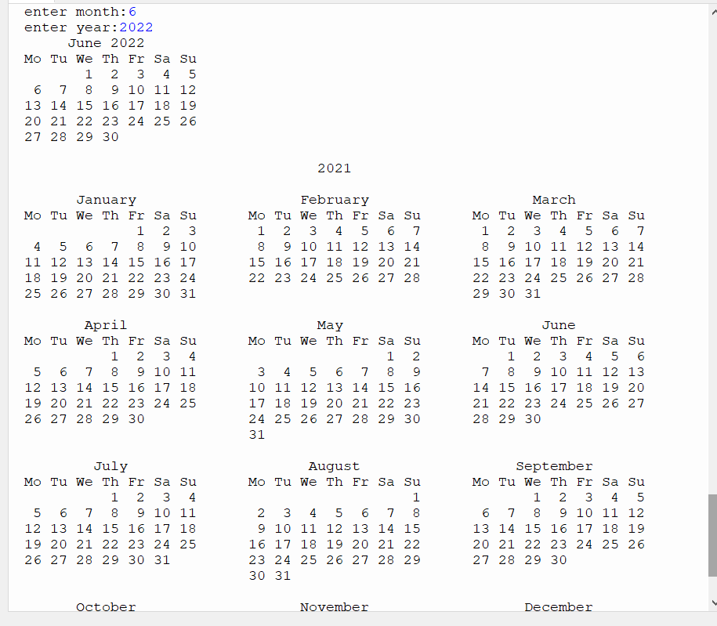

*Math*

*import math*

*print(math.pi)*

*import math as m*

*print(m.pi)*

*from math import pi,sqrt*

*print(math.pi,math.sqrt(4))*

*from math import pi,sqrt*

*print(pi,sqrt(4))*

*print(math.cos(90))*

*print(math.sin(45))*

*print(math.tan(30))*

*output:*

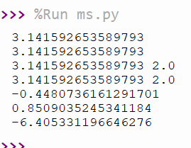

**Random**

|  |
| --- |
| importrandom |
|  | l1 = [1, 2, 3, 4, 5, 6] |
|  | print(random.choice(l1)) |
|  | random.seed(4) |
|  | print(random.random()) |
|  | print(random.random()) |
|  | r1=random.randint(1,2) |
|  | print(r1) |

**Output**

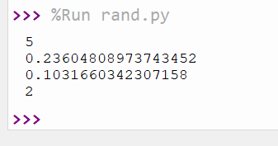

**Statistic**

|  |
| --- |
| import statistics |
|  | l1=[4,7,8,2,3,4,5,7,8,9,0,7,1] |
|  | a=statistics.mean(l1) |
|  | print(a) |
|  | b=statistics.median(l1) |
|  | print(b) |
|  | c=statistics.mode(l1) |
|  | print(c) |
|  | d=statistics.stdev(l1) |
|  | print(d) |
|  | e=statistics.variance(l1) |
|  | print(e) |

**Output:**

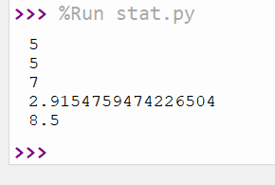

**Time**

|  |
| --- |
| import time |
|  | print("current time in sec",time.time()) |
|  | print("current time ",time.ctime()) |
|  | print("current time sfter 30 sec",time.ctime(time.time()+30)) |
|  | t=time.localtime() |
|  | print(" time ",t) |
|  | print("current year",t.tm_year) |
|  | print("current month",t.tm_mon) |
|  | print("current day",t.tm_mday) |
|  | print("current hour",t.tm_hour) |
|  | print("current week",t.tm_wday) |
|  | print("day of year",t.tm_yday) |

Output

