**Co5**

**1.write a program to read a file line by line and store it into a list.**

f1=open("file.txt","r")

print(f1.readline())

print(f1.readline())

print(f1.readline())

f1.seek(0,0)

print(f1.readlines())

print()

**file.txt**

hi!

My name is c,

iam currently

**output:**

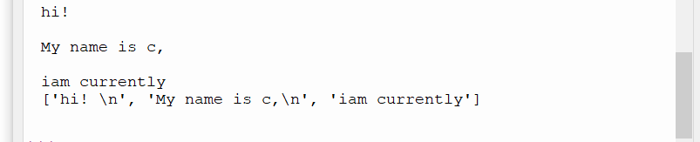

**2.Python program to copy odd lines of one file to other.**

fn = open('fil1.txt', 'r')

fn1 = open('fil2.txt', 'w')

cont = fn.readlines()

type(cont)

for i in range(0, len(cont)):

if(i%2!=0):

fn1.write(cont[i])

else:

pass

fn1.close()

fn1 = open('fil2.txt', 'r')

fn=open('fil1.txt','r')

cont1 = fn1.read()

print(cont1)

fn.close()

fn1.close()

**fil1.txt**

this is 1

this is 2

this is 3

this is 4

this is 5

**output:**

