**co2**

**1. Program to find the factorial of a number**

n=int(input("enter a number"))

f=1

for i in range(1,n+1):

f=f*i

print("factorial",f)

output:

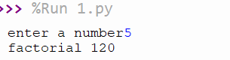

**2. Program to find the factorial of a number**

n=int(input("enter a limit"))

a=0

b=1

c=0

i=0

print("fibonacci series")

while(i<=n):

print(c,end=" ")

i=i+1

a=b

b=c

c=a+b

output:

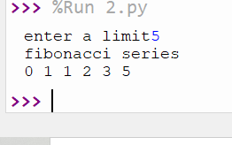

**3. Find the sum of all items in a list**

l1=[2,4,5,6,2]

a=sum(l1)

print(a)

output:

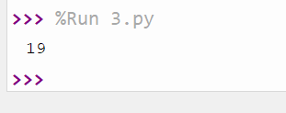

**4. Generate a list of four digit numbers in a given range with all their digits even and the number is a perfect square.**

from math import sqrt as s for i in range(1000,10000):

if s(i)==int(s(i)) and i%2==0: print(i,end=" ")

output:

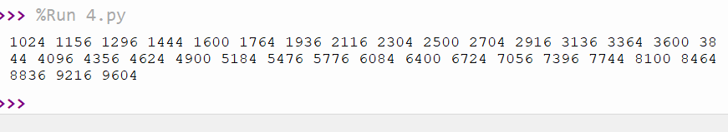

**5. Display the given pyramid with step number accepted from user. Eg: N=4 1 2 4 3 6 9 4 8 12 16**

n=int(input("enter a number"))

for i in range(1,n+1):

for j in range(1,i+1):

print(i*j,end= " ")

print()

output:

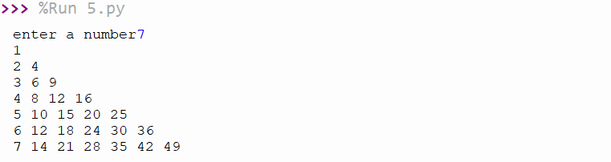

**6. Count the number of characters (character frequency) in a string**

test_str=str(input("Enter the string : "))

freq = {}

for i in test_str:

if i in freq:

freq[i] += 1

else:

freq[i] = 1

print ("Count of all characters : "+ str(freq))

**output**

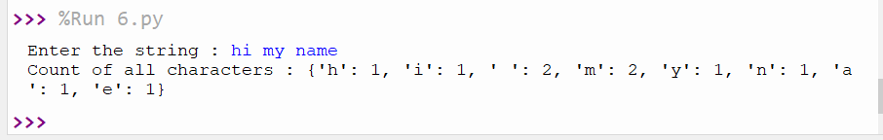

**7. Add ‘ing’ at the end of a given string. If it already ends with ‘ing’, then add ‘**ly’

str=input("input string:")

print("Entered string:",str)

if(str.endswith("ing")):

str=str+'ly'

else:

str=str+'ing'

print("format string:",str)

**output:**

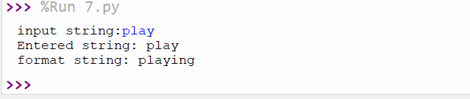

**8. Accept a list of words and return length of longest word**

a=[]

n= int(input("Enter the number of elements in list:"))

for x in range(0,n):

element=input("Enter element "+ str(x+1))

a.append(element)

max1=len(a[0])

temp=a[0]

for i in a:

if(len(i)>max1):

max1=len(i)

temp=i

print("Longest Word:",temp,sep=",")

print("Length of longest word :",max1)

**output:**

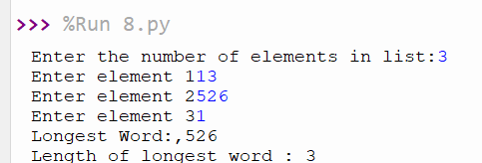

**9. Construct following pattern using nested loop * * * * * * * * * * * * * * * * * * * * * * * * \***

n= int(input("Enter the limit:"))

for i in range(n):

for j in range(i):

print ('* ', end="")

print('')

for i in range(n,0,-1):

for j in range(i): print('* ', end="")

print('')

**output:**

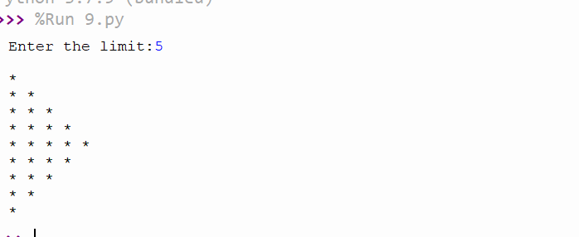

**10. Generate all factors of a number.**

def factors(x):

for i in range(1,x+1):

if(x%i==0):

print(i)

n=int(input("enter a elements"))

factors(n)

**output:**

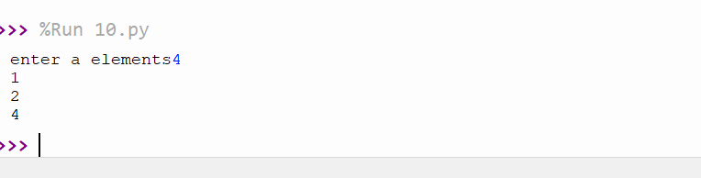

**11. Write lambda functions to find area of square, rectangle and triangle**

import math

arsq=lambda a:a*a

arrec=lambda l,b:l*b

artr=lambda l,b:1/2*l*b

print("area=",arsq(4))

print("area=",arrec(4,2))

print("area=",artr(2,4))

**output:**

