**Boku Wa Shinitai**

**MyMajeksServer  
Analysis Class Report**

**Revision History**

|  |  |  |  |  |
| --- | --- | --- | --- | --- |
| **Authors** | **Description of Change** | **Sections** | **Rev** | **Date** |
|  |  |  |  |  |
|  |  |  |  |  |

**Table of Contents**

1 Team Description 4

2 Project Description 4

2.1 Analysis Class Diagram 5

2.2 Analysis Class List 6

2.2.1 <Analysis Class 1 Name> 6

2.2.2 <Analysis Class 1 Name> 6

# Team Description

|  |  |
| --- | --- |
| **Team Member Name** | **Email Address** |
| Aatib Abdullah | aatibabdullah@csu.fullerton.edu |
| Aarib Abdullah | aarib@csu.fullertone.edu |
| Andrew Shaker | ashaker@csu.fullerton.edu |
| Sami Halwani | 4sakenmage1@csu.fullerton.edu |
|  |  |
|  |  |

# Project Description

**Statement of Purpose:**

The purpose of MyMajeks is to create an easy to use communication platform for casual users, gamers, and business environments which allows the user to connect with peers, create lobbies for voice, text, and video chat, and give live updates of activity of other users they are connected to.

TLDR: Communication platform that allows users to communicate with peers.

**Detailed Description:**

The application will consist of 2 main parts:

* Users
* Channels

**The User:**

The User will have to create an account using an email or username, and a password to log in. The user will have the ability to customize their account by changing their DisplayName. The user will also have the option to host private lobbies. Lobbies will default to close on login (Busy), unless the user changes their user/lobby status. The user/lobby statuses will include:

* + Available - Open for all users (Can customize to allow certain users to wait for an acceptation to the lobby)
  + Away – User is idle, but still available to host lobbies
  + Busy – User is in another Lobby or has closed their lobby
  + Offline - User is offline and cannot host lobbies.

Users will also have access to a friend’s list, where they can find their peer’s usernames to add them. By adding friends, you will be able to freely communicate with them using a direct text chat, Lobby hosted voice, video or audio chat. The friend’s activity will automatically show up in the Primary Users Feed unless otherwise specified. These private lobbies will also allow for multiple users (2+).

**Communication Lobby:**

Users will be able to connect with friends in custom group lobbies. Each Lobby will include a new text Channels, voice and video with IDs for each personal conversation. Within the Channel, and all users will receive notification of any text updates.

Channel Properties

* + Channels will include voice Channels text, And Video
  + Text:
    - Allow strings for up to 2,000 characters (Constant character count) to be posted within text chat
  + Voice:
    - Users will be able to initiate Voice Call with other users
  + Video:
    - Users will be able to initiate Video Calls with others st

## Analysis Class Diagram

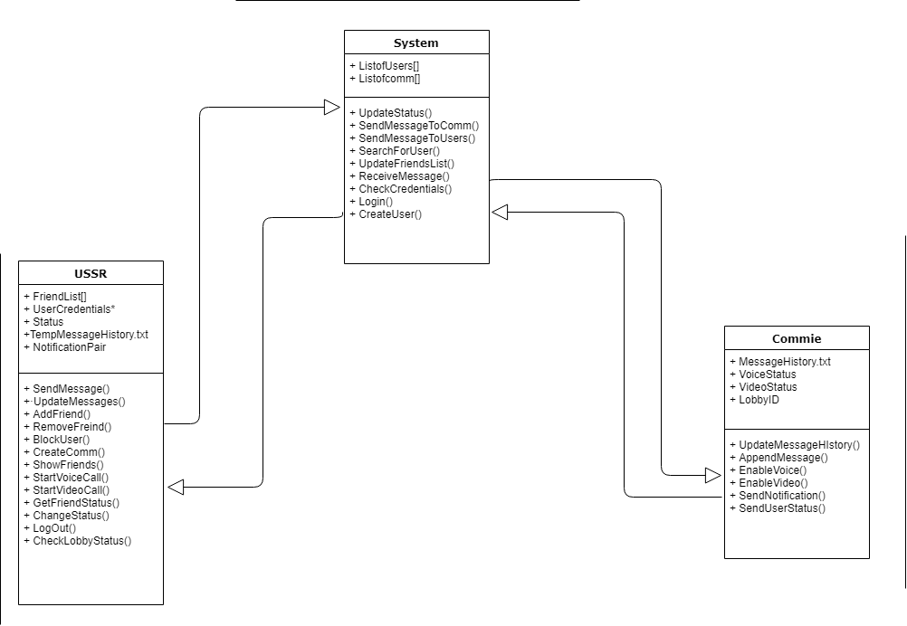

## Analysis Class List

|  |  |
| --- | --- |
| **Sequence Number** | **Analysis Class** |
| 1 | User Class |
| 2 | System Class |
| 3 | Comm Class |
| 4 |  |
| 5 |  |
| 6 |  |

### <User Class>

Description: User controlled accounts in which individuals can use as a proxy to communicate amongst each other or update status to express their current activity.

Methods:

* SendMessage()
* UpdateMessages()
* AddFriend()
* RemoveFriend()
* BlockUser()
* CreateComm()
* ShowFriends()
* StartVoiceCall()
* StartVideoCall()
* GetFriendStatus()
* ChangeStatus()
* LogOut()
* CheckLobbyStatus()

Attributes:

* FriendsList
* BlockedList
* UserCredentials*
* Status
* TempMessageHistory.txt
* NotificationsPair

### <System Class>

Description: The system Class acts as a dispatcher (Middle Man) for the commutation between users, be it amongst others or amongst its self, in text, Voice call and Video Calls. Its main function will be initiate update queries to all users.

Methods:

* UpdateStatus()
* SendMessageToComm()
* SendMessagetoUsers()
* SearchForUser()
* UpdateFriendsList()
* ReceiveMessage()
* CheckCredentials()
* Login()
* CreateUser()

Attributes:

* ListofUsers[]
* ListofComm[]

### <Communication Class >

Description: Lobby in which text documentation is stored along with the status of voice, and video chats.

Methods:

* UpdateMessageHistory()
* AppendMessage()
* EnableVoice()
* EnableVideo()
* SendNotification()
* SendUserStatus()

Attributes:

* MessageHistory.txt
* VoiceStatus
* VideoStatus
* LobbyID