**BOOTSTRAP**

[**https://getbootstrap.com/docs/4.0/components/navbar/**](https://getbootstrap.com/docs/4.0/components/navbar/)

[**https://www.w3schools.com/bootstrap4/bootstrap_navbar.asp**](https://www.w3schools.com/bootstrap4/bootstrap_navbar.asp)

**Code of any Component**

Bootstrap 4 is the newest version of Bootstrap, which is the most popular HTML, CSS, and JavaScript framework for developing responsive, mobile-first websites.

You can create a complete website using bootstrap 4 classes and No CSS.

You can download bootstrap file from <https://getbootstrap.com/docs/4.4/getting-started/download/> , extract it, add **bootstrap.min.css** file into your project and embed in html under head tag as **<link rel = “stylesheet” href = “link of bootstrap file which you add into your project”**

**CDN: Content Delivery Network** (Use cdn link which is faster than offline link but cannot use when you don’t have internet connection)

**PREQUISITES for BOOTSTRAP**

Some links to be added into your webpage before starting bootstrap.

* **Add the HTML5 doctype**

<meta charset="utf-8"> (under head tag)

* **Bootstrap 4 is mobile-first**

<meta name="viewport" content="width=device-width, initial-scale=1"> (under head tag)

* **Bootstrap 4 CDN**

<link rel="stylesheet" href="https://cdn.jsdelivr.net/npm/bootstrap@4.6.1/dist/css/bootstrap.min.css">  
  <script src="https://cdn.jsdelivr.net/npm/jquery@3.5.1/dist/jquery.slim.min.js"></script>  
  <script src="https://cdn.jsdelivr.net/npm/popper.js@1.16.1/dist/umd/popper.min.js"></script>  
  <script src="https://cdn.jsdelivr.net/npm/bootstrap@4.6.1/dist/js/bootstrap.bundle.min.js"></script>

script tag used under body tag at the end

**STARTER TEMPLATE**

<!doctype html>

<html lang="en">

<head>

<!-- Required meta tags -->

<meta charset="utf-8">

<meta name="viewport" content="width=device-width, initial-scale=1, shrink-to-fit=no">

<!-- Bootstrap CSS -->

<link rel="stylesheet" href="https://maxcdn.bootstrapcdn.com/bootstrap/4.0.0/css/bootstrap.min.css" integrity="sha384-Gn5384xqQ1aoWXA+058RXPxPg6fy4IWvTNh0E263XmFcJlSAwiGgFAW/dAiS6JXm" crossorigin="anonymous">

<title>Hello, world!</title>

</head>

<body>

<h1>Hello, world!</h1>

<!-- Optional JavaScript -->

<!-- jQuery first, then Popper.js, then Bootstrap JS -->

<script src="https://code.jquery.com/jquery-3.2.1.slim.min.js" integrity="sha384-KJ3o2DKtIkvYIK3UENzmM7KCkRr/rE9/Qpg6aAZGJwFDMVNA/GpGFF93hXpG5KkN" crossorigin="anonymous"></script>

<script src="https://cdnjs.cloudflare.com/ajax/libs/popper.js/1.12.9/umd/popper.min.js" integrity="sha384-ApNbgh9B+Y1QKtv3Rn7W3mgPxhU9K/ScQsAP7hUibX39j7fakFPskvXusvfa0b4Q" crossorigin="anonymous"></script>

<script src="https://maxcdn.bootstrapcdn.com/bootstrap/4.0.0/js/bootstrap.min.js" integrity="sha384-JZR6Spejh4U02d8jOt6vLEHfe/JQGiRRSQQxSfFWpi1MquVdAyjUar5+76PVCmYl" crossorigin="anonymous"></script>

</body>

</html>

**Classes of Bootstrap (CSS vs BOOTSTRAP)**

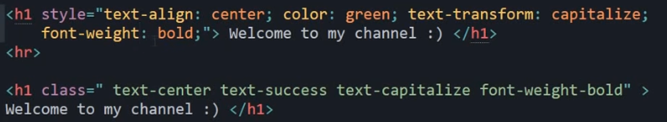

The classes for text colors are: .text-muted, .text-primary, .text-success, .text-info, .text-warning, .text-danger, .text-secondary, .text-white, .text-dark, .text-body (default body color/often black) and .text-light

The classes for background colors are: .bg-primary, .bg-success, .bg-info, .bg-warning, .bg-danger, .bg-secondary, .bg-dark and .bg-light

**NAVBAR Code in Bootstrap**

<nav class="navbar navbar-expand-lg navbar-light bg-light"> **//bg-light and navbar-light are classes of nav tag**

<a class="navbar-brand" href="#">Navbar</a>

<button class="navbar-toggler" type="button" data-toggle="collapse" data-target="#navbarSupportedContent" aria-controls="navbarSupportedContent" aria-expanded="false" aria-label="Toggle navigation">

<span class="navbar-toggler-icon"></span>

</button>

<div class="collapse navbar-collapse" id="navbarSupportedContent">

<ul class="navbar-nav **mr-auto**"> **//mr represents margin right (this will show your navbar in left position. If you want to show in right side the use ml-auto)**

<li class="nav-item active">

<a class="nav-link" href="#">Home <span class="sr-only">(current)</span></a>

</li>

<li class="nav-item">

<a class="nav-link" href="#">Link</a>

</li>

<li class="nav-item dropdown">

<a class="nav-link dropdown-toggle" href="#" id="navbarDropdown" role="button" data-toggle="dropdown" aria-haspopup="true" aria-expanded="false">

Dropdown

</a>

<div class="dropdown-menu" aria-labelledby="navbarDropdown">

<a class="dropdown-item" href="#">Action</a>

<a class="dropdown-item" href="#">Another action</a>

<div class="dropdown-divider"></div>

<a class="dropdown-item" href="#">Something else here</a>

</div>

</li>

<li class="nav-item">

<a class="nav-link disabled" href="#">Disabled</a>

</li>

</ul>

<form class="form-inline my-2 my-lg-0">

<input class="form-control mr-sm-2" type="search" placeholder="Search" aria-label="Search">

<button class="btn btn-outline-success my-2 my-sm-0" type="submit">Search</button>

</form>

</div>

</nav>

**NOTE:** Add a **white** text color to all links in the navbar with the .navbar-dark class, or use the .navbar-light class to add a **black** text color.



**CAROUSEL Code in Bootstrap**

**HEAD Tag**

<style>

/* Make the image fully responsive */

.carousel-inner img {

width: 100%;

height: 100%;

}

</style>

**BODY Tag**

<div id="demo" class="carousel slide" data-ride="carousel">

<ul class="carousel-indicators">

<li data-target="#demo" data-slide-to="0" class="active"></li>

<li data-target="#demo" data-slide-to="1"></li>

<li data-target="#demo" data-slide-to="2"></li>

</ul>

<div class="carousel-inner">

<div class="carousel-item active">

<img src="la.jpg" alt="Los Angeles" width="1100" height="500">

<div class="carousel-caption">

<h3>Los Angeles</h3>

<p>We had such a great time in LA!</p>

</div>

</div>

<div class="carousel-item">

<img src="chicago.jpg" alt="Chicago" width="1100" height="500">

<div class="carousel-caption">

<h3>Chicago</h3>

<p>Thank you, Chicago!</p>

</div>

</div>

<div class="carousel-item">

<img src="ny.jpg" alt="New York" width="1100" height="500">

<div class="carousel-caption">

<h3>New York</h3>

<p>We love the Big Apple!</p>

</div>

</div>

</div>

<a class="carousel-control-prev" href="#demo" data-slide="prev">

<span class="carousel-control-prev-icon"></span>

</a>

<a class="carousel-control-next" href="#demo" data-slide="next">

<span class="carousel-control-next-icon"></span>

</a>

</div>



**BOOTSTRAP CONTAINER**

Containers are used to pad the content inside of them, and there are two container classes available:

1. The .container class provides a responsive **fixed width container**
2. The .container-fluid class provides a **full width container**, spanning the entire width of the viewport



**Fixed Container:** Use the .**container** class to create a responsive, fixed-width container.

Note that its width (max-width) will change on different screen sizes:

|  | **Extra small <576px** | **Small ≥576px** | **Medium ≥768px** | **Large ≥992px** | **Extra large ≥1200px** |
| --- | --- | --- | --- | --- | --- |
| max-width | 100% | 540px | 720px | 960px | 1140px |
|  |  |  |  |  |  |

Open the example below and resize the browser window to see that the container width will change at different breakpoints:

### Example

<div class="container">  
  <h1>My First Bootstrap Page</h1>  
  <p>This is some text.</p>   
</div>

## Fluid Container: Use the .container-fluid class to create a full width container that will always span the entire width of the screen (width is always 100%):

### Example

<div class="container-fluid">  
  <h1>My First Bootstrap Page</h1>  
  <p>This is some text.</p>   
</div>

**BOOTSTRAP 4 GRIDS**

Bootstrap's grid system is built with flexbox and allows up to 12 columns across the page. If you do not want to use all 12 columns individually, you can group the columns together to create wider columns:

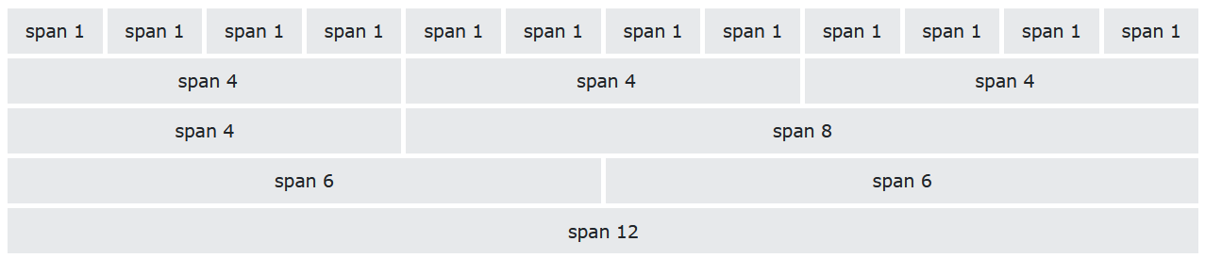

The grid system is responsive, and the columns will re-arrange automatically depending on the screen size.

Make sure that the sum adds up to 12 or fewer (it is not required that you use all 12 available columns).

**Grid Classes:** The Bootstrap 4 grid system has five classes:

* .col- (extra small devices - screen width less than 576px)
* .col-sm- (small devices - screen width equal to or greater than 576px)
* .col-md- (medium devices - screen width equal to or greater than 768px)
* .col-lg- (large devices - screen width equal to or greater than 992px)
* .col-xl- (xlarge devices - screen width equal to or greater than 1200px)

The classes above can be combined to create more dynamic and flexible layouts.

**Tip:** Each class scales up, so if you wish to set the same widths for sm and md, you only need to specify sm

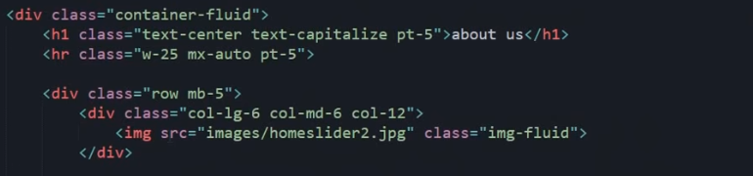

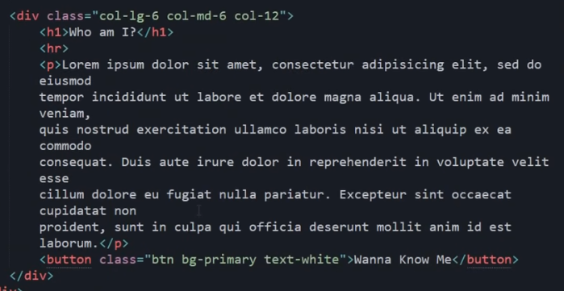

**pt-5**: padding bottom

**w-25**: width of section like div tag

**mx-auto**: margin on left and right side

**col-lg-6**: number of columns in large devices

**col-md-6**: number of columns in mid sized devices

**btn**: class for button

**bg-primary**: background color

**img-fluid**: this is very important class to create responsive image

**mb-5**: margin from bottom with 5px



**BOOTSTRAP CARDS**

A card in Bootstrap 4 is a bordered box with some padding around its content. It includes options for headers, footers, content, colors, etc.

<div class="card" style="width:400px">  
  <img class="card-img-top" src="img_avatar1.png" alt="Card image">  
  <div class="card-body">  
    <h4 class="card-title">John Doe</h4>  
    <p class="card-text">Some example text.</p>  
    <a href="#" class="btn btn-primary">See Profile</a>  
  </div>  
</div>



**Example:**

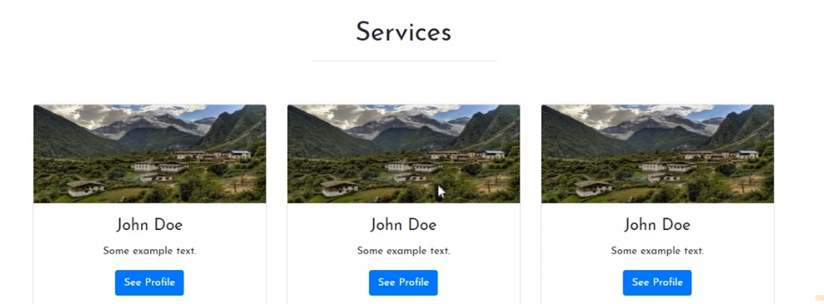

**BOOTSTRAP MODAL**

The Modal component is a dialog box/popup window that is displayed on top of the current page.

<button type="button" class="btn btn-primary" data-toggle="modal" data-target="#myModal">

Open modal

</button>

<div class="modal fade" id="myModal">

<div class="modal-dialog modal-dialog-centered">

<div class="modal-content">

**<!-- Modal Header -->**

<div class="modal-header">

<h4 class="modal-title">Sign Up</h4>

<button type="button" class="close" data-dismiss="modal">&times;</button>

</div>

**<!-- Modal body -->**

<div class="modal-body">

<form class="form-inline" action="/action_page.php">  
  <label for="email">Email address:</label>  
  <input type="email" class="form-control" placeholder="Enter email" id="email" autocomplete=”off” placeholder=”Enter Your Email ID”>  
  <label for="pwd">Password:</label>  
  <input type="password" class="form-control" placeholder="Enter password" id="pwd" autocomplete=”off” placeholder=”Enter Your Password”>  
  <div class="form-check">  
    <label class="form-check-label">  
      <input class="form-check-input" type="checkbox"> Remember me  
    </label>  
  </div>  
  <button type="submit" class="btn btn-primary">Submit</button>  
</form>

</div>

**<!-- Modal footer -->**

<div class="modal-footer">

<button type="button" class="btn btn-secondary" data-dismiss="modal">Close</button>

</div>

</div>

</div>

</div>

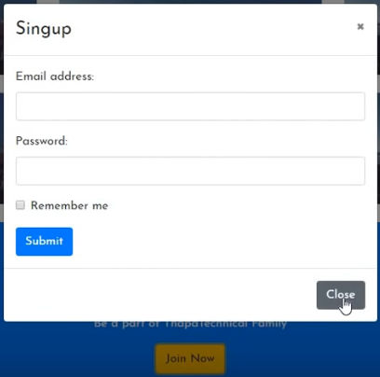

**BOOTSTRAP FLEX:**

<https://www.w3schools.com/bootstrap4/bootstrap_flex.asp>