# **GITHUB SETUP**

# **COMPLETE GIT SSH SETUP | ADD MERN PROJECT IN GITHUB USING SSH KEY**

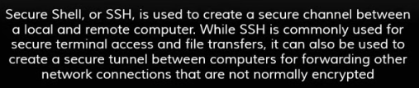

**Steps:**

1. **Open your GitHub Account**
2. **Download Git Bash (using recommended settings)**

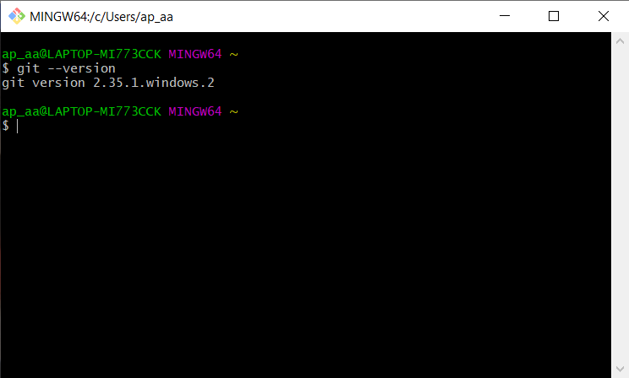

1. **Initialize git for your project**

PS D:\Learning\expresslearning> git status

fatal: not a git repository (or any of the parent directories): .git

PS D:\Learning\expresslearning> git init

Initialized empty Git repository in D:/Learning/expresslearning/.git/

PS D:\Learning\expresslearning> git status

On branch master

No commits yet

Untracked files:

(use "git add <file>..." to include in what will be committed)

**node_modules/ //need not add to git project**

package-lock.json

package.json

public/

src/

nothing added to commit but untracked files present (use "git add" to track)

1. Add a new file to your project named as **.gitignore (it is a plain text file where each line contains a pattern for files/directories to ignore).** Go to that file that type **node_modules** (we don’t want this file to be uploaded on git)
2. Now, we need to add this project onto local system so that it can be tracked:

**PS D:\Learning\expresslearning> git add .**

Add your email and name to git repository:

**git config --global user.email "aayushagarwal4u@gmail.com"**

**git config --global user.name "Aayush Agarwal"**

Now, we need to commit our operations:

**PS D:\Learning\expresslearning> git commit -m "node project first commit"**

Check again status:

**PS D:\Learning\expresslearning> git status**

**On branch master**

**nothing to commit, working tree clean**

1. **Now, create your repository in github by giving its name:**

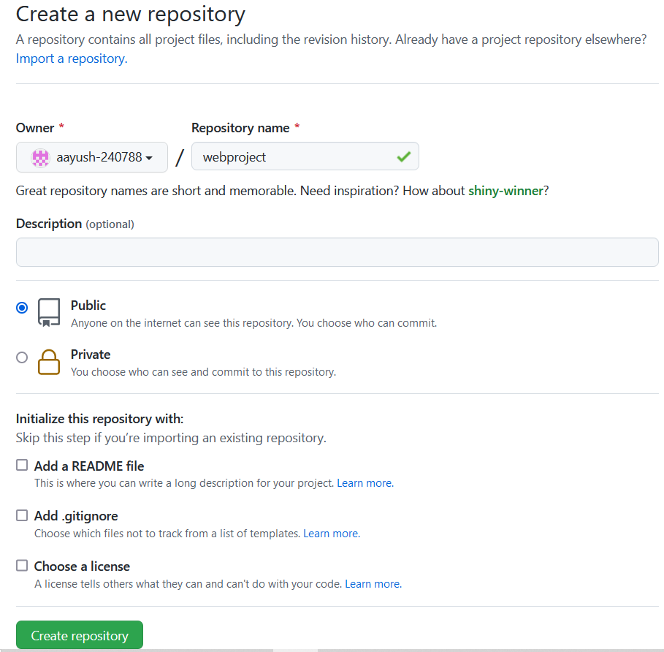

### **Push an existing repository from the command line:**

### git remote add origin <https://github.com/aayush-240788/webproject.git>

### **PS D:\Learning\expresslearning> git remote add origin https://github.com/aayush-240788/webproject.git**

1. **Set up SSH key onto local system (git bash):**

ssh-keygen –t rsa –b 4096 –C “aayushagarwal4u@gmail.com”

Just press enter while asking about passphrase

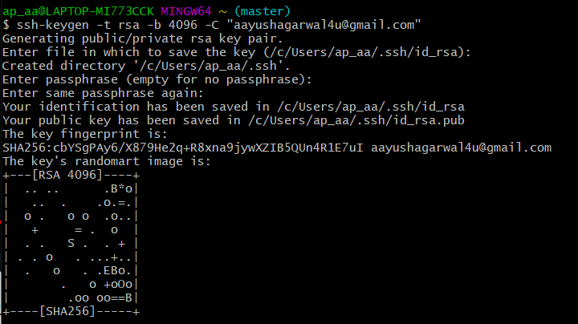

It will generate two keys: **private** and **public**. To check, type:

ls ~/.ssh

**OUTPUT**: id_rsa id_rsa.pub

1. **Add private key on your system and public key onto github repository.**

Before adding the new SSH key to the ssh-agent first ensure the ssh-agent is running by executing:

eval $(ssh-agent –s) **//on git bash**

**OUTPUT:** Agent pid 198  **//return agent id**

**After that you need to add private key onto your system:**

ssh–add ~/.ssh/id_rsa **//on git bash**

**OUTPUT:** Identity added: /c/Users/ap_aa/.ssh/id_rsa ([aayushagarwal4u@gmail.com](mailto:aayushagarwal4u@gmail.com))

1. **Now, add your public key on github account. You need your public key which you got from git bash by typing:**

cat ~/.ssh/id_rsa.pub **//got your public key, add it to github account**

ssh-rsa  aayushagarwal4u@gmail.com

**Copy this public key and add it into your github project**

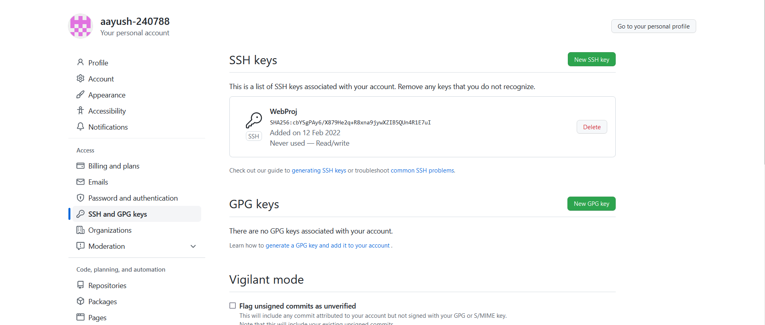

1. **To identify whether secure channel has been created or not, type:**

ssh –T [git@github.com](mailto:git@github.com) **//visual code or git bash**

1. **Finally, now we need to upload our files from local system to github account:**

D:\Learning\expresslearning> git push -u origin master

**NOTE: If you need to update your code from local system to github account:**

1. First you need to add modified code: **git add . //visual code**
2. Commit your operations: **git commit –m “message” //visual code**
3. Finally push your code to github account: **git push //visual code**