_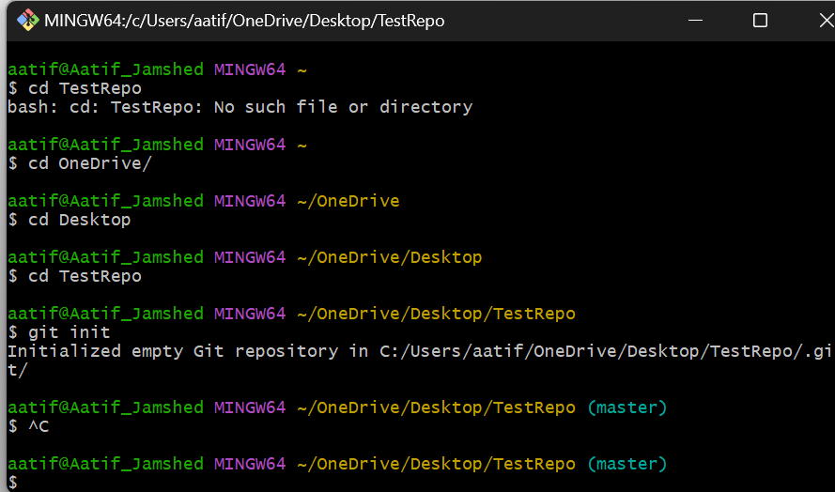

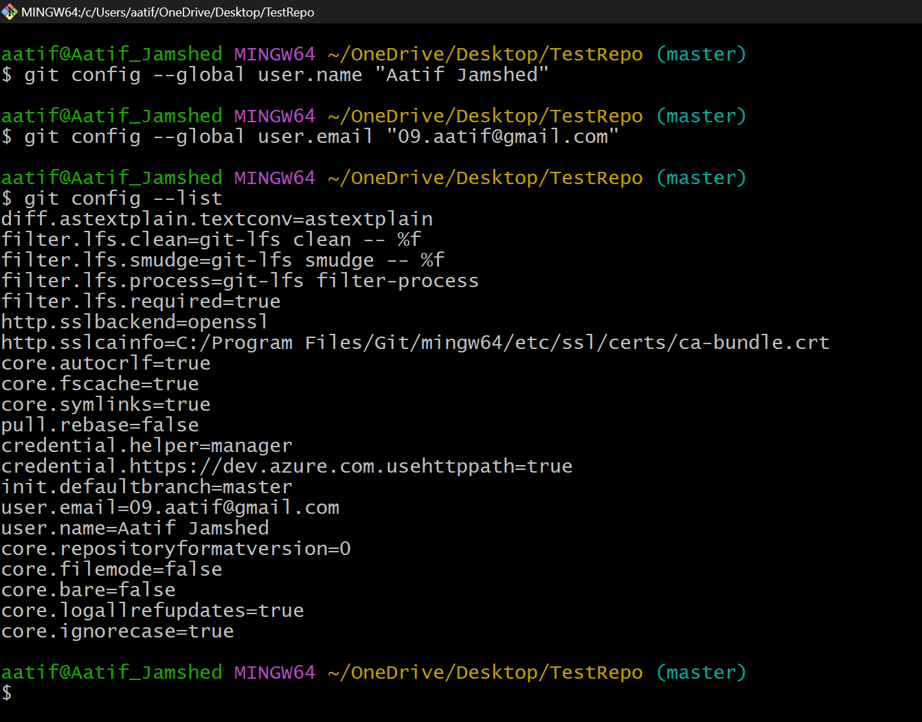

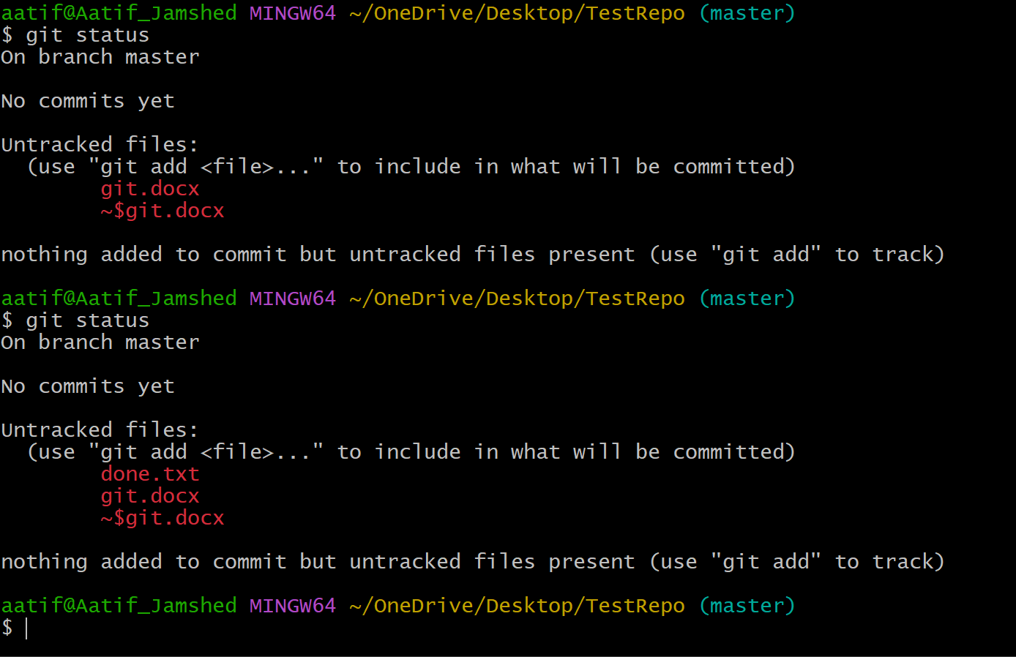

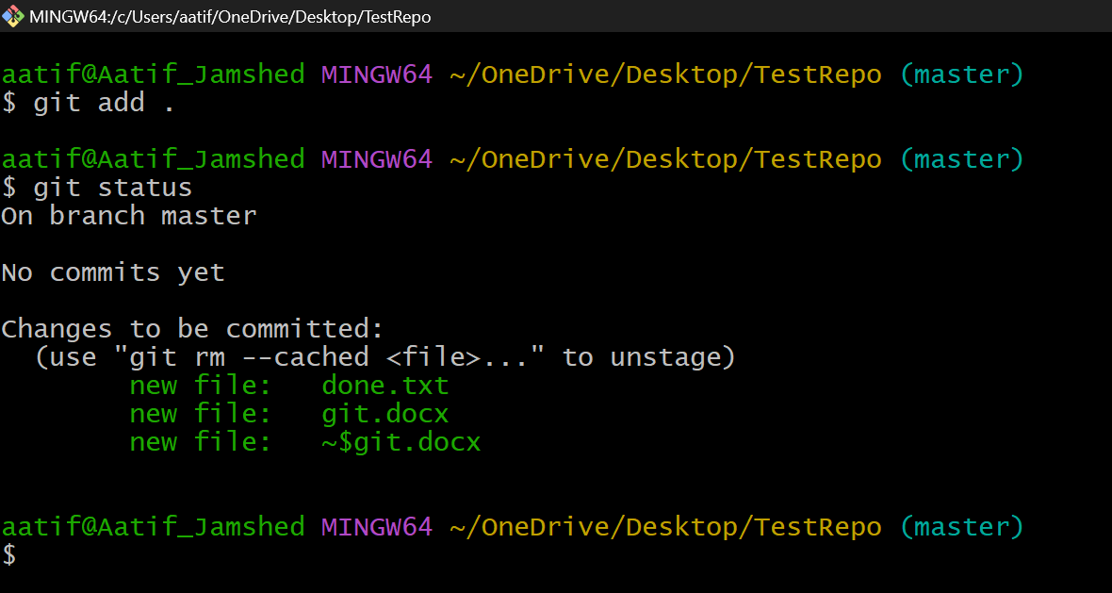

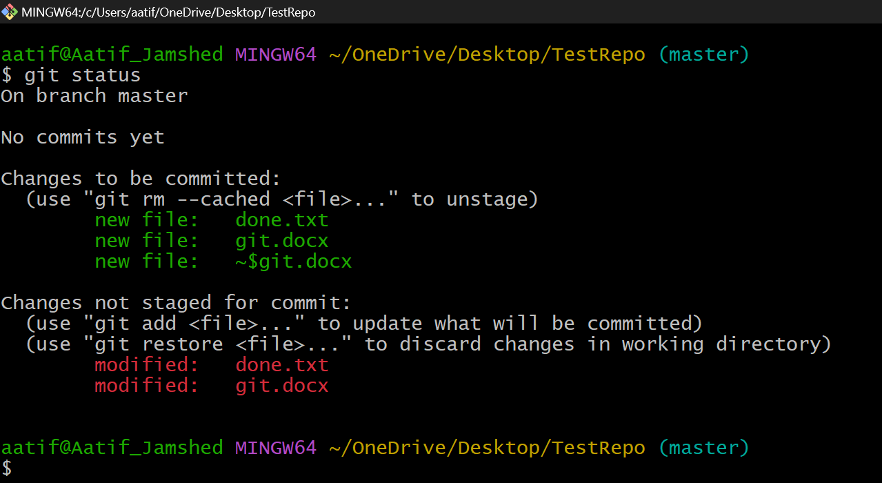

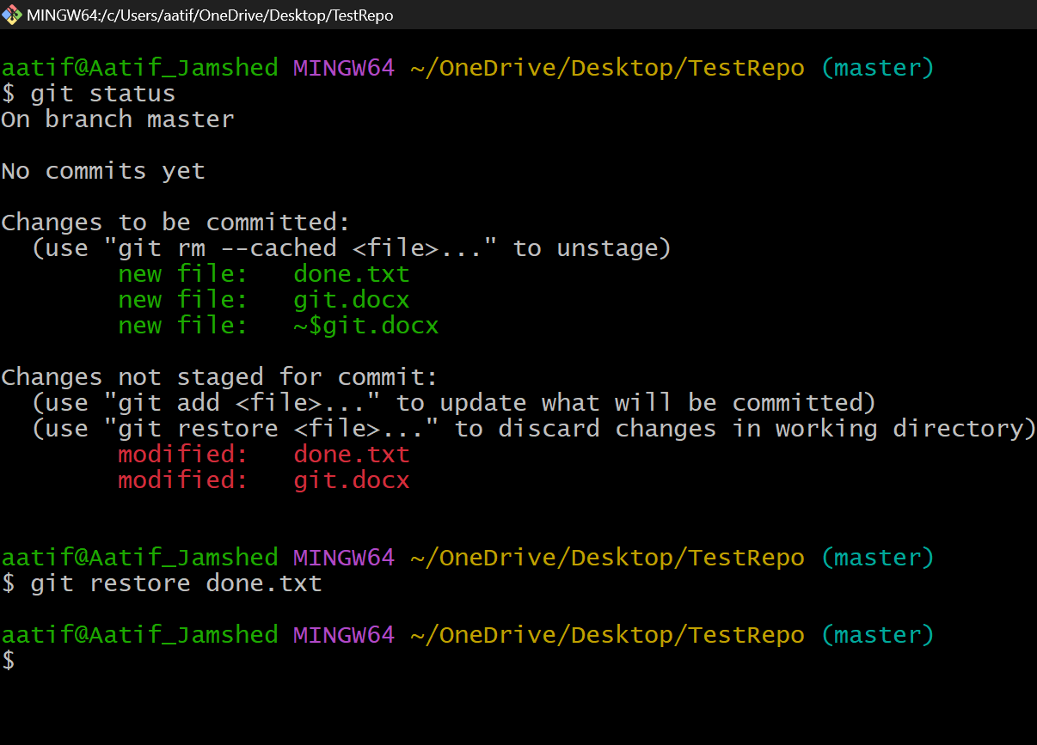

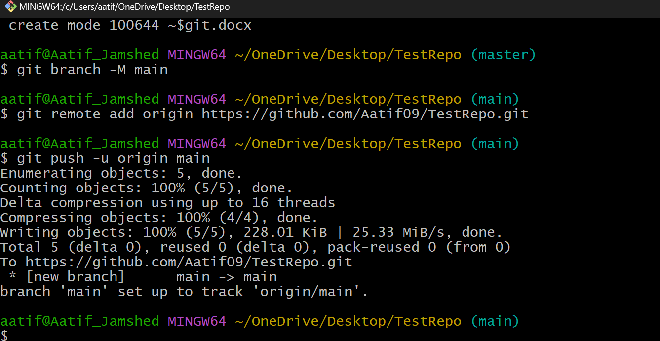

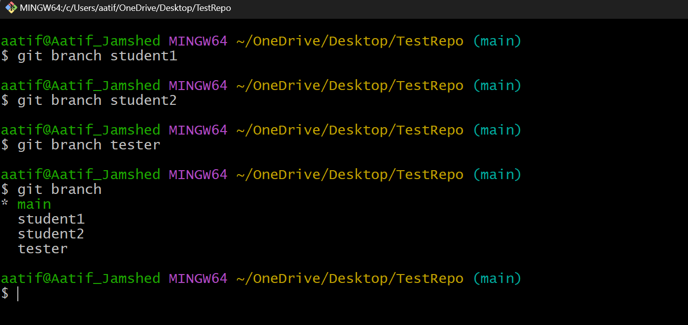

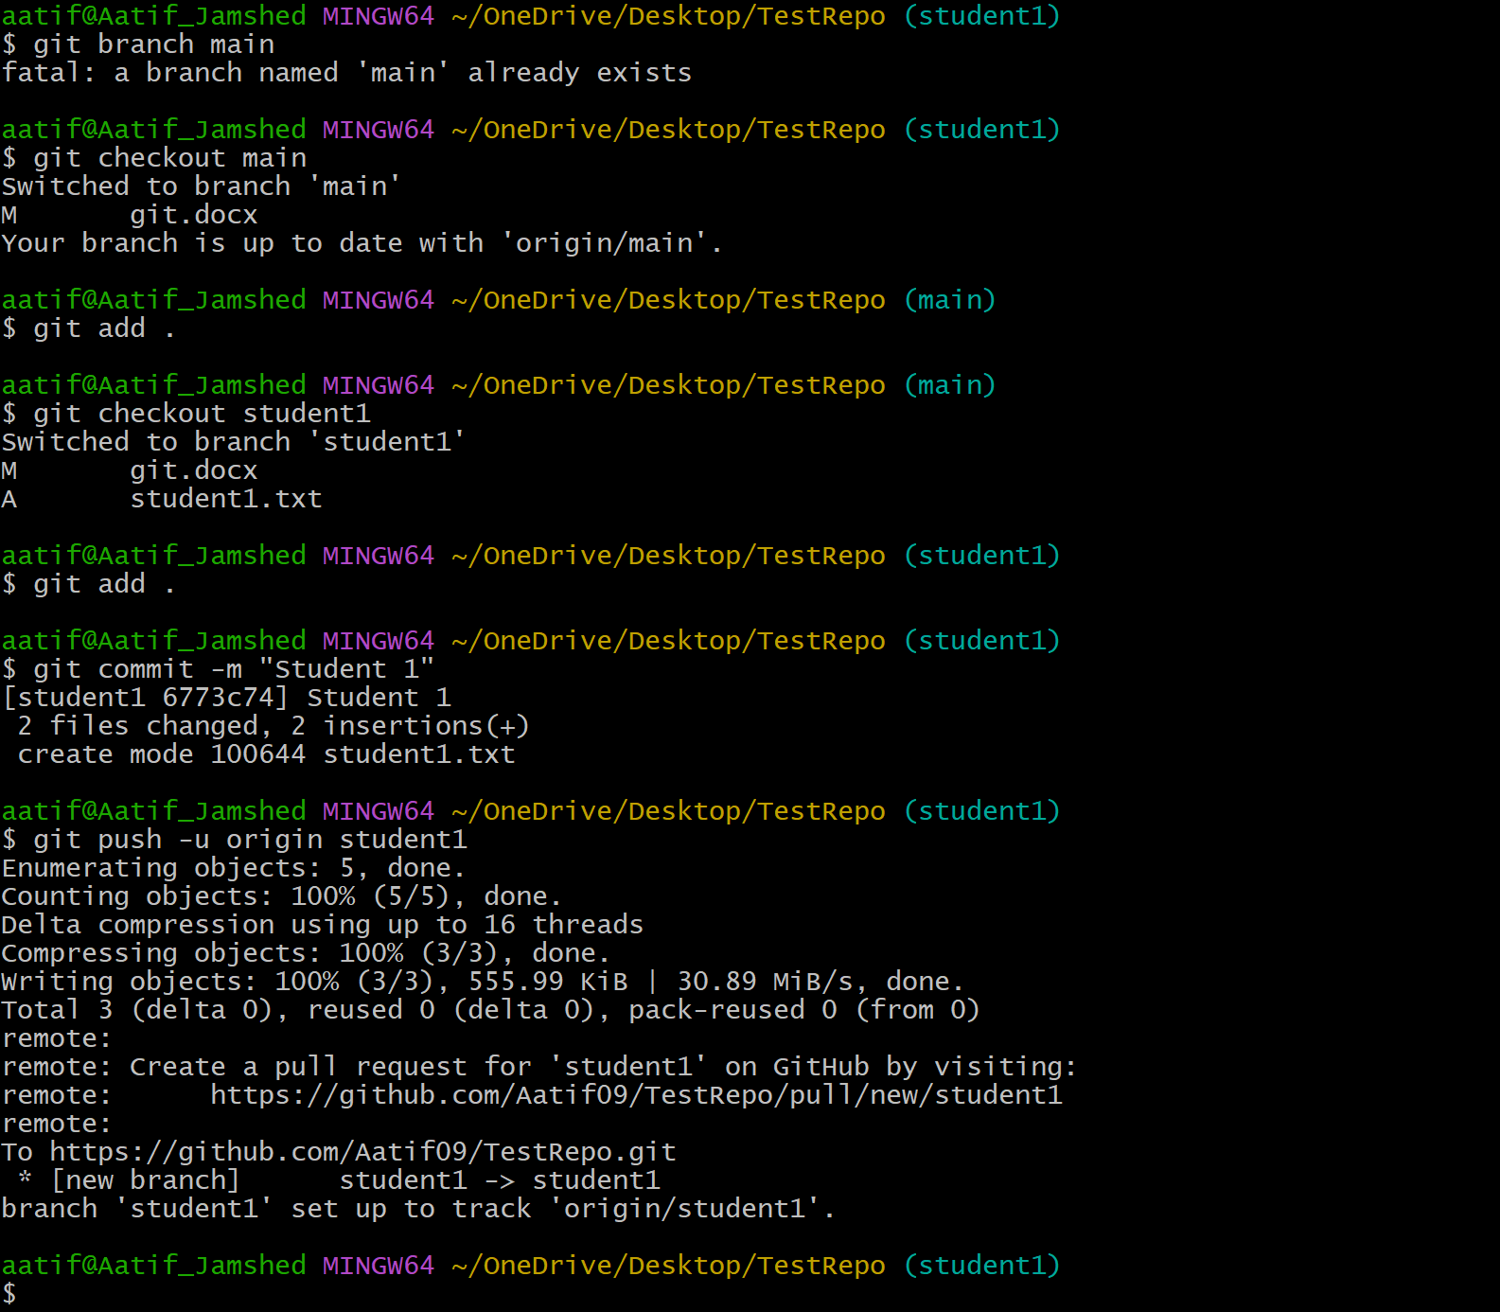

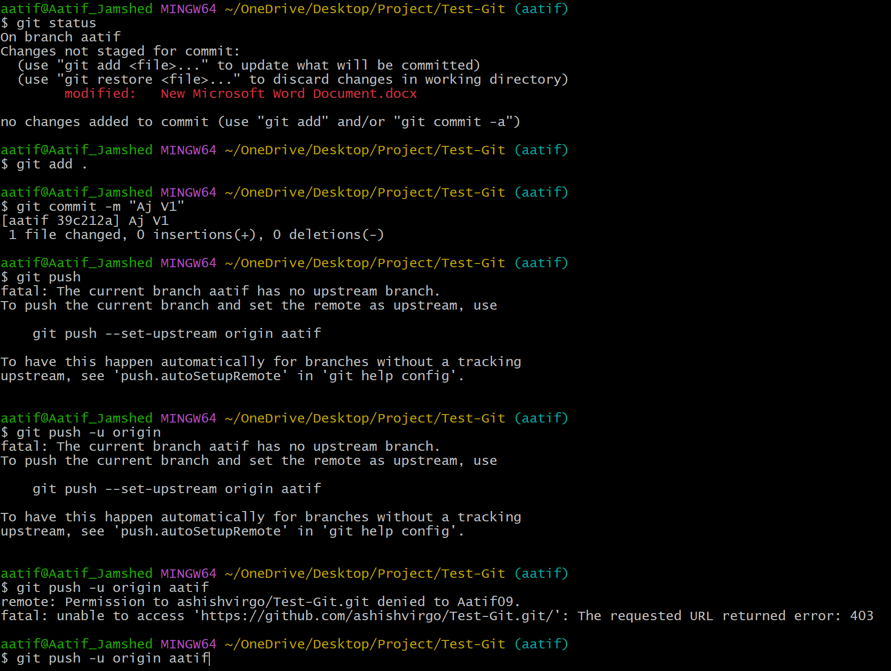

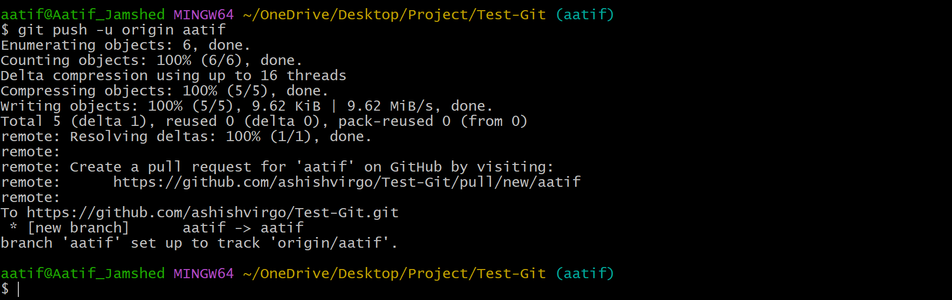

* **git config --global user.name "Aatif Jamshed"**
* **git config --global user.email "09.aatif@gmail.com"**

***At Master End at one laptop***

* git init
* git config --global user.name "Aatif"
* git config --global user.email [09.aatif@gmail.com](mailto:09.aatif@gmail.com)
* git add .
* git commit -m "Version1"
* git remote add origin <https://github.com/Aatif09/CSE.git>
* git status 🡺 On branch **master**
* git branch -M main
* git status 🡺 On branch **main**
* git push origin main
* git branch abhishek
* git branch harsh
* git branch yashi
* git push --set-upstream origin abhishek **or** git push -u origin abhishek
* git push --set-upstream origin harsh
* git push --set-upstream origin yashi
* git push origin main

***At Branch End at another laptop***

* git init
* git clone https://github.com/Aatif09/ELC.git
* cd ELC
* git checkout yashi
* git status 🡺 On branch yashi
* git add .
* git commit -m "my files"
* git push -u origin yashi

The command **git branch -M main** renames the default branch (which used to be master in older versions of Git) to **main**.

* If you **do not** run this command, your branch will remain named master, and your push will try to push to the **master** branch instead of **main**.
* Since many new GitHub repositories default to having a **main** branch skipping the git branch -M main command may result in a situation where your local branch is **master**, but the remote repository expects the **main** branch.

The error you're encountering is because there is a conflict between the local repository and the remote repository (on GitHub). Specifically, you've edited the README.md file on GitHub, but your local repository doesn't have these changes, leading to a "non-fast-forward" error.

* git pull origin main **--allow-unrelated-histories**
* git push origin main

**Renaming Local and Gihub & Merging**

* **git init**
* **git branch -M main**
* **git remote add origin https://github.com/Aatif09/check.git**
* **git add .**
* **git commit -m "v1"**
* **git fetch origin**
* **git merge origin/main**

**or**

**git merge origin/main --allow-unrelated-histories**

* **git push -u origin main**