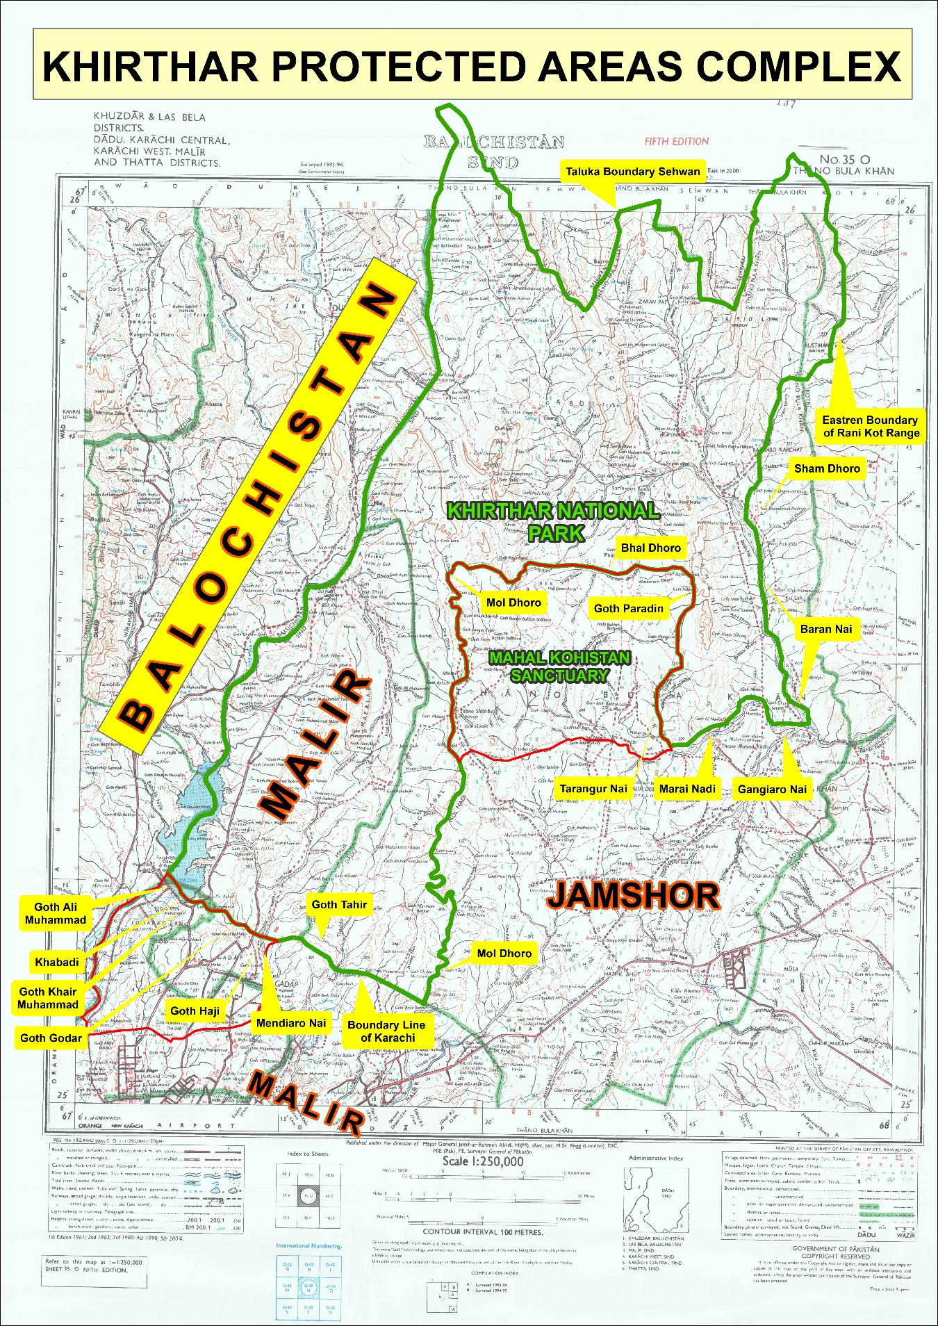
This report was published by the Gul Hassan Kalmatti Academy for the 3rd Gul Hassan Kalmatti Conference 2026, titled “Kirthar: A Man-Made Disaster.”

Introduction
Sindh, one of the four provinces of Pakistan, holds immense environmental significance due to its diverse ecosystem, rich biodiversity, and unique geographical features. From the vast Indus River Delta to the arid landscapes of Thar Desert and Khirthar Mountain Range, Sindh is home to a variety of ecosystems that support both human and wildlife populations. However, rapid urbanization, industrialization, and climate change pose significant threats to the region’s natural resources, making it imperative to understand and address these challenges.
The Khirthar Protected Areas Complex (KPAC) stretches over 4,350km2 , and comprises of Khirthar National Park (3,087km2 ), Mahal Kohistan Wildlife Sanctuary (705.7 km2 ), Hub Dam Wildlife Sanctuary (272 km2 ), Surjan Game Reserve, Sumbak Game Reserve, Eri Game Reserve, and Huthiano Game Reserve (285.3km2 ) (Khan et al., 2013).
Kirthar National Park is one of Pakistan’s largest and most ecologically significant protected areas, located in the rugged Kirthar Mountain Range of Sindh province. Established in 1974.
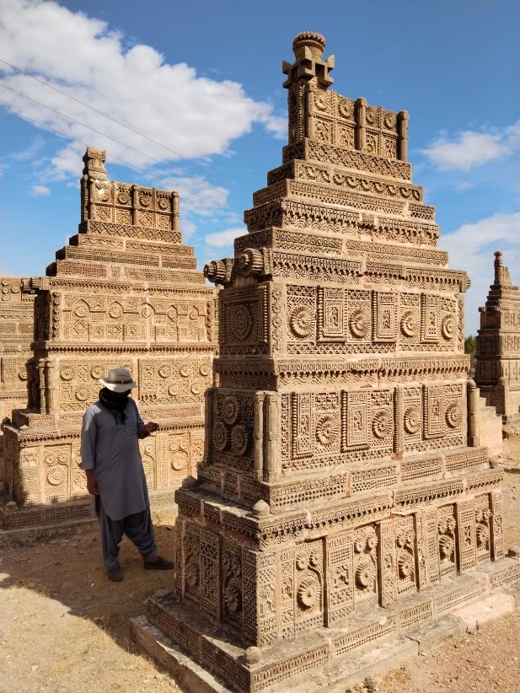
Khirthar are not just geography but a living book of history. Across these valleys, mountain passes, and plains lie scattered traces of human life spanning centuries. There are remnants of ancient settlements, human stories engraved on rocks, old graveyards, and archaeological remains that have yet to undergo formal scientific study. Many of these sites still exist on the ground, yet they remain unseen by state institutions and the wider world.
For example, the rock engravings found in the Thano Bula Khan Rock Art Caves testify that human activity existed in this region thousands of years ago. Likewise, the grand historical fortress of Ranikot Fort further underscores the historical significance of the entire region. And several Chowkundi Style and Rock Carving graveyards in this park like Jam Lohar Chowkkundi graveyard, Taung, Bazar Graveyard, Kund wari Roomi .
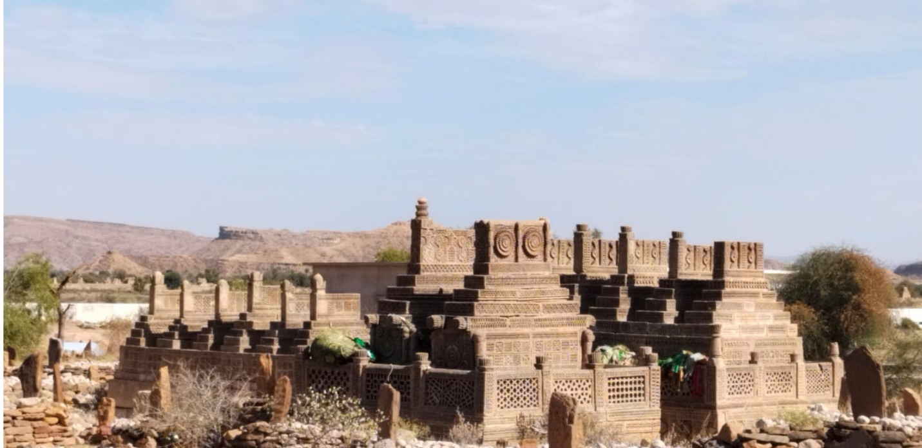
Jam Lohar Graveyard , Taung
Researcher, Historian and, Gul Hassan Kalmatti, writes
When Vision 2020 was announced, the villages of Malir District did not include the 12 Dehs of Kathore, Boyal, Langheji, Bolhari, Hudarwah, Karmatiyani, Lath and Old Union Council Moidan. 12 Dehs of Moidan which are included in Wildlife Khar Sanctuary. Kathore, Boyal, Langheji, Bolhari, Gadap, Hudarwah, Karmatiyani Latt are in the Wildlife Support Area and were completely protected due to being in mountainous areas. The whole area where Bahria Town is being built is hilly and lush, with huge mountains flowing with water and in some places dense forests. The mountains are being destroyed because of the Bahria Town project. According to international law, no mountain or peak above 55 feet can be broken. The area around Bahria Town has hundreds of peaks ranging from 700 to 1000 feet.
1972 Under the Sindh Wildlife Protection Ordinance 1972, it has been declared as a sanctuary and sanctuary has been declared by banning hunting and trees cutting and wildlife. The sanctuary was later converted into a National Park in 1974 under Sindh Government Notification No. 74 (993-WLRFT (SO-I-DCF). Under the National Park support area where hunting, cutting down trees or building a tall building is prohibited.
Where Bahria Town is built, two big rivers and many Tributaries used to flow into Malir River. They have been completely removed and Phase 1 has been built on them. If the flow of water is stopped after the rains, then this water will take one way or the other, which will create the danger of catastrophe. All this is a clear violation of the Environmental Protection Act. The Department of Wildlife Conservation and the Department of Mineral Protection have been silent spectators to this process. Tree cutting continues throughout the area. The mountains are being demolished, which has a dangerous effect on the environment, the recent consequences of which you have seen in the form of hundreds of deaths due to extreme heat in Karachi. Nature has been challenged. This destruction of the natural environment has also increased the risk of earthquakes in the region. The entire area is located on the seismic belt up to the coast of Karachi city.
When this whole area was allotted to Bahria Town, the Sindh Wildlife Protection Act was also ignored. The Department of Wildlife Conservation is also silent on the whole process. On the other hand, if any Poor Person, hunter or gypsy, hunt a bird and cut down a tree from these areas, game inspectors would arrest them, but they are silent on such a catastrophe.
The entire region is home to rare and valuable breeds of animals and birds. It may be recalled that Khirthar National Park covers an area of ​​1192 square miles. One third of the park is in Malir district of Karachi.
Nations around the world are trying to save their historical sites and heritage, but Sindh is the only region where the government-led historical sites and their folk heritage are being destroyed. In Malir District alone, there are many archeological sites from Bakran to Hub and Mai Garhi, Stone Age monuments, quadrangular (Chowkandi) carved tombs, rock carvings, old cemeteries and ancient sites and Tracks.
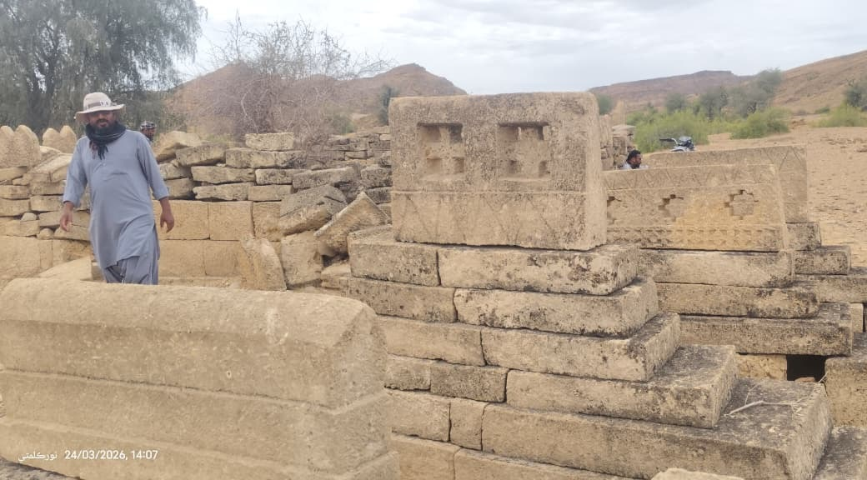

Bazar Graveyard Rek, Jamshoro

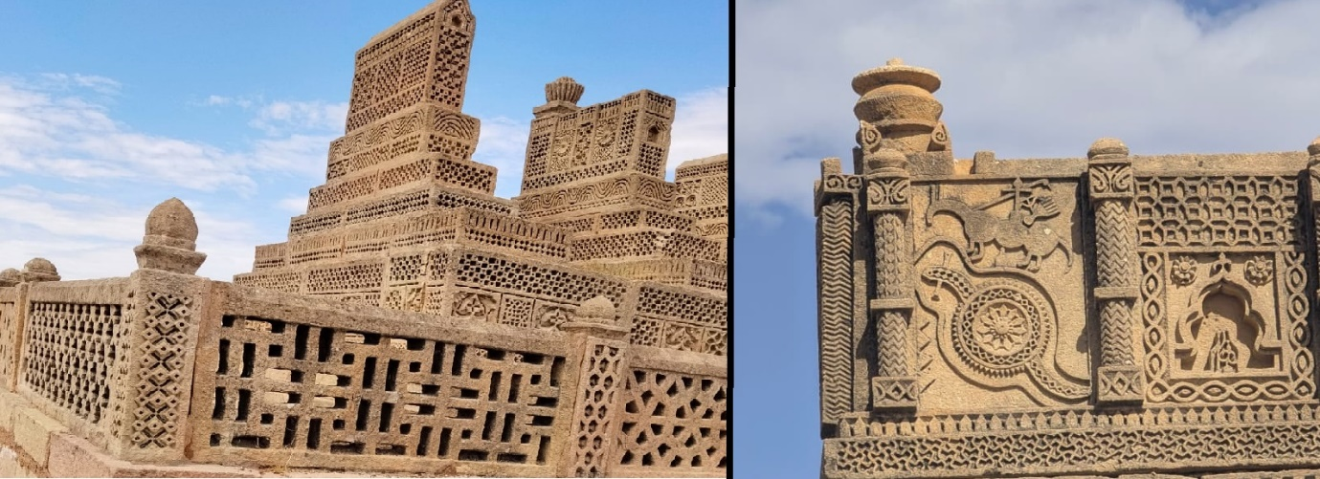
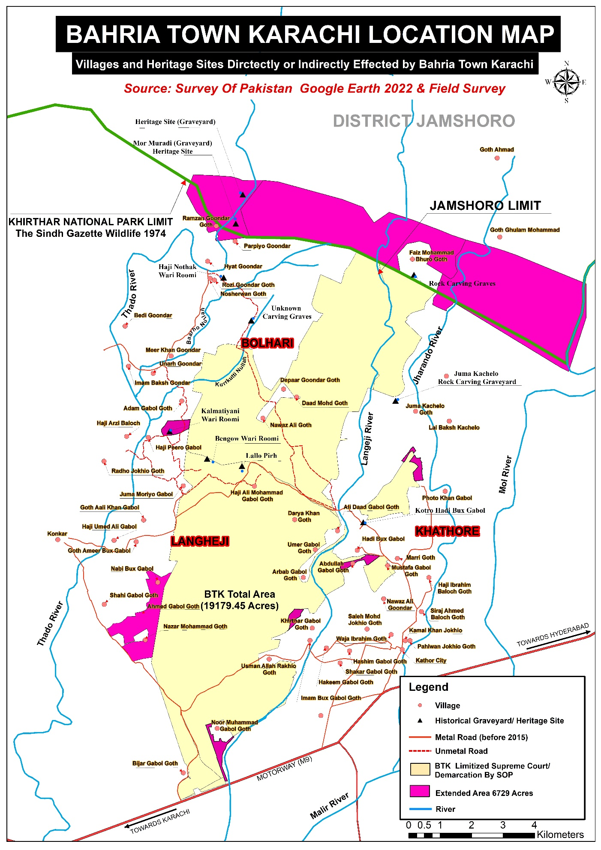

Ecological Importance of Kirthar and the Growing Threat of Man-Made Disasters
Wildlife and wildlife habitats are vital to the ecological and biological processes that are essential to the preservation of life. Pakistan's protected areas system represents a significant contribution to the protection of global biodiversity.
Spread across the Kirthar mountain range in Sindh and touching parts of Balochistan, this vast arid ecosystem serves as a refuge for wildlife, a natural climate regulator for Karachi and surrounding districts, and a lifeline for underground water systems that sustain millions of people.
Yet today, this ecological treasure faces unprecedented pressure from illegal mining, land grabbing, unregulated development, deforestation, and climate change. The story of Kirthar is not just about biodiversity; it is about survival — ecological survival and human survival intertwined.
Kirthar represents one of the largest remaining intact arid mountain ecosystems in South Asia. Unlike lush northern forests, Kirthar’s value lies in its fragile desert-mountain ecology, which is uniquely adapted to extreme heat, water scarcity, and rocky terrain.
Kirthar’s natural landscape supports a diverse range of flora and fauna, including the Sindh ibex, vultures, migratory birds, various reptiles, and amphibians that live both in water and on land.
According to a baseline study conducted in 2001 by the University of Melbourne on Kirthar National Park, a total of 475 plant species were found in the study area. The survey— which recorded at least 67 percent of the park’s plant species— estimated that if a complete floristic inventory were carried out, the total number of plant species in the park would be close to 700.
Regarding fauna, the survey recorded 277 species of vertebrates (animals with backbones), including 203 species of birds. Among these, 6 bird species, 8 mammal species, and 1 reptile species are listed on the IUCN Red List of internationally threatened species.

Fauna Diversity
Kirthar provides habitat to iconic species such as:
- Sindh Ibex
- Urial
- Chinkara (Indian Gazelle)
- Striped Hyena
- Caracal
- Honey Badger
- Indian Fox
- Jungle Cat
Bird occurrence with numbers was recorded in seven habitats types. A total of 207 species of birds belonging to 17 Orders and 52 Families have been recorded from the KPAC
These species depend on the rugged terrain for breeding, protection, and grazing. The Sindh Ibex, in particular, symbolizes the ecological health of the region. When ibex populations decline, it signals deeper ecosystem stress. (Sayed A Ghalib et’al. : Canadian Journal of pure & applied sciences: AN OVERVIEW OF OCCURRENCE, DISTRIBUTION AND STATUS OF THE BIRDS OF KHIRTHAR PROTECTED AREA COMPLEX (KPAC), SINDH November 2013).
Large carnivores and scavengers maintain ecological balance by controlling herbivore populations and cleaning carrion, preventing disease spread.
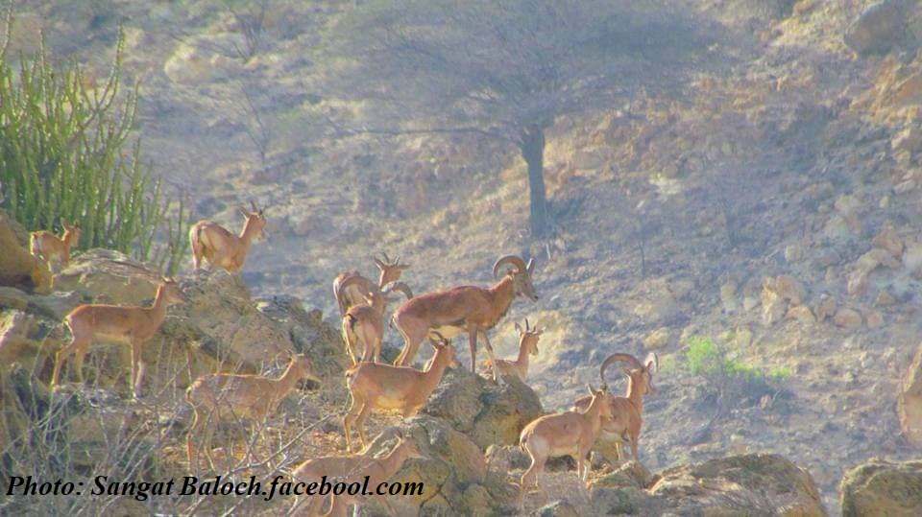
This photo was captured by Sangat Baloch in 2014 (the location where the BTK Eiffel Tower now stands).

Sand and Gravel Mining Within Kirthar National Park
Sand and gravel mining in Kirthar National Park, as well as in the areas of Malir and Jamshoro, has created not only environmental destruction but also a serious social crisis. On one hand, illegal mining has caused a rapid decline in groundwater levels; on the other, the remaining water has become increasingly saline and contaminated, leading to the spread of various diseases. Recently, an outbreak of diarrhea in a village in Kohistan resulted in the deaths of several children.
The reckless cutting of mountains and forests has not only disturbed the ecological balance but has also left wildlife vulnerable to dangerous viral diseases, causing significant animal deaths.
In Malir, mining is legally banned, yet illegal extraction continues openly. In both Kirthar and Malir, court orders and environmental laws are being blatantly violated.
The indigenous people of Kohistan helplessly watch as their lands, forests, and mountains are plundered and destroyed. Many are being displaced from their ancestral areas. This is not merely an environmental issue; it is a major human tragedy that could lead to a far greater disaster in the future.
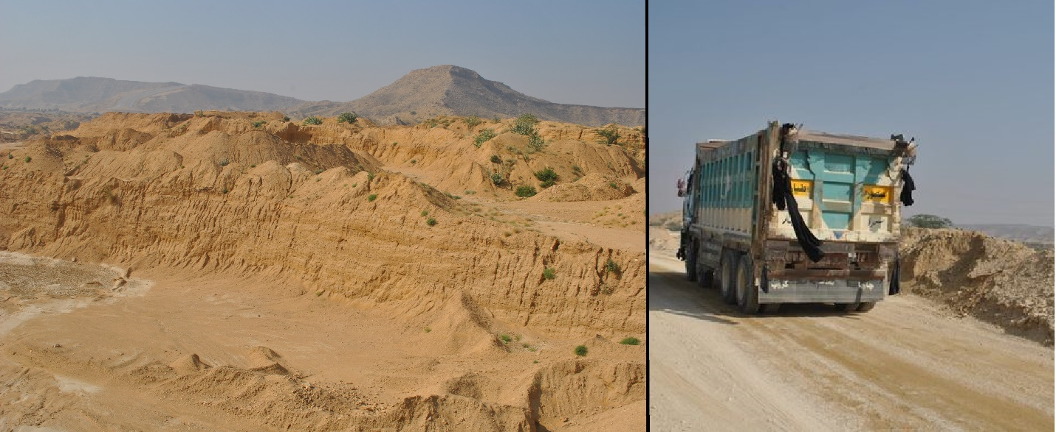
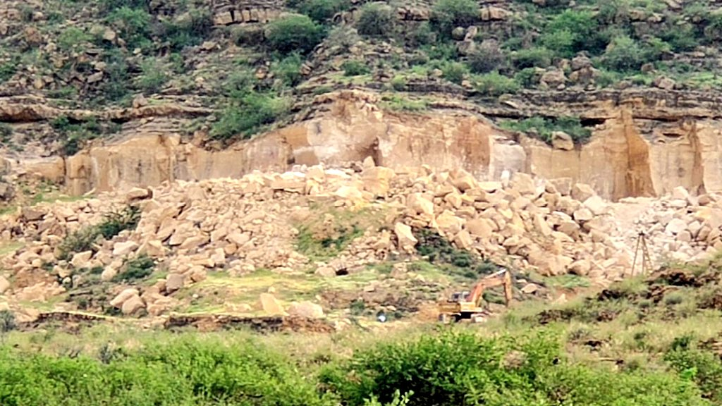
Pachran Hill, Mol River Kirthar National Park Jamshoro
Kirthar National Park has been classified by the International Union for Conservation of Nature (IUCN) as a Category II Protected Area (National Park).
It is designated under Pakistan’s protected areas framework and is specifically listed as a protected national park in the Sindh Wildlife Protection, Preservation, Conservation and Management Act 2020 (Wildlife Act).

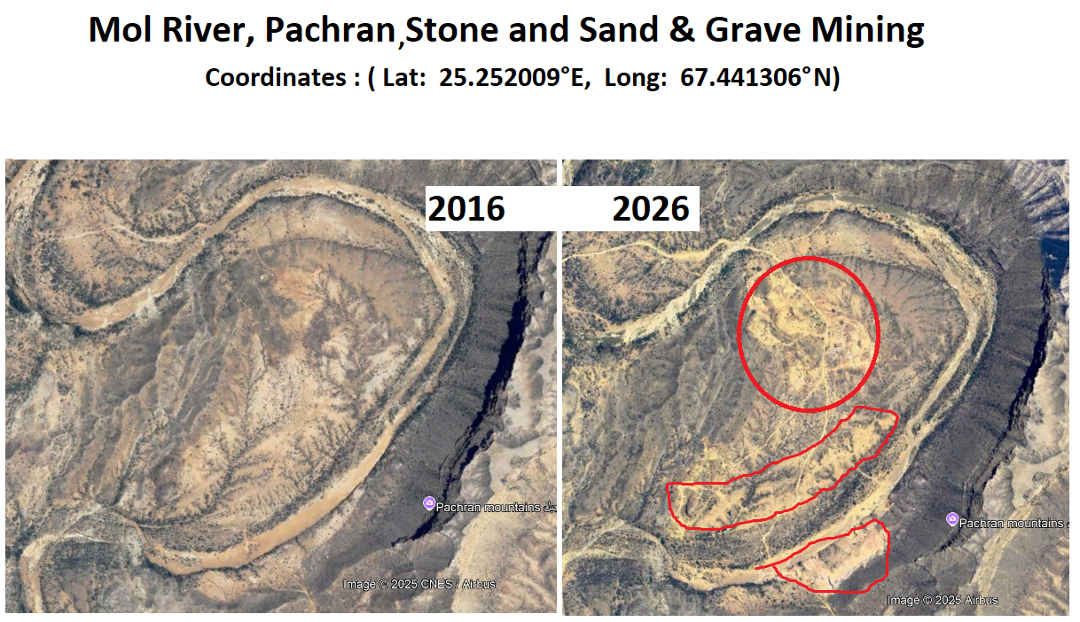

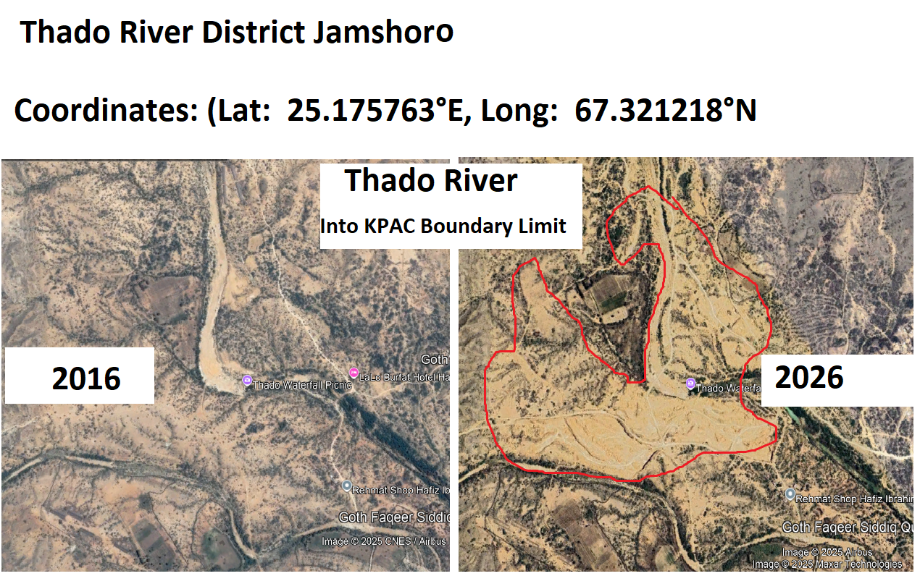
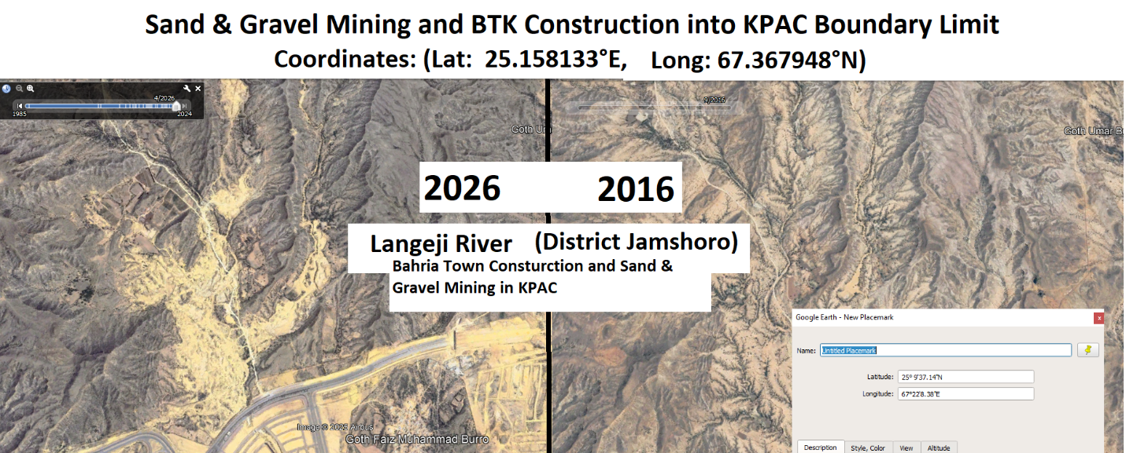
Provincial Laws and Regulatory Framework
Under the Sindh Wildlife Protection, Preservation, Conservation and Management Act 2020, hunting of wildlife, destruction of vegetation, pollution of water resources, and damage to the natural structure of protected areas such as Kirthar National Park are strictly prohibited.
According to the Sindh Environmental Protection Act 2014, any construction activity requires formal approval following an Environmental Impact Assessment (EIA) and a public hearing. In protected areas like Kirthar National Park, construction and mining activities are generally not permitted in order to preserve the clean and natural environment — regardless of whether EIA requirements are technically fulfilled.
The Sindh Mines and Mineral Development Act 2003 (often referred to in relation to sand and gravel extraction) makes licensing mandatory for mining activities. However, such licenses cannot authorize any activity within Kirthar National Park, as its sand and gravel resources are not open for extraction.
The Kirthar Complex includes:
- Kirthar National Park (Malir and Jamshoro, 308,733 hectares);
- Mahal Kohistan Sanctuary (Jamshoro, 70,577 hectares), which is adjacent to the southern boundary of Kirthar National Park;
- Hub Dam Wildlife Sanctuary (Malir, 27,219 hectares), located in the southwestern part of Kirthar National Park;
and
- Sumbak, Soorjan, Eri, and Hothiano (40,631 hectares), which are designated game reserves in Jamshoro to the east of Kirthar National Park.
The buffer zone of this protected area extends up to three miles around the core habitats and also includes important archaeological and cultural sites.
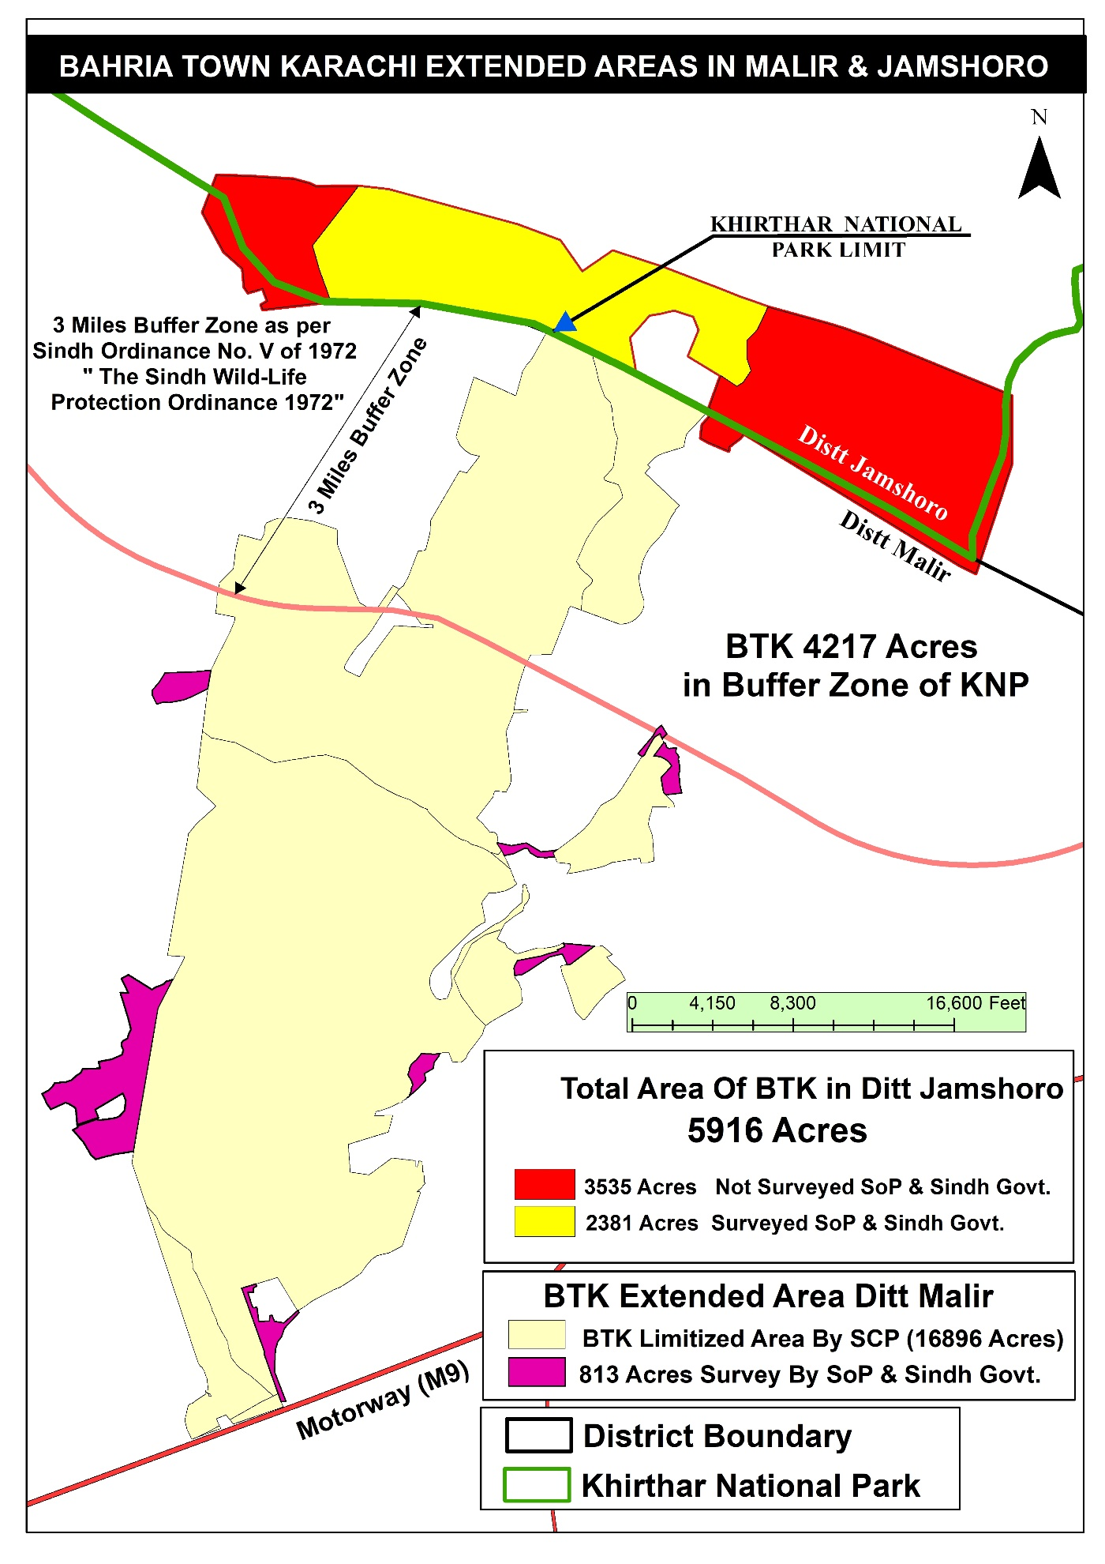

Sindh Kohistan (Khirthar Range) A Voice of an Indigenous
For centuries, the indigenous communities of this mountainous region have served as guardians of its forests, mountains, rivers, and wildlife. This is not just a piece of land; it is the center of our social, cultural, and spiritual life.
Our ancestors gave names to every river, every mountain, and every valley to recognize them as living entities. Their stories, their marks, and their sacred places still guide us today.
Our identity and territorial rights were acknowledged by all historical rulers—from the Mughals to the British, and from the Talpurs to the Samma dynasties. None of them interfered in the internal affairs of Kohistan Kirthar. To defend this status, our ancestors fought many battles to have their rights recognized. The ancient Chaukhandi-style in Kohistan still stand as silent witnesses to those sacrifices.
After 2010: The Beginning of Destruction
As time moved forward, after 2010 Karachi began expanding toward the Kohistan region of Kirthar. Activities started within areas that were officially declared part of the park through the gazette notification—activities that posed a serious threat to the park’s existence and sanctity.
From the back of Gadap, including Deh Karmtiyani, Lath Nadi, and Thado Nadi Dam, to the northern side of Kirthar National Park covering Paraarh Ji Jabal, Mukh Jabal, Ardi Jabal, and Mol Nadi—and toward the southern side including Mokhi, Band Murad, Shahji Chhap, Deh Gadap, and up to the Car Center—these entire areas were part of the park boundaries and buffer zones.
Here, Chinkara and hundreds of other wildlife species lived for centuries alongside indigenous communities. Forests, rivers, and freshwater springs formed the foundation of this entire ecosystem, and we, the indigenous people, were its protectors.

Killing the Law in the Name of Law
From 2000 to 2014, clear court orders and Section 144 imposed a ban on sand and gravel mining in District Malir, District Thatta, and Jamshoro, including all catchment areas of the Malir River. Only small-scale illegal extraction occurred at night, but large-scale mining was not possible.
However, in 2014, with the arrival of DHA and Bahria Town, Section 144 was suddenly lifted. And then began a horrific and ruthless wave of destruction.
For the construction of Bahria Town Karachi, DHA, and other private housing schemes, large-scale illegal extraction of sand and gravel expanded across vast areas. Bahria Town Karachi, being constructed in Gadap, Malir, Karachi between Deh Langhiji, Deh Kathore, Deh Bohari and Deh Konkar, and in District Jamshoro Deh Mol, led to systematic deforestation, mountain cutting, and destruction of rivers.
Mol Nadi, Jarando Nadi, Langhiji Nadi, and Thado Nadi were stripped of their sand and gravel. On the banks of Mol Nadi, the vast forests of Ardi Jabal were cut down. Mukh Jabal and Paraarh ji Jabal—areas where records of Chinkara and dozens of other wildlife species exist—were cut and turned into construction zones.
The upper surface of Paraarh ji Jabal was excavated, and Bahria Town Karachi built its artificial Eiffel Tower on it—turning a living mountain into a manufactured spectacle. Between Paraarh ji Jabal and Mukh Jabal, which are part of Kirthar National Park’s official boundary, large-scale sand and gravel mining continued. The scars of this destruction are still visible today.

Our Voice, Our Demand
From Mol Nadi and Ardi Jabal to Band Murad in the southern reaches of Kirthar Protected Area Complex (Hub Dam Sanctuary, this entire stretch is under systematic and ruthless destruction. This is not just environmental damage—it is an attack on our indigenous identity, our history, and the rights of future generations.
All of this is clearly visible in the official map of Kirthar Protected Area Complex —and our testimony predates even that map.

Conclusion
Conclusions drawn from this environmental survey the survey participants also came to the conclusion that.
The illegal activities taking place in the Wildlife Protected Area include all national and international and UN-designated laws and conditions that have been set aside for wildlife conservation are completely ignored.
The environmental and ecological losses in Khirthar National Park trigger a cascade of adverse effects throughout Sindh. When the park’s natural functions—especially water recharge and habitat protection—are compromised by activities such as sand mining and urban encroachment, the downstream consequences include water scarcity, diminished agricultural productivity, and increased flood risks. In Karachi, these impacts are magnified, leading to an exacerbated urban water crisis, infrastructural vulnerabilities, and a loss of urban green spaces that further degrade the quality of life.
Addressing these issues requires coordinated efforts: stronger enforcement of environmental regulations, integrated water and land-use planning, community engagement in conservation, and policy reforms that prioritize long-term ecological sustainability over short-term development gains.
By restoring the ecological balance in Khirthar National Park, it is possible to safeguard not only the park’s unique biodiversity but also the well-being of millions of people in Sindh, particularly in Karachi.

There are hundreds of archeological sites in the entire region which, despite the knowledge of the Sindh government and the concerned Department, have turned a blind eye to their protection. Due to mega housing projects in the region, many archeological sites were destroyed and many such archeological sites were destroyed.
The silence of the Sindh government in this whole process is an indication that the Sindh government is equally involved in this illegal act.

https://tribune.com.pk/story/518468/shc-halts-illegal-excavation-of-sand-and-gravel?utm_source=chatgpt.com
https://tribune.com.pk/story/465896/illegal-mining-court-warns-police-of-criminal-prosecution?

